Supplementary information
Fig. S1. Validation of simulated currents from the GLOFS model using observed drifter trajectories. MAE indicates the mean absolute error, and RMSE indicates the root mean square error. Note that 0 degrees represents North, and angles increase clockwise.

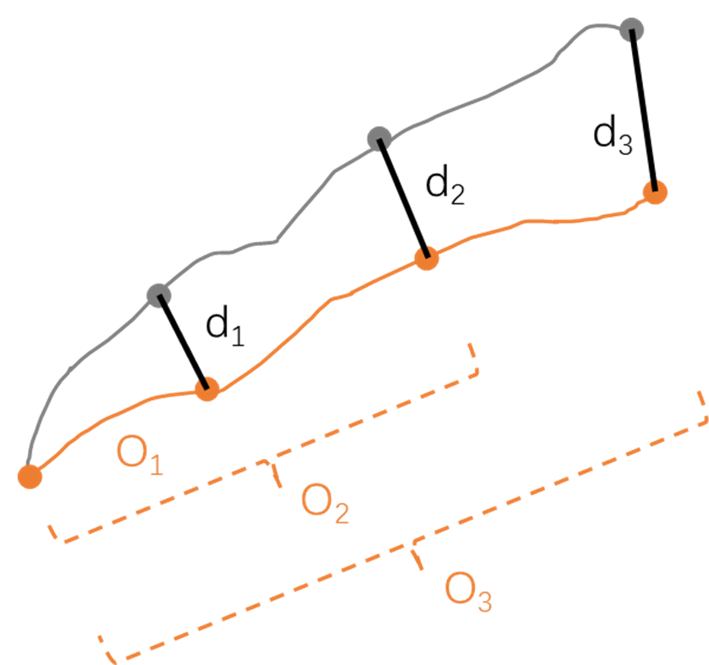
Fig. S2. Conceptual illustration of SI. The grey dot represents the average location of simulated particles and the orange dot represents the drifter trajectories. $O_{i}$ is the accumulated length of the actual observed trajectory and $d_{i}$ is the separation distance.

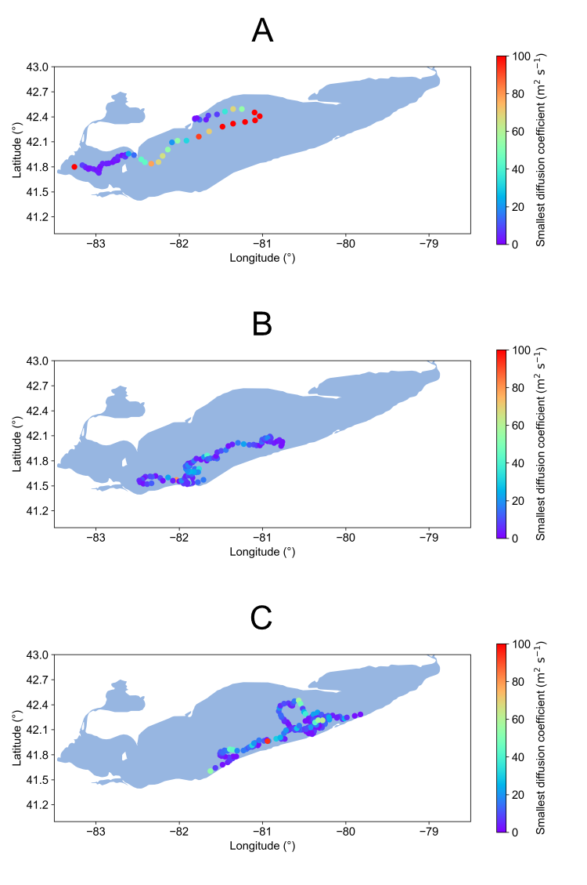
Fig. S3. Spatial distribution of the SDCs: (A) 62 cases in 2016, (B) 110 cases in 2018, (C) 190 cases in 2019.

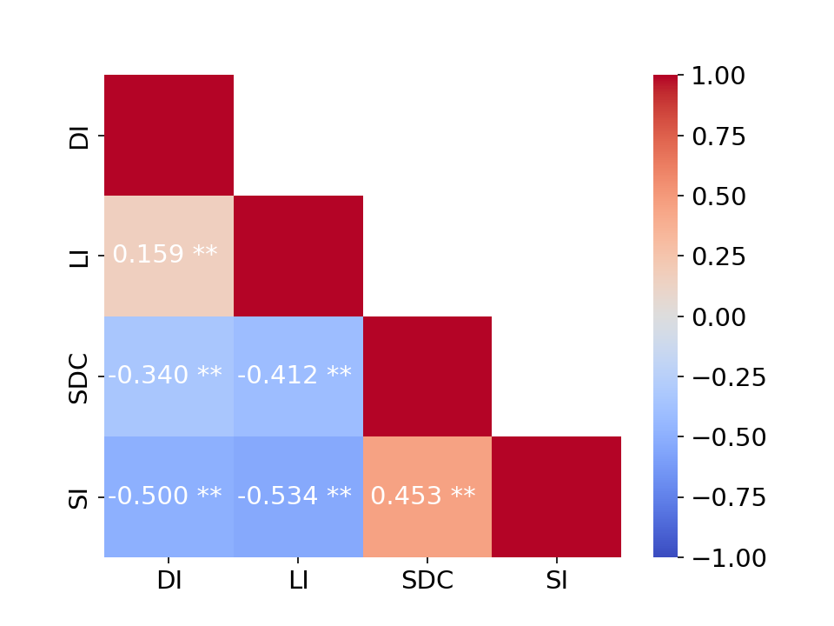
Fig. S4. Spearman correlations for DI, LI, SDC, and SI. * indicates P < 0.05, and ** indicates P < 0.01.

