Supporting Information for

Changes in body size with age do not follow the temperature-size rule
Jennifer S. Bigman^{1,2*}, Lewis A.K. Barnett³, James T. Thorson³, Sean C. Anderson⁴, Krista Oke^{5,6}, Kelly Kearney³, Darren Pilcher⁷, Wei Cheng⁷, Esther Goldstein³, Mary E. Matta³, Kirstin K. Holsman³, & Lauren A. Rogers³

¹School of Marine Science and Policy, University of Delaware, Lewes, DE, USA
²Office of Science and Technology, NOAA Fisheries, Seattle, WA, USA
³Alaska Fisheries Science Center, NOAA Fisheries, Seattle, WA, USA
⁴Department of Fisheries and Oceans Canada, Nanaimo, B.C., Canada
⁵Alaska Fisheries Science Center, NOAA Fisheries, Juneau, AK, USA
⁶Fisheries, Aquatic Science, and Technology Laboratory, Alaska Pacific University, Anchorage, AK
⁷Cooperative Institute for Climate, Ocean, and Ecosystem Studies, University of Washington, Seattle, WA
*Corresponding author: jennifersbigman@gmail.com, ORCID: 0000-0001-8070-3061

This file contains:
Supplementary Methods
Supplementary Results
Supplementary Tables
Supplementary Figures
Supplementary References

Supplementary Methods

To understand whether weight for a given age changed from year to year, we fit linear mixed effects models where the average weight $w$ for each year $y_{i}$ for distinct locations in space $g_{i}$ for each age is:

$\log\left(w_{y_{i}g_{i}}\right)\sim Normal(X_{y_{i}}β+ ω_{g_{i} }+ ε_{y_{i}g_{i}, }{ ϕ}^{2})$ , where

$X_{y_{i}}β$ = main effects (year as factor)
$ω_{g_{i} }$= spatial variation for each point in space (g)
$ε_{y_{i}g_{i}}$ = spatiotemporal variation for each point in space (g) for each year (y)
$ϕ^{2}$ = observation error variance
$ω=MVN(0, σ_{ω}^{2}R_{ω}$)
$E_{y }\sim MVN(σ_{ε}^{2}R_{ε}$)

Spatial and spatiotemporal variation was estimated as Gaussian Markov random fields with mean = 0, specified through precision matrices arising from the stochastic partial differential equation (SPDE) approach that approximates a Gaussian random field (Lindgren, 2011). For interpretability, these models can be equivalently expressed in terms of their implied covariance matrices $σ_{ω}^{2}R_{ω}$and $σ_{ε}^{2}R_{ε}$, where $R_{ω}$ and $R_{ε}$ encode spatial correlation between locations based on a Matérn function. The correlation structure is governed by a shared decorrelation rate κ (i.e. the distance that locations are effectively uncorrelated), and the marginal variances $σ_{ω}^{2}$ and $σ_{ε}^{2}$.

To understand how temperature (t_{i}) affects weight $w$ for age $a_{i}$, we fit generalized linear mixed effects models where the average weight for each age for distinct locations in space $g_{i}$ is:

$\log\left(w_{a_{i}g_{i}}) \sim Normal(X_{{t_{i}a}_{i}g_{i}}β + ω_{a_{i}g_{i} }+ ε_{a_{i}g_{i}y_{i}}, { ϕ}_{a}^{2}\right)$, where

$X_{{t_{i}a}_{i}g_{i}}β$ = main effects (age and temperature, additive or interactive depending on model; see main text)
$ω_{a_{i}g_{i} }$= spatial variation for each point in space (g)
$ε_{a_{i}g_{i}y_{i}}$= spatiotemporal variation for each point in space (g) for each year (y)
${ ϕ}_{a}^{2}$ = observation error variance for each age (a)
$ω_{a}=MVN(0, σ_{ω_{a}}^{2}R_{ω_{a}}$)
$E_{y,a }\sim MVN(0, σ_{ε}^{2}R_{ε}$)
Spatial and spatiotemporal variation was estimated as above with exceptions: for the ‘shared spatial field model’ there was no spatiotemporal variation ($ε_{y_{i}g_{i}}$), and for the ‘age-specific fields’ models, spatial and spatiotemporal variation were estimated for each age a (noted in formula above, $ω_{a_{i}g_{i} }+ ε_{a_{i}y_{i}g_{i}}$).
Supplementary Results

Functional form of the temperature-weight relationship
Although the functional form of many of the most-supported models was either second or third order polynomial, comparison based on AIC indicated similar support for different functional forms (Tables S3-S6). This was especially true for Pacific cod and yellowfin sole, where the five and four highest-ranked models, respectively, were all within two AIC units of each other and described the relationship between weight and temperature as linear or as a second or third order polynomial (Tables S4, S6). For arrowtooth flounder and walleye pollock, the top two-ranked models had the lowest AIC, but were within two units of each other and described the weight-temperature relationship as a third order and second order polynomial (Tables S3, S5).

Supplementary Tables

Table S1. Number of samples (individuals) and range of collection years per species.

Species | Year range | Years | Sample size
arrowtooth flounder | 1996-2021 | 1996, 2004, 2010, 2012, 2014-2019, 2021 | 6021
Pacific cod | 1993-2022 | 1993, 1998-2019, 2021-2022 | 32161
walleye pollock | 1991-2023 | 1991, 1999-2019, 2021-2023 | 40930
yellowfin sole | 1987-2022 | 1987, 1994, 1999-2019, 2021-2022 | 20222

Table S2. Models with age-specific random fields are more supported than models with shared spatial and spatiotemporal fields across ages for arrowtooth flounder. Comparison of models fitted with restricted maximum likelihood (REML) based on marginal AIC for arrowtooth flounder. Models include those with different functional forms (second column), different covariates (temperature, oxygen, none), an interaction between temperature or oxygen and age class (allowing the relationship to vary by age class, e.g., age-specific effects), and different random field structures (models with independent spatial and spatiotemporal effects [‘age-specific effects’], models with shared spatial and spatiotemporal effects across ages [‘shared spatial/spatiotemporal fields’], and models with no spatiotemporal effect and a shared spatial effect across ages [‘shared spatial field’]). For this comparison (using REML), only random effect structures are to be compared (i.e., last three columns, ‘age-specific effects’, ‘shared spatial/spatiotemporal fields’, and ‘shared spatial field’. The bolded values indicate the lowest AIC values (and most supported random effect structure).

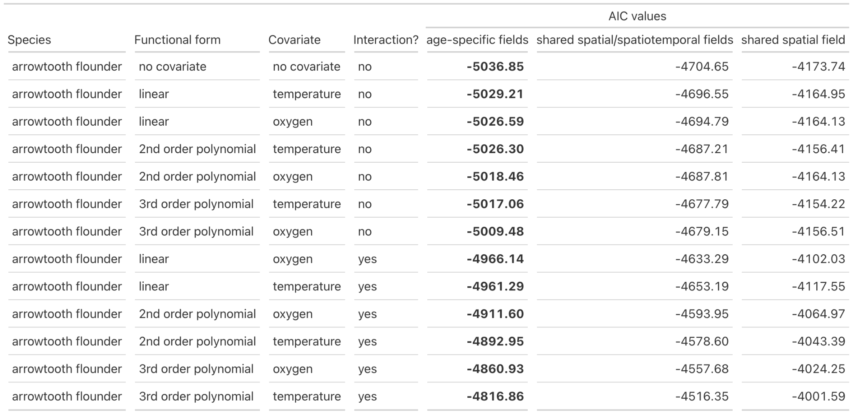

Table S3. Models with temperature and no interaction between temperature and age are the most supported models explaining changes in weight-at-age over time for arrowtooth flounder. Comparison of models fitted with maximum likelihood (ML) based on marginal AIC for arrowtooth flounder. Models include those with different functional forms (second column), different covariates (temperature, oxygen, none), and an interaction between temperature or oxygen and age class (allowing the relationship to vary by age class, e.g., age-specific effects). The random effect structure for all models in this comparison follow the most supported structure, age-specific spatial and spatiotemporal fields. For this comparison (using ML), only the importance of fixed effects are to be compared (i.e., functional form, covariate, interaction). All models within 2 AIC units of the most supported model are highlighted in grey and the most supported model (that with the lowest AIC) is emboldened.

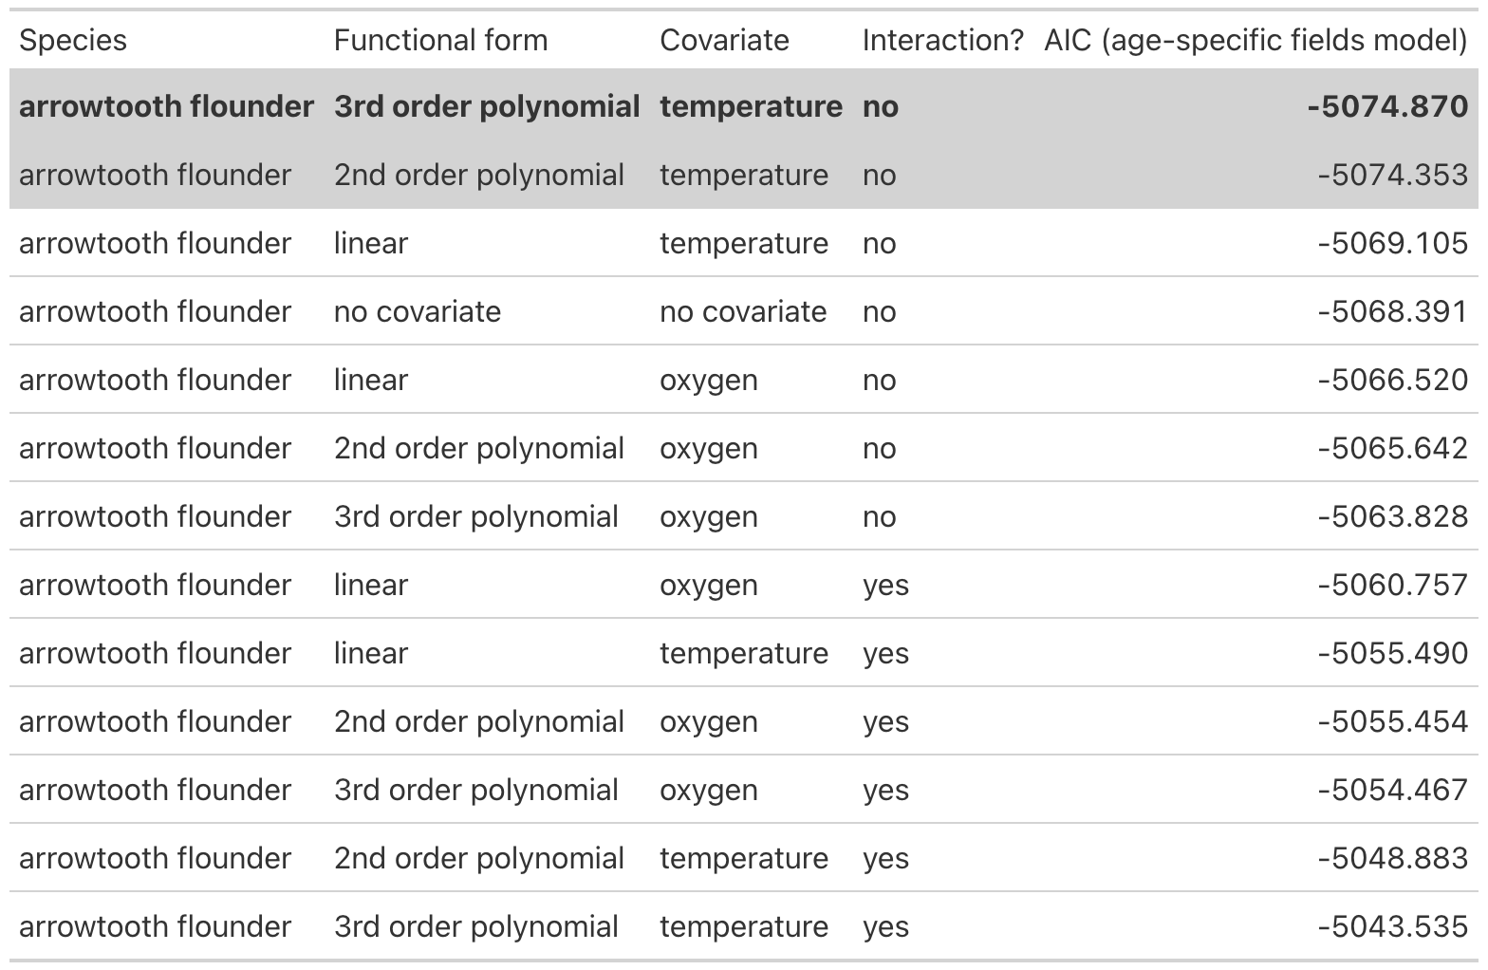

Table S4. Same as Table S3 but for Pacific cod. Models with temperature and no interaction between temperature and age are the most supported models explaining changes in weight-at-age over time for Pacific cod. Comparison of models fitted with maximum likelihood (ML) based on marginal AIC for Pacific cod. Models include those with different functional forms (second column), different covariates (temperature, oxygen, none), and an interaction between temperature or oxygen and age class (allowing the relationship to vary by age class, e.g., age-specific effects). The random effect structure for all models in this comparison follow the most supported structure, age-specific spatial and spatiotemporal fields. For this comparison (using ML), only the importance of fixed effects are to be compared (i.e., functional form, covariate, interaction). All models within 2 AIC units of the most supported model are highlighted in grey and the most supported model (that with the lowest AIC) is emboldened.

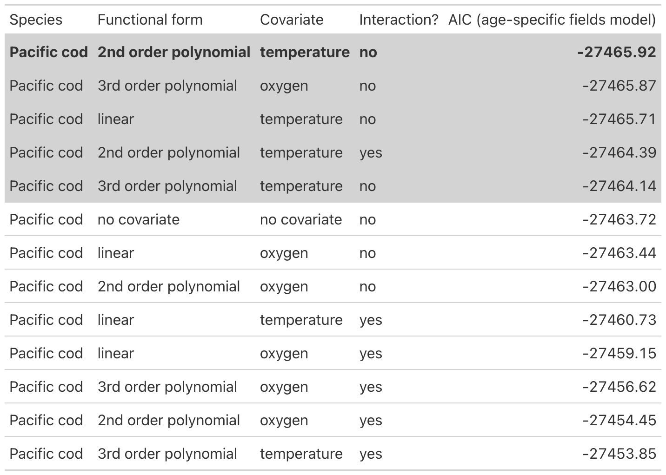

Table S5. Same as Table S3 but for walleye pollock. Models with temperature and no interaction between temperature and age are the most supported models explaining changes in weight-at-age over time for walleye pollock. Comparison of models fitted with maximum likelihood (ML) based on marginal AIC for walleye pollock. Models include those with different functional forms (second column), different covariates (temperature, oxygen, none), and an interaction between temperature or oxygen and age class (allowing the relationship to vary by age class, e.g., age-specific effects). The random effect structure for all models in this comparison follow the most supported structure, age-specific spatial and spatiotemporal fields. For this comparison (using ML), only the importance of fixed effects are to be compared (i.e., functional form, covariate, interaction). All models within 2 AIC units of the most supported model are highlighted in grey and the most supported model (that with the lowest AIC) is emboldened.

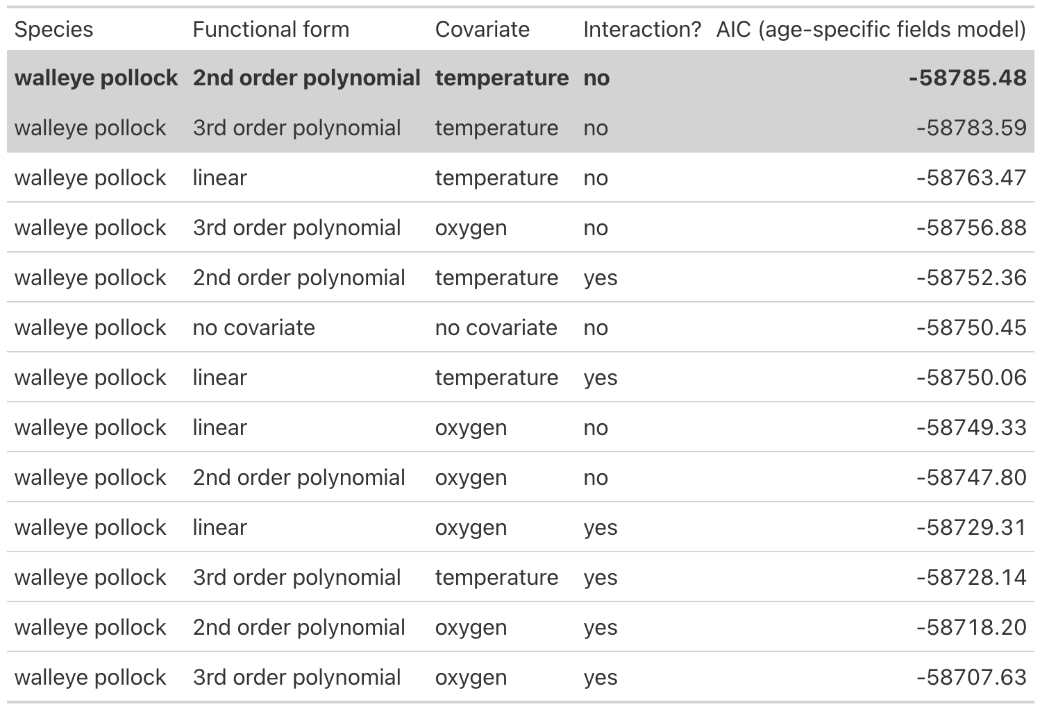

Table S6. Same as Table S3 but for yellowfin sole. Models with temperature and no interaction between temperature and age are the most supported models explaining changes in weight-at-age over time for yellowfin sole. Comparison of models fitted with maximum likelihood (ML) based on marginal AIC for yellowfin sole. Models include those with different functional forms (second column), different covariates (temperature, oxygen, none), and an interaction between temperature or oxygen and age class (allowing the relationship to vary by age class, e.g., age-specific effects). The random effect structure for all models in this comparison follow the most supported structure, age-specific spatial and spatiotemporal fields. For this comparison (using ML), only the importance of fixed effects are to be compared (i.e., functional form, covariate, interaction). All models within 2 AIC units of the most supported model are highlighted in grey and the most supported model (that with the lowest AIC) is emboldened.

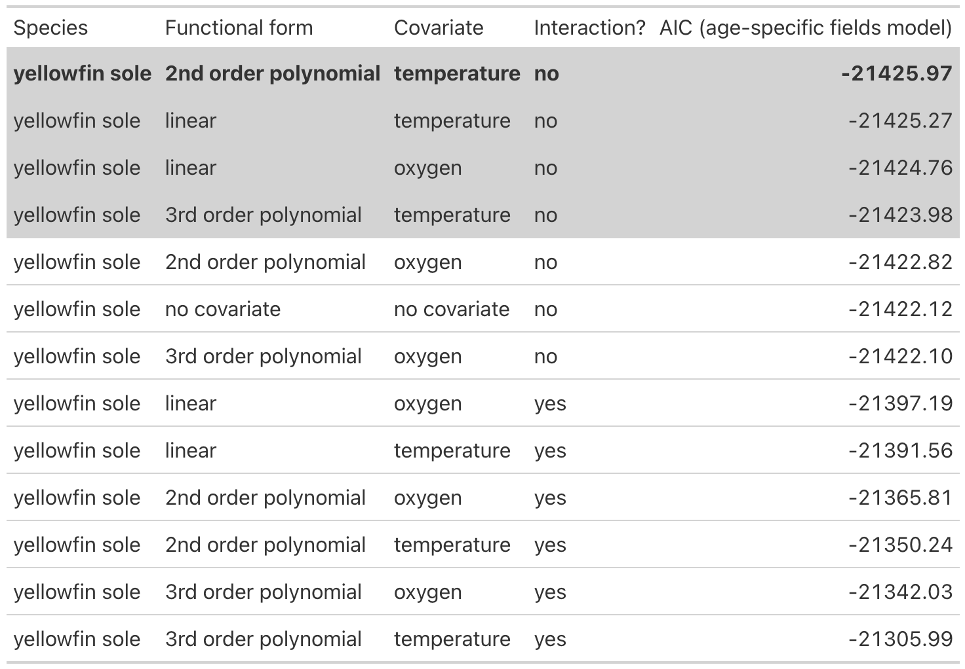

Table S7. Models with age-specific random fields are more supported than models with shared spatial and spatiotemporal fields across ages for Pacific cod (same as Table S2 but for Pacific Cod). Models with age-specific random fields are more supported than models with shared spatial and spatiotemporal fields across ages for Pacific cod. Models include those with different functional forms (second column), different covariates (temperature, oxygen, none), an interaction between temperature or oxygen and age class (allowing the relationship to vary by age class, e.g., age-specific effects), and different random field structures (models with independent spatial and spatiotemporal effects [‘age-specific effects’], models with shared spatial and spatiotemporal effects across ages [‘shared spatial and spatiotemporal fields’], and models with no spatiotemporal effect and a shared spatial effect across ages [‘shared spatial field’]). For this comparison (using REML), only random effect structures are to be compared (i.e., last three columns, ‘age-specific effects’, ‘shared spatial and spatiotemporal fields’, and ‘shared spatial field’. The bolded values indicate the lowest AIC values (and most supported random effect structure).

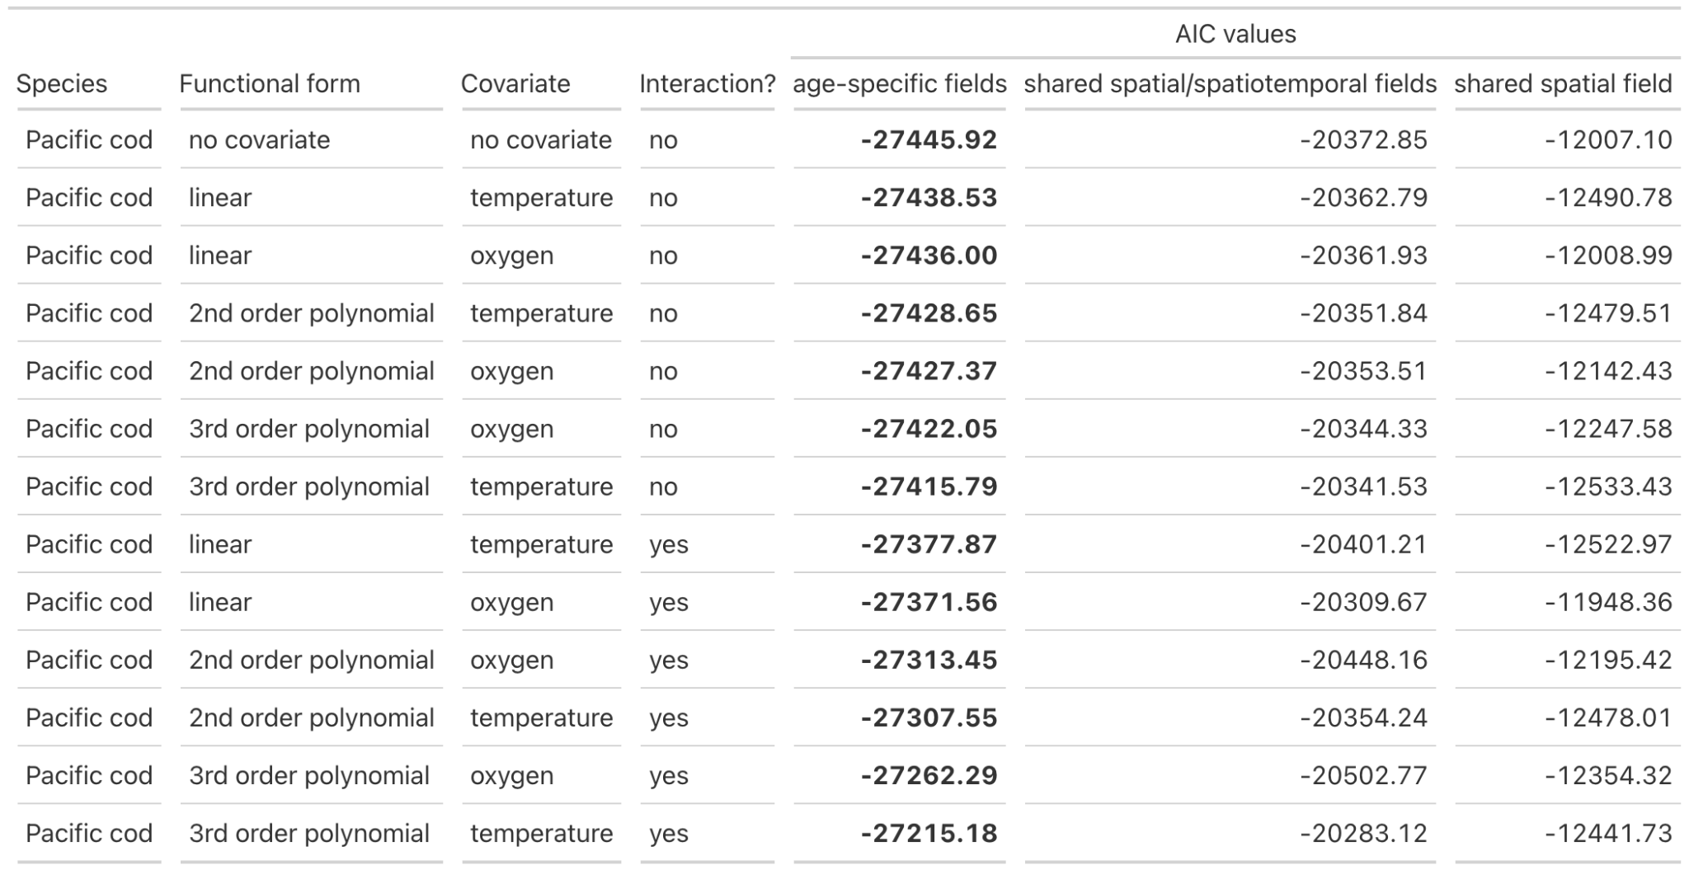
Table S8. Models with age-specific random fields are more supported than models with shared spatial and spatiotemporal fields across ages for walleye pollock (same as Table S2 but for walleye pollock). Models with age-specific random fields are more supported than models with shared spatial and spatiotemporal fields across ages for walleye pollock. Models include those with different functional forms (second column), different covariates (temperature, oxygen, none), an interaction between temperature or oxygen and age class (allowing the relationship to vary by age class, e.g., age-specific effects), and different random field structures (models with independent spatial and spatiotemporal effects [‘age-specific effects’], models with shared spatial and spatiotemporal effects across ages [‘shared spatial and spatiotemporal fields’], and models with no spatiotemporal effect and a shared spatial effect across ages [‘shared spatial field’]). For this comparison (using REML), only random effect structures are to be compared (i.e., last three columns, ‘age-specific effects’, ‘shared spatial and spatiotemporal fields’, and ‘shared spatial field’.
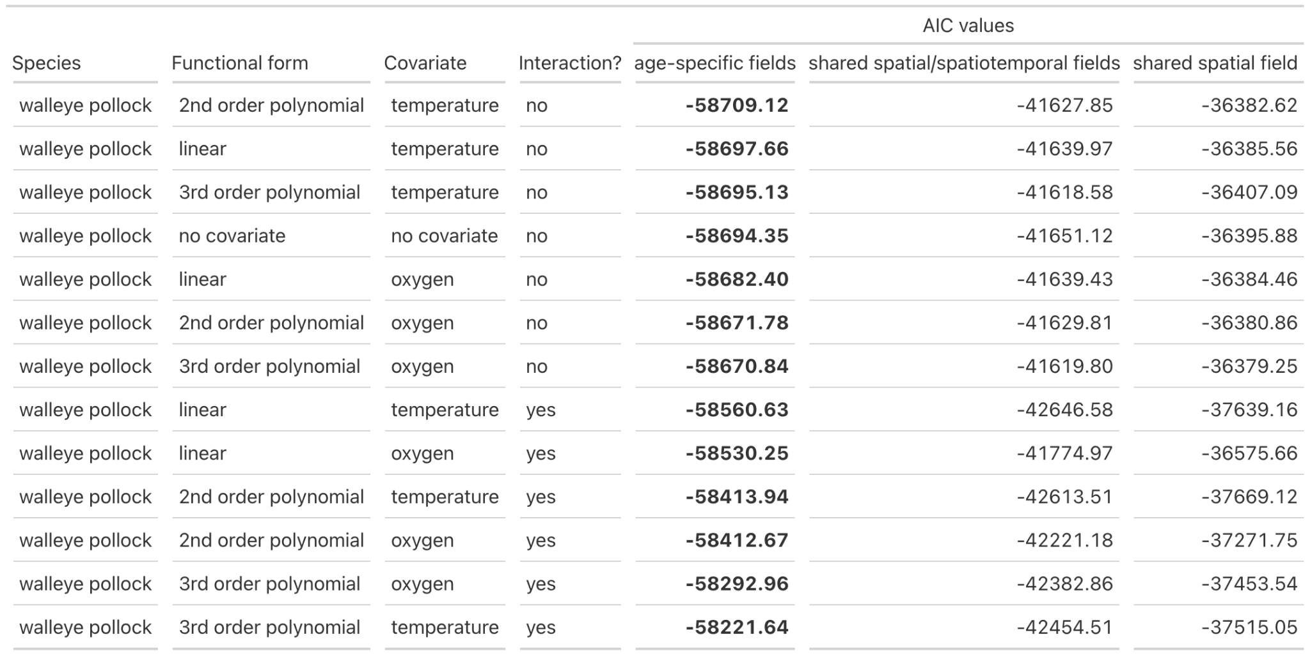

Table S9. Models with age-specific random fields are more supported than models with shared spatial and spatiotemporal fields across ages for yellowfin sole (same as Table S2 but for yellowfin sole). Models with age-specific random fields are more supported than models with shared spatial and spatiotemporal fields across ages for yellowfin sole. Models include those with different functional forms (second column), different covariates (temperature, oxygen, none), an interaction between temperature or oxygen and age class (allowing the relationship to vary by age class, e.g., age-specific effects), and different random field structures (models with independent spatial and spatiotemporal effects [‘age-specific effects’], models with shared spatial and spatiotemporal effects across ages [‘shared spatial and spatiotemporal fields’], and models with no spatiotemporal effect and a shared spatial effect across ages [‘shared spatial field’]). For this comparison (using REML), only random effect structures are to be compared (i.e., last three columns, ‘age-specific effects’, ‘shared spatial and spatiotemporal fields’, and ‘shared spatial field’. The bolded values indicate the lowest AIC values (and most supported random effect structure).
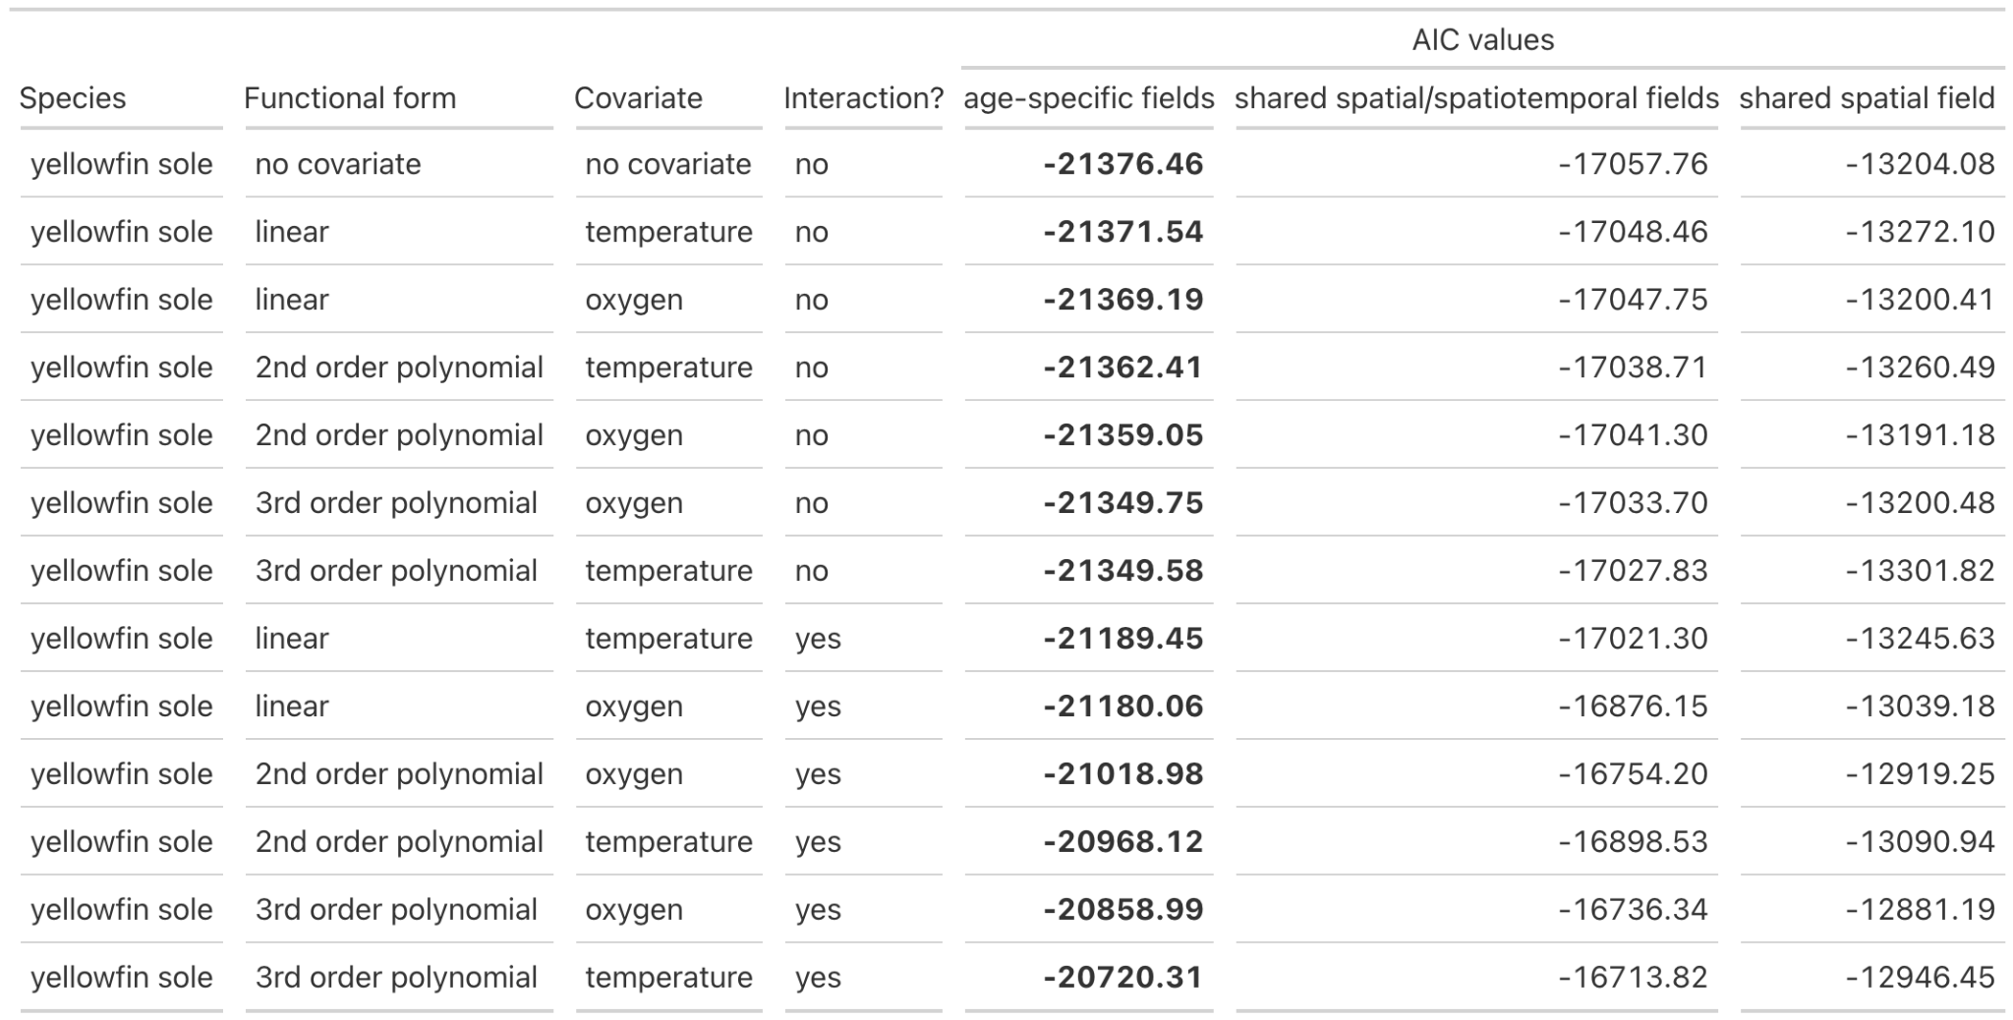

Supplementary Figures

Figure S1. Time series of temperature and oxygen averaged over a shorter (three months prior to the survey) and longer (averaged year before survey) time span for (a) arrowtooth flounder, (b) Pacific cod, (c) walleye pollock, and (d) yellowfin sole. The left column of each four-panel plot is oxygen and the right column is temperature; the top row of each four-panel plot is the shorter time span for covariate averaging and the bottom row is the longer time span for covariate averaging. Weight data is missing for select years - please refer to Table S1.
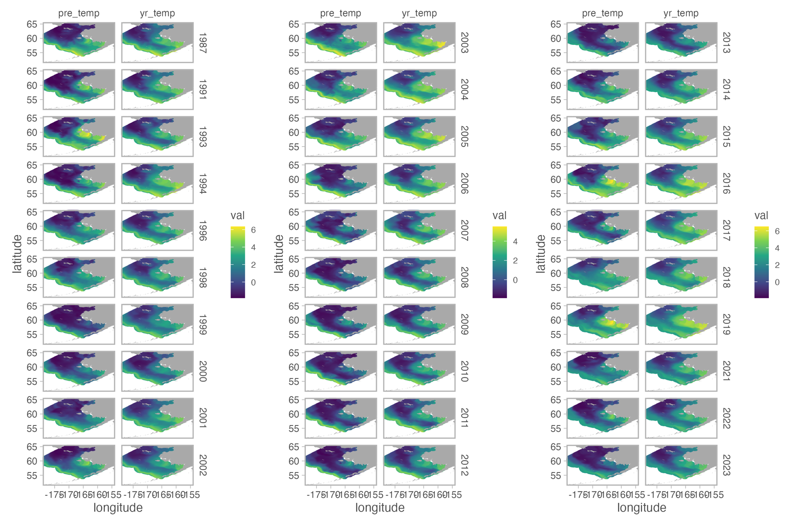
Figure S2. Comparison of temperature averaged over a shorter (three months prior to the survey) and longer (averaged year before survey) time span for each grid cell for each year (broken up across three panels for to ensure readability). The left column of each panel is the shorter time span for covariate averaging (‘pre’ label above) and the right column is the longer time span for covariate averaging (‘yr’ label above). Each row of each ‘pillar’ is one year.

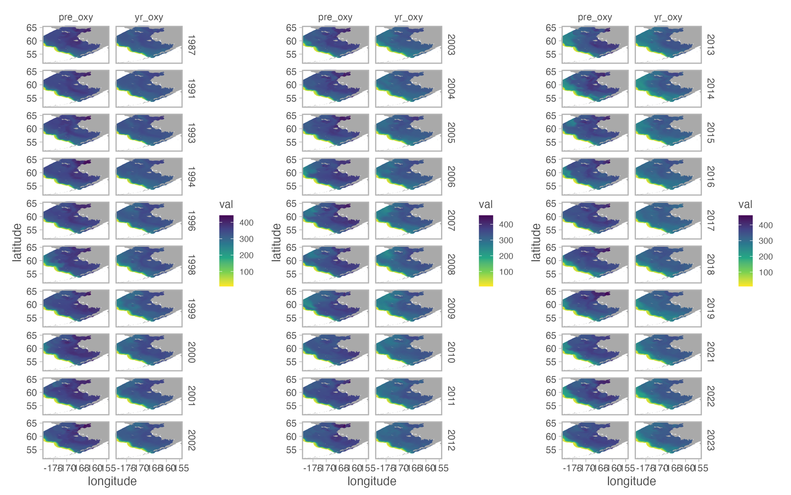
Figure S3. Comparison of oxygen averaged over a shorter (three months prior to the survey) and longer (averaged year before survey) time span for each grid cell for each year (broken up across three panels for to ensure readability). The left column of each panel is the shorter time span for covariate averaging (‘pre’ label above) and the right column is the longer time span for covariate averaging (‘yr’ label above). Each row of each ‘pillar’ is one year.

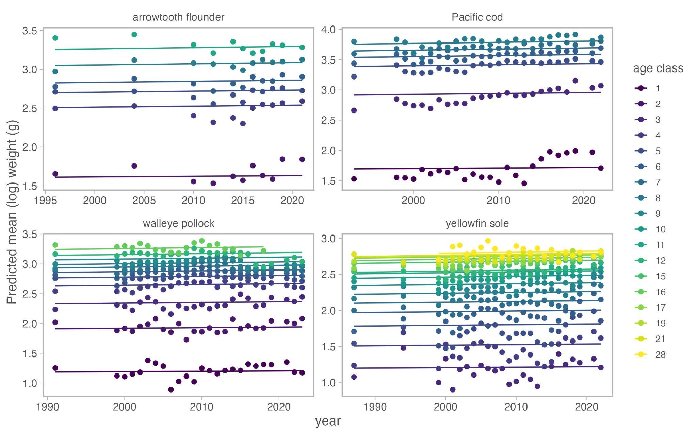
Figure S4. There was no long-term change in weight-at-age over time for any of the four species examined in this study. Each panel corresponds to a species (name on top of panel). Prediction lines come from spatiotemporal models for each age of each species fit to weight data with a year (continuous) fixed effect and spatial and spatiotemporal random fields.

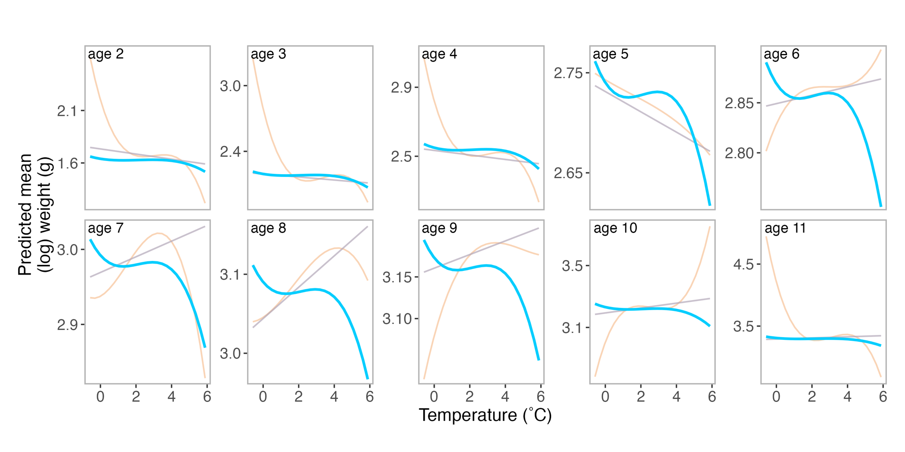
Figure S5. Predictions of weight from temperature from three spatiotemporal models: (1) age-specific spatial and spatiotemporal fields (blue lines), (2) shared spatial field and spatiotemporal fields across ages (purple lines), and (3) shared spatial field across ages with no spatiotemporal fields (orange lines) for arrowtooth flounder. Each panel corresponds to a separate age class (labeled in the upper left-hand side of the panel). Predictions were generated from the most supported model for each random effect structure (see Table S2).

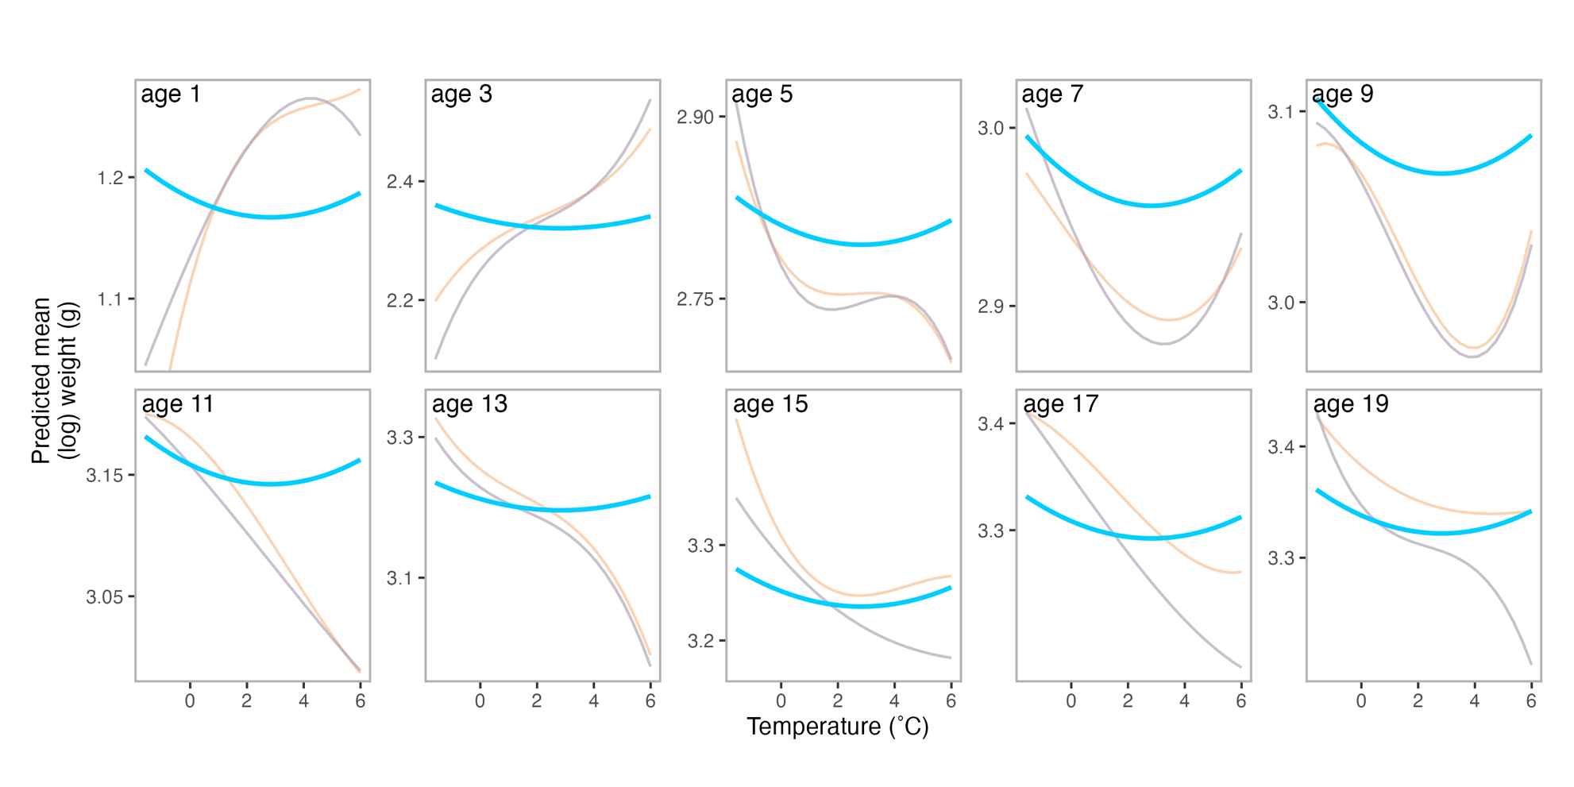
Figure S6. Predictions of weight from temperature from three spatiotemporal models: (1) age-specific spatial and spatiotemporal fields (blue lines), (2) shared spatial field and spatiotemporal fields across ages (purple lines), and (3) shared spatial field across ages with no spatiotemporal fields (orange lines) for walleye pollock. Each panel corresponds to a separate age class (labeled in the upper left-hand side of the panel). Predictions were generated from the most supported model for each random effect structure (see Table S4).

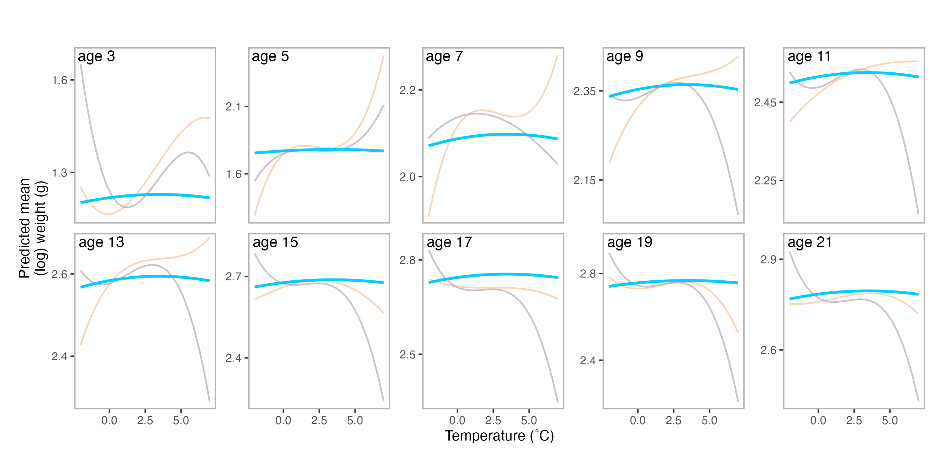 Figure S7. Predictions of weight from temperature from three spatiotemporal models: (1) age-specific spatial and spatiotemporal fields (blue lines), (2) shared spatial field and spatiotemporal fields across ages (purple lines), and (3) shared spatial field across ages with no spatiotemporal fields (orange lines) for yellowfin sole. Each panel corresponds to a separate age class (labeled in the upper left-hand side of the panel). Predictions were generated from the most supported model for each random effect structure (see Table S5).

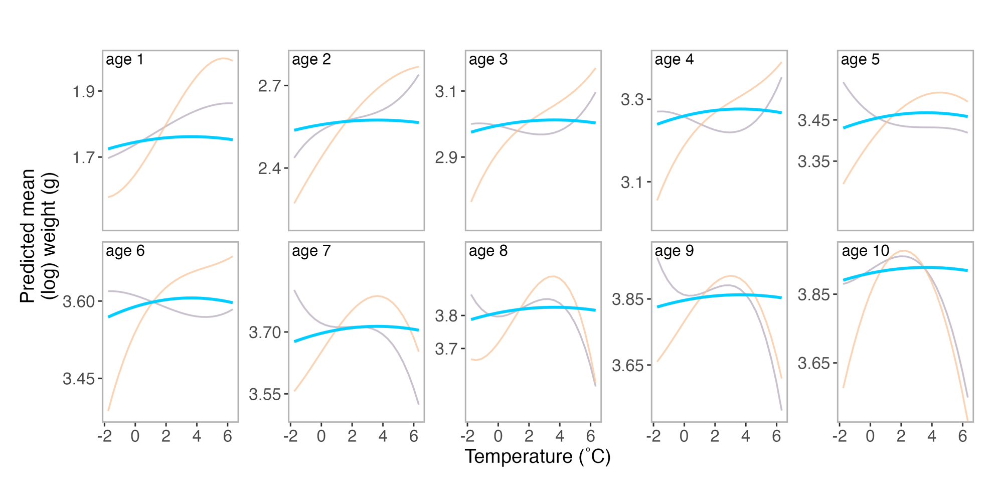
Figure S8. Predictions of Pacific cod weight from temperature from three spatiotemporal models: (1) age-specific spatial and spatiotemporal fields (blue lines), (2) shared spatial field and spatiotemporal fields across ages (purple lines), and (3) shared spatial field across ages with no spatiotemporal fields (orange lines) using data from years 2008 and forward (Figure 4 in main text has results with full dataset). Each panel corresponds to a separate age class (labeled in the upper left-hand side of the panel). Predictions in figure for the three models with different random effect structures (blue, purple, and blue lines) were generated from the most supported model for each random effect structure (i.e., most supported models for each random effect structure in Table S3). Note the y-axis (the predicted mean weight [log10 g]) differs for each panel.

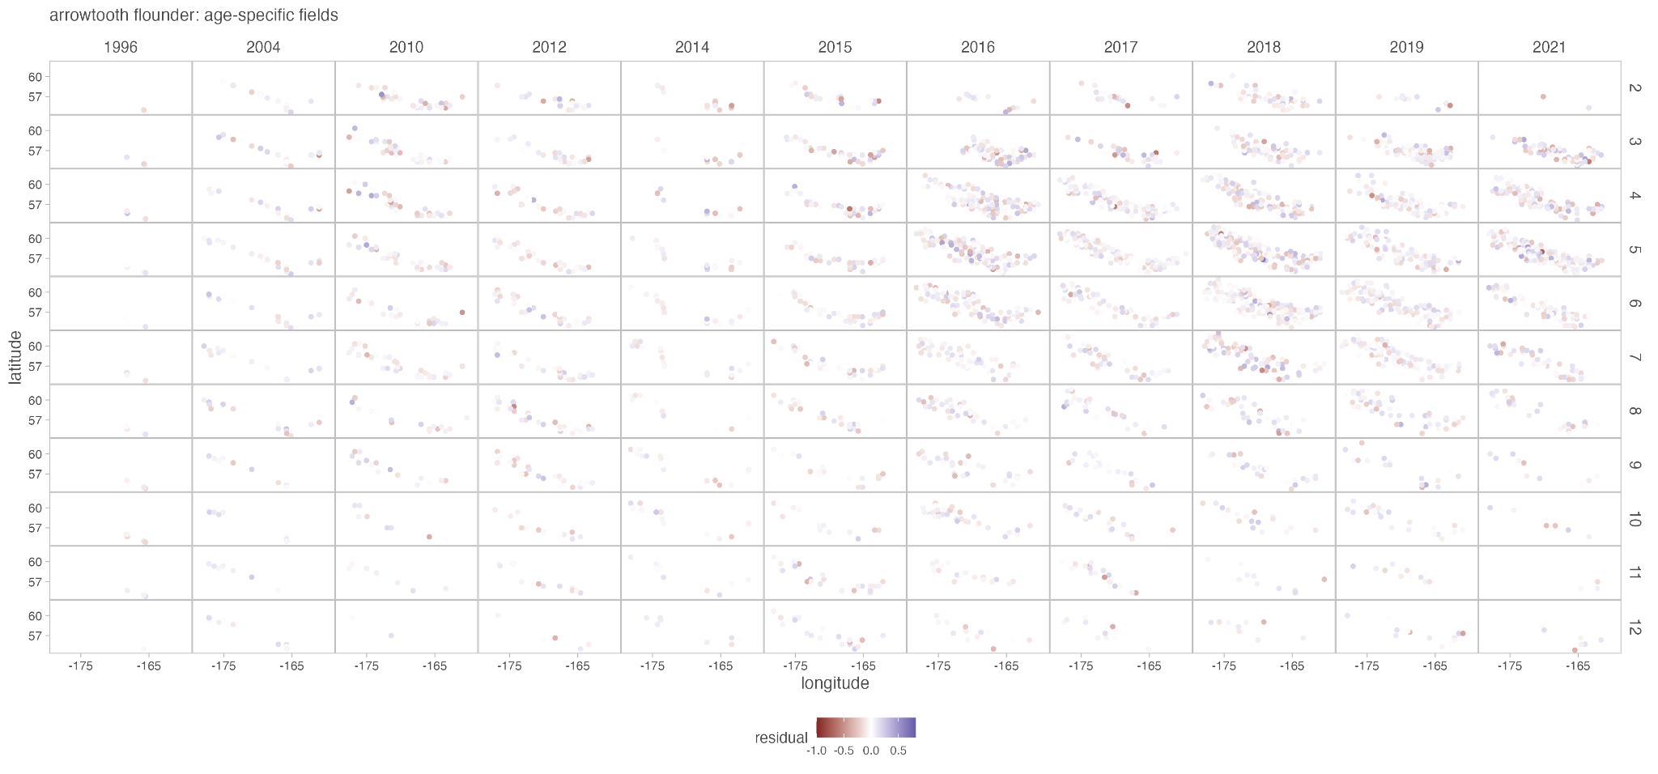
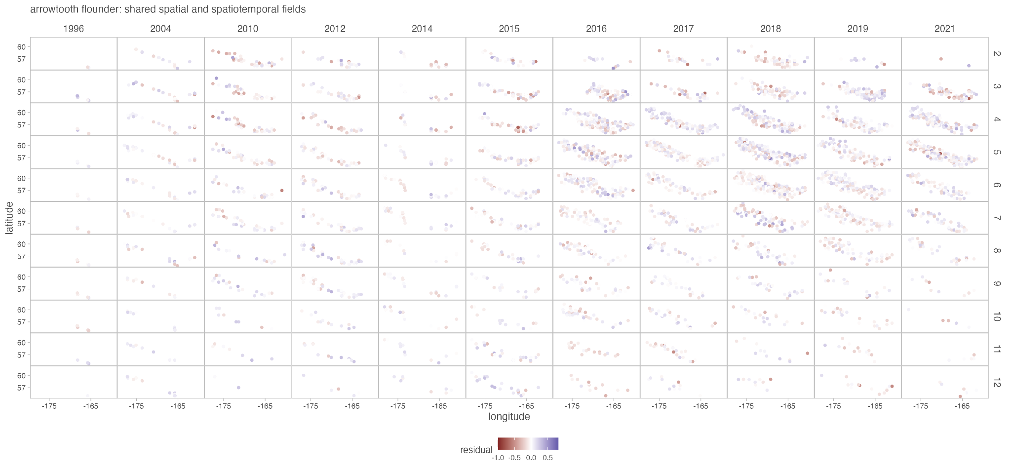
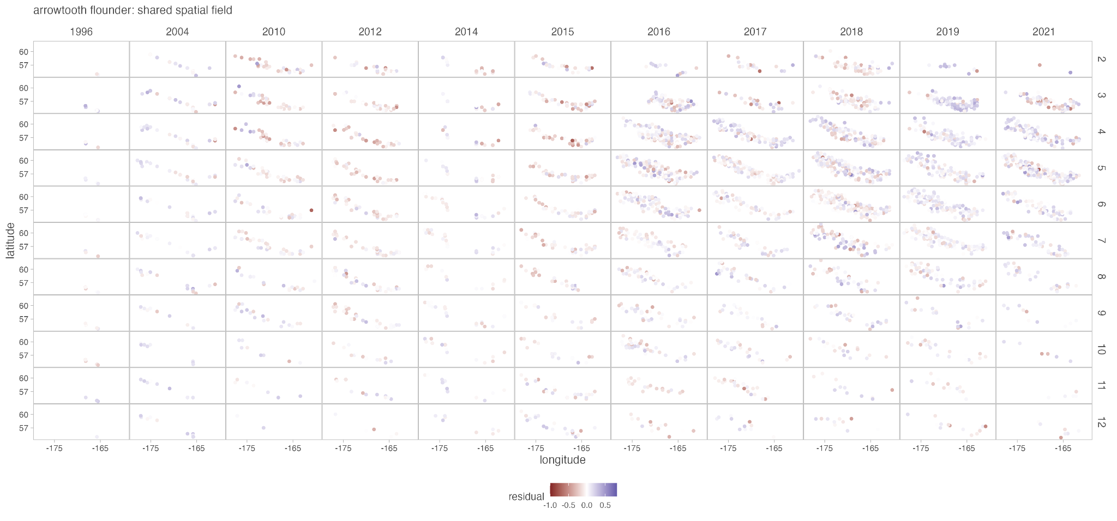
Figure S9. Comparison of residuals over space and time for arrowtooth flounder among models with the same fixed effect structure but the three different random effect structures (see text): age-specific fields (first figure), shared spatial and spatiotemporal fields (second figure), and shared spatial fields (third figure). Residuals shown here are from the most supported model with the most supported random effect structure, i.e., the most supported model in Table S6, which has a third order polynomial relationship between weight and temperature with no interaction between age and temperature. Age class is indicated by row (i.e., 2 = Age 2).

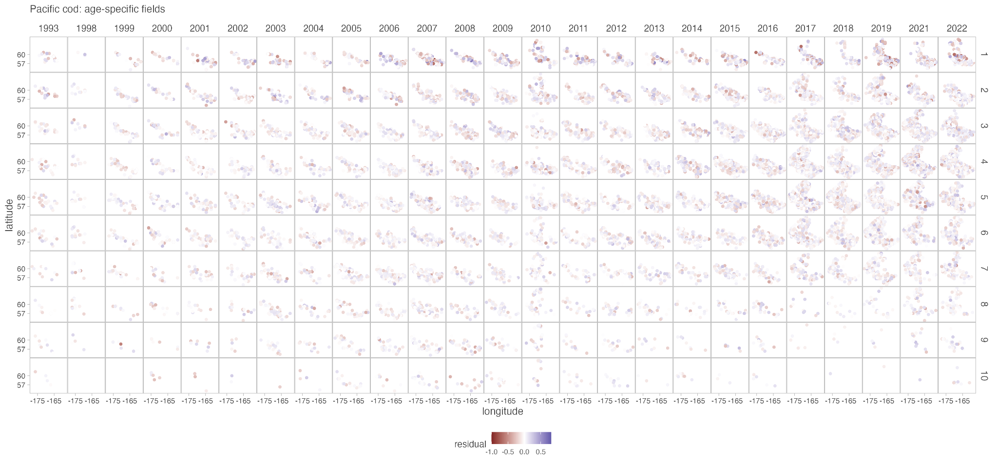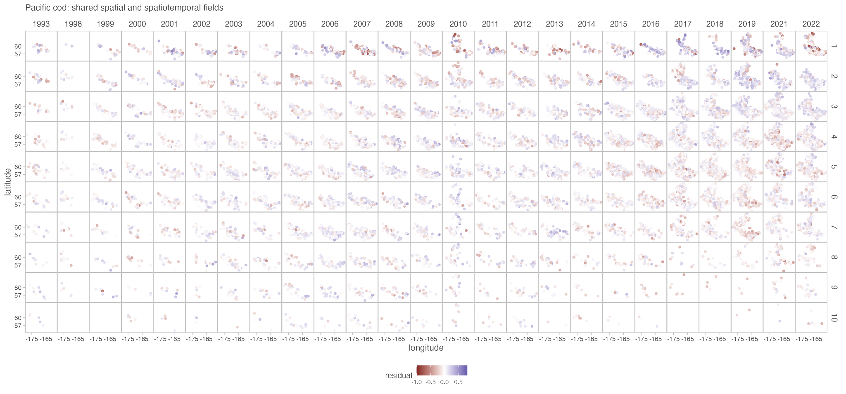

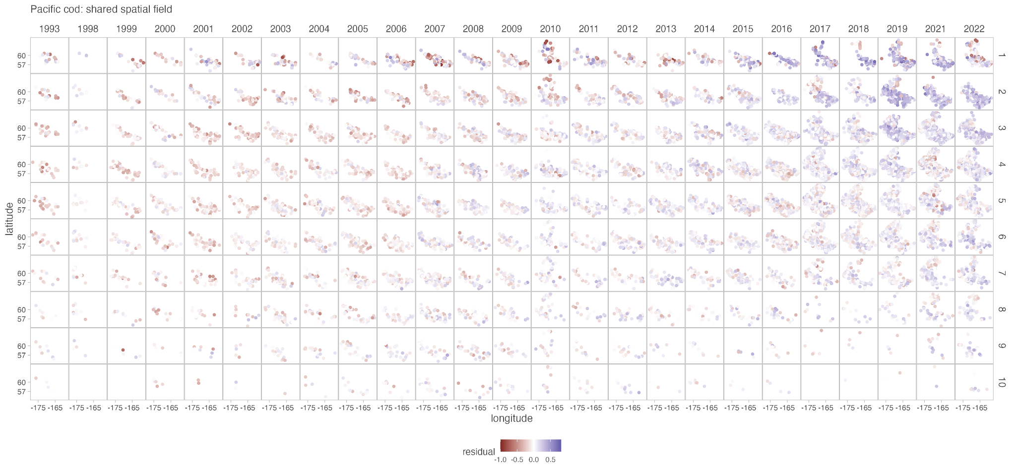

Figure S10. Comparison of residuals over space and time for Pacific cod among models with the same fixed effect structure but the three different random effect structures (see text): age-specific fields (first figure), shared spatial and spatiotemporal fields (second figure), and shared spatial fields (third figure). Residuals shown here are from the most supported model with the most supported random effect structure, i.e., the most supported model in Table S7, which has a second order polynomial relationship between weight and temperature with no interaction between age and temperature. Age class is indicated by row (i.e., 2 = Age 2).

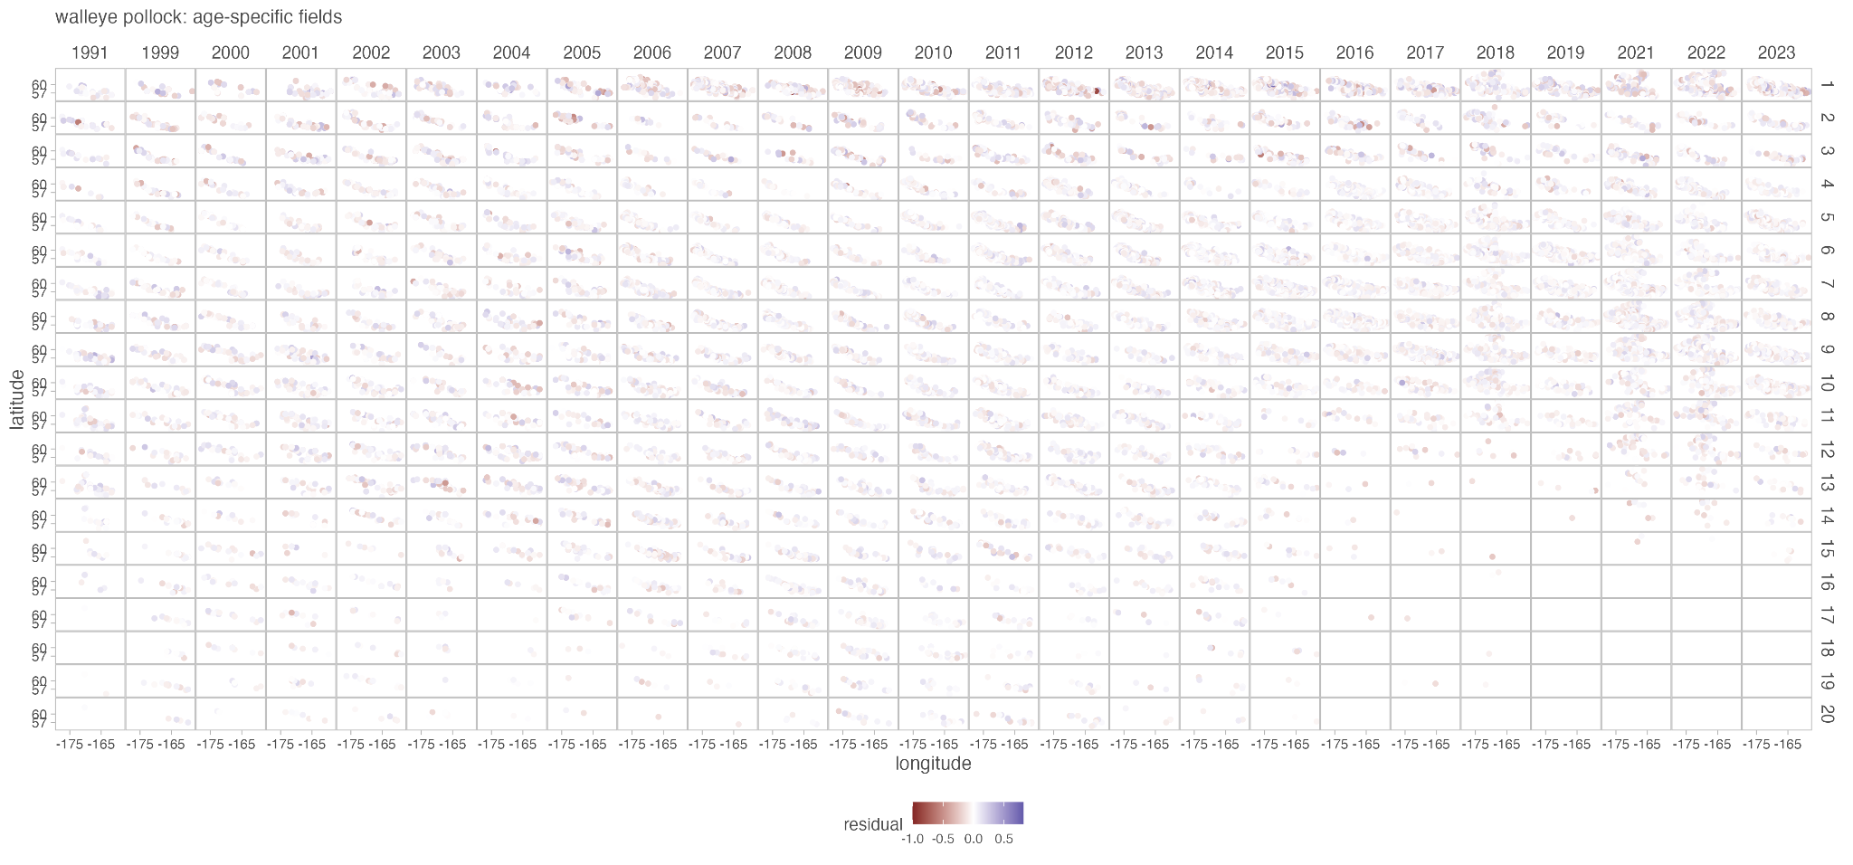

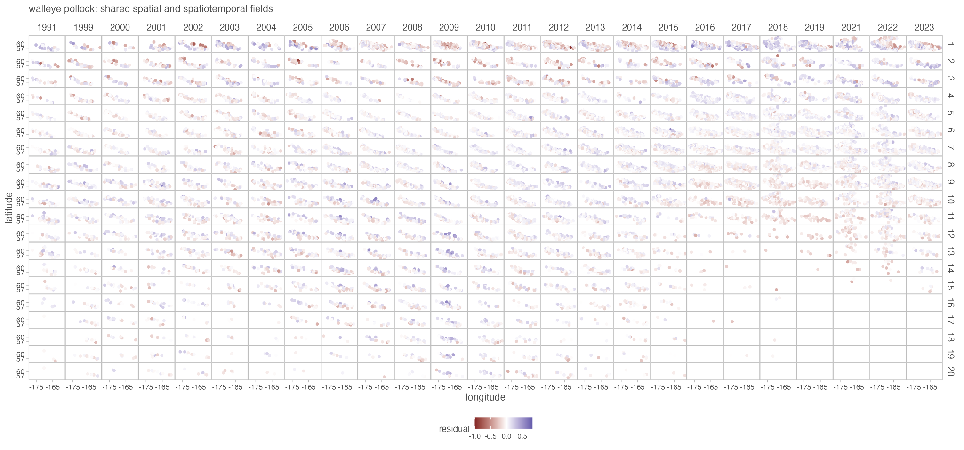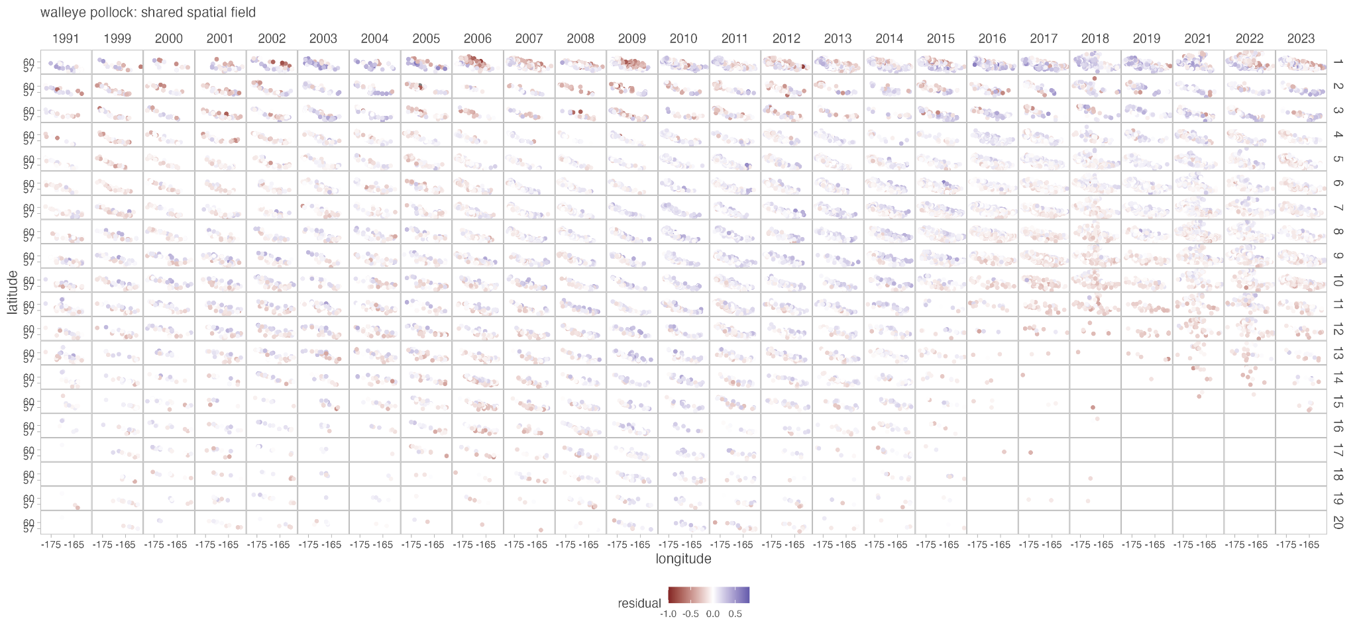
Figure S11. Comparison of residuals over space and time for walleye pollock among models with the same fixed effect structure but the three different random effect structures (see text): age-specific fields (first figure), shared spatial and spatiotemporal fields (second figure), and shared spatial fields (third figure). Residuals shown here are from the most supported model with the most supported random effect structure, i.e., the most supported model in Table S8, which has a second order polynomial relationship between weight and temperature with no interaction between age and temperature. Age class is indicated by row (i.e., 2 = Age 2).

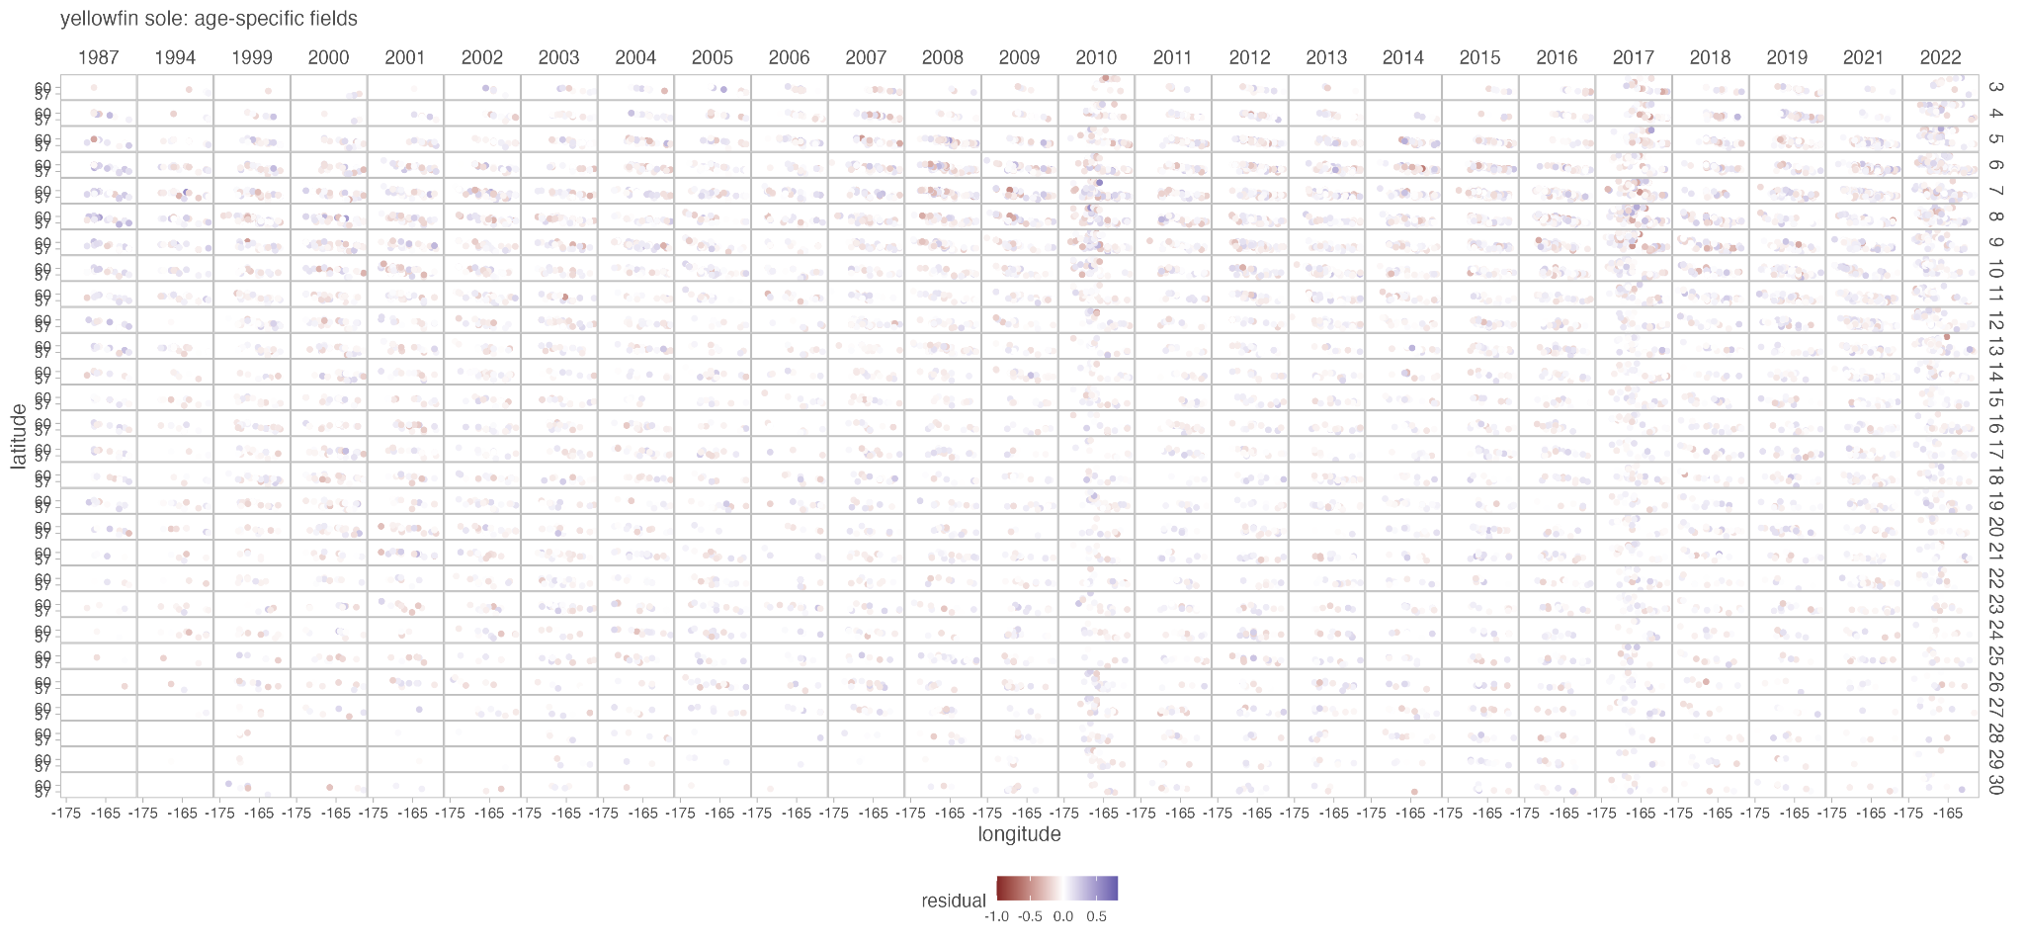
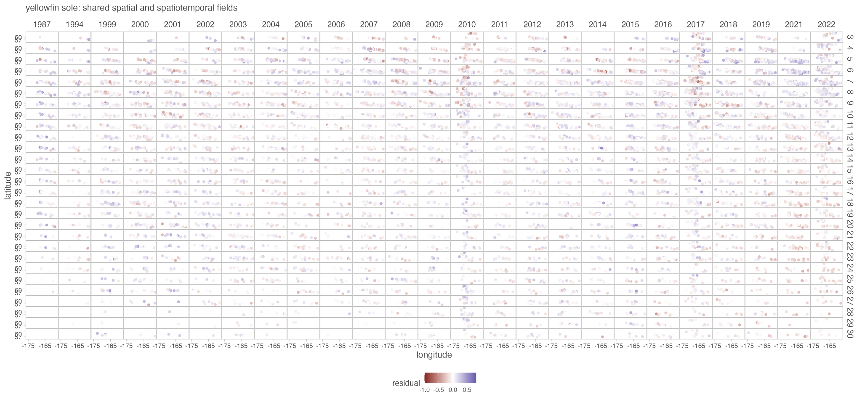
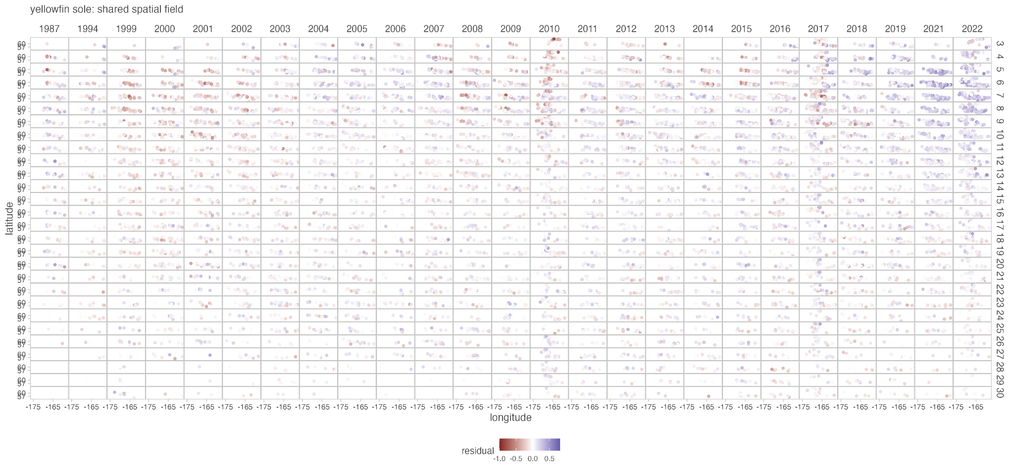

Figure S12. Comparison of residuals over space and time for yellowfin sole among models with the same fixed effect structure but the three different random effect structures (see text): age-specific fields (first figure), shared spatial and spatiotemporal fields (second figure), and shared spatial fields (third figure). Residuals shown here are from the most supported model with the most supported random effect structure, i.e., the most supported model in Table S9, which has a second order polynomial relationship between weight and temperature with no interaction between age and temperature. Age class is indicated by row (i.e., 2 = Age 2).

Supplementary References

Lindgren, F., Rue, H., & Lindström, J. (2011). An Explicit Link between Gaussian Fields and Gaussian Markov Random Fields: The Stochastic Partial Differential Equation Approach. Journal of the Royal Statistical Society Series B: Statistical Methodology, 73(4), 423498. https://doi.org/10.1111/j.1467-9868.2011.00777.x

