Finding of No Significant Impact
for the Pierce County Planning and Public Works Flood Risk Reduction Structures Maintenance and Operations Habitat Conservation Plan and Incidental Take Permits

[43990.859]

The National Environmental Policy Act (NEPA) (42 U.S.C. § 4321 et seq.) requires the preparation of an Environmental Impact Statement (EIS) for any proposal for a major Federal action significantly affecting the quality of the human environment. 42 U.S.C. § 4332(C). Agencies may issue a Finding of No Significant Impact (FONSI) if they determine that a proposed agency action will not have a significant effect on the human environment and therefore does not require the issuance of an EIS. Id. § 4336e(7). Based on the Final Environmental Assessment for Pierce County Planning and Public Works Flood Risk Reduction Structures Maintenance and Operations Habitat Conservation Plan (HCP) and Incidental Take Permits (Pierce County HCP and ITPs), the National Oceanic and Atmospheric Administration (NOAA) National Marine Fisheries Service (NMFS) has determined in this FONSI that preparation of an EIS is not required for the Pierce County HCP because the proposed action will not have significant effects.

This FONSI incorporates by reference the Final Environmental Assessment for the Pierce County HCP and ITPs, which contains the evidence and analysis supporting this FONSI. As further detailed in the EA, the purpose of, and need for, the proposed Federal action is to fulfill the NMFS’ Section 10(a)(1)(B) conservation authorities, render decisions on the ITP application, and provide conservation for the Covered Species.
As part of its incidental take permit (ITP) application, Pierce County Planning and Public Works prepared a habitat conservation plan that included conservation program that would mitigate the impacts to Covered Species incidental to the County’s expected flood risk reduction actions over the 30-year term of the ITPs. This conservation program includes best management practices (BMPs) and construction of three habitat restoration projects. These restoration projects could result in adverse impacts during the construction phase; however, the HCP includes measures that adequately mitigate the short-term potential impacts. Over the long term, implementation of the Preferred Alternative would result in a substantial environmental benefit, including 193 acres of restored floodplain habitat and increased flood capacity. Restoration would directly address habitat-limiting factors that depress salmonid populations in the HCP-covered areas. In the long term, levee setbacks would reconnect the floodplain and restore fluvial processes important for channel complexity and availability, including formation of spawning riffles, pools with wood, and off-channel habitat. Retention of sand, gravel, and cobble would improve and create spawning areas for steelhead and salmon. Restoring riparian forests would support high levels of biological production and diversity and provide a source of large wood to the rivers in the long term. As described in section 5.3 of the HCP, the Pierce County Planning and Public Works will monitor HCP implementation to verify they are appropriately implementing the HCP and to evaluate whether the effects of implementing the HCP’s conservation program is consistent with the assumptions made in the HCP. An annual monitoring report will be provided to the Services for review. The ITP requires the Permittee to comply with and implement reasonable and prudent measures in Section 2.9.3 and the associated terms and conditions in Section 2.9.4 of the biological opinion for this HCP and the conditions in the Section 10(a)(1)(B) permit. For these reasons, the proposed action will not have a significant impact on the human environment.
DETERMINATION

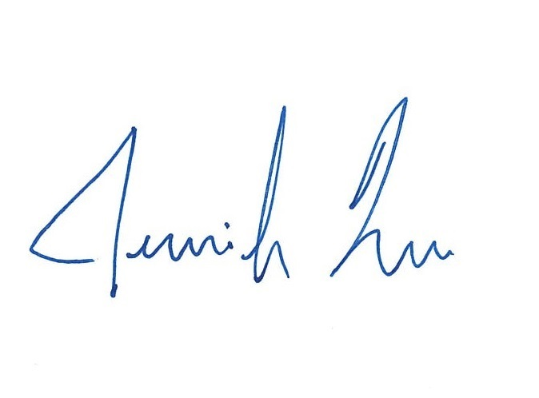
Based on the Final Environmental Assessment for the Pierce County Planning and Public Works Flood Risk Reduction Structures Maintenance and Operations Habitat Conservation Plan (HCP) and Incidental Take Permit, the NOAA NMFS has determined in this FONSI that preparation of an EIS for the Pierce County HCP and ITP is not required because the proposed action will not have significant effects. All adverse impacts of the proposed action as well as mitigation measures have been evaluated to reach this conclusion of no significant impacts.

_______________________________________ ________________
Jennifer Quan Date
Regional Administrator
West Coast Region

