Supplemental Information
Increasing Extreme Hourly Precipitation Risk for New York City after Hurricane Ida
Carolien Mossel*_{1,2}, Spencer A. Hill_{2,1} Nihar R. Samal₃, James F. Booth_{2,1} Naresh Devineni_{4,1}
1. Earth and Environmental Sciences, The City University of New York – Graduate Center
2. Department of Earth and Atmospheric Science, The City University of New York – City College
3. New York City Department of Environmental Protection
4. Department of Civil Engineering, The City University of New York – City College
* Corresponding author: Carolien Mossel, cmossel@gradcenter.cuny.edu

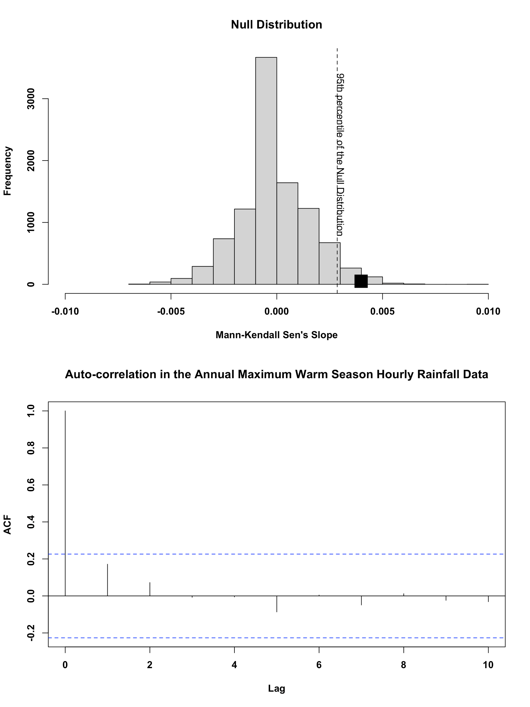
Figure S1. Null distribution of the Mann-Kendall Sen’s Slope resulting from bootstrap resampling of the warm season maximum hourly rainfall intensity (top panel). The observed trend is shown using a black square symbol over the null distribution. The autocorrelation (ACF) in the time series is shown in the bottom panel.

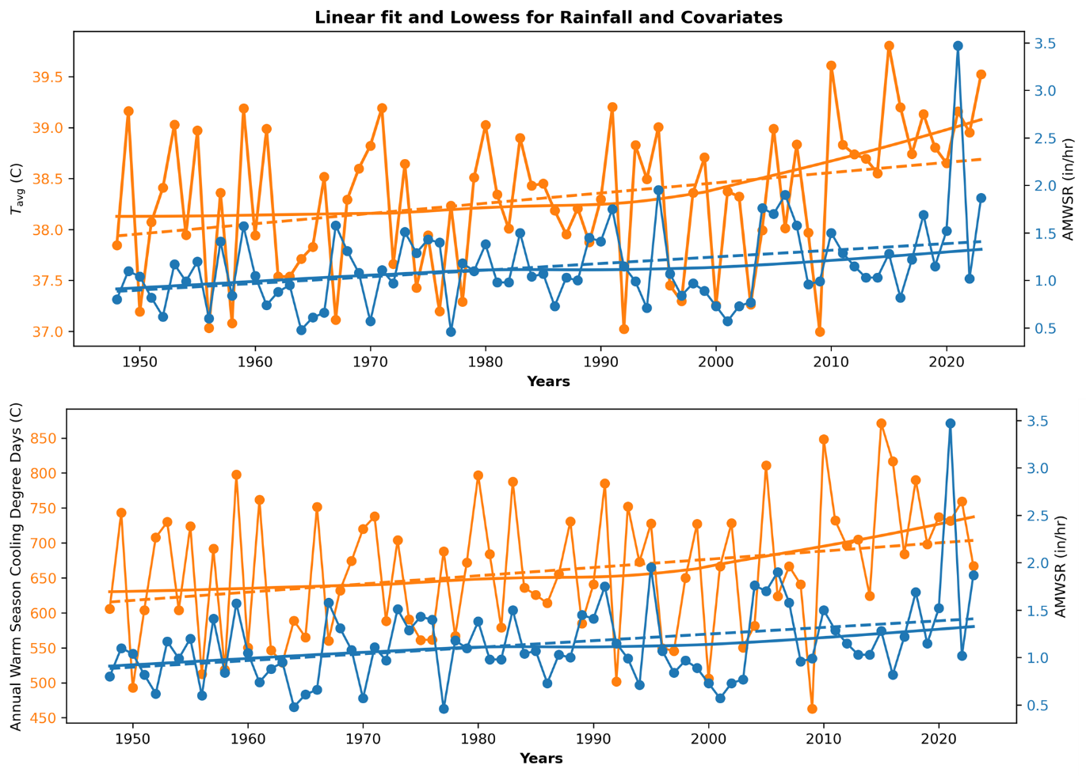
Figure S2. A comparison of $T_{avg}$(top panel) and CDD (bottom panel) for their similarity in time-varying trends as compared to R, Annual Maximum Warm Season Hourly Rainfall (AMWSR). Left y-axis shows $T_{avg}$(top) or CDD (bottom). For the top and bottom panels: right y-axis shows AMWSR; the solid line shows the locally weighted scatterplot smoothing (i.e., LOWESS fitted curve); the dashed line shows the linear fit.

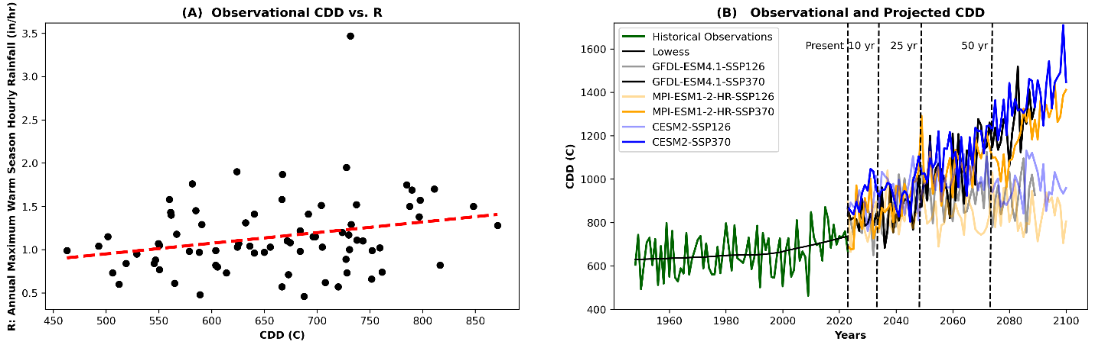
Figure S3. The relationship between CDD and R (a), showing a mildly positive relationship. The historical and future CDD for the warm season are shown in (b). The historical observations (1948-2023) are in green, and the resolution-adjusted simulations are shown on the right side of the dotted line.

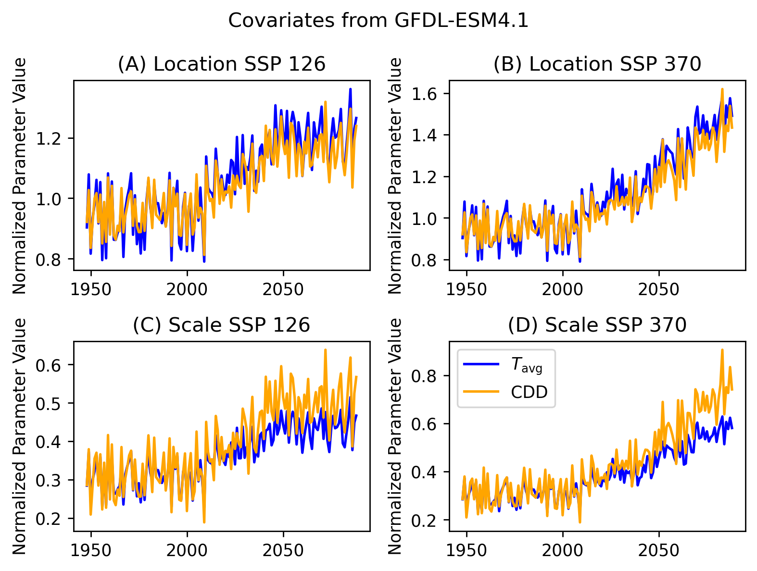

Figure S4. Comparison of the location parameters (A,B, top row) and scale parameters (C, D, bottom row) fit to $T_{avg}$ and CDD for one climate model- GFDL-ESM4.1. The left column shows future scenario SSP 126, and the right column shows scenario SSP 370. In all subplots, blue shows the parameters for $T_{avg}$ and gold shows the parameters for CDD. The similarity in location and the divergence in scale between $T_{avg}$ and CDD and translates to the overall risk, since CDD will have a larger tail, and thus more extremes over 3.47 inches/hour. The results for the other climate models are very similar. Note that during the historical period, prior to 2024, parameters are more similar.

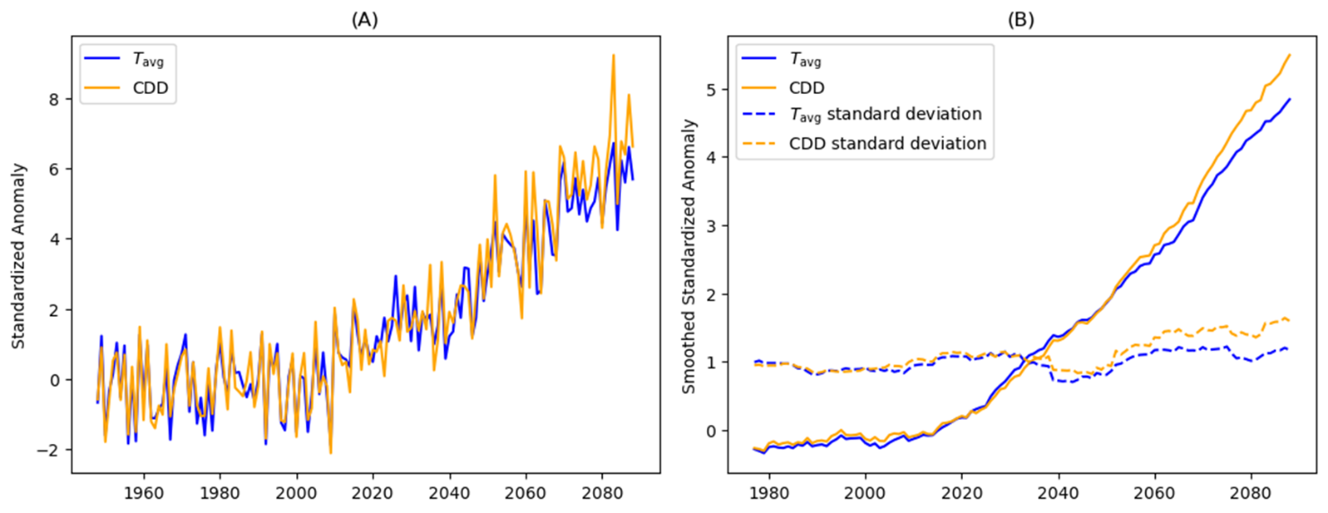
Figure S5. Standardized Anomalies for unitless comparison of $T_{avg}$ and CDD datasets. Panel A shows the annual data from the GFDL-ESM4.1 SSP 370 projection that is used to run the non-stationary models M2 and M3. The smoothed values in (B) have a rolling window of 30. Although the correlation between historical observations was very similar between $T_{avg}$ and CDD, the standardized anomaly highlights the slight differences between the datasets, especially in the far future, and how they diverge in projections. The rolling mean value and standard deviations also diverge in the future projections, which is connected to the changing location and scale parameters seen above in S3.

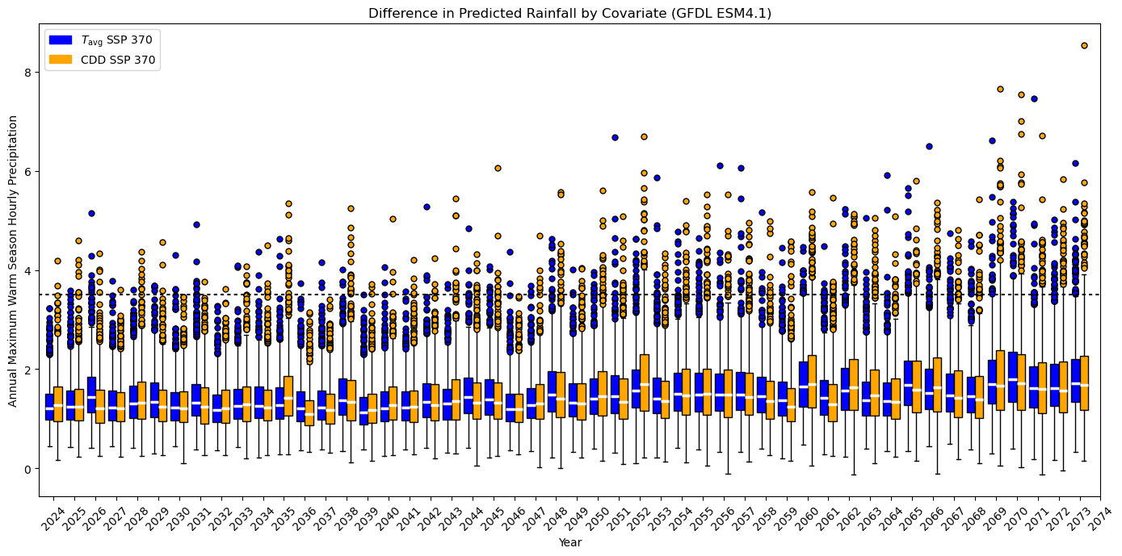
Figure S6. Boxplot showing the distribution of 1000 simulations per year of expected warm season annual maximum hourly precipitation conditioned on the two climate covariates. The scenario from which the model parameters are calculated from is SSP 370 from the GFDL ES4.1 climate model and shows how CDD as a covariate predicts a heavier tail than average temperature, especially in values over 3.47 inches per hour (the Ida baseline) decades in the future.

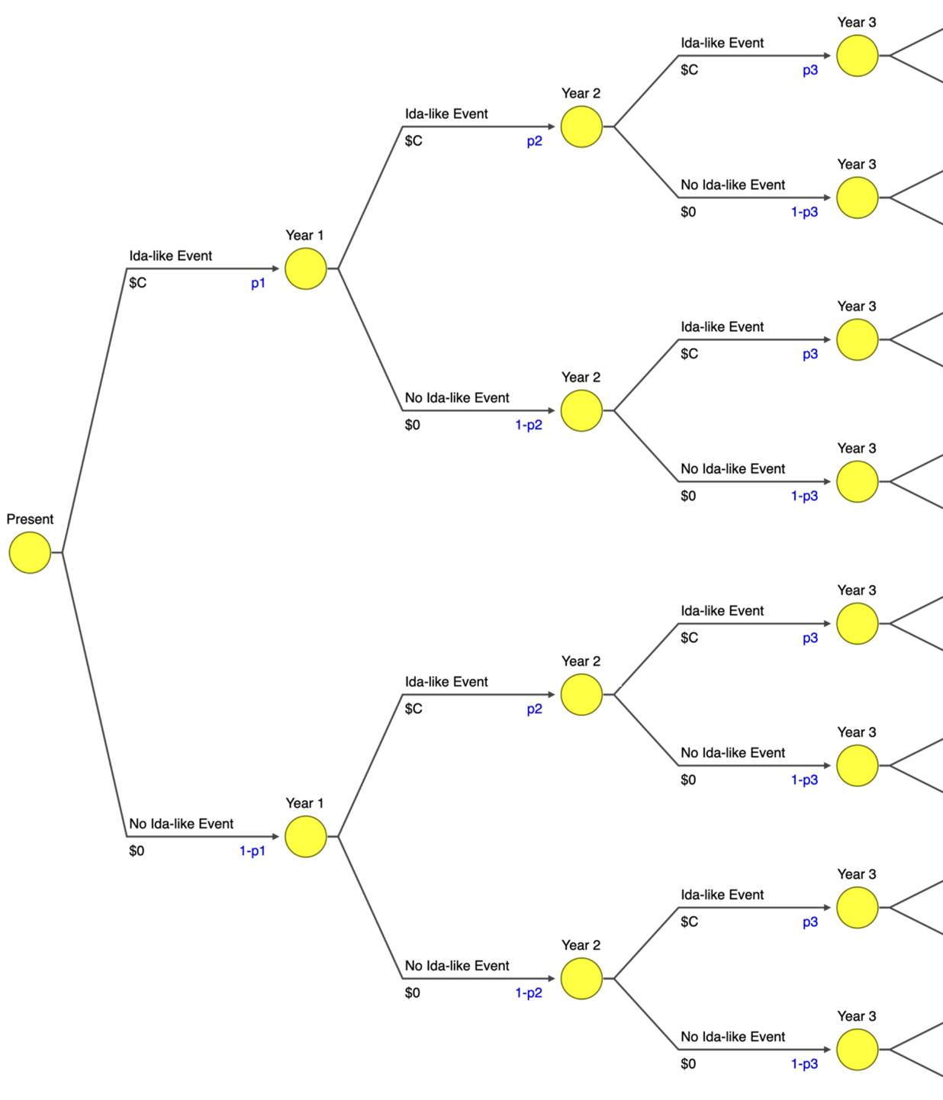
Figure S7. Outcome tree illustrating the compounded risk of an Ida-like event over three years with different probabilities of the event.

Table T1. Model Coefficients for the non-stationary Gumbel distribution location and scale parameters conditioned on the two climate covariates. To enable comparison in the time varying location and scale equations (Eqs. 9 and 10), the standardized anomalies from the historical period shown in S4 were used to calculate these parameters using the GFDL ESM4.1 SSP 370 scenario as an example. The intercepts ($a_{u_{2}};a_{u_{3}} and a_{β_{2}};a_{β_{3}}$) are similar but the slopes ($b_{u_{2}};b_{u_{3}} and b_{β_{2}};b_{β_{3}}$) are different, which partially explains the time deviations in the location and scale parameters and is consistent with the behavior seen in S3.

Parameters From Standardized Anomaly Timeseries of Covariates
 | $$a_{u_{2}}(based on T_{avg})$$ | $$a_{u_{3}}(based on CDD)$$ | $$b_{u_{2}}(based on T_{avg})$$ | $$b_{u_{3}}(based on CDD)$$
Location Parameter ($u_{2}\left(t\right)$ and $u_{3}\left(t\right)$) | 0.965 | 0.963 | 0.093 | 0.071
 | $$a_{β_{2}}(based on T_{avg})$$ | $$a_{β_{3}}(based on CDD)$$ | $$b_{β_{2}}(based on T_{avg})$$ | $$b_{β_{3}}(based on CDD)$$
Scale Parameter ($β_{2}\left(t\right)$ and $β_{3}\left(t\right)$) | 0.316 | 0.322 | 0.046 | 0.063

Table T2. Probability of Reoccurrence of Ida. The future probabilities of Ida-like event derived from the three statistical models for the 10-year planning phase (2023-2034). These probabilities are used in the decision tree analysis to calculate the number of Ida-like events.
Yearly Probabilities from All Models and Scenarios for CDD
GCM |  |  | GFDL-ESM4.1 |  | CESM2 |  | MPI-ESM1-2-HR
Year | Stationary Model | Nonstationary Model 1: Time | Nonstationary Model 3: Low Emission | Nonstationary Model 3: High Emission | Nonstationary Model 3: Low Emission | Nonstationary Model 3: High Emission | Nonstationary Model 3: Low Emission | Nonstationary Model 3: High Emission
2024 | 0.045% | 0.265% | 0.343% | 0.371% | 0.775% | 0.551% | 0.046% | 0.057%
2025 | 0.045% | 0.276% | 0.162% | 0.402% | 0.655% | 0.470% | 0.429% | 0.059%
2026 | 0.045% | 0.288% | 0.337% | 0.372% | 0.668% | 0.799% | 0.287% | 1.416%
2027 | 0.045% | 0.300% | 0.208% | 0.202% | 1.205% | 0.530% | 0.437% | 0.438%
2028 | 0.045% | 0.313% | 0.178% | 0.885% | 0.844% | 1.101% | 0.465% | 0.228%
2029 | 0.045% | 0.326% | 0.826% | 0.268% | 0.772% | 1.428% | 0.194% | 0.922%
2030 | 0.045% | 0.339% | 0.617% | 0.301% | 0.200% | 1.195% | 0.099% | 0.527%
2031 | 0.045% | 0.353% | 0.399% | 0.484% | 0.380% | 2.259% | 0.217% | 1.734%
2032 | 0.045% | 0.367% | 0.035% | 0.277% | 0.779% | 2.123% | 0.535% | 0.127%
2033 | 0.045% | 0.382% | 0.417% | 0.481% | 1.875% | 1.261% | 0.810% | 0.253%
2034 | 0.045% | 0.397% | 1.171% | 0.289% | 0.622% | 0.985% | 0.190% | 0.233%

