Supplementary Material

Title: Multi-scale observations during the 2024 mass coral bleaching event on Heron Reef, Australia; Journal: Marine Biology
Authors: Devin A. Rowell, Nicholas M. Hammerman, Kirsten M. Golding, Tania Marie Kenyon, Zoe Meziere, Courtney Morgans, Kristen Taylor Brown, Faye F. Diederiks, David E. Carrasco Rivera, Karen Eigeland, Roima Paewai-Huggins, Kathryn Markey, Maria Beger, Fiona Chong, Gabriella Donno, Alice Dutton, Wanchien Victoria Hsiao, Stuart Kininmonth, Caitlin A. Lawson, Heather Middleton, Gal Eyal, and Chris Roelfsema.

Affiliation and e-mail address of the corresponding author: Devin A. Rowell, devin.rowell@uq.edu.au, Marine Spatial Ecology Lab, School of the Environment, The University of Queensland, Brisbane, Australia; Centre of Marine Science, The University of Queensland, Brisbane, Australia.

Supplemental Table 1 The location of temperature and light loggers deployed across Heron Reef between August 2023 - June 2024. Note that ElectricBlue EnvLoggers and HOBO® loggers record temperature only, while Odyssey loggers record temperature as well as PAR.
Reef zone | Site name | Latitude and Longitude | Depth (m) | Equipment deployed | Dates deployed | Sampling interval (minutes)
Leeward north | Libby’s Lair | 23.43453 S, 151.93353 E | 10–15 | HOBO® TidbiT MX (MX2203) | 1/8/2023 to 14/5/2024 | 15 min
Windward east | Eco 1 | 23.47193 S, 151.97746 E | 4–8 | H1, O2 | 10/12/2023 to 8/6/2024 | H1 10 min;  O1 15 min
Windward east | Eco 1 | 23.472 S, 151.979317 E | 10–14 | H1 | 10/12/2023 to 8/6/2024 | 10 min
Windward east | Eco 2 | 23.47086 S ,151.95296 E | 4–7 | O1 | 13/10/2023 to 8/6/2024 | 15 min
Windward east | Eco 2 | 23.47083 S, 151.9526 E | 9–13 | H1 | 13/10/2023 to 8/6/2024 | 10 min
Windward west | Coral Gardens | 23.44666 S, 151.91176 E | 4–8 | H1, O1 | 14/10/2023 to 11/6/2024 | H1 10 min;  O1 15 min
Windward west | Coral Gardens | 23.44664 S, 151.91139 E | 9–13 | H1 (x2) | 14/10/2023 to 11/6/2024 | 10 min
Windward west | Halfway Site 1 | 23.45042 S, 151.91724 E | 4–8 | O1 (x2) | 16/10/2023 to 14/6/2024 | 15 min
Windward west | Halfway Site 1 | 23.45023 S, 151.91698 E | 9–13 | H1, O1 | 16/10/2023 to 14/6/2024 | H1 10 min;  O1 15 min
Reef Flat | Coral Gardens reef flat | 23.4452 S, 151.91268 E | 1–2 | H1, O1 | 15/10/2023 to 14/6/2024 | H1 10 min;  O1 15 min
Reef Flat | Halfway reef flat | 23.44841 S, 151.91821 E | 1–2 | H1 | 14/10/2023 to 14/6/2024 | 10 min
Reef Flat | Reef crest | 23.4589 S, 151.9296 E | 0.8 | HOBO® 64K Pendant (UA-001-64) | 1/8/2023 to 7/5/2024 | 60 min
Reef Flat | Research Beach - nearshore (#2) | 23.44447 S, 151.91341 E | 1–2 | ElectricBlue EnvLogger (version T7.3) | 13/12 2023 to 31/7/2024 | 60 min
Reef Flat | Research Beach - offshore (#3) | 23.44552 S, 151.91311 E | 1–2 | ElectricBlue EnvLogger (version T7.3) | 13/12 2023 to 31/7/2024 | 60 min
Reef Flat | North Beach - nearshore (#4) | 23.43958 S, 151.91722 E | 1–2 | ElectricBlue EnvLogger (version T7.3) | 13/12 2023 to 31/7/2024 | 60 min
Reef Flat | North Beach - offshore (#5) | 23.43811 S, 151.91744 E | 1–2 | ElectricBlue EnvLogger (version T7.3) | 13/12 2023 to 29/6/2024 | 60 min
Reef Flat | Shark Bay (#6) | 23.44305 S, 151.92055 E | 1–2 | ElectricBlue EnvLogger (version T7.3) | 13/12 2023 to 31/7/2024 | 60 min
H1 = HOBO® Pendant Mx Temperature/light Data Logger - IC-MX2202 (Bluetooth model)
O1 = Odyssey® Submersible Photosynthetic Active Radiation (PAR) Logger

Supplemental Table 2 The location of ecological data collection sites across Heron Reef between September 2022 - September 2024. Note that coordinates for photo quadrat transects are at the start of each transect.
Ecological Scale | Analysis | Geomorphic Zone | Site Name | Latitude | Longitude | Depth (m) | Time Period
Community | Photo quadrat transects | Leeward North Slope | Junction | -23.43534 | 151.90776 | 5 | 23/03/2024 - 27/03/2024
Community | Photo quadrat transects | Leeward North Slope | Plate Ledge | -23.43448 | 151.91478 | 5 | 23/03/2024 - 27/03/2025
Community | Photo quadrat transects | Leeward North Slope | Coral Grotto | -23.43392 | 151.92148 | 5 | 23/03/2024 - 27/03/2026
Community | Photo quadrat transects | Leeward North Slope | Cascades | -23.43335 | 151.93030 | 5 | 23/03/2024 - 27/03/2027
Community | Photo quadrat transects | Leeward North Slope | Libby's Lair | -23.43531 | 151.94222 | 5 | 23/03/2024 - 27/03/2028
Community | Photo quadrat transects | Leeward North Slope | NWTR7 | -23.42922 | 151.95096 | 5 | 23/03/2024 - 27/03/2029
Community | Photo quadrat transects | Leeward North Slope | NWTR6 | -23.43338 | 151.96100 | 5 | 23/03/2024 - 27/03/2030
Community | Photo quadrat transects | Leeward North Slope | NETR5 | -23.43189 | 151.98615 | 5 | 23/03/2024 - 27/03/2031
Community | Photo quadrat transects | Windward West Slope | NETR4 | -23.42959 | 151.99692 | 5 | 23/03/2024 - 27/03/2032
Community | Photo quadrat transects | Windward West Slope | SETR3 | -23.45677 | 151.99469 | 5 | 23/03/2024 - 27/03/2033
Community | Photo quadrat transects | Windward West Slope | SETR2 | -23.46758 | 151.98650 | 5 | 23/03/2024 - 27/03/2034
Community | Photo quadrat transects | Windward West Slope | SETR1 | -23.47281 | 151.97134 | 5 | 23/03/2024 - 27/03/2035
Community | Photo quadrat transects | Windward West Slope | SETR0 | -23.47034 | 151.94987 | 5 | 23/03/2024 - 27/03/2036
Community | Photo quadrat transects | Windward East Slope | Harry's Bommie | -23.46044 | 151.92997 | 5 | 23/03/2024 - 27/03/2037
Community | Photo quadrat transects | Windward East Slope | Coral Canyons | -23.45369 | 151.92227 | 5 | 23/03/2024 - 27/03/2038
Community | Photo quadrat transects | Windward East Slope | Halfway | -23.44928 | 151.91516 | 5 | 23/03/2024 - 27/03/2039
Community | Photo quadrat transects | Windward East Slope | Coral Gardens | -23.44621 | 151.91085 | 5 | 23/03/2024 - 27/03/2040
Community | Photo quadrat transects | Windward East Slope | Heron Bommie | -23.44208 | 151.90537 | 5 | 23/03/2024 - 27/03/2041
Community | Photo quadrat transects | Reef Flat | RF Blue Pools | -23.44271 | 151.91950 | 1-2 | 23/03/2024 - 27/03/2042
Community | Photo quadrat transects | Reef Flat | RF Research Beach | -23.44253 | 151.91100 | 1-2 | 23/03/2024 - 27/03/2043
Community | Photo quadrat transects | Reef Flat | RF West | -23.44141 | 151.91125 | 1-2 | 23/03/2024 - 27/03/2044
Colony | Coral demography plots | Leeward North Slope | Libby's Lair | -23.43458 | 151.93364 | 6-8 | 13/09/2022; 14/09/2023; 10/09/2024
Colony | Coral demography plots | Windward West Slope | Coral Gardens | -23.44729 | 151.91197 | 6-8 | 14/09/2022; 13/09/2023; 08/09/2024
Colony | Different substrate types | Windward West Slope | Halfway Interlocked | -23.44985 | 151.91723 | 8-10 | 18/02/2024 - 5/3/2024
Colony | Different substrate types | Windward West Slope | Halfway Loose | -23.45025 | 151.91725 | 8-10 | 18/02/2024 - 5/3/2024
Colony | Different substrate types | Windward West Slope | Halfway Hard Carbonate | -23.45043 | 151.91783 | 8-10 | 18/02/2024 - 5/3/2024
Colony | Juvenile coral quadrats | Windward West Slope | Site 1: Halfway | -23.4511 | 151.91818 | 8-10 | 14/02/2024 - 15/2/2024
Colony | Juvenile coral quadrats | Windward West Slope | Site 2: Halfway | -23.45239 | 151.9201 | 8-10 | 14/02/2024 - 15/2/2024
Colony | Coral fragments collection | Leeward North Slope | Libby’s Lair | 151.93645 | -23.43528 | 5-12 | 7/02/2024
Colony | Coral fragments collection | Leeward North Slope | BA1 | 151.95106 | -23.42804 | 5-12 | 5/02/2024
Colony | Coral fragments collection | Leeward North Slope | BA2 | 151.92026 | -23.43407 | 5-12 | 5/02/2024
Colony | Coral fragments collection | Windward East Slope | H5B | 151.99738 | -23.43217 | 5-12 | 3/02/2024
Colony | Coral fragments collection | Windward East Slope | H5A | 151.99555 | -23.4526 | 5-12 | 3/02/2024
Colony | Coral fragments collection | Windward East Slope | FR1 | 151.97793 | -23.47209 | 5-12 | 4/02/2024
Colony | Coral fragments collection | Windward East Slope | FR2 | 151.95106 | -23.47082 | 5-12 | 4/02/2024
Colony | Coral fragments collection | Windward West Slope | FL1 | 151.92568 | -23.45617 | 5-12 | 6/02/2024
Colony | Coral fragments collection | Windward West Slope | Coral Gardens | 151.9106 | -23.44570 | 5-12 | 6/02/2024
Colony | Coral fragments collection | Windward West Slope | Heron Bommie | 151.90358 | -23.44094 | 5-12 | 7/02/2024

Supplemental Table 3 ReefCloud label set used to classify benthic cover within photo quadrats, including the hard coral bleaching status and morphotype used for the analyses in this paper. Within ReefCloud, 50 random points were overlaid onto each photo quadrat and assigned a benthic classification by the machine (F1 > 0.8), typically down to morphotype or family level (Roelfsema et al. 2021; Supplementary Table 2). Training points were only annotated as bleached if the coral was distinctly white or fluorescent, to avoid model confusion between bleaching and healthy pale morphs.
Broad Category | ReefCloud Label | Hard Coral Bleaching Status | Hard Coral Morphotype
Hard coral | Acropora Branching | Not Bleached | Branching
 | Acropora Branching Bleached | Bleached | Branching
 | Acropora Digitate | Not Bleached | Branching
 | Acropora Digitate Bleached | Bleached | Branching
 | Acropora Hispidose | Not Bleached | Branching
 | Acropora Hispidose Bleached | Bleached | Branching
 | Acropora Other (Isopora) | Not Bleached | Branching
 | Acropora Other Bleached | Bleached | Branching
 | Pocillopora | Not Bleached | Branching
 | Pocillopora Bleached | Bleached | Branching
 | Porites Branching | Not Bleached | Branching
 | Porites Branching Bleached | Bleached | Branching
 | Branching Other | Not Bleached | Branching
 | Branching Other Bleached | Bleached | Branching
 | Favid Mussid | Not Bleached | Massive
 | Favid Mussid Bleached | Bleached | Massive
 | Porites Massive | Not Bleached | Massive
 | Porites Massive Bleached | Bleached | Massive
 | Massive Other | Not Bleached | Massive
 | Massive Other Bleached | Bleached | Massive
 | Acropora Tabulate and Corymbose | Not Bleached | Plate/Encrusting
 | Acropora Tabulate and Corymbose Bleached | Bleached | Plate/Encrusting
 | Acroporidae Plate Encrusting (Montipora) | Not Bleached | Plate/Encrusting
 | Acroporidae Plate Encrusting Bleached | Bleached | Plate/Encrusting
 | Foliose or Plate with ridges | Not Bleached | Plate/Encrusting
 | Foliose or Plate with ridges Bleached | Bleached | Plate/Encrusting
 | Foliose or Plate with round corallites | Not Bleached | Plate/Encrusting
 | Foliose or Plate with round corallites Bleached | Bleached | Plate/Encrusting
 | Porites Encrusting | Not Bleached | Plate/Encrusting
 | Porites Encrusting Bleached | Bleached | Plate/Encrusting
 | Solitary coral | Not Bleached | -
 | Solitary coral Bleached | Bleached | -
Soft Coral | Alcyoniidae Soft Coral | - | -
 | Alcyoniidae Soft Coral Bleached | - | -
 | Gorgonian | - | -
 | Gorgonian Bleached | - | -
 | Soft Coral Other | - | -
 | Soft Coral Bleached | - | -
Other | Sessile Invertebrate Other | - | -
Invertebrates | Crown of Thorns Sea Star | - | -
 | Mobile Invertebrate | - | -
Algae | BMA Sand | - | -
 | Caulerpa | - | -
 | Chlorodesmis | - | -
 | Crustose Coralline Algae on DHC | - | -
 | Crustose Coralline Algae on Rubble | - | -
 | Dictyota species | - | -
 | Epithelial Algal Matrix on DHC | - | -
 | Epithelial Algal Matrix on Rubble | - | -
 | Halimeda | - | -
 | Lobophora Species | - | -
 | Padina | - | -
 | Sargassum | - | -
 | Turbinaria algae | - | -
 | Algae Other | - | -
Cyanobacteria | Cyano species | - | -
Seagrass | Seagrass | - | -
Abiotic Cover | Sand | - | -
Other | Transect gear | - | -
 | Unclear | - | -
 | Unknown | - | -
 | Water | - | -
 | All Other | - | -

Supplemental Table 4 Genera that were recorded and grouped into Merulinidae and Pocilloporidae for coral demography plot analyses.
Merulinidae | Pocilloporidae
Astrea | Pocillopora
Cyphastrea | Seriatopora
Dipsastraea | Stylophora
Echinopora
Favites
Goniastrea
Hydnophora
Leptoria
Merulina
Mycedium
Oulophyllia
Platygyra

The CoralWatch program has historically relied upon changes to average colour scores as an indicator of potential bleaching events (Figure S6 and Table S5). However, data collected during the 2024 mass bleaching event at Heron Island revealed that this metric is insufficient when used on its own to signal bleaching events to citizen scientists. A chi-squared test found statistically significant differences in the frequency distribution of colour scores before and during the bleaching event across all zones (p-value < 0.001; Table S6; Presented in Manuscript Section 3.2.2). We then tested the difference between the average colour scores across each of the four zones before and after the bleaching with a Welch’s t-test. The differences between average colour scores were only significant in the Leeward North and Reef Flat zones (p-value < 0.001 and p-value = 0.004, respectively; Table S5).
Coral species exhibit varying levels of susceptibility and resilience to thermal stress, leading to significant differences in colour as they enter and recover from a bleaching event. As a result, averaging colour scores across a coral colony, and across surveys can produce a deceptively high overall score, which obscures the fine-scale differences in coral colour during the progression of bleaching. Due to variation in coral colour when entering and recovering from bleaching events, average colour scores recorded during the bleaching event remained high (Table S5). This limitation meant that bleaching events could only be identified after a substantial number of corals had already become fully bleached. As a result of these findings, the approach to recording and reporting bleaching events in the CoralWatch global coral health database has been improved and now incorporates changes to the frequency distribution of recorded colour scores to assist in the early detection and communication of bleaching events.

Supplemental Table 5 Average CoralWatch colour scores calculated across the four reef zones before and during the 2024 mass bleaching event. Due to variation in coral colour when entering and recovering from bleaching events, average colour scores recorded during the bleaching event remained high. *Indicates statistical significance at p = <0.005.
 | Before |  |  |  | During |  |  |  | Welch's t-test
Zone | Ave. colour score | Min | Max | SE | Ave. colour score | Min | Max | SE | t | df | p
Leeward north | 3.05 | 1 | 6 | 0.05 | 2.68 | 1 | 6 | 0.04 | 5.65 | 668.25 | 2.35E-08*
Windward west | 2.97 | 1.5 | 5.5 | 0.05 | 3.03 | 1 | 6 | 0.07 | -0.73 | 504.26 | 0.468
Windward east | 2.62 | 2 | 5 | 0.11 | 2.44 | 1 | 4.5 | 0.1 | 1.23 | 110.87 | 0.221
Reef flat | 3.34 | 1 | 5.5 | 0.03 | 3.18 | 1 | 6 | 0.05 | 2.89 | 860.77 | 0.004*

Supplemental Table 6 Chi-squared test results comparing the frequency distribution of colour scores before and during the bleaching event for each of the four Heron Reef zones.
Zone | X-Squared | P
Leeward north | 140.72 | < 2.2e-16
Windward west | 196.5 | < 2.2e-16
Windward east | 63.151 | 2.71E-12
Reef flat | 145.11 | < 2.2e-16

Supplemental Table 7 Summary statistics of log coral size ratio (log₂(new size/old size)) across two sites before (2022-23) and after (2023-24) the bleaching event (time period). n is the number of corals recorded.
Site | Time period | n | mean | sd | min | Q1 | median | Q3 | max
Coral Gardens | 2022-23 | 104 | -0.259 | 1.677 | -6.567 | -0.764 | 0.135 | 0.574 | 4.100
Coral Gardens | 2023-24 | 39 | -0.653 | 1.4 | -4.826 | -1.249 | -0.237 | 0.101 | 1.964
Libby’s Lair | 2022-23 | 233 | 0.084 | 1.164 | -5.997 | -0.412 | 0.068 | 0.588 | 3.495
Libby’s Lair | 2023-24 | 99 | -0.548 | 1.0 | -4.739 | -0.943 | -0.399 | 0.184 | 0.976

Supplemental Table 8 Summary statistics of log coral size ratio (log₂(new size/old size)) across the four most abundant taxa groups before (2022-23) and after (2023-24) the bleaching event (time period). n is the number of corals recorded.
Taxa | Time period | n | mean | sd | min | Q1 | median | Q3 | max
Acropora | 2022-23 | 137 | 0.170 | 1.415 | -6.567 | -0.437 | 0.088 | 0.698 | 3.495
Acropora | 2023-24 | 53 | -0.531 | 1.201 | -4.500 | -1.126 | -0.375 | 0.323 | 1.954
Merulinidae | 2022-23 | 65 | -0.112 | 0.503 | -1.619 | -0.406 | -0.078 | 0.173 | 0.969
Merulinidae | 2023-24 | 42 | -0.626 | 0.989 | -4.739 | -1.094 | -0.500 | -0.050 | 0.778
Montipora | 2022-23 | 52 | -0.249 | 1.147 | -3.321 | -0.776 | 0.106 | 0.570 | 1.317
Montipora | 2023-24 | 17 | -0.972 | 1.468 | -4.826 | -1.343 | -0.417 | 0.024 | 0.462
Pocilloporidae | 2022-23 | 55 | 0.110 | 1.827 | -5.997 | -0.394 | 0.515 | 1.060 | 4.100
Pocilloporidae | 2023-24 | 7 | -0.264 | 0.645 | -1.310 | -0.586 | -0.057 | 0.156 | 0.381

Supplemental Table 9 Post-hoc Dunn’s test statistics for pair-wise comparisons of log₂(new size/old size) across the four most abundant taxa groups before (2022-23) the bleaching event. Log size ratio differences across taxa were not significant at 95% significance level.
Comparison | Z | P unadjusted | P adjusted
Acropora-Merulinidae | 1.90 | 0.057 | 0.342
Acropora-Montipora | 1.04 | 0.297 | 1.00
Merulinidae-Montipora | -0.588 | 0.556 | 1.00
Acropora-Pocilloporidae | -0.998 | 0.319 | 1.00
Merulinidae-Pocilloporidae | -2.36 | 0.018 | 0.109
Montipora-Pocilloporidae | -1.68 | 0.093 | 0.560

Supplemental Table 10 Conditional odds ratios (using the R function ‘odds.ratio()’) of mortality by site (Libby’s Lair and Coral Gardens) and by taxa (Acropora, Merulinidae, Montipora, and Pocilloporidae).
 |  | Conditional odds ratio
Site | Libby’s Lair | 3.50
Site | Coral Gardens | 5.66
Taxa | Acropora | 4.38
Taxa | Merulinidae | 2.54
Taxa | Montipora | 7.31
Taxa | Pocilloporidae | 16.1

Supplemental Table 11 PERMANOVA results from coral morphotype community composition analysis between substrates (loose rubble beds vs. interlocked rubble beds vs. hard carbonate plots).
Source | df | SS | MS | Pseudo-F | P(perm) | Unique perms
Substrate | 2 | 3668.6 | 1834.3 | 3.0269 | 0.067 | 999
Site | 5 | 2969.8 | 593.97 | 1.1304 | 0.326 | 998
Res | 41 | 21544 | 525.45
Total | 48 | 28182

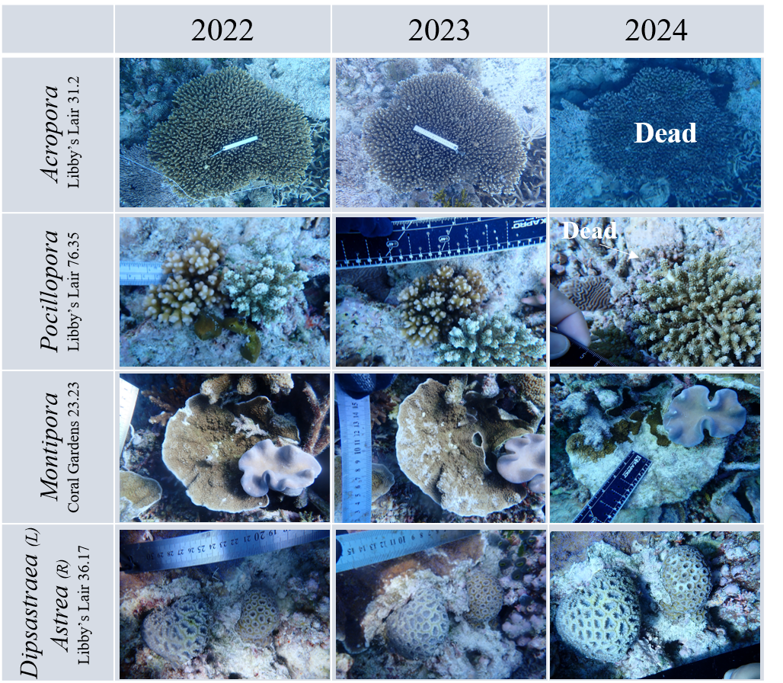
Supplemental Figure 1 Images showing the trajectories of five focal coral colonies from 2022 to 2024. The Acropora, Pocillopora and Dipsastraea, and Astrea colonies were from Libby’s Lair, while the Montipora colony is from Coral Gardens. All photos by Fiona Chong or Victoria Hsiao.

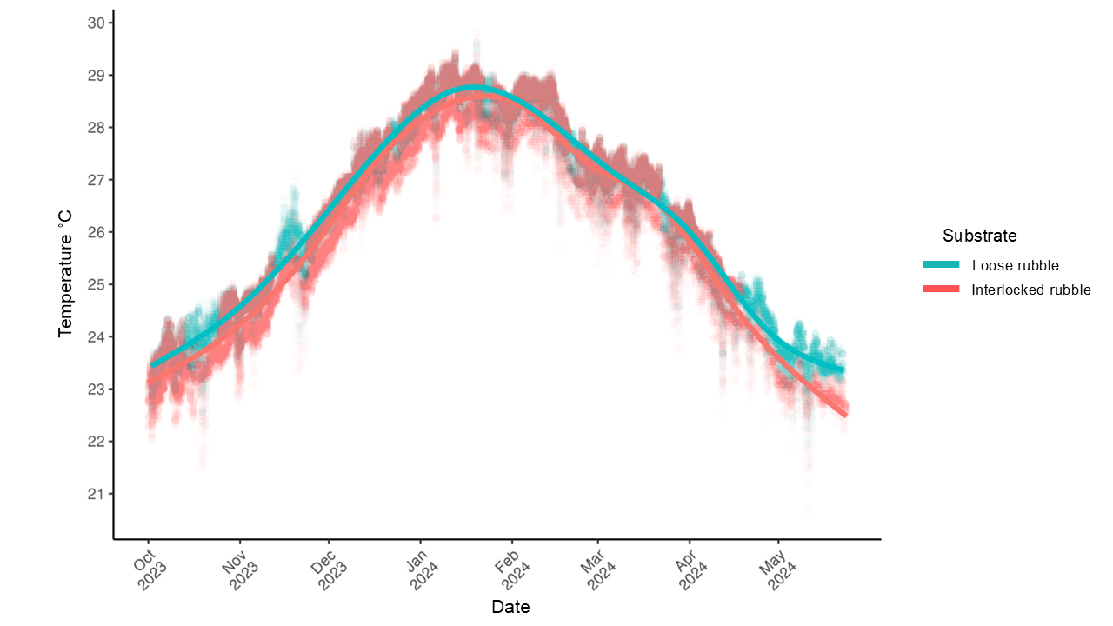
Supplemental Figure 2 Mean daily temperature (˚C) from October 2023 through May 2024 in the loose and interlocked rubble bed plots on the windward west slope.

Supplemental Figure 3 Temperature profile in the common garden experiment, following the concurrent heatwave. Week 0 (W0) to Week 12 (W12) represent the time points at which phenotypic measurements were taken. Vertical grid lines are separated by one week and the red dashed line represents the climatic maximum monthly mean at Heron Reef (27.3°C).

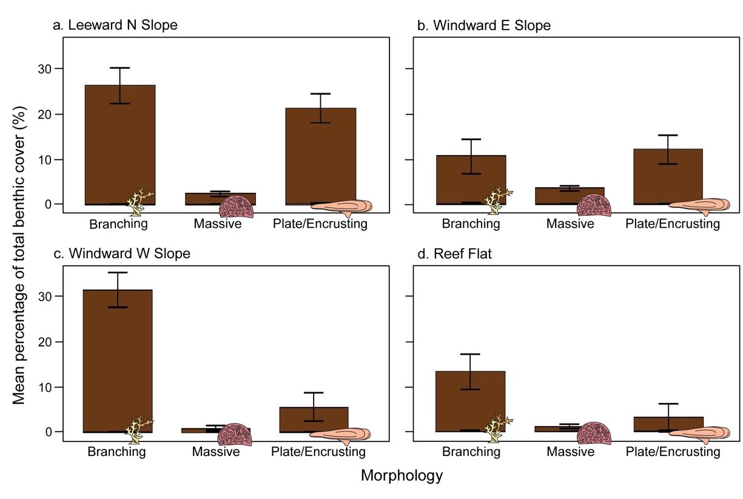
Supplemental Figure 4 Mean percentage of total benthic cover (% ± standard error) of live hard coral prior to the bleaching event, for three hard coral morphotypes (branching, massive, plate/encrusting), within each of four geomorphic zones (panels a - d) on Heron Reef in November 2023. The slope was surveyed at ~5 m depth and the reef flat at 1-2 m depth. Refer to Figure 1b for the location of each zone. Data from Carrasco Rivera et al. (2025).

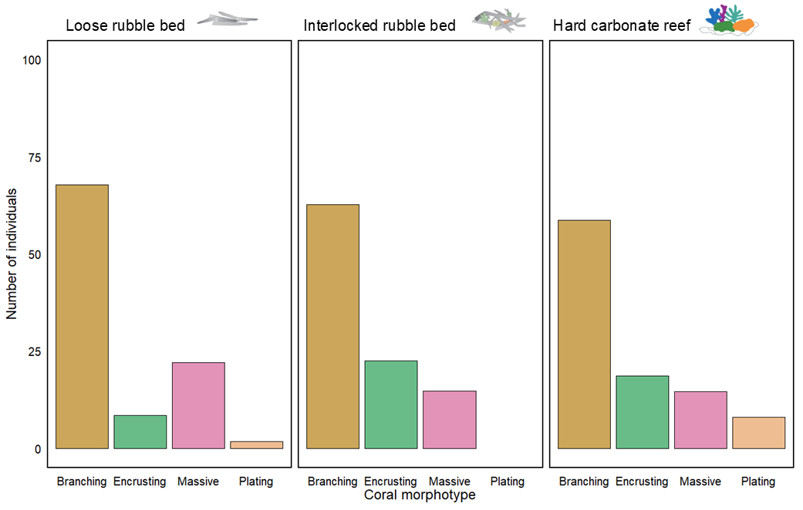
Supplemental Figure 5 Number of individual corals per coral morphotype (branching, encrusting, massive, plating) in the three substrate typologies studied (hard carbonate, loose, or interlocked rubble beds) on the windward west slope during the bleaching event (February 2024).

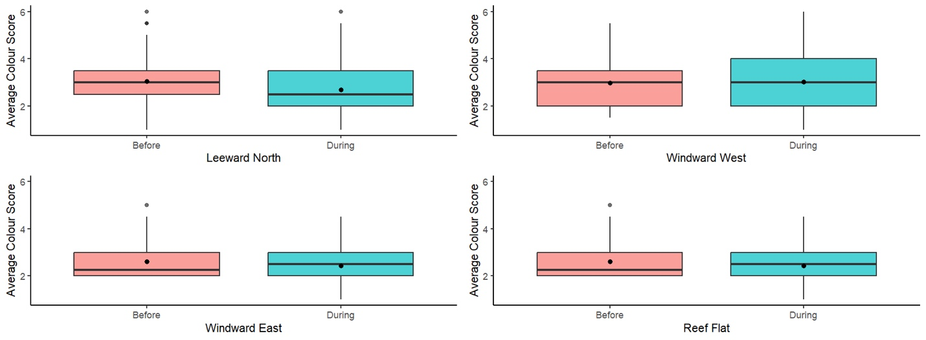
Supplemental Figure 6 Average colour scores (± SE) of coral colonies before and during the bleaching event across four reef zones (leeward north, windward west, windward east, and reef flat).

References
Carrasco Rivera DE, Diederiks FF, Hammerman NM, Staples T, Kovacs E, Markey K, Roelfsema CM (2025) Remote sensing reveals multidecadal trends in coral cover at Heron Reef, Australia. Remote Sens 17: 1286. https://doi.org/10.3390/rs17071286.
Roelfsema C, Kovacs EM, Markey K, Vercelloni J, Rodriguez-Ramirez A, Lopez-Marcano S, Gonzalez-Rivero M, Hoegh-Guldberg O, Phinn SR (2021) Benthic and coral reef community field data for heron reef, southern great barrier reef, australia, 2002–2018. Scientific Data 8: 84.

