Supplementary text
Deep Waters a Significant Source of Black Carbon Aerosols in the Arabian Sea
Ashish Soni^{1,*}, Pawan S. Soyam¹, Shivdas Bankar¹, Thara Prabhakaran¹, Harindra J.S. Fernando², Devmi Gamage², Griffin Modjeski², Selina Bolella², Joaquim Goes³, Charles Kovach⁴, Sudarsan Bera¹, A. Arvindhavel¹, Maria Laura Zoffoli⁵, Amit Tandon⁶, Mahen Konwar¹, P. Murugavel¹, Pramod Safai¹, Stefano Decesari⁷, Maria Cristina Facchini⁷, Craig M. Lee⁸, and Nandakumar Kalarikkal⁹

¹Indian Institute of Tropical Meteorology, Ministry of Earth Sciences, Pune-411008, Maharashtra, India
²University of Notre Dame, Notre Dame, IN 46556, USA
³Columbia University, New York City, NY 10964, USA
⁴NOAA/NESDIS/STAR, College Park, MD 20740, USA
⁵Institute of Marine Sciences, National Research Council of Italy (ISMAR-CNR), 00133, Rome, Italy
⁶University of Massachusetts Dartmouth, New Bedford, MA 02744, USA
⁷Institute of Atmospheric Sciences and Climate, National Research Council of Italy (ISAC-CNR), 40121, Bologna, Italy
⁸University of Washington, Seattle, WA, USA
⁹School of Pure and Applied Physics, Mahatma Gandhi University, Kottayam, 686560, Kerala, India

* Corresponding Author: Dr. Ashish Soni (absoni@live.com)

List of Figures
Figure S1: (a) Fine mode Aerosol Optical Depth (AOD_{f}) measured using a Microtops-II sun photometer; (b) scatter plot between measured Fine mode Aerosol Optical Depth (AOD_{f}) and BC mass concentrations.
Figure S2: Estimated fine mode AOD_{f} using MODIS Aqua Level-2 data (MYD04_L2). The AOD_{f} data are further linearly interpolated for better representation.
Figure S3: Zonal wind (u) estimated from the radiosonde observations. Positive zonal winds indicate westerly winds, while negative zonal winds indicate easterly winds.
Figure S4: WRF-LES simulated CCN vertical fluxes revealed that the upward and downward fluxes were limited to a maximum of up to 2.5 km height.
Figure S5: CALIPSO aerosol sub-type profile observed over high BC zone. The blue horizontal Dumbbell shape indicates the observation study region, where high altitude (3km) polluted dust is observed in purple colour.
Figure S6: The screenshots display marine traffic near TGT. The white dots indicate ship locations per hour, while the red lines represent the TGT locations recorded by the AIS. Each panel also shows the observed BC mass concentration, along with the total number of ships and hours spent in the area (excluding TGT). The purple diamond marks the location of loitering for other science experiments. Marine traffic data and screenshots were adapted with permission from Global Fishing Watch, Inc. CC BY-NC 4.0
Figure S7: (a) The screenshots display cumulative marine traffic within the 7-day back trajectory region (outlined by the white polygon), with red lines indicating the TGT locations captured by the AIS. (b) A line graph showing the total daily hours spent by moving ships (>2knots) within this region, including the total hours for all categories of vessels, as well as the breakdown for major vessel categories. The marine traffic and screenshots were adapted with permission from Global Fishing Watch, Inc. CC BY-NC 4.0
Figure S8: Panel (a) Ekman velocities calculated using wind stress at thermocline depth (estimated average depth was 52m); Panel (b) zonal and meridional component of Ekman mass flux; and Panel (c) magnitude of Ekman mass flux.
Figure S9: Received signal strength by ADCP for each day during the observation campaign. The black arrows show increased turbulence at the surface water over the cyclone-impacted region, where high BC was observed. The diurnal vertical transport of zooplankton is clearly visible at sunrise (down) and sunset (up) in each panel.
Figure S10: Line graph depicting high-resolution Reynolds numbers (Re) estimated for each day during the observation campaign, with daily average values displayed in each panel. The equation for estimating the Reynolds number is provided at the bottom right.
List of Tables
Table S1: High-resolution TEM-EDS outputs. The particle image is marked with a few codes (marked with blue circles), where the elemental composition is measured using an energy-dispersive X-ray spectrometer (EDS).

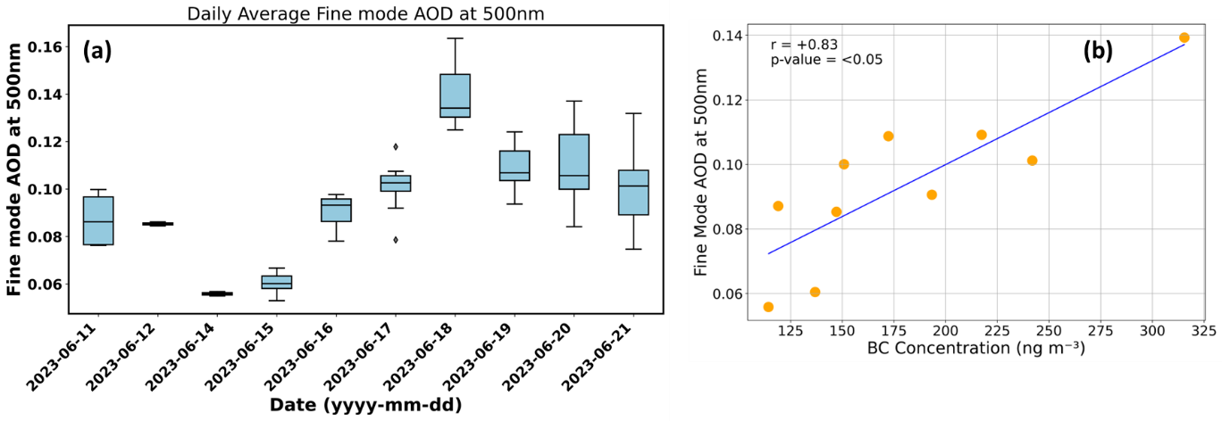
Figure S1: (a) Fine mode Aerosol Optical Depth (AOD_{f}) measured using a Microtops-II sun photometer; (b) scatter plot between measured Fine mode Aerosol Optical Depth (AOD_{f}) and BC mass concentrations.

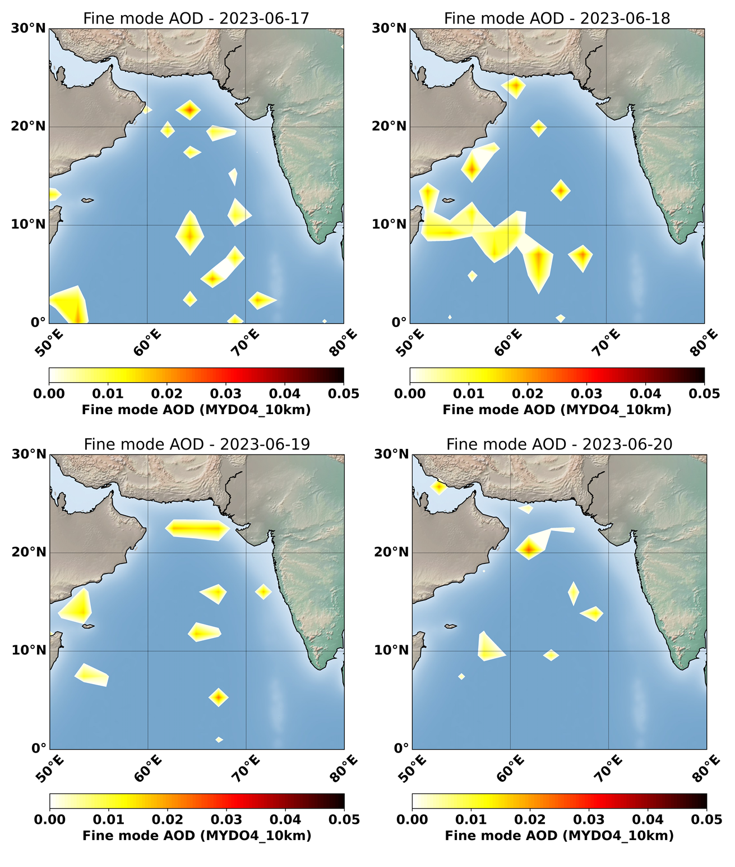
Figure S2: Estimated fine mode AOD_{f} using MODIS Aqua Level-2 data (MYD04_L2). The AOD_{f} data are further linearly interpolated for better representation.
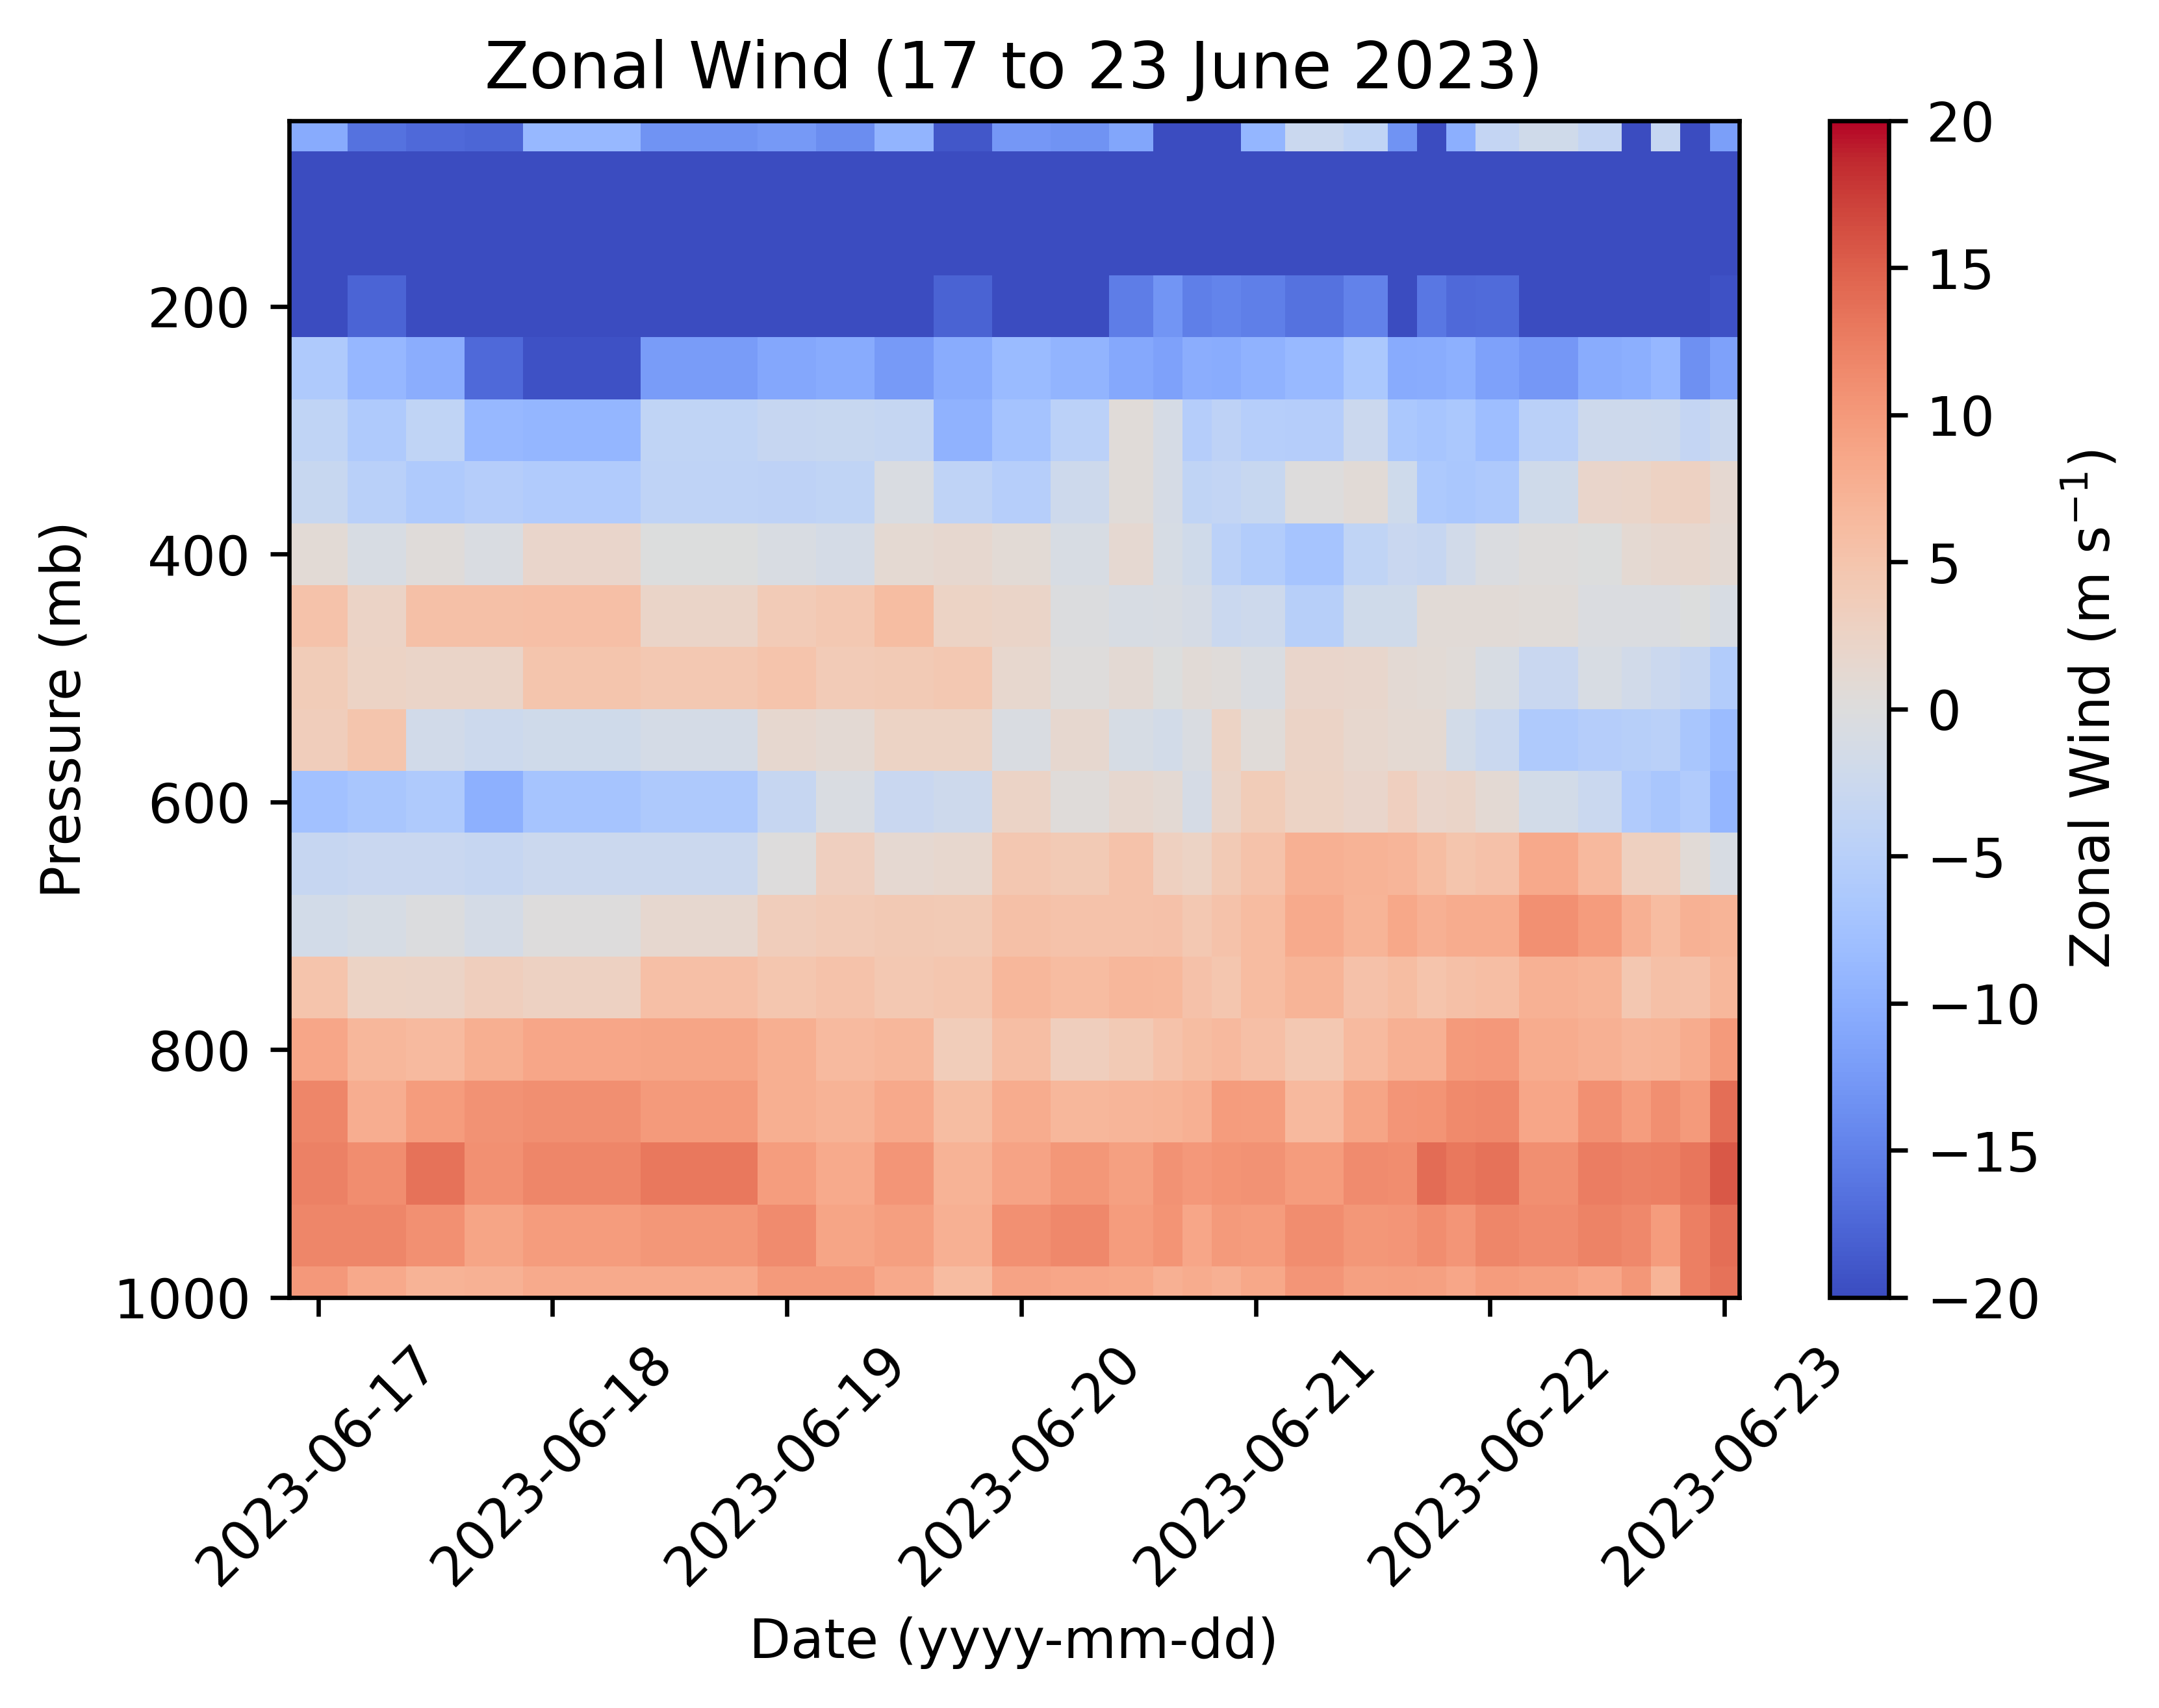
Figure S3: Zonal wind (u) estimated from the radiosonde observations. Positive zonal winds indicate westerly winds, while negative zonal winds indicate easterly winds.
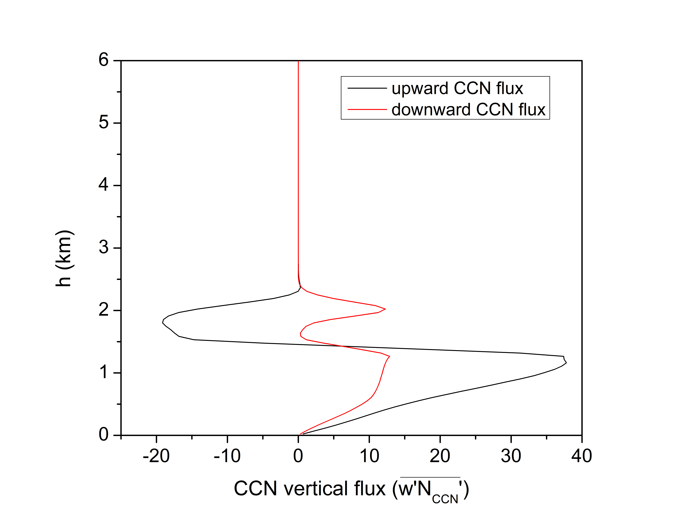
Figure S4: WRF-LES simulated CCN vertical fluxes revealed that the upward and downward fluxes were limited to a maximum of up to 2.5 km height.
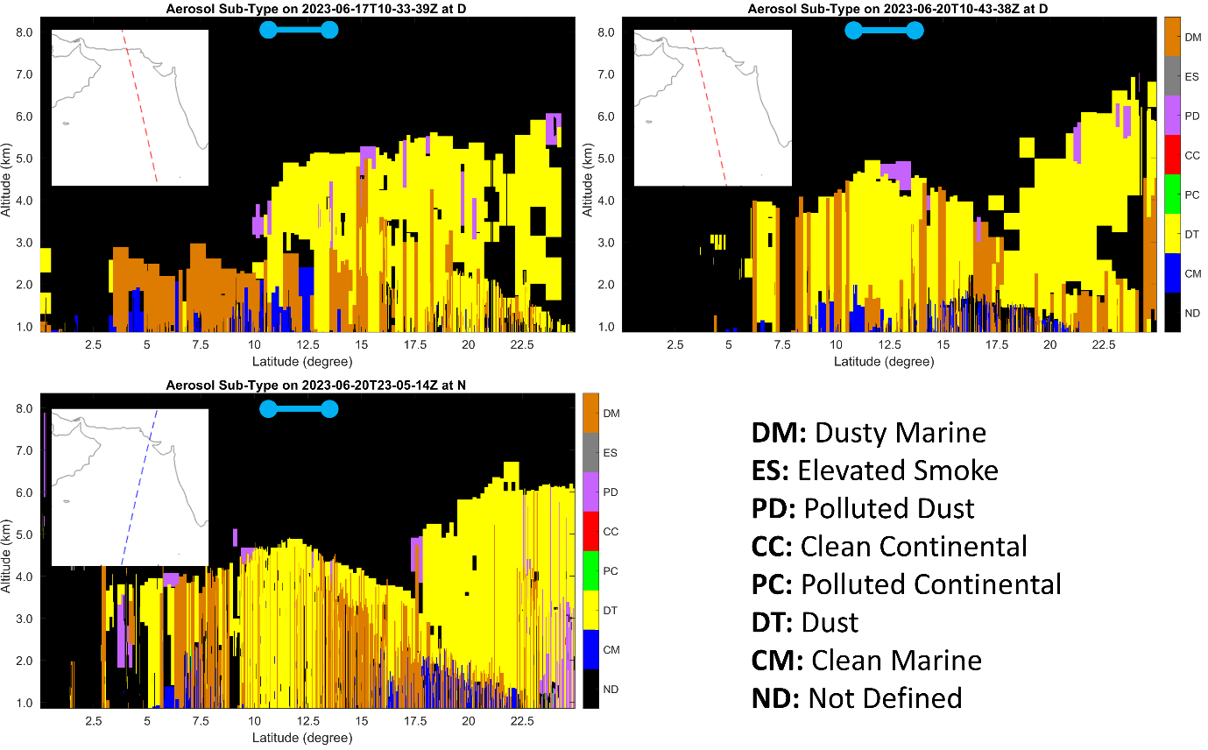
Figure S5: CALIPSO aerosol sub-type profile observed over high BC zone. The blue horizontal Dumbbell shape indicates the observation study region, where high altitude (3km) polluted dust is observed in purple colour.
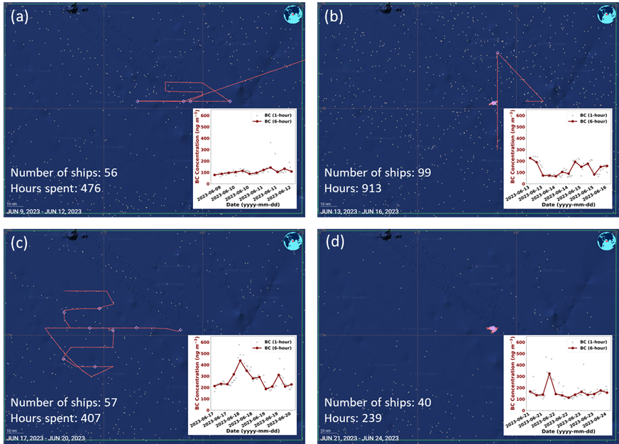
Figure S6: The screenshots display marine traffic near TGT. The white dots indicate ship locations per hour, while the red lines represent the TGT locations recorded by the AIS. Each panel also shows the observed BC mass concentration, along with the total number of ships and hours spent in the area (excluding TGT). The purple diamond marks the location of loitering for other science experiments. Marine traffic data and screenshots were adapted with permission from Global Fishing Watch, Inc. CC BY-NC 4.0
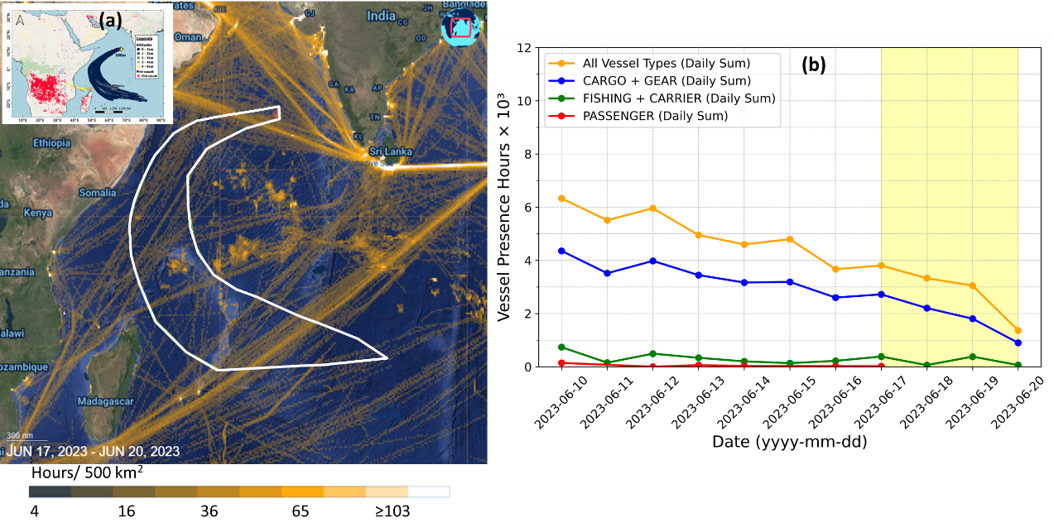
Figure S7: (a) The screenshots display cumulative marine traffic within the 7-day back trajectory region (outlined by the white polygon), with red lines indicating the TGT locations captured by the AIS. (b) A line graph showing the total daily hours spent by moving ships (>2knots) within this region, including the total hours for all categories of vessels, as well as the breakdown for major vessel categories. The marine traffic and screenshots were adapted with permission from Global Fishing Watch, Inc. CC BY-NC 4.0

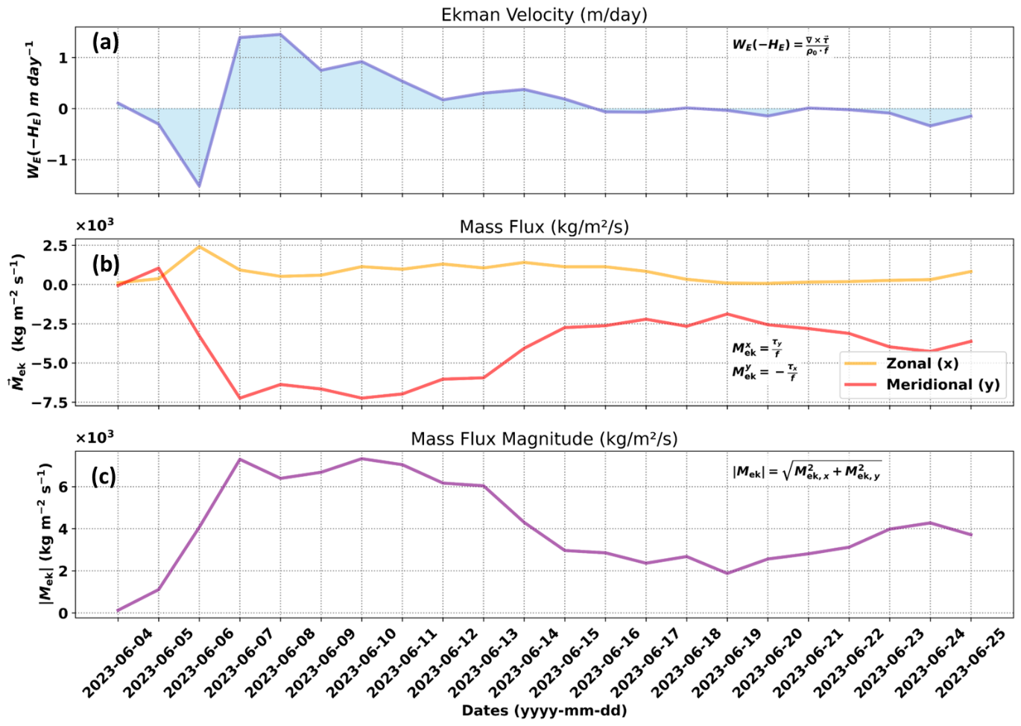
Figure S8: Panel (a) Ekman velocities calculated using wind stress at thermocline depth (estimated average depth was 52m); Panel (b) zonal and meridional component of Ekman mass flux; and Panel (c) magnitude of Ekman mass flux.
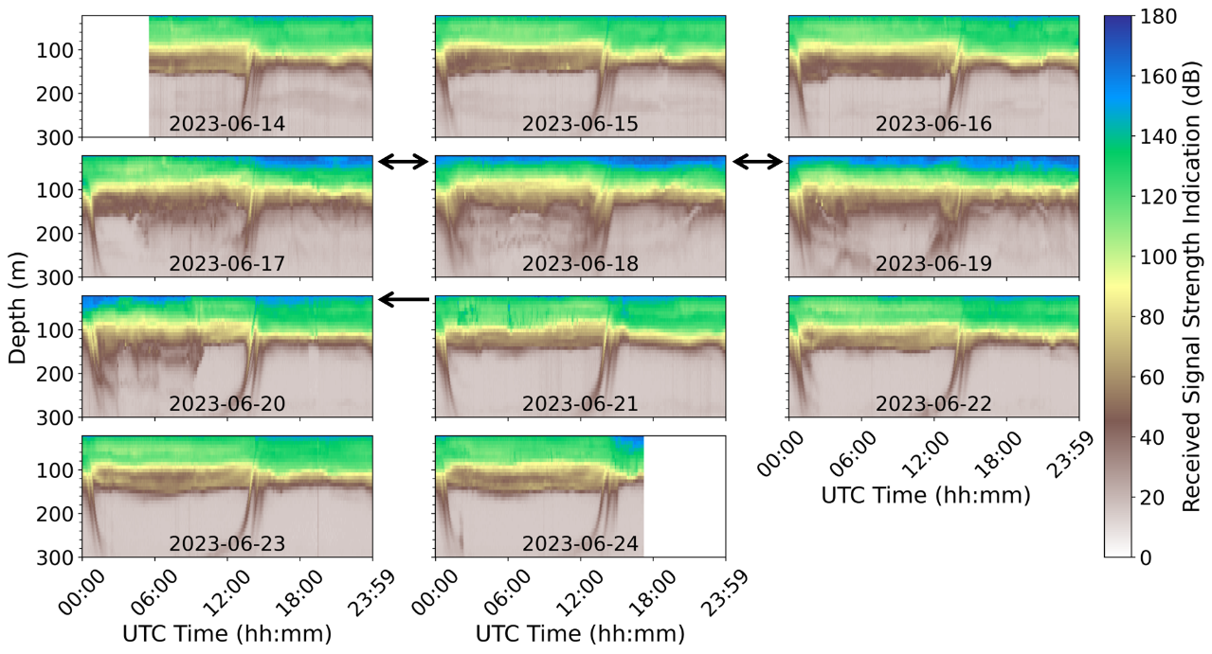
Figure S9: Received signal strength by ADCP for each day during the observation campaign. The black arrows show increased turbulence at the surface water over the cyclone-impacted region, where high BC was observed. The diurnal vertical transport of zooplankton is clearly visible at sunrise (down) and sunset (up) in each panel.
Figure S10: Line graph depicting high-resolution Reynolds numbers (Re) estimated for each day during the observation campaign, with daily average values displayed in each panel. The equation for estimating the Reynolds number is provided at the bottom right.
Table S1: High-resolution TEM-EDS outputs. The particle image is marked with a few codes (marked with blue circles), where the elemental composition is measured using an energy-dispersive X-ray spectrometer (EDS).
S.N. | Image | Code | EDS result
1. | 18/06/2023 | A
  Element | Weight% | Atomic%
  C | 93.36 | 97.52
  O | 1.83 | 1.44
  Fe | 1.92 | 0.43
  Co | 2.88 | 0.61
1. |  | G
  Element | Weight% | Atomic%
  C | 93.89 | 97.60
  O | 1.90 | 1.48
  Fe | 1.96 | 0.44
  Co | 2.26 | 0.48
2. | 18/06/2023 | K
  Element | Weight% | Atomic%
  C | 16.79 | 26.26
  O | 37.89 | 44.50
  Na | 15.01 | 12.27
  P | 25.21 | 15.29
  Fe | 2.58 | 0.87
  Co | 2.52 | 0.80
2. |  | L
  Element | Weight% | Atomic%
  C | 16.11 | 24.96
  O | 38.88 | 45.21
  Na | 19.00 | 15.37
  P | 21.82 | 13.10
  Fe | 1.52 | 0.51
  Co | 2.68 | 0.85
2. |  | M
  Element | Weight% | Atomic%
  C | 37.50 | 50.52
  O | 33.12 | 33.50
  Na | 9.46 | 6.66
  P | 15.43 | 8.06
  Fe | 2.16 | 0.62
  Co | 2.34 | 0.64
3. | 18/06/2023 | H
  Element | Weight% | Atomic%
  C | 62.28 | 88.79
  Fe | 15.95 | 4.89
  Co | 21.77 | 6.32
3. |  | I
  Element | Weight% | Atomic%
  C | 59.59 | 87.56
  Fe | 19.99 | 6.32
  Co | 20.42 | 6.12
3. |  | J
  Element | Weight% | Atomic%
  C | 66.92 | 90.68
  Fe | 12.09 | 3.52
  Co | 20.99 | 5.80
4. | 18/06/2023 | C
  Element | Weight% | Atomic%
  C | 94.95 | 97.50
  O | 2.55 | 1.96
  Cr | 0.48 | 0.11
  Co | 2.02 | 0.42
5. | 18/06/2023 | D
  Element | Weight% | Atomic%
  C | 93.56 | 95.84
  O | 4.04 | 3.11
  Si | 2.40 | 1.05
6. | 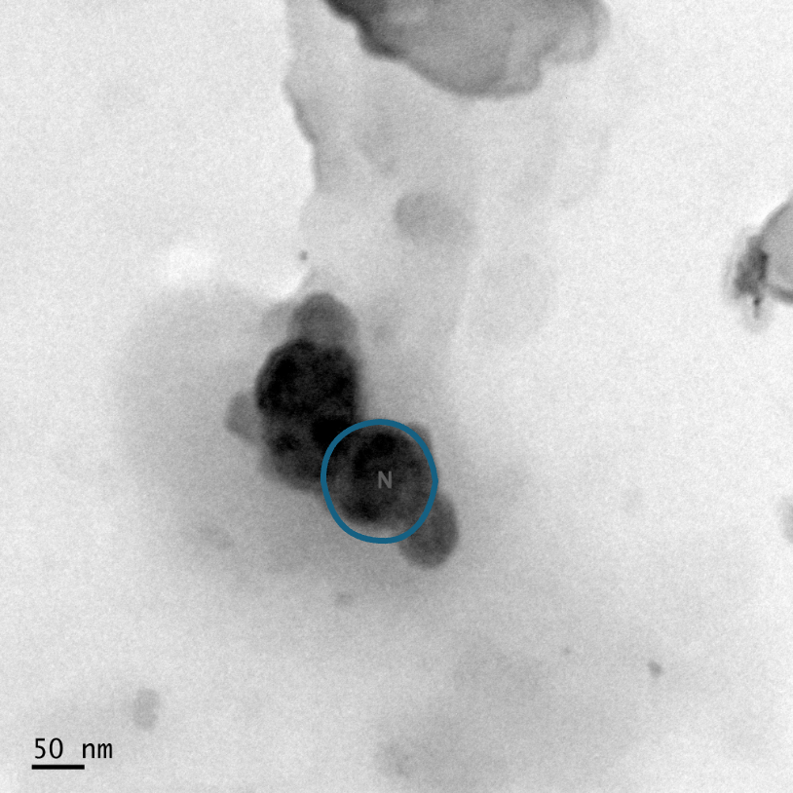  14/06/2023 | N
  Element | Weight% | Atomic%
  C | 82.31 | 95.70
  Fe | 7.90 | 1.98
  Co | 9.79 | 2.32
7. | 23/06/2023 | F
  Element | Weight% | Atomic%
  C | 100.00 | 100.00
7. |  | G
  Element | Weight% | Atomic%
  C | 100.00 | 100.00
Abbreviation of elements: C - Carbon, O - Oxygen, Fe - Iron, Co - Cobalt, Na - Sodium, P - Phosphorus, Si - Silicon

Reference:
Copyright [2024], Global Fishing Watch, Inc. Accessed on [March 04, 2025]. [Link].

Disclaimer:
Global Fishing Watch has made every attempt to ensure the completeness, accuracy and reliability of the information provided on this Site. However, due to the nature and inherent limitations in source materials for information provided, Global Fishing Watch qualifies all designations of vessel fishing activity, including synonyms of the term “fishing activity,” such as “fishing” or “fishing effort,” as “apparent,” rather than certain. And accordingly, the information is provided “as is” without warranty of any kind.

