Supplementary Material

Long-Term evolution and
synoptic meteorological modulation of PM_{2.5} and PM₁₀ in Seoul

Wooseok Jang ª, Simon Wang ^{b}, Hyun Cheol Kim ^{c,d}, Jee-Hoon Jeong ^{e}, Changhyun Yoo ^{f}, Jin-Young Choi ^{g}, Jin-Ho Yoon ^{a,*}

ªDepartment of Environment and Energy Engineering, College of Engineering, Gwangju Institute of Science and Technology, Gwangju, South Korea

^{b}Department of Agronomy, Kasetsart University, Bangkok, Thailand

^{c}Air Resources Laboratory, National Oceanic and Atmospheric Administration, College Park, MD, USA

^{d}Cooperative Institute for Satellite Earth System Studies, University of Maryland, College Park, MD, USA

^{e}Department of Environment and Energy, Sejong University, Seoul, South Korea

^{f}Department of Climate and Energy Systems Engineering, Ewha Womans University, Seoul, South Korea

^{g}Air Quality Forecasting Center, National Institute of Environmental Research, Incheon, South Korea

* Corresponding author at: Department of Environment and Energy Engineering, College of Engineering, Gwangju Institute of Science and Technology, Gwangju, South Korea.
E-mail address: yjinho@gist.ac.kr
Table S1. Date information about missing values during (a) winter (DJF) and (b) spring (MAM).
(a) DJF | (b) MAM
2004.01.22. | 2002.04.29. | 2007.03.15.
2006.02.04. | 2006.03.11. | 2007.04.01.
2006.02.05. | 2006.03.13. | 2007.04.24.
2008.01.07. | 2006.03.14. | 2010.03.01.
2008.01.29. | 2006.04.08. | 2015.04.20.
2008.01.30 | 2006.04.09. | 2017.05.26.
2008.02.16. | 2006.04.24.
2011.02.27. | 2007.03.08.

Table S2. Model selection results for seasonal PM_{2.5} and PM₁₀ trends (2000–2020), using AIC and Chow test criteria. For each season and PM type, both linear and quadratic fits were compared using the Akaike Information Criterion (AIC), and the presence of a structural break between decades (2000–2010 vs. 2011–2020) was tested using the Chow test. The Chow test statistic is accompanied by degrees of freedom in the form (k, n–2k), where k is the number of model parameters and n is the total sample size. Statistical significance is reported where applicable.
Season | PM Type | Model Type | AIC | Chow Test Statistic | Degree of Freedom | Structural Break Significance
Winter | PM_{2.5} | Linear | 138.14 | 12.96 | (2, 17) | Yes (p < 0.01)
 |  | Quadratic | 122.12 | - | - | -
 | PM₁₀ | Linear | 132.24 | 0.25 | (2, 17) | No
 |  | Quadratic | 133.51 | - | - | -
Spring | PM_{2.5} | Linear | 137.05 | 20.41 | (2, 16) | Yes (p < 0.01)
 |  | Quadratic | 123.22 | - | - | -
 | PM₁₀ | Linear | 129.28 | 3.39 | (2, 16) | Moderate (p ≈ 0.05–0.1)
 |  | Quadratic | 125.81 | - | - | -
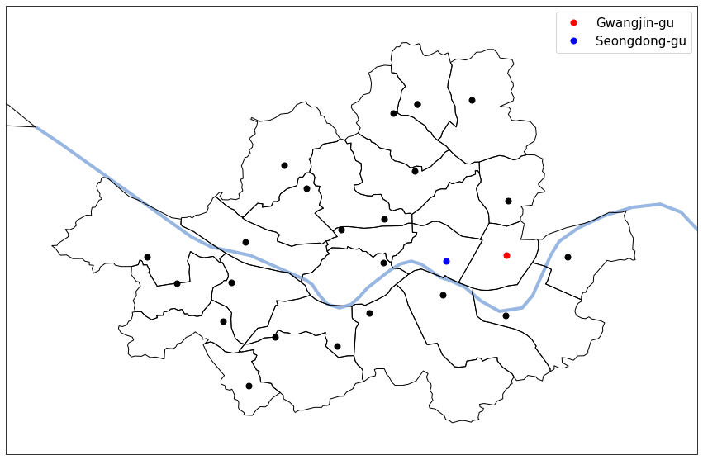
Figure S1. Locations of 25 stations in Seoul, South Korea. Gwangjin-gu and Seongdong-gu stations are highlighted.

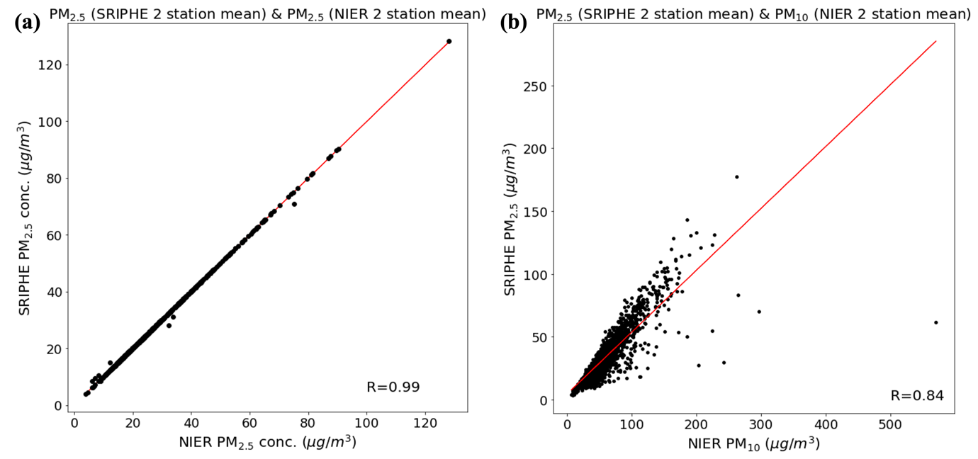
Figure S2. Scatter plot of the daily (a) (y-axis) NIER PM_{2.5} concentration and (x-axis) SRIPHE PM_{2.5} concentration for an average of two stations (Seongdong-gu and Gwangjin-gu) during DJF 2015-2020. (b) Same as (a), but the x-axis is for NIER PM₁₀ concentration during DJF 2001-2020. The red line illustrates the linear regression line.

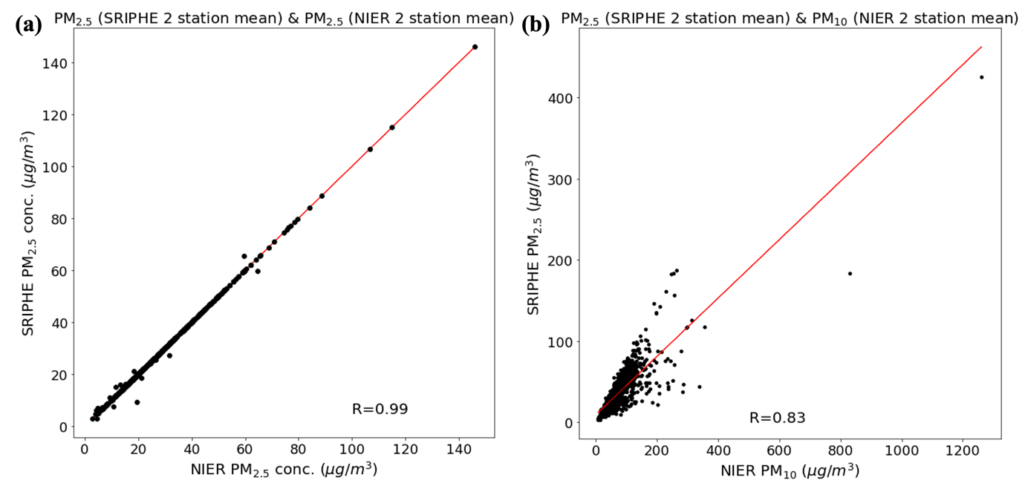
Figure S3. Scatter plot of the daily (a) (y-axis) NIER PM_{2.5} concentration and (x-axis) SRIPHE PM_{2.5} concentration for an average of two stations (Seongdong-gu and Gwangjin-gu) during MAM 2015-2020. (b) Same as (a), but the x-axis is for NIER PM₁₀ concentration during MAM 2001-2020. The red line illustrates the linear regression line.

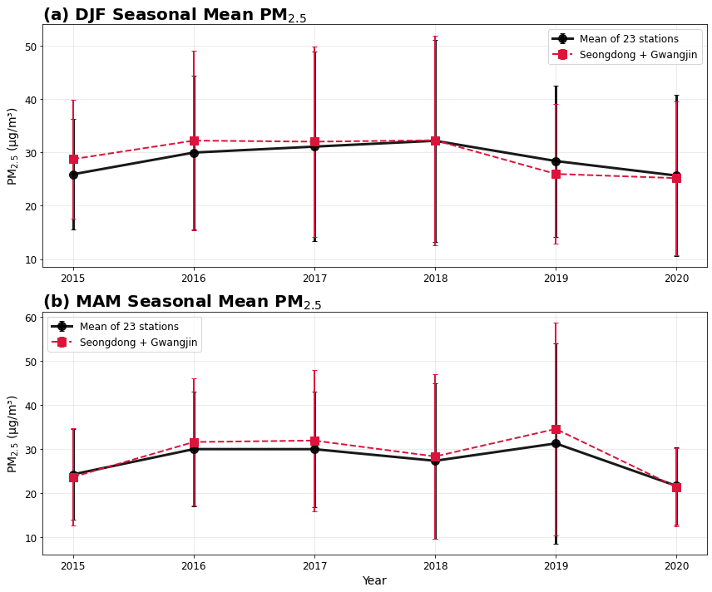
Figure S4. Seasonal mean PM_{2.5} concentrations (μg/m³) during (a) DJF and (b) MAM for 2015–2020. The red dashed line represents the average of Seongdong-gu and Gwangjin-gu, and the black solid line represents the mean of the remaining 23 NIER stations in Seoul. Error bars indicate ±1 standard deviation. Across both seasons, the two time series show close agreement in both magnitude and interannual variability, with correlation coefficients of r = 0.96 (DJF) and r = 0.97 (MAM), respectively.

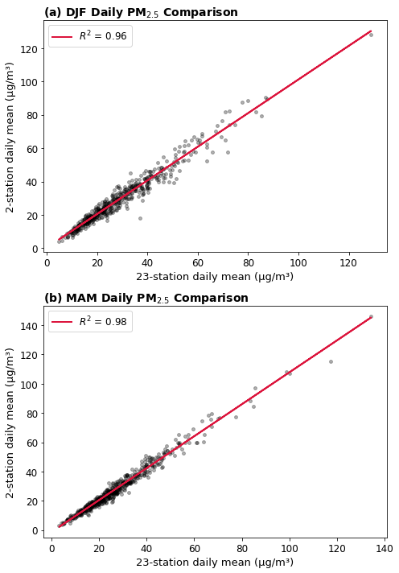
Figure S5. Daily PM_{2.5} comparison between the Seongdong+Gwangjin average and the mean of 23 other stations during (a) DJF and (b) MAM for the period 2015-2020. Each dot represents a daily mean value. The red line indicates the least-squares regression fit, with R² = 0.96 for DJF and R² = 0.97 for MAM, demonstrating strong day-to-day covariation between the two series in both seasons.
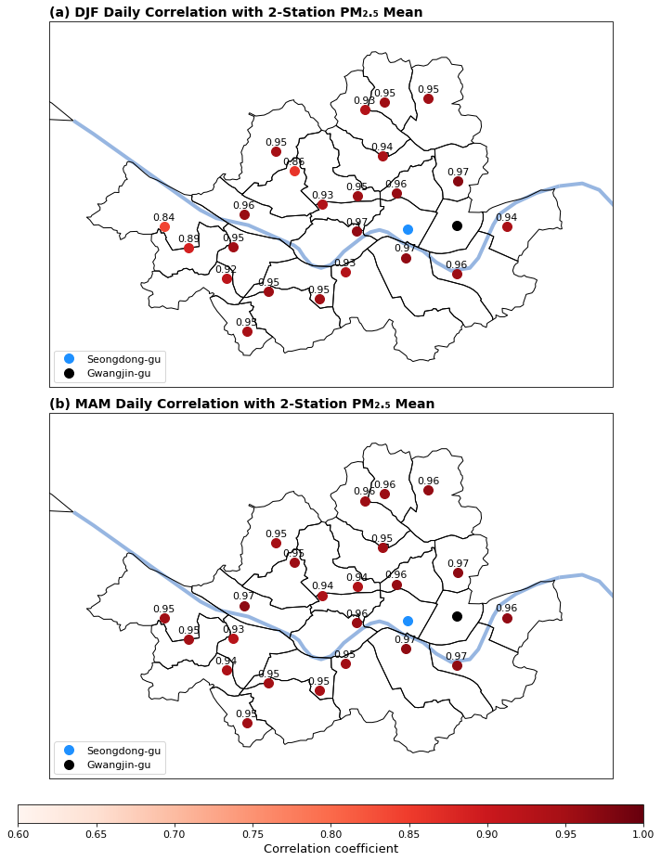
Figure S6. Spatial distribution of Pearson correlation coefficients between the Seongdong+Gwangjin average and each of the remaining 23 stations during (a) DJF and (b) MAM over 2015–2020. In both seasons, most stations exhibit correlation values above 0.94, indicating robust spatial coherence. Seongdong-gu (blue) and Gwangjin-gu (black) are highlighted for reference. A common colorbar indicates the correlation strength.

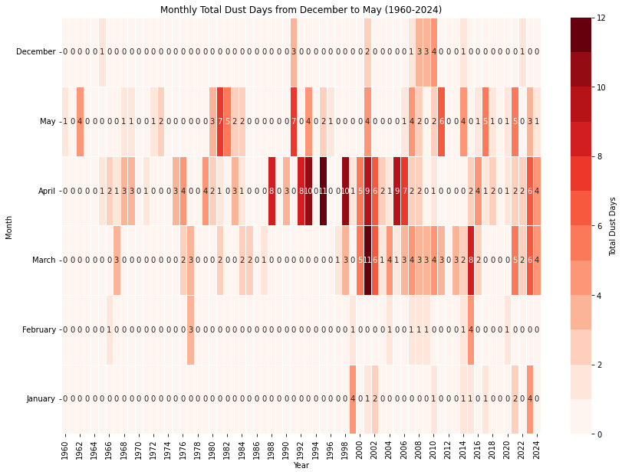
Figure S7. Number of Asian dust events from December to May during 1960 - 2024 in Seoul.

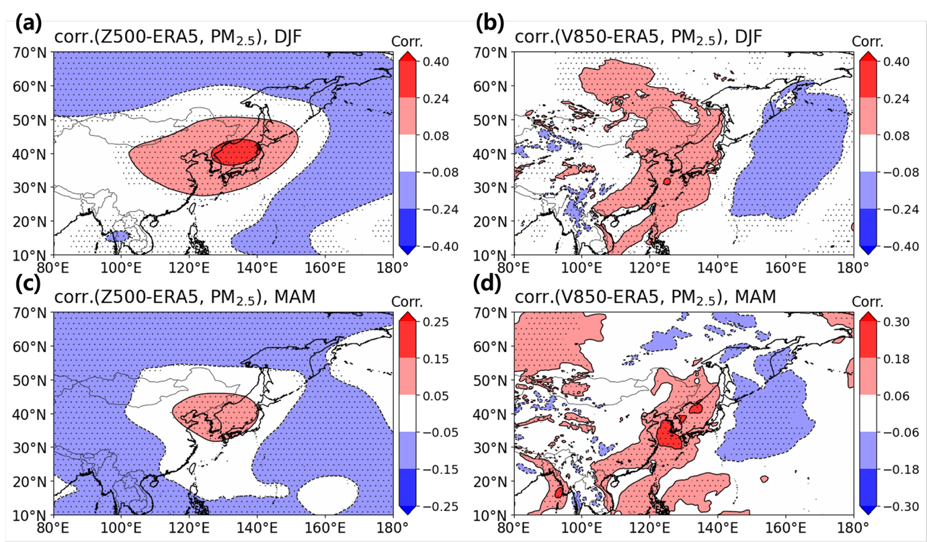
Figure S8. Correlation maps between daily PM_{2.5} concentrations and (a, c) 500-hPa geopotential height (Z500) and (b, d) 850-hPa meridional wind (V850) from ERA5 during (a–b) DJF and (c–d) MAM, over the period 2000–2020. Stippling indicates regions where correlations are statistically significant at the 95% confidence level based on a two-tailed t-test. Despite the finer horizontal resolution of ERA5 (0.25°), the overall spatial patterns closely resemble those obtained from JRA-55, supporting the robustness of the synoptic-scale meteorological signals identified in this study.

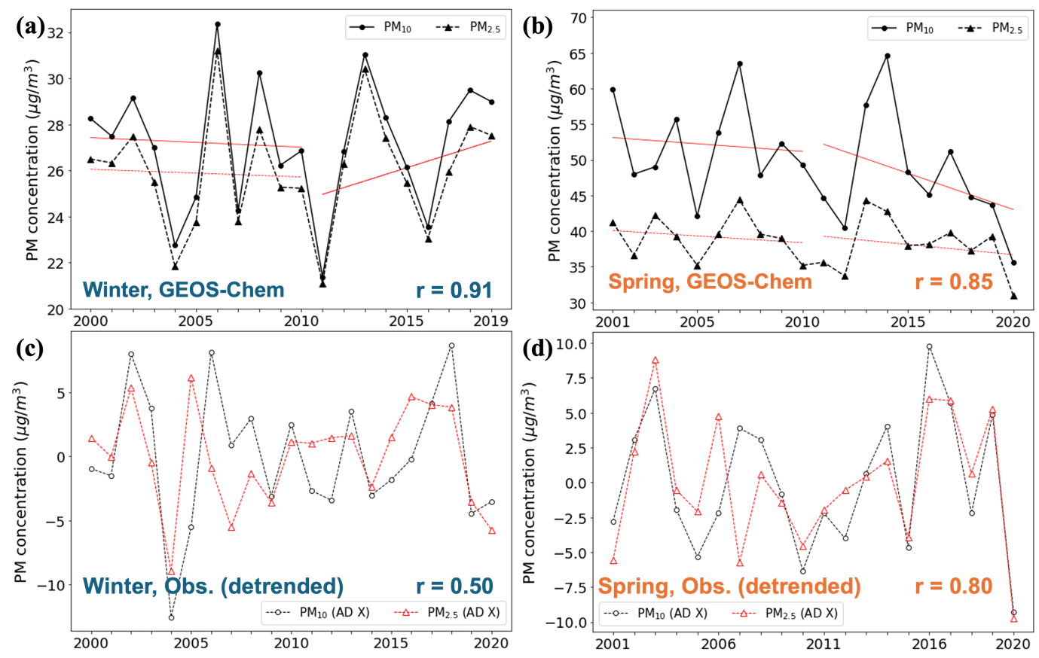
Figure S9. Same as Figure 1, but for GEOS-Chem PM_{2.5} and PM_{10.}
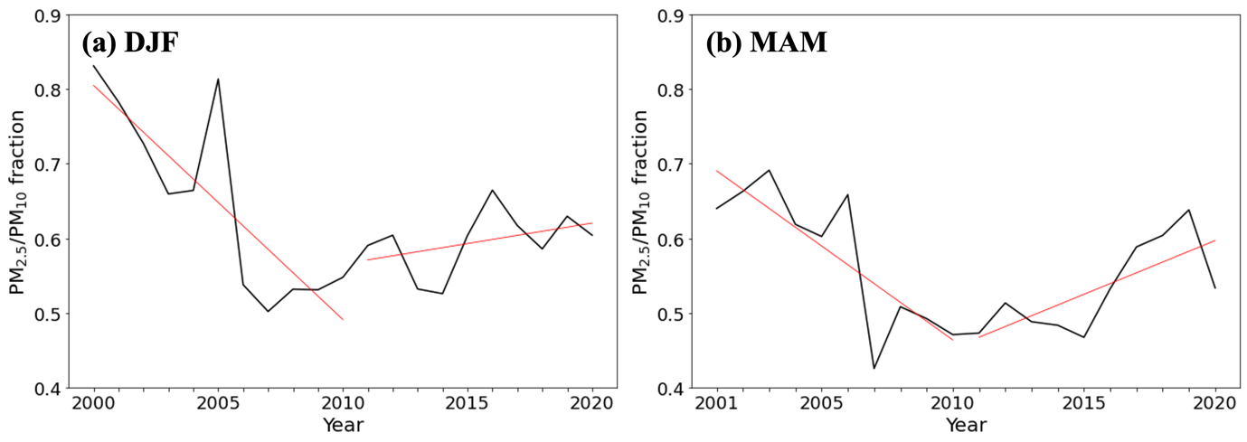
Figure S10. PM_{2.5}/PM₁₀ fraction of winter mean concentrations.

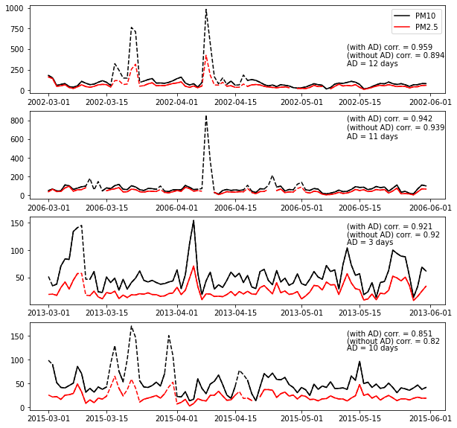
Figure S11. Daily PM concentrations of spring in 2002, 2006, 2013, and 2015.

Text S1. GEOS-Chem configuration.
The GEOS-Chem simulation used in this study is a nested-grid atmospheric chemistry model run over East Asia with a horizontal resolution of 0.5° latitude × 0.625° longitude and 72 vertical levels. Boundary conditions were provided by a global simulation with coarser resolution (4° × 5°). The model was driven by assimilated meteorological data from the MERRA-2 (Modern-Era Retrospective analysis for Research and Applications, Version 2) reanalysis product provided by NASA’s Global Modeling and Assimilation Office.
Anthropogenic emissions were held constant throughout the simulation, based on year-2006 inventory data. This fixed-emissions setting enables the analysis of variability in aerosol concentrations driven solely by meteorological conditions, without the influence of temporal changes in emissions. Monthly outputs of PM_{2.5} and PM₁₀ concentrations were used for the analysis. These outputs are consistent with the model configuration described in Jeong et al. (2018).

