Supplementary figures

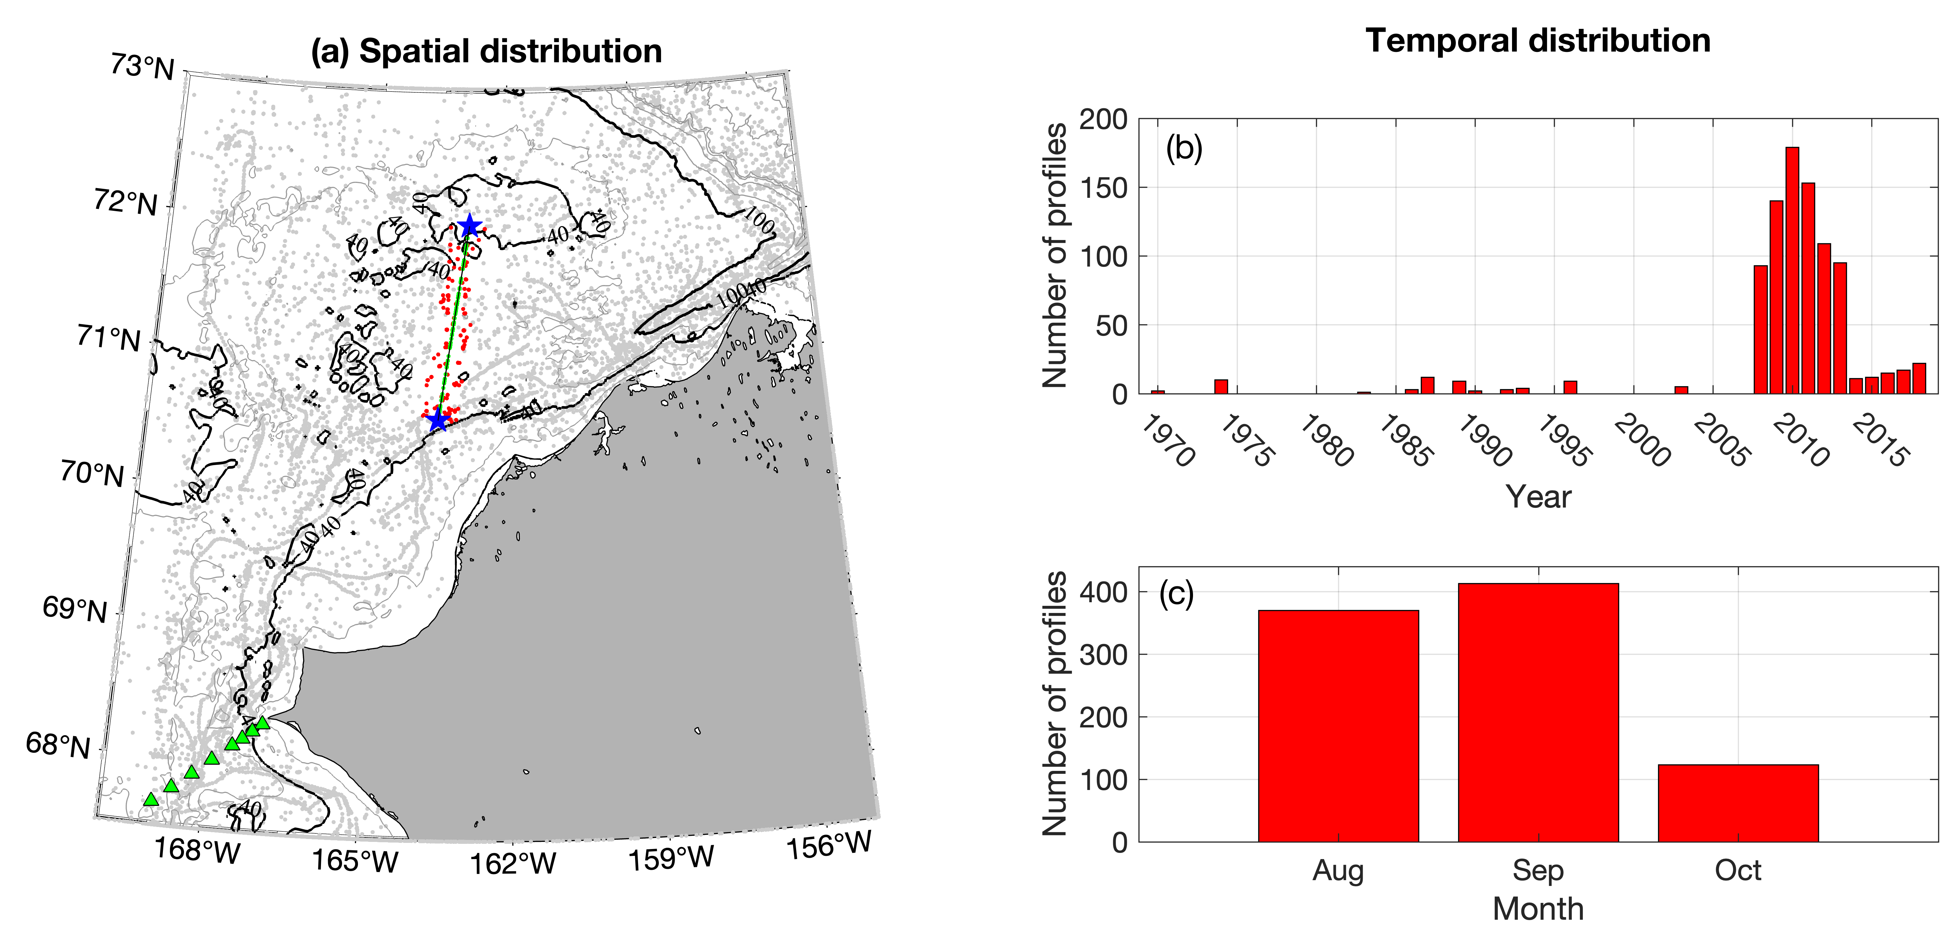
Supplementary Fig. 1: Historical CTD data coverage used to construct the mean hydrographic sections of Fig. 7. Left-hand panel: Geographical distribution of the data (gray dots). The red dots indicate the stations that were projected onto the black line (as green dots) to make the composite sections. The green triangles are the DBO3 station sites. Right-hand panel: Temporal distribution of the data by year and month.

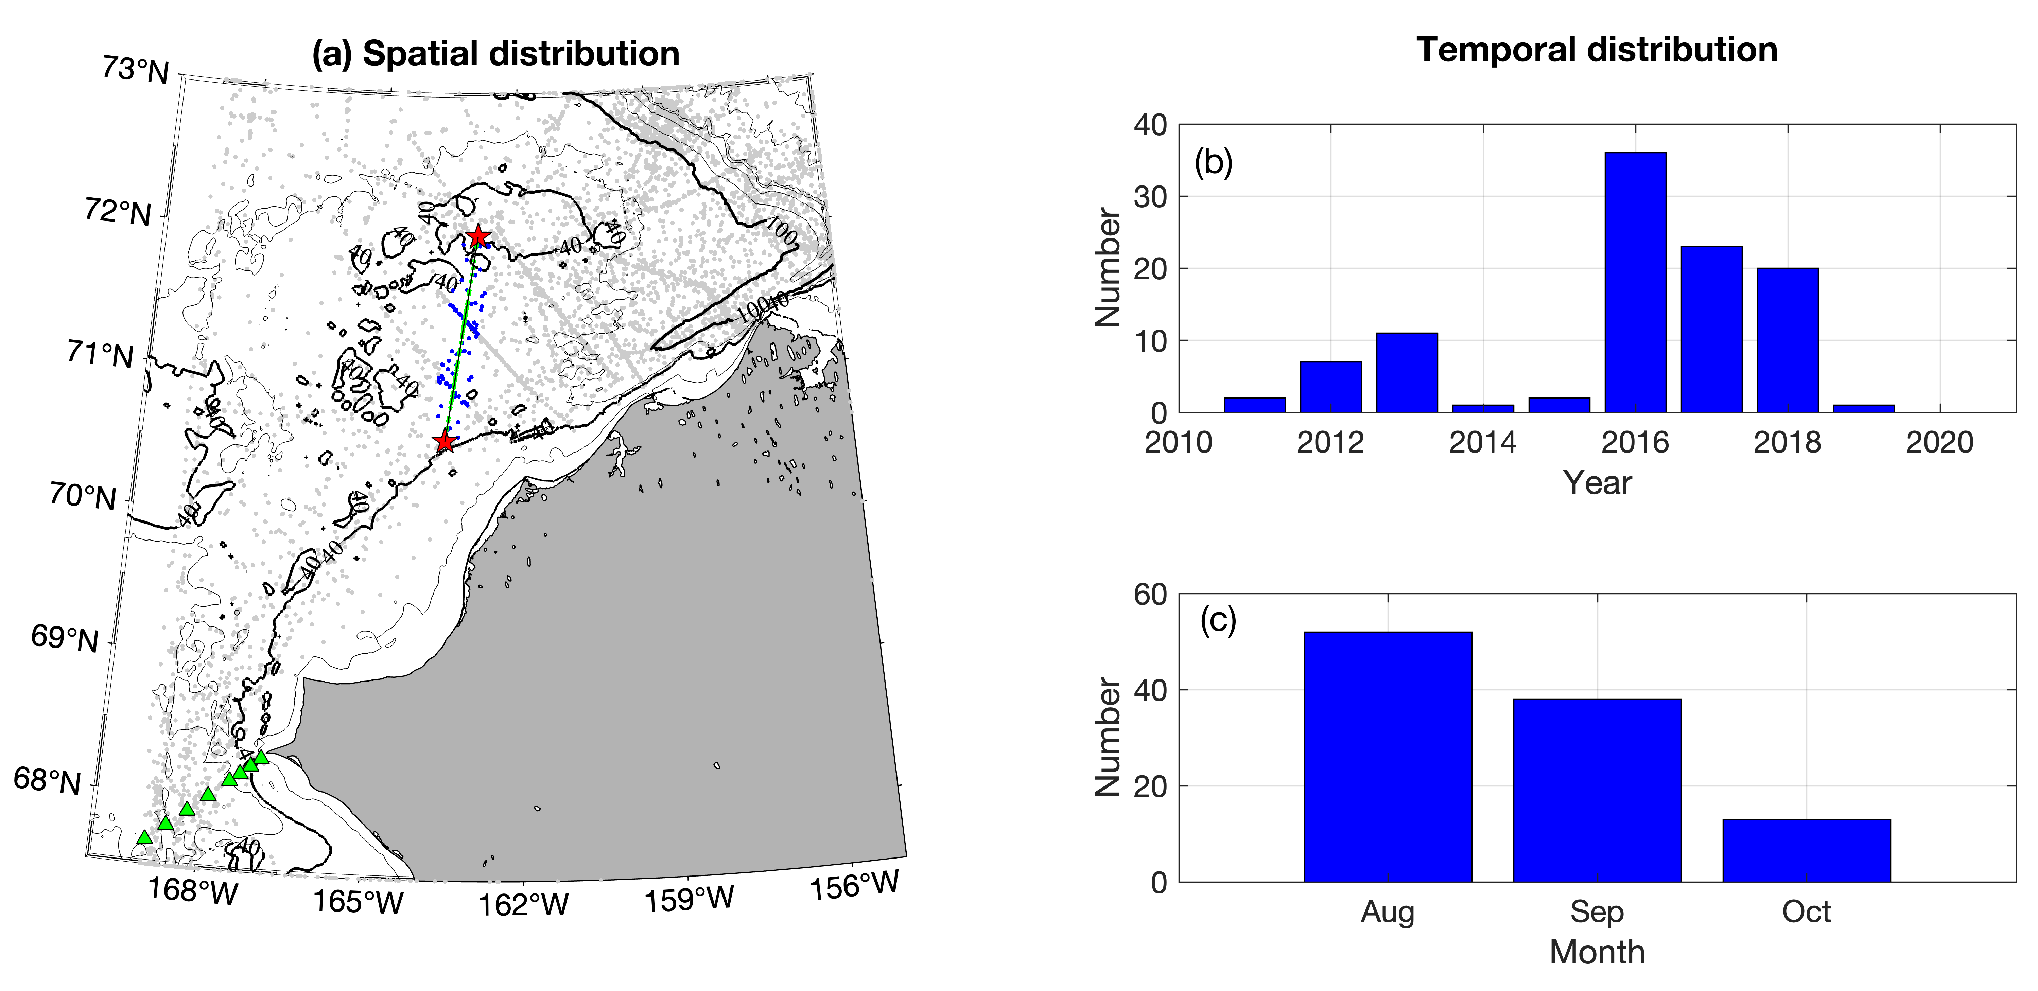
Supplementary Fig. 2: ChukSA ADCP data used to construct the mean absolute geostrophic velocity section of Fig. 7. Left-hand panel: Geographical distribution of the data (gray dots). The blue dots indicate the stations that were projected onto the black line (as green dots) to make the composite sections. The green triangles are the DBO3 station sites. Right-hand panel: Temporal distribution of the data by year and month.
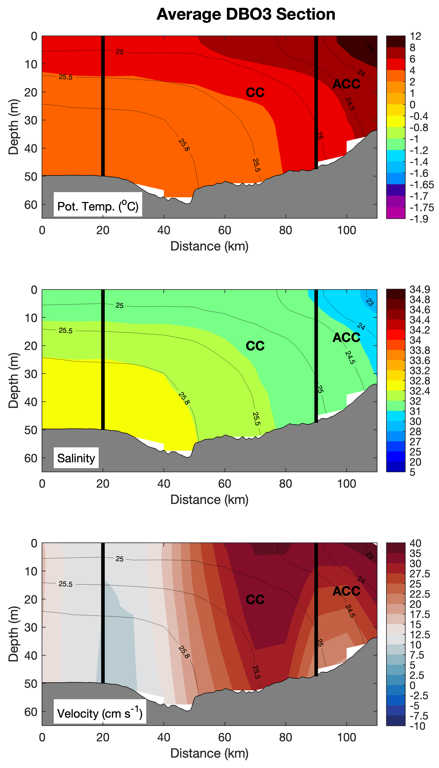
Supplementary Fig. 3: Mean vertical sections at the DBO3 line from Pickart et al. (2023), using the same velocity colorbar employed in the present study. (a) potential temperature; (b) salinity; (c) absolute geostrophic velocity (positive is northward). The contours are potential density (kg m⁻³). The thick black lines denote the boundaries of the ACC and the Central Channel flow branch (CC). The viewer is looking to the north.

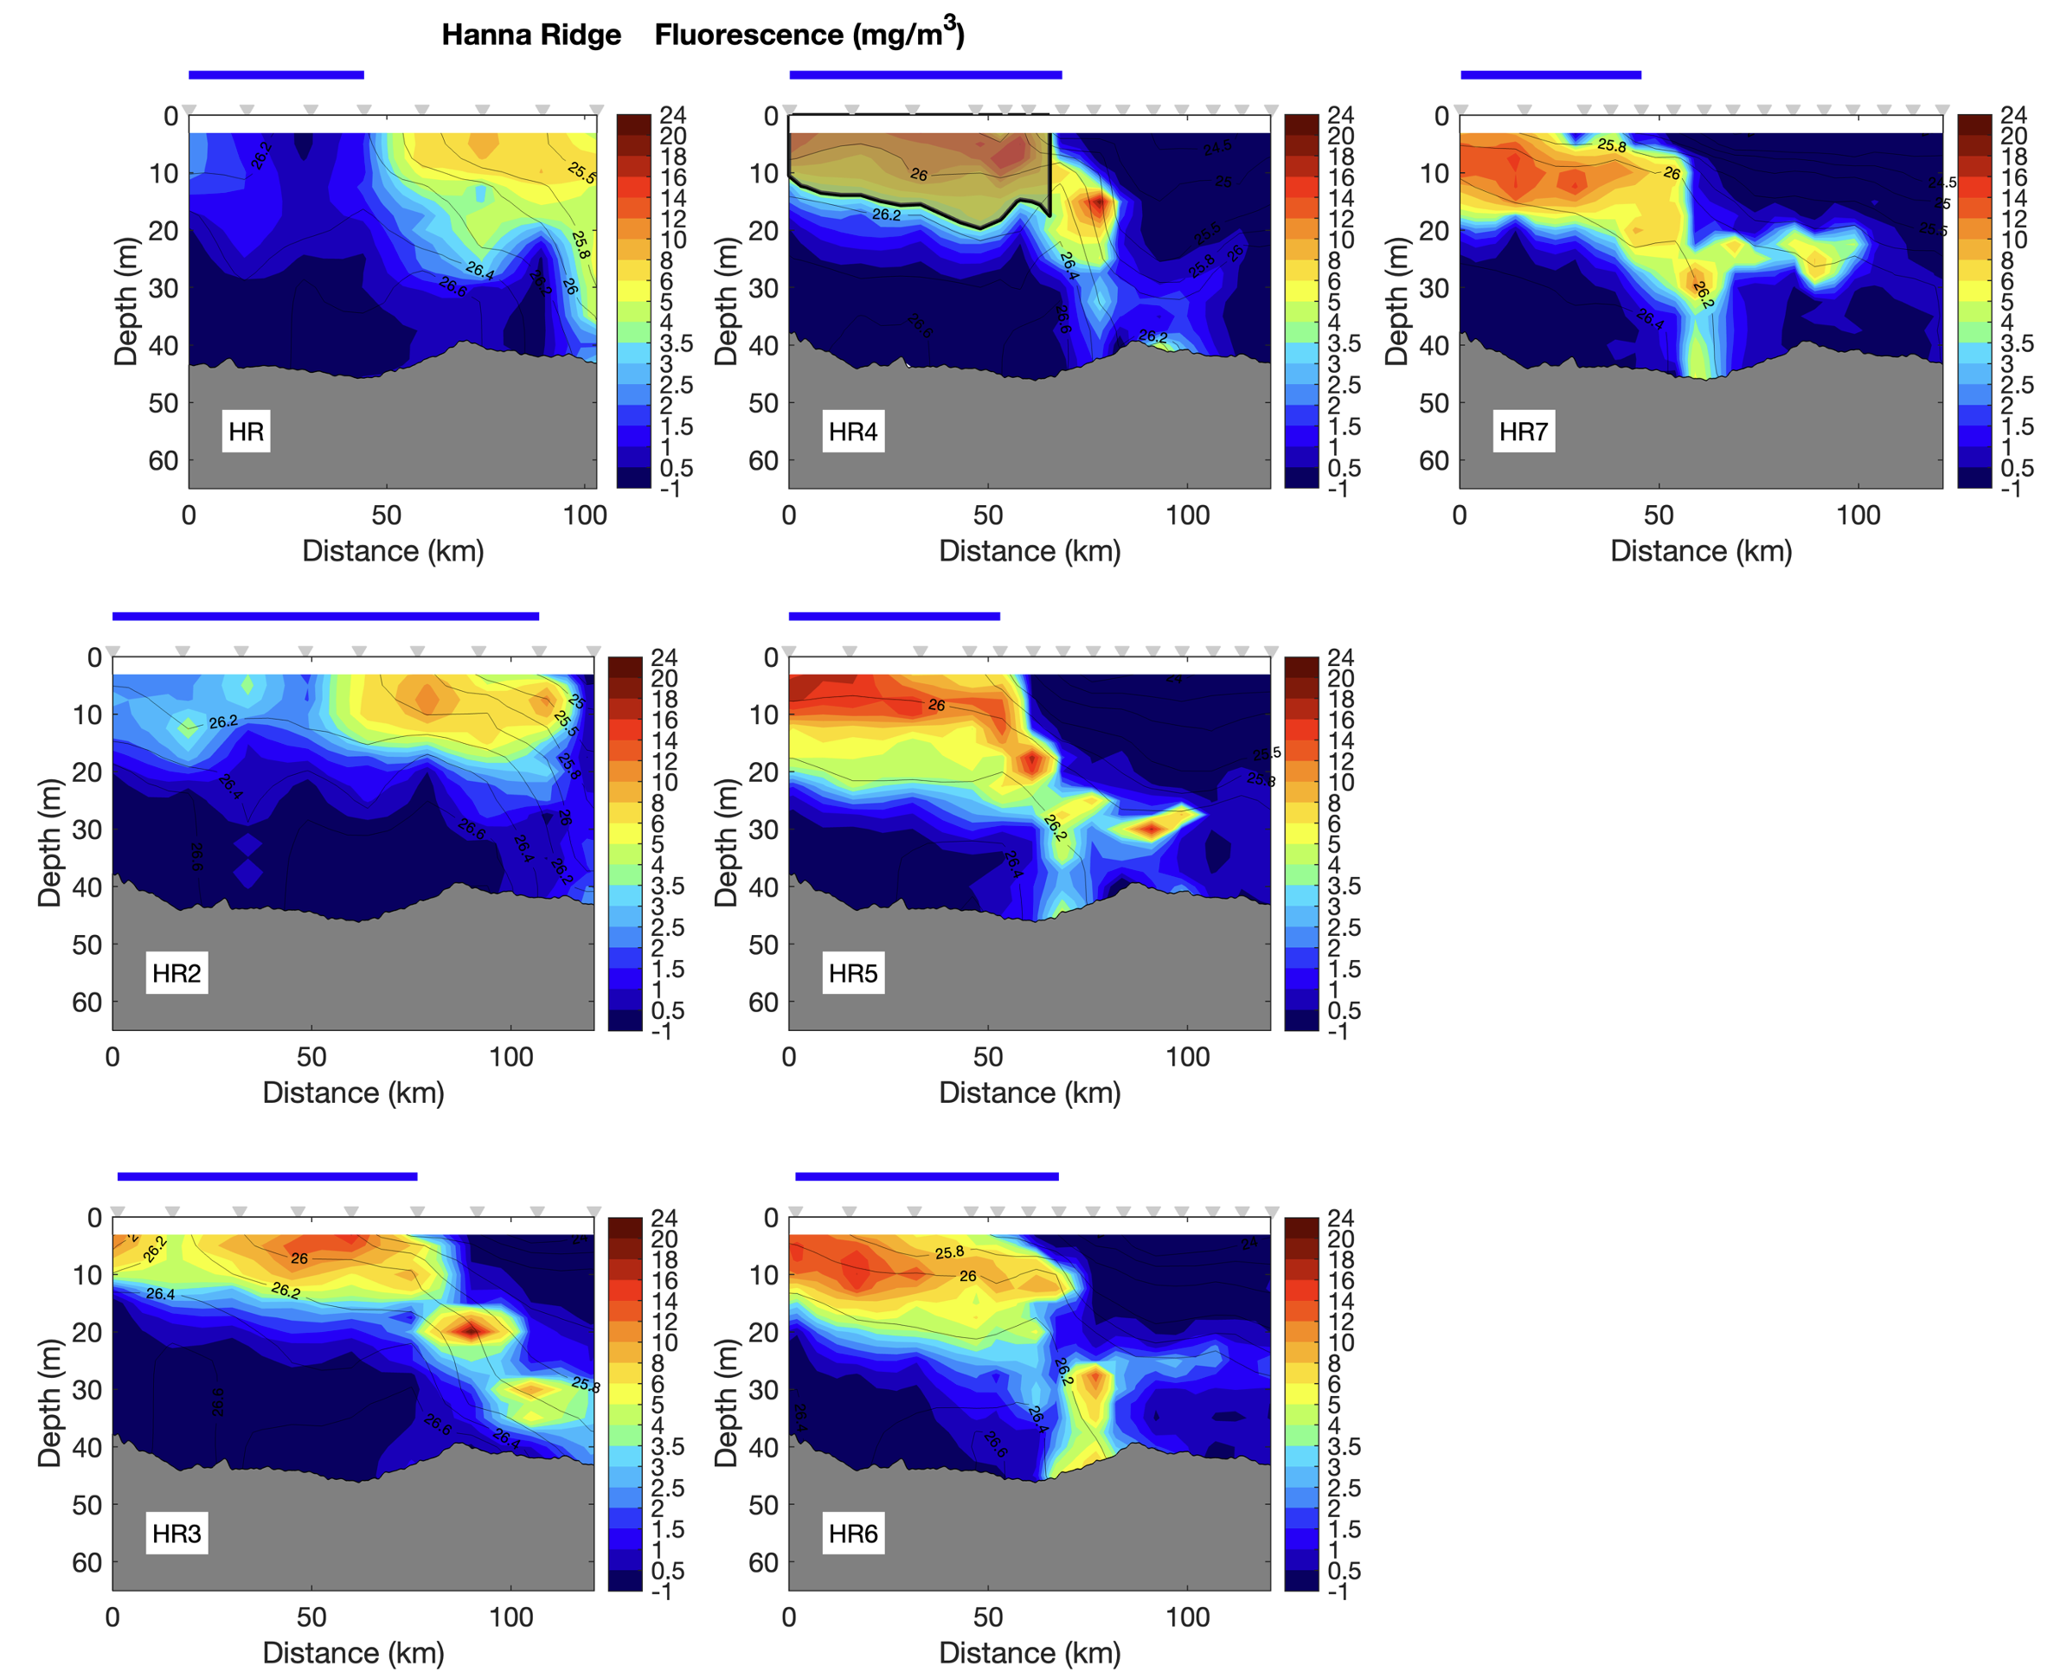

Supplementary Fig. 4: Vertical sections of fluorescence for the occupation of the HR line. The contours are potential density (kg m⁻³). The ice cover during each occupation is indicated by the thick blue line. The stations are listed along the top. For transect HR4, the region of the phytoplankton bloom greater than 4 mg m⁻³, excluding the region of the hydrographic front, is shaded. The bottom is from Sikuliaq’s echosounder.

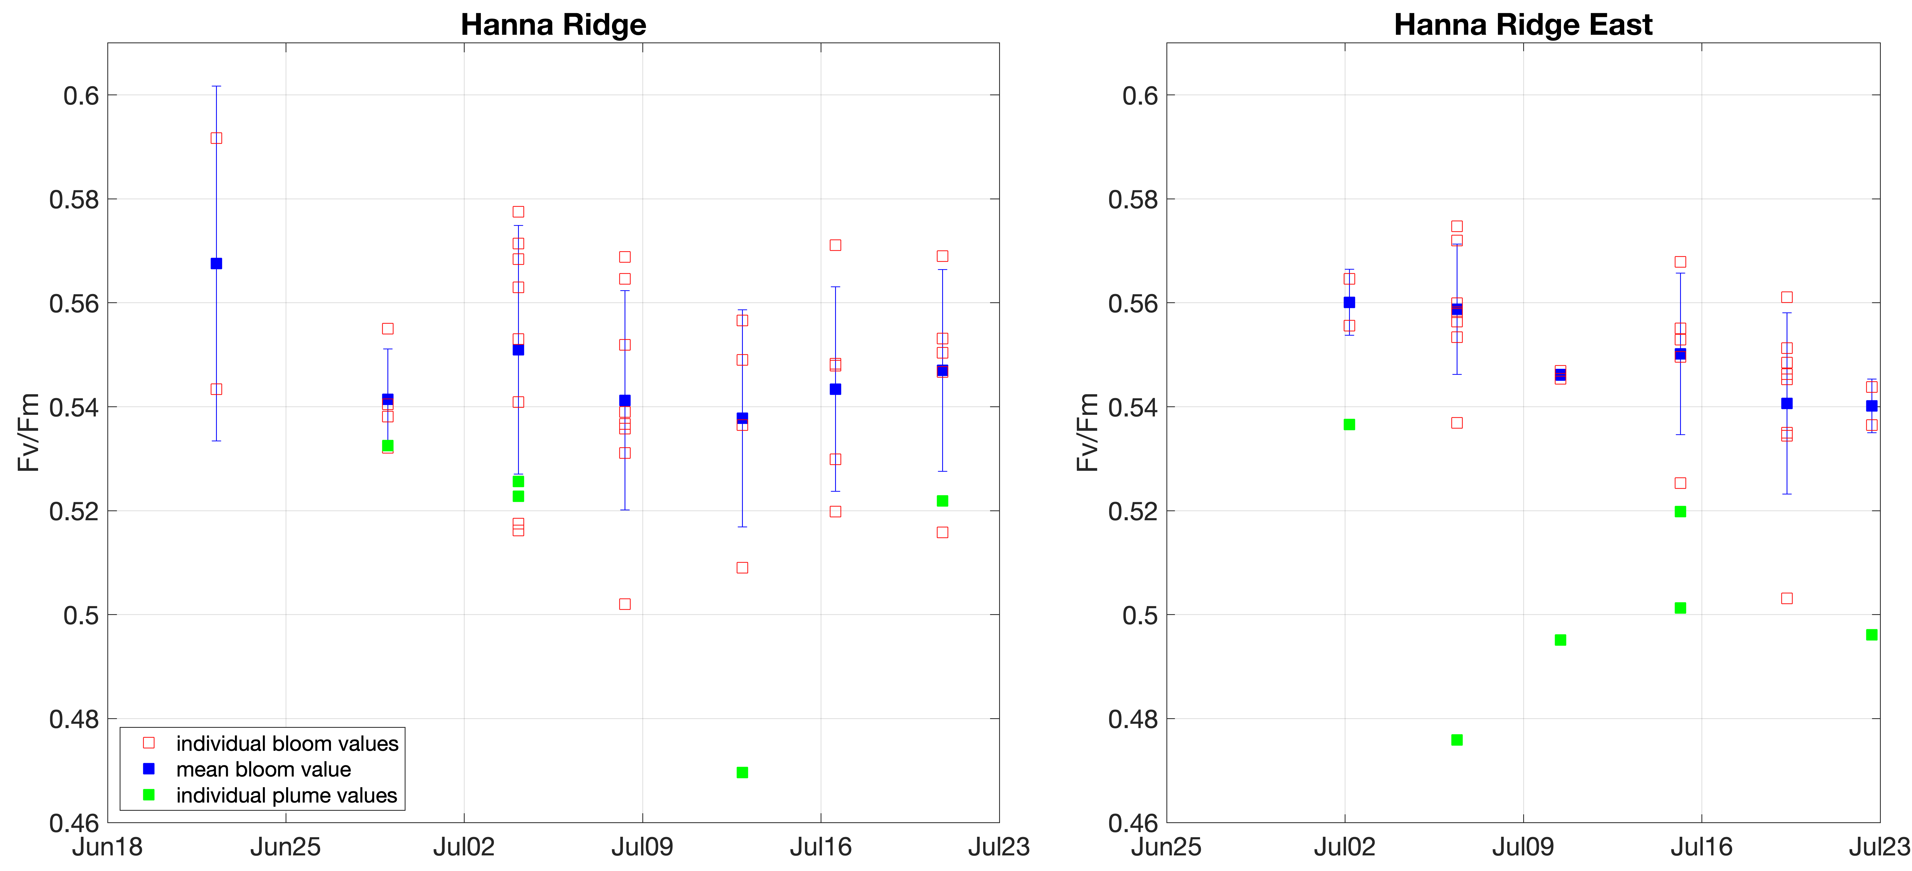

Supplementary Fig. 5: Timeseries of efficiency of electron flow through photosystem II (Fv/Fm) at the Hanna Ridge and Hanna Ridge East lines. See the legend for explanation of the symbols. The standard deviations are shown.

