SUPPLEMENTARY MATERIALS: The importance of fleet definition for estimating economic exposure of the summer flounder fishery to offshore wind farms

Authors: Meghna N. Marjadi^{1,3*}, Andrew W. Jones¹, Anna J. M. Mercer¹, Benjamin Galuardi^{2,3}, and Steven X. Cadrin³
¹Northeast Fisheries Science Center, Narragansett, Rhode Island 02882, USA
²Greater Atlantic Regional Fisheries Office, Gloucester, Massachusetts 01930, USA
³University of Massachusetts, School for Marine Science & Technology, New Bedford, Massachusetts 02744, USA
Corresponding author tel: 1(508) 910-6310 e-mail: mmarjadi@umassd.edu

Abstract: As offshore wind development continues across the globe, accurate spatial data are required to characterize fishing activity, inform wind farm siting decisions, and estimate economic exposure. We assess the influence of fishing behavior and fleet definition within a multispecies fishery on coarse (logbook based) footprint biases using a precise (GPS-based) approach. We constructed precise footprints for 838 trips that caught summer flounder (Paralichthys dentatus) trips and 1,439 trips that caught any species in the Summer Flounder, Scup (Stenotomus chrysops), Black Sea Bass (Centropristis striata) Fishery Management Plan from 2016–2021. Using the precise footprints as a ground truth, we compared the intersections and estimated economic exposure between coarse footprints (90th, 75th, 50th, 25th percentiles) for 37 wind farms in the Northeast US. Unrestricted coarse footprints (90th percentile) consistently identified all “true” intersections with wind farms while also overestimating economic exposure. For the multispecies fisheries, restricting footprints between 25th and 50th percentile yielded the most accurate estimates of economic exposure. This contrasts previous work that found the 25th percentile was most accurate for the targeted longfin squid (Doryteuthis pealeii) fishery, highlighting the importance of fleet definition in this process. Replicating this approach for other fisheries will allow development of a tool to accurately estimate economic exposure by restricting coarse footprints in the absence of fine-scale data.
Supplementary Material:

Study fleet coverage of the fluke fishery

Our study relies on fine-scale haul-level data collected by vessels that participate in the Study Fleet program(Jones et al. 2022). We compared reported summer flounder landings and trips for Study Fleet vessels with fine scale data to the overall fleet. From 2006 to 2023, Study Fleet vessels represented <1%–16 % of landings for statistical areas 451–650 (Supplementary Figure 1). For 2019 to 2023, Study Fleet coverage of trips and landings ranges from 10–16 % for large mesh trawl vessels that had summer flounder catch. Between 2011 and 2018, increases in coverage were accompanied by decreases in landings; however, between 2019 and 2023, changes in percent coverage appear to mirror landings trends. For our study years (2016–2021) Study Fleet summer flounder landings represented 10–17 % of fleet landings (Supplementary Table 1).

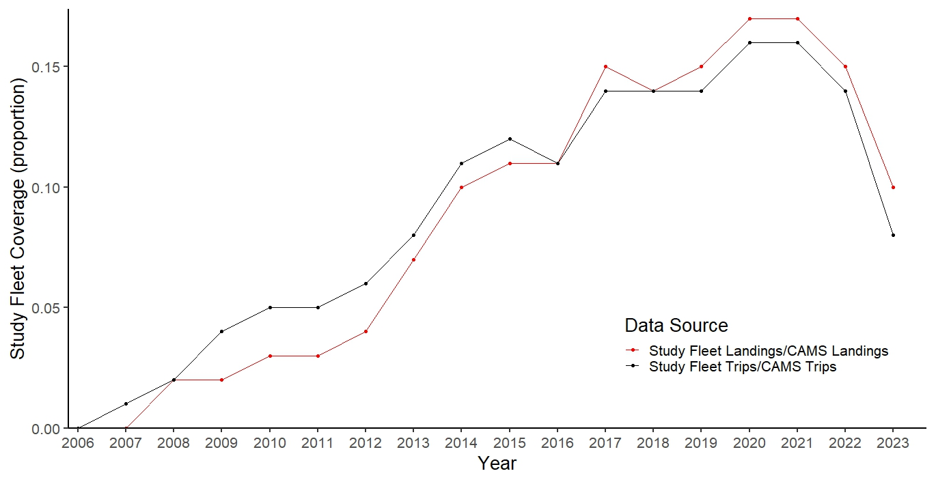

Figure S1: Percent of Study Fleet summer flounder landings and trips data compared to CAMS between 2006 and 2023 considering landings and trips for large mesh (>5 in) in statistical areas 451 – 650.

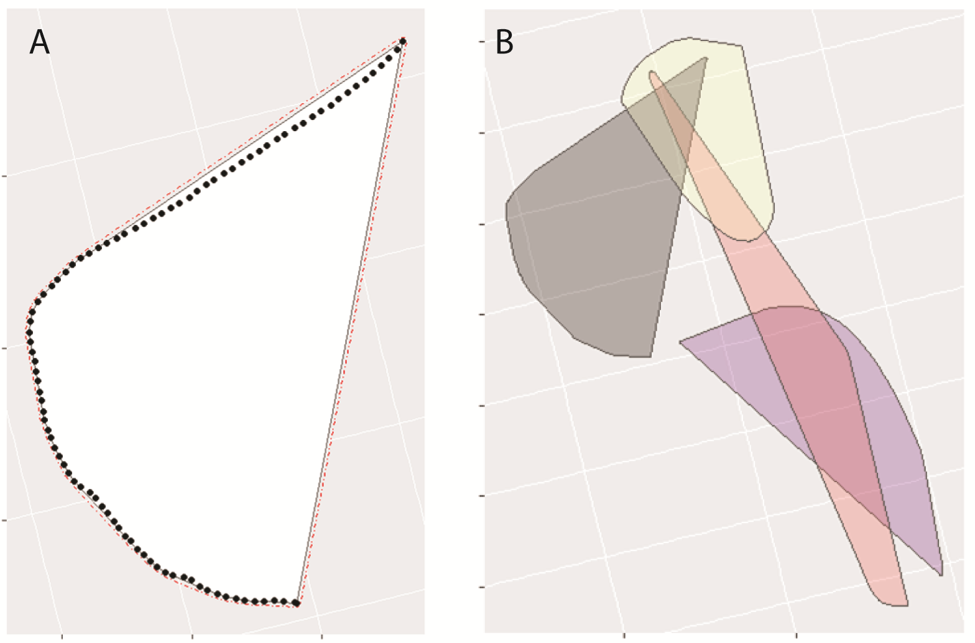

Figure S2: Adapted from Allen-Jacobson et al. 2023. A) We created a convex hull for each haul by wrapping a convex hull (the solid black line) around GPS points from active fishing locations ( black circles). We then added a 50 m buffer to each convex hull (dashed-dotted red line). B) We created a “precise fishing footprint” for each trip by merging all the convex hauls into one polygon. This trip included 4 separate hauls.
Table S1: Comparison of reported summer flounder landings and trips for Study Fleet vessels to the overall fleet (Catch and Account Monitoring System, CAMS) between 2006 and 2023. Highlighted years were included in our study. This includes all New England statistical areas (451-460).

Year | Study Fleet Trips (#) | Study Fleet Vessels (#) | Study Fleet Landings (lbs) | Study Fleet Landings (mt) | CAMS Trips (#) | CAMS Vessels (#) | CAMS Landings (lbs) | CAMS Landings (mt) | Study Fleet/CAMs trips (%) | Study Fleet/CAMS Vessels (%) | Study Fleet/CAMS landings (%)
2006 | 35 | 3 | 11,954 | 5 | 18,282 | 880 | 12,969,832 | 5,883 | 0.19% | 0.34% | 0.09%
2007 | 143 | 10 | 41,769 | 19 | 16,109 | 835 | 8,840,288 | 4,010 | 0.89% | 1.20% | 0.47%
2008 | 277 | 16 | 151,992 | 69 | 15,165 | 787 | 8,250,296 | 3,742 | 1.83% | 2.03% | 1.84%
2009 | 730 | 20 | 229,255 | 104 | 16,370 | 777 | 9,812,409 | 4,451 | 4.46% | 2.57% | 2.34%
2010 | 871 | 29 | 342,362 | 155 | 17,300 | 798 | 12,239,246 | 5,552 | 5.03% | 3.63% | 2.80%
2011 | 889 | 25 | 524,327 | 238 | 18,145 | 735 | 15,113,928 | 6,856 | 4.90% | 3.40% | 3.47%
2012 | 944 | 35 | 435,428 | 198 | 16,722 | 706 | 11,921,110 | 5,407 | 5.65% | 4.96% | 3.65%
2013 | 1,250 | 44 | 838,874 | 381 | 16,494 | 674 | 11,580,460 | 5,253 | 7.58% | 6.53% | 7.24%
2014 | 1,815 | 69 | 1,034,660 | 469 | 16,055 | 633 | 10,258,589 | 4,653 | 11.30% | 10.90% | 10.09%
2015 | 1,689 | 52 | 1,083,389 | 491 | 14,355 | 623 | 9,878,781 | 4,481 | 11.77% | 8.35% | 10.97%
2016 | 1,760 | 53 | 767,583 | 348 | 16,187 | 658 | 7,145,771 | 3,241 | 10.87% | 8.05% | 10.74%
2017 | 1,785 | 58 | 781,206 | 354 | 12,733 | 691 | 5,337,576 | 2,421 | 14.02% | 8.39% | 14.64%
2018 | 1,719 | 60 | 820,686 | 372 | 12,706 | 637 | 5,691,580 | 2,582 | 13.53% | 9.42% | 14.42%
2019 | 1,870 | 58 | 1,246,801 | 566 | 13,557 | 603 | 8,503,267 | 3,857 | 13.79% | 9.62% | 14.66%
2020 | 1,788 | 50 | 1,443,412 | 655 | 11,209 | 527 | 8,422,009 | 3,820 | 15.95% | 9.49% | 17.14%
2021 | 1,656 | 57 | 1,617,583 | 734 | 10,469 | 515 | 9,733,563 | 4,415 | 15.82% | 11.07% | 16.62%
2022 | 1,281 | 42 | 1,772,889 | 804 | 8,902 | 420 | 11,790,807 | 5,348 | 14.39% | 10.00% | 15.04%
2023 | 741 | 35 | 1,189,260 | 539 | 9,441 | 346 | 12,182,330 | 5,526 | 7.85% | 10.12% | 9.76%

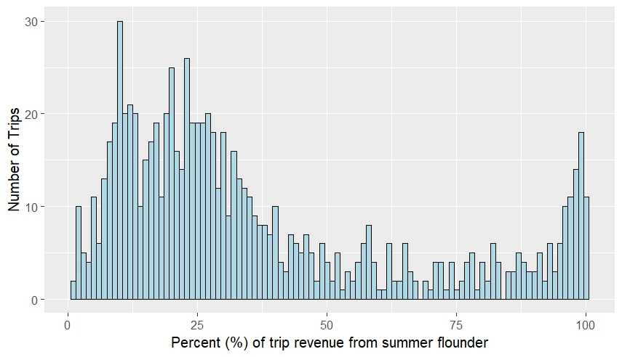
Figure S3. Percent (%) of revenue from summer flounder for trips that had kept summer flounder catch.

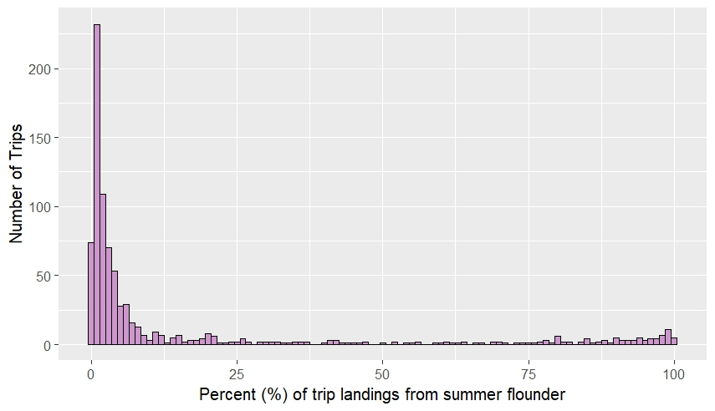
Figure S4. Percent (%) of landings from summer flounder for trips that had kept summer flounder catch.
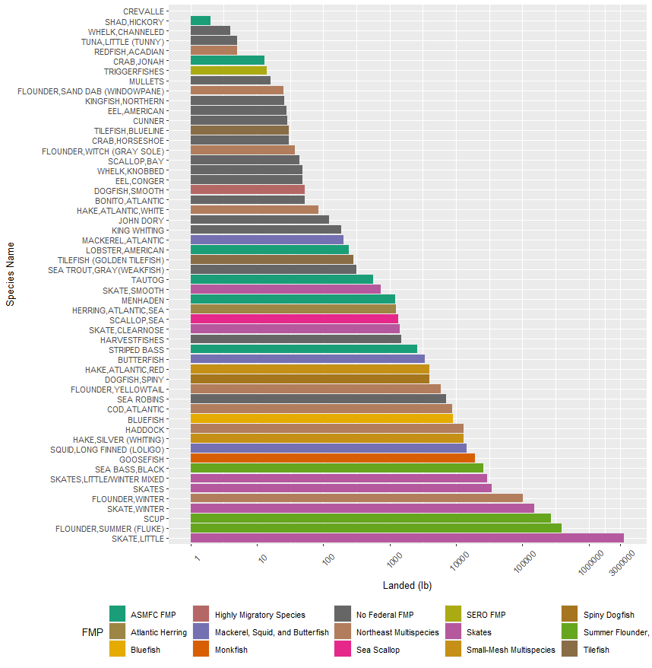
Figure S5: Reported landings by species and fisheries management plan (FMP) for “trips with summer flounder catch”; the figure is inclusive of species without reported revenues (From CAMS/GARFO DATA).
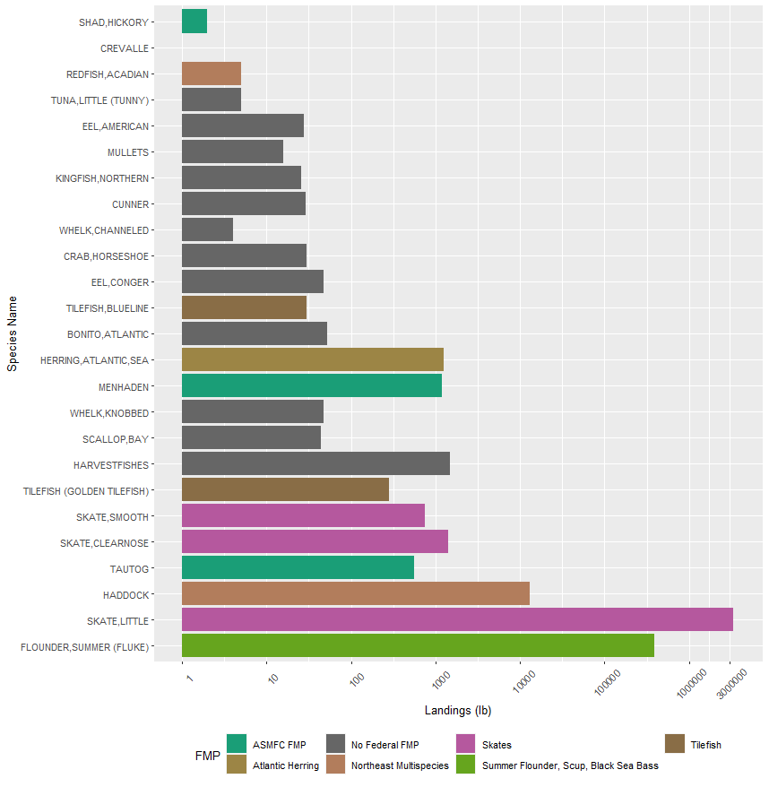
Figure S6: Landings for “summer flounder-trips” for all species with reported revenue (From CAMS/GARFO DATA).

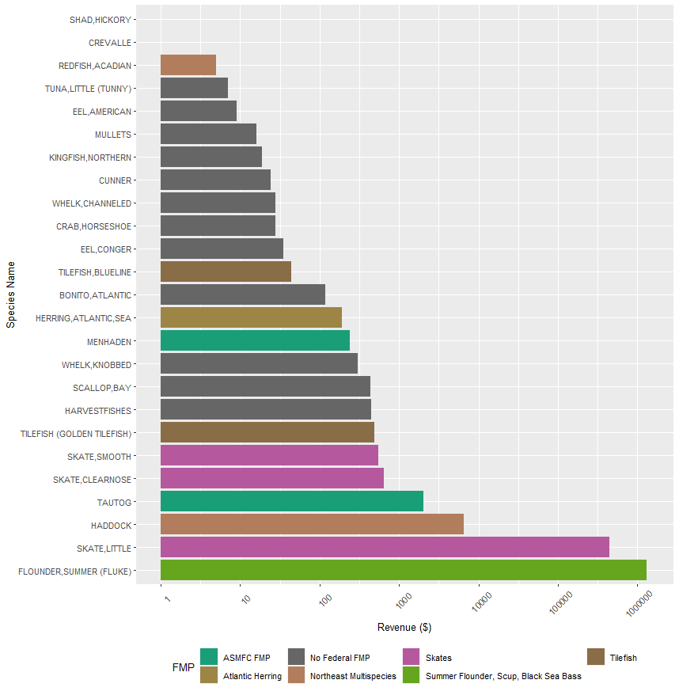
Figure S7: Revenue for “summer flounder-trips” for all species with reported revenue (From CAMS/GARFO DATA). (This revenue needs to be corrected for GDP in the next iteration).

