Supporting Information for
The potential impacts of improved MJO prediction on the prediction of MJO teleconnections in the UFS global fully coupled model
Jiabao Wang¹*, Daniela I.V. Domeisen^{2,3}, Chaim I. Garfinkel⁴, Andrea M. Jenney⁵, Hyemi Kim⁶, Zheng Wu⁷, Cheng Zheng⁸, and Cristiana Stan⁹

¹Center for Western Weather and Water Extremes, Scripps Institute of Oceanography, University of California, San Diego, USA
²University of Lausanne, Lausanne, Switzerland
³ETH Zürich, Institute for Atmospheric and Climate Science, Zürich, Switzerland
⁴The Fredy and Nadine Hermann Institute of Earth Sciences, Hebrew University of Jerusalem, Israel
⁵College of Earth, Ocean, and Atmospheric Sciences, Oregon State University, Corvallis, USA
⁶Department of Science Education, Ewha Womans University, Seoul, Republic of Korea
⁷Department of Atmospheric and Environmental Sciences, University at Albany, Albany, USA
⁸School of Marine and Atmospheric Sciences, Stony Brook University,
Stony Brook, New York, USA
⁹Department of Atmospheric, Oceanic and Earth Sciences, George Mason University, Virginia, USA

Contents of this file

Figures S1-S3

Introduction
This supporting information provides supplementary supporting figures to the main manuscript including results of the single-column model (SCM) experiments comparing the specific humidity tendency with contributions from microphysics only and all physics processes (Fig. S1), troposphere-stratosphere upward coupling (Fig. S2), modulation on the strength of the polar vortex, and the downward coupling within the stratosphere (Fig. S3). The SCM is the Common Community Physics Package (CCPP) v6.0.0 which contains the parameterizations used in the NOAA UFS. Data used to force the SCM was collected during cumulus convection activity occurring in the Barbados Oceanographic and Meteorological Experiment (BOMEX) during 22-26 June 1969 (Davidson 1968). During this period, radar observations provided a mean precipitation rate of 0.2 mm/day. The 5-day forcing is repeated to cover 35 days of simulation.
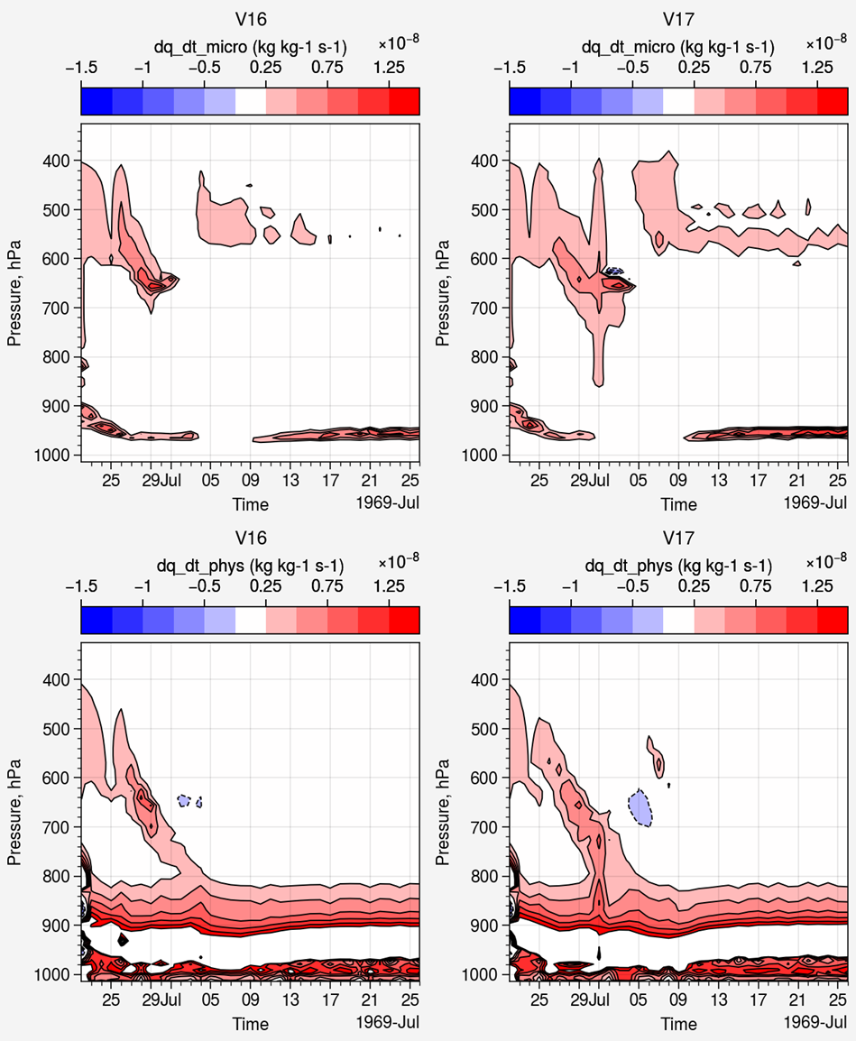

Figure S1. Specific humidity tendency in single-column simulations of physics suite GFSv16 (left) and GFSv17 (right) with the contribution of (top) microphysics only and of (bottom) all physics processes from simulations using BOMEX observations (60°W, 15°N).

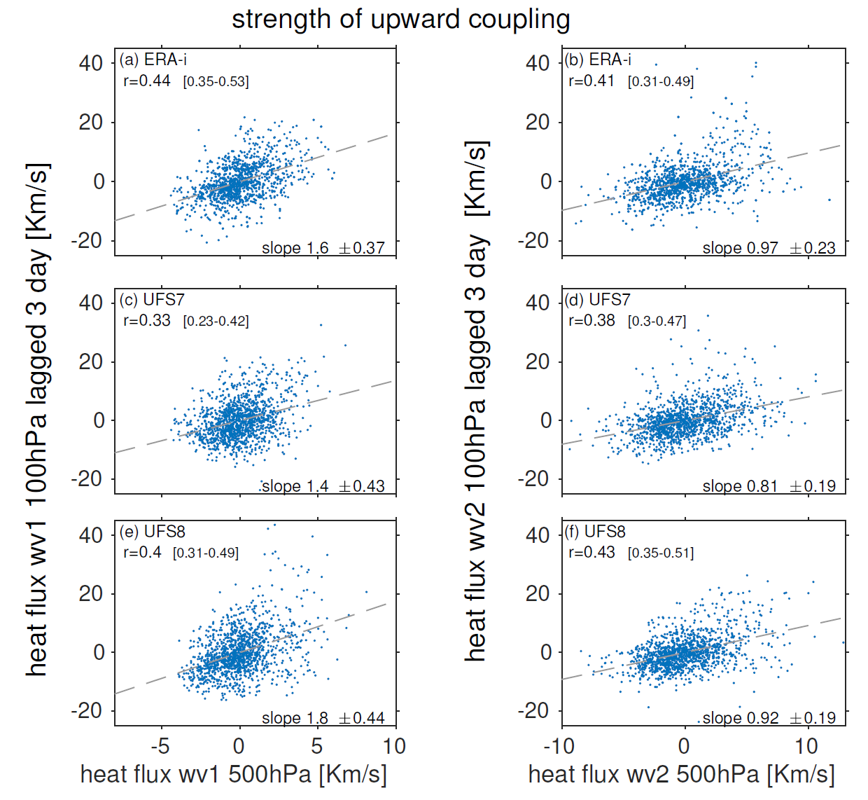
Figure S2. Comparison of (left) wavenumber-1 and (right) wavenumber-2 heat flux at 500hPa with heat flux at 100hPa three days later in Week 3-5. Heat flux is averaged over 40°-80°N.

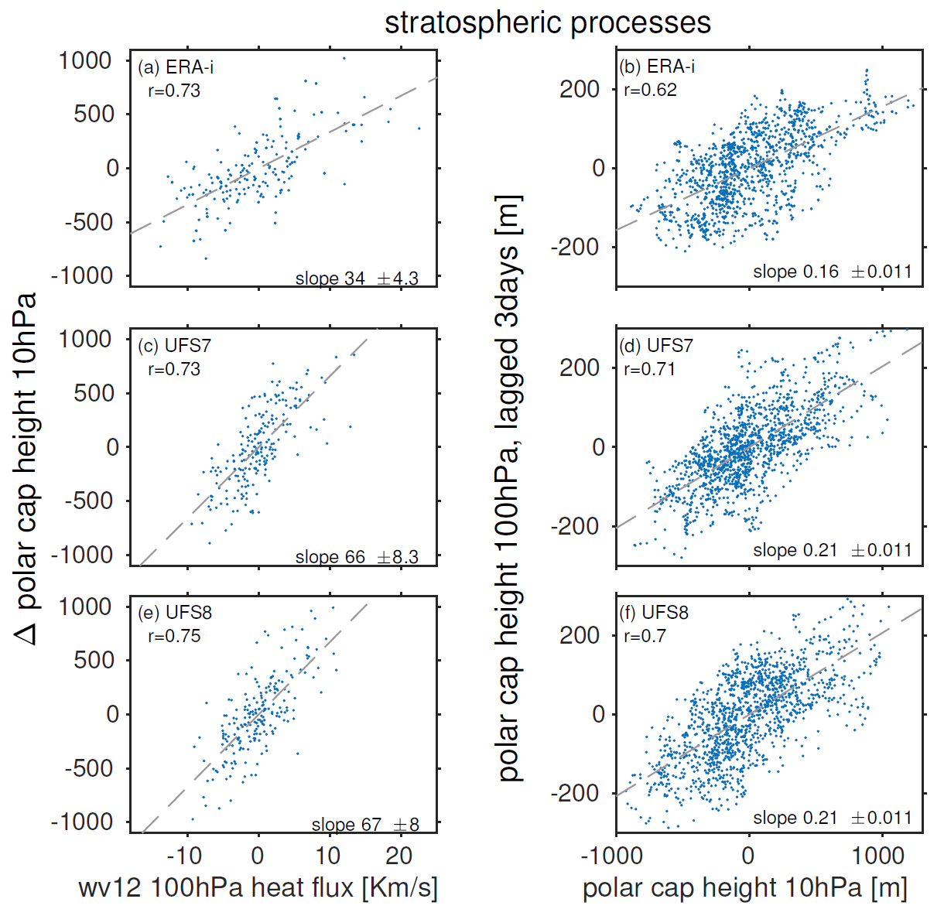
Figure S3. (Left) Comparison of wavenumber 1+2 heat flux at 100hPa in Week 2-4 with the difference in polar cap height anomalies at 10hPa one week before vs. one week after (i.e., the tendency of the vortex). (Right) Comparison of polar cap height at 10hPa with anomalies at 100hPa with a 3-day lag during Weeks 2-4. Heat flux is averaged over 40°-80°N.

References:
Davidson, B., 1968: The Barbados Oceanographic and Meteorological Experiment, Bull. Amer. Meteor. Soc., 49, 928-934.

