Geophysical Research Letters
Supporting Information for
Boundary Layer Observations and Near-Surface Wind Estimation during the Landfalls of Hurricanes Ida (2021) and Zeta (2020)
Zebulon W. Leffler¹, Xiaomin Chen^{1*}, Lawrence D. Carey¹, Kevin Knupp¹, and Wen-Chau Lee²
¹The University of Alabama in Huntsville, Huntsville, AL
²National Center for Atmospheric Research, Boulder, CO

Contents of this file

Figures S1 to S5
Tables S1 to S4

Introduction
Figure S1 is a Google Earth image of the KLIX and KASD sites detailing the 800 m distance between the radar and the ASOS station. Figure S2 shows the evolution of 10-min sustained wind direction for both hurricanes. Figure S3 provides a time series of the root mean square error (RMSE) and the explained variance of the 200-600 m log-law fit. Figure S4 is an example of a KLIX VAD wind profile. Figure S5 shows a map of the NOAA C-CAP data surrounding the KLIX and KASD sites. Table S1 includes the KLIX volume coverage patterns used for Ida (2021) and Zeta (2020). Tables S2 and S3 present the mean, median, standard deviation, maximum error, and uncertainty spread associated with each near-surface wind estimation method used within this study. Table S4 presents the NOAA C-CAP land cover data classifications and qualitative surface roughness length estimates within this study.

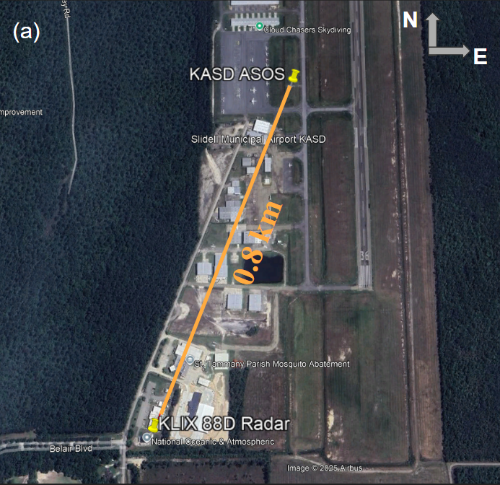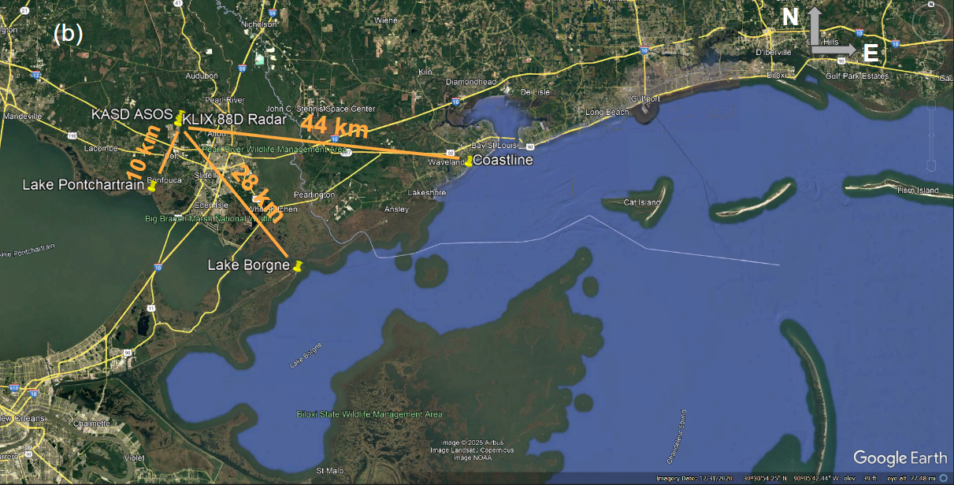
Figure S1. a) Google Earth image showing locations of the KLIX radar and KASD ASOS station, and the distance between both sites. b) Google Earth image showing the distance between the KLIX/KASD sites and Lake Pontchartrain (10 km), Lake Borgne (28 km), and the Gulf of America coastline (44 km).

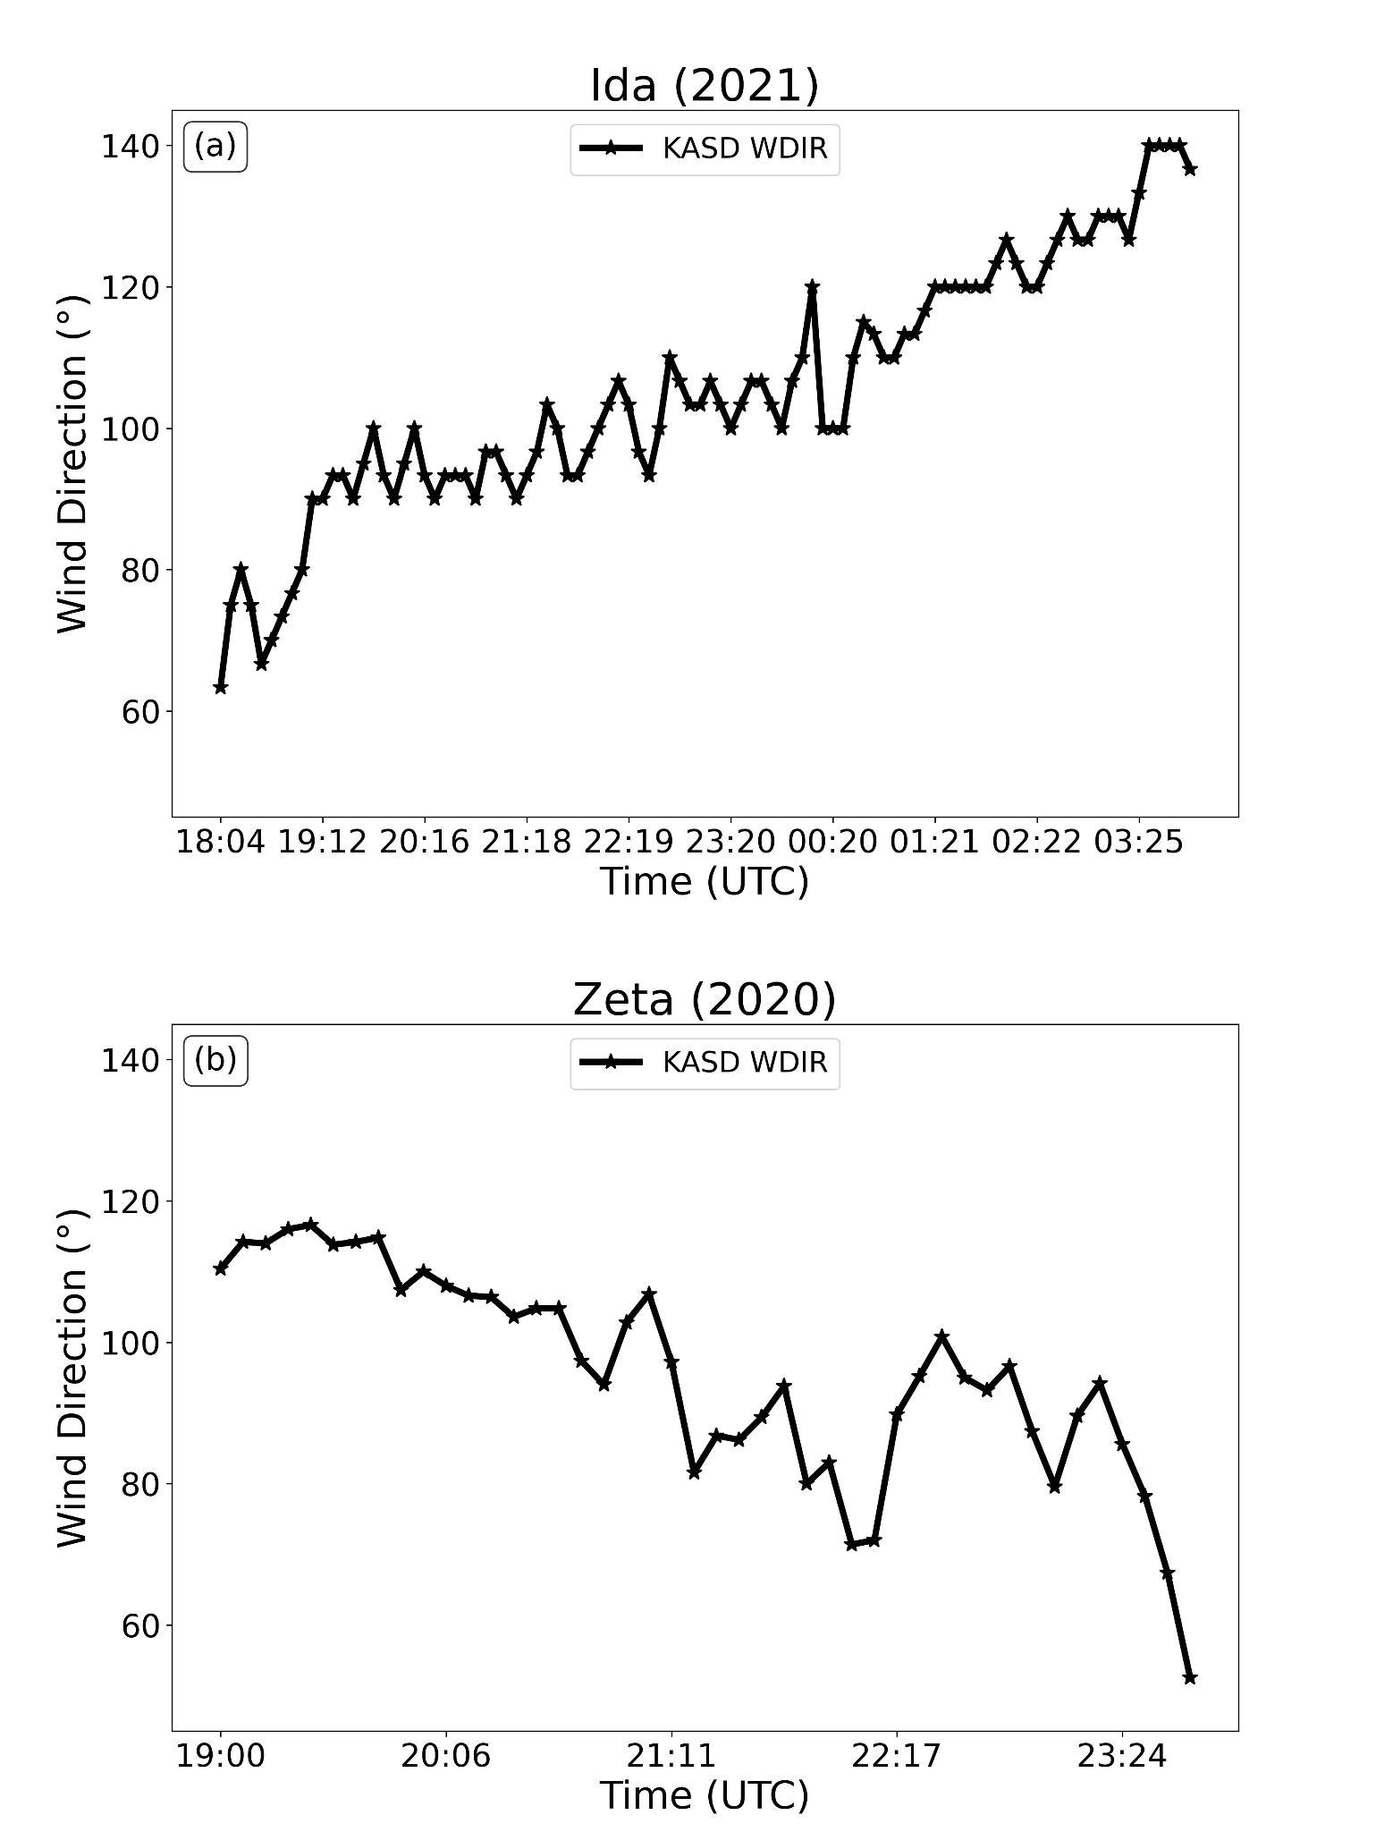

Figure S2. (a) KASD ASOS 10-min averaged wind direction observations between 1804 UTC 29 August and 0355 UTC 30 August for Ida (2021). (b) Similar to (a) but for 1900 UTC - 2344 UTC 28 October 2020 for Zeta (2020).
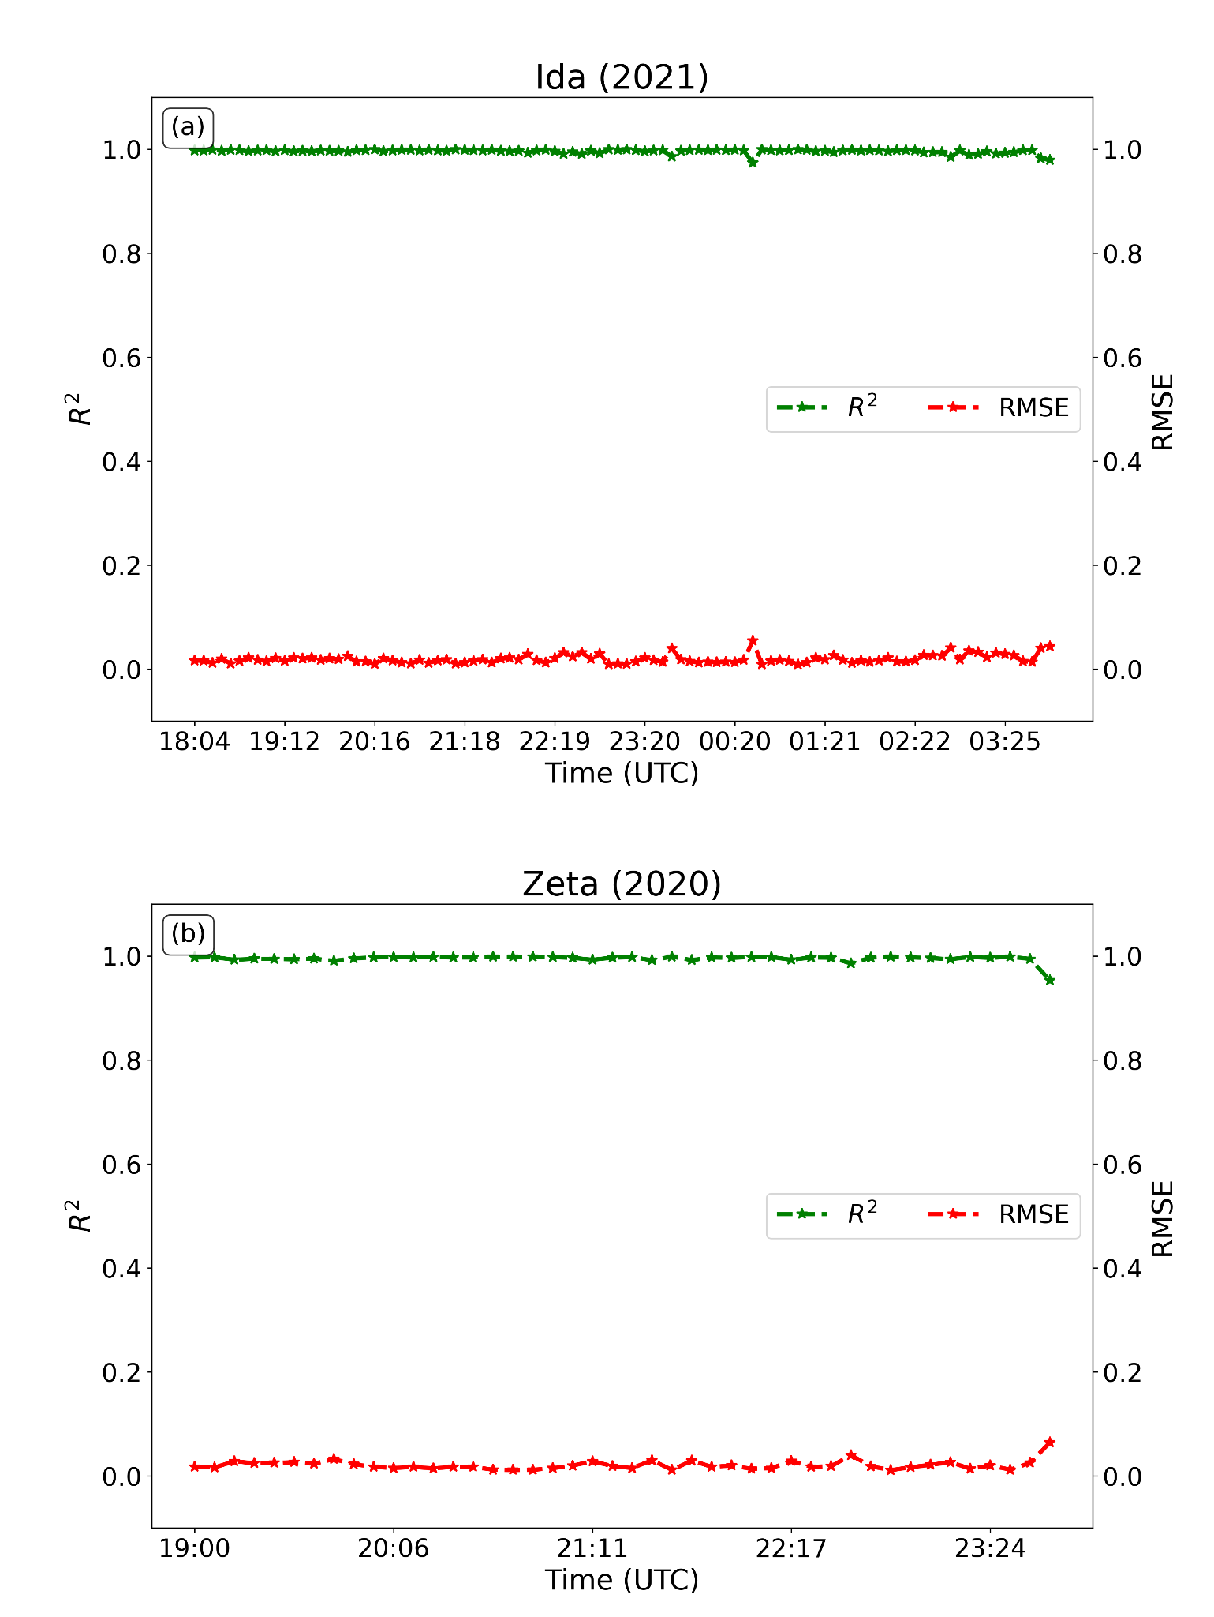
Figure S3. (a) Time series of the root mean squared error (MSE) and R-squared (R²) values for the 200-600 m log-law fit between 1804 UTC 29 August and 0355 UTC 30 August for Ida (2021). (b) Similar to (a) but for 1900 UTC - 2344 UTC 28 October 2020 for Zeta (2020). The top of the fitting layer is adjusted to 500 m at 2337 UTC and 2344 UTC to adapt to the descending jet in the eyewall.

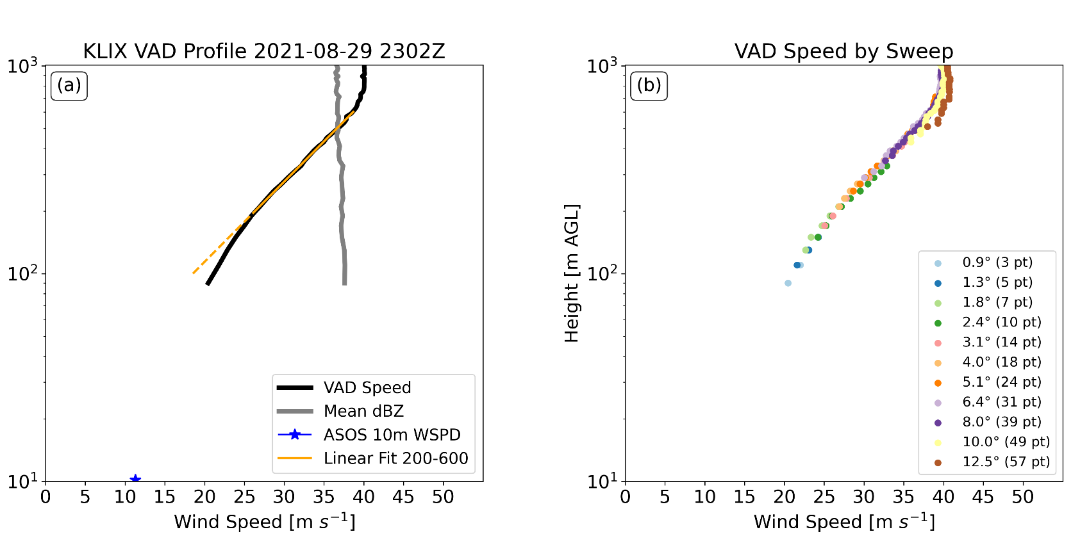
Figure S4. (a) KLIX-retrieved VAD wind profile, and (b) VAD wind speed by sweep at 2302 UTC on 29 August 2021 during Ida. The numbers of VAD outputs for each sweep are shown in the legend.

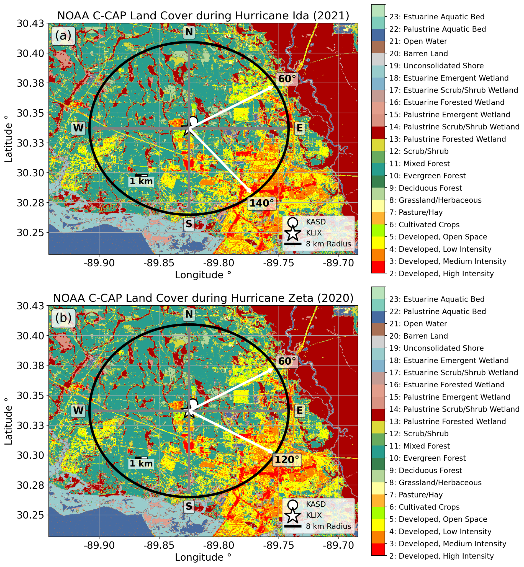
Figure S5. (a) NOAA Coastal Change Analysis Program (C-CAP) data and KASD observed wind direction ranges for Ida (2021). The black circles indicate the 8 km range ring from the KLIX radar site. White arrows represent the range of the observed KASD ASOS wind direction values. (b) Similar to (a) but for Zeta (2020).

Table S1. KLIX volume coverage patterns (VCPs) during Ida (2021) and Zeta (2020).
Hurricane | Date/Time | VCP | Elevation Angle (°)
Ida | 2021-08-29 1804 UTC - 2021-08-29 1945 UTC | 112 | 0.5, 0.5, 0.5, 0.9, 0.9, 0.9, 1.3, 1.3, 1.3, 1.8, 0.5, 0.5, 0.5, 2.4, 3.1, 4.0, 5.1, 6.4, 8.0, 10.0, 12.5, 15.6, 19.5
Ida | 2021-08-29 1952 UTC - 2021-08-30 0355 UTC | 212 | 0.5, 0.5, 0.9, 0.9, 1.3, 0.5, 0.5, 1.8, 2.4, 3.1, 4.0, 5.1, 0.5, 0.5, 6.4, 8.0, 10.0, 12.5, 19.5
Zeta | 2020-10-28 1900 UTC - 2020-10-28 2344 UTC | 212 | 0.5, 0.5, 0.9, 0.9, 1.3, 1.3, 0.5, 0.5, 1.8, 2.4, 3.1, 0.5, 0.5, 4.0, 5.1, 6.4, 8.0, 0.5, 0.5, 10.0, 12.5, 19.5

Table S2. Mean, median, standard deviation, and maximum bias for each 10-m wind estimation method used for Ida (2021) (z₀ = 0.3 m). The mean uncertainty range of V10_Diff attributable to z₀ heterogeneity within the VAD domain (see shading in Figs. 4) is shown in the rightmost column (units: m s⁻¹). Bold-face numbers denote the smallest error or value in each column.
Method | Mean | Median | Std. Deviation | Max Error | Mean range
500 m fit | -12.69 | -12.59 | 2.57 | -18.44 | n/a
500 m proj | 5.20 | 5.43 | 1.24 | 7.72 | 8.64
90 m proj | 0.90 | 1.17 | 1.29 | 3.72 | 4.67

Table S3. Same as Table S2, but for Zeta (2020)
Method | Mean | Median | Std. Deviation | Max Error | Mean range
500 m fit | -11.80 | -11.77 | 1.79 | -15.73 | n/a
500 m proj | 4.75 | 4.76 | 0.79 | 5.99 | 6.41
90 m proj | 0.87 | 0.87 | 0.60 | 1.92 | 3.21

Table S4. NOAA C-CAP land cover data classifications and corresponding qualitative roughness length values. As in Table 5 in Hirth et al. (2012).
C-CAP Classification | Description | Assigned z₀ (m)
2 | Developed, High Intensity | 1.2
3 | Developed, Medium Intensity | 0.8
4 | Developed, Low Intensity | 0.1
5 | Developed, Open Space | 0.03
6 | Cultivated Crops | 0.05
7 | Pasture/Hay | 0.03
8 | Grassland/Herbaceous | 0.03
9 | Deciduous Forest | 1.0
10 | Evergreen Forest | 1.0
11 | Mixed Forest | 1.0
12 | Scrub/Shrub | 0.35
13 | Palustrine Forested Wetland | 1.0
w14 | Palustrine Scrub/Shrub Wetland | 0.35
15 | Palustrine Emergent Wetland | 0.03
16 | Estuarine Forested Wetland | 1.0
17 | Estuarine Scrub/Shrub Wetland | 0.35
18 | Estuarine Emergent Wetland | 0.05
19 | Unconsolidated Shore | 0.01
20 | Barren Land | 0.02
21 | Open Water | 0.001
22 | Palustrine Aquatic Bed | 0.001
23 | Estuarine Aquatic Bed | 0.001

