Supplemental Information for:
Assessing Air Pollution Exposure Disparities in Disadvantaged Communities of Greater Boston: A New Cumulative Environmental Justice Score System
Khanh Doª, Yang Zhang^{a,*}, Siqi Ma^{b}, and Daniel Tong^{b}
ª Civil and Environmental Engineering Department, Northeastern University, Boston, MA 02115, USA
^{b} Atmospheric, Oceanic and Earth Sciences Department, George Mason University, Fairfax, VA 22030, USA
*Corresponding Author: ya.zhang@northeastern.edu

Modulair-PM vs FEM T640 PM_{2.5} 1-hr average:

Table S1. AQMD AQ-SPEC field evaluation
 | x | b | R²
Modulair-PM 1¹ | 0.6269 | 3.5626 | 0.8441
Modulair-PM 2¹ | 0.6709 | 2.889 | 0.8801
Modulair-PM 3¹ | 0.6234 | 2.8457 | 0.8753

Average of 3 Modulair-PM:
$$y= 0.6404x+3.099$$
$$R^{2}=0.87$$
Table S2. Total available sensors for PM_{2.5} and O₃ across the Greater Boston area, and the number of usable sensors is in parentheses.
 | PA | MODULAIR | MassDEP
PM_{2.5} sensors | 76 (44) | 20 (11) | 0
O₃ sensors | 0 | 0 | 9 (9)

¹Modulair-PM 1, Modulair-PM 2, and Modulair-PM 3 were the three Modulair PM sensors evaluated by AQMD AQ-SPEC.
Table S3. Environmental justice scores for municipalities in Massachusetts from 2016 to 2022. Table S3 is calculated based on Equation 7 and the criteria in Table 2 for all the census blocks in the municipalities. The final EJ scores are the average EJ scores from the census blocks in the municipalities.
Municipality | 2016 | 2017 | 2018 | 2019 | 2020 | 2021 | 2022
Abington town | 86.1 | 83.5 | 83.4 | 83.4 | 79.7 | 75.9 | 74.4
Acton town | 71.0 | 73.3 | 72.5 | 72.5 | 72.1 | 74.9 | 65.3
Acushnet town | 80.6 | 82.6 | 82.8 | 82.8 | 84.5 | 83.3 | 82.1
Adams town | 92.8 | 93.8 | 96.6 | 96.6 | 92.9 | 91.2 | 88.8
Agawam Town city | 90.0 | 91.4 | 91.5 | 91.5 | 87.1 | 82.3 | 81.7
Alford town | 67.6 | 65.1 | 65.6 | 65.6 | 72.1 | 69.1 | 75.8
Amesbury Town city | 77.4 | 75.8 | 75.4 | 75.4 | 76.3 | 75.3 | 72.6
Andover town | 74.0 | 72.3 | 71.3 | 71.3 | 69.2 | 70.4 | 65.0
Aquinnah town | 117.5 | 103.7 | 101.3 | 101.3 | 95.5 | 97.4 | 87.7
Arlington town | 79.7 | 80.2 | 80.5 | 80.5 | 77.8 | 73.2 | 67.7
Ashburnham town | 74.3 | 74.9 | 70.3 | 70.3 | 63.8 | 66.8 | 63.3
Ashby town | 72.4 | 71.1 | 68.9 | 68.9 | 71.6 | 71.1 | 67.3
Ashfield town | 78.6 | 79.7 | 80.4 | 80.4 | 81.3 | 81.2 | 78.0
Ashland town | 113.1 | 104.3 | 101.3 | 101.3 | 95.7 | 98.3 | 96.5
Athol town | 90.5 | 88.9 | 90.3 | 90.3 | 90.5 | 88.4 | 86.9
Attleboro city | 94.3 | 94.4 | 92.9 | 92.9 | 90.9 | 90.0 | 87.3
Auburn town | 83.8 | 84.6 | 84.0 | 84.0 | 84.0 | 79.0 | 76.1
Avon town | 103.2 | 108.7 | 109.1 | 109.1 | 95.1 | 91.8 | 91.2
Barnstable Town city | 95.8 | 93.7 | 95.0 | 95.0 | 95.9 | 91.9 | 90.2
Barre town | 82.1 | 81.8 | 80.9 | 80.9 | 78.6 | 76.3 | 72.9
Becket town | 80.4 | 79.1 | 79.7 | 79.7 | 82.3 | 82.0 | 79.1
Bedford town | 88.7 | 85.8 | 83.5 | 83.5 | 70.2 | 69.5 | 62.4
Belmont town | 79.2 | 78.2 | 80.0 | 80.0 | 76.0 | 71.3 | 69.1
Berkley town | 67.6 | 72.0 | 73.6 | 73.6 | 70.2 | 66.9 | 58.1
Berlin town | 79.4 | 78.6 | 67.4 | 67.4 | 72.3 | 71.0 | 64.6
Bernardston town | 76.6 | 77.3 | 76.5 | 76.5 | 75.9 | 74.5 | 70.8
Beverly city | 81.0 | 78.5 | 79.7 | 79.7 | 79.4 | 76.9 | 70.6
Billerica town | 77.5 | 80.4 | 80.4 | 80.4 | 78.4 | 74.9 | 73.3
Blackstone town | 84.0 | 83.2 | 78.7 | 78.7 | 81.1 | 80.7 | 76.1
Bolton town | 50.4 | 52.4 | 50.7 | 50.7 | 47.3 | 49.4 | 42.4
Boston city | 140.3 | 138.3 | 137.8 | 137.8 | 130.9 | 124.3 | 123.0
Bourne town | 85.5 | 85.7 | 85.1 | 85.1 | 83.4 | 80.2 | 78.2
Boxborough town | 80.1 | 88.2 | 87.0 | 87.0 | 88.6 | 79.3 | 80.9
Boxford town | 54.1 | 53.4 | 42.2 | 42.2 | 40.8 | 34.6 | 28.6
Boylston town | 83.3 | 84.0 | 82.3 | 82.3 | 72.5 | 66.6 | 66.0
Braintree Town city | 97.8 | 99.3 | 98.1 | 98.1 | 101.4 | 94.5 | 93.6
Brewster town | 76.0 | 77.8 | 77.8 | 77.8 | 77.0 | 75.5 | 70.1
Brimfield town | 78.0 | 77.1 | 79.9 | 79.9 | 80.6 | 73.9 | 69.8
Brockton city | 157.3 | 157.0 | 155.4 | 155.4 | 155.9 | 151.8 | 153.0
Brookfield town | 85.2 | 84.2 | 82.9 | 82.9 | 79.4 | 77.9 | 77.7
Brookline town | 92.4 | 91.7 | 91.2 | 91.2 | 86.5 | 84.2 | 81.1
Buckland town | 85.4 | 87.3 | 85.9 | 85.9 | 86.7 | 85.1 | 81.9
Burlington town | 86.6 | 84.7 | 80.9 | 80.9 | 67.6 | 61.4 | 55.5
Cambridge city | 102.9 | 102.7 | 102.9 | 102.9 | 97.9 | 95.0 | 92.5
Canton town | 76.2 | 75.5 | 72.3 | 72.3 | 76.6 | 71.4 | 68.6
Carlisle town | 51.8 | 49.4 | 48.2 | 48.2 | 42.8 | 36.1 | 28.6
Carver town | 77.6 | 78.7 | 81.7 | 81.7 | 84.2 | 85.0 | 80.2
Charlton town | 75.2 | 75.1 | 70.7 | 70.7 | 70.1 | 66.9 | 63.5
Chatham town | 79.8 | 77.0 | 74.8 | 74.8 | 73.1 | 67.1 | 65.8
Chelmsford town | 78.9 | 78.3 | 77.4 | 77.4 | 75.2 | 71.9 | 69.5
Chelsea city | 200.4 | 194.5 | 188.8 | 188.8 | 193.4 | 180.7 | 188.4
Cheshire town | 85.8 | 83.2 | 83.9 | 83.9 | 80.4 | 81.2 | 80.9
Chicopee city | 112.7 | 113.6 | 114.9 | 114.9 | 119.3 | 117.5 | 116.6
Chilmark town | 73.1 | 76.7 | 71.8 | 71.8 | 74.9 | 67.7 | 49.2
Clarksburg town | 81.9 | 81.5 | 79.9 | 79.9 | 78.7 | 80.2 | 77.9
Clinton town | 109.5 | 110.5 | 114.5 | 114.5 | 115.9 | 109.5 | 113.5
Colrain town | 85.1 | 87.1 | 85.9 | 85.9 | 85.8 | 86.4 | 76.4
Concord town | 54.7 | 58.5 | 57.6 | 57.6 | 51.6 | 47.3 | 44.6
Conway town | 70.6 | 66.1 | 67.8 | 67.8 | 69.9 | 73.9 | 70.1
Cummington town | 88.0 | 88.0 | 85.9 | 85.9 | 80.4 | 78.7 | 75.5
Dalton town | 83.6 | 82.3 | 83.2 | 83.2 | 78.8 | 78.4 | 78.4
Danvers town | 77.7 | 79.1 | 75.6 | 75.6 | 77.8 | 74.6 | 69.7
Dartmouth town | 85.6 | 84.4 | 82.9 | 82.9 | 80.7 | 79.3 | 78.9
Dedham town | 84.4 | 84.0 | 82.6 | 82.6 | 79.4 | 78.9 | 77.4
Deerfield town | 83.4 | 82.0 | 85.7 | 85.7 | 80.4 | 80.3 | 77.9
Dennis town | 92.3 | 92.7 | 93.0 | 93.0 | 89.4 | 84.6 | 80.6
Dighton town | 69.7 | 74.0 | 77.5 | 77.5 | 74.1 | 69.8 | 60.4
Dover town | 38.7 | 34.5 | 26.2 | 26.2 | 23.2 | 26.1 | 24.4
Dracut town | 80.6 | 81.6 | 82.1 | 82.1 | 86.0 | 85.8 | 83.9
Dudley town | 94.6 | 100.8 | 102.3 | 102.3 | 104.7 | 102.5 | 100.5
Dunstable town | 65.6 | 57.9 | 61.9 | 61.9 | 54.2 | 52.3 | 43.1
Duxbury town | 55.0 | 52.7 | 48.4 | 48.4 | 52.3 | 50.8 | 39.9
East Bridgewater town | 79.0 | 74.1 | 75.8 | 75.8 | 71.9 | 68.3 | 64.7
East Brookfield town | 81.1 | 84.5 | 80.5 | 80.5 | 81.7 | 84.2 | 81.6
East Longmeadow town | 84.0 | 82.4 | 82.9 | 82.9 | 82.6 | 80.4 | 77.7
Eastham town | 85.3 | 84.6 | 81.7 | 81.7 | 85.2 | 81.2 | 81.7
Easthampton Town city | 91.7 | 91.0 | 90.1 | 90.1 | 91.4 | 90.3 | 88.4
Easton town | 78.8 | 78.2 | 76.5 | 76.5 | 78.7 | 74.5 | 71.5
Edgartown town | 70.9 | 77.7 | 77.8 | 77.8 | 78.9 | 78.0 | 77.3
Erving town | 85.4 | 83.1 | 87.4 | 87.4 | 89.8 | 89.4 | 87.2
Essex town | 68.3 | 62.7 | 66.1 | 66.1 | 67.0 | 62.9 | 56.1
Everett city | 167.0 | 167.6 | 171.0 | 171.0 | 173.5 | 167.0 | 172.3
Fairhaven town | 86.4 | 87.2 | 85.8 | 85.8 | 80.6 | 79.1 | 76.0
Fall River city | 119.7 | 118.8 | 121.3 | 121.3 | 122.4 | 117.0 | 119.8
Falmouth town | 88.9 | 88.5 | 86.9 | 86.9 | 85.5 | 83.9 | 80.8
Fitchburg city | 127.0 | 127.5 | 127.4 | 127.4 | 130.3 | 126.1 | 127.5
Florida town | 84.2 | 86.3 | 84.2 | 84.2 | 82.3 | 80.7 | 76.9
Foxborough town | 74.1 | 73.3 | 74.0 | 74.0 | 81.8 | 80.2 | 77.8
Franklin Town city | 65.6 | 63.8 | 64.4 | 64.4 | 59.6 | 55.1 | 53.8
Freetown town | 72.3 | 73.9 | 72.4 | 72.4 | 71.4 | 68.4 | 57.1
Gardner city | 105.3 | 104.8 | 103.8 | 103.8 | 102.7 | 101.1 | 100.0
Georgetown town | 66.1 | 64.3 | 61.0 | 61.0 | 62.0 | 59.6 | 51.6
Gill town | 84.4 | 86.9 | 88.8 | 88.8 | 89.8 | 86.0 | 83.5
Gloucester city | 87.9 | 87.9 | 88.9 | 88.9 | 86.4 | 83.5 | 83.4
Grafton town | 83.4 | 82.0 | 83.6 | 83.6 | 86.3 | 84.7 | 81.0
Granby town | 79.1 | 76.9 | 76.2 | 76.2 | 75.8 | 73.4 | 70.3
Groton town | 65.8 | 63.8 | 62.3 | 62.3 | 53.7 | 43.2 | 36.8
Groveland town | 69.9 | 73.8 | 70.7 | 70.7 | 63.5 | 54.8 | 52.4
Hadley town | 95.3 | 93.8 | 90.9 | 90.9 | 86.5 | 82.1 | 75.4
Halifax town | 78.7 | 77.6 | 74.7 | 74.7 | 72.6 | 70.6 | 66.6
Hamilton town | 62.4 | 65.4 | 59.0 | 59.0 | 54.3 | 54.4 | 48.2
Hampden town | 78.1 | 77.9 | 75.9 | 75.9 | 68.5 | 67.0 | 66.6
Hancock town | 79.4 | 80.3 | 84.1 | 84.1 | 85.0 | 81.0 | 74.8
Hanover town | 64.6 | 59.7 | 59.0 | 59.0 | 49.9 | 47.0 | 48.9
Hanson town | 70.5 | 67.4 | 63.9 | 63.9 | 66.0 | 65.2 | 64.5
Hardwick town | 88.4 | 89.3 | 89.1 | 89.1 | 88.8 | 85.7 | 84.3
Harwich town | 86.6 | 85.0 | 84.3 | 84.3 | 83.3 | 83.6 | 81.2
Hatfield town | 82.1 | 84.7 | 85.2 | 85.2 | 84.7 | 79.9 | 71.2
Haverhill city | 103.5 | 103.8 | 105.9 | 105.9 | 106.0 | 102.4 | 100.0
Hawley town | 87.2 | 86.0 | 85.6 | 85.6 | 90.5 | 91.0 | 88.0
Heath town | 90.1 | 89.0 | 88.3 | 88.3 | 79.9 | 78.0 | 77.3
Hingham town | 54.9 | 55.0 | 50.0 | 50.0 | 46.4 | 41.4 | 34.5
Hinsdale town | 84.7 | 81.8 | 81.2 | 81.2 | 82.4 | 83.0 | 89.8
Holbrook town | 97.5 | 101.4 | 103.3 | 103.3 | 103.7 | 102.9 | 94.7
Holden town | 73.7 | 72.6 | 71.5 | 71.5 | 68.8 | 66.3 | 64.2
Holland town | 78.9 | 78.3 | 76.8 | 76.8 | 80.1 | 79.2 | 76.9
Holliston town | 70.1 | 65.6 | 63.4 | 63.4 | 60.2 | 61.2 | 58.4
Holyoke city | 163.0 | 161.7 | 163.7 | 163.7 | 166.9 | 159.2 | 164.3
Hopedale town | 76.6 | 77.2 | 74.8 | 74.8 | 74.8 | 72.1 | 67.9
Hopkinton town | 58.9 | 56.5 | 53.1 | 53.1 | 50.9 | 49.6 | 44.5
Hubbardston town | 74.9 | 73.2 | 76.6 | 76.6 | 71.6 | 69.1 | 64.5
Hudson town | 90.0 | 91.3 | 90.7 | 90.7 | 86.1 | 85.7 | 80.6
Hull town | 78.2 | 77.9 | 76.2 | 76.2 | 71.7 | 66.5 | 62.2
Huntington town | 80.9 | 82.8 | 87.6 | 87.6 | 83.0 | 84.6 | 80.6
Ipswich town | 81.4 | 80.5 | 78.1 | 78.1 | 70.1 | 67.6 | 63.8
Kingston town | 73.7 | 69.5 | 69.2 | 69.2 | 68.5 | 65.6 | 59.5
Lakeville town | 70.5 | 69.8 | 66.7 | 66.7 | 67.7 | 65.9 | 60.8
Lancaster town | 87.2 | 85.7 | 89.5 | 89.5 | 85.7 | 78.5 | 77.6
Lanesborough town | 78.4 | 77.8 | 81.0 | 81.0 | 81.8 | 80.1 | 76.2
Lawrence city | 214.0 | 211.5 | 214.7 | 214.7 | 208.9 | 195.6 | 203.7
Lee town | 91.3 | 87.7 | 87.7 | 87.7 | 79.0 | 79.1 | 83.1
Leicester town | 93.0 | 88.2 | 85.0 | 85.0 | 87.0 | 87.0 | 81.1
Lenox town | 83.4 | 81.5 | 81.6 | 81.6 | 76.2 | 70.4 | 63.5
Leominster city | 115.8 | 117.6 | 121.9 | 121.9 | 119.7 | 112.6 | 113.8
Leverett town | 78.7 | 78.5 | 77.4 | 77.4 | 77.4 | 76.1 | 72.5
Lexington town | 73.6 | 72.9 | 73.0 | 73.0 | 69.3 | 66.9 | 68.9
Leyden town | 83.1 | 81.9 | 81.1 | 81.1 | 80.4 | 77.5 | 77.0
Littleton town | 66.9 | 61.5 | 66.1 | 66.1 | 66.8 | 62.4 | 61.7
Longmeadow town | 75.3 | 72.7 | 72.9 | 72.9 | 70.5 | 66.8 | 64.6
Lowell city | 156.1 | 155.4 | 156.2 | 156.2 | 148.7 | 142.8 | 143.7
Ludlow town | 97.3 | 95.6 | 96.9 | 96.9 | 99.3 | 98.1 | 100.8
Lunenburg town | 76.6 | 74.0 | 75.2 | 75.2 | 75.0 | 75.6 | 73.0
Lynn city | 155.3 | 154.8 | 156.9 | 156.9 | 158.9 | 151.3 | 154.2
Lynnfield town | 57.2 | 59.5 | 52.1 | 52.1 | 45.7 | 42.7 | 39.2
Malden city | 155.9 | 152.3 | 157.2 | 157.2 | 147.7 | 137.7 | 140.8
Manchester-by-the-Sea | 65.1 | 64.1 | 55.2 | 55.2 | 36.1 | 31.5 | 23.8
Mansfield town | 71.8 | 69.3 | 69.9 | 69.9 | 65.2 | 63.1 | 60.0
Marblehead town | 67.5 | 64.5 | 63.1 | 63.1 | 54.7 | 46.6 | 40.6
Marion town | 81.5 | 80.9 | 79.6 | 79.6 | 80.5 | 71.9 | 75.2
Marlborough city | 114.3 | 115.5 | 115.6 | 115.6 | 119.9 | 114.8 | 114.1
Marshfield town | 75.1 | 74.6 | 73.5 | 73.5 | 62.7 | 56.1 | 49.5
Mashpee town | 85.9 | 85.8 | 87.4 | 87.4 | 84.2 | 81.2 | 79.1
Mattapoisett town | 74.9 | 74.6 | 71.5 | 71.5 | 71.9 | 63.7 | 64.0
Maynard town | 80.0 | 80.9 | 77.2 | 77.2 | 76.0 | 70.9 | 69.8
Medfield town | 49.0 | 43.3 | 42.5 | 42.5 | 39.2 | 35.3 | 34.7
Medford city | 99.0 | 98.2 | 96.0 | 96.0 | 91.8 | 87.1 | 86.3
Medway town | 71.0 | 70.2 | 71.9 | 71.9 | 74.8 | 72.9 | 59.7
Melrose city | 80.0 | 74.6 | 70.1 | 70.1 | 75.3 | 70.8 | 73.1
Mendon town | 57.6 | 57.2 | 58.5 | 58.5 | 63.0 | 66.5 | 67.2
Merrimac town | 72.9 | 70.0 | 68.9 | 68.9 | 73.5 | 70.0 | 62.8
Methuen Town city | 106.4 | 108.1 | 108.6 | 108.6 | 110.3 | 107.7 | 104.6
Middleborough town | 74.4 | 73.2 | 70.7 | 70.7 | 76.5 | 77.5 | 76.5
Middlefield town | 77.0 | 77.6 | 78.7 | 78.7 | 78.2 | 76.3 | 74.0
Milford town | 120.0 | 122.2 | 123.8 | 123.8 | 127.5 | 124.6 | 131.4
Millbury town | 88.1 | 85.5 | 83.7 | 83.7 | 87.3 | 83.4 | 81.7
Millville town | 71.7 | 72.6 | 77.4 | 77.4 | 77.4 | 77.1 | 73.8
Milton town | 73.8 | 70.5 | 70.4 | 70.4 | 63.6 | 58.4 | 54.8
Monson town | 80.1 | 78.5 | 77.8 | 77.8 | 79.3 | 81.7 | 76.5
Montague town | 93.1 | 95.1 | 95.9 | 95.9 | 94.2 | 90.9 | 89.5
Monterey town | 85.5 | 85.1 | 82.4 | 82.4 | 66.3 | 65.9 | 63.3
Mount Washington town | 84.5 | 86.4 | 85.5 | 85.5 | 82.5 | 78.5 | 74.8
Nahant town | 83.4 | 78.7 | 77.9 | 77.9 | 71.8 | 64.8 | 63.4
Nantucket town | 90.0 | 90.5 | 80.7 | 80.7 | 75.6 | 75.8 | 76.5
Natick town | 80.9 | 82.8 | 80.5 | 80.5 | 78.3 | 74.8 | 71.8
Needham town | 56.3 | 57.6 | 52.9 | 52.9 | 39.9 | 38.3 | 32.9
New Ashford town | 77.3 | 77.9 | 79.6 | 79.6 | 82.2 | 83.1 | 78.5
New Bedford city | 143.6 | 143.5 | 142.5 | 142.5 | 140.1 | 135.6 | 136.1
New Braintree town | 73.4 | 72.4 | 71.0 | 71.0 | 71.1 | 72.6 | 67.1
New Marlborough town | 78.1 | 77.9 | 79.3 | 79.3 | 79.3 | 80.1 | 78.8
New Salem town | 80.4 | 80.7 | 82.4 | 82.4 | 83.8 | 82.8 | 80.6
Newbury town | 72.6 | 71.3 | 72.9 | 72.9 | 47.2 | 37.3 | 35.5
Newburyport city | 67.3 | 67.1 | 61.0 | 61.0 | 56.7 | 54.8 | 44.9
Newton city | 74.4 | 71.1 | 71.0 | 71.0 | 67.1 | 63.4 | 63.0
Norfolk town | 54.0 | 54.7 | 53.4 | 53.4 | 49.9 | 46.0 | 40.7
North Adams city | 101.8 | 100.5 | 99.6 | 99.6 | 98.5 | 97.8 | 96.9
North Andover town | 73.2 | 73.1 | 72.9 | 72.9 | 67.4 | 67.6 | 64.7
North Brookfield town | 80.9 | 81.6 | 81.1 | 81.1 | 80.9 | 80.0 | 77.6
Northampton city | 96.8 | 96.4 | 96.7 | 96.7 | 94.7 | 93.0 | 91.4
Northborough town | 78.6 | 78.7 | 78.4 | 78.4 | 68.7 | 66.3 | 63.5
Northbridge town | 87.6 | 87.7 | 86.1 | 86.1 | 79.5 | 71.4 | 71.4
Northfield town | 82.8 | 80.8 | 81.3 | 81.3 | 80.3 | 77.1 | 72.4
Norton town | 74.6 | 71.1 | 69.9 | 69.9 | 69.7 | 67.1 | 65.9
Norwell town | 60.3 | 56.6 | 47.6 | 47.6 | 42.8 | 38.1 | 39.0
Norwood town | 94.6 | 93.9 | 95.7 | 95.7 | 100.4 | 95.8 | 97.9
Oak Bluffs town | 91.4 | 91.5 | 90.6 | 90.6 | 87.5 | 80.8 | 87.4
Oakham town | 74.7 | 74.9 | 76.4 | 76.4 | 77.0 | 77.3 | 74.2
Orange town | 95.0 | 93.6 | 92.3 | 92.3 | 90.5 | 92.1 | 92.4
Orleans town | 82.6 | 80.2 | 77.6 | 77.6 | 73.6 | 69.3 | 64.5
Otis town | 80.6 | 79.9 | 75.0 | 75.0 | 73.4 | 71.4 | 66.4
Oxford town | 88.5 | 86.6 | 88.7 | 88.7 | 82.1 | 81.4 | 77.8
Palmer Town city | 91.4 | 89.6 | 92.2 | 92.2 | 93.3 | 92.3 | 91.2
Paxton town | 80.1 | 79.8 | 80.5 | 80.5 | 64.8 | 62.3 | 61.3
Peabody city | 98.2 | 99.0 | 99.8 | 99.8 | 97.0 | 92.9 | 90.1
Pembroke town | 68.9 | 65.1 | 65.4 | 65.4 | 62.4 | 57.8 | 53.8
Pepperell town | 78.1 | 77.6 | 75.9 | 75.9 | 75.2 | 72.7 | 69.1
Peru town | 78.1 | 77.8 | 77.5 | 77.5 | 77.4 | 76.2 | 74.2
Pittsfield city | 101.8 | 101.2 | 102.3 | 102.3 | 99.8 | 99.6 | 98.2
Plainfield town | 88.1 | 88.3 | 90.8 | 90.8 | 85.4 | 83.3 | 87.5
Plymouth town | 80.4 | 78.0 | 78.1 | 78.1 | 77.3 | 75.3 | 72.4
Plympton town | 72.9 | 68.8 | 72.2 | 72.2 | 64.2 | 59.8 | 63.1
Princeton town | 60.1 | 57.5 | 55.2 | 55.2 | 57.3 | 50.6 | 45.8
Provincetown town | 107.7 | 107.0 | 107.0 | 107.0 | 103.9 | 98.5 | 86.0
Quincy city | 130.4 | 127.6 | 130.4 | 130.4 | 129.9 | 121.2 | 122.6
Raynham town | 72.6 | 72.0 | 74.2 | 74.2 | 75.9 | 82.9 | 80.3
Reading town | 68.5 | 65.4 | 64.6 | 64.6 | 62.8 | 59.2 | 56.9
Rehoboth town | 72.1 | 69.8 | 68.0 | 68.0 | 62.7 | 60.3 | 59.0
Revere city | 148.0 | 146.9 | 150.5 | 150.5 | 151.5 | 143.4 | 146.0
Richmond town | 72.1 | 69.9 | 72.9 | 72.9 | 69.8 | 73.7 | 73.5
Rochester town | 66.8 | 64.7 | 69.0 | 69.0 | 65.1 | 66.0 | 65.2
Rockland town | 89.1 | 89.0 | 88.4 | 88.4 | 91.0 | 88.3 | 84.5
Rockport town | 79.2 | 76.4 | 74.4 | 74.4 | 72.2 | 69.4 | 67.5
Rowe town | 93.2 | 94.3 | 96.1 | 96.1 | 93.9 | 90.9 | 89.3
Rowley town | 72.0 | 68.8 | 65.9 | 65.9 | 64.6 | 62.7 | 55.8
Salem city | 107.4 | 108.6 | 107.4 | 107.4 | 105.8 | 101.9 | 100.4
Salisbury town | 82.9 | 80.5 | 75.0 | 75.0 | 77.3 | 72.2 | 67.7
Sandisfield town | 81.6 | 81.4 | 82.6 | 82.6 | 79.6 | 77.4 | 81.3
Sandwich town | 74.8 | 73.5 | 73.1 | 73.1 | 69.1 | 64.1 | 59.1
Saugus town | 93.5 | 94.9 | 97.6 | 97.6 | 94.3 | 95.0 | 92.5
Savoy town | 90.0 | 87.5 | 85.9 | 85.9 | 91.5 | 89.5 | 87.6
Scituate town | 57.7 | 53.3 | 52.1 | 52.1 | 43.1 | 38.5 | 39.0
Seekonk town | 79.7 | 79.2 | 77.3 | 77.3 | 77.2 | 74.3 | 74.0
Sharon town | 78.2 | 80.3 | 82.1 | 82.1 | 73.1 | 69.0 | 64.3
Sheffield town | 83.2 | 82.6 | 79.4 | 79.4 | 85.1 | 81.0 | 74.2
Shelburne town | 88.4 | 87.3 | 87.3 | 87.3 | 89.1 | 86.6 | 89.1
Sherborn town | 54.0 | 46.2 | 42.8 | 42.8 | 34.9 | 32.2 | 24.6
Shirley town | 97.9 | 101.9 | 101.8 | 101.8 | 96.9 | 90.8 | 88.1
Shrewsbury town | 87.5 | 87.7 | 88.1 | 88.1 | 81.3 | 81.3 | 74.9
Shutesbury town | 81.1 | 83.4 | 81.2 | 81.2 | 81.4 | 80.8 | 74.4
Somerset town | 84.7 | 84.4 | 84.7 | 84.7 | 73.0 | 72.6 | 70.0
Somerville city | 105.8 | 102.9 | 101.2 | 101.2 | 97.3 | 89.7 | 84.5
South Hadley town | 84.3 | 84.9 | 84.2 | 84.2 | 85.3 | 83.3 | 78.7
Southampton town | 74.1 | 73.2 | 73.5 | 73.5 | 73.9 | 69.5 | 68.1
Southborough town | 63.4 | 68.3 | 68.5 | 68.5 | 63.8 | 61.0 | 55.1
Southbridge Town city | 133.1 | 132.8 | 135.0 | 135.0 | 134.9 | 134.4 | 137.3
Southwick town | 75.6 | 75.1 | 76.8 | 76.8 | 78.4 | 72.5 | 69.5
Spencer town | 78.7 | 80.6 | 79.4 | 79.4 | 81.5 | 80.0 | 80.6
Springfield city | 171.2 | 170.3 | 171.0 | 171.0 | 172.5 | 166.5 | 170.1
Sterling town | 67.1 | 70.5 | 73.0 | 73.0 | 58.0 | 66.3 | 63.3
Stockbridge town | 78.3 | 86.3 | 86.9 | 86.9 | 89.9 | 88.5 | 81.3
Stoneham town | 88.5 | 86.6 | 86.8 | 86.8 | 75.4 | 72.4 | 70.9
Stoughton town | 108.6 | 112.4 | 115.9 | 115.9 | 111.7 | 110.1 | 111.7
Sturbridge town | 81.3 | 81.2 | 81.4 | 81.4 | 80.3 | 83.0 | 76.8
Sudbury town | 53.8 | 50.1 | 49.6 | 49.6 | 44.6 | 33.8 | 27.8
Sunderland town | 103.1 | 105.4 | 109.8 | 109.8 | 113.8 | 111.2 | 109.4
Sutton town | 60.3 | 62.2 | 61.8 | 61.8 | 65.6 | 63.7 | 58.6
Swampscott town | 59.7 | 57.1 | 49.7 | 49.7 | 54.2 | 49.0 | 44.3
Swansea town | 81.2 | 81.3 | 79.8 | 79.8 | 74.0 | 72.1 | 64.1
Taunton city | 105.5 | 106.9 | 107.5 | 107.5 | 106.2 | 104.8 | 104.6
Tewksbury town | 75.5 | 76.0 | 74.2 | 74.2 | 73.3 | 71.0 | 68.6
Tisbury town | 111.2 | 110.2 | 110.1 | 110.1 | 112.1 | 110.1 | 108.5
Topsfield town | 57.3 | 55.6 | 54.9 | 54.9 | 53.0 | 43.6 | 46.6
Townsend town | 76.6 | 76.2 | 77.3 | 77.3 | 76.2 | 74.8 | 72.8
Truro town | 85.7 | 93.2 | 95.8 | 95.8 | 101.9 | 71.1 | 80.2
Tyngsborough town | 72.4 | 72.8 | 74.2 | 74.2 | 76.7 | 71.1 | 67.8
Tyringham town | 76.5 | 74.2 | 78.1 | 78.1 | 70.2 | 65.4 | 53.8
Upton town | 60.2 | 57.6 | 60.8 | 60.8 | 59.6 | 57.2 | 54.2
Uxbridge town | 72.9 | 72.9 | 68.1 | 68.1 | 68.3 | 64.9 | 63.3
Wakefield town | 77.8 | 78.1 | 78.4 | 78.4 | 71.7 | 70.3 | 65.8
Wales town | 89.8 | 90.5 | 89.7 | 89.7 | 79.5 | 74.7 | 72.7
Walpole town | 76.8 | 72.9 | 72.3 | 72.3 | 67.8 | 61.3 | 58.7
Waltham city | 108.7 | 110.3 | 111.3 | 111.3 | 108.6 | 102.8 | 99.8
Ware town | 94.9 | 96.4 | 96.9 | 96.9 | 95.5 | 92.7 | 91.3
Wareham town | 92.8 | 90.0 | 92.5 | 92.5 | 89.2 | 88.5 | 84.2
Warren town | 80.7 | 78.5 | 77.7 | 77.7 | 83.1 | 81.9 | 79.4
Warwick town | 84.7 | 82.5 | 85.2 | 85.2 | 82.4 | 77.5 | 74.9
Washington town | 76.2 | 72.5 | 74.9 | 74.9 | 77.9 | 77.4 | 74.0
Watertown Town city | 81.0 | 80.4 | 76.2 | 76.2 | 77.7 | 79.4 | 75.7
Wayland town | 66.9 | 61.3 | 60.9 | 60.9 | 51.9 | 51.8 | 49.7
Webster town | 100.6 | 100.1 | 98.8 | 98.8 | 99.6 | 94.2 | 96.6
Wellesley town | 47.7 | 46.5 | 46.3 | 46.3 | 42.7 | 40.3 | 36.1
Wellfleet town | 84.6 | 84.9 | 83.0 | 83.0 | 83.1 | 81.5 | 79.2
Wendell town | 98.5 | 98.9 | 99.8 | 99.8 | 90.3 | 91.3 | 88.6
Wenham town | 61.9 | 66.2 | 63.1 | 63.1 | 54.5 | 47.1 | 29.9
West Boylston town | 83.0 | 82.5 | 77.2 | 77.2 | 85.7 | 83.1 | 80.5
West Bridgewater town | 79.9 | 76.4 | 78.8 | 78.8 | 75.7 | 70.9 | 71.7
West Brookfield town | 83.2 | 81.8 | 80.0 | 80.0 | 81.2 | 79.8 | 76.7
West Newbury town | 51.0 | 51.9 | 53.3 | 53.3 | 54.1 | 50.2 | 42.7
West Springfield Town city | 108.8 | 110.4 | 109.8 | 109.8 | 108.8 | 104.5 | 103.3
West Stockbridge town | 82.0 | 79.7 | 80.1 | 80.1 | 79.5 | 81.2 | 81.1
West Tisbury town | 77.0 | 76.0 | 76.2 | 76.2 | 74.1 | 60.8 | 45.6
Westborough town | 87.9 | 90.7 | 90.6 | 90.6 | 86.2 | 86.1 | 82.8
Westfield city | 91.9 | 93.1 | 94.6 | 94.6 | 93.0 | 90.4 | 91.4
Westford town | 72.9 | 71.1 | 71.0 | 71.0 | 71.0 | 66.5 | 63.3
Westhampton town | 73.6 | 72.5 | 71.9 | 71.9 | 73.5 | 72.0 | 71.7
Westminster town | 68.8 | 67.9 | 68.7 | 68.7 | 70.9 | 67.9 | 70.9
Weston town | 39.4 | 40.9 | 42.6 | 42.6 | 40.8 | 32.0 | 38.3
Westport town | 78.3 | 77.3 | 76.9 | 76.9 | 77.6 | 74.0 | 72.4
Westwood town | 58.8 | 56.4 | 54.6 | 54.6 | 59.4 | 53.2 | 48.3
Weymouth Town city | 88.2 | 87.9 | 85.2 | 85.2 | 82.1 | 82.0 | 75.4
Whately town | 82.4 | 81.7 | 84.5 | 84.5 | 77.1 | 74.8 | 71.2
Whitman town | 79.5 | 79.9 | 79.8 | 79.8 | 80.7 | 79.6 | 77.4
Wilbraham town | 71.2 | 69.4 | 68.6 | 68.6 | 67.3 | 66.1 | 62.7
Williamstown town | 96.0 | 92.8 | 90.8 | 90.8 | 85.1 | 80.2 | 77.3
Wilmington town | 75.3 | 71.7 | 70.3 | 70.3 | 62.7 | 58.1 | 53.6
Winchester town | 58.8 | 56.7 | 56.1 | 56.1 | 49.9 | 48.0 | 42.2
Windsor town | 77.3 | 75.6 | 75.6 | 75.6 | 75.1 | 70.1 | 68.5
Winthrop Town city | 92.5 | 90.7 | 89.4 | 89.4 | 88.0 | 83.1 | 78.0
Woburn city | 93.5 | 94.3 | 93.8 | 93.8 | 94.2 | 92.0 | 87.6
Worcester city | 140.9 | 143.1 | 145.0 | 145.0 | 143.0 | 137.0 | 137.7
Wrentham town | 69.9 | 67.3 | 66.0 | 66.0 | 60.3 | 58.7 | 56.0
Yarmouth town | 95.8 | 94.5 | 95.4 | 95.4 | 94.0 | 91.6 | 89.1

Tables S4. PM_{2.5} and O₃ statistics for the EJ groups from MA EJ system and Cumulative EJ score method.
 | Minimum |  | Maximum |  | Average
 | PM_{2.5} | O₃ | PM_{2.5} | O₃ | PM_{2.5} | O₃
EJ MA System | 4.87 | 59.9 | 6.87 | 64.8 | 6.0 | 63.7
Cumulative EJ Score | 4.82 | 59.9 | 6.89 | 64.8 | 6.0 | 63.6
All Census blocks | 4.64 | 59.9 | 6.89 | 64.8 | 5.8 | 62.9

Tables S5. Statistic table for EJ indicators calculated using Cumulative EJ Score.
 | Cumulative EJ Score
 | Minimum | Maximum | Average
PM_{2.5} [µg m⁻³] | 4.82 | 6.87 | 6.0
O₃ [ppb] | 59.9 | 64.8 | 63.6
Income [$] | 11,123 | 250,000 | 99,158
Minority [%] | 5.5 | 99.5 | 46.4
English Isolation [%] | 0.0 | 67.8 | 10.0

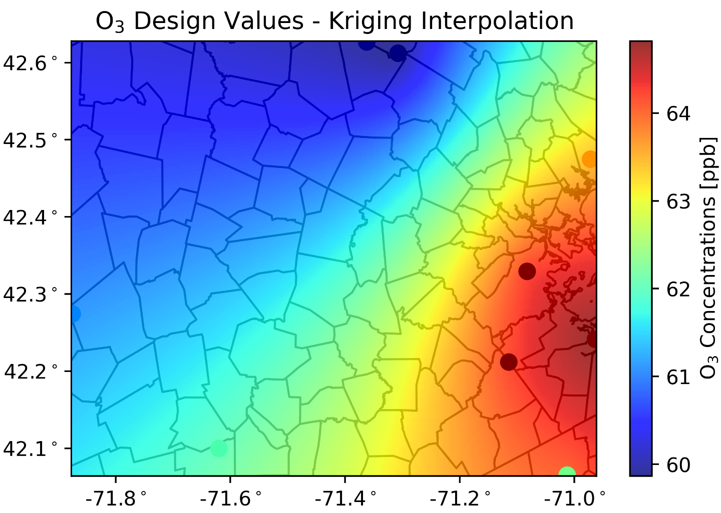
Figure S1. O₃ design values interpolated from 9 MassDEP air monitoring stations over the Greater Boston area. Ordinary Kriging interpolation method was employed to estimate 2D O₃ concentrations. The dots are the location of the MassDEP stations, and the color corresponds to the levels of O₃.
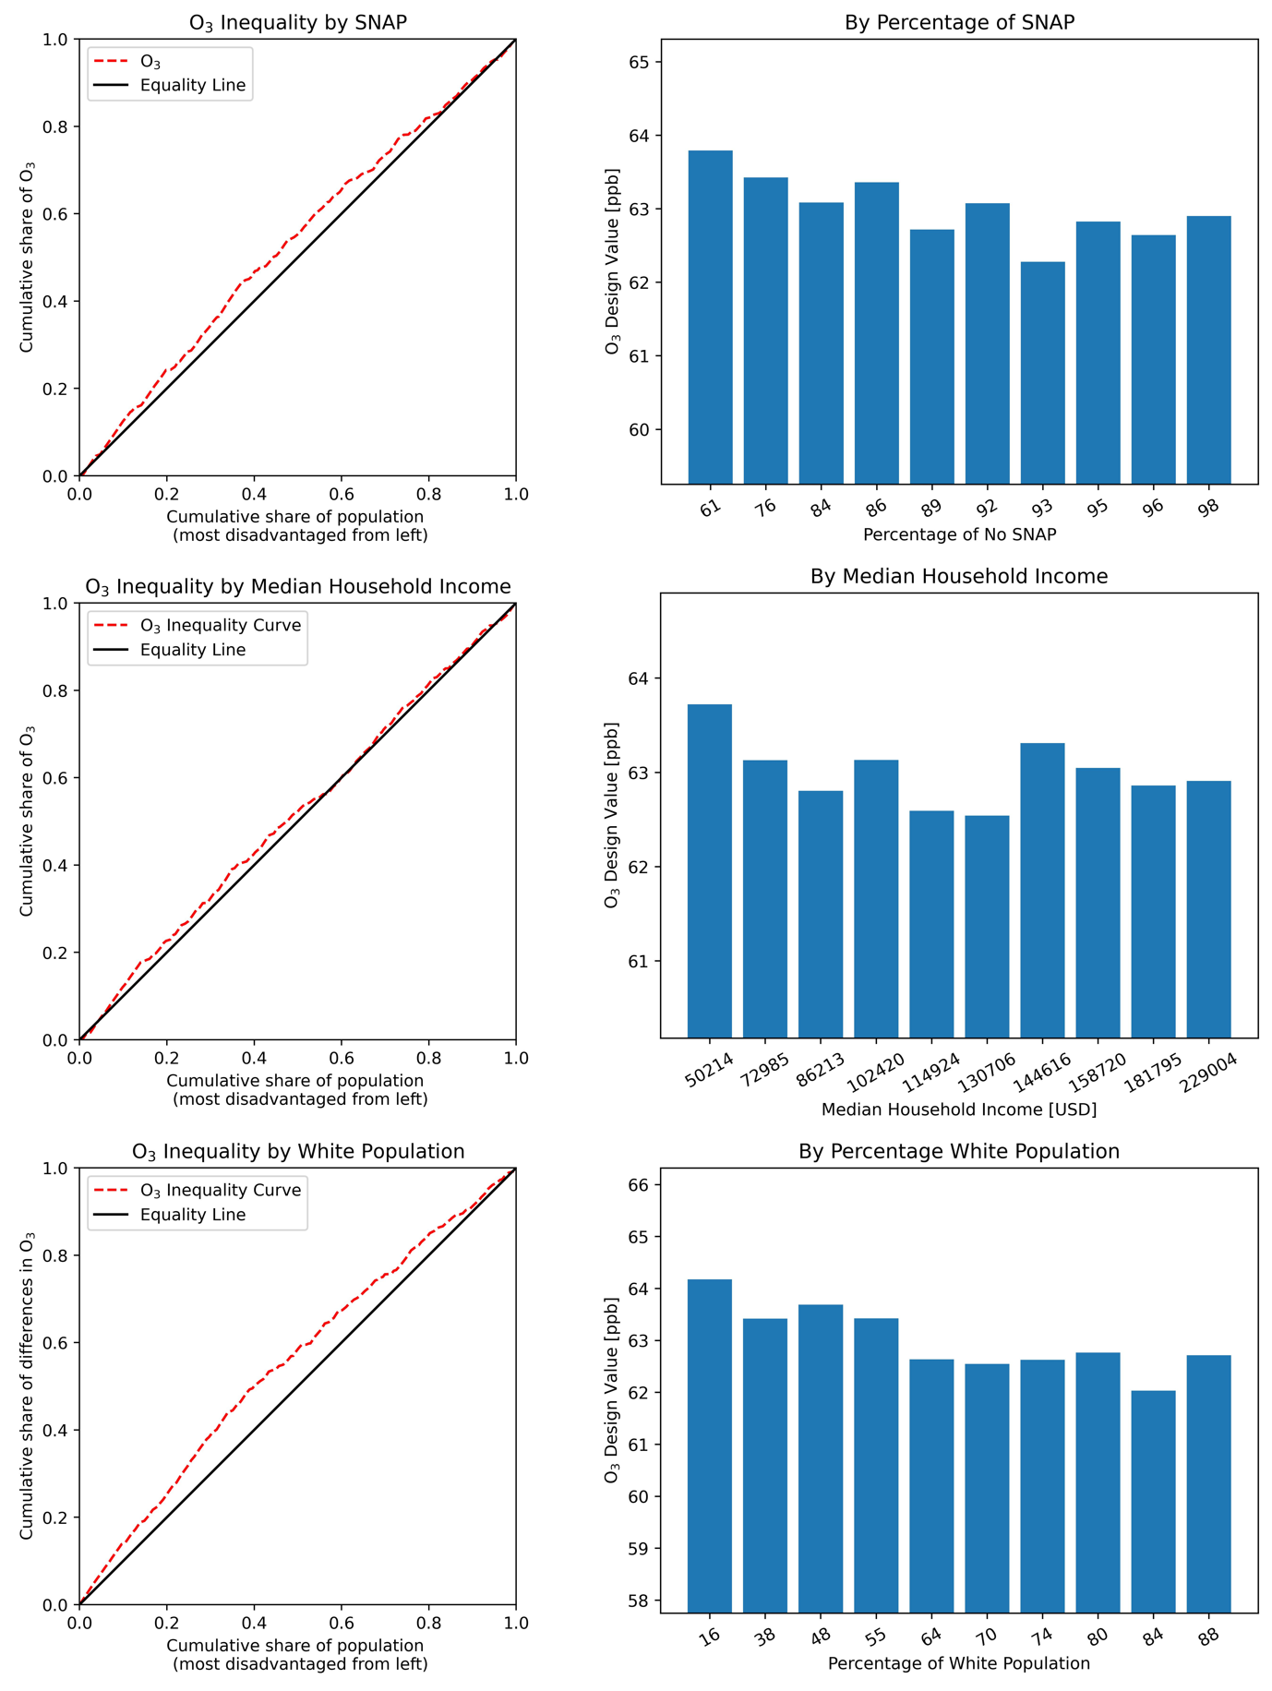
Figure S2. Environmental inequality curve of cumulative share of difference in O₃ exposure (left panels), and individual O₃ exposure with bar plots (right panels) for Supplemental Nutrition Assistance Program (SNAP), median household income, and percentage of white population. The most disadvantaged groups are from the left of the x-axis.
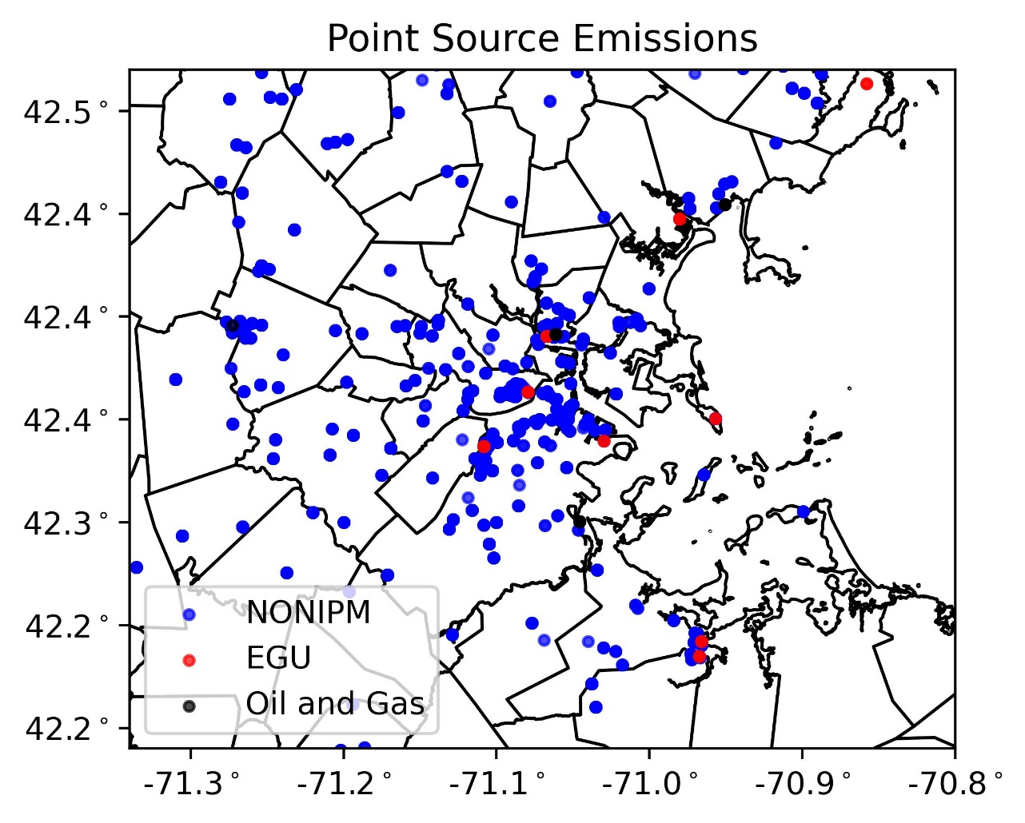
Figure S3. Point source emission locations in the Greater Boson Area based on 1km resolution George Mason University Emissions. The blue dots are emissions non integrated planning model (NONIPM), the red dots are electric generating units (EGU), and the black dots are oil and gas.

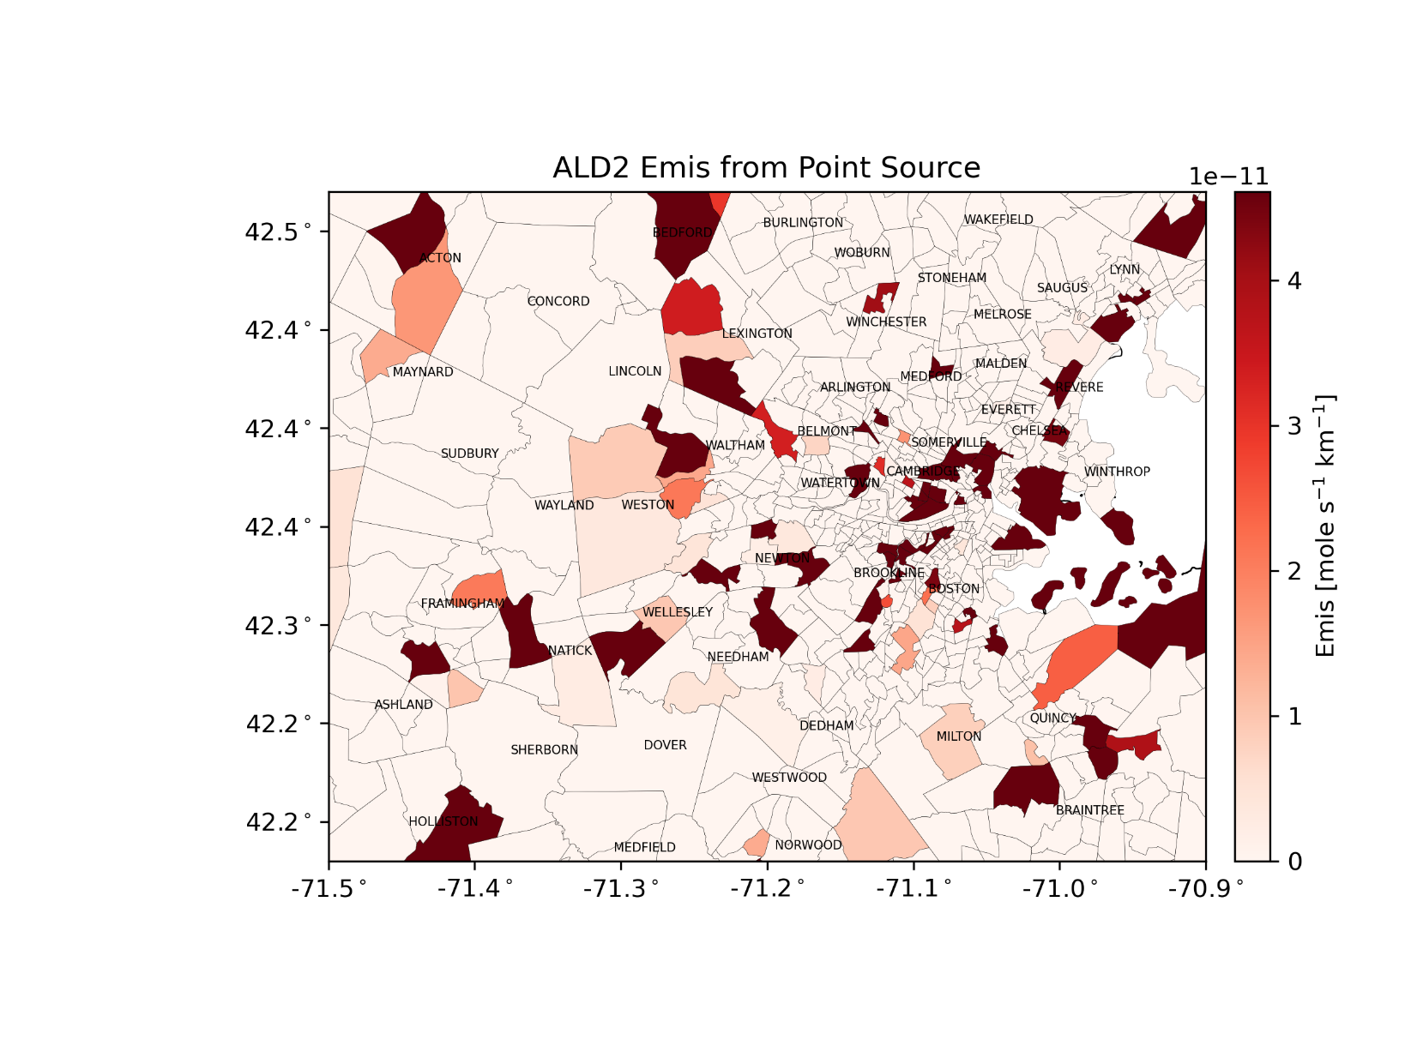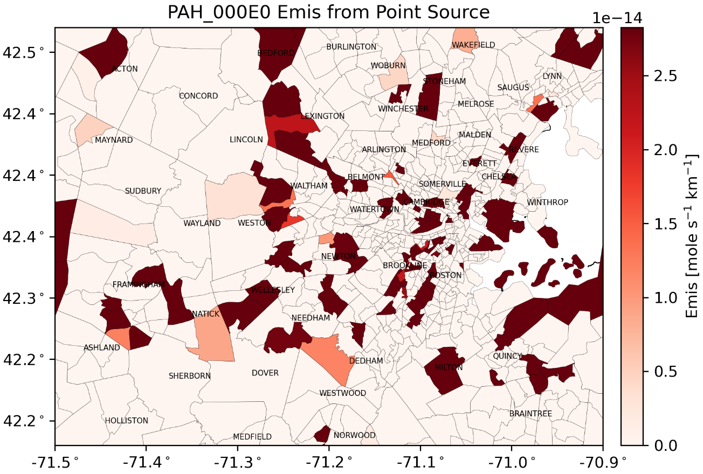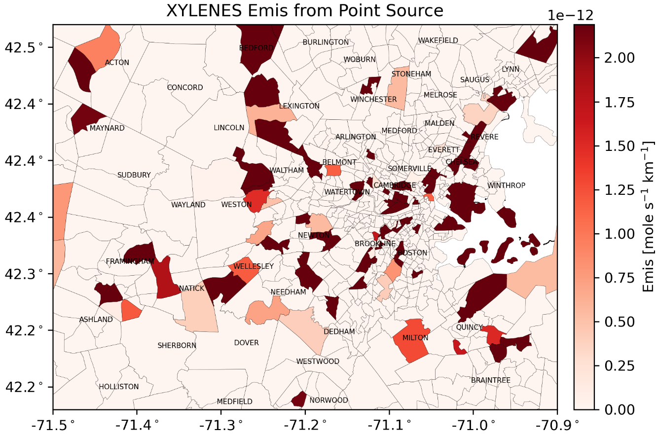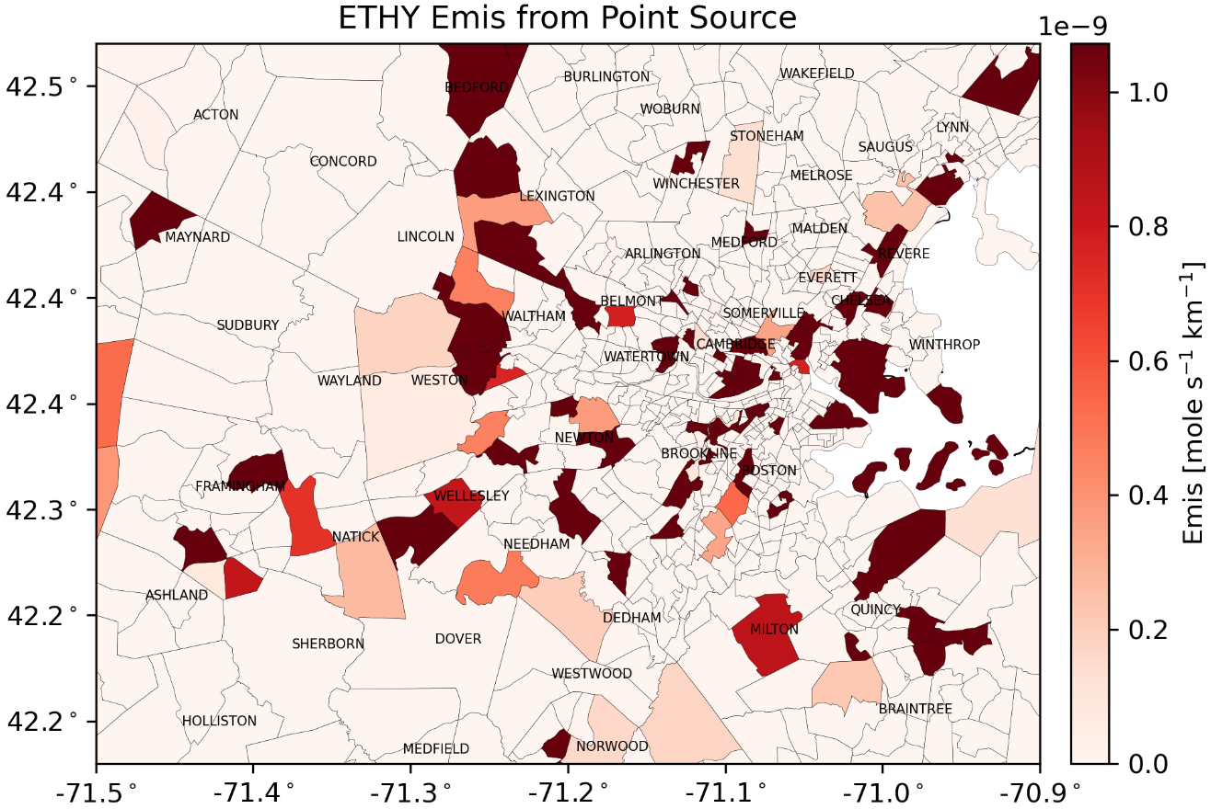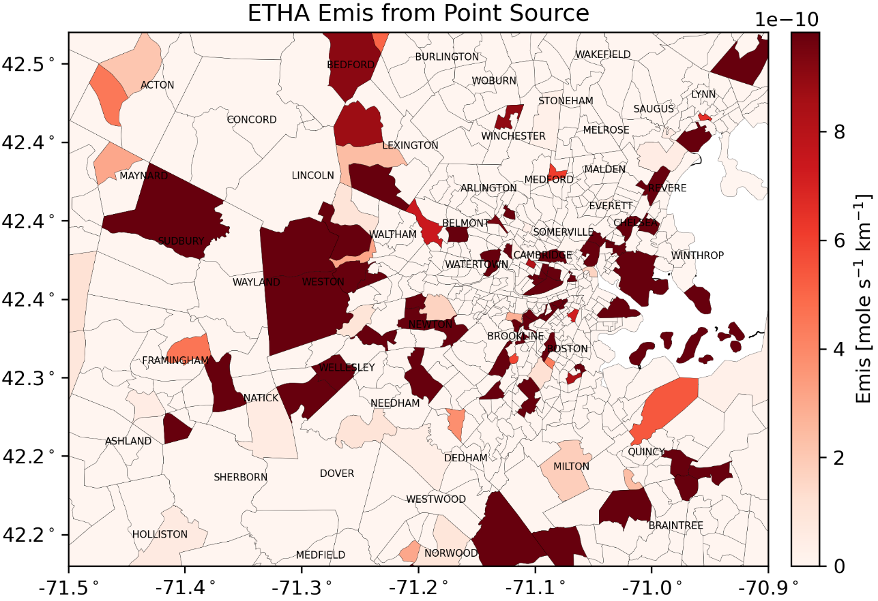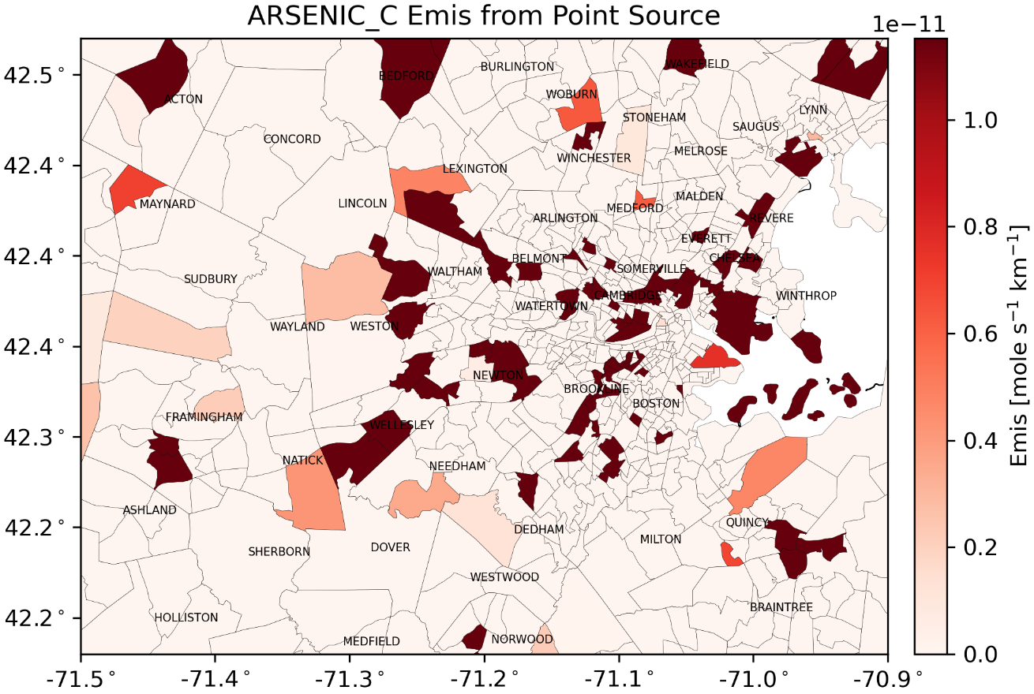
Figure S4. Point source emissions over the Greater Boston area.

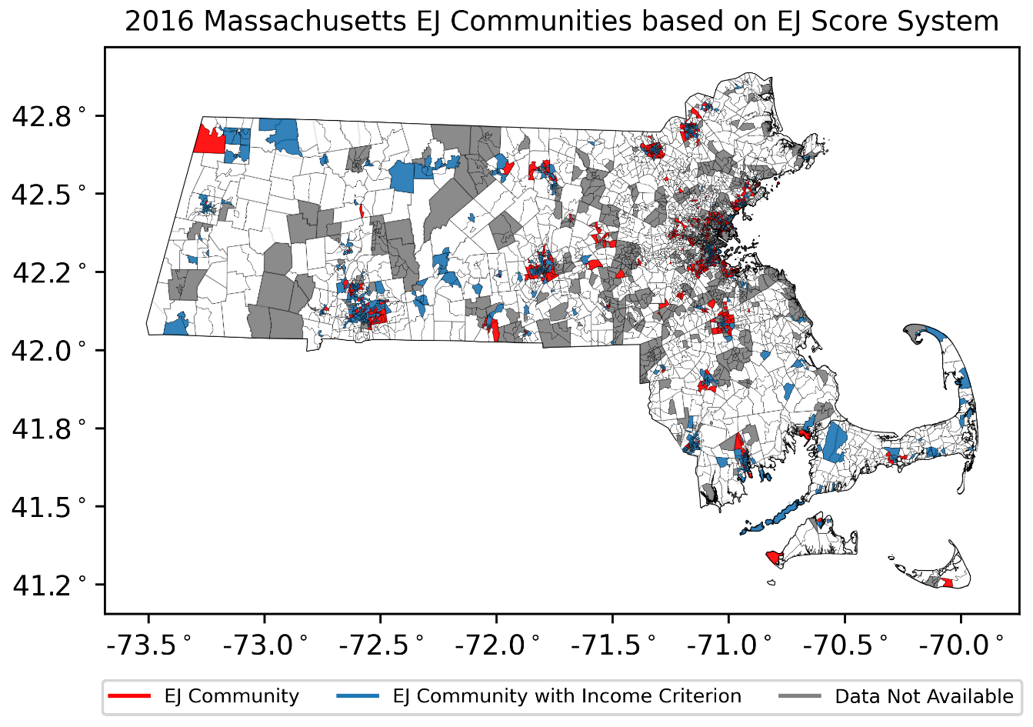
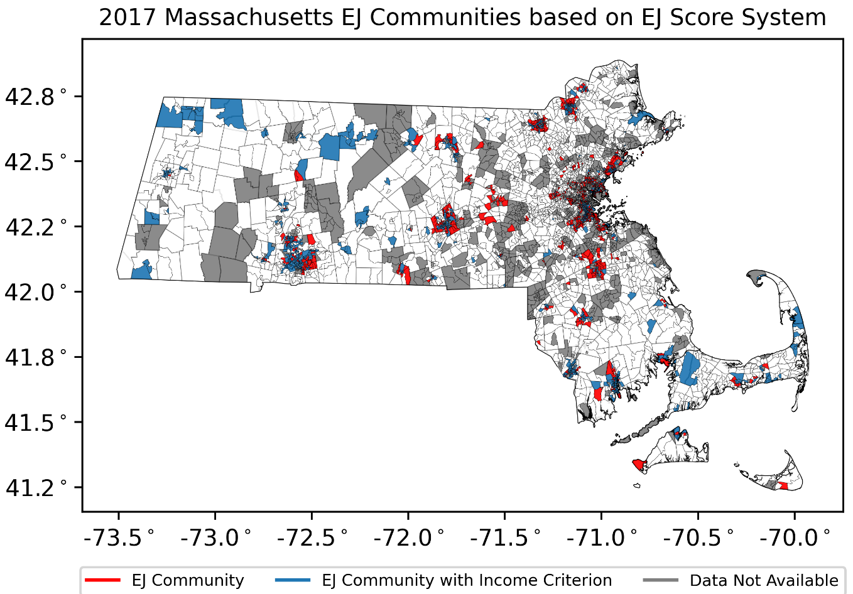
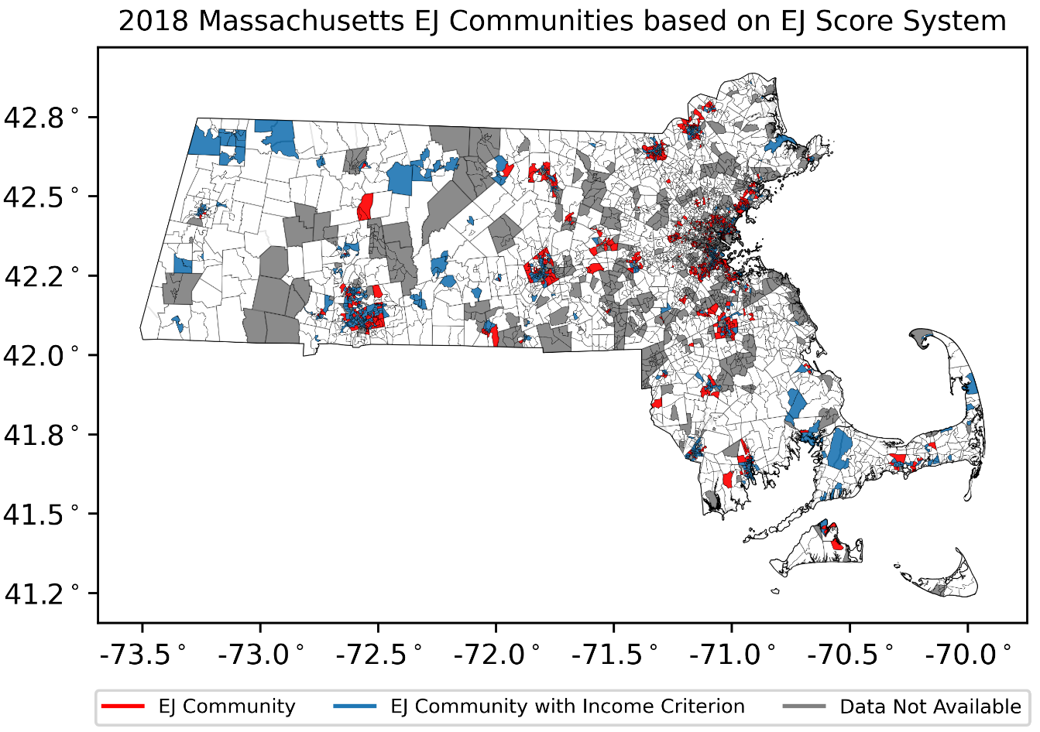
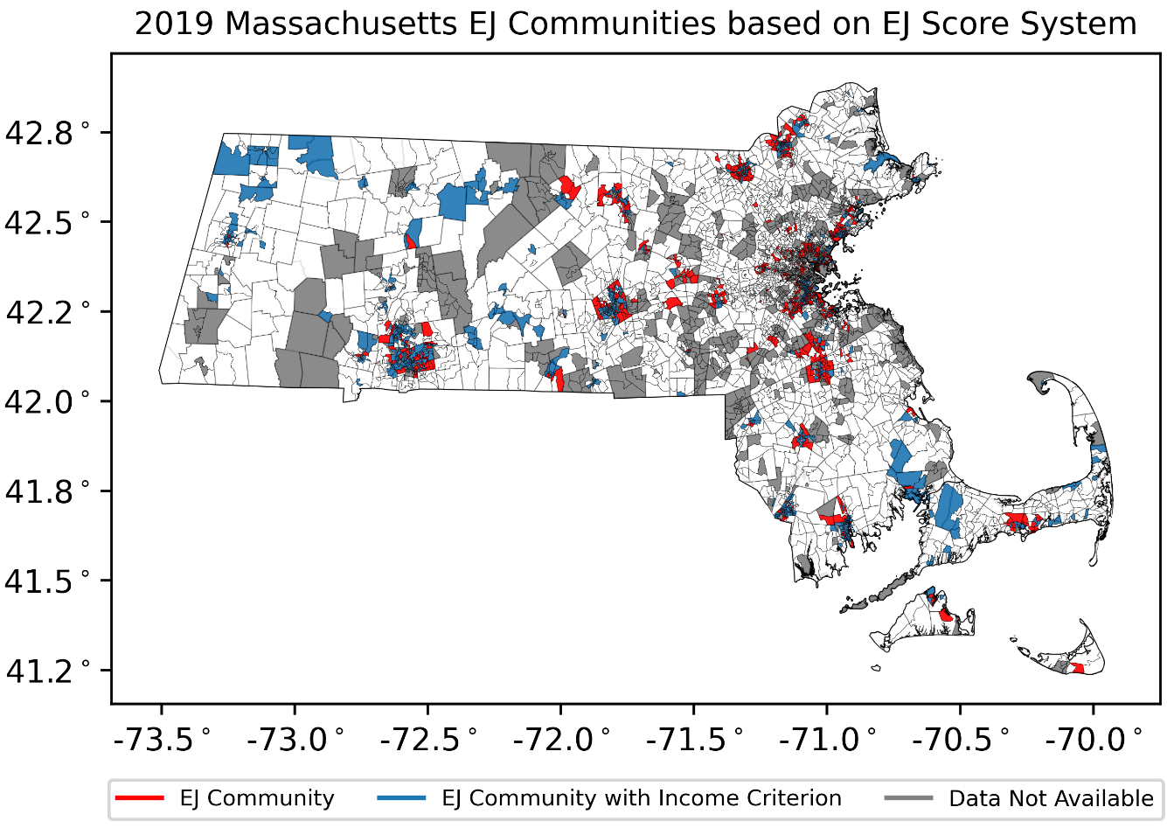
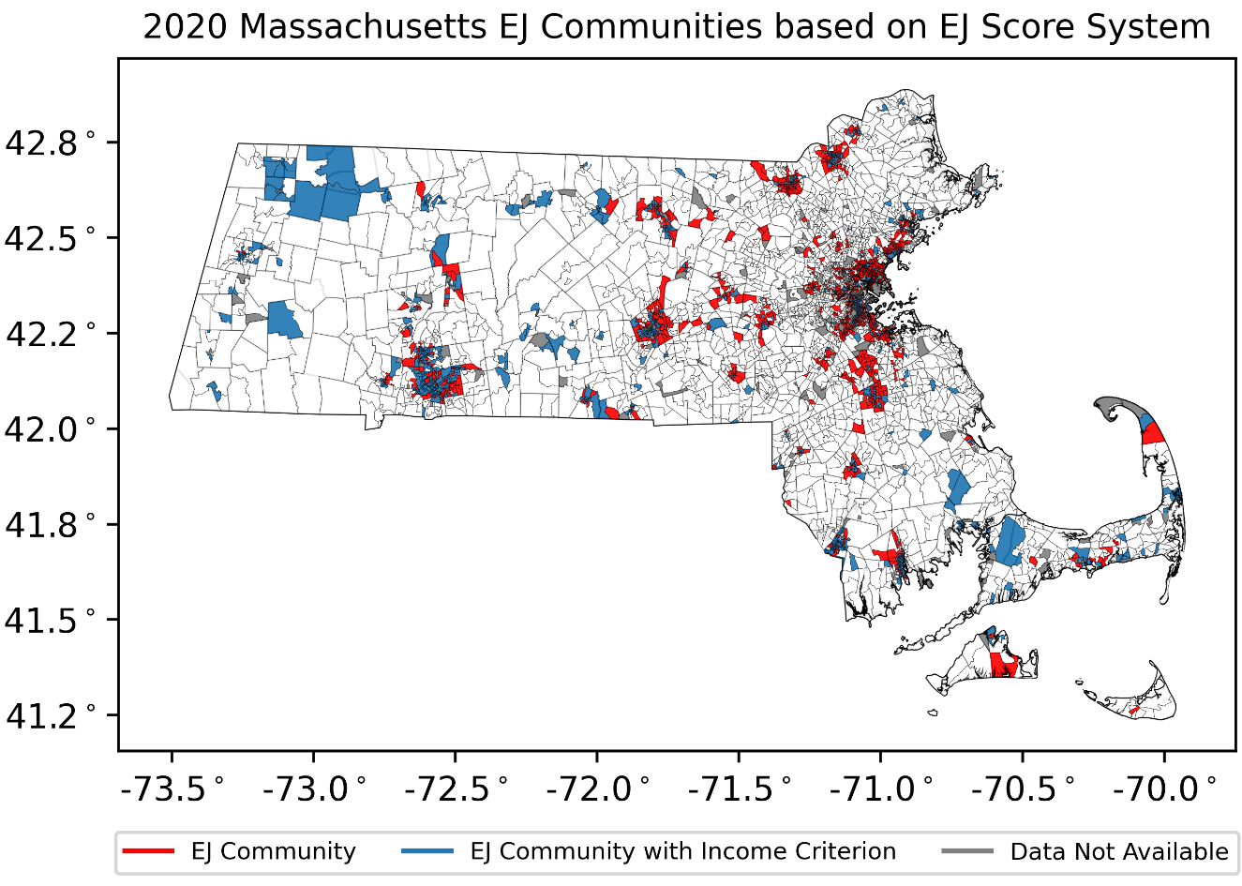
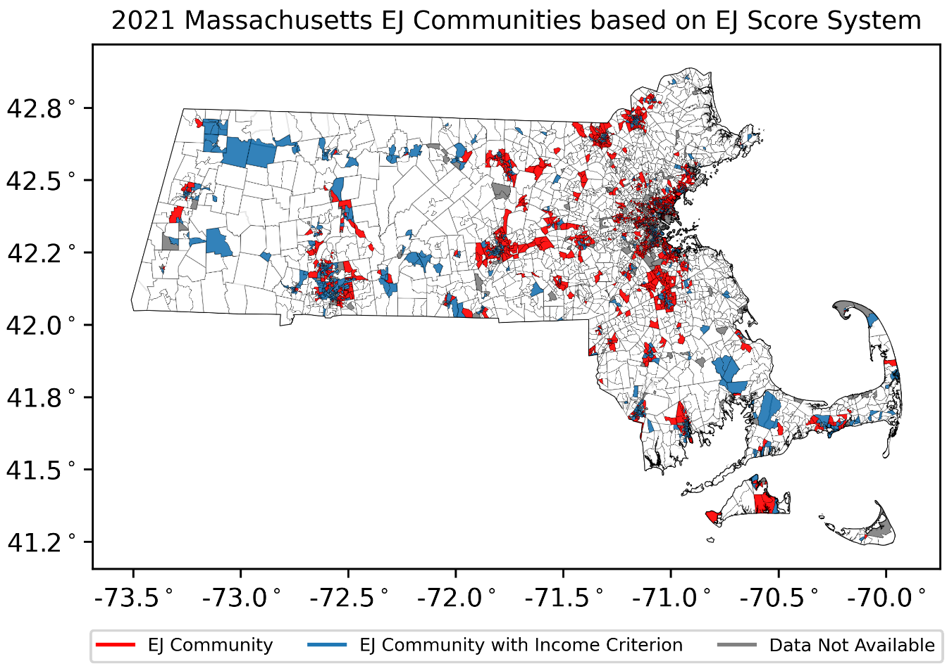
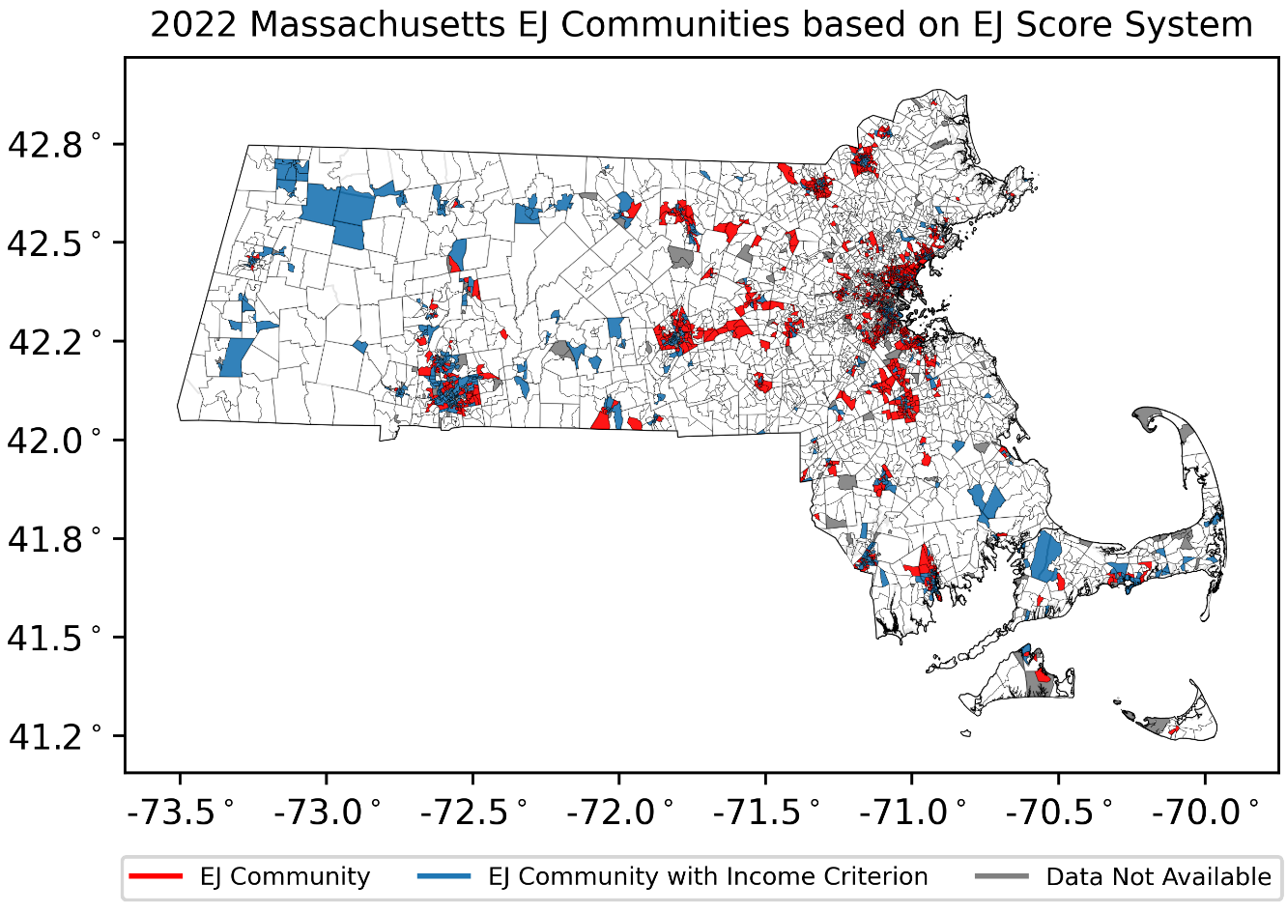
Figure S5. MA EJ maps based on cumulative EJ score method from 2016 to 2022. The EJ scores are influenced by three indicators (i.e., median household income, English isolation, and minority percentage). Blue color indicates EJ blocks due to median household income, and the red color specifies EJ blocks with the EJ score above the baseline.

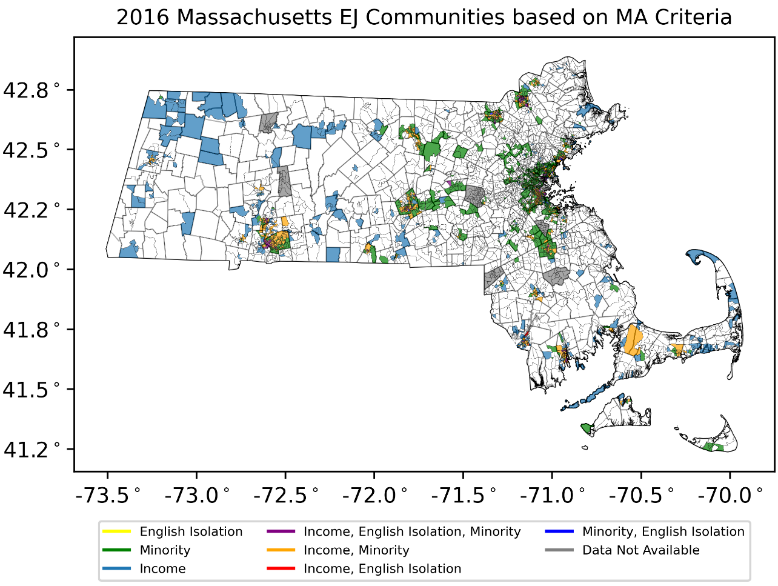
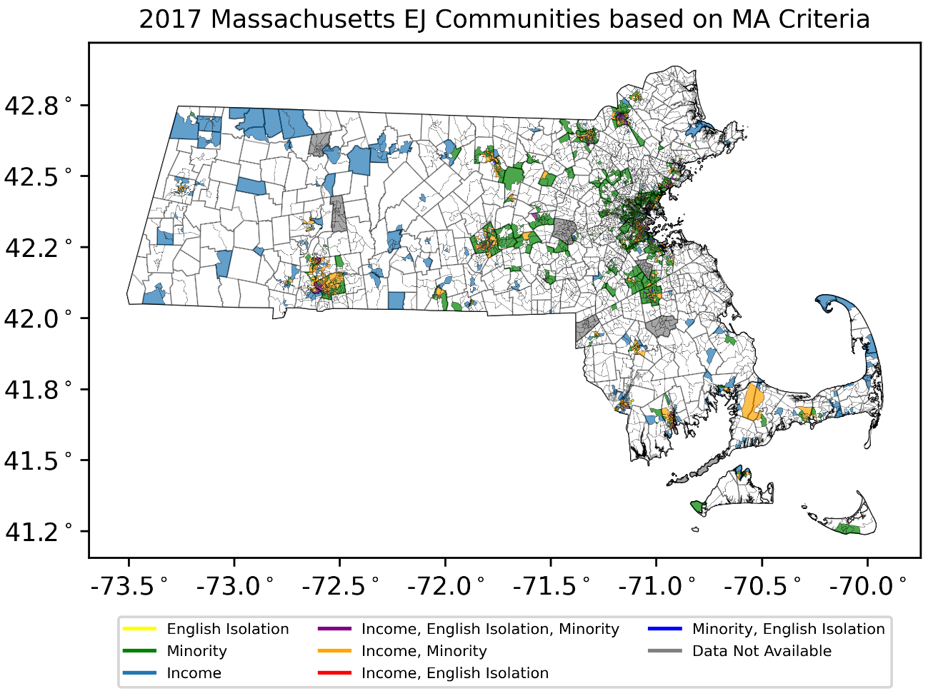
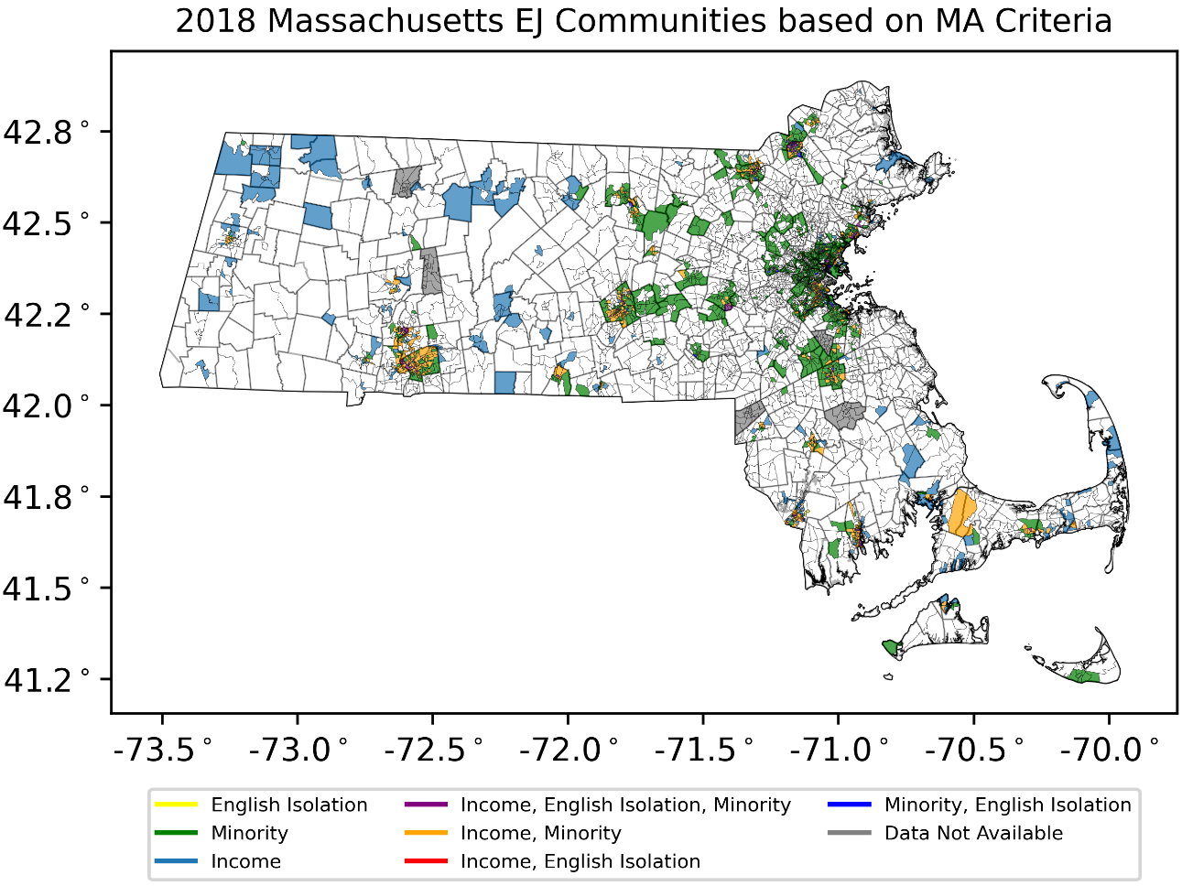
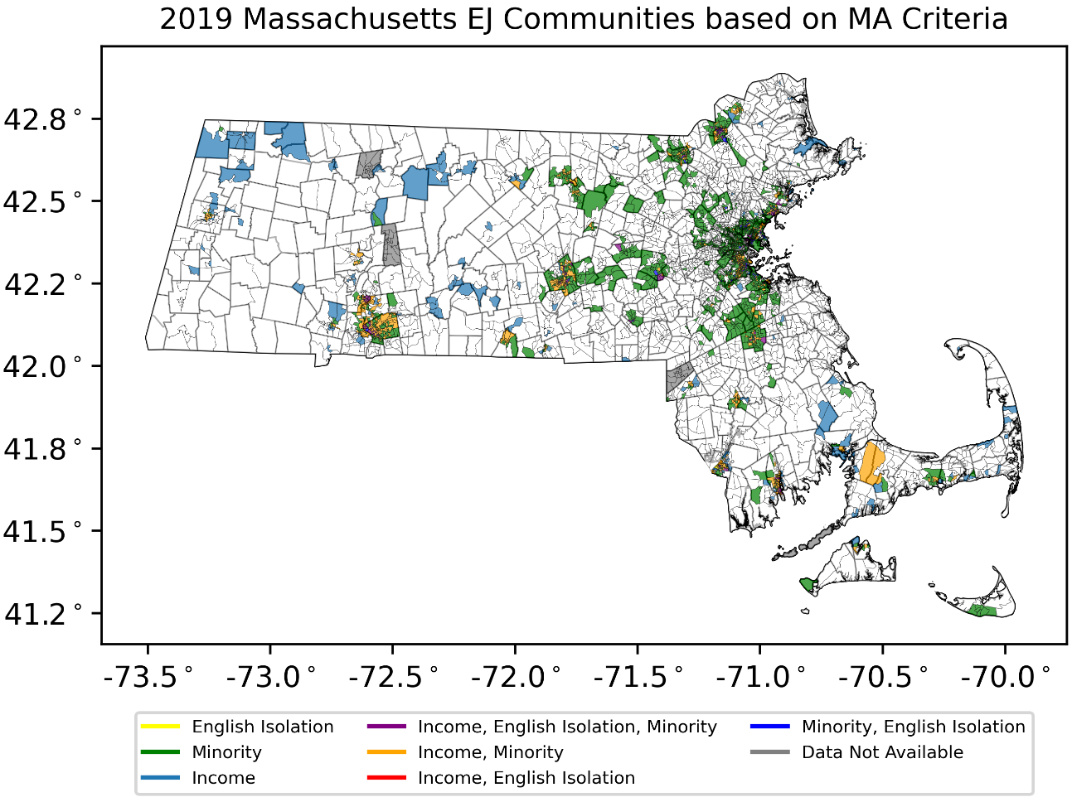
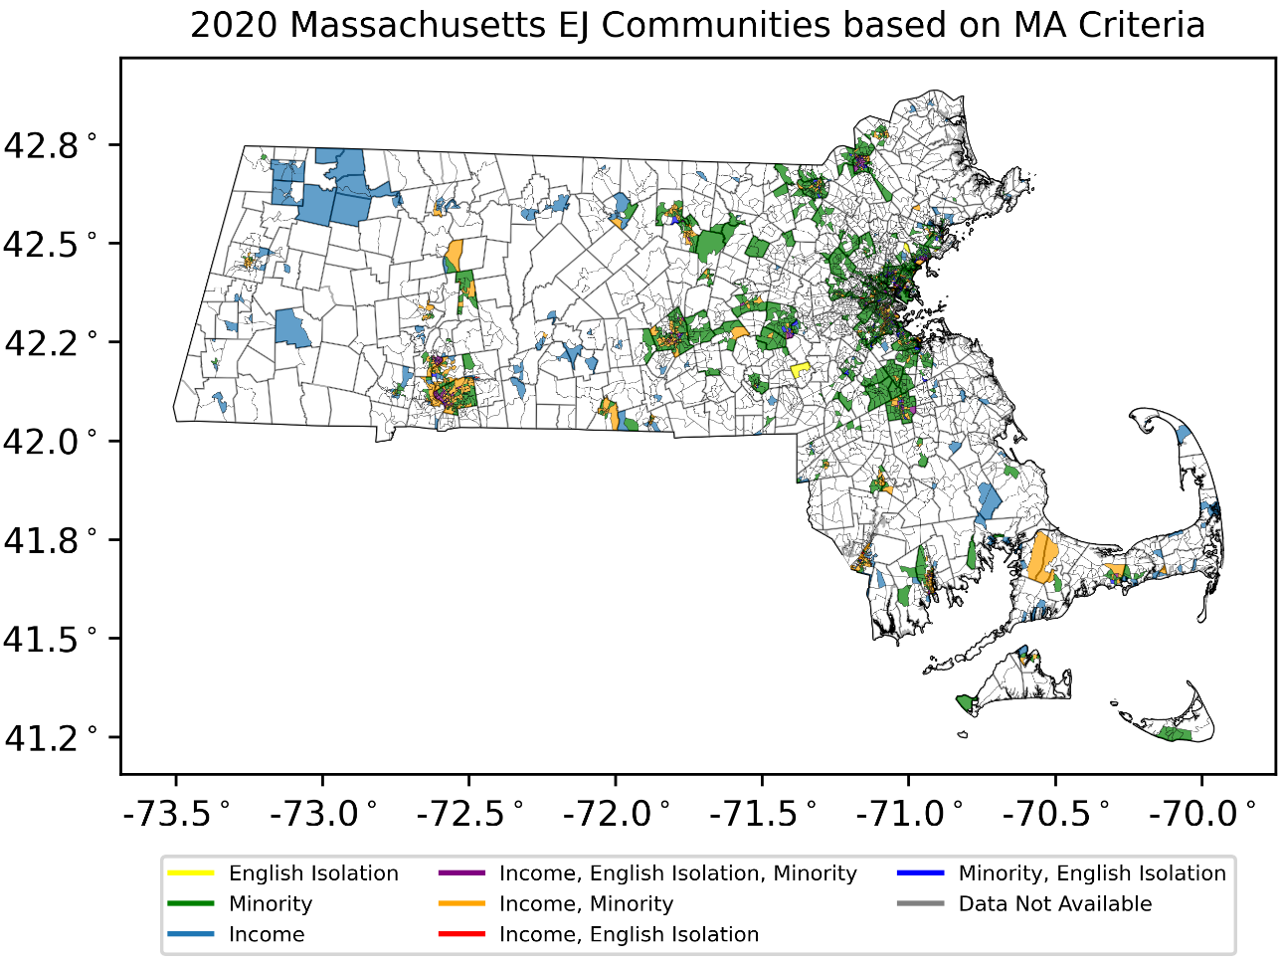
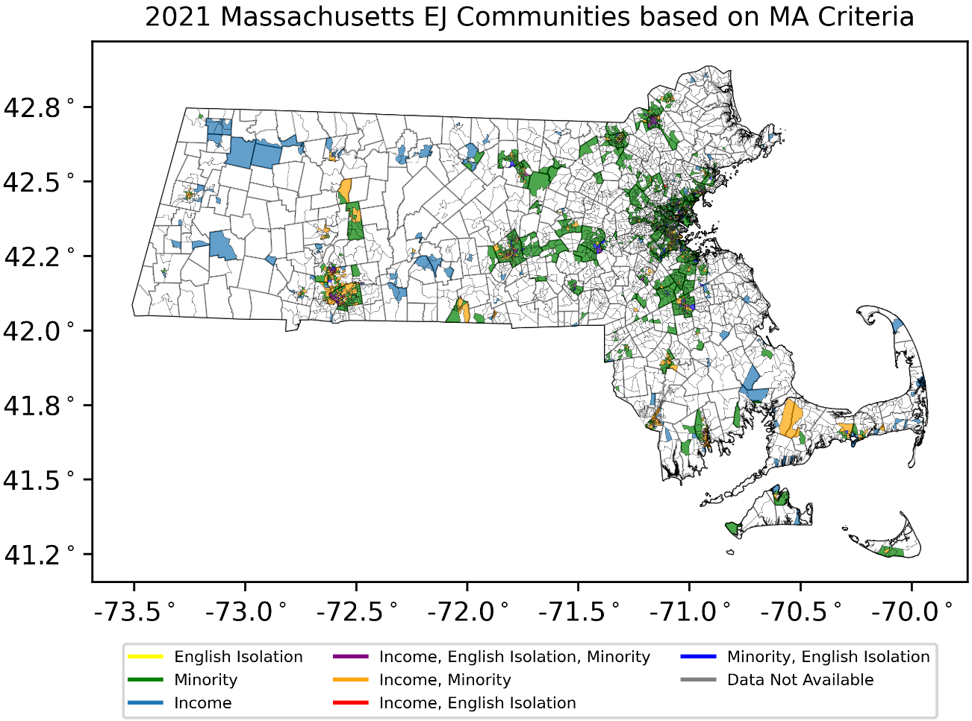
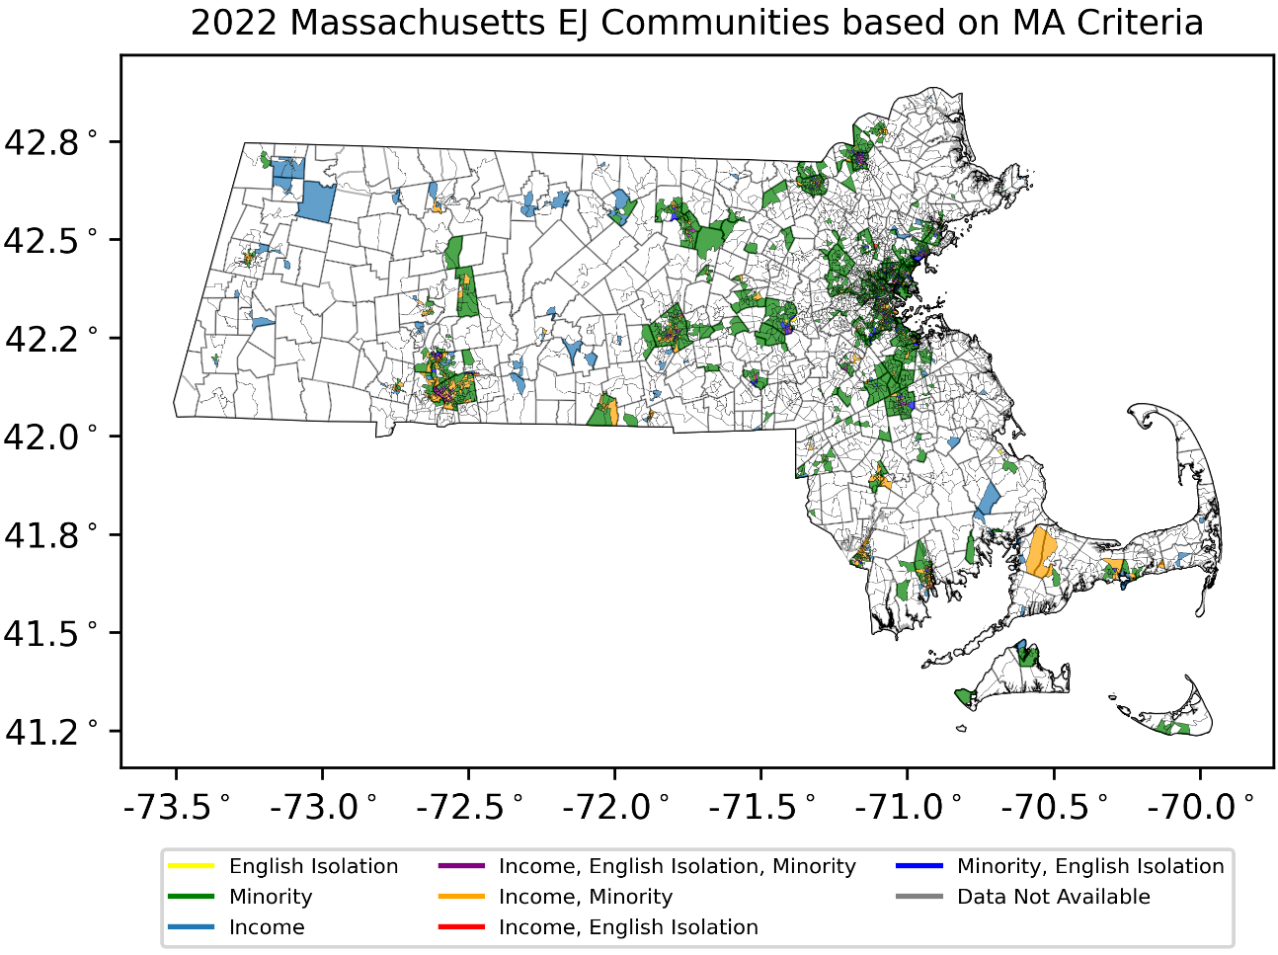
Figure S6. MA EJ maps based on MA EJ criteria as shown in Table 1 from 2016 to 2022. The maps are influenced by three indicators (i.e., median household income, English isolation, and minority percentage).

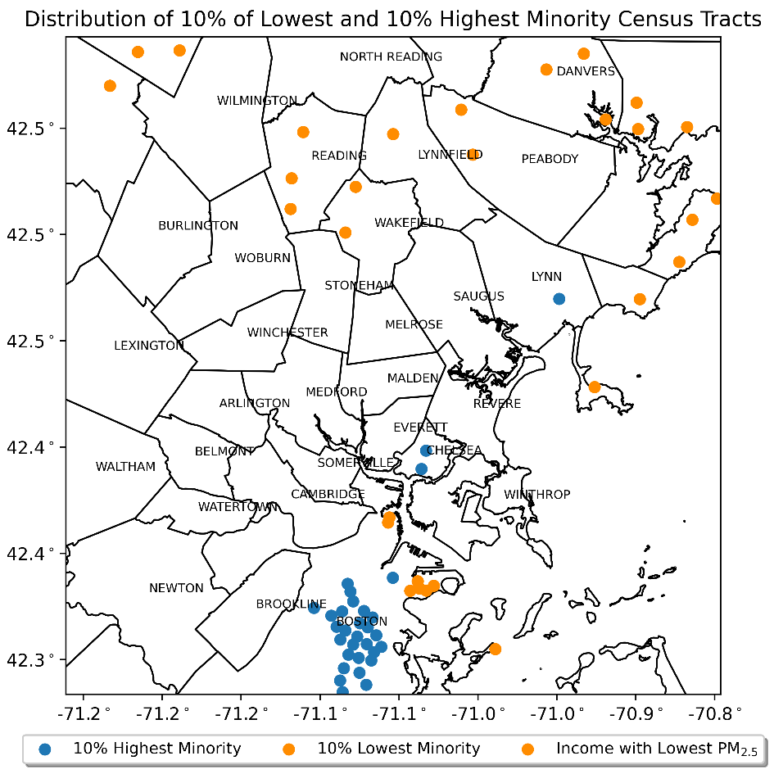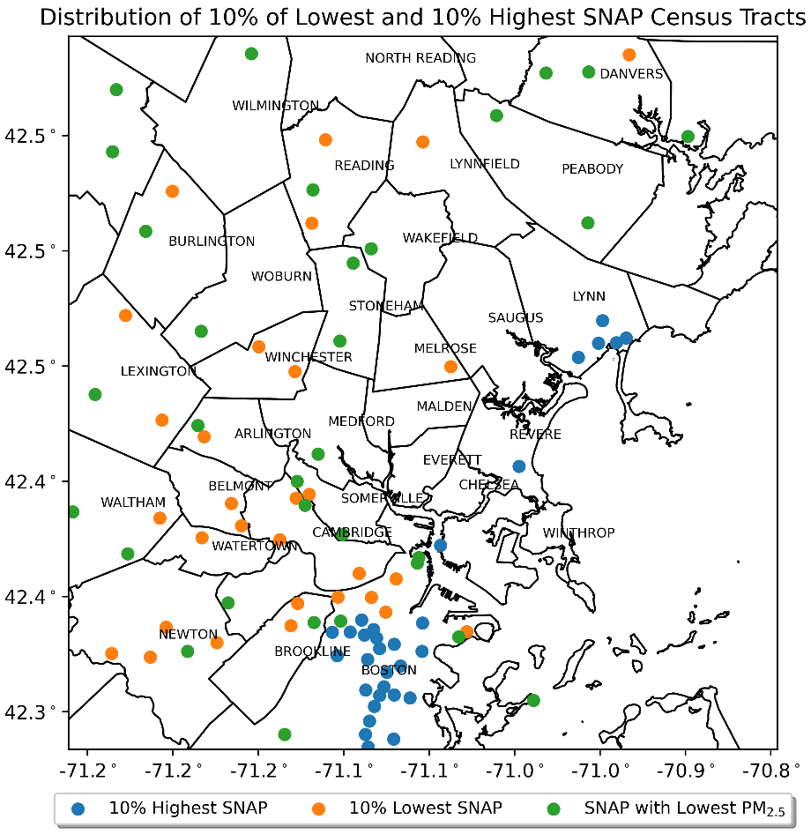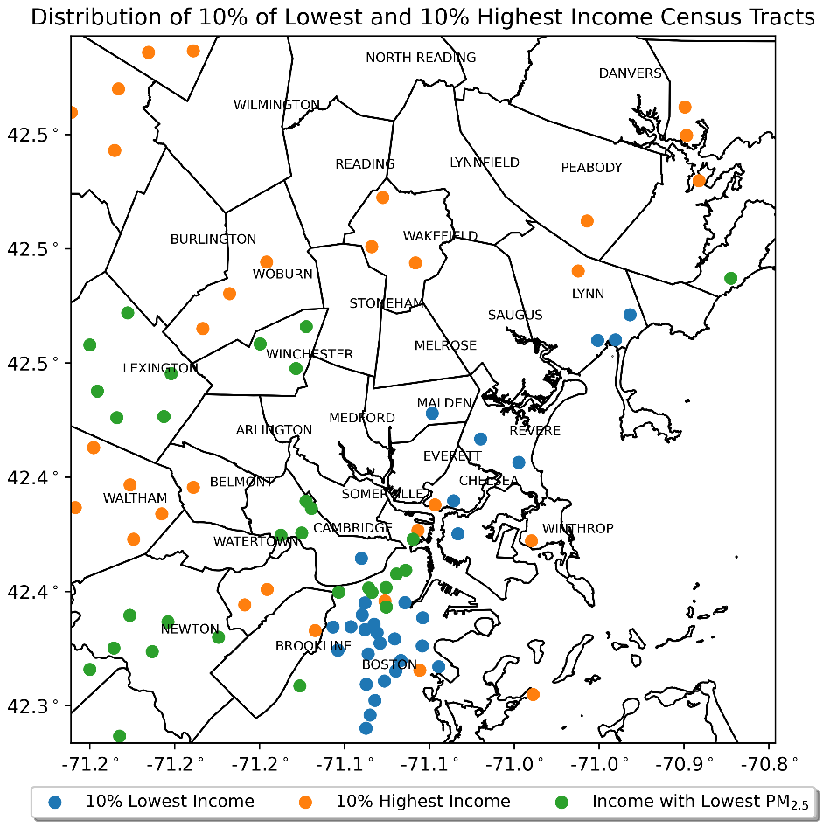
Figure S7. Distribution of 10% population with the lowest percentage, 10% population with the highest percentage, and 10% population with lowest PM_{2.5} concentrations in the Greater Boston area for minority, SNAP, and income indicator. Dots on the maps are the census tracts from the distribution.

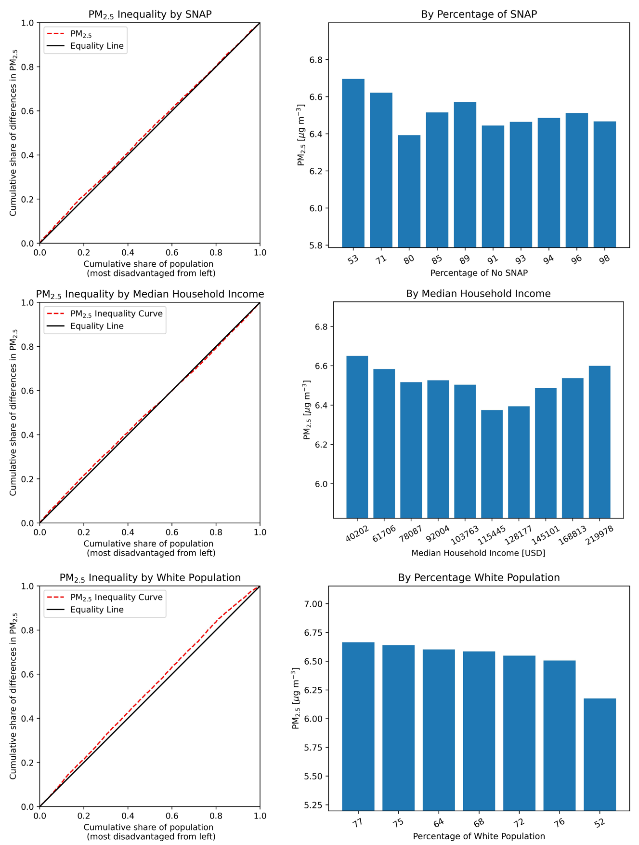
Figure S8. Environmental inequality curve of cumulative share of PM_{2.5} and O₃ concentrations from EPA’s Office of Air and Radiation, illustrating differences in PM_{2.5} exposure (left panels) and individual PM_{2.5} exposure with bar plots (right panels) for Supplemental Nutrition Assistance Program (SNAP), median household income, and percentage of white population. The most disadvantaged groups with a CPP value of 0 are from the left of the x-axis of the plots in the left panel.
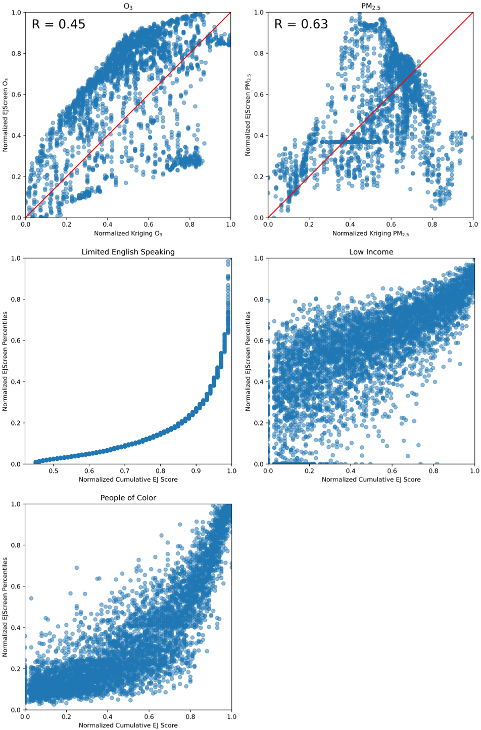
Figure S9. Comparison between EJScreen index and Cumulative EJ Score for Limited English Speaking, low income, and people of color.
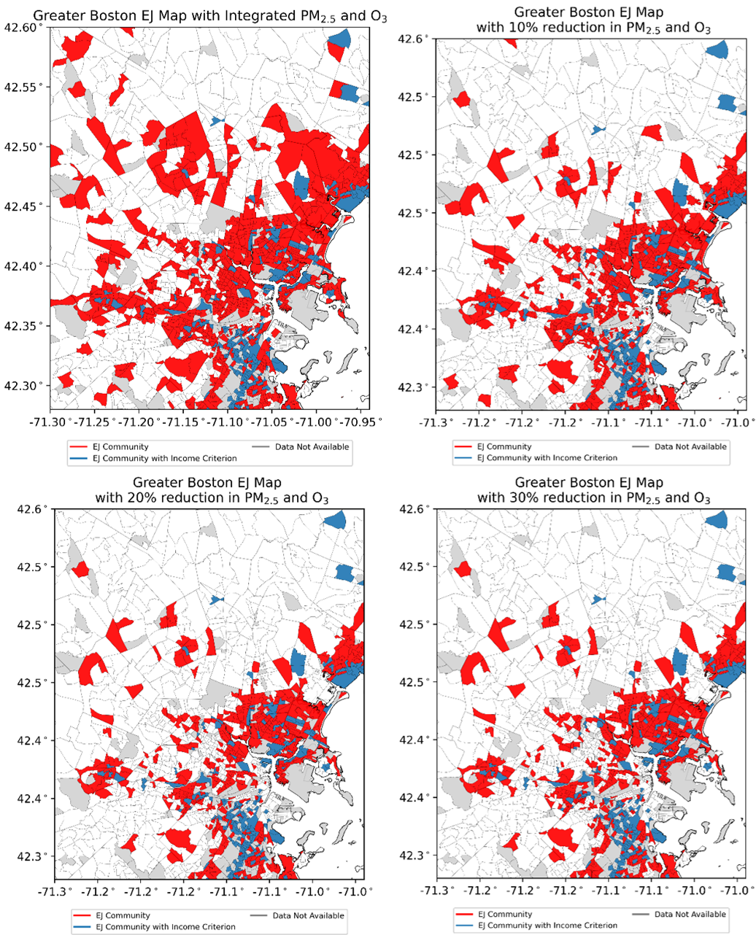
Figure S10. EJ blocks in Greater Boston with the reduction in PM_{2.5} and O₃ by 10%, 20%, and 30%.

Point source emissions
We calculate the point source emission rates per kilometer for various toxic gases for every census tract across MA. We use the 2019 George Mason University (GMU) emissions (Ma & Tong, 2022) and assigned census tract geoid labels to the point source emissions. The total emission density for each census tract is computed as the sum of all point sources within the tract, divided by the area of the census tract in $mole s^{-1} km^{-1}$ for gas and $g s^{-1} km^{-1}$ for PM.

Distribution of point source emissions
Several factors contribute to air pollution in the Greater Boston area, with one significant factor being the influence of point source emissions originating from sewage treatment plants, oil refineries, or electric generating units. We use 2019 high-resolution point source emissions provided by GMU (Ma & Tong, 2022) to calculate the average emission rates for toxic gases for each census tract per square km. Figure S3 displays the point source emission locations for non-integrated planning model (NONIPM, e.g., industry and commercial boilers, gas turbines, process heaters), electric generating units (EGU), and oil and gas production. There is a high density of point sources clustered around Greater Boston, with large EGU point sources serving the high population in the region.
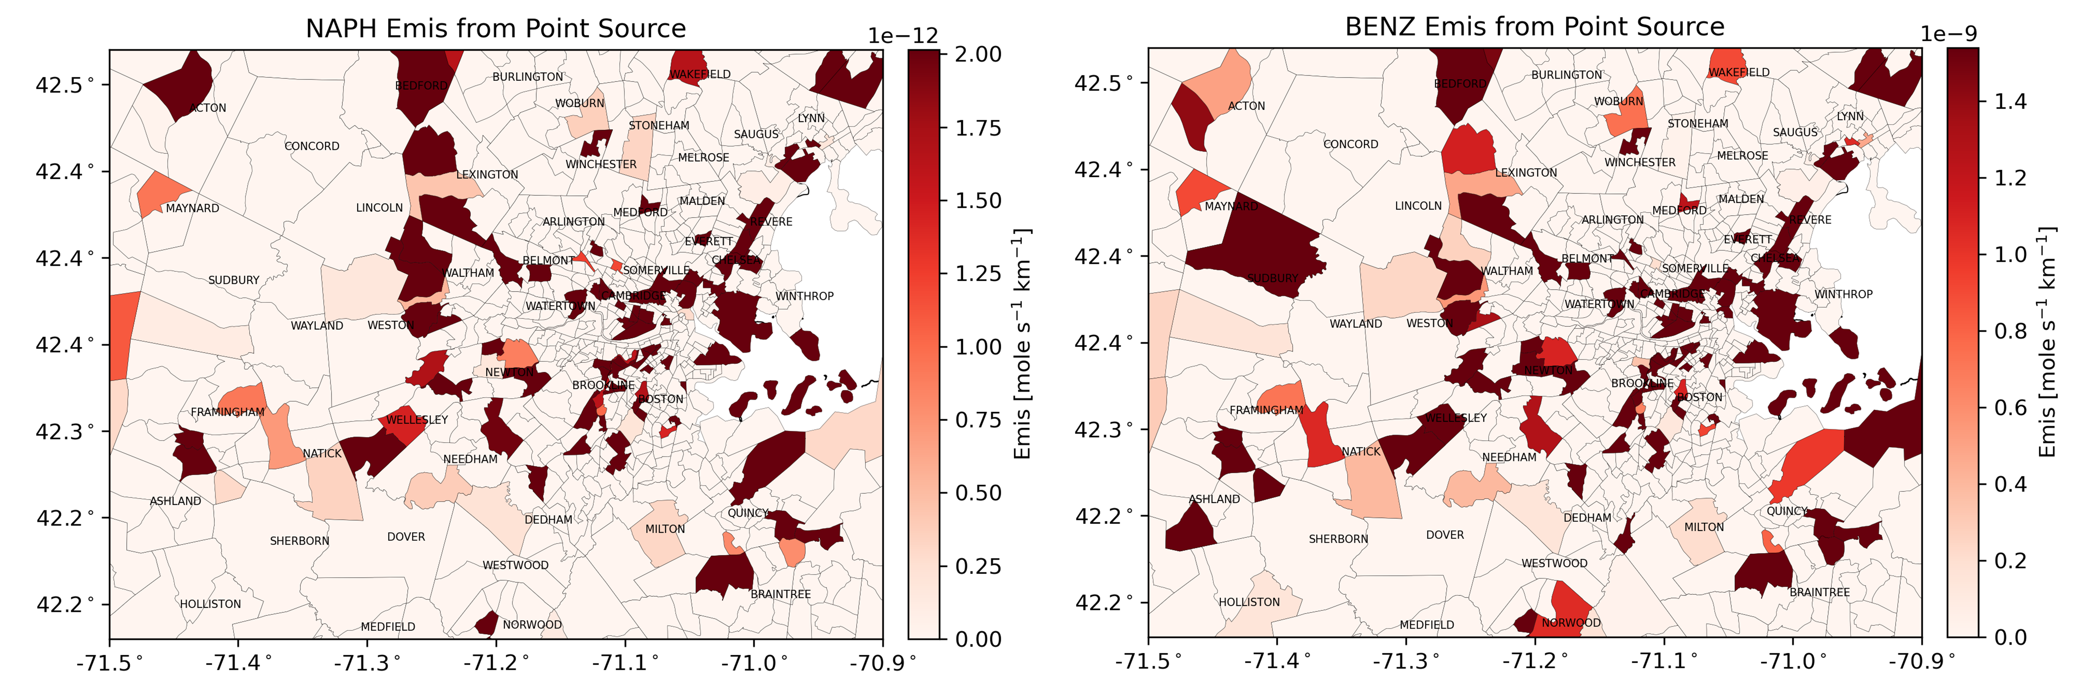
Figure S11. GMU point source emissions over Greater Boston for naphthalene (NAPH) (left panel) and benzene (BENZ) (right panel).
The left panel of Figure S11 shows the point source emissions for naphthalene (NAPH), a substance associated with both cancer and noncancer health effects (ATSDR, 2005). NAPH is released from manufacturing processes such as pesticides, resins, and leather tanning agents (ATSDR, 2005). Elevated levels of NAPH are observed in downtown Boston, Chelsea, Somerville, and Revere. Benzene (BENZ) point source emission rates (right panel) can be detected at similar locations as for NAPH, with higher concentrations at the center of Greater Boston. Residents near the emission sources are exposed to the NAPH and other toxic gases through airborne transmission and off-gassing of NAPH-containing and toxic gas-containing products (ATSDR, 2005; Jia & Batterman, 2010; Yost et al., 2021). Additional point source plots for other toxic gases are provided in Figure S4.
Reconstructing Massachusetts environmental justice map
To study MA EJ populations and assess its suitability for the Greater Boston area, we reconstruct the MA EJ map based on MA EJ criteria, which includes three indicators: median household income (MHHI), percent of minority, and percent of limited English speaking, as shown in Table S6. Three EJ categories are derived from four criteria, representing the combination of one or two indicators. If any threshold is surpassed, census blocks are classified as EJ blocks. EJ communities can fall into one or more of these categories. EJ scores are calculated for each MA census block using three socioeconomic statuses from American Community Survey 5-year estimate at block group level. The relevant information and data are listed in the Data and Source Code sections. Further details about the MA EJ populations can be found on mass.gov (MassGIS, 2022), and the definitions of EJ neighborhoods can be found in Chapter 8 of the Acts of 2021 (Commonwealth of Massachusetts, 2021).
Table S6. Massachusetts environmental justice criteria (Office of Environmental Justice & Equity, 2022)
EJ Category | Criteria | Conditions/Threshold
Income | Income | MHHI < 65% of MA MHHI
Minority | Minority | Percent of minority ≥ 40%
Minority | Minority, Income | Percent of minority ≥ 25% and  municipality MHHI ≤ 150% of MA MHHI
English Isolation | English Isolation | Limited English speaking ≥ 25%

Massachusetts environmental justice score calculation
We construct the EJ population in MA based on MA criteria as listed in Table S6 to examine disparities in communities and assess the equality of environmental protection and benefits. Figure S13 shows the EJ communities (census block) color-coded for 8 combinations of three criteria (income, English isolation, and minority). White color census blocks are considered as non-EJ communities. The lower part of Figure S13 shows the EJ communities across MA, while the top right panel provides a zoomed-in view of the Greater Boston area. On the west side of the state, there are EJ communities driven by low income with a single indicator, where the MHHI in these census blocks is less than 65% of MA MHHI. More EJ communities are observed in Greater Boston and other large MA cities such as Springfield, Worcester, and Brockton. Most of the communities in Greater Boston fall into the income EJ category (blue). However, a few EJ communities are categorized by a combination of several criteria. All Chelsea communities are classified as EJ communities, and many of them are a combination of two or more EJ categories. In contrast, most Brookline are considered EJ communities and fall under the minority category. Figure S6 shows historical MA EJ maps based on MA EJ criteria from 2016 to 2022.
Table S7. Summary of EJ community in Massachusetts. The data is from the 2020 Census Data Block Groups (U.S. Census Bureau, 2023).
 | Land [km²]  (% of MA land area) | Population  (% of MA population) | EJ Blocks  (% of MA Census Block)
EJ with any Criteria | 2,949 (14.6%) | 3,471,745 (49.4%) | 2,588 (50.7%)
EJ with 1 EJ Criterion | 2,447 (12.1%) | 2,363,222 (33.6%) | 1,742 (34.1%)
EJ with 2 EJ Criteria | 452 (2.2%) | 863,612 (12.3%) | 662 (13.0%)
EJ with 3 EJ Criteria | 50 (0.25%) | 244,911 (3.5%) | 184 (3.6%)
Total Massachusetts | 20,204 (100%) | 7,029,917 (100%) | 5,109 (100%)

Moving away from large cities, the intensity of EJ diminishes. However, when considering the population density concentrated in cities with smaller census blocks, the total EJ population in MA constitutes 49.4% of the state’s total population. This includes 33.6% of the MA population classified as EJ communities with one EJ criterion, 12.3% classified with two EJ criteria, and 3.5% classified with all EJ criteria. The EJ area covers only 14.6% compared to the total area of the state Table 3. Further details about EJ communities in MA are provided in Table S3.
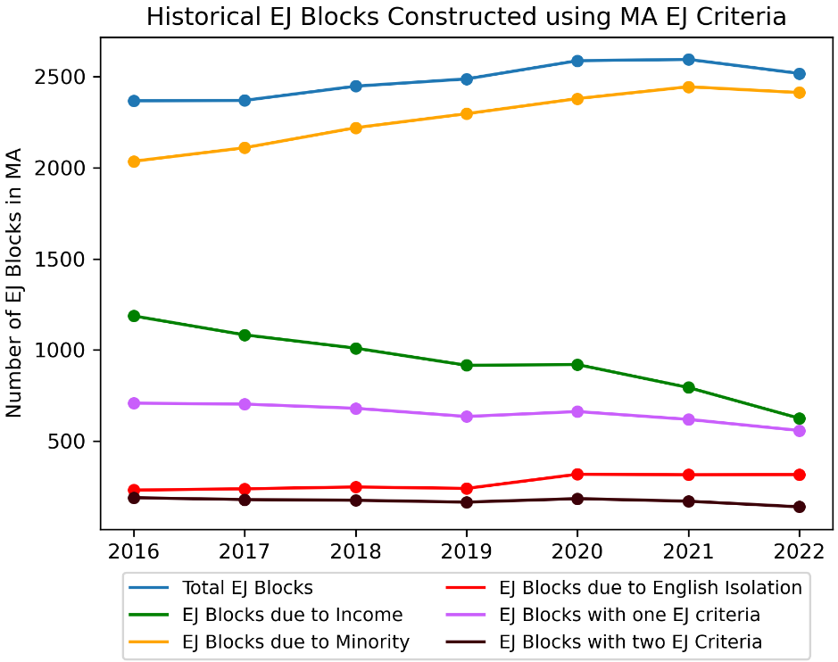
The total number of EJ blocks in MA has consistently increased from 2016 to 2021, with a slight decrease in 2022 (Figure S12, Table S4). Notably, the income EJ blocks show significant improvement, decreasing from 1187 EJ blocks in 2016 to 625 EJ blocks in 2022 due to the improvement in MHHI. One contributing factor to the increase in EJ blocks is related to minority criteria which saw a 19% increase in minority EJ blocks from 2016 to 2022. As the minority EJ group expanded, the number of English isolation EJ blocks also increased by 37% during the same period. Despite the overall increase in the total EJ blocks, those with two or more criteria show improvements, indicating an enhancement in EJ conditions for the more severe EJ communities in MA.
Figure S12. Historical EJ data was constructed for the years from 2016 to 2022 using MA criteria, as listed in Table 1.
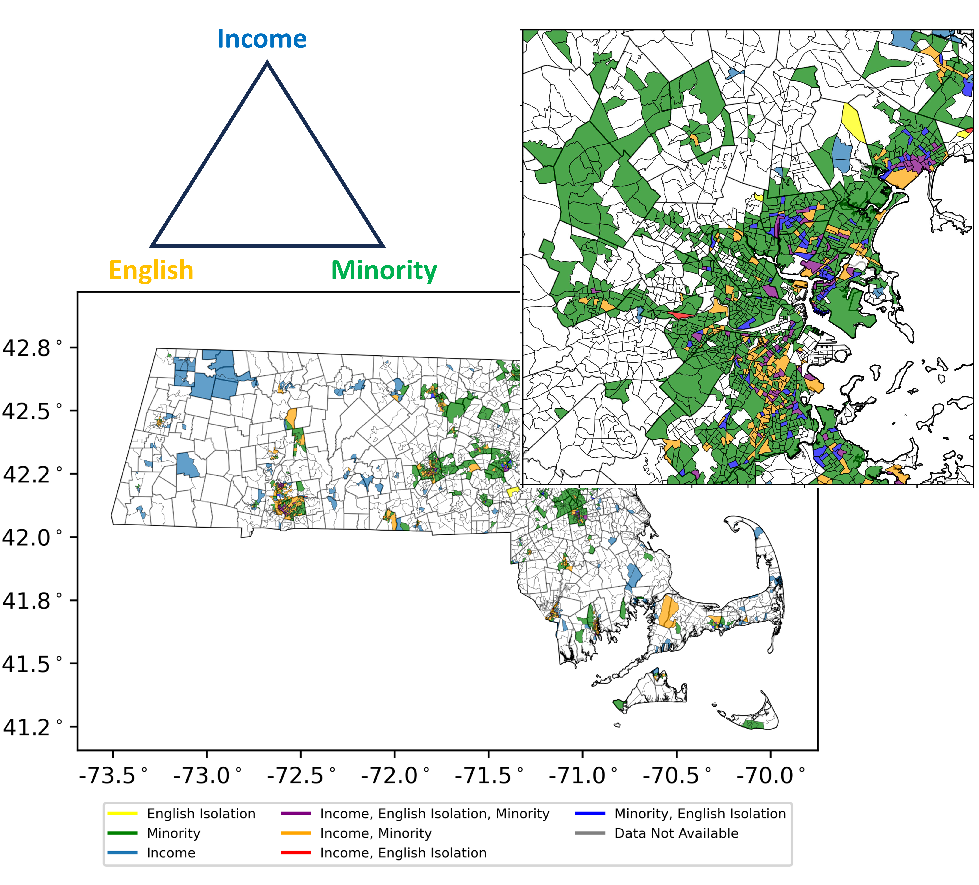
Figure S13. 2020 MA EJ maps based on MA EJ criteria as shown in Table 1. The bottom panel shows EJ maps over MA, and the zoom in (top right panel) is the EJ maps for Greater Boston. The maps are influenced by three indicators (i.e., median household income, English isolation, and minority percentage).

