Longitudinal Stream Synoptic (LSS) Monitoring to Evaluate Water Quality in Restored Streams

Joseph T. Malin¹, Sujay S. Kaushal¹, Paul M. Mayer², Carly M. Maas³, Steven Hohman², Megan A. Rippy^{4,5,6}

¹: Department of Geology & Earth System Science Interdisciplinary Center, University of Maryland, College Park, Maryland 20742
²: Environmental Protection Agency, 805 SW Broadway #500, Portland, OR 97205
³: United States Geological Survey, 1730 E Parham Road, Richmond, VA 23228
⁴: Occoquan Watershed Monitoring Laboratory, The Charles E. Via, Jr. Department of Civil and Environmental Engineering, Virginia Tech, 9408 Prince William Street, Manassas VA, USA
⁵: Center for Coastal Studies, Virginia Tech, 1068A Derring Hall (0420), Blacksburg, VA, USA
⁶: Disaster Resilience and Risk Management (DRRM), 1068A Derring Hall, 405 Perry Street, Blacksburg, VA 24061, USA.

Joseph T. Malin: joemalin@umd.edu
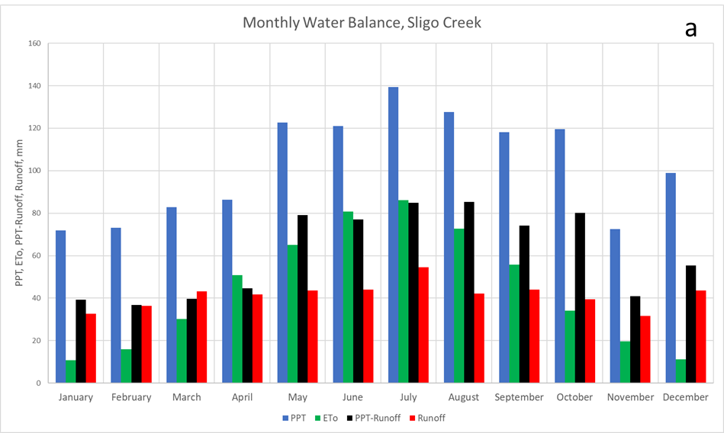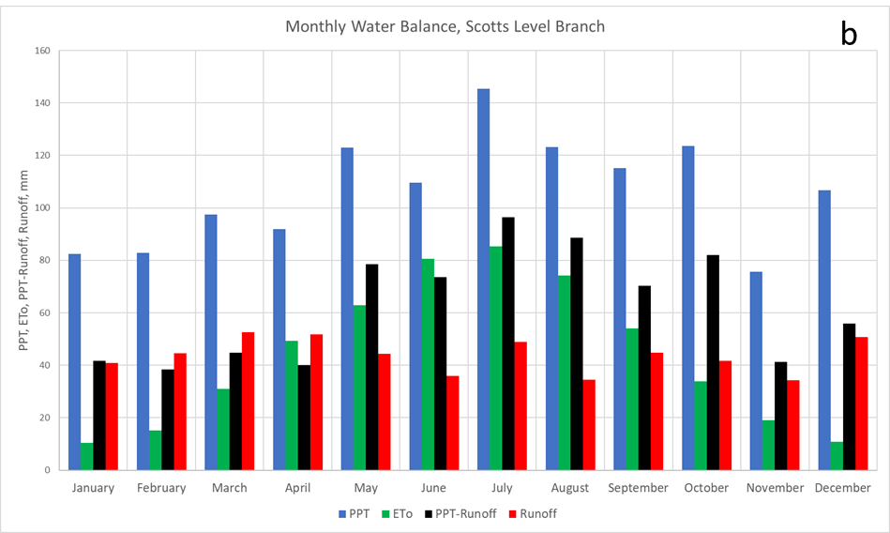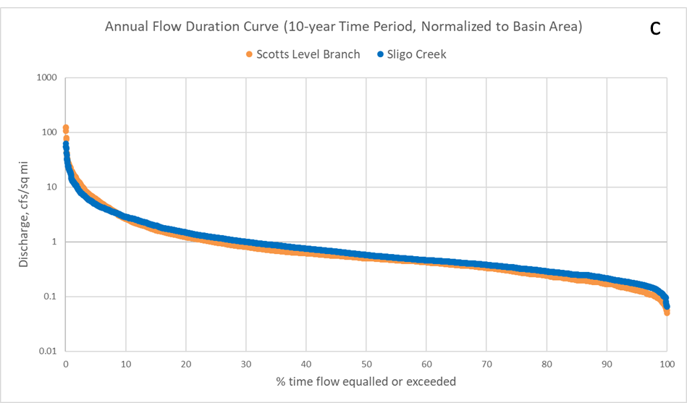
Online Resource 1 Monthly water balances at Sligo Creek (a) and Scotts Level Branch (b). ETo is the reference evapotranspiration. Annual flow duration curve based on 10 years of data, normalized to basin area (c)
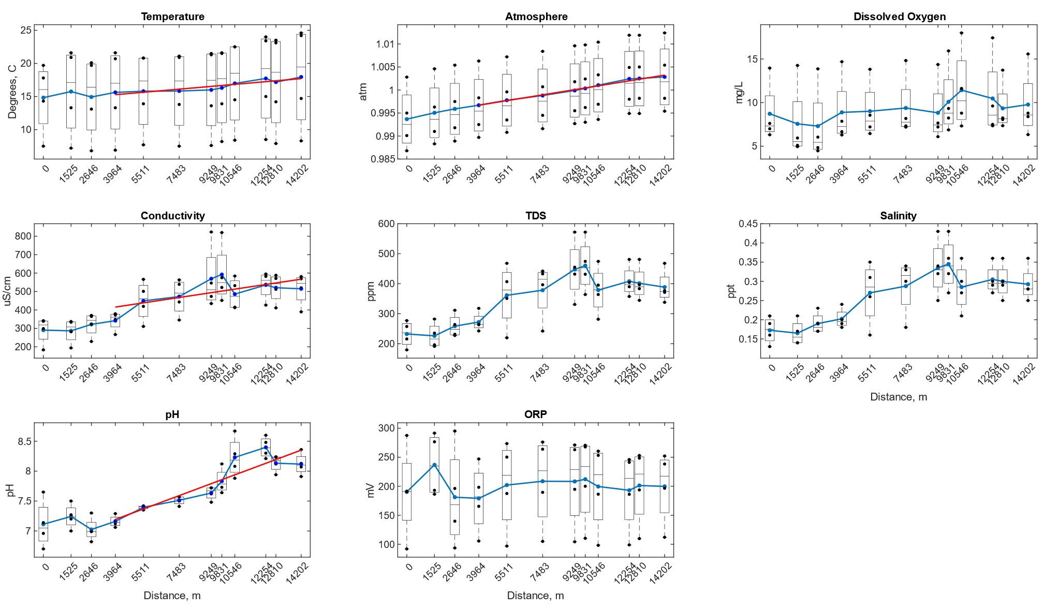
Online Resource 2 Longitudinal variations in field measurements at Sligo Creek
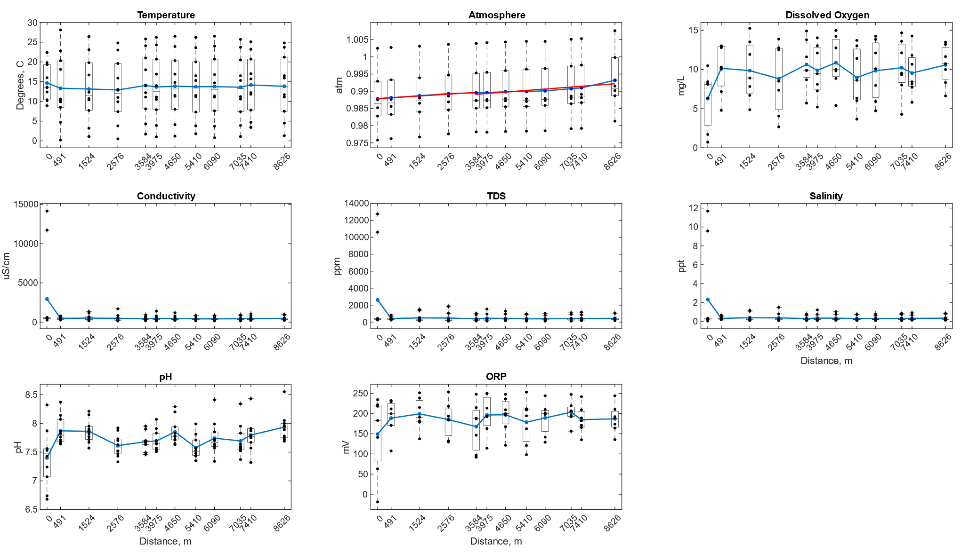
Online Resource 3 Longitudinal variations in field measurements at Scotts Level Branch
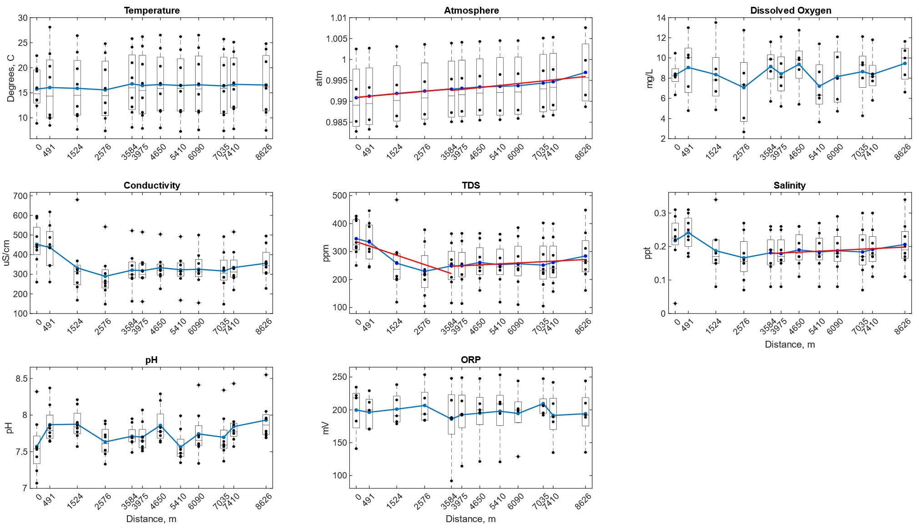
Online Resource 4 Longitudinal variations in field measurements at Scotts Level Branch, not including data collected during or after road salting events
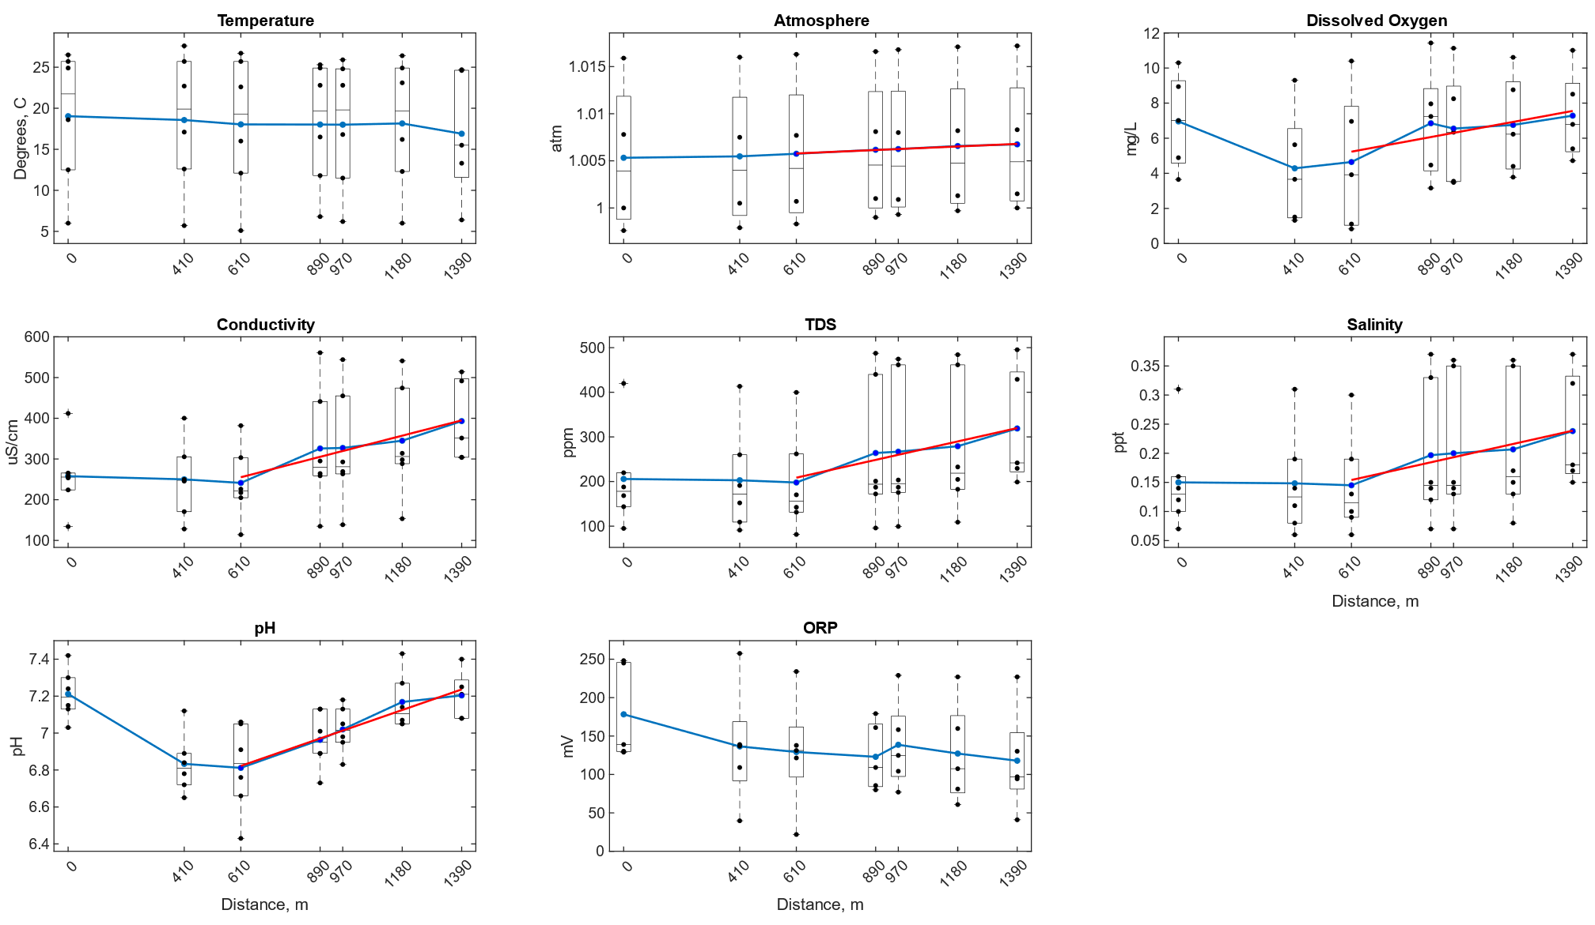
Online Resource 5 Longitudinal variations in field measurements at Campus Creek
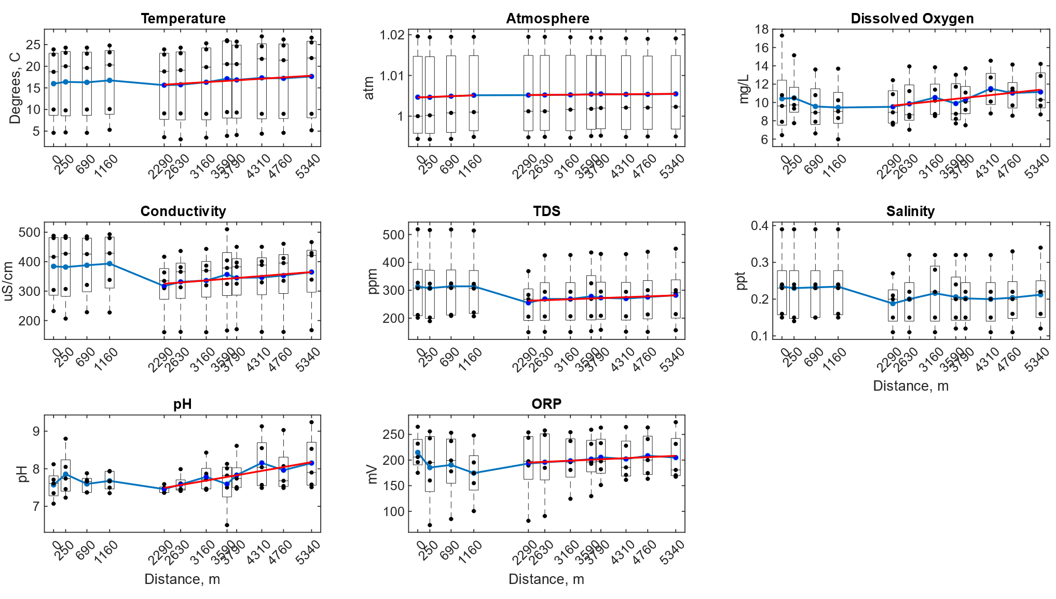
Online Resource 6 Longitudinal variations in field measurements at Paint Branch
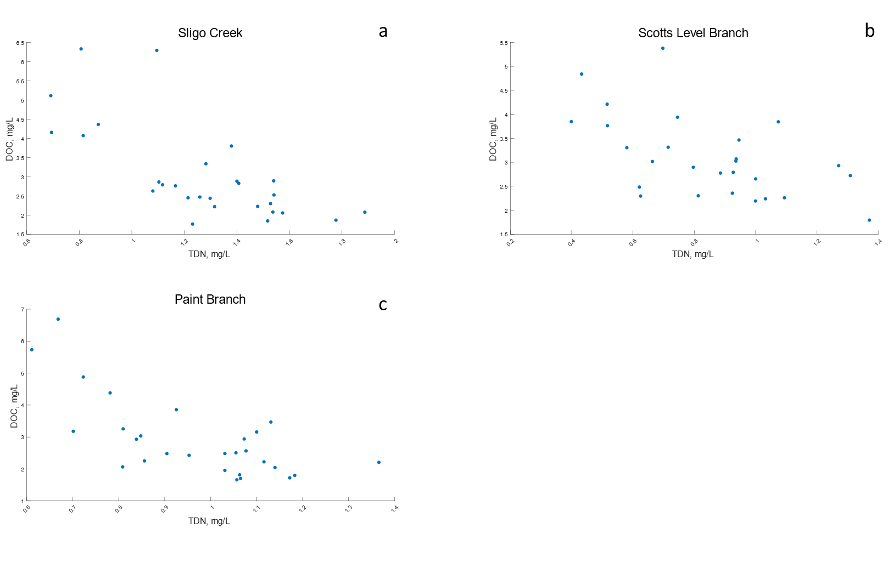
Online Resource 7 Relationships between longitudinal measurements of TDN and DOC at Sligo Creek (a), Scotts Level Branch (b), and Paint Branch (c)

