Supplementary Material
- Zoospore survival and germination
Table 1: Sphericity-corrected three-way mixed ANOVA for arcsine-transformed proportions of germinated zoospores to total zoospore count in A. marginata and N.luetkeana, across treatments and species with Time as a within-group variable. Bold text indicates a significant effect – main effects are disregarded if included in a significant higher-level interaction.
Effect | DF_{n} | DF_{d} | F | p | ges
Species | 1 | 32 | 6.411 | 0.016 | 0.059
Treatment | 3 | 32 | 2.468 | 0.080 | 0.068
Time | 1 | 32 | 4.516 | 0.041 | 0.088
Species*Treatment | 3 | 32 | 1.562 | 0.218 | 0.044
Species*Time | 1 | 32 | 9.318 | 0.005 | 0.166
Treatment*Time | 3 | 32 | 0.295 | 0.829 | 0.019
Species*Treatment*Time | 3 | 32 | 0.231 | 0.874 | 0.015

- Gametophyte abundance
Table 2: Sphericity-corrected three-way mixed ANOVA for log-transformed gametophyte abundance in A. marginata and N.luetkeana, across treatments and species with Time as a within-group variable. Bold text indicates a significant effect – main effects are disregarded if included in a significant higher-level interaction.
Effect | DF_{n} | DF_{d} | F | p | ges
Species | 1 | 31 | 0.591 | 0.448 | 0.009
Treatment | 3 | 31 | 16.852 | 1.12e⁻⁶ | 0.436
Time | 1.59 | 49.27 | 4.254 | 0.027 | 0.067
Species*Treatment | 3 | 31 | 5.321 | 0.004 | 0.196
Species*Time | 1.59 | 49.27 | 1.679 | 0.201 | 0.102
Treatment*Time | 4.77 | 49.27 | 2.226 | 0.069 | 0.102
Species*Treatment*Time | 4.77 | 49.27 | 1.077 | 0.384 | 0.052
Table 3: Sphericity-corrected one-way ANOVAs for log-transformed gametophyte abundance, showing effect of stressor treatment in each species and effect of species for each stressor treatment. Bold text indicates a significant effect – main effects are disregarded if included in a significant higher-level interaction.
Effect | DF_{n} | DF_{d} | F | p | ges
TREATMENT
Alaria marginata (AM) | 3 | 75 | 13.4 | 8.92e⁻⁷ | 0.348
Nereocystis luetkeana (NL) | 3 | 76 | 41.2 | 1.32e⁻¹⁵ | 0.619
SPECIES
Climate change (CLIM) | 1 | 37 | 0.607 | 1 | 0.016
Control (CTRL) | 1 | 38 | 6.70 | 0.06 | 0.15
Glacial melt (GLAC) | 1 | 38 | 3.14 | 0.34 | 0.076
Meltwater (MELT) | 1 | 38 | 13.7 | 0.003 | 0.266

Table 4: Significant pairwise t-test comparisons with Bonferroni correction between stressor treatments for gametophyte abundance in A. marginata and N. luetkeana.
Species | Comparison | p
Alaria marginata | CTRL v GLAC | 0.002
 | CLIM v MELT | 1.06e⁻⁴
 | GLAC v MELT | 1.18e⁻⁶
Nereocystis luetkeana | CLIM v CTRL | 1.43e-¹⁴
 | CTRL v GLAC | 2.59e⁻¹³
 | CLIM v MELT | 0.026
 | CTRL v MELT | 5.95e⁻⁹

- Gametophyte size and sex ratios
Table 5: Sphericity-corrected three-way mixed ANOVA for square-root transformed mean gametophyte size in A. marginata and N. luetkeana, across stressor treatments and species with Time as a within-group variable. Bold text indicates a significant effect – main effects are disregarded if included in a significant higher-level interaction.
Effect | DF_{n} | DF_{d} | F | p | ges
Species | 1 | 32 | 14.003 | 7.19e⁻⁴ | 0.182
Treatment | 3 | 32 | 50.033 | 3.49e⁻¹² | 0.705
Time | 2.96 | 94.68 | 55.005 | 1.59e⁻²⁰ | 0.458
Species*Treatment | 3 | 32 | 9.116 | 1.65e⁻⁴ | 0.303
Species*Time | 2.96 | 94.68 | 5.803 | 0.001 | 0.082
Treatment*Time | 8.88 | 94.68 | 2.112 | 0.037 | 0.089
Species*Treatment*Time | 8.88 | 94.68 | 1.336 | 0.230 | 0.058
Table 6: Sphericity-corrected one-way ANOVAs for square-root transformed mean gametophyte size, showing effect of stressor treatment in each species and effect of species for each stressor treatment. Bold text indicates a significant effect – main effects are disregarded if included in a significant higher-level interaction.
Effect | DF_{n} | DF_{d} | F | p | ges
TREATMENT
Alaria marginata (AM) | 3 | 116 | 58.9 | 6.6e⁻²³ | 0.604
Nereocystis luetkeana (NL) | 3 | 116 | 42.1 | 3.52e⁻¹⁸ | 0.521
SPECIES
Climate change (CLIM) | 1 | 58 | 4.51 | 0.152 | 0.072
Control (CTRL) | 1 | 58 | 2.88 | 0.38 | 0.047
Glacial melt (GLAC) | 1 | 58 | 45.1 | 3.52e⁻⁸ | 0.437
Meltwater (MELT) | 1 | 58 | 21.3 | 8.84e⁻⁵ | 0.269

Table 7: Significant pairwise t-test comparisons with Bonferroni correction between stressor treatments for gametophyte size in A. marginata and N. luetkeana.
Species | Comparison | p
Alaria marginata | CLIM v CTRL | 9.36e⁻¹³
 | CLIM v GLAC | 5.05e⁻¹²
 | CLIM v MELT | 6.9e⁻⁷
 | CTRL v GLAC | 6.6e⁻⁴
 | CTRL v MELT | 1.27e⁻¹²
 | GLAC v MELT | 2.86e⁻¹⁰
Nereocystis luetkeana | CLIM v CTRL | 9.72e⁻¹²
 | CTRL v GLAC | 3.76e⁻⁹
 | CTRL v MELT | 4.92e⁻¹⁵

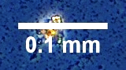
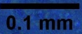
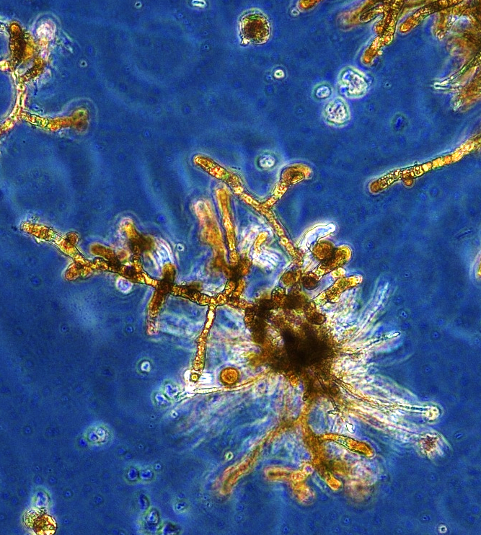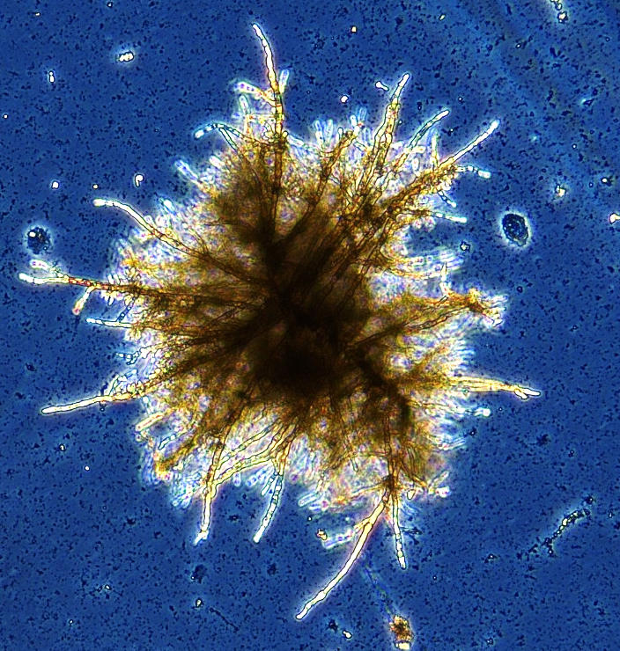
A
B
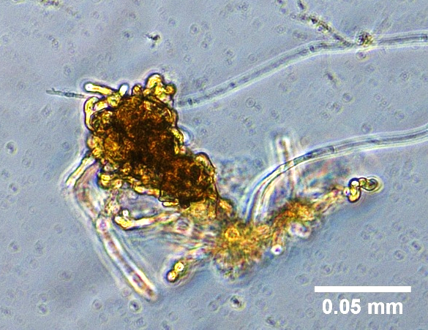
C
Figure 1: Gametophytes of Alaria marginata after 35 days of growth. A: healthy female in control conditions; B: healthy male in control conditions; C: deformed gametophyte in the MELT (meltwater) treatment – high temperature, low salinity, normal suspended sediment load.

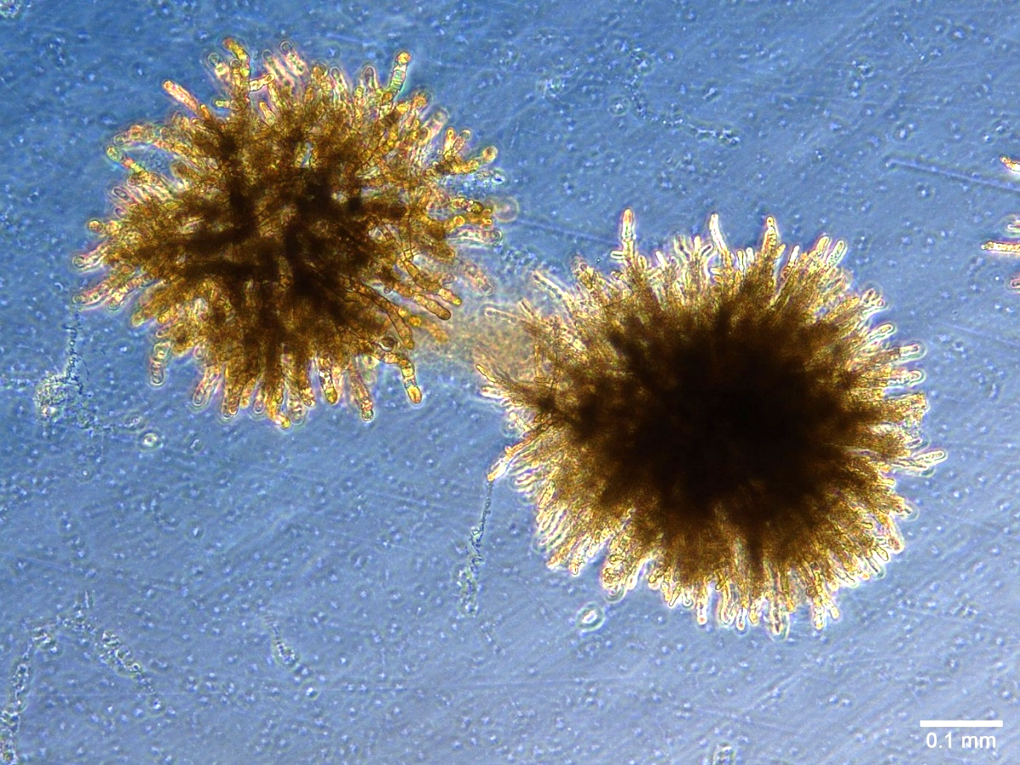
A
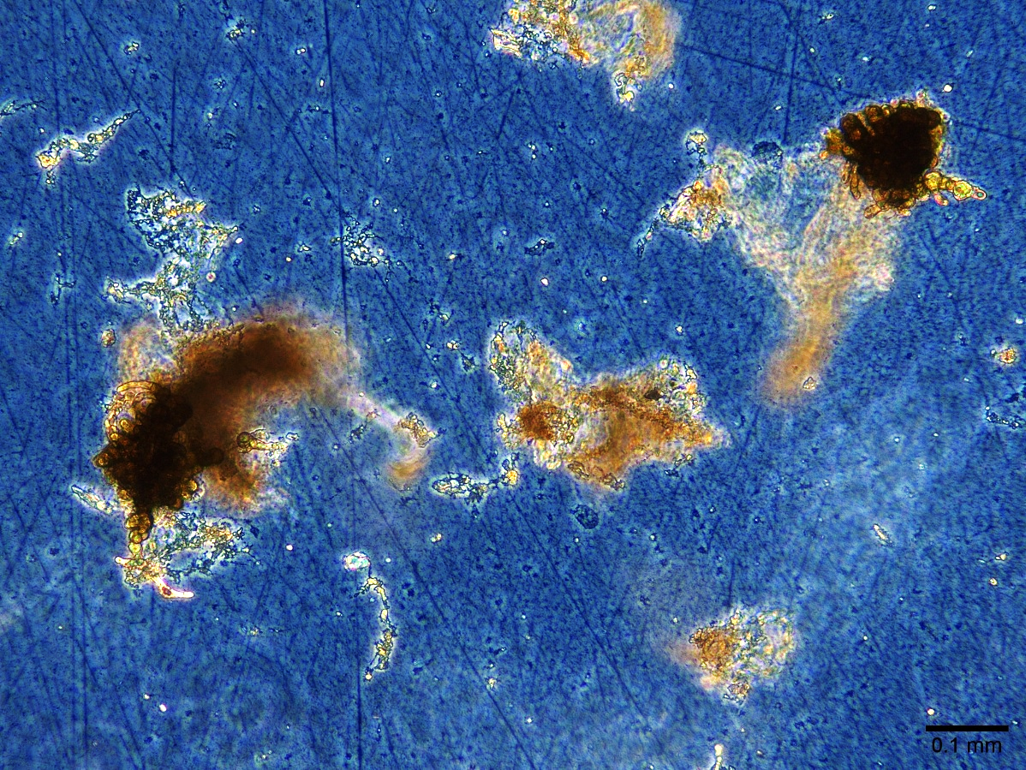
B
Figure 2: Gametophytes of Nereocystis luetkeana after 35 days of growth. A: healthy female (left) and male (right) in control conditions; B: deformed gametophytes in the MELT (meltwater) treatment – high temperature, low salinity, normal suspended sediment load.

Table 8: Sphericity-corrected three-way mixed ANOVA for square-root transformed number of gametophytes of unidentifiable sex in A. marginata and N. luetkeana, across stressor treatments and species with Time as a within-group variable. Bold text indicates a significant effect – main effects are disregarded if included in a significant higher-level interaction.
Effect | DF_{n} | DF_{d} | F | p | ges
Species | 1 | 32 | 3.540 | 0.069 | 0.037
Treatment | 3 | 32 | 82.687 | 3.68e⁻¹⁵ | 0.730
Time | 3.21 | 102.86 | 18.459 | 4.6e⁻¹⁰ | 0.273
Species*Treatment | 3 | 32 | 4.007 | 0.016 | 0.116
Species*Time | 3.21 | 102.86 | 0.933 | 0.433 | 0.019
Treatment*Time | 9.64 | 102.86 | 7.910 | 3.85e⁻⁹ | 0.326
Species*Treatment*Time | 9.64 | 102.86 | 3.386 | 8.6e⁻⁴ | 0.171
Table 9: Sphericity-corrected two-way ANOVAs for square-root transformed number of gametophytes of unidentifiable sex in A. marginata and N. luetkeana, across stressor treatments with Time as a within-group variable. Bold text indicates a significant effect – main effects are disregarded if included in a significant higher-level interaction.
Effect | DF_{n} | DF_{d} | F | p | ges
A. MARGINATA
Time | 2.65 | 42.34 | 6.036 | 0.002 | 0.228
Treatment | 3 | 16 | 59.547 | 6.6e⁻⁹ | 0.706
Treatment*Time | 7.94 | 42.34 | 5.141 | 1.69e⁻⁴ | 0.431
N. LUETKEANA
Time | 2.63 | 42.08 | 16.397 | 8.62e⁻⁷ | 0.337
Treatment | 3 | 16 | 35.321 | 2.75e⁻⁷ | 0.769
Treatment*Time | 7.89 | 42.08 | 6.577 | 1.62e⁻⁵ | 0.380
Table 10: Significant pairwise t-test comparisons with Bonferroni correction between stressor treatments for number of unidentifiable gametophytes in A. marginata and N. luetkeana.
Species | Comparison | p
Alaria marginata | CLIM v MELT | 3.44e⁻⁸
 | CTRL v MELT | 4.76e-¹⁵
 | GLAC v MELT | 3.38e⁻¹¹
Nereocystis luetkeana | CLIM v CTRL | 8.82e⁻⁹
 | CLIM v GLAC | 0.038
 | CLIM v MELT | 1.23e⁻⁵
 | CTRL v GLAC | 2.71e⁻⁴
 | CTRL v MELT | 2.33e⁻²⁸
 | GLAC v MELT | 3.63e⁻⁸

- Egg and sporophyte production
Table 11: Sphericity-corrected three-way mixed ANOVA for square-root transformed number of eggs produced per female in A. marginata and N. luetkeana, across stressor treatments and species with Time as a within-group variable. Bold text indicates a significant effect – main effects are disregarded if included in a significant higher-level interaction.
Effect | DF_{n} | DF_{d} | F | p | ges
Species | 1 | 32 | 19.386 | 1.12e⁻⁴ | 0.135
Treatment | 3 | 32 | 27.828 | 4.8e⁻⁹ | 0.402
Time | 2.62 | 83.76 | 27.854 | 1.15e⁻¹¹ | 0.393
Species*Treatment | 3 | 32 | 10.177 | 7.36e⁻⁵ | 0.197
Species*Time | 2.62 | 83.76 | 5.871 | 0.002 | 0.120
Treatment*Time | 7.85 | 83.76 | 7.219 | 3.6e⁻⁷ | 0.334
Species*Treatment*Time | 7.85 | 83.76 | 4.262 | 2.72e⁻⁴ | 0.229
Table 12: Sphericity-corrected two-way ANOVAs for square-root transformed number of eggs produced per female in A. marginata and N. luetkeana, across stressor treatments with Time as a within-group variable. Bold text indicates a significant effect – main effects are disregarded if included in a significant higher-level interaction.
Effect | DF_{n} | DF_{d} | F | p | ges
A. MARGINATA
Time | 2.07 | 33.16 | 20.894 | 1.07e⁻⁶ | 0.508
Treatment | 3 | 16 | 32.946 | 4.44e⁻⁷ | 0.562
Treatment*Time | 6.22 | 33.16 | 7.575 | 3.10e⁻⁵ | 0.529
N. LUETKEANA
Time | 2.65 | 42.48 | 7.174 | 8.26e⁻⁴ | 0.224
Treatment | 3 | 16 | 2.983 | 0.062 | 0.166
Treatment*Time | 7.96 | 42.48 | 1.329 | 0.256 | 0.139

Table 13: Sphericity-corrected three-way mixed ANOVA for square-root transformed number of sporophytes produced per female in A. marginata and N. luetkeana, across stressor treatments and species with Time as a within-group variable. Bold text indicates a significant effect – main effects are disregarded if included in a significant higher-level interaction.
Effect | DF_{n} | DF_{d} | F | p | ges
Species | 1 | 32 | 0.764 | 0.388 | 0.005
Treatment | 3 | 32 | 5.027 | 0.006 | 0.093
Time | 5 | 160 | 14.208 | 1.68e⁻¹¹ | 0.258
Species*Treatment | 3 | 32 | 4.046 | 0.002 | 0.076
Species*Time | 5 | 160 | 0.619 | 0.686 | 0.015
Treatment*Time | 15 | 160 | 2.974 | 3.32e⁻⁴ | 0.179
Species*Treatment*Time | 15 | 160 | 2.414 | 0.003 | 0.150
Table 14: Sphericity-corrected two-way ANOVAs for square-root transformed number of sporophytes produced per female in A. marginata and N. luetkeana, across stressor treatments with Time as a within-group variable. Bold text indicates a significant effect – main effects are disregarded if included in a significant higher-level interaction.
Effect | DF_{n} | DF_{d} | F | p | ges
A. MARGINATA
Time | 5 | 80 | 9.356 | 4.77e⁻⁷ | 0.332
Treatment | 3 | 16 | 11.422 | 2.98e⁻⁴ | 0.245
Treatment*Time | 15 | 80 | 4.380 | 6.58e⁻⁶ | 0.411
N. LUETKEANA
Time | 5 | 80 | 0.988 | 0.424 | 0.049
Treatment | 3 | 16 | 5.215 | 3.41e⁻⁴ | 0.190
Treatment*Time | 15 | 80 | 0.786 | 0.689 | 0.096

