Supplementary Materials
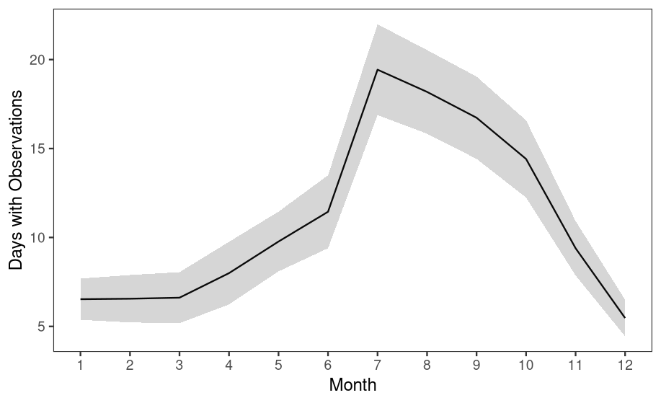
Figure S1. Mean (±SD) number of days per month with ocean color observations across the 10-year timeseries from the high-resolution GOCI grid (500 m 8x per day) highlighting the increaesd number of days with observations during the summer months.

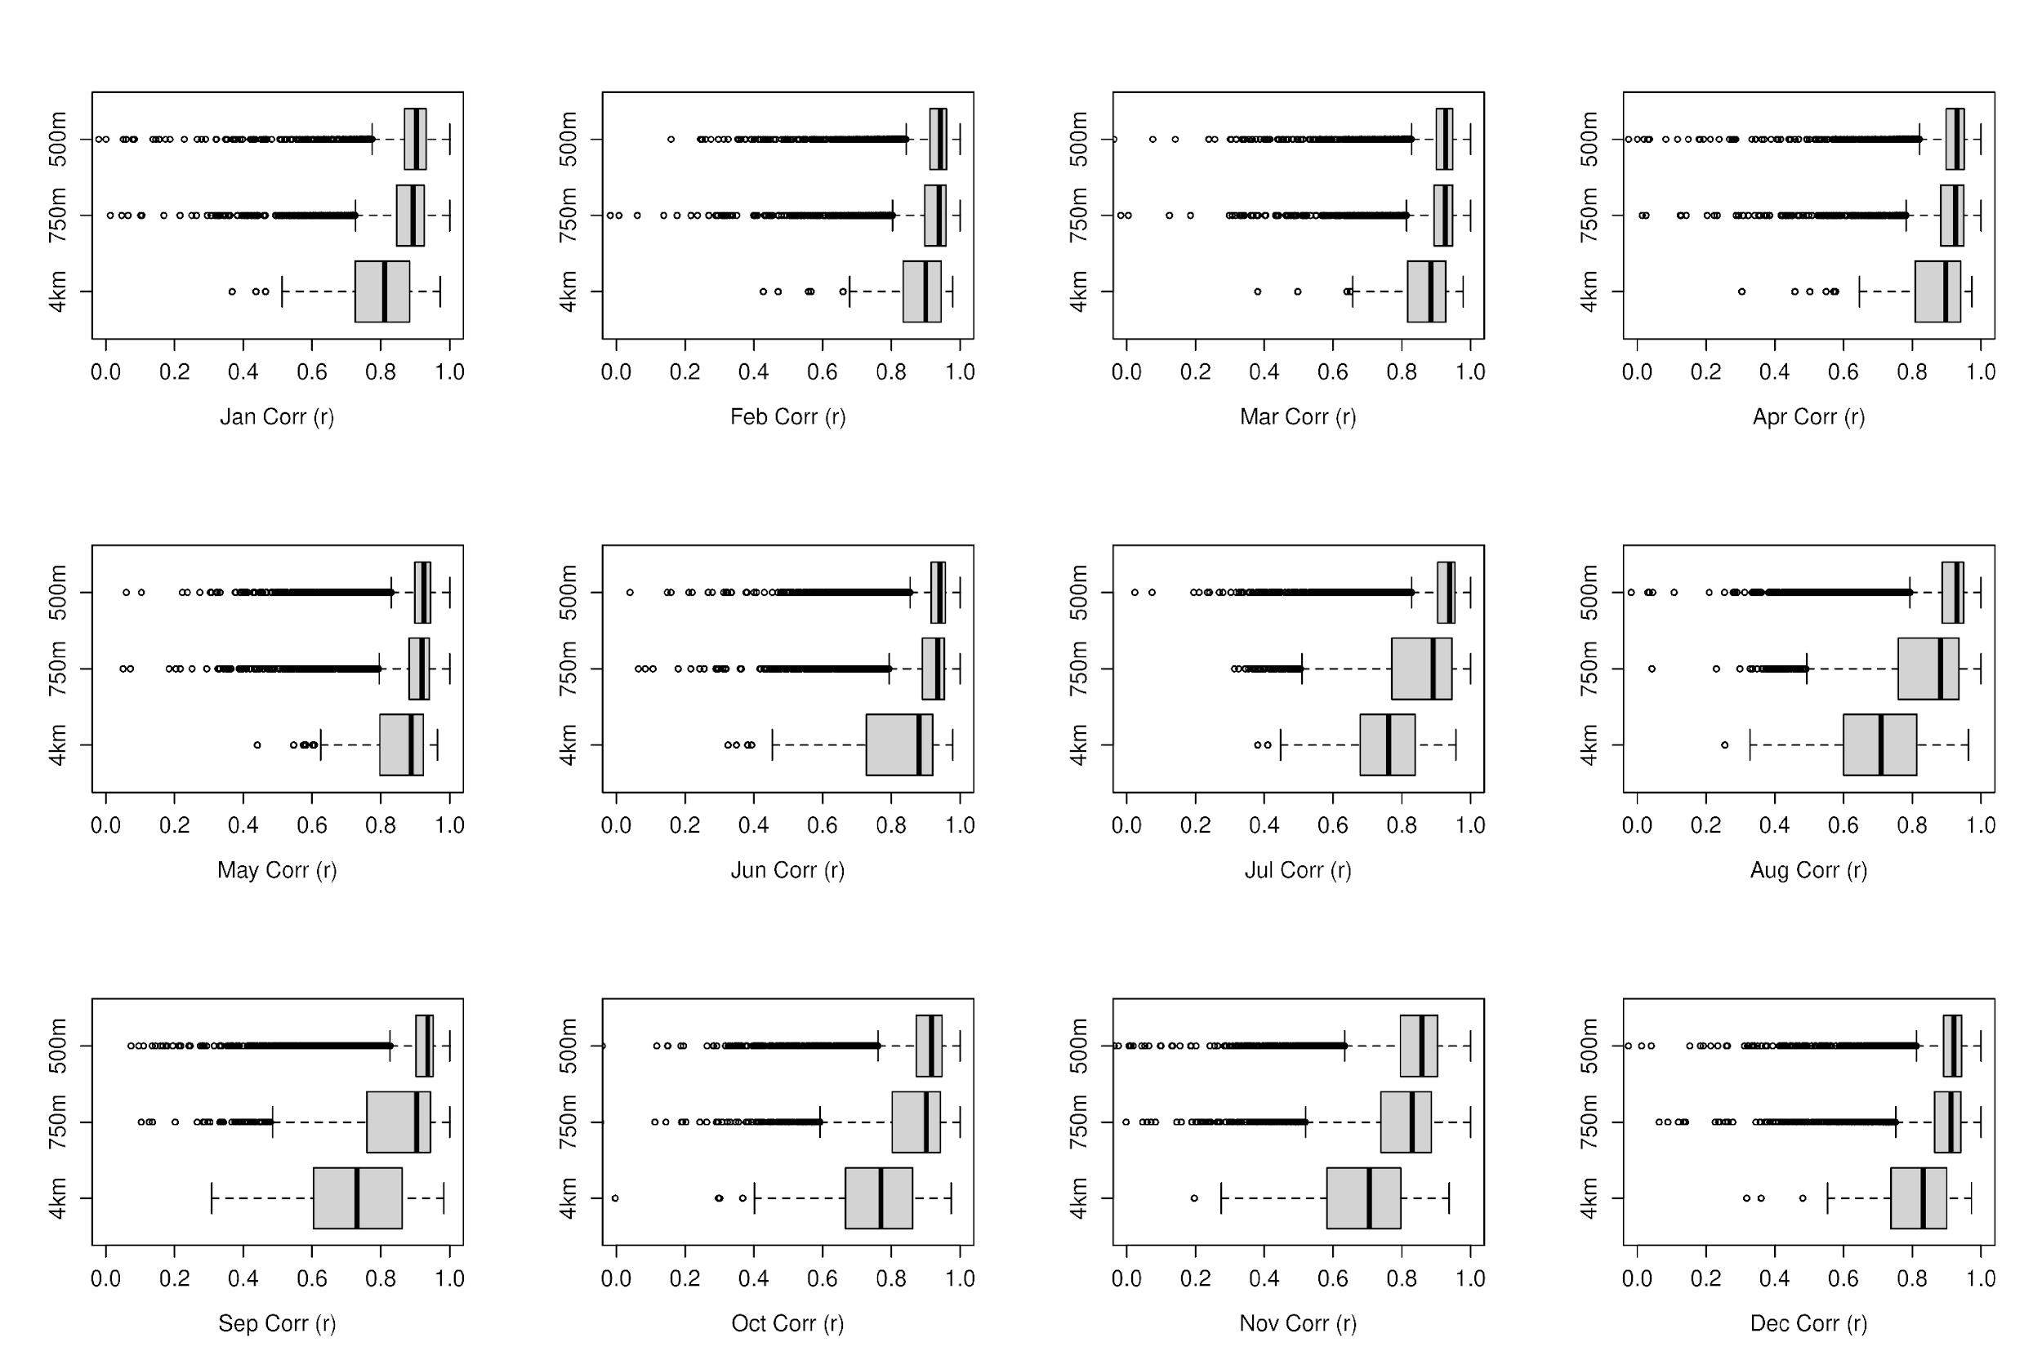
Figure S2. Changes in coastal chlor-a and K_{d}490 correlations (2011-2021) across spatial scales at the daily temporal resolution broken down by month. Boxplots show the range of cell-by-cell correlations and slopes values across the entire Okinawa Prefecture region at coarse (4 km), moderate (750 m), and full (500 m) resolution grid configurations.

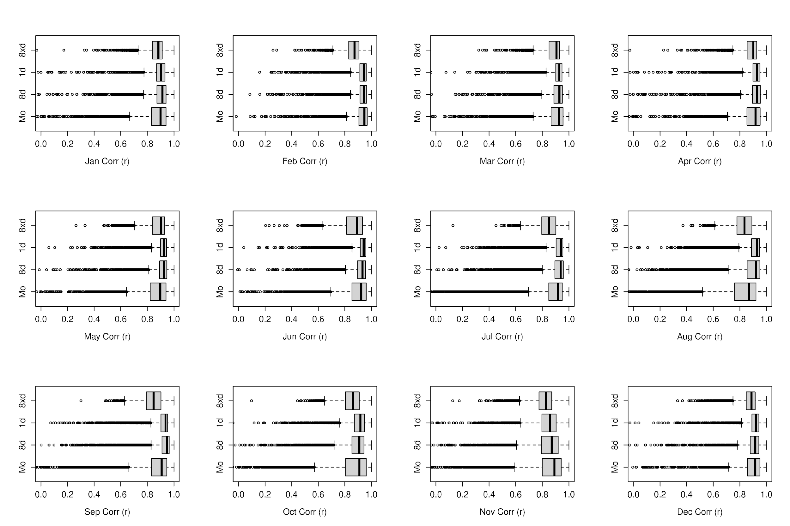
Figure S3. Changes in coastal chlor-a and K_{d}490 correlations (2011-2021) across temporal scales at the full 500 m grid resolution broken down by month. Boxplots show the range of cell-by-cell correlations and slopes values across the entire Okinawa Prefecture region at monthly, 8-day, daily, and 8x/day time configurations.

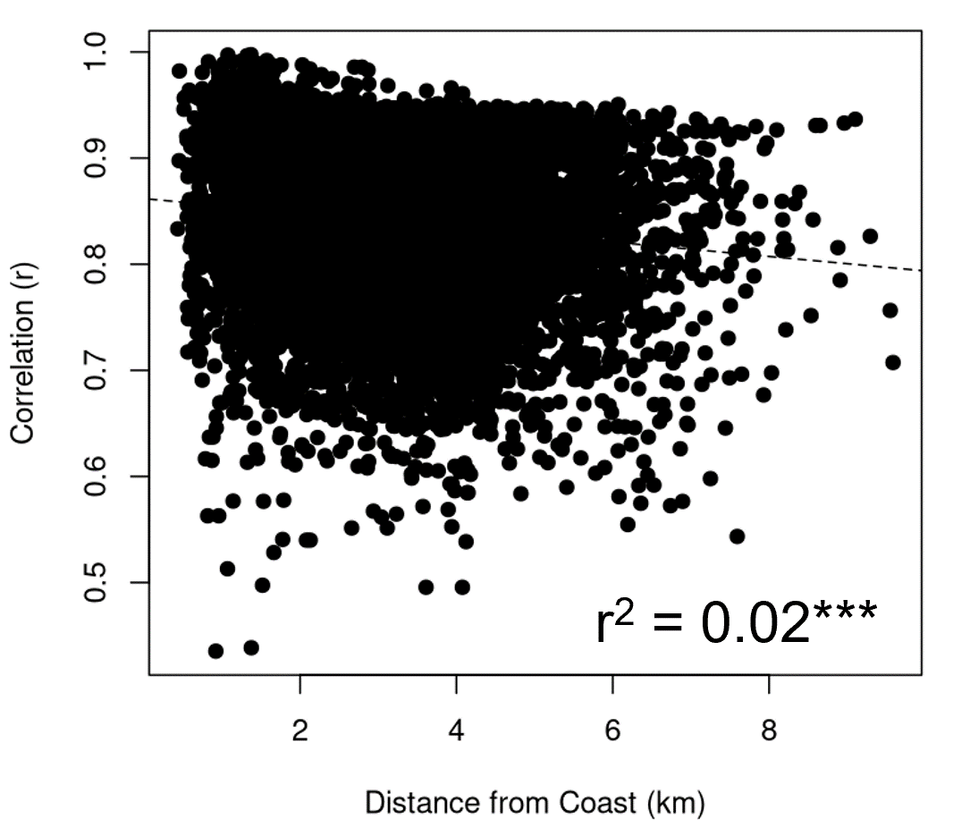
Figure S4. Results from a linear regression between daily chlor-a and K_{d}490 correlations (2011-2021) and distance from the coast for all grid cells (4 km, 750 m, and 500 m) around coastal Okinawa. *** indicates a significant relationship (p < 0.001).
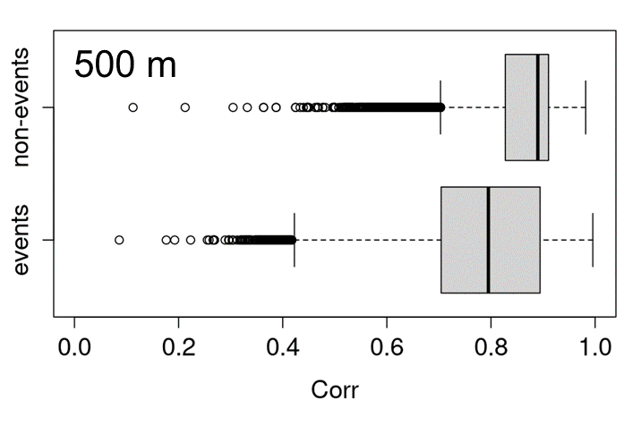
Figure S5. Boxplots showing the cell-by-cell (500 m resolution) correlations between chlor-a and K_{d}490 across Okinawa during episodic events and non-events.

