Supplementary Material A – Data Visualizations and Exploratory Analyses
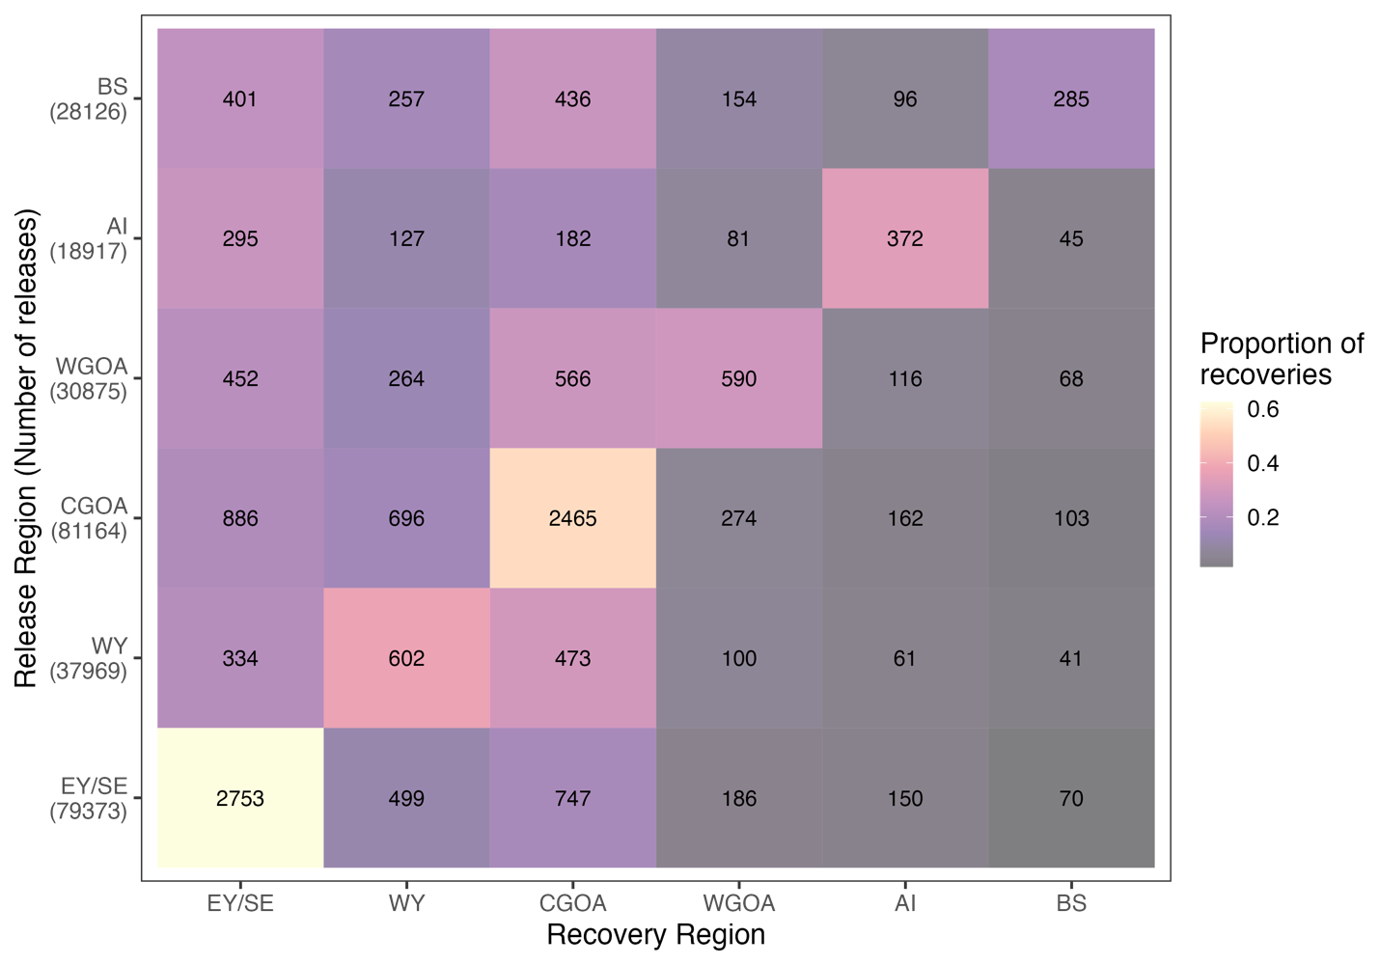
Figure A1. Observed tag recovery matrix by recovery and release region. Here, regions are defined as fishery management units (BS: Bering Sea, AI: Aleutian Islands, WGOA: Western Gulf of Alaska, CGOA: Central Gulf of Alaska, WY: West Yakutat, EY/SE: East Yakutat/Southeast). Numbers depicted in parentheses on the y-axis represent the total number of releases in a given region, while numbers depicted in the figure represent the total number of recoveries in a given region. Colors in the figure are shaded from a low (purple) to high (yellow) proportion of recoveries in a given recovery region.

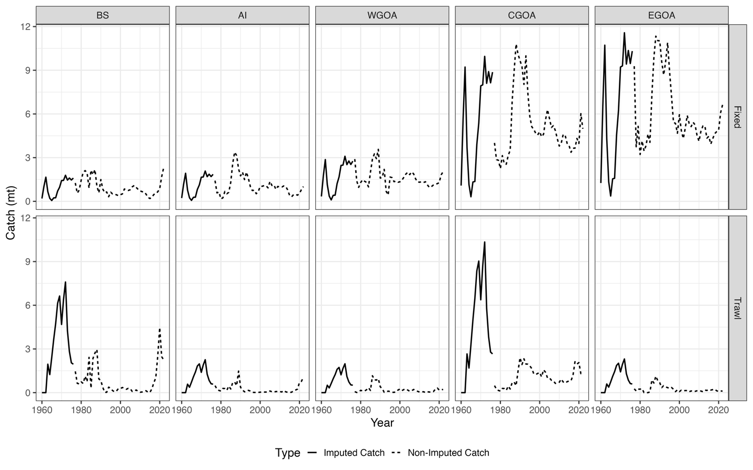
Figure A2. Fishery removals from the fixed-gear fleet (top row) and trawl fleet (bottom row) across the Bering Sea (BS), Aleutian Islands (AI), western Gulf of Alaska (GOA), central GOA, and eastern GOA. Solid lines represent catches (1960 – 1976) imputed using average regional catch proportions from 1977 – 2021, while dashed lines are catches reported on the region-level. These regional fishery removals are directly utilized in the spatial models considered in this study.

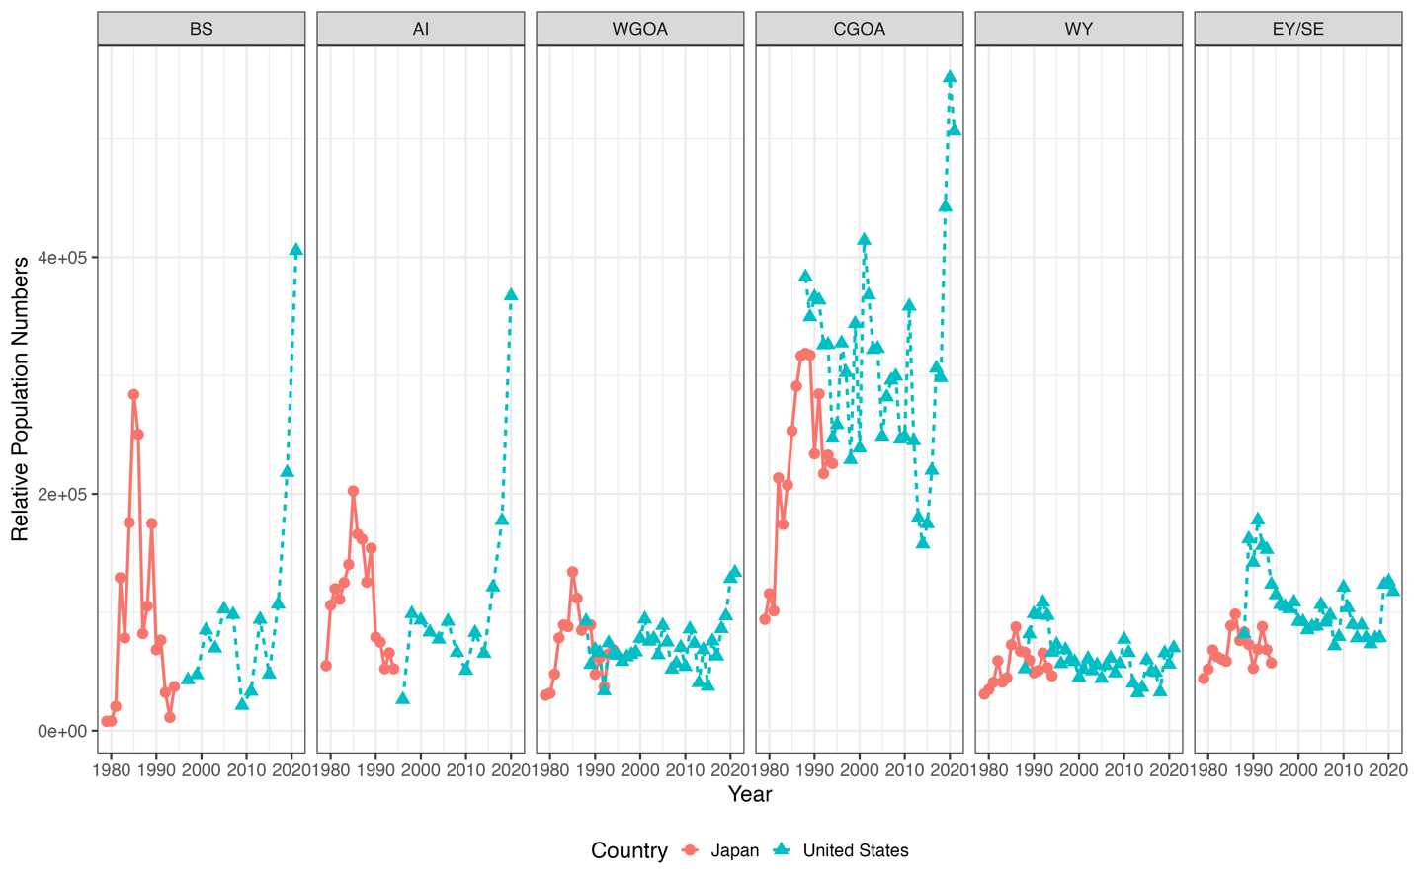
Figure A3. Relative indices of abundance from the fishery-independent longline survey across fishery management units (BS: Bering Sea, AI: Aleutian Islands, WGOA: Western Gulf of Alaska, CGOA: Central Gulf of Alaska, WY: West Yakutat, EY/SE: East Yakutat/Southeast). Red solid lines with circles represent indices from the Japanese longline survey, while blue dashed lines with triangles are indices from the United States longline survey.

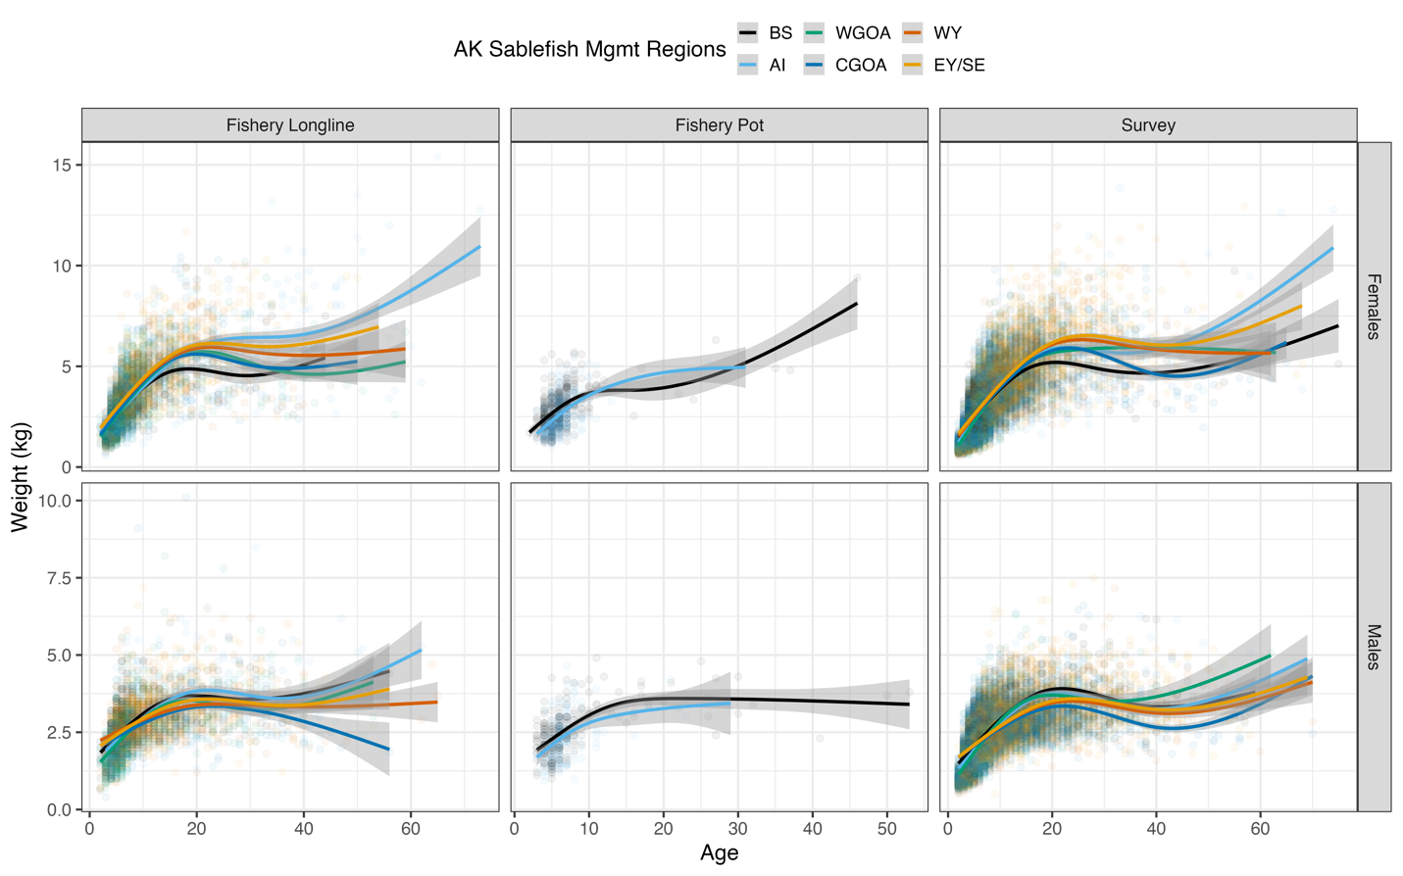
Figure A4. Weight-at-age observations across sexes (rows) and sampling method (columns). Colored points represent individual observations from a given fishery management unit (BS: Bering Sea, AI: Aleutian Islands, WGOA: Western Gulf of Alaska, CGOA: Central Gulf of Alaska, WY: West Yakutat, EY/SE: East Yakutat/Southeast). Individual observations are smoothed using a cubic spline (colored lines), with their associated 95% confidence intervals shown as grey shaded ribbons.
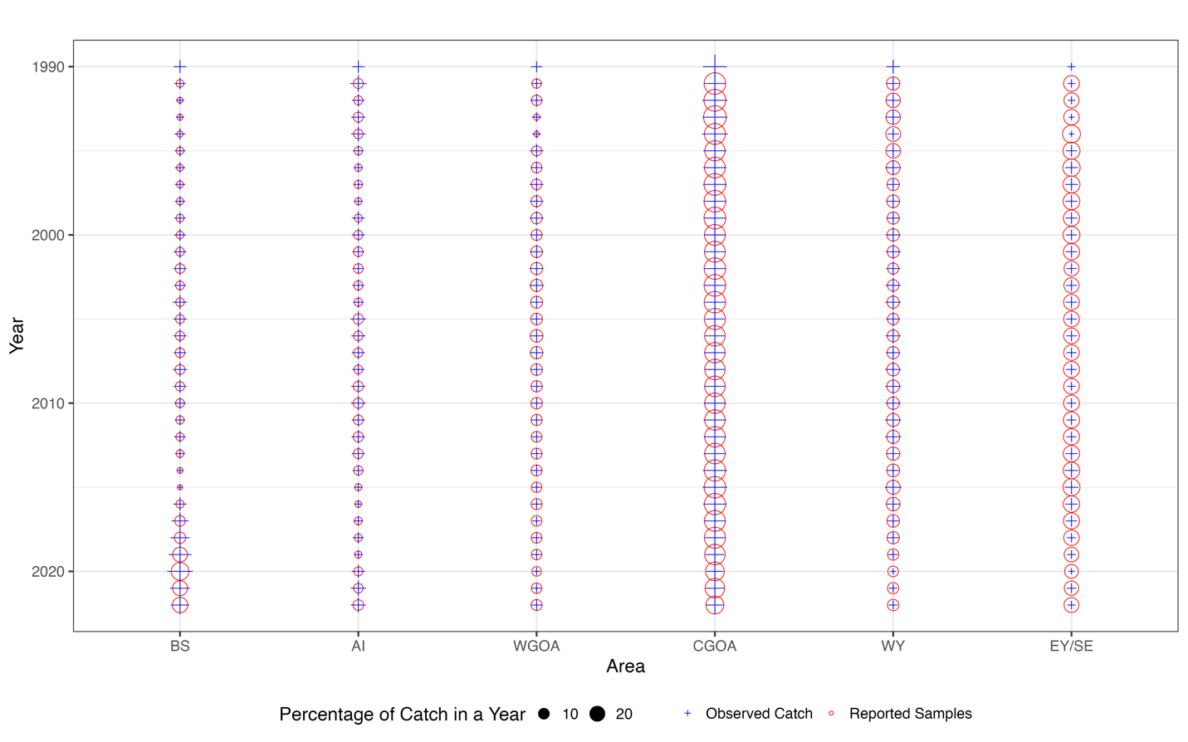
Figure A5. The proportion of biological sampling effort (i.e., age frequencies; red circles) relative to the proportion of total landed catch (blue crosses, scale by size) across fishery management units (x-axis; BS: Bering Sea, AI: Aleutian Islands, WGOA: Western Gulf of Alaska, CGOA: Central Gulf of Alaska, WY: West Yakutat, EY/SE: East Yakutat/Southeast) and time (y-axis). Management units and years that are adequately sampled (i.e., the proportion of reported biological samples equates to the proportion of total landed catch) are shown with blue crosses equal in size to the red circles. Under sampled units and years are depicted with blue crosses smaller than the red circles, while those oversampled are represented by blue crosses larger than the red circles. No biological samples (age frequencies) were available in year 1990.

