Supplemental Materials

Table S1. Common names, families, known habitat of adults, economic importance, total number of specimens identified from eggs, and encounter frequency for all fish taxa identified (listed in alphabetical order). Habitat and economic importance information was gathered from FishBase (http://www.fishbase.org/search.php).
Legend: Bold = Federally managed taxa
X = Taxa that had at least one occurrence of 20 or more eggs being collected at a site.
Y = Taxa that had at least one occurrence of 50 or more eggs being collected at a site.
* = There was a single Thunnus atlanticus reference sequence in BOLD that our sequences matched >97% at the time of identification, this reference sequence has now been removed from BOLD.
** = There is a single Acanthocybium solandri reference sequence in BOLD that our sequences match 100%, but the reference sequence is likely misidentified.
Taxon | Family | Common Name | Habitat | Economic Importance | Total Number of Eggs Identified | Encounter Frequency  (n = 170)
Acanthostracion quadricornis | Ostraciidae | Scrawled cowfish | Reef-associated | minor commercial; aquarium | 2 | 2
Alectis ciliaris | Carangidae | African pompano | Reef-associated | minor commercial; gamefish; aquarium | 3 | 2
Anisotremus virginicus/surinamensis | Haemulidae | Porkfish/Black margate | Reef-associated | minor commercial; gamefish; aquarium | 2 | 1
Antigonia capros | Caproidae | Deepbody boarfish | Demersal | minor commercial | 27 | 5
Antigonia combatia | Caproidae | Shortspine boarfish | Bathydemersal | minor commercial | 9 | 1
Auxis thazard/rochei ^{Y} | Scombridae | Frigate tuna/Bullet tuna | Pelagic-neritic | highly commercial; gamefish | 48 | 11
Bascanichthys scuticaris | Ophichthidae | Whip eel | Reef-associated | no | 16 | 8
Calamus penna | Sparidae | Sheepshead porgy | Reef-associated | minor commercial | 1 | 1
Callechelys guineensis | Ophichthidae | Shorttail snake eel | Demersal burrower | no | 1 | 1
Chaetodon ocellatus | Chaetodontidae | Spotfin butterflyfish | Reef-associated | aquarium | 1 | 1
Chloroscombrus chrysurus ^{X} | Carangidae | Atlantic bumper | Pelagic-neritic | commercial | 44 | 6
Citharichthys macrops | Cyclopsettidae | Spotted whiff | Reef-associated | no | 3 | 3

Table S1. (Continued)
Cubiceps baxteri/pauciradiatus | Nomeidae | Black fathead/Bigeye cigarfish | Pelagic-oceanic/Bathypelagic | no | 1 | 1
Cyclopsetta fimbriata | Cyclopsettidae | Spotfin flounder | Reef-associated | minor commercial | 32 | 18
Cynoscion nothus/arenarius | Sciaenidae | Silver seatrout/Sand weakfish | Demersal | minor commercial/commercial | 2 | 2
Decapterus punctatus/tabl ^{Y} | Carangidae | Round scad/Roughear scad | Reef-associated/Demersal | minor commercial; bait | 1034 | 87
Diplectrum formosum | Serranidae | Sand perch | Reef-associated | commercial; gamefish | 29 | 12
Echeneis/Remora sp. | Echeneidae | Remoras | Reef-associated | minor commercial | 5 | 4
Echiophis intertinctus | Ophichthidae | Spotted spoon-nose eel | Demersal | no | 1 | 1
Eques/Pareques sp. | Sciaenidae | Drums (Jacknifes/Highats) | Reef-associated | minor commercial; aquarium | 4 | 3
Etropus crossotus | Cyclopsettidae | Fringed flounder | Demersal | minor commercial | 1 | 1
Eucinostomus sp. | Gerreidae | Mojarras | Reef-associated/Demersal | minor commercial | 22 | 10
Euthynnus alletteratus ^{X} | Scombridae | Little tunny | Pelagic-oceanic | commercial; gamefish | 44 | 10
Exocoetidae sp. | Exocoetidae | Flyingfish | Pelagic-neritic/Pelagic-oceanic | no/minor commercial; bait | 2 | 2
Gordiichthys irretitus | Ophichthidae | Horsehair eel | Demersal | no | 1 | 1
Gymnachirus spp. | Achiridae | Soles | Demersal | commercial | 7 | 6
Gymnothorax saxicola | Muraenidae | Honeycomb moray | Demersal | no | 1 | 1
Haemulon aurolineatum/striatum | Haemulidae | Tomtate grunt/Striped grunt | Reef-associated | minor commercial; aquarium | 75 | 23
Haemulon plumierii | Haemulidae | White grunt | Reef-associated | minor commercial; gamefish; aquarium | 18 | 10
Hemicaranx amblyrhynchus | Carangidae | Bluntnose jack | Pelagic-neritic | minor commercial | 3 | 2
Heteroconger luteolus | Congridae | Yellow garden eel | Demersal burrower | no | 1 | 1
Hyporhamphus unifasciatus | Hemiramphidae | Common halfbeak | Reef-associated | minor commercial; bait | 1 | 1
Hyporthodus flavolimbatus | Serranidae | Yellowedge grouper | Demersal | commercial; gamefish | 10 | 4
Istiophorus platypterus | Istiophoridae | Sailfish | Pelagic-oceanic | commercial; gamefish | 3 | 3
Katsuwonus pelamis | Scombridae | Skipjack tuna | Pelagic-oceanic | highly commercial; gamefish | 16 | 3
Katsuwonus pelamis/Thunnus atlanticus* | Scombridae | Skipjack tuna/Blackfin tuna | Pelagic-oceanic | highly commercial; gamefish | 4 | 1
Table S1. (Continued)
Lepophidium brevibarbe/Ophidion holbrooki ^{X} | Ophidiidae | Shortbeard/Band cusk-eel | Demersal/Reef-associated | minor commercial | 28 | 1
Letharchus velifer | Ophicthidae | Sailfin eel | Demersal | no | 19 | 11
Liopropoma eukrines | Serranidae | Wrasse bass | Reef-associated | no | 1 | 1
Lutjanus analis | Lutjanidae | Mutton snapper | Reef-associated | highly commercial; gamefish; aquarium | 10 | 2
Lutjanus campechanus | Lutjanidae | Northern red snapper | Reef-associated | commercial; gamefish | 70 | 22
Lutjanus griseus | Lutjanidae | Gray snapper | Reef-associated | commercial; gamefish; aquarium | 2 | 2
Lutjanus synagris | Lutjanidae | Lane snapper | Reef-associated | commercial; gamefish; aquarium | 20 | 12
Malacanthus plumieri | Malacanthidae | Sand tilefish | Reef-associated | minor commercial | 1 | 1
Micropogonias undulatus | Sciaenidae | Atlantic croaker | Demersal | commercial; aquaculture; gamefish | 10 | 4
Myrophis punctatus | Ophichthidae | Speckled worm-eel | Reef-associated | commercial; bait | 2 | 2
Ocyurus chrysurus | Lutjanidae | Yellowtail snapper | Reef-associated | commercial; aquaculture; gamefish; aquarium | 1 | 1
Ophidion selenops | Ophidiidae | Mooneye cusk-eel | Reef-associated | no | 3 | 2
Opisthonema oglinum | Clupeidae | Atlantic thread herring | Reef-associated | commercial; bait | 1 | 1
Otophidium omostigma | Ophidiidae | Polka-dot cusk-eel | Demersal | no | 2 | 1
Paraconger caudilimbatus | Congridae | Margintail conger | Reef-associated burrower | no | 1 | 1
Parahollardia lineata | Triacanthodidae | Jambeau | Demersal | no | 1 | 1
Pareques iwamotoi | Sciaenidae | Blackbar drum | Demersal | no | 1 | 1
Peprilus paru | Stromateidae | American harvestfish | Benthopelagic | minor commercial | 30 | 13
Peprilus triacanthus/burti ^{X} | Stromateidae | Atlantic butterfish/Gulf butterfish | Benthopelagic | commercial; gamefish/no | 205 | 15
Peristedion gracile | Triglidae | Slender searobin | Bathydemersal | no | 2 | 1
Pomacanthus arcuatus | Pomacanthidae | Gray angelfish | Reef-associated | minor commercial; aquarium | 2 | 2
Pomatomus saltatrix | Pomotomidae | Bluefish | Pelagic-oceanic | highly commercial; aquaculture; gamefish; bait | 6 | 2
Priacanthus arenatus | Priacanthidae | Atlantic bigeye | Reef-associated | minor commercial; gamefish; aquarium | 8 | 4
Prionotus spp. ^{X} | Triglidae | Searobins | Demersal | no | 550 | 68
Pristipomoides aquilonaris ^{X} | Lutjanidae | Wenchman | Demersal | minor commercial | 145 | 22

Table S1. (Continued)
Prognichthys occidentalis | Exoceotidae | Western bluntnose flyingfish | Pelagic-neritic | no | 2 | 2
Pseudupeneus maculatus | Mullidae | Spotted goatfish | Reef-associated | commercial; aquarium | 1 | 1
Pterois sp. | Scorpaenidae | Lionfishes | Reef-associated | Invasive | 1 | 1
Rhomboplites aurorubens | Lutjanidae | Vermilion snapper | Demersal | minor commercial | 122 | 33
Rypticus bistrispinus | Serranidae | Freckled soapfish | Reef-associated | no | 1 | 1
Rypticus saponaceus/maculatus ^{X} | Serranidae | Greater soapfish/Whitespotted soapfish | Reef-associated/Demersal | subsistence; aquarium/no | 84 | 18
Sardinella aurita ^{X} | Clupeidae | Round sardinella | Pelagic-neritic | highly commercial; bait | 53 | 10
Saurida sp. | Synodontidae | Lizardfishes | Reef-associated/Demersal | no | 3 | 2
Sciaenops ocellatus ^{Y} | Sciaenidae | Red drum | Demersal | minor commercial; aquaculture; gamefish; aquarium | 79 | 3
Scomberomorus cavalla | Scombridae | King mackerel | Pelagic-neritic | commercial; gamefish | 68 | 19
Scomberomorus cavalla/Acanyhocybium solandri** | Scombridae | King mackerel/Wahoo | Pelagic-neritic/Pelagic-oceanic | commercial; gamefish | 11 | 5
Scomberomorus maculatus ^{X} | Scombridae | Atlantic Spanish mackerel | Pelagic-neritic/Reef-associated | highly commercial; gamefish/minor commercial; gamefish | 59 | 13
Selar crumenophthalmus | Carangidae | Bigeye scad | Reef-associated | highly commercial; bait | 7 | 6
Selene setapinnis/vomer | Caranngidae | Atlantic moonfish/Lookdown | Benthopelagic/Demersal | highly commercial; aquarium/minor commercial; gamefish; aquarium | 13 | 4
Serraniculus pumilio | Serranidae | Pygmy sea bass | Reef-associated | no | 11 | 10
Syacium papillosum/gunteri | Cyclopsettidae | Dusky flounder | Reef-associated | minor commercial | 271 | 56
Symphurus diomedeanus | Cynoglossidae | Spotted tonguefish | Reef-associated | no | 1 | 1
Symphurus plagiusa | Cynoglossidae | Blackcheek tonguefish | Demersal | minor commercial | 1 | 1
Synodus spp. ^{X} | Synodontidae | Lizardfishes | Reef-associated/Demersal | no | 254 | 66
Synodus poeyi/Saurida normani | Synodontidae | Offshore lizardfish/Shortjaw lizardfish | Reef-associated | no | 2 | 1
Thunnus spp. | Scombridae | Tunas | Pelagic-oceanic | highly commercial; gamefish | 19 | 10
Table S1. (Continued)
Trachinocephalus myops | Synodontidae | Snakefish | Reef-associated | minor commercial | 116 | 40
Xyrichtys novacula | Labridae | Pearly razorfish | Reef-associated | minor commercial; aquarium | 4 | 3

Table S2. Significant indicators from IndVal analysis for DISPROF groups.
Taxon | DISPROF group | Indicator value (IndVal) | Probability
Prionotus spp. | 1 | 0.4761 | 0.001
Synodus spp. | 1 | 0.4745 | 0.001
Myrophis punctatus | 2 | 0.975 | 0.043
Xyrichtys novacula | 4 | 0.9208 | 0.047
Selar crumenophthalmus | 5 | 0.906 | 0.007
Prognichthys occidentalis | 6 | 1 | 0.001
Saurida sp. | 8 | 0.9735 | 0.03
Decapterus punctatus/tabl | 15 | 0.4565 | 0.001

Table S3. Leave one out cross-validation (LOO-CV) confusion matrix for depth classification.
 | Reference
Prediction | 0-25m | 25-50m | 50-100m | 100-200m
0-25m | 35 (81.4%) | 12 (18.5%) | 0 | 0
25-50m | 7 (16.3%) | 42 (64.6%) | 10 (27.0%) | 3 (12%)
50-100m | 1 (2.3%) | 11 (16.9%) | 22 (59.5%) | 3 (12%)
100-200m | 0 | 0 | 5 (13.5%) | 19 (76.0%)

Table S4. Significant indicators from IndVal analysis for depth classification.

Taxon | Depth | Indicator value (IndVal) | Probability
Prionotus spp. | 0-25 | 0.4951 | 0.001
Haemulon aurolineatum/striatum | 0-25 | 0.2663 | 0.001
Serraniculus pumilio | 0-25 | 0.2326 | 0.001
Rypticus saponaceus/maculatus | 0-25 | 0.2235 | 0.002
Scomberomorus maculatus | 0-25 | 0.198 | 0.001
Peprilus paru | 0-25 | 0.1835 | 0.001
Haemulon plumierii | 0-25 | 0.1552 | 0.004
Chloroscombrus chrysurus | 0-25 | 0.1395 | 0.006
Diplectrum formosum | 0-25 | 0.138 | 0.004
Sardinella aurita | 0-25 | 0.1321 | 0.007
Letharchus velifer | 0-25 | 0.1247 | 0.011
Lutjanus synagris | 0-25 | 0.1099 | 0.026
Bascanichthys scuticaris | 0-25 | 0.0886 | 0.033
Citharichthys macrops | 0-25 | 0.0698 | 0.028
Synodus spp. | 25-50 | 0.3087 | 0.002
Syacium papillosum/gunteri | 50-100 | 0.3278 | 0.001
Trachinocephalus myops | 50-100 | 0.2038 | 0.011
Rhomboplites aurorubens | 50-100 | 0.1451 | 0.047
Euthynnus alletteratus | 50-100 | 0.0886 | 0.042
Pristipomoides aquilonaris | 100-200 | 0.3722 | 0.001
Thunnus spp. | 100-200 | 0.2039 | 0.001
Peprilus triacanthus/burti | 100-200 | 0.1898 | 0.001
Hyporthodus flavolimbatus | 100-200 | 0.16 | 0.002
Katsuwonus pelamis | 100-200 | 0.12 | 0.004
Antigonia capros | 100-200 | 0.102 | 0.008

Table S5. Leave one out cross-validation (LOO-CV) confusion matrix for region classification.

 | Reference
Prediction | Big Bend | Panhandle | South Florida
Big Bend | 29 (48.3%) | 11 (20.0%) | 26 (47.3%)
Panhandle | 14 (23.3%) | 30 (54.5%) | 9 (16.4%)
South Florida | 17 (28.3%) | 14 (25.5%) | 20 (36.4%)

Table S6. Significant indicators from IndVal analysis for region classification.

Taxon | Region | Indicator value (IndVal) | Probability
Sardinella aurita | Big Bend | 0.1409 | 0.001
Rypticus saponaceus/maculatus | Big Bend | 0.1265 | 0.007
Scomberomorus maculatus | Big Bend | 0.1121 | 0.013
Letharchus velifer | Big Bend | 0.1027 | 0.008
Peprilus paru | Big Bend | 0.0912 | 0.042
Peprilus triacanthus/burti | Panhandle | 0.2179 | 0.001
Lutjanus campechanus | Panhandle | 0.1835 | 0.001
Micropogonias undulatus | Panhandle | 0.0727 | 0.025
Selene setapinnis/vomer | Panhandle | 0.0727 | 0.017
Lutjanus synagris | South Florida | 0.1082 | 0.012

Table S7. Leave one out cross-validation (LOO-CV) confusion matrix for sampling years.
 | Reference
Prediction | 2013 | 2014 | 2019
2013 | 33 (62.3%) | 2 (3.4%) | 20 (34.5%)
2014 | 6 (11.3%) | 54 (91.5%) | 7 (12.1%)
2019 | 14 (26.4%) | 3 (5.1%) | 31 (53.4%)

Table S8. Significant indicators from IndVal analysis for sampling years.
Taxon | Sampling year | Indicator value (IndVal) | Probability
Decapterus punctatus/tabl | 2013 | 0.3931 | 0.001
Synodus spp. | 2013 | 0.3421 | 0.001
Syacium papillosum/gunteri | 2013 | 0.2865 | 0.001
Prionotus spp. | 2013 | 0.2446 | 0.013
Rhomboplites aurorubens | 2013 | 0.1798 | 0.007
Letharchus velifer | 2013 | 0.1122 | 0.004
Scomberomorus cavalla | 2013 | 0.1102 | 0.046
Bascanichthys scuticaris | 2013 | 0.0809 | 0.038
Micropogonias undulatus | 2013 | 0.0755 | 0.006
Cyclopsetta fimbriata | 2019 | 0.1683 | 0.001
Pristipomoides aquilonaris | 2019 | 0.1611 | 0.003
Peprilus triacanthus/burti | 2019 | 0.1129 | 0.023
Auxis thazard/rochei | 2019 | 0.1035 | 0.014
Echeneis/Remora sp. | 2019 | 0.069 | 0.021
Hyporthodus flavolimbatus | 2019 | 0.069 | 0.024

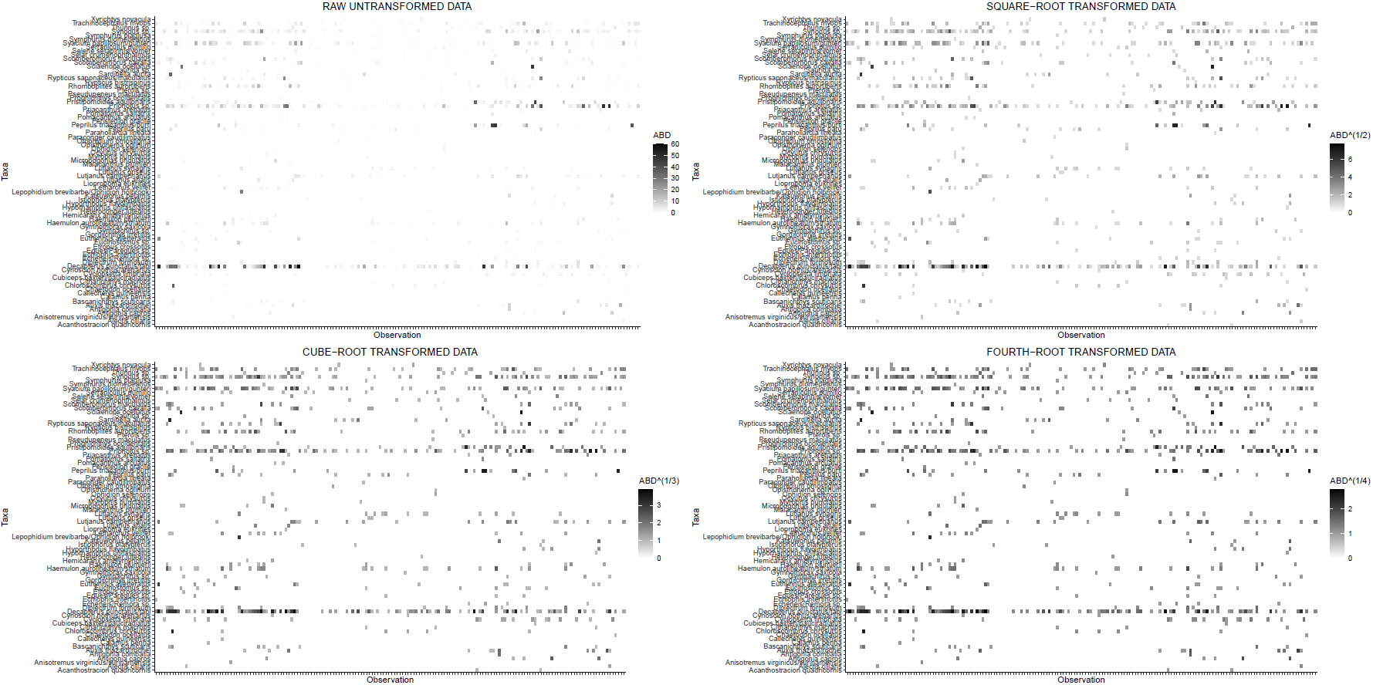

Figure S1. Shadeplot showing the raw untransformed fish egg data and the data transformed using square root, cube root, and fourth root transformations.

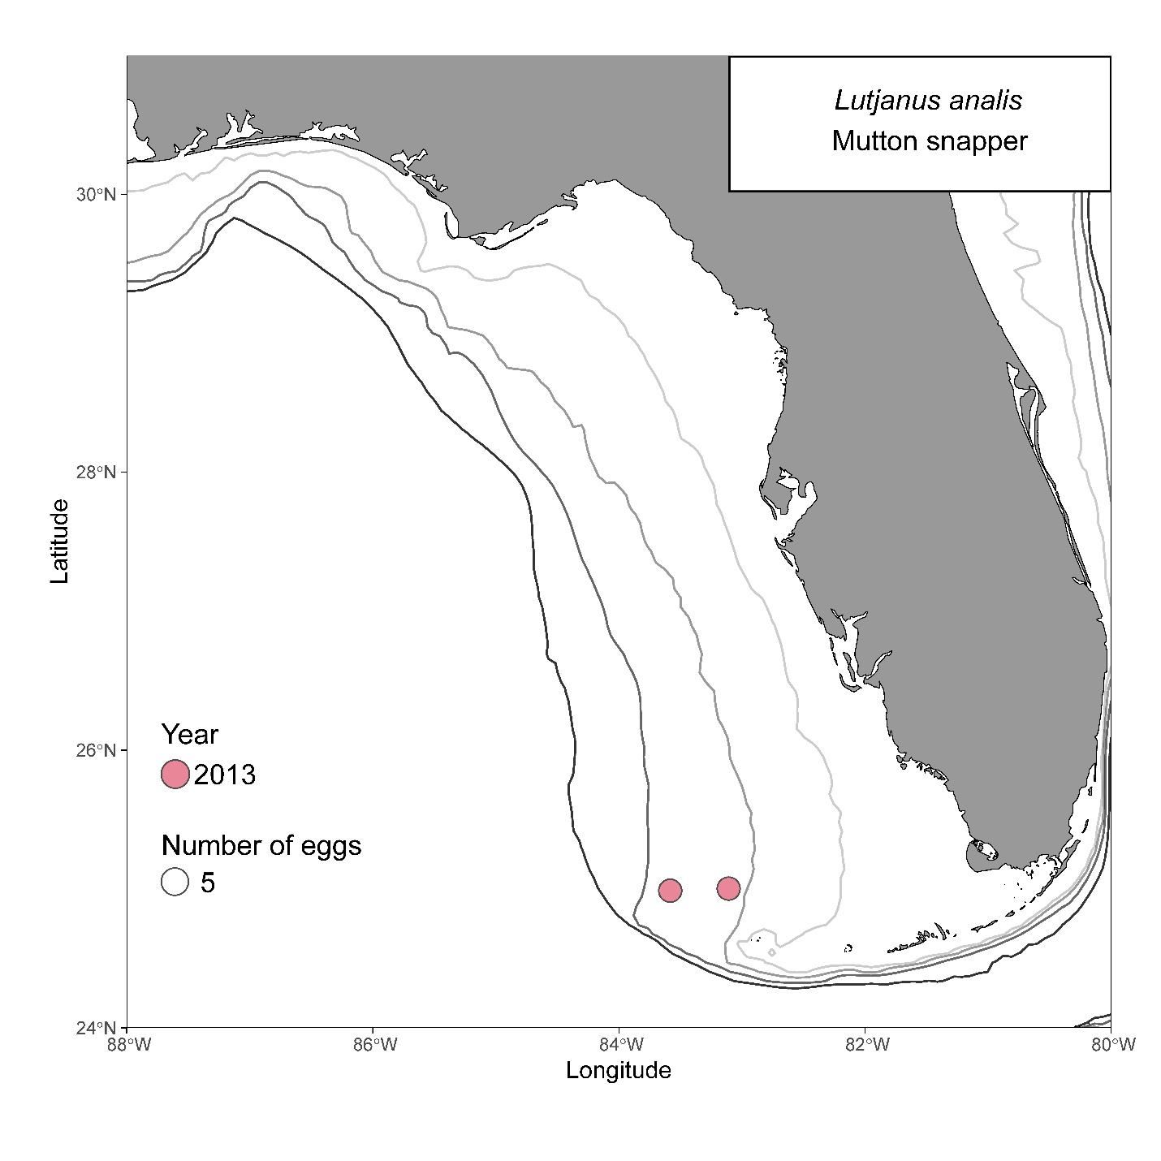
Figure S2. Map of sites where Lutjanus analis (mutton snapper) eggs were collected. Circle size is scaled to the number of eggs collected at each site, with larger circles representing higher counts. Gray and black lines represent 25 m, 50 m, 100 m, and 200 m isobaths.

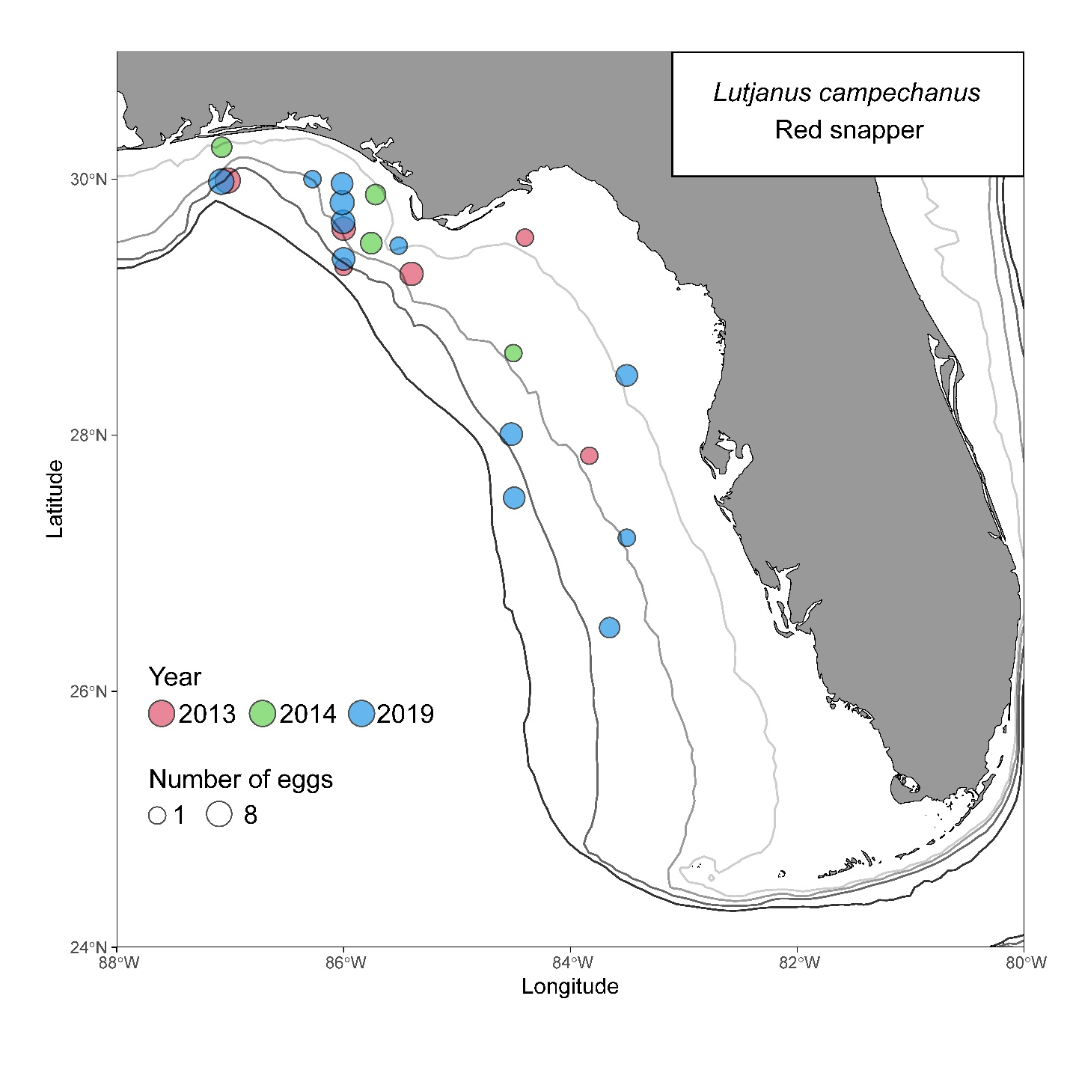
Figure S3. Map of sites where Lutjanus campechanus (red snapper) eggs were collected. Circle size is scaled to the number of eggs collected at each site, with larger circles representing higher counts. Gray and black lines represent 25 m, 50 m, 100 m, and 200 m isobaths.

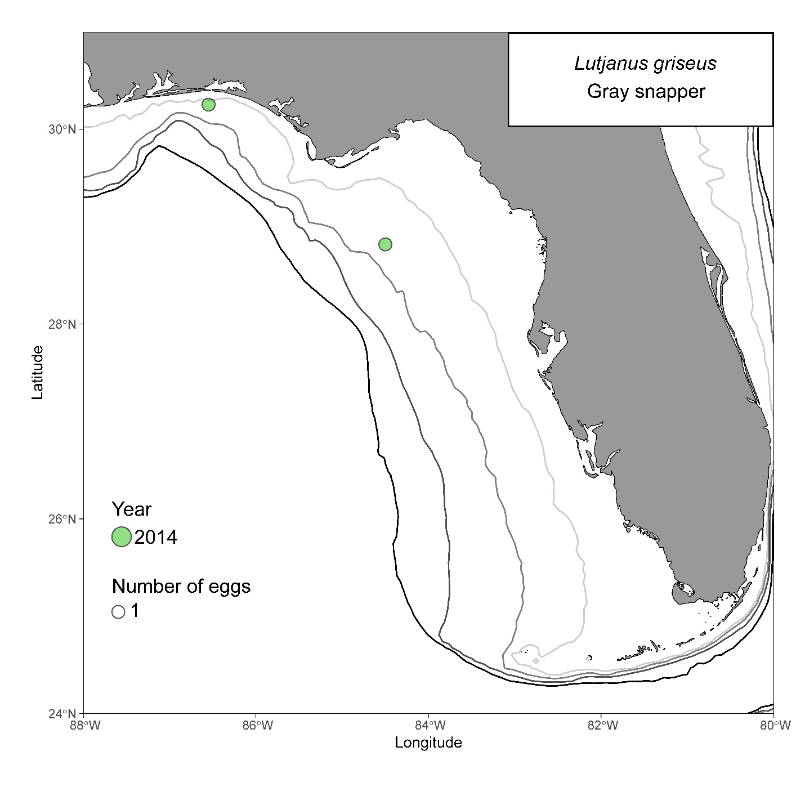
Figure S4. Map of sites where Lutjanus griseus (gray snapper) eggs were collected. Circle size is scaled to the number of eggs collected at each site, with larger circles representing higher counts. Gray and black lines represent 25 m, 50 m, 100 m, and 200 m isobaths.

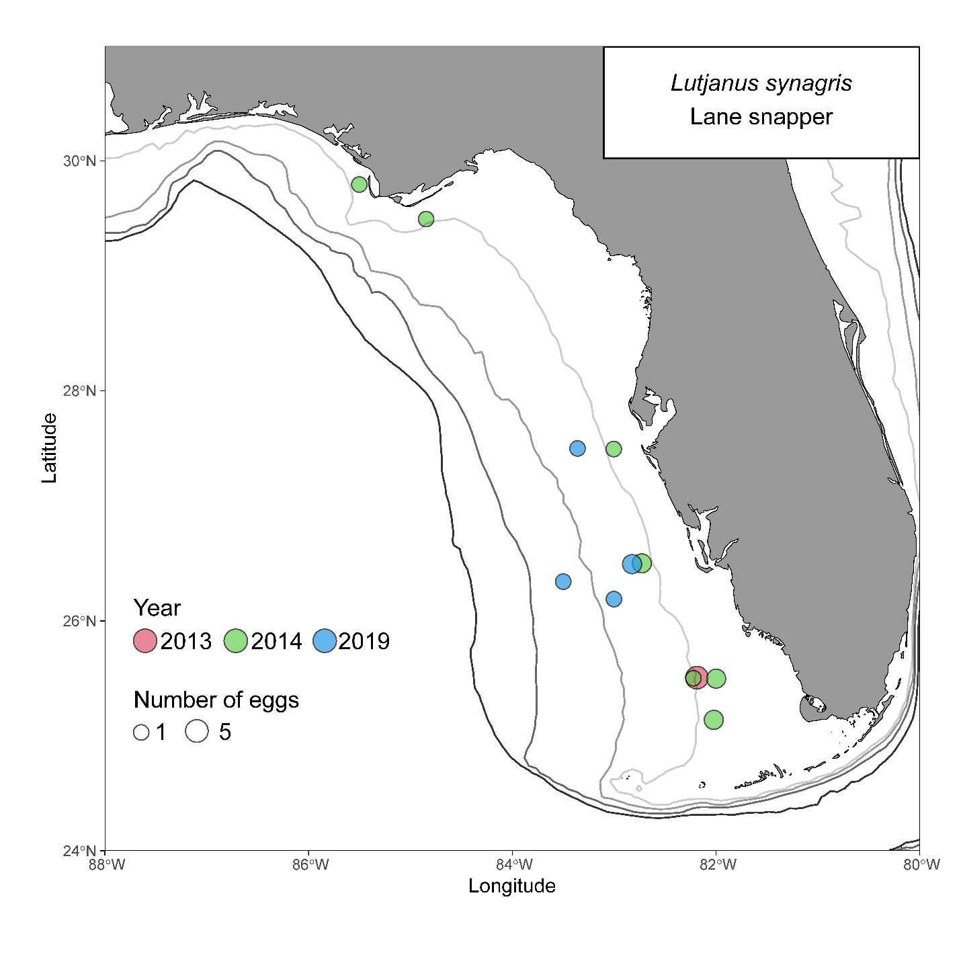
Figure S5. Map of sites where Lutjanus synagris (lane snapper) eggs were collected. Circle size is scaled to the number of eggs collected at each site, with larger circles representing higher counts. Gray and black lines represent 25 m, 50 m, 100 m, and 200 m isobaths.

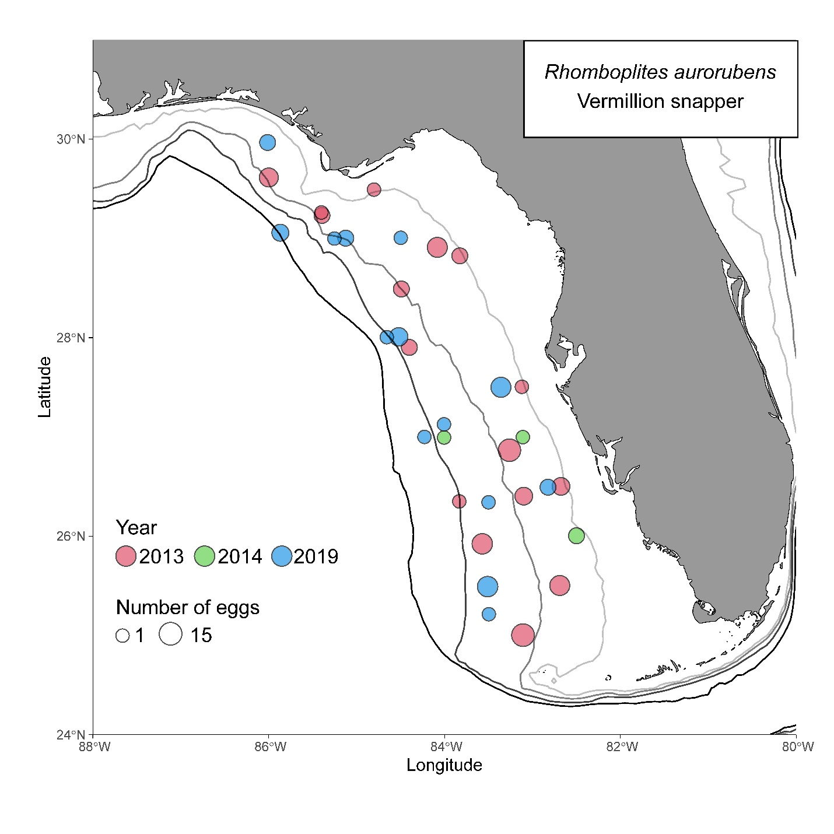
Figure S6. Map of sites where Rhomboplites aurorubens (vermilion snapper) eggs were collected. Circle size is scaled to the number of eggs collected at each site, with larger circles representing higher counts. Gray and black lines represent 25 m, 50 m, 100 m, and 200 m isobaths.

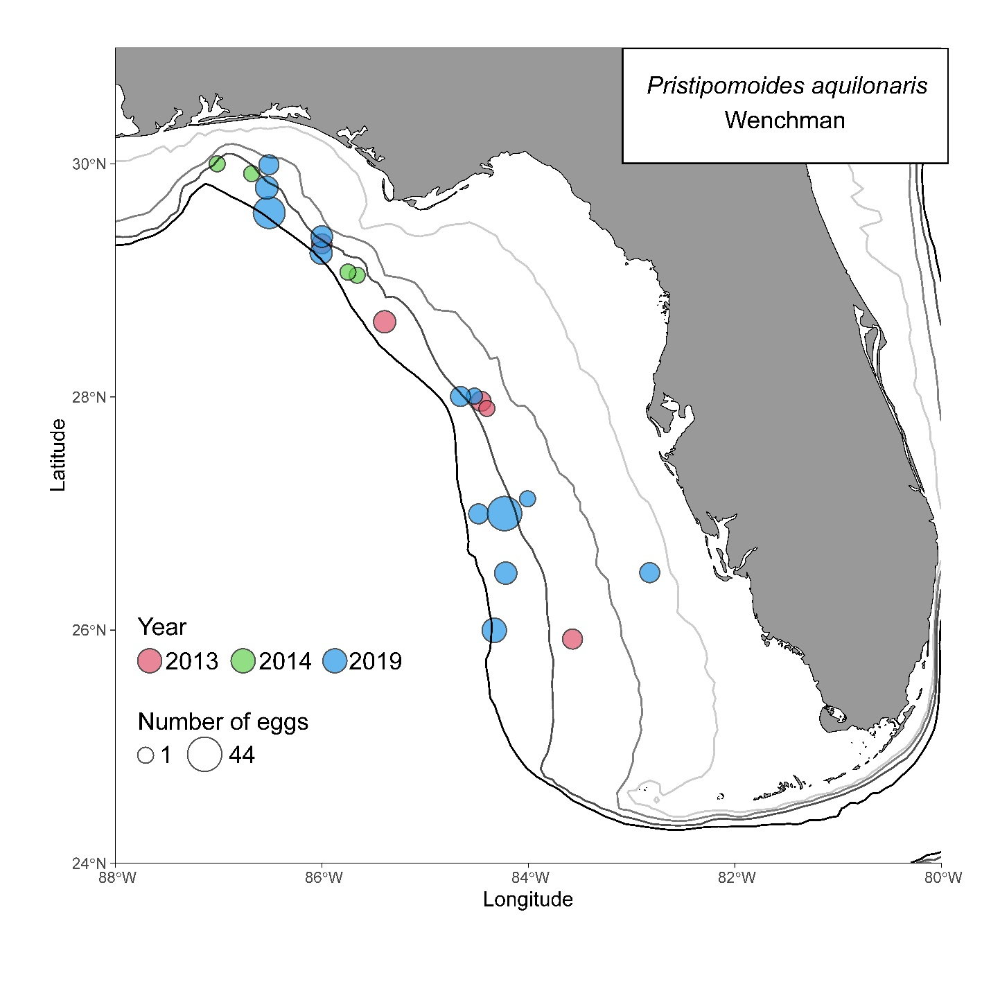
Figure S7. Map of sites where Pristipomoides aquilonaris (wenchman) eggs were collected. Circle size is scaled to the number of eggs collected at each site, with larger circles representing higher counts. Gray and black lines represent 25 m, 50 m, 100 m, and 200 m isobaths.

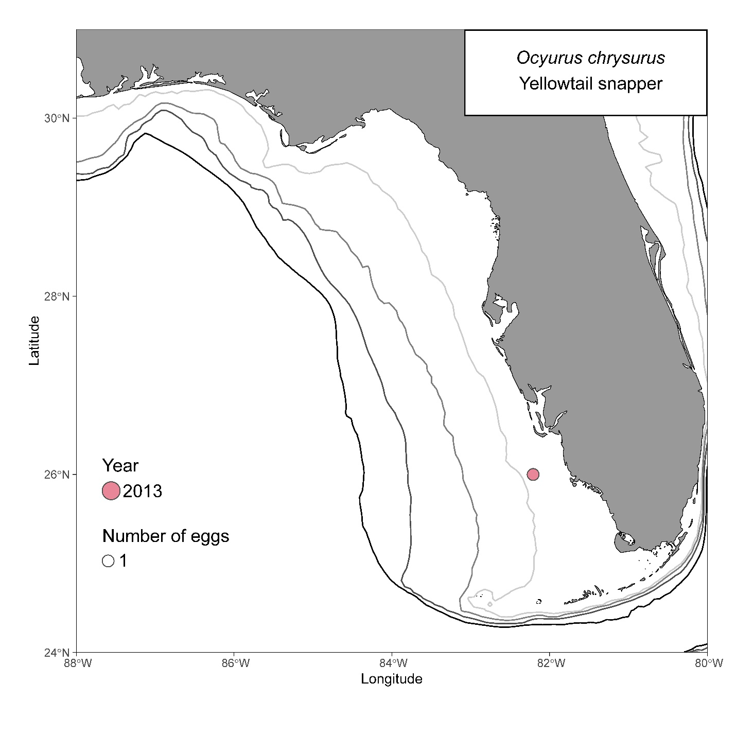
Figure S8. Map of sites where Ocyurus chrysurus (yellowtail snapper) eggs were collected. Circle size is scaled to the number of eggs collected at each site, with larger circles representing higher counts. Gray and black lines represent 25 m, 50 m, 100 m, and 200 m isobaths.

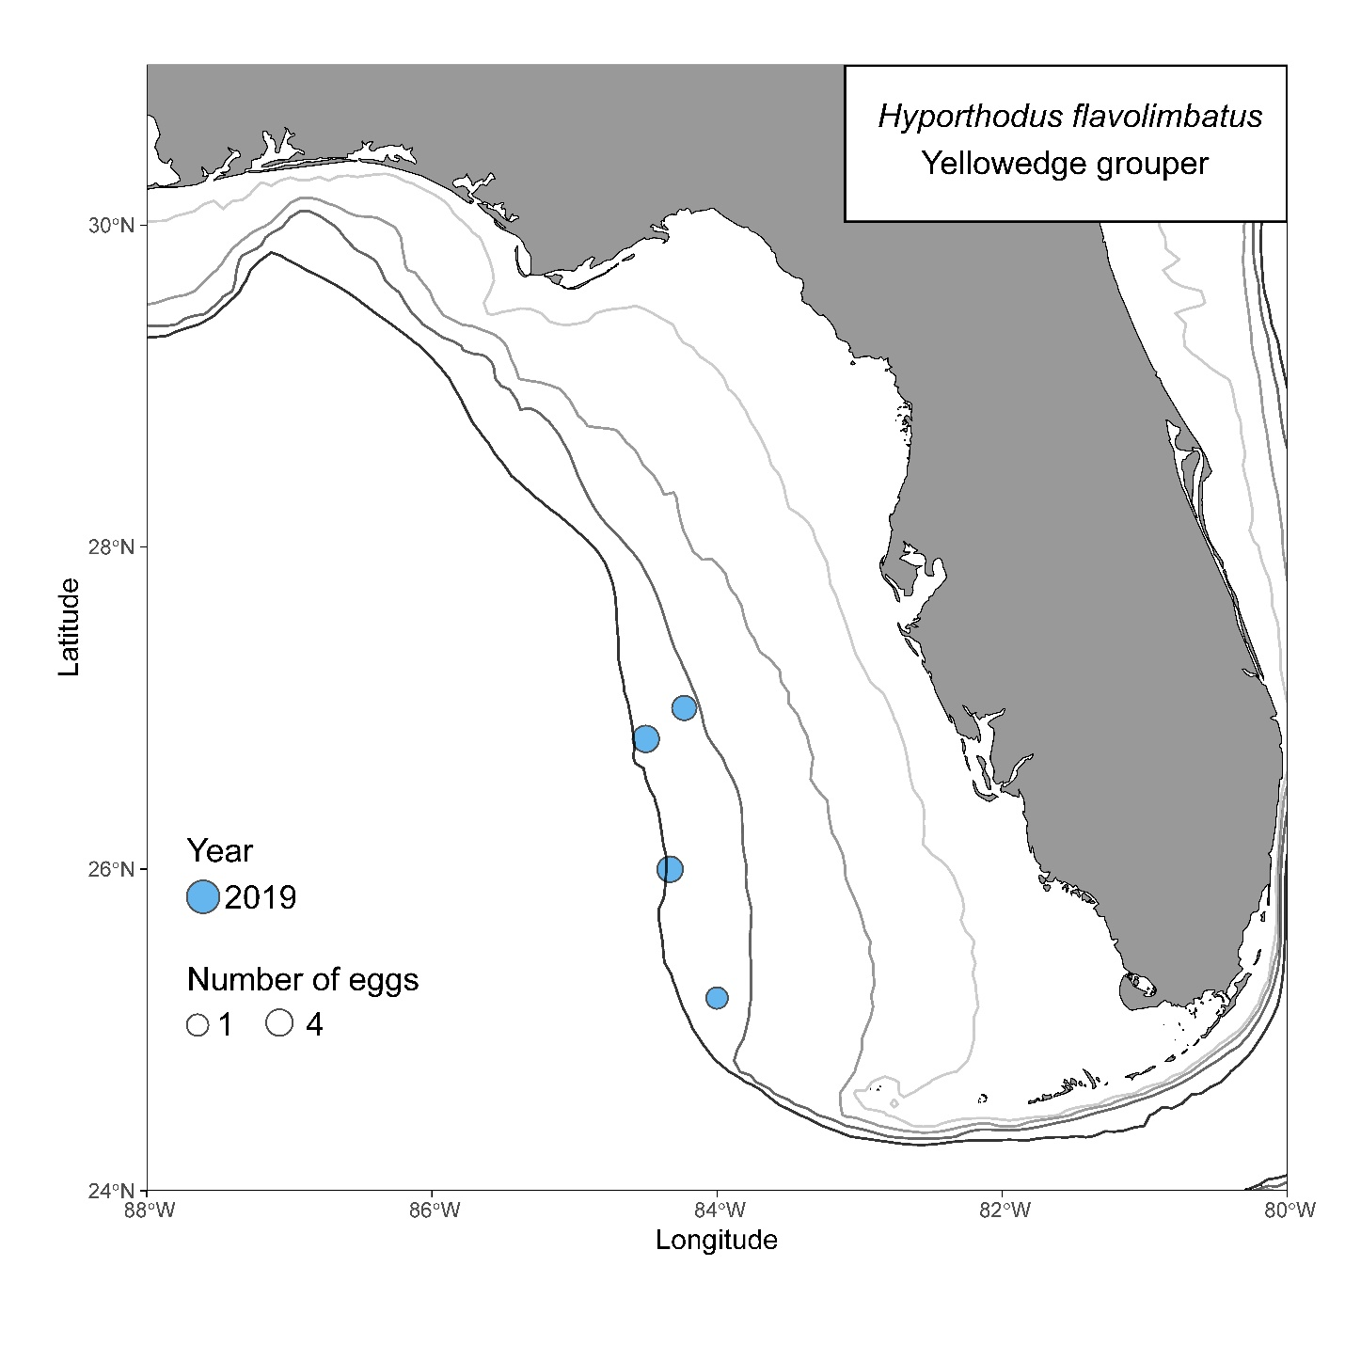
Figure S9. Map of sites where Hyporthodus flavolimbatus (yellowedge grouper) eggs were collected. Circle size is scaled to the number of eggs collected at each site, with larger circles representing higher counts. Gray and black lines represent 25 m, 50 m, 100 m, and 200 m isobaths.

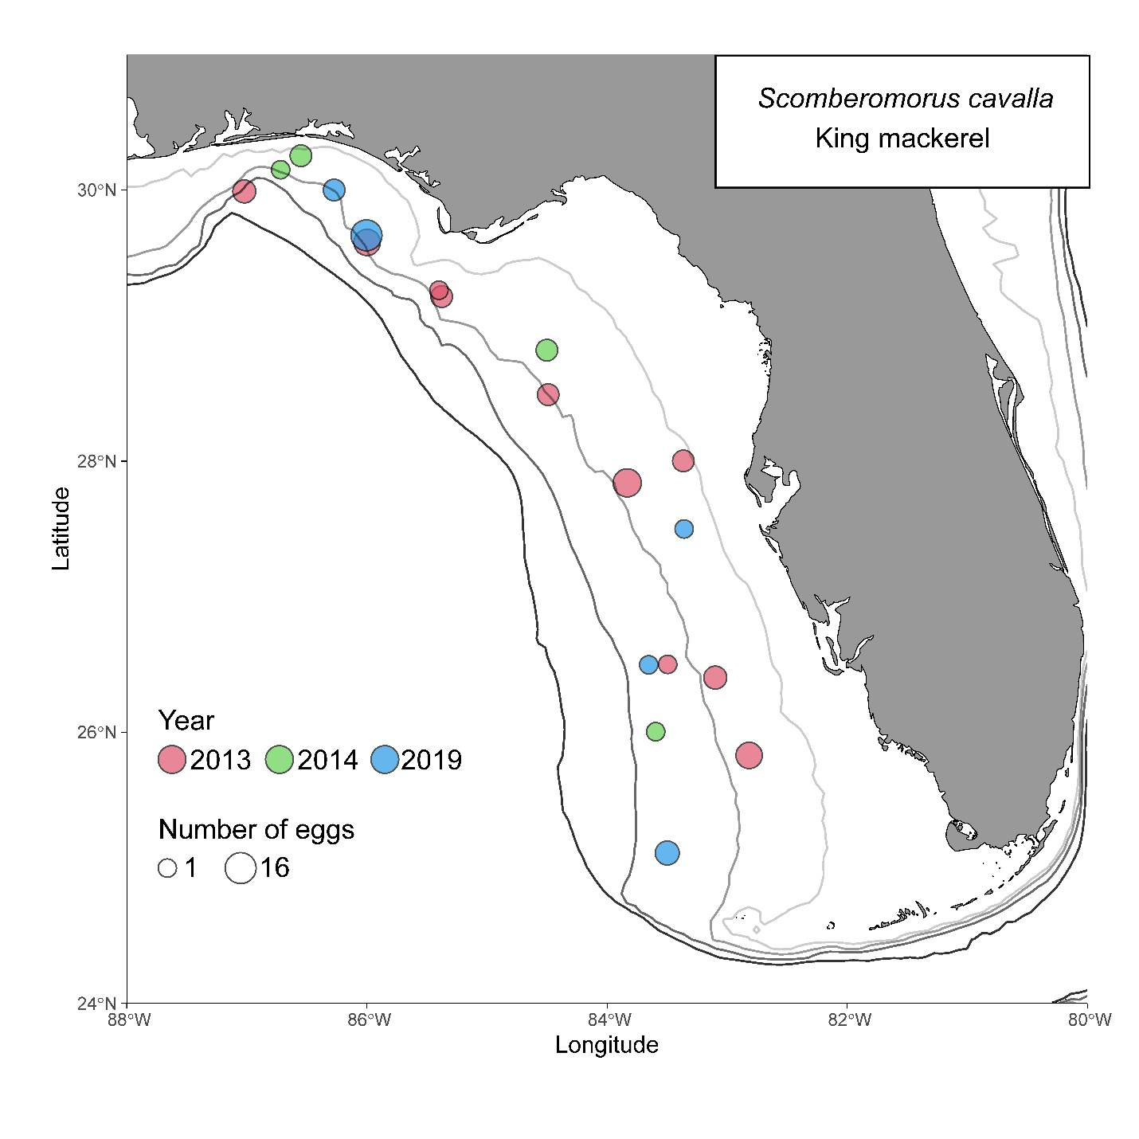
Figure S10. Map of sites where Scomberomorus cavalla (king mackerel) eggs were collected. Circle size is scaled to the number of eggs collected at each site, with larger circles representing higher counts. Gray and black lines represent 25 m, 50 m, 100 m, and 200 m isobaths.

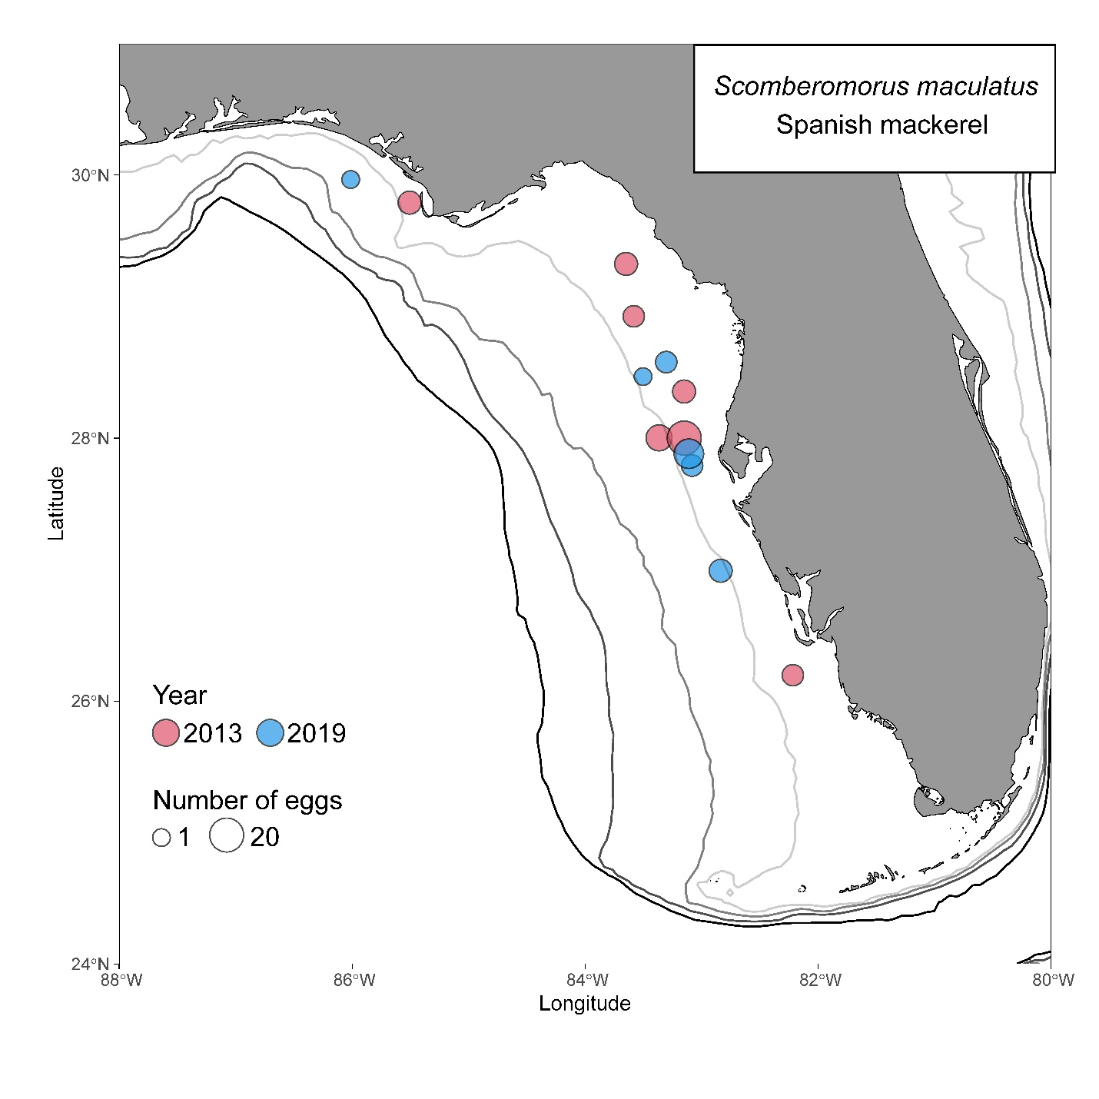
Figure S11. Map of sites where Scomberomorus maculatus (Atlantic Spanish mackerel) eggs were collected. Circle size is scaled to the number of eggs collected at each site, with larger circles representing higher counts. Gray and black lines represent 25 m, 50 m, 100 m, and 200 m isobaths.

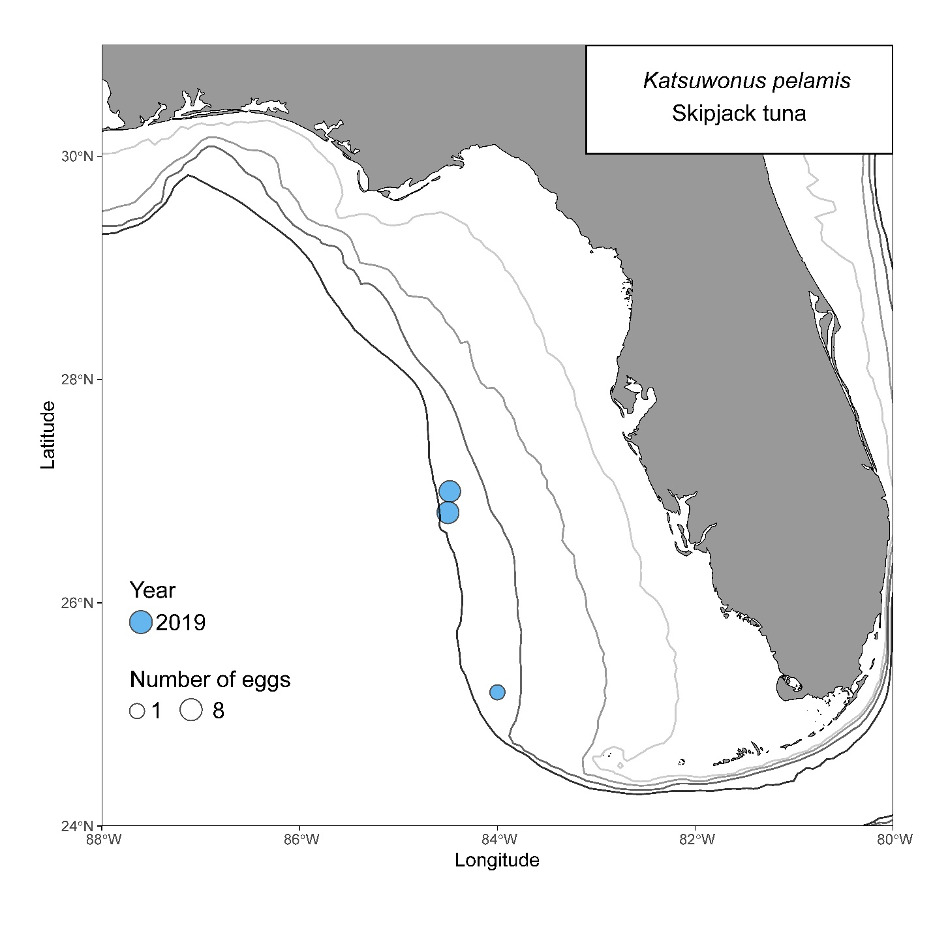
Figure S12. Map of sites where Katsuwonus pelamis (skipjack tuna) eggs were collected. Circle size is scaled to the number of eggs collected at each site, with larger circles representing higher counts. Gray and black lines represent 25 m, 50 m, 100 m, and 200 m isobaths.

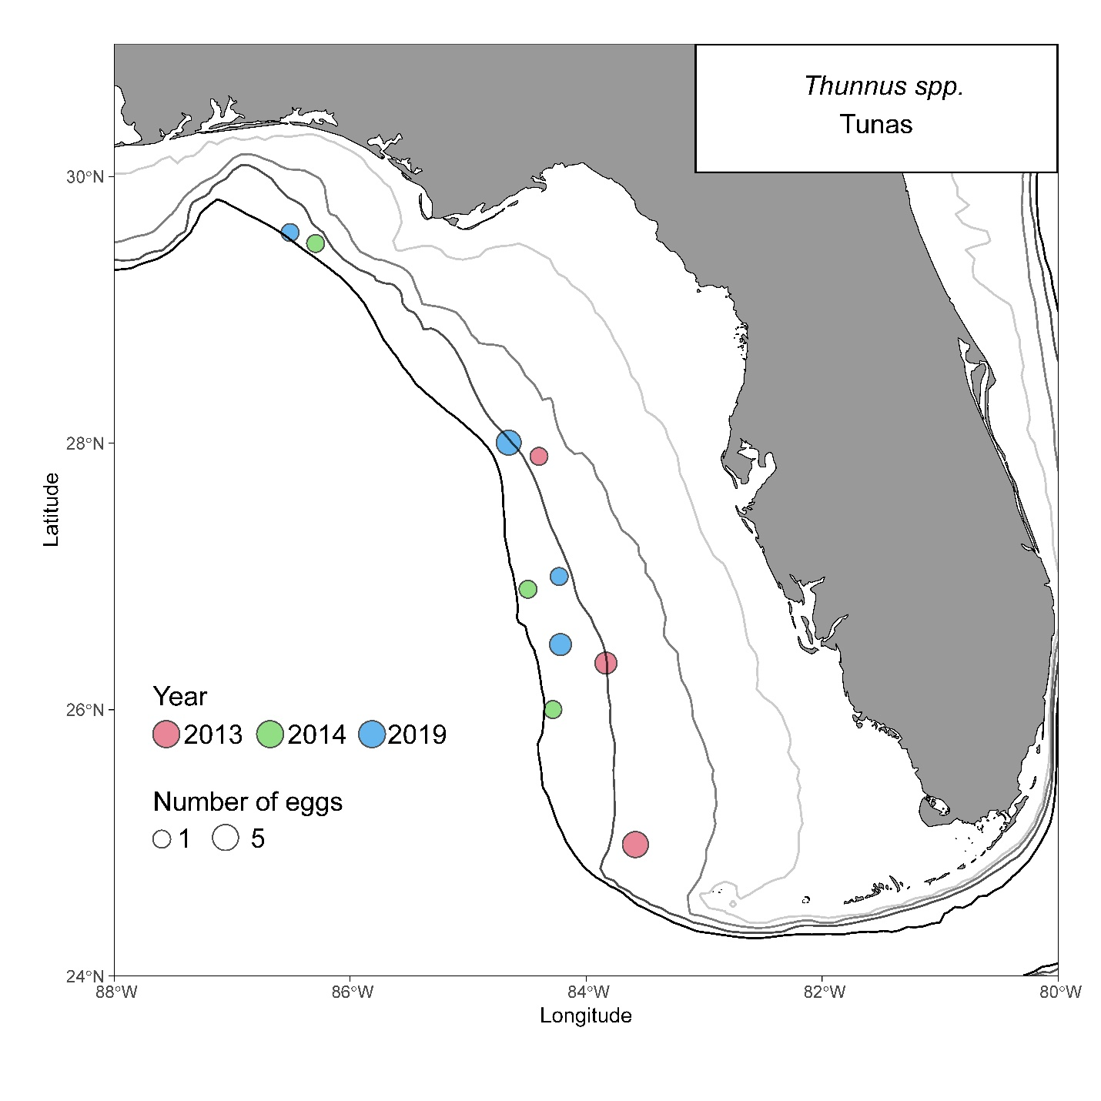
Figure S13. Map of sites where Thunnus spp. eggs were collected. Circle size is scaled to the number of eggs collected at each site, with larger circles representing higher counts. Gray and black lines represent 25 m, 50 m, 100 m, and 200 m isobaths.

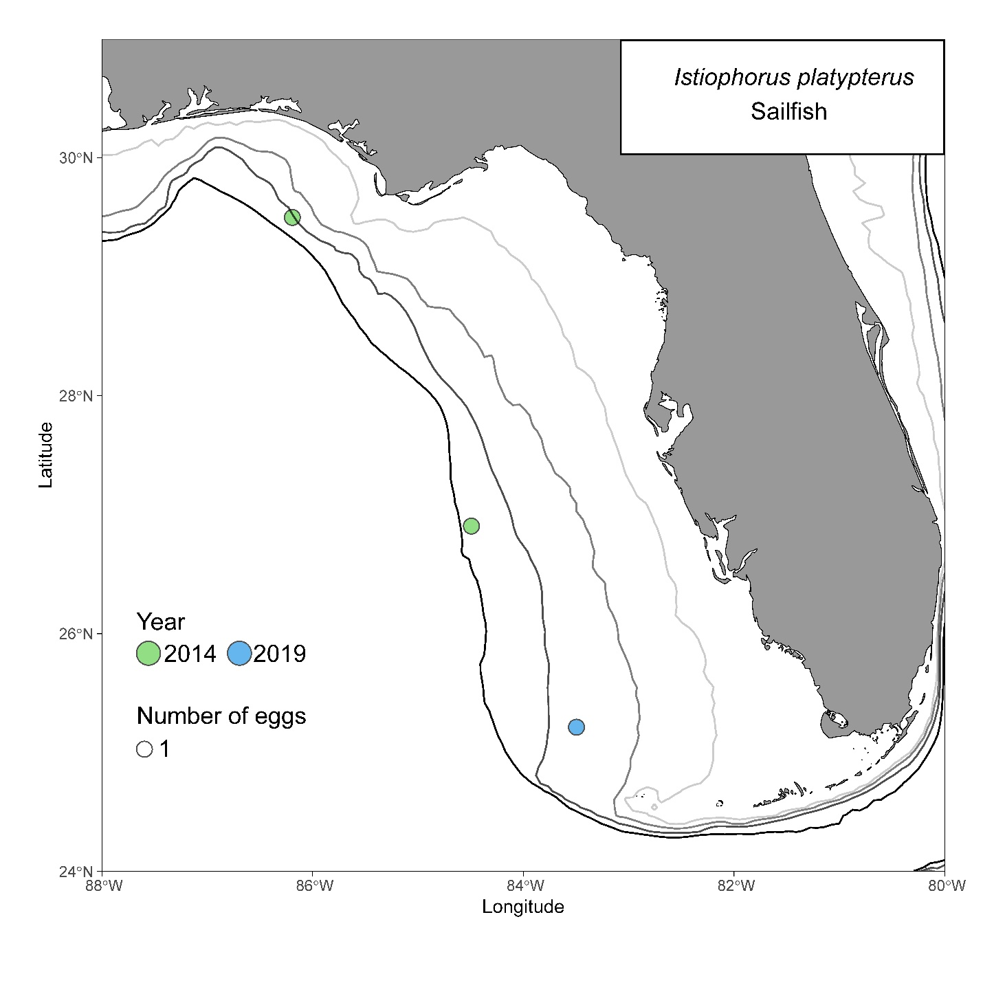
Figure S14. Map of sites where Istiophorus platypterus (sailfish) eggs were collected. Circle size is scaled to the number of eggs collected at each site, with larger circles representing higher counts. Gray and black lines represent 25 m, 50 m, 100 m, and 200 m isobaths.

