Supporting Information for:

Assessing benthos through predator stomach contents: spatiotemporal modeling of abundance and habitat use

Table of Contents

Bottom trawl survey. Details regarding EBS summer bottom trawl survey.
Stomach Content Data. Details regarding stomach collection and processing.
Table S1. Overview of stomach counts for EBS predators and prevalence of benthic forage groups in predator diets.
Table S2. Taxonomic composition of EBS benthic forage groups.
Fig. S1. Map of total stomach sampling effort in the Eastern Bering Sea.
Fig. S2. Interannual variation in spatial coverage of stomach samples.
Fig. S3. Distribution of benthic grabs used for polychaete and bivalve model validation.
Fig. S4. Diagnostic plots of PIT residuals.
Fig. S5. Correlation biplots of different density measures.
Fig. S6. Estimated annual distribution of polychaets.
Fig. S7. Estimated annual distribution of benthic amphipods.
Fig. S8. Estimated annual distribution of bivalves.
Fig. S9. Estimated annual distribution of brittle stars.
Fig. S10. Estimated annual distribution of miscellaneous worms.
Fig. S11. Estimated annual distribution of non-pandalid benthic shrimp.
Fig. S12 Estimated annual distribution of miscellaneous crustaceans.
Fig. S13 Estimated annual distribution of snow crab.
Fig. S14 Estimated annual distribution of Tanner crab.

Bottom trawl survey
The groundfish bottom trawl survey begins at the southern extent of the survey domain typically in late May or early June and progresses northward, ending in August. Sampling is performed using a 83–112 Eastern otter trawl constructed with a 102-mm stretched mesh body, 89-mm stretched mesh intermediate, and 32-mm mesh codend liner. Upon contact with the seafloor, the gear is towed at 3 knots between 15 and 30 min. Catch is sorted according to species, sex, and subsampled if necessary to obtain biomass, numerical abundances, and body length frequencies. Further details regarding gear and sampling methodology are available elsewhere (Stauffer 2004).

Stomach content data
As part of the bottom trawl survey, the AFSC Food Habits program has collected stomach content data for several groundfish. Each year, four “core” (walleye pollock, Pacific cod, Pacific halibut, and arrowtooth flounder) species were sampled along with three to five non-core species which were selected on a rotating basis with the goal of sampling all commercial or ecologically important species over a five year period (Livingston et al. 2017). For each species, sampling effort was allocated across the survey area, with maximum sample sizes in subregions typically ranging between 50 and 250 individuals depending on the level of diet variability of the species and capacity to process samples. At a given station, individuals were selected according to species-specific length categories to increase size coverage, with no more than five individuals collected per size category (Livingston et al. 2017). If individuals showed signs of regurgitation they were replaced with a new individual of similar size. Stomachs were then dissected, stored in 10% buffered formalin solution, and contents were later identified to the lowest taxonomic level possible, sorted by life stage and digestion state, and weighed (Livingston et al. 2017).

Table S1. Stomach counts of EBS predators and number of years sampled in the Eastern Bering Sea bottom trawl survey. The proportion of individual predators with observations of each prey group are presented. Bold values correspond to proportions larger than 0.10 and indicate predators (rows) that were included in spatio-temporal models of the respective prey group (columns). Predators with the highest proportions (denoted with an asterisk) were treated as the reference predator in the model. Superscripts: 1, Pleuronectes quadrituberculatus; 2, Arctoraja parmifera; 3, Atheresthes stomias; 4, Hippoglossoides robustus; 5, Hippoglossoides elassodon; 6, Reinhardtius hippoglossoides; 7, Lepidopsetta polyxystra; 8, Gadus macrocephalus; 9, Hippoglossus stenolepis; 10, Gadus chalcogrammus; 11, Limanda aspera.
 |  |  | Prey group
Predator | Total Records | Number of Years | Polychaetes | Benthic Amphipods | Benthic Shrimps | Bivalves | Brittle stars | Misc. Worm. Etc. | Misc. Crustaceans | Snow crab | Tanner crab
Alaska plaice¹ | 4,397 | 22 | 0.79* | 0.41* | 0 | 0.44* | 0.09 | 0.22* | 0.04 | 0 | 0
Alaska skate² | 4,723 | 21 | 0.13 | 0.25 | 0.38 | 0 | 0 | 0.01 | 0.01 | 0.09 | 0.03
Arrowtooth flounder³ | 18,586 | 38 | 0.01 | 0.01 | 0.07 | 0 | 0 | 0 | 0 | 0 | 0
Bering flounder⁴ | 1,154 | 14 | 0.12 | 0.18 | 0.12 | 0.11 | 0.08 | 0.03 | 0.01 | 0 | 0
Flathead sole⁵ | 8,280 | 21 | 0.13 | 0.13 | 0.14 | 0.09 | 0.33 | 0.02 | 0.03 | 0.01 | 0.02
Greenland turbot⁶ | 2,238 | 24 | 0 | 0.01 | 0.03 | 0 | 0 | 0 | 0 | 0 | 0
Northern rock sole⁷ | 7,338 | 27 | 0.7 | 0.41 | 0.04 | 0.35 | 0.08 | 0.13 | 0.13 | 0 | 0
Pacific cod⁸ | 57,228 | 38 | 0.4 | 0.33 | 0.43* | 0.06 | 0.02 | 0.16 | 0.03 | 0.16* | 0.1*
Pacific halibut⁹ | 9,476 | 31 | 0.02 | 0.01 | 0.2 | 0.01 | 0.01 | 0.02 | 0 | 0.06 | 0.07
Walleye pollock¹⁰ | 86,645 | 39 | 0.05 | 0.15 | 0.13 | 0 | 0 | 0.01 | 0.06 | 0 | 0
Yellowfin sole | 13,727 | 25 | 0.43 | 0.35 | 0.04 | 0.26 | 0.1 | 0.1 | 0.14* | 0 | 0

Table S2. Taxonomic composition of EBS benthic forage groups. See Aydin et al. (2007) for additional information.
Forage group or species | Major taxonomic groups and description
Polychaetes | Polychaeta; prey items are often unidentifiable beyond this class
Benthic Amphipods | Major families: Caprellidae, Gammaridae, Ampeliscidae, Corophiidae, Eusiridae, Haustoriidae, Isaeidae, Ischyroceridae, Lysianassidae, Pardaliscidae
Benthic Shrimps | Major families: Penaeidae, Sergestidae, Oplophoridae, Pasiphaeidae, Hippolytidae, Crangonidae, and caridean shrimps
Bivalves | Major families: Nuculidae, Nuculanidae, Mytilidae, Pectinidae, Lucinidae, Cardiidae, Tellinidae, Myidae.
Brittle stars | Major families: Ophiuridae, Ophiocomidae and Amphiuridae
Misc. Worm. Etc. | A composite assemblage containing annelid worms (including oligochaetes, leeches, flatworms), sipunculids (peanut worms), bryozoans (moss animals), and brachiopods (lampshells).
Misc. Crustaceans | A composite assemblage containing ostracods, cladocerans, isopods, cumaceans and sea spiders.
Snow crab | Chionocetes opilio
Tanner crab | Chionocetes bairdi

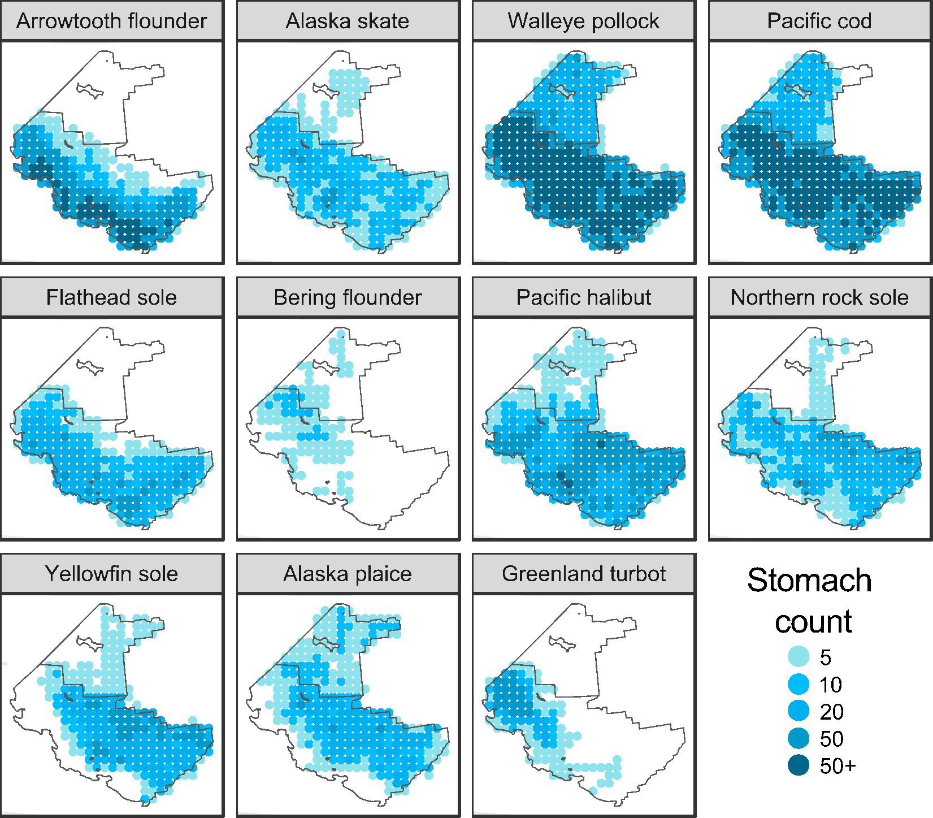
Figure S1. Total count of individual stomachs from predators sampled between 1984 and 2022 in the Eastern Bering Sea groundfish bottom trawl survey.

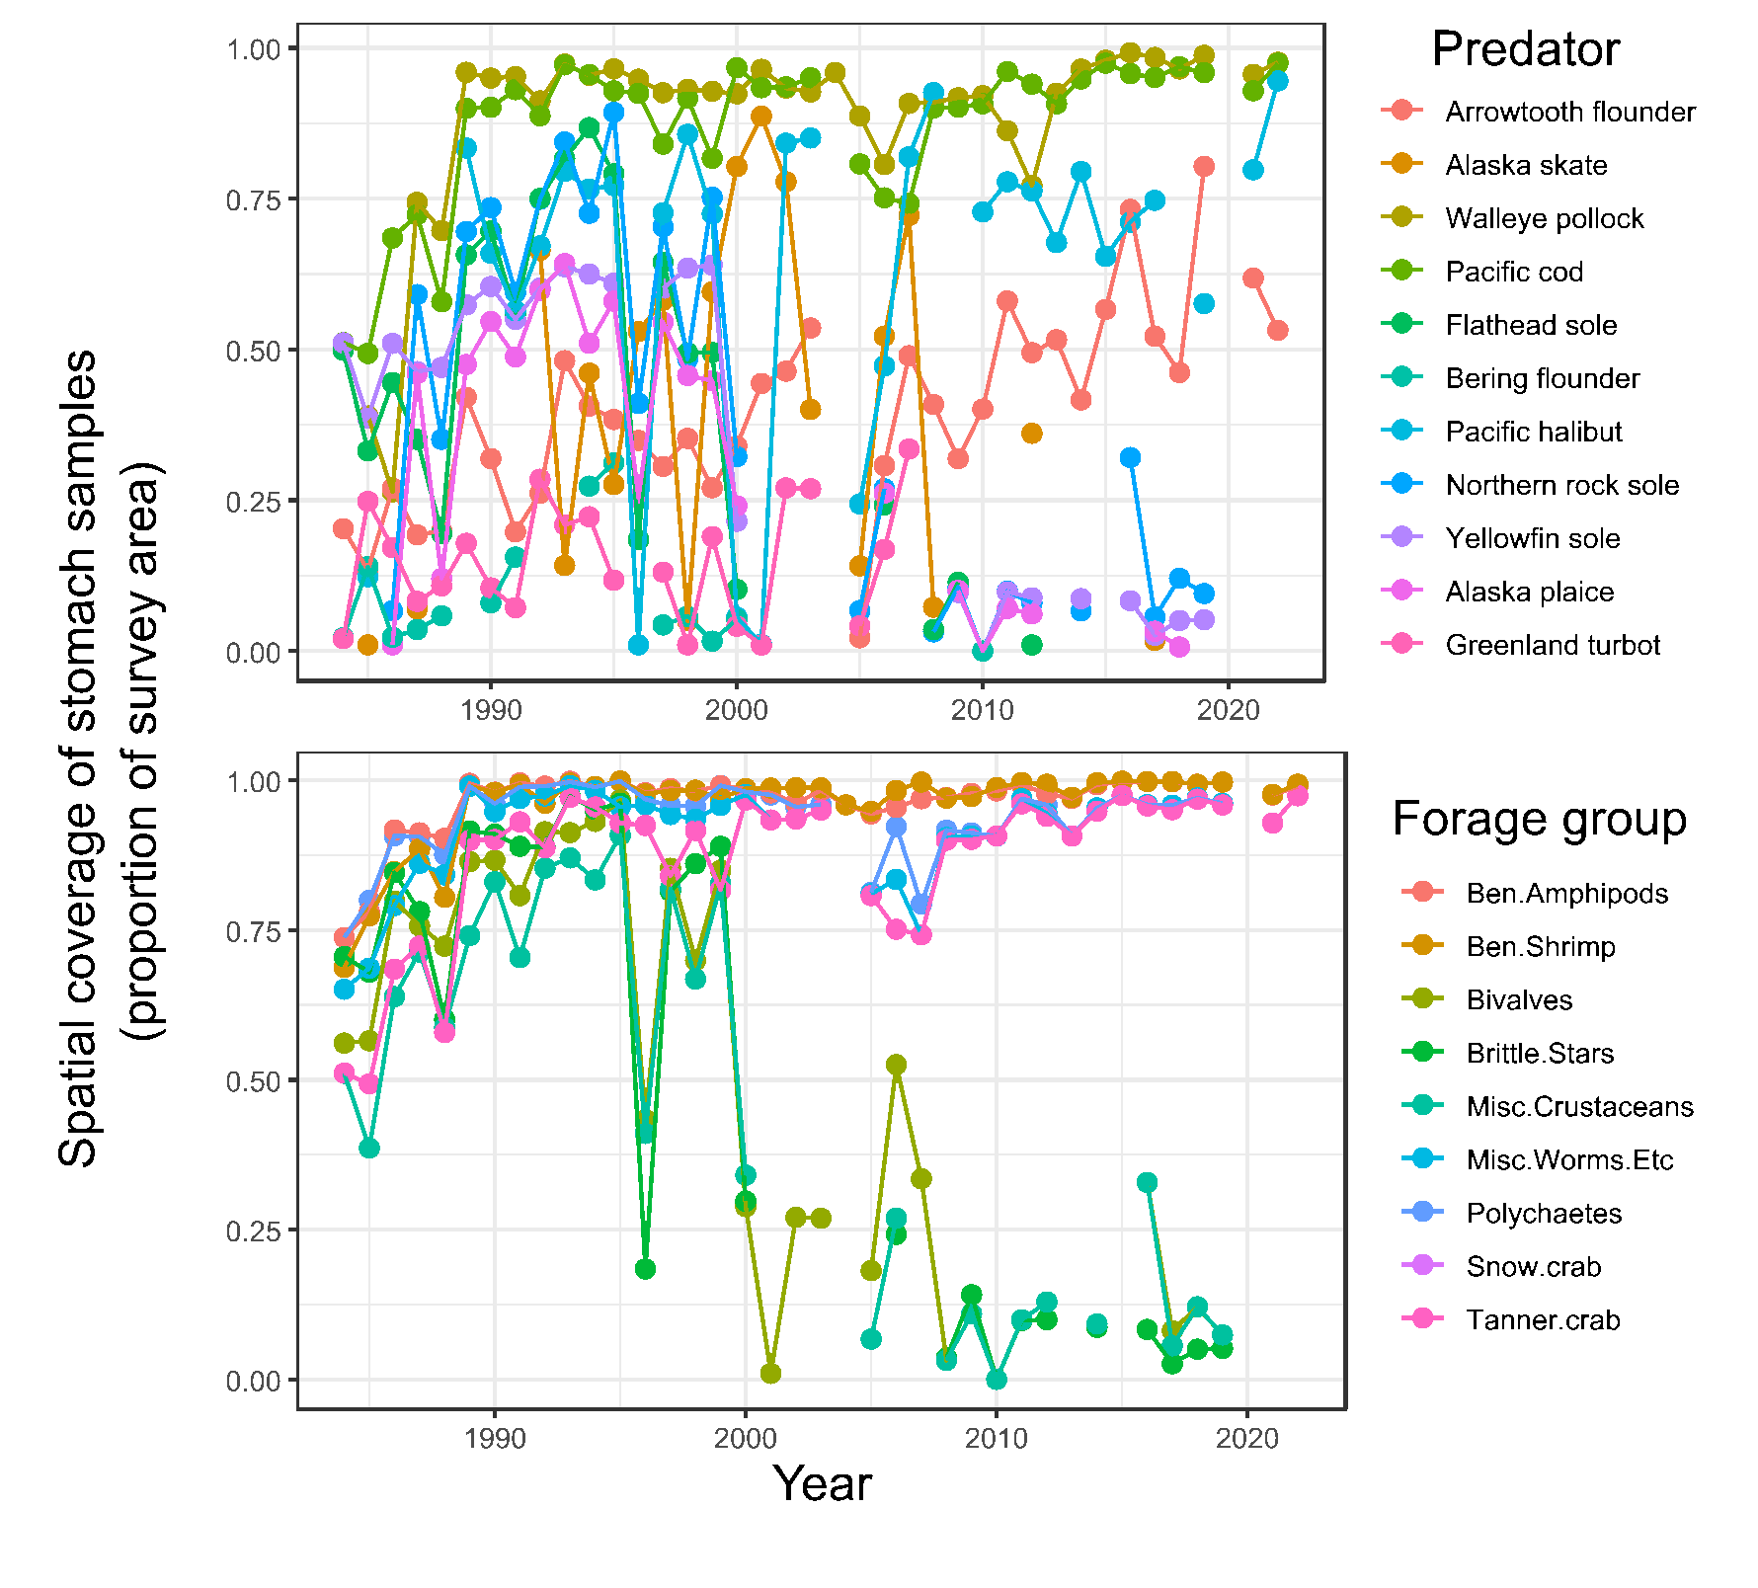
Figure S2. Top panel: spatial coverage of stomach samples over time for individual predators; bottom panel: spatial coverage of stomach samples based on all predator species used to estimate forage group densities.

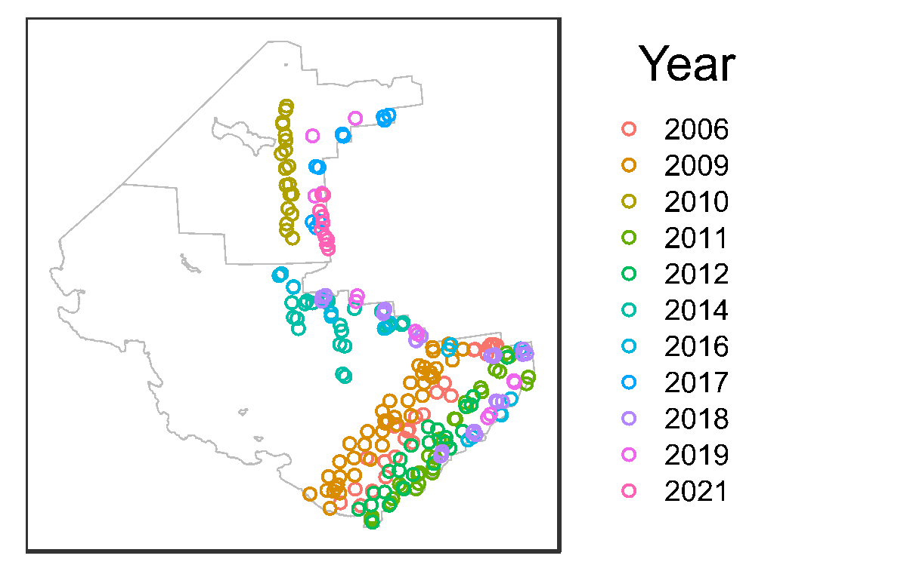
Figure S3. Benthic grab sampling locations (jittered for visibility) for polychaets and bivalve densities in the eastern Bering Sea. See Yeung et al. (2010) for additional details regarding benthic grab sampling methodology.

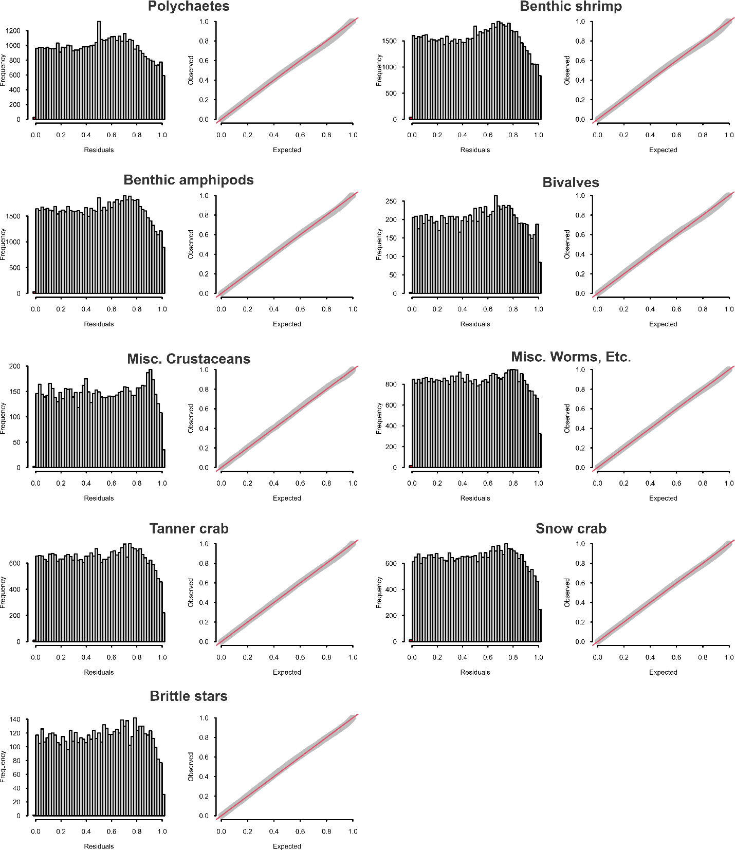
Figure S4. Histograms and Q-Q plots of PIT residuals for forage group spatiotemporal models. Red line in Q-Q plots indicates the 1:1 line.

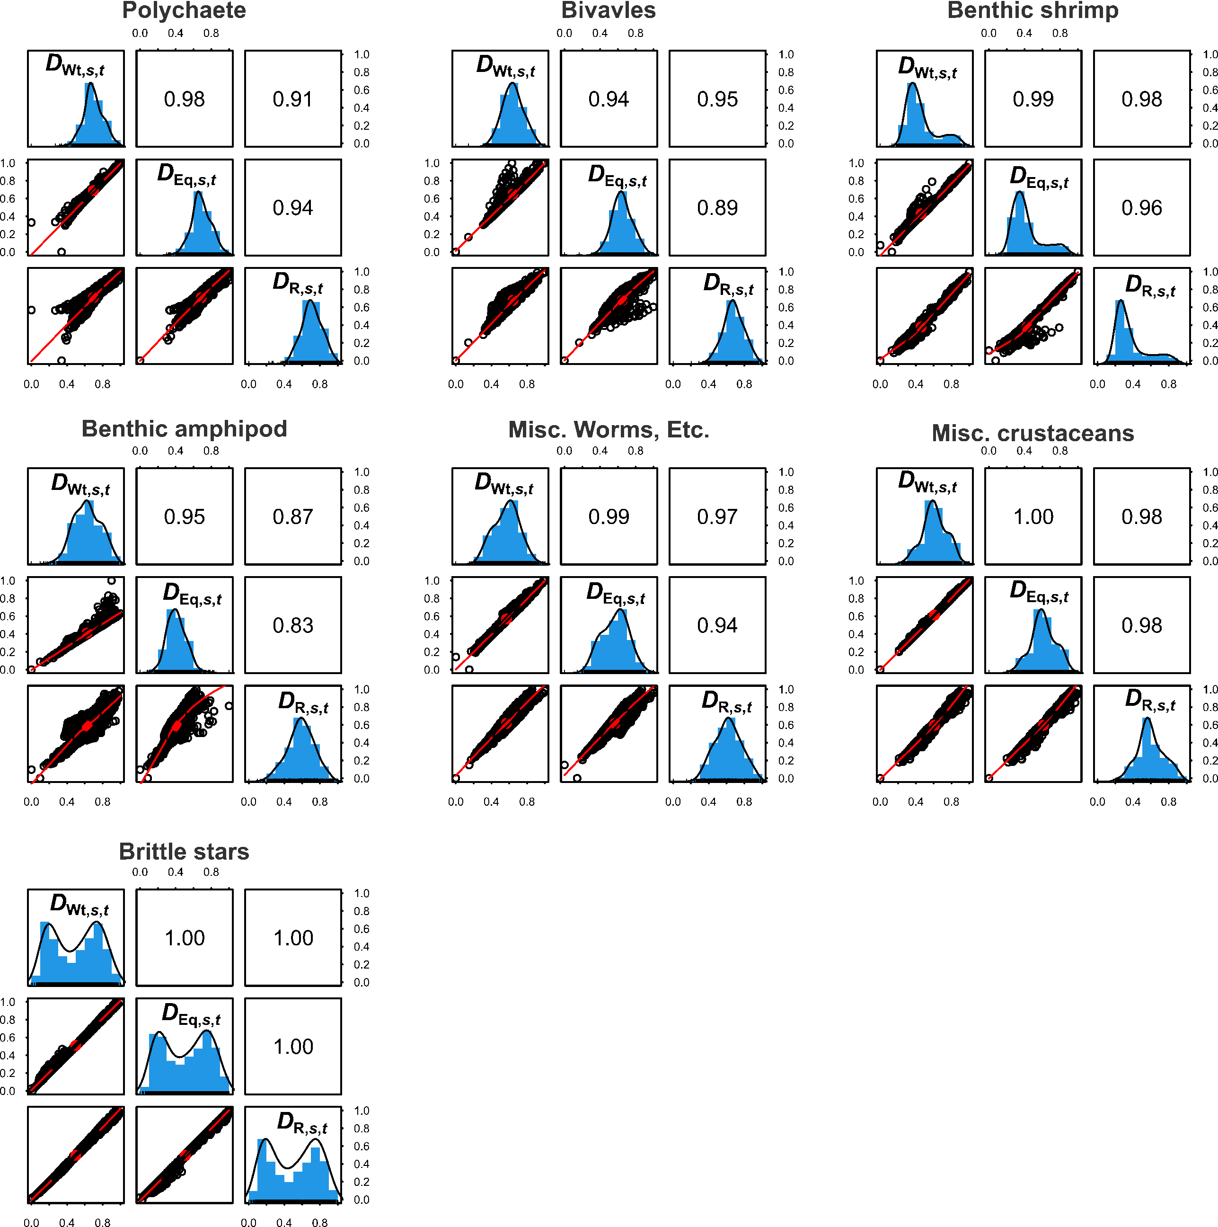
Figurer S5. Correlations between density measures that include composite measures where forage rates were weighted according to the prevalence of prey in predator diets (D_{Wt,s,t}), equally across predators (D_{Eq,s,t}), and where density estimates were obtained for only the reference predator (D_{R,s,t}). For each prey group panel, the lower triangle contains biplots of the density measures, the upper triangle depicts the corresponding Pearson’s correlation coefficient, and the diagonal plots are histograms of the density measure (4th-root transformed and scaled to a maximum value of 1).

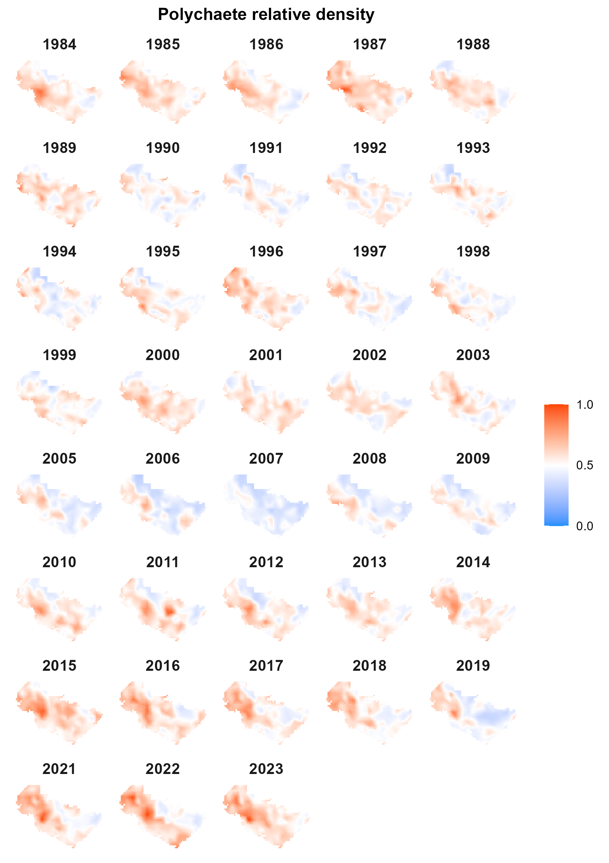
Fig. S6. Estimated density of polychaetes scaled relative to the maximum density.

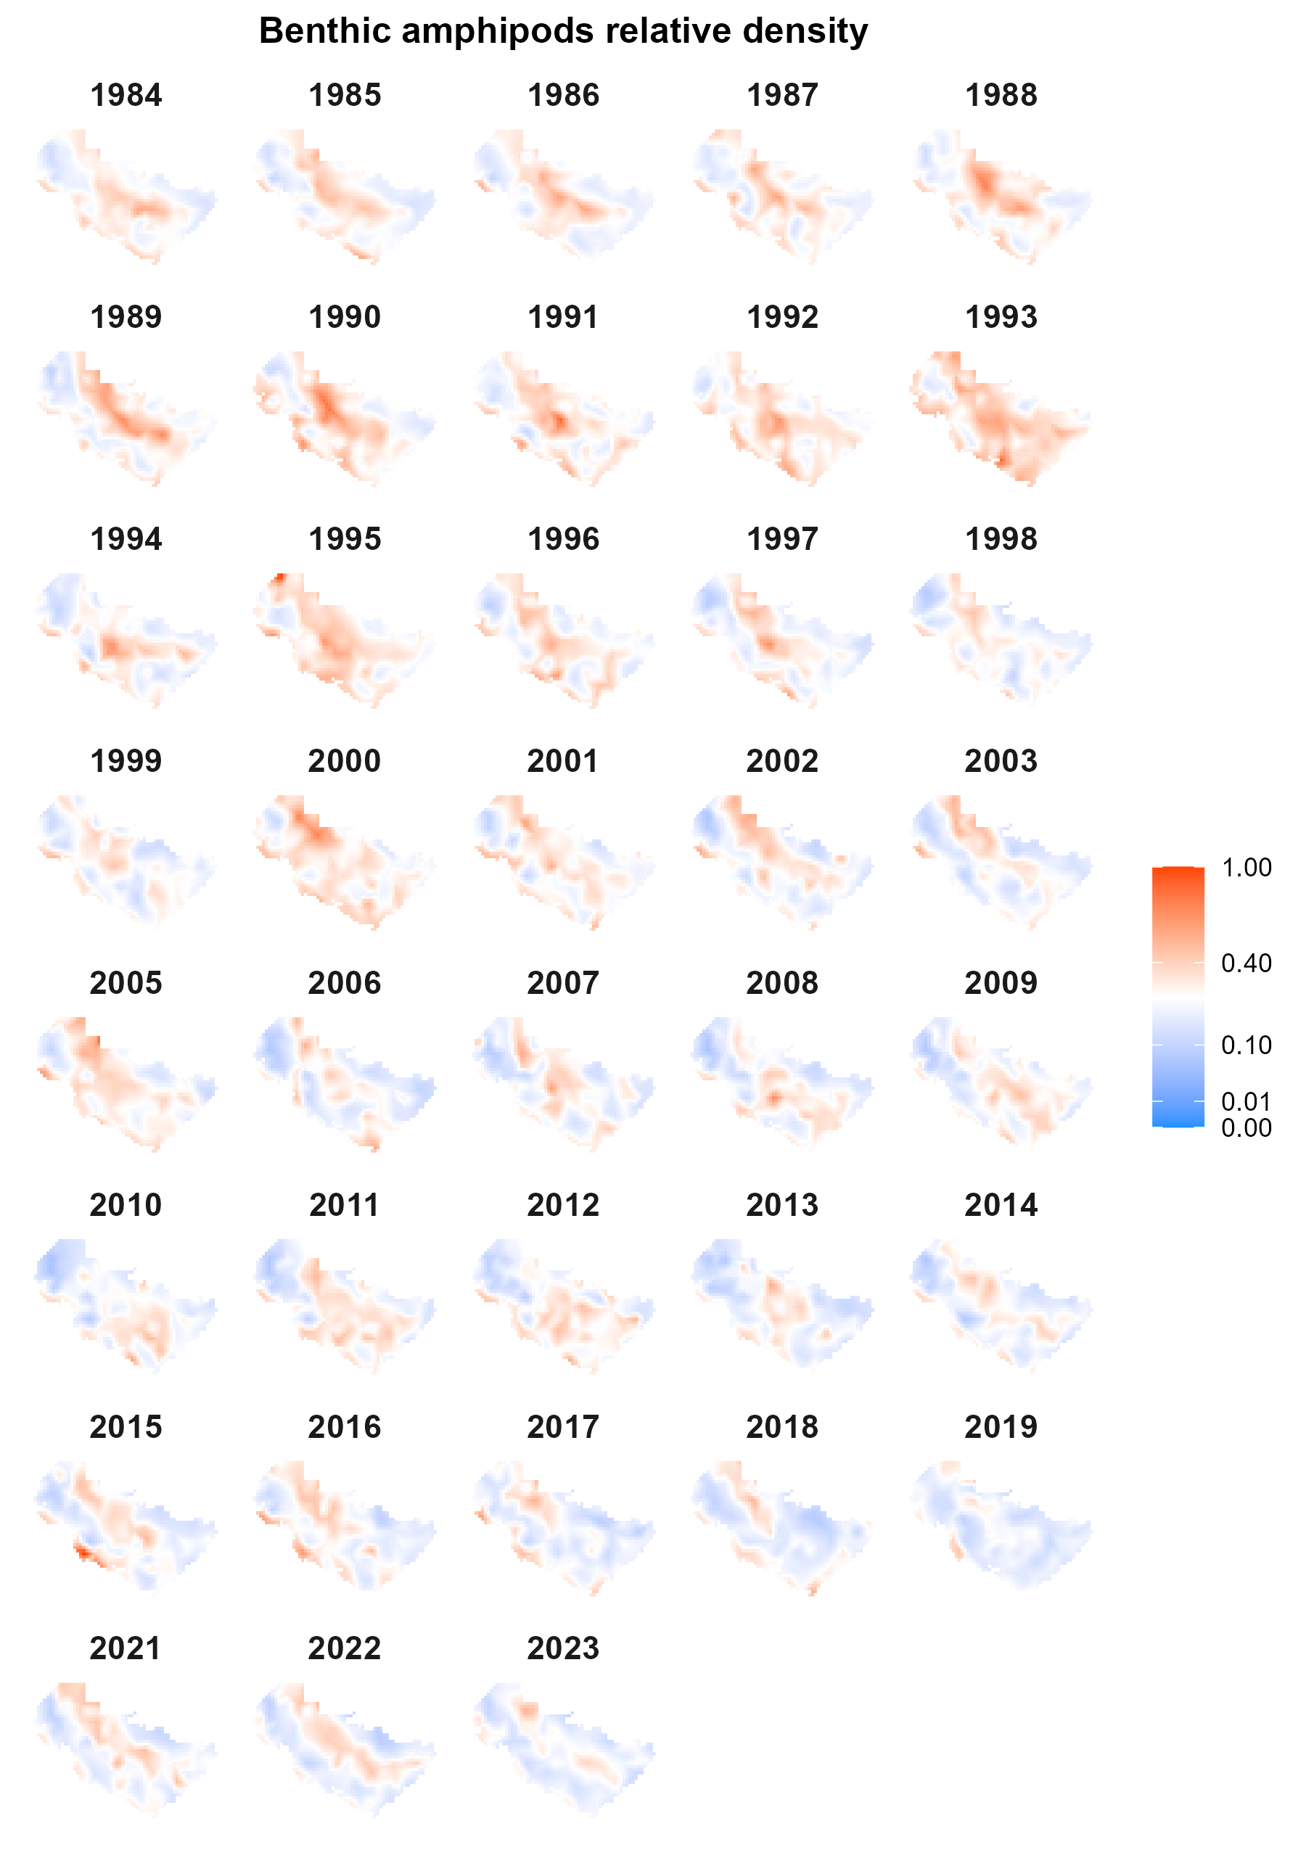
Fig. S7. Estimated density of benthic amphipods scaled relative to the maximum density.

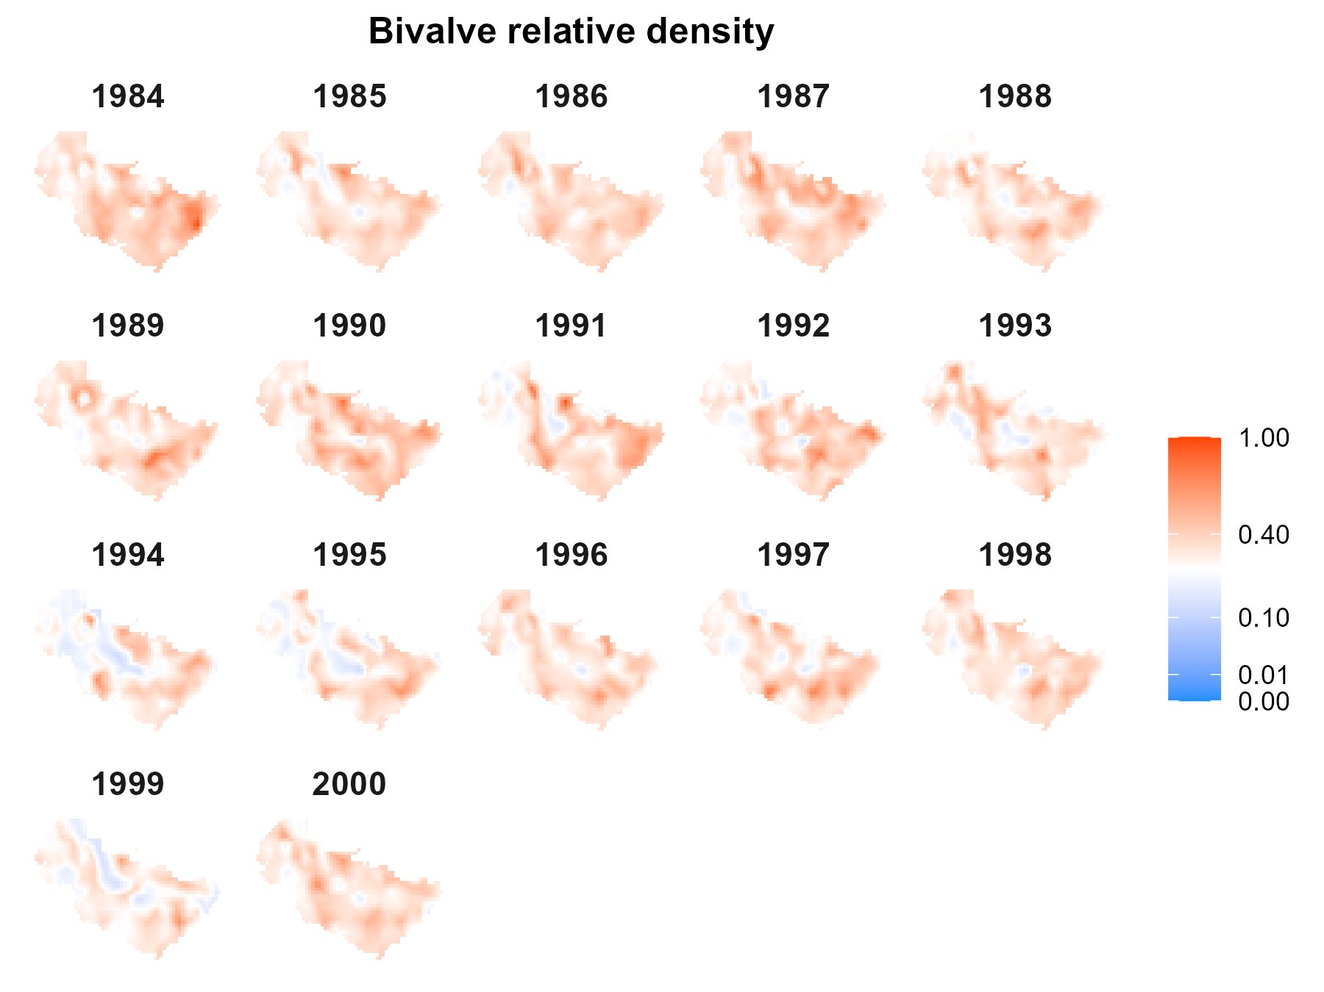
Fig. S8. Estimated density of bivalves scaled relative to the maximum density.

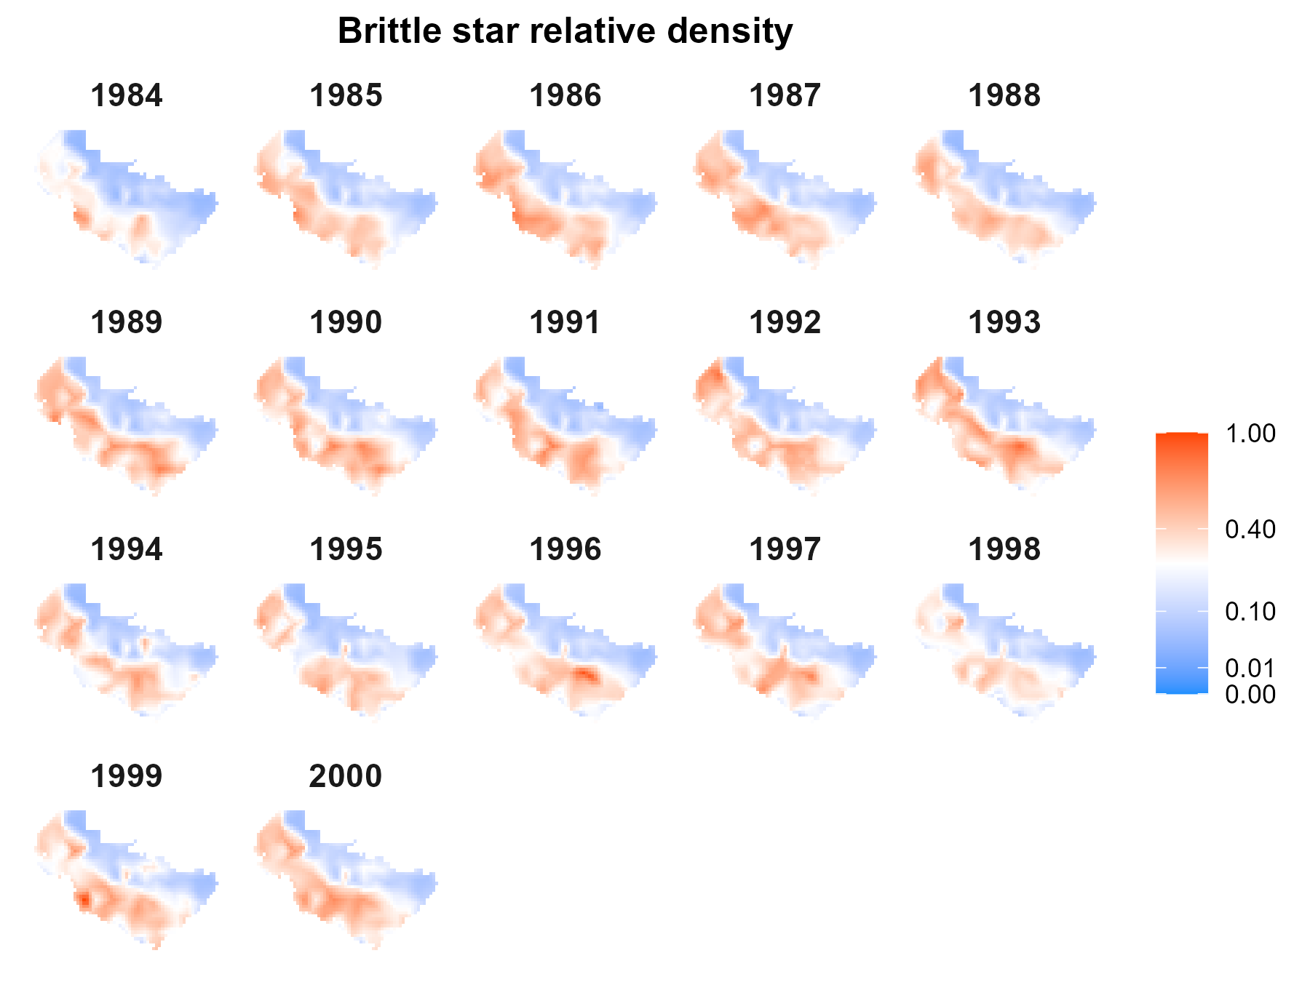
Fig. S9. Estimated density of brittle stars scaled relative to the maximum density.

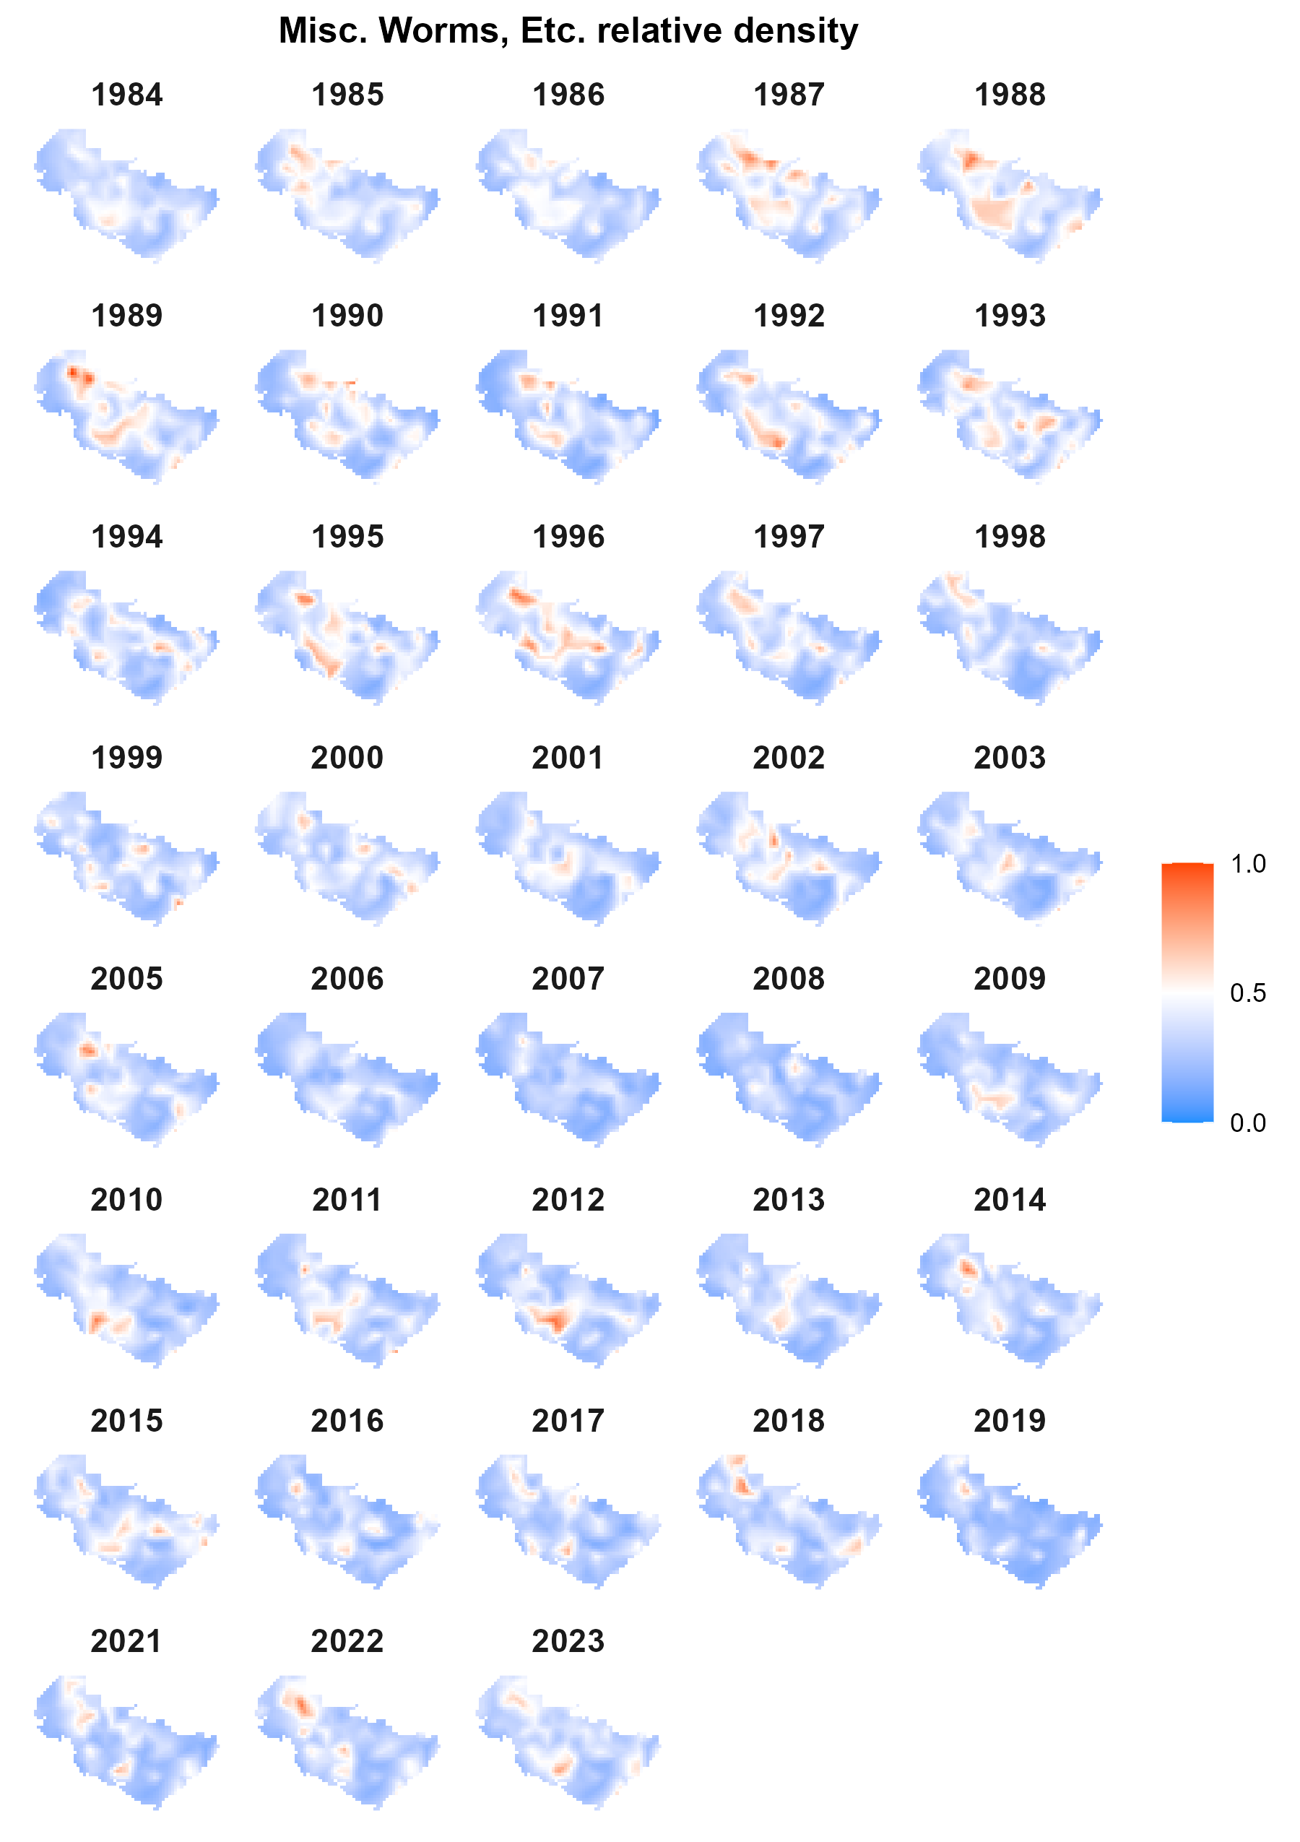
Fig. S10. Estimated density of miscellaneous worms, etc., scaled relative to the maximum density.

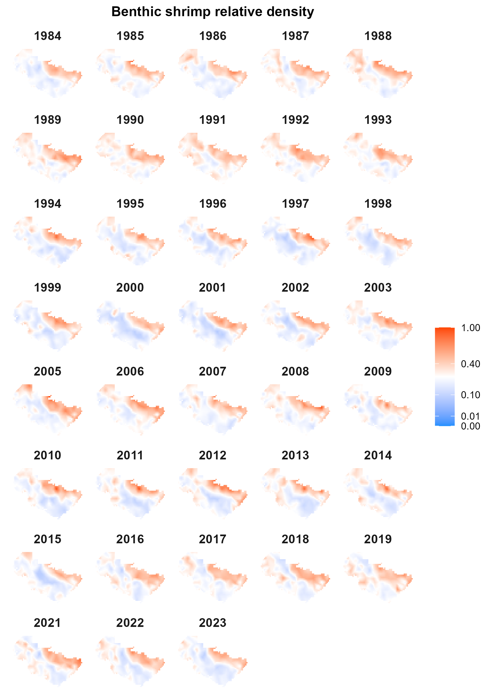
Fig. S11. Estimated density of benthic shrimp scaled relative to the maximum density.

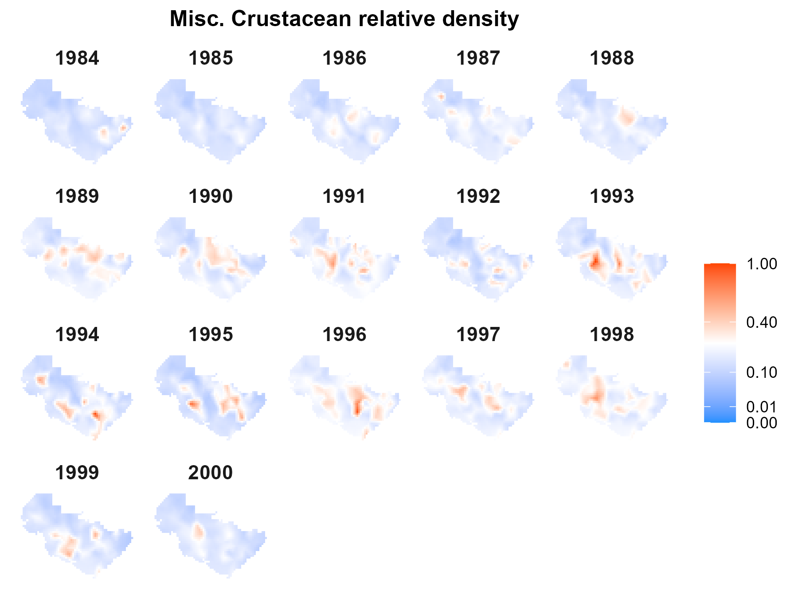
Fig. S12 Estimated density of miscellaneous crustaceans scaled relative to the maximum density.

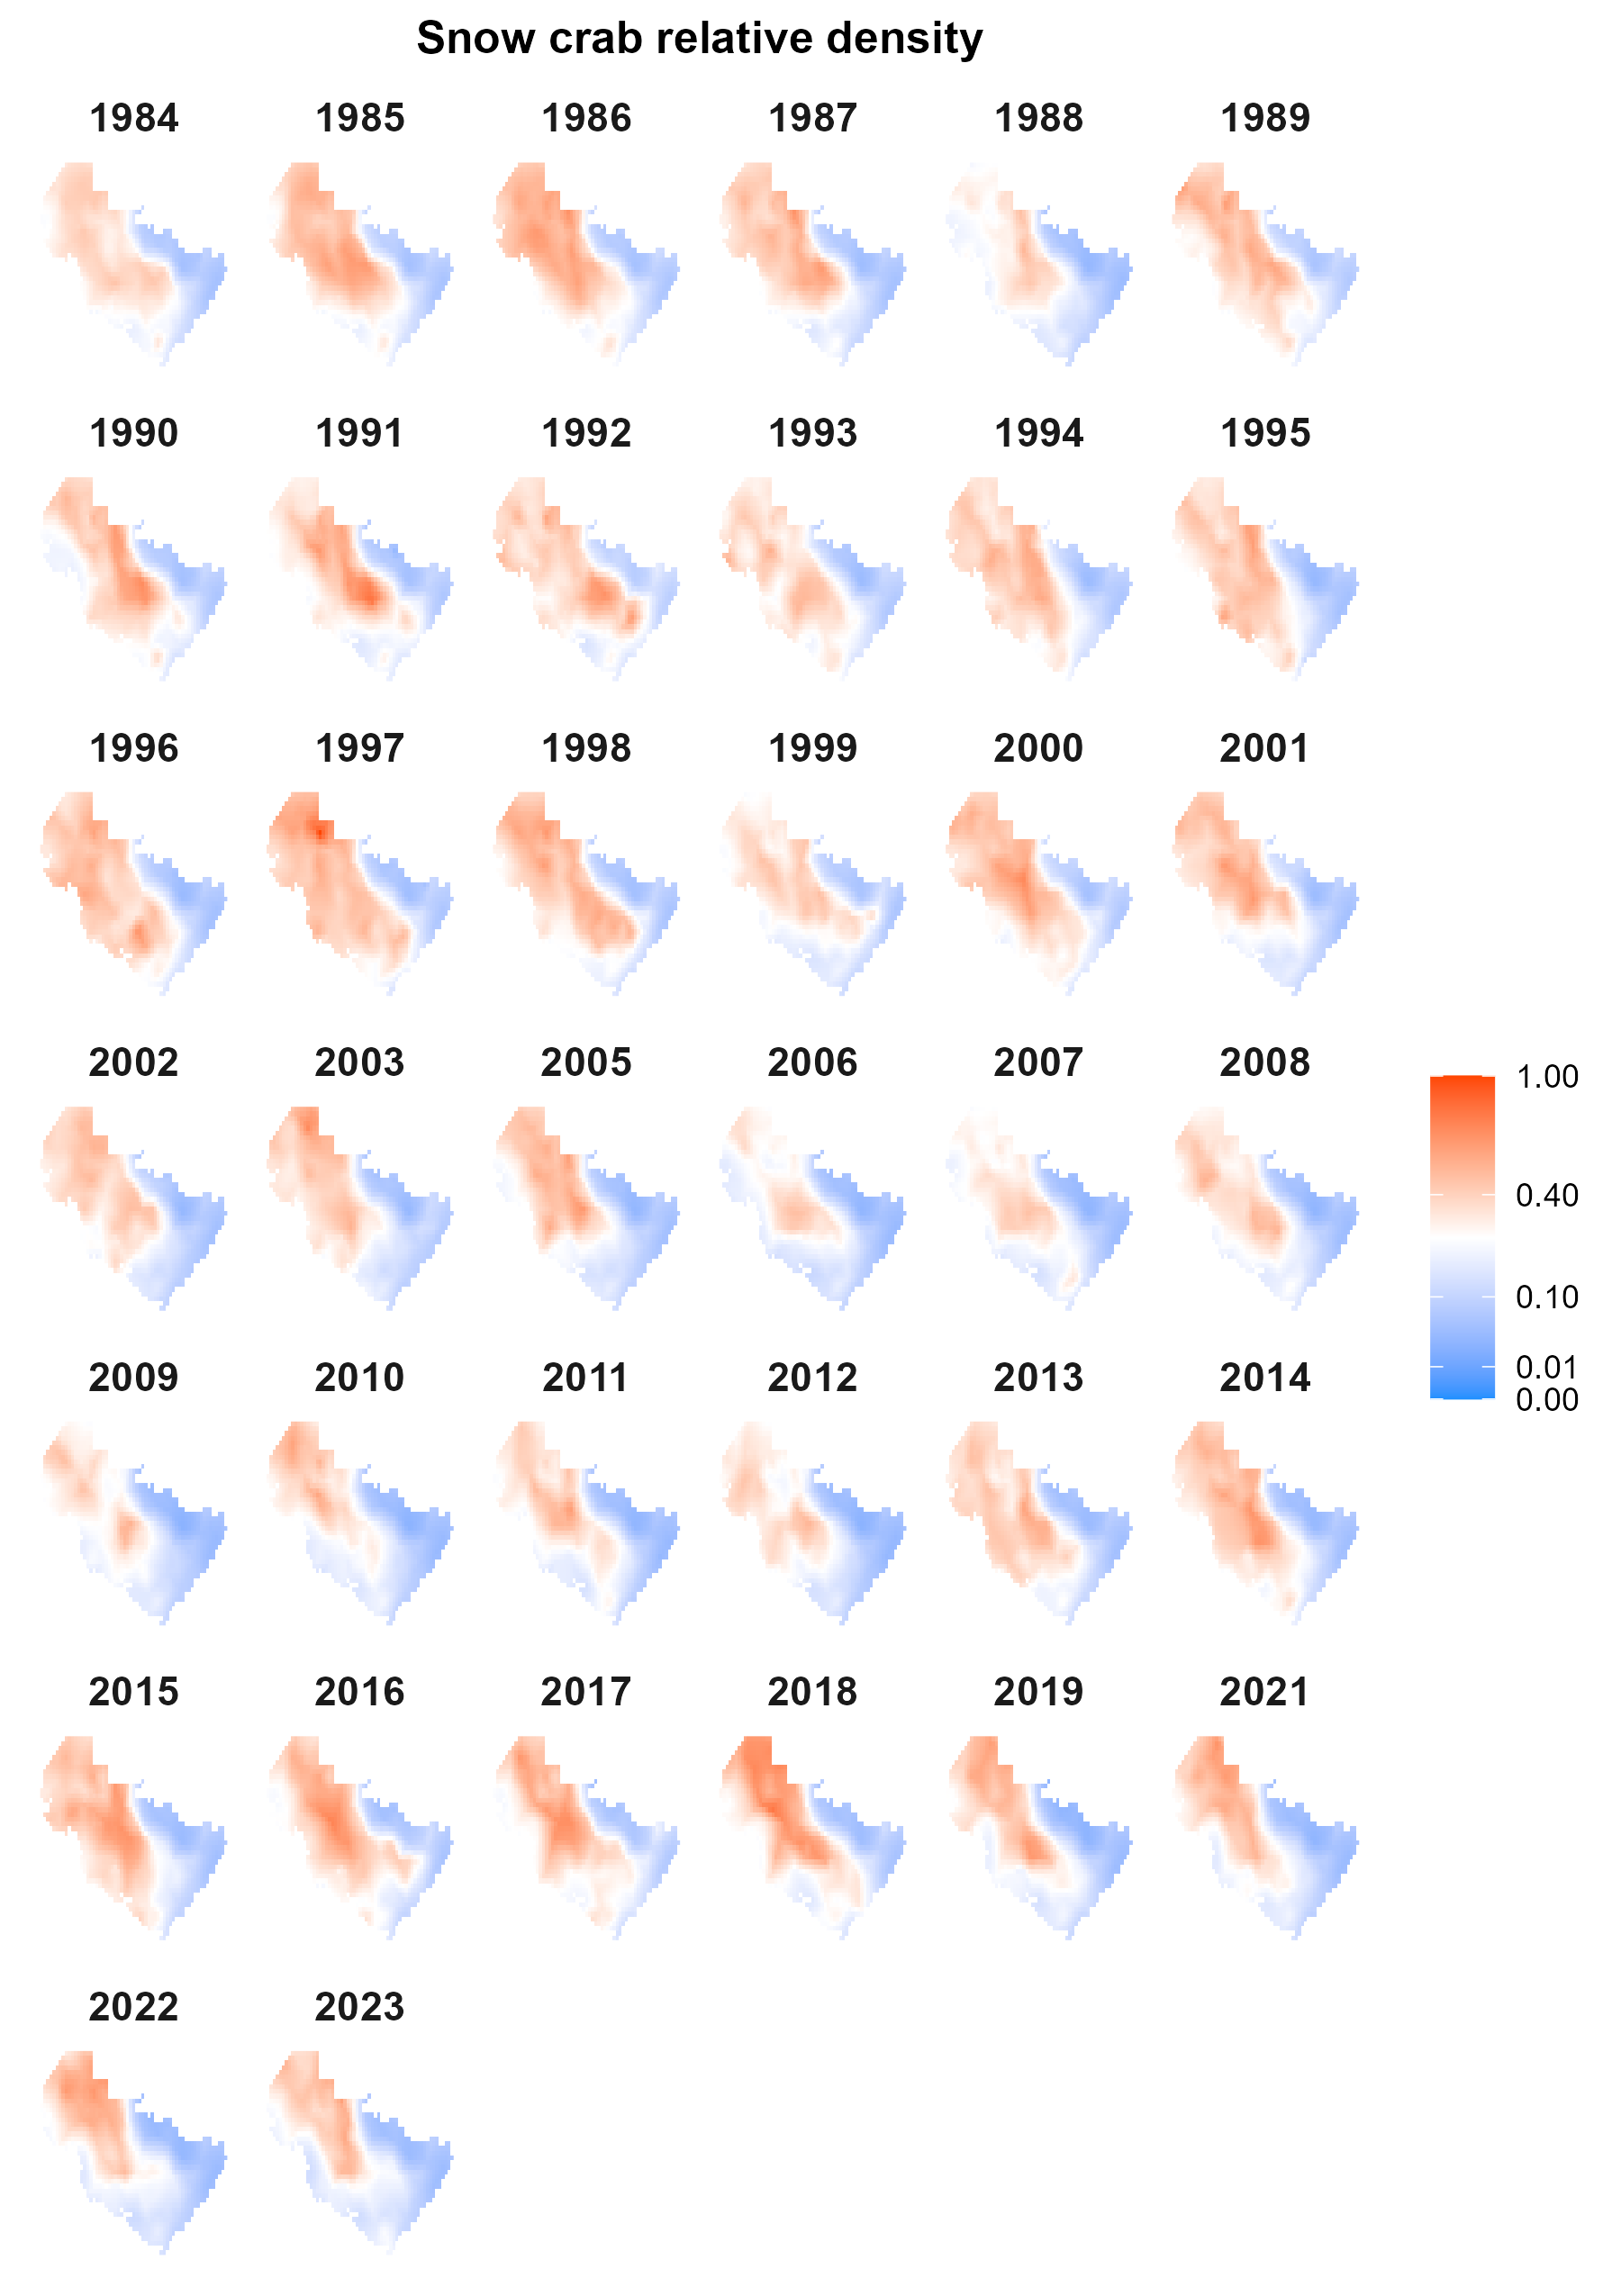
Fig. S13 Estimated density of snow crab scaled relative to the maximum density.

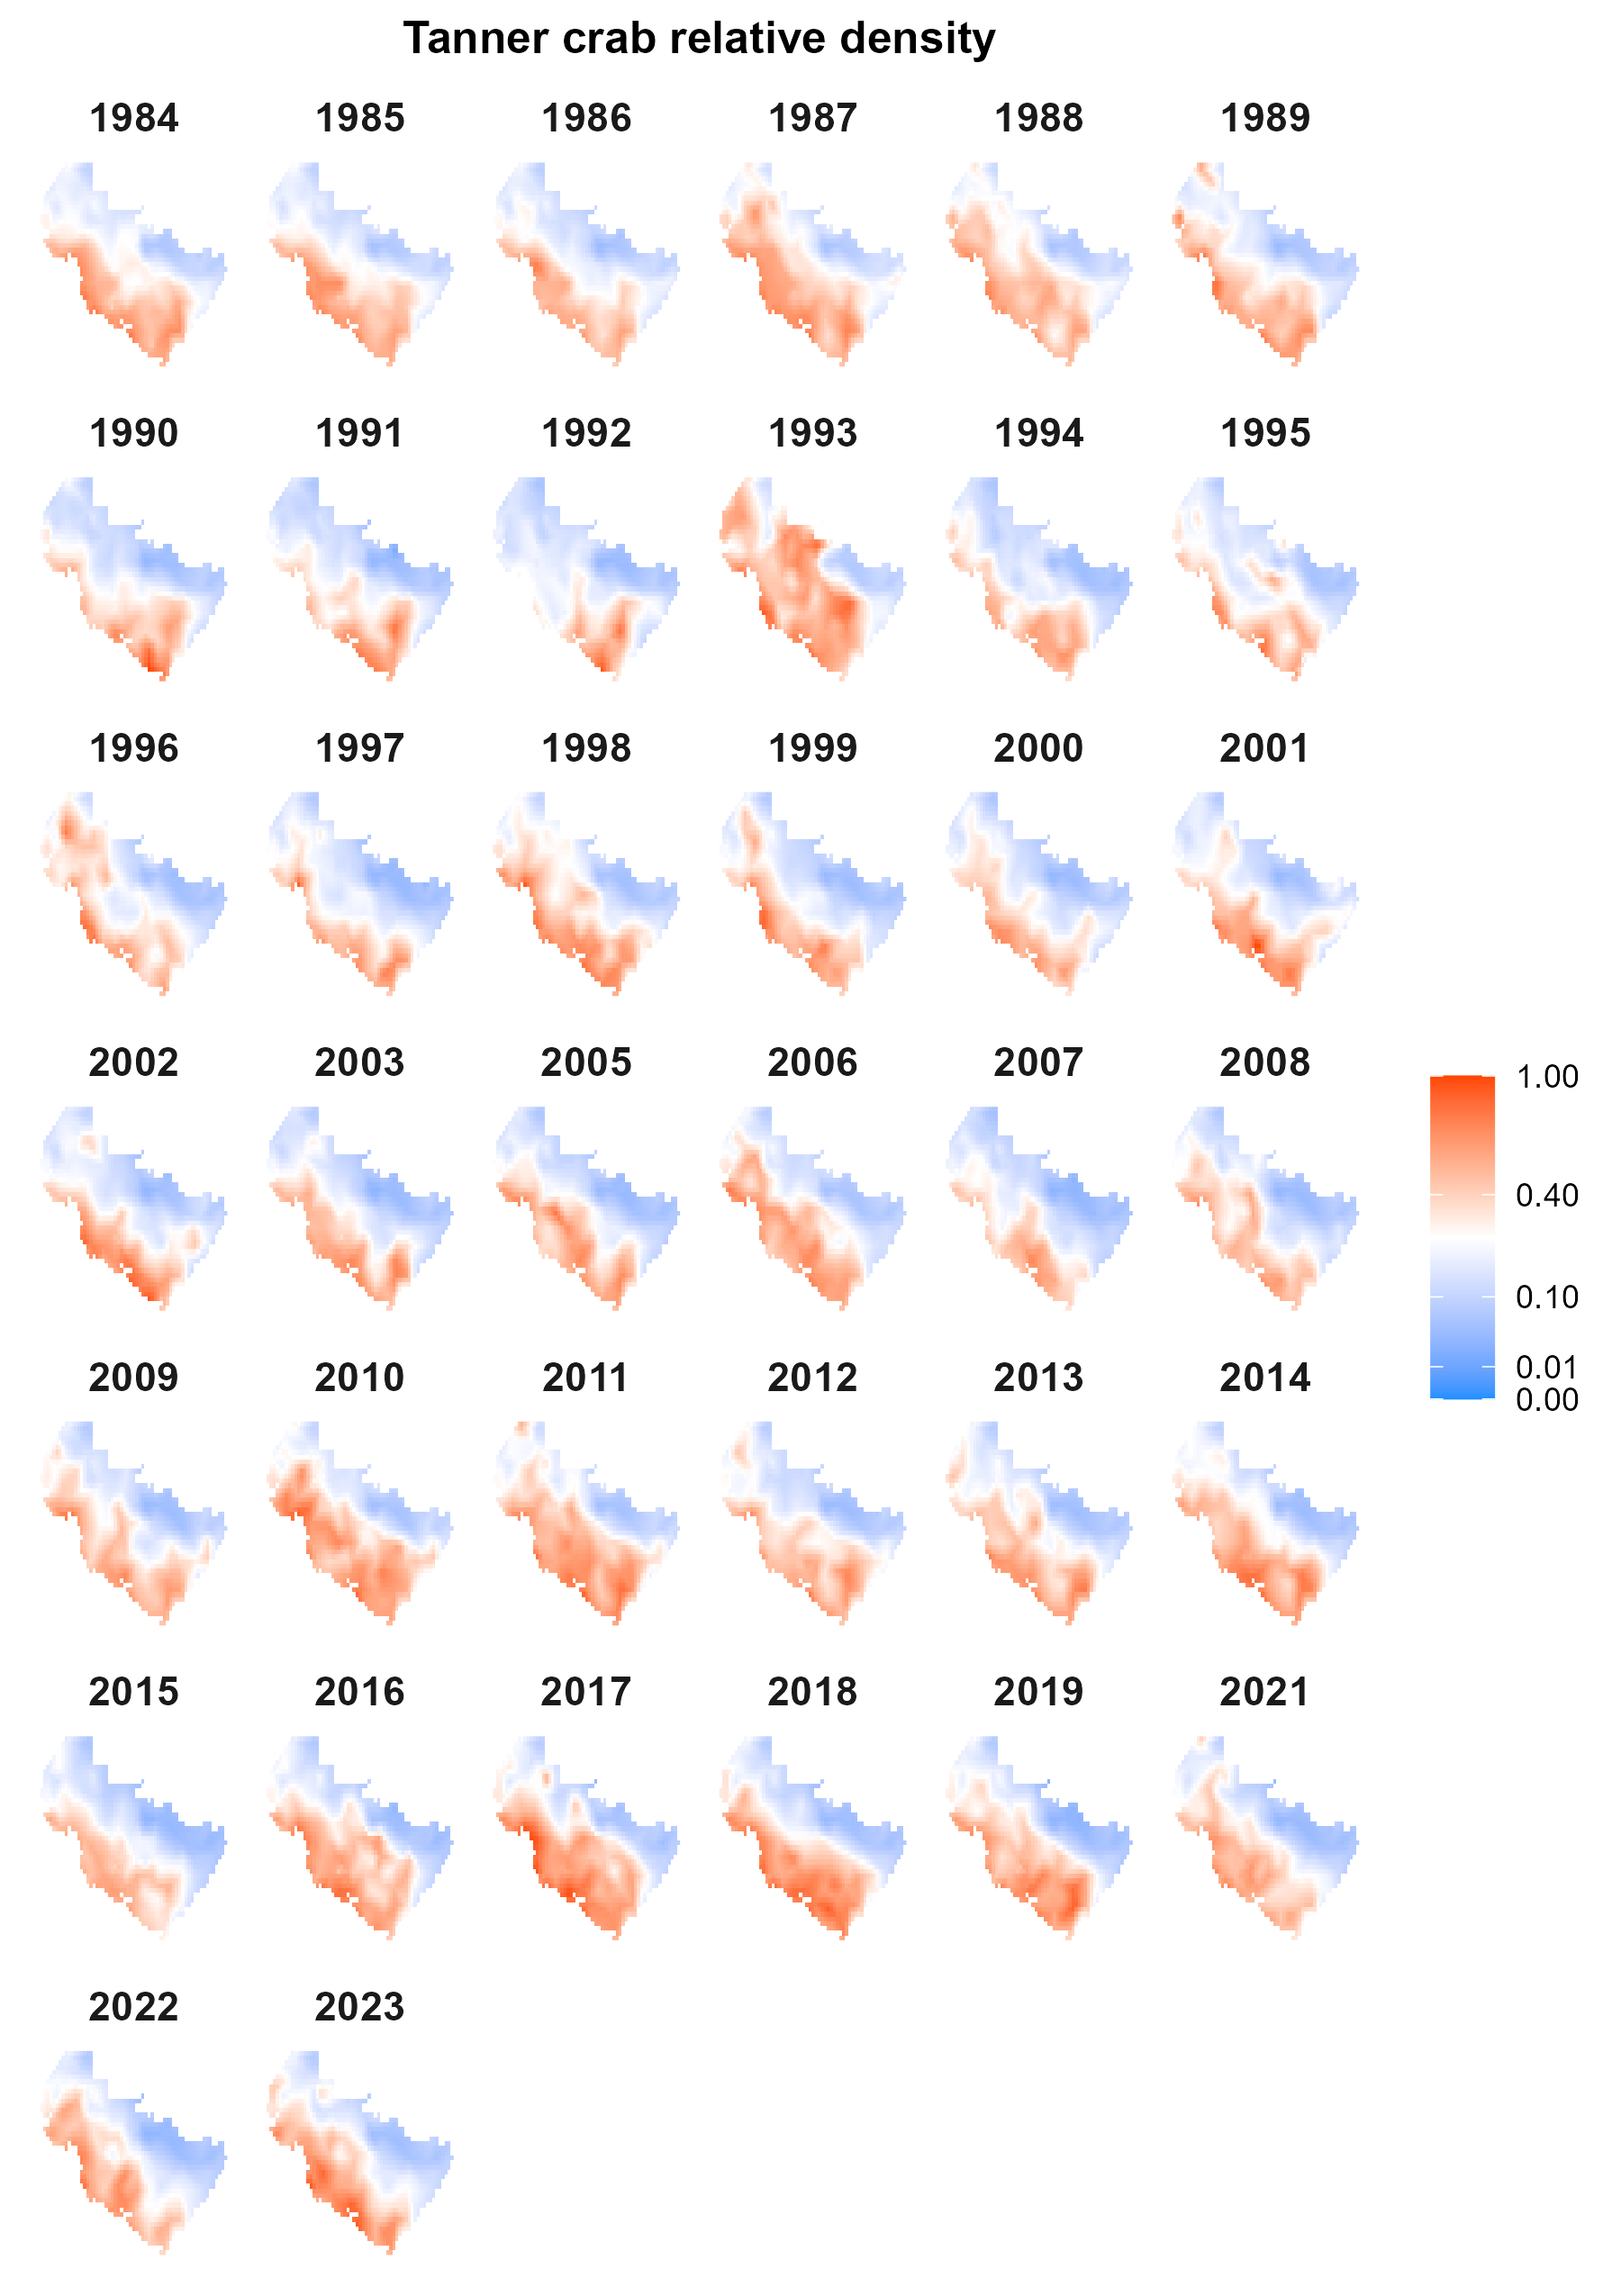
Fig. S14 Estimated density of Tanner crab scaled relative to the maximum density.

References
Aydin KY, Gaichas S, Ortiz I, Kinzey D, Friday N (2007) A comparison of the Bering Sea, Gulf of Alaska, and Aleutian Islands large marine ecosystems through food web modeling. U.S. Dep. Commer., NOAA Tech. Memo. NMFS-AFSC-178, 298 p.
Livingston PA, Aydin K, Buckley TW, Lang GM, Yang M-S, Miller BS (2017) Quantifying food web interactions in the North Pacific–a data-based approach. Environ Biol Fishes 100:443–470.
Stauffer G (2004) NOAA protocols for groundfsh bottom trawl surveys of the nation’s fshery resources. US Dep Commer

