Supplemental Table 1. Summary of social vulnerability metrics employed in this study. Expected influence on potential tornado impacts are also noted.
Vulnerability | Metric | Influence on Potential Impacts
Population | Total Persons | Affects the exposure of people to a hazard; The higher the population, the greater the tornado impact^{20,40,82}
Population | Population Density | Affects the exposure of people to a hazard; The higher the population, the greater the tornado impact; Highlights where crowding is a concern^{20,40,81}
Socio-economic | Income below the poverty level in the last 12 months | Hindered capacity to rebuild and recover; limited access to insurance, financial networks, savings^{40,77,83,84,85}
Socio-economic | Civilian labor force unemployed | Hindered capacity to rebuild and recover; limited access to insurance, financial networks, savings^{40,77,83}
Socio-economic | Public assistance/Food Stamps in the last 12 months | Hindered capacity to rebuild and recover; limited access to insurance, financial networks, savings^{40,84}
Housing | Mobile or manufactured homes | Poor construction design; associated with economic factors; often outside of high-density areas16,17,40,62,64,65,66,67,68,76,86
Housing | Renters | Lack of financial resources and recovery aid^{37,40,84}
Age | Aged 65 years or greater | Reliance on outside assistance; mobility; medical care; socially and economically isolated^{40,60,77,87,88}
Age | Less than 18 years old | Reliance on outside assistance^{40,77,84,89}
Age | Less than 5 years old | Reliance on outside assistance^{36,37,40,77,88}
Race and Ethnicity | Non-white | Historical social and economic marginalization of minority groups^{40,77,83,90,91,92,93}
Race and Ethnicity | Hispanic | Language and cultural barriers to response and recovery⁵⁸
Race and Ethnicity | Black | Historic marginalization; cultural barriers^{40,77,94}
Migrants | Citizenship and Date of US Entry | Language barriers; limited economic and social networks; reliance on family, neighbors for hazard information^{40,58,77,84,92}
Language | Speaks English "less than well" | Limited hazard information comprehension^{58,40,77,92}
Disability | Adults (16-64 years old) with a disability | Reliance on outside assistance; medical care; socially and economically isolated^{40,77}
Sex | Female | Historic lower economic status compared to males^{40,77,95}
Sex | Single female head of household with children present | Family care responsibilities; lower economic status and limited financial resources^{40,77,76,84}
Education | Less than 4 years of High School  (No Diploma) | Limited understanding and comprehension of hazard information; associated with economic factors^{40,77}
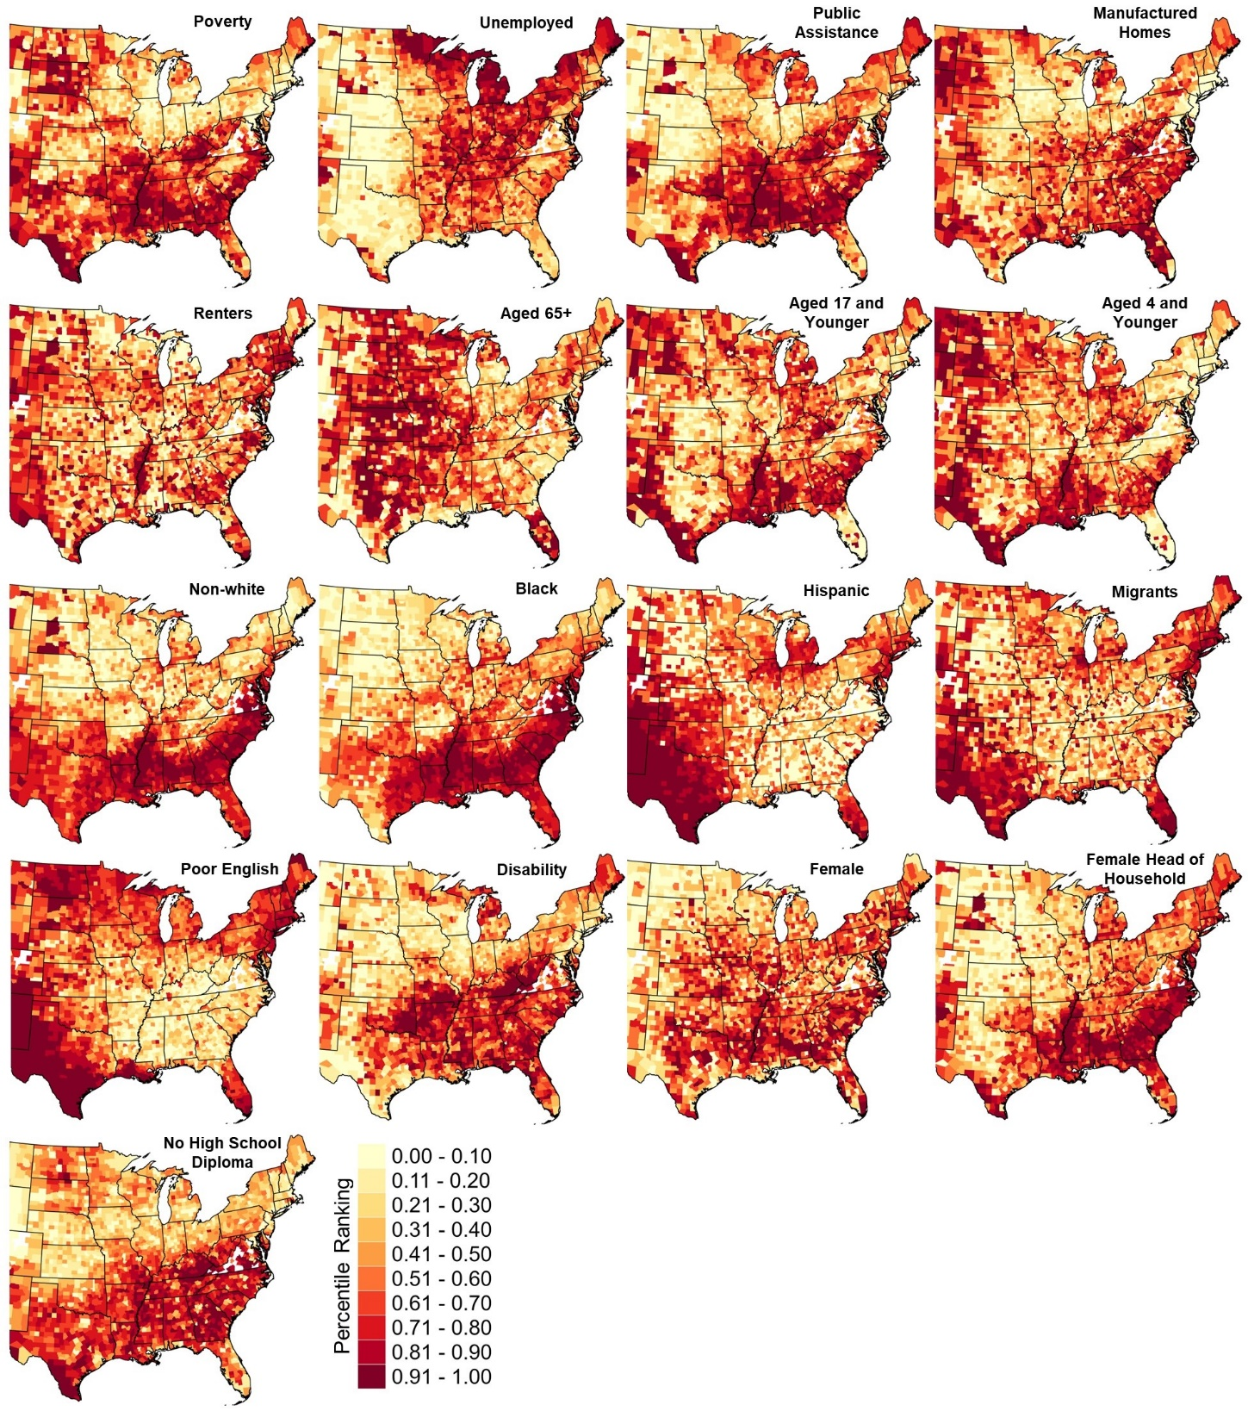
Supplemental Figure 1. County-level vulnerability percentile rankings for each societal metric in 1980.

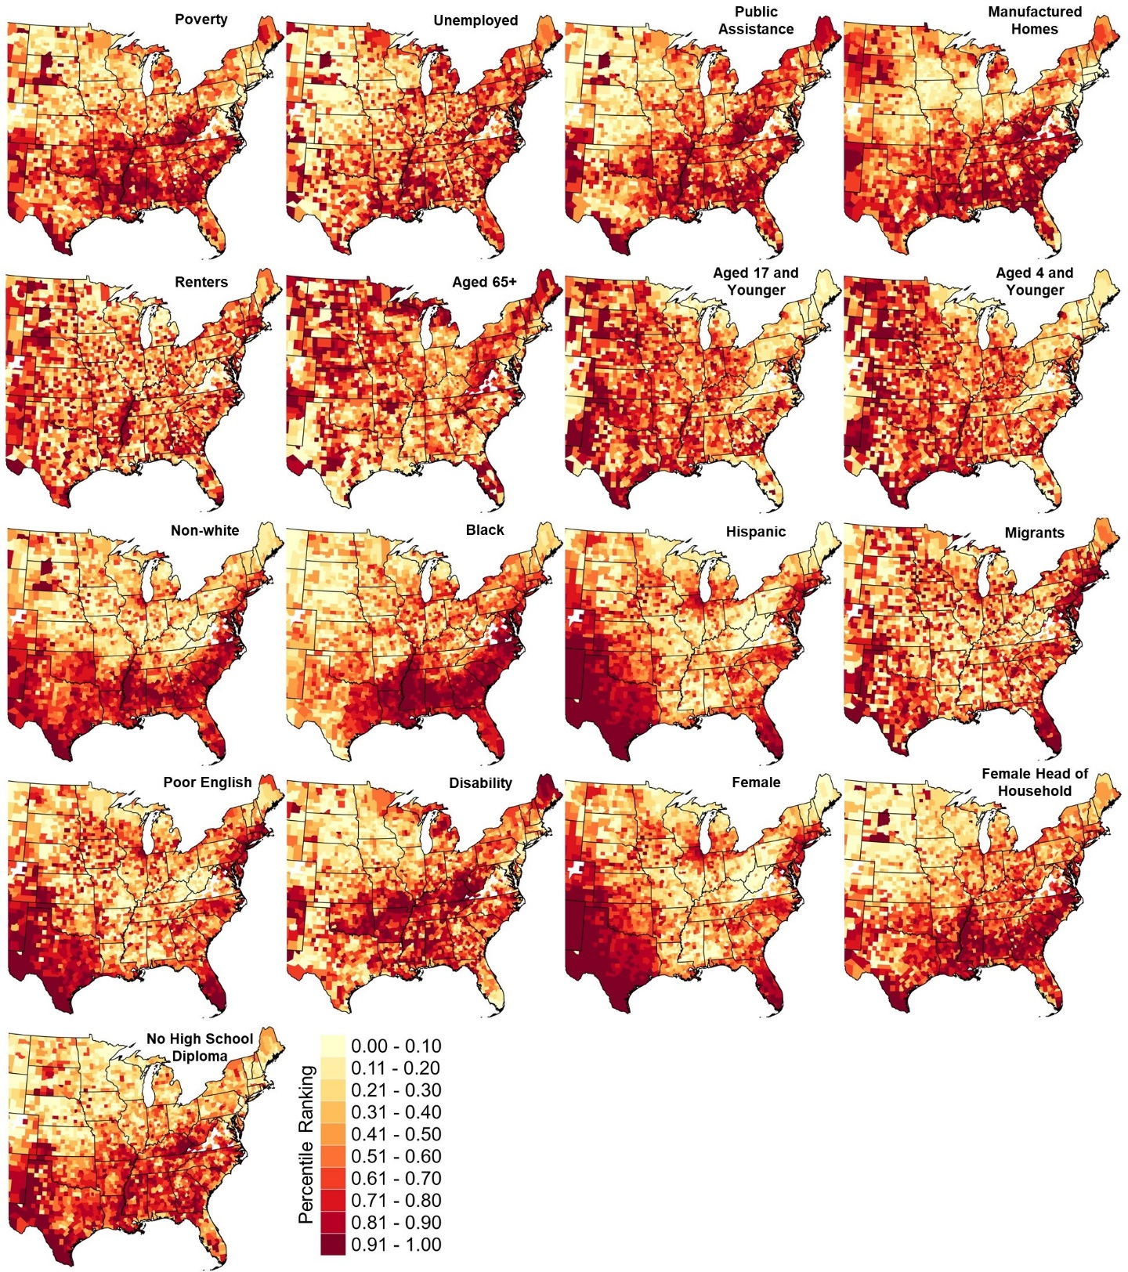
Supplemental Figure 2. County-level vulnerability percentile rankings for each societal metric in 2020.

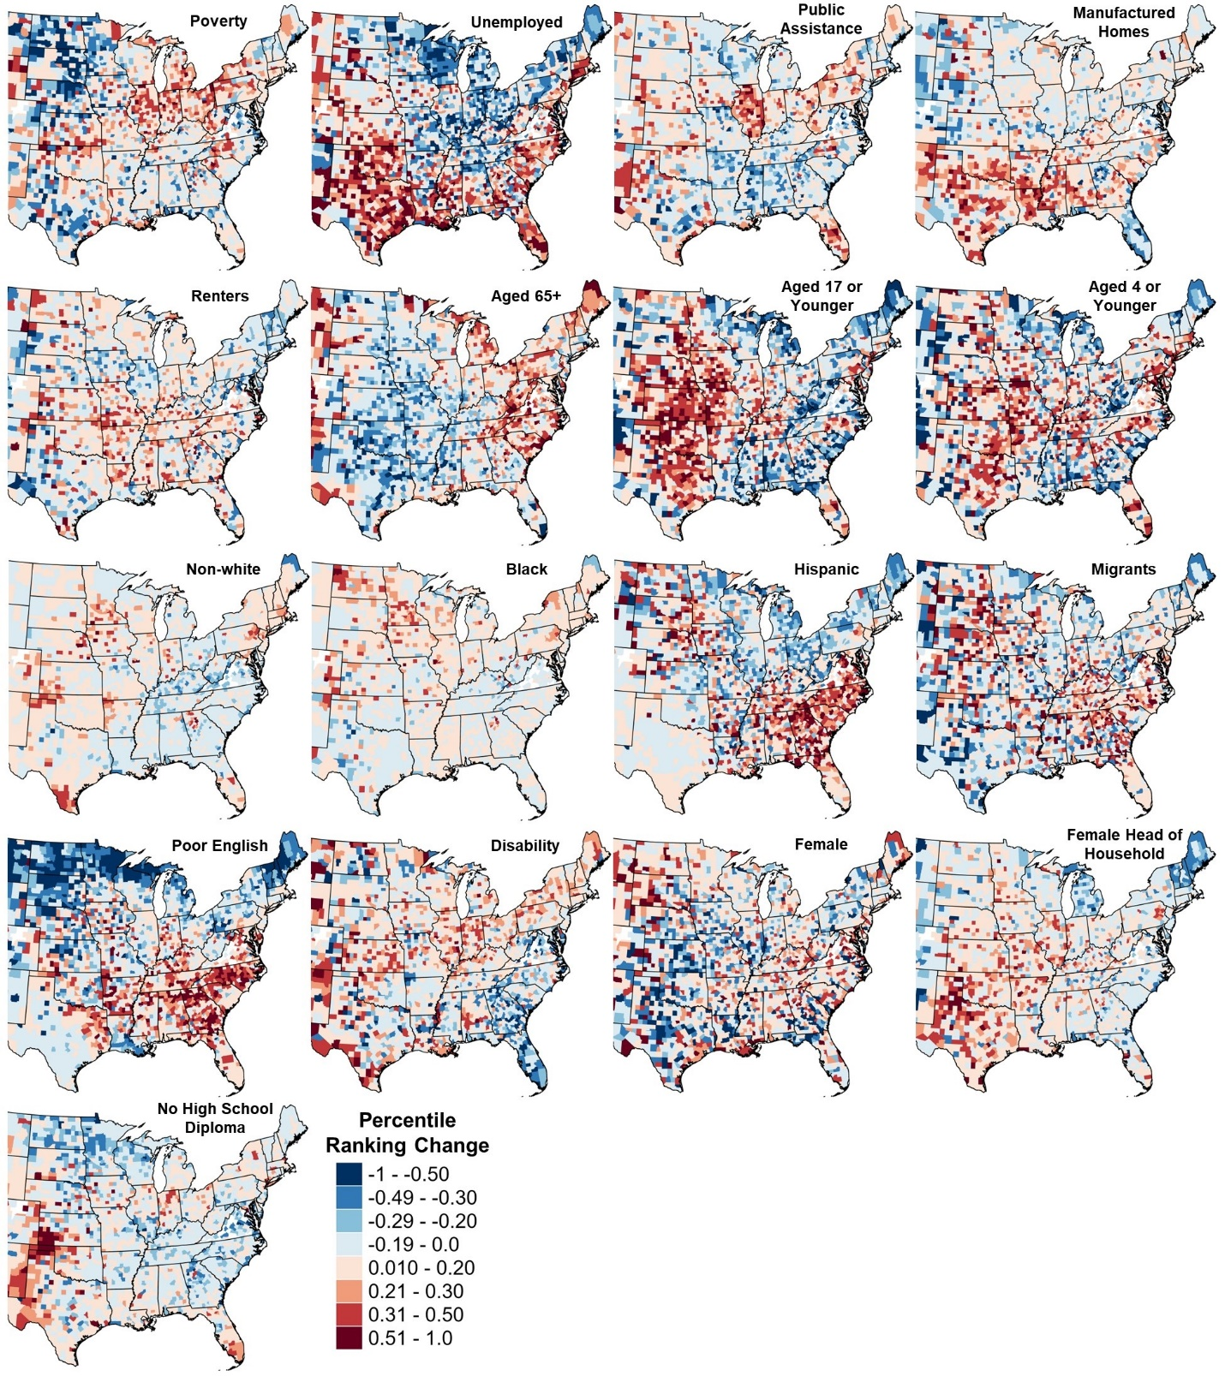
Supplemental Figure 3. County-level differences (1980 to 2020) in social vulnerability metric percentile ranking.

82. Ehrlich, D., Kemper, T., Pesaresi, M., & Corbane, C. Built-up area and population density: Two essential societal variables to address climate hazard impact. Environmental Science & Policy, 90, 73–82 (2018).
83. Peacock, W. G., Gladwin, H. & Morrow, B. H. Hurricane Andrew: Ethnicity, gender and the sociology of disasters. Routledge, 304 pp. (1997).
84. Morrow, B. H. Identifying and mapping community vulnerability. Disasters, 23, 1–18 (1999).
85. Hallegatte, S., Vogt-Schilb, A., Rozenberg, J., Bangalore, M., & Beaudet, C. From poverty to disaster and back: A review of the literature. Economics of Disasters and Climate Change, 4, 223–247 (2020).
86. Eidson, M., J. A. Lybarger, J. E. Parsons, J. N. MacCormack, & Freeman, J. I. Risk Factors for Tornado Injuries. International Journal of Epidemiology, 19, 1051–1056 (1990).
87. Ngo, E. B. When disasters and age collide: Reviewing vulnerability of the elderly. Nat. Hazards Rev., 2, 80–89 (2001).
88. Phillips, B. D. & P. L. Hewett. Home alone: Disasters, mass emergencies, and children in self-care. J. Emerg. Manage., 3(2), 31–35 (2005).
89. Martin, S. D., A. C. Bush, & Lynch, J.A. National survey of terrorism preparedness training among pediatric, family practice, and emergency medicine programs. Pediatrics, 118, e620–626 (2006).
90. Fothergill, A., & Peek, L. Poverty and disasters in the United States: A review of recent sociological findings. Nat. Hazards, 32, 89–110 (2004).
91. Cutter, S. L. C. T. Emrich, J. T. Mitchell, B. J. Boruff, M. Gall, M. C. Schmidtlein, C. G. Burton, & Melton, G. The long road home: Race, class, and recovery from Hurricane Katrina. Environ. Sci. Policy, 48, 8–20 (2006).
92. Peguero, A. Latino disaster vulnerability: The dissemination of hurricane mitigation information among Florida’s home-owners. Hisp. J. Behav. Sci., 28, 5–22 (2006).
93. Elder, K., S. Xirasagar, N. Miller, S. A. Bowen, S. Glover, & Piper, C. African Americans’ decisions not to evacuate New Orleans before Hurricane Katrina: A qualitative study. Amer. J. Public Health, 97, S124–S129 (2007).
94. Senkbeil, J. C., Scott, D. A., Guinazu-Walker, P., & Rockman, M. S. Ethnic and racial differences in tornado hazard perception, preparedness, and shelter lead time in Tuscaloosa. The Professional Geographer, 66(4), 610–620 (2014).
95. Laska, S., & Morrow, B. H. Social vulnerabilities and Hurricane Katrina: an unnatural disaster in New Orleans. Marine technology society journal, 40(4), 16–26 (2006).

