Supplementary Material for Wilson et al. - Spatial variation in age-specific growth of female Chinook salmon

Supplemental Figure 1: Scale measurements by increment (FW, SW1, …, SW4) and maturation age (green = age 5, orange = age 6) for female Chinook salmon from 14 Alaska populations. Scale measurements for each increment are sum of growth for that increment and prior increments. Points are median and error bars indicate 90% quantiles of measurements by population from growth years 1993–2010.
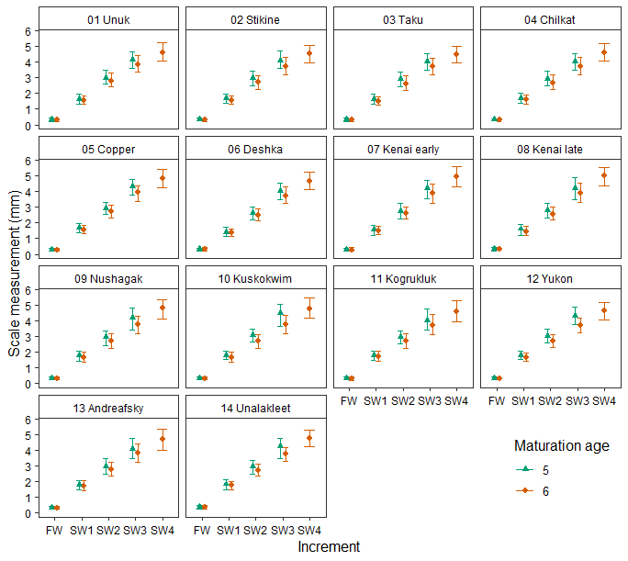

Supplemental Figure 2: Female Chinook salmon scale size during the year in fresh water (FW) and from the first (SW1) through fourth (SW4) years at sea for fish that matured at age 5 (circle) and 6 (triangle), growth years 1961–2014. Size is estimated from scale measurements shown in terms of fish length. Shaded bands are 90% quantiles.

Supplemental Figure 3: Increment by population random effect intercepts, in a model for scale measurements from female Chinook salmon from 14 populations, 1965–2014. The mean among populations of increment effects were, FW = -0.63, SW1 = 0.32, SW2 = 0.17, SW3 = 0.19, and SW4 = -0.05. Other random effects included in the model were maturation age effects by population and calendar year effects by increment and population.
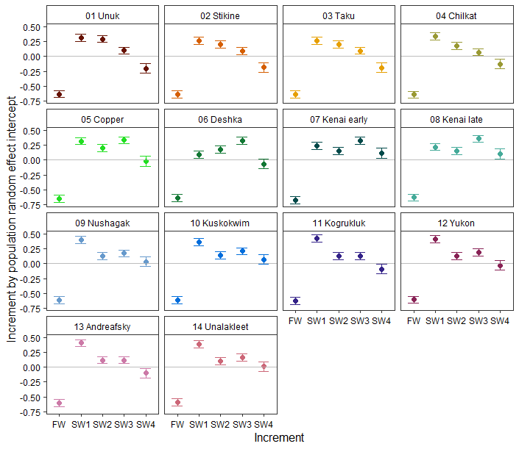

Supplemental Figure 4: Maturation age by increment and population random effect intercepts in a model for scale measurements from female Chinook salmon from 14 populations, 1965–2014. Other random effects included in the model were maturation age by population and calendar year by increment and population.
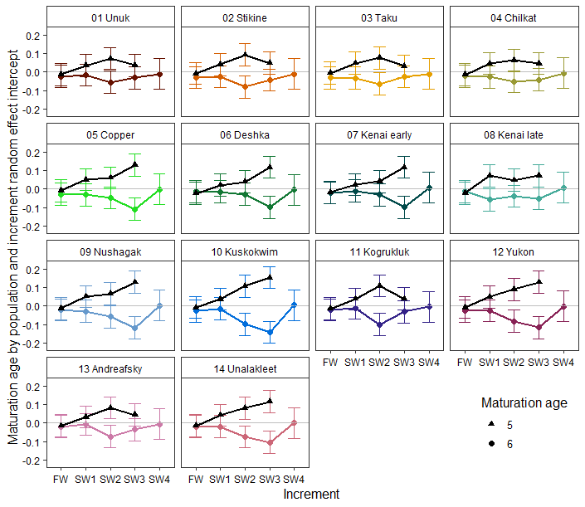

Supplemental Figure 5: Correlation matrix of increment growth, sum of maturation-related growth (SumMRG), sum of increment growth (SumInc), and river mouth alongshore coastal order from southeast to northwest (Coast) for female Chinook salmon from 14 populations in Alaska, 1965–2014 (populations listed in Supplemental Figure 1). Maturation-related growth were the incremental differences in growth of fish that matured at age 5 vs. age 6. Increment growth was a population’s deviation from the mean increment growth among populations and included FW.inc, SW1.inc through SW4.inc. Maturation-related and increment growth were estimated in a random-effects model that also included a random effect for calendar year by increment and population. Correlation coefficients (R = Pearson, Rt = Kendall’s tau) and P values are shown below the diagonal, and plotted values above the diagonal.
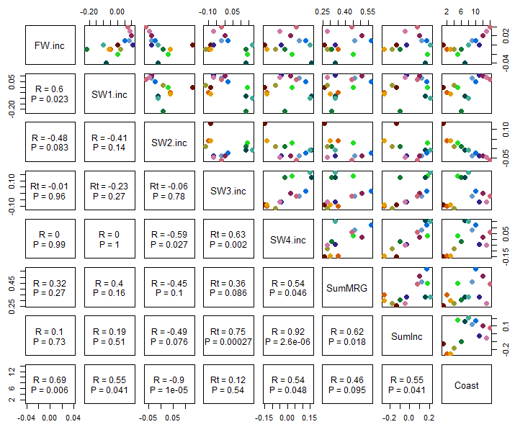

Supplemental Figure 6: Correlation between FW and SW1 growth of female Chinook salmon by age at maturity (age 5, left column; age 6, right column), population (rows), and brood year (x-axis) for 14 populations in Alaska, sampled 1965–2014.
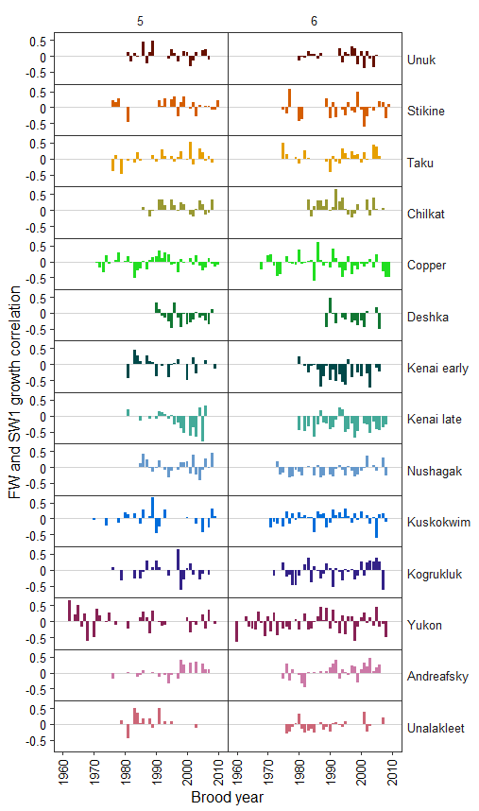
Supplemental Figure 7: Correlation between SW1 and SW2 growth of female Chinook salmon by age at maturity (age 5, left column; age 6, right column), population (rows), and brood year (x-axis) for 14 populations in Alaska, sampled 1965–2014.
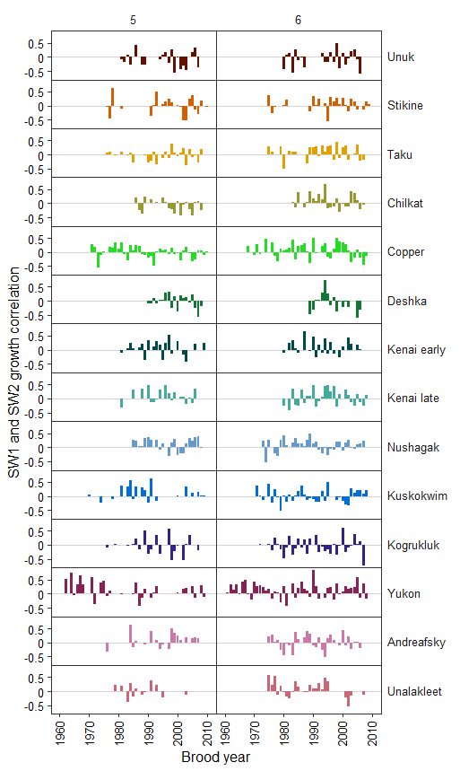
Supplemental Figure 8: Correlation between SW2 and SW3 growth of female Chinook salmon by age at maturity (age 5, left column; age 6, right column), population (rows), and brood year (x-axis) for 14 populations in Alaska, sampled 1965–2014.
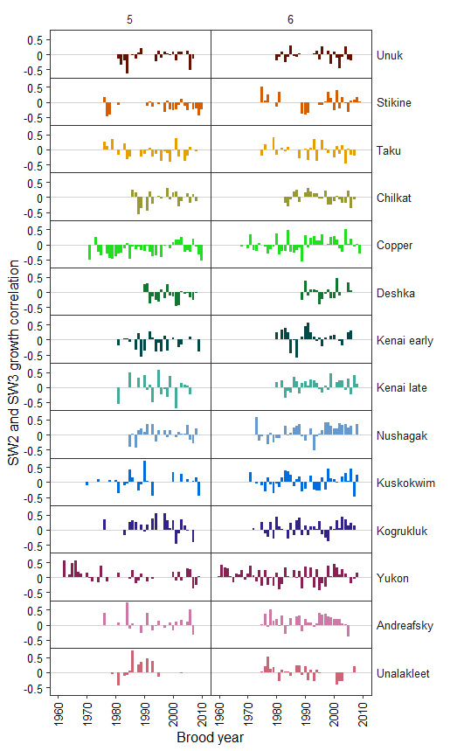
Supplemental Figure 9: Correlation between SW3 and SW4 growth for female Chinook salmon that matured at age 6, by population (rows), and brood year (x-axis) for 14 populations in Alaska, sampled 1965–2014.
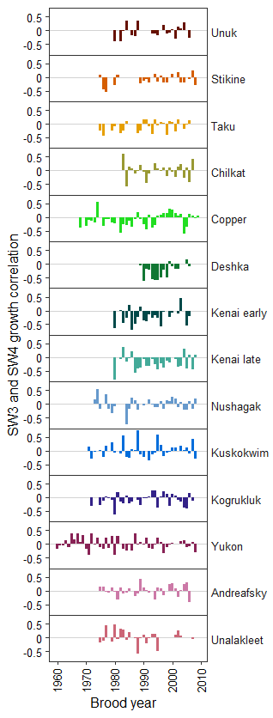
Supplemental Figure 10: Correlation between FW and SW2 growth of female Chinook salmon by age at maturity (age 5, left column; age 6, right column), population (rows), and brood year (x-axis) for 14 populations in Alaska, sampled 1965–2014.
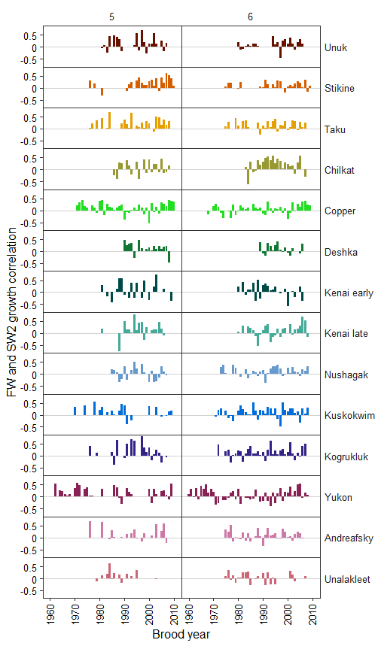
Supplemental Figure 11: Correlation between FW and SW3 growth of female Chinook salmon by age at maturity (age 5, left column; age 6, right column), population (rows), and brood year (x-axis) for 14 populations in Alaska, sampled 1965–2014.
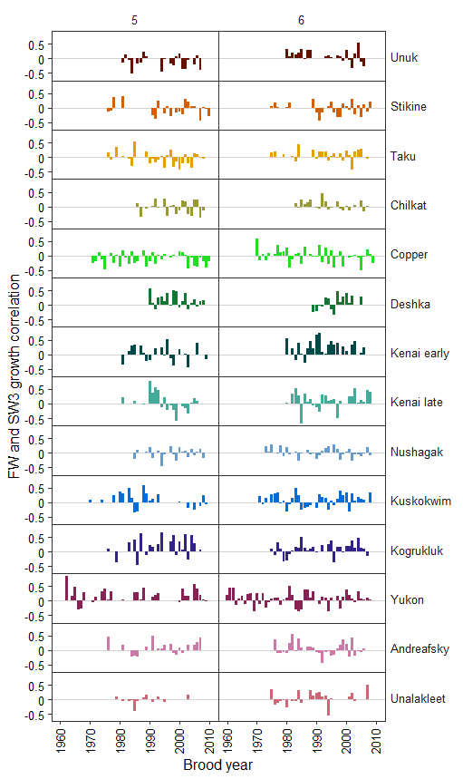
Supplemental Figure 12: Correlation between FW and SW4 growth for female Chinook salmon that matured at age 6, by population (rows), and brood year (x-axis) for 14 populations in Alaska, sampled 1965–2014.
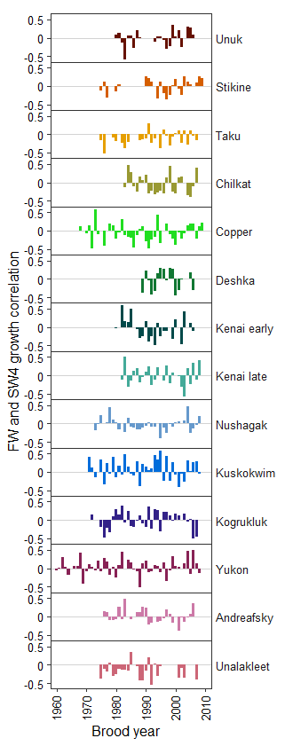
Supplemental Figure 13: Correlation between SW1 and SW3 growth of female Chinook salmon by age at maturity (age 5, left column; age 6, right column), population (rows), and brood year (x-axis) for 14 populations in Alaska, sampled 1965–2014.
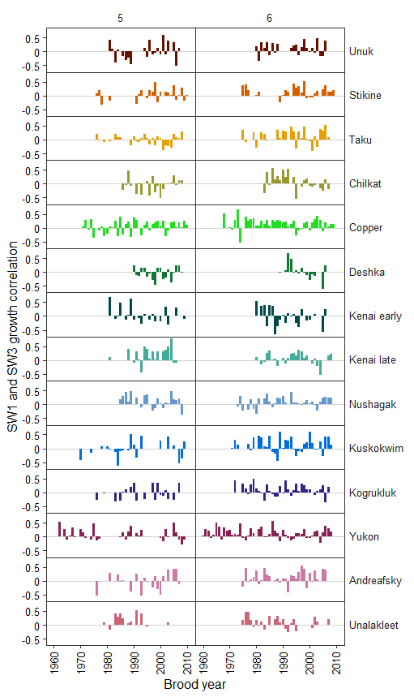
Supplemental Figure 14: Correlation between SW1 and SW4 growth (left column) and between SW2 and SW4 growth (right column) for female Chinook salmon that matured at age 6, by population (rows), and brood year (x-axis) for 14 populations in Alaska, sampled 1965–2014.
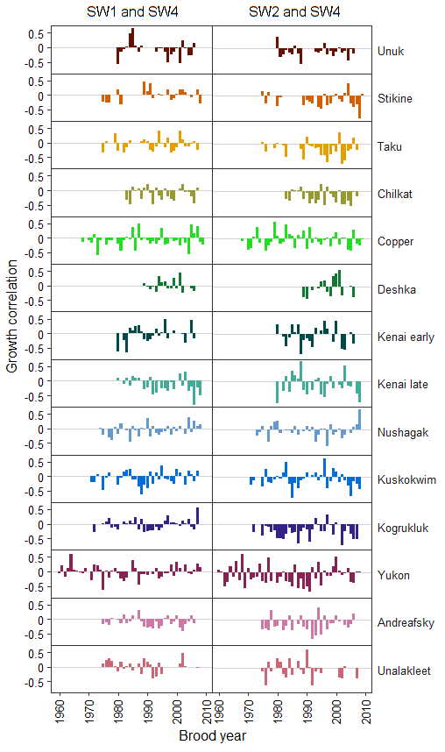
Supplemental Figure 15: Correlation matrix of maturation-related growth, sum of maturation-related growth (SumMRG), sum of increment growth (SumInc), and river mouth alongshore coastal order from southeast to northwest (Coast) for female Chinook salmon from 14 populations in Alaska, 1965–2014 (populations listed in Supplemental Figure 1). Maturation-related growth were the incremental (FW, SW1–SW3) differences in growth of fish that matured at age 5 vs. age 6 (MRG.FW, MRG.SW1, MRG.SW2, and MRG.SW3). Increment growth was a population’s deviation from the mean increment growth among populations. Maturation-related and increment growth were estimated in a random-effects model that also included a random effect for calendar year by increment and population. Correlation coefficients (R = Pearson, Rt = Kendall’s tau) and P values are shown below the diagonal, and plotted values above the diagonal.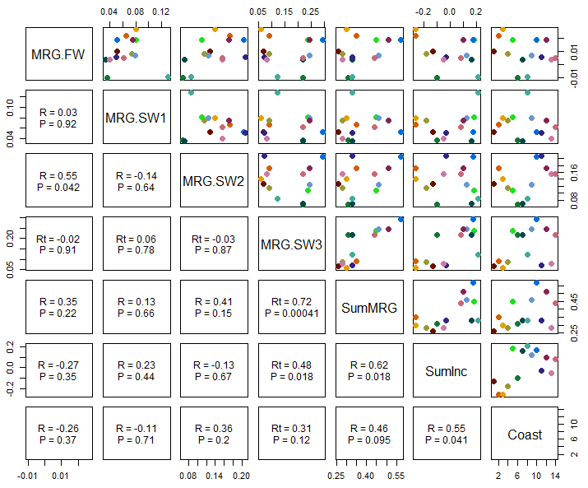

Supplemental Figure 16: Slope estimated from a linear regression between scale radius (longest axis, mm) and fish length (mid-eye to fork of tail, mm) and the standard error of the slope (SE) from female Chinook salmon sampled from 14 populations in Alaska.
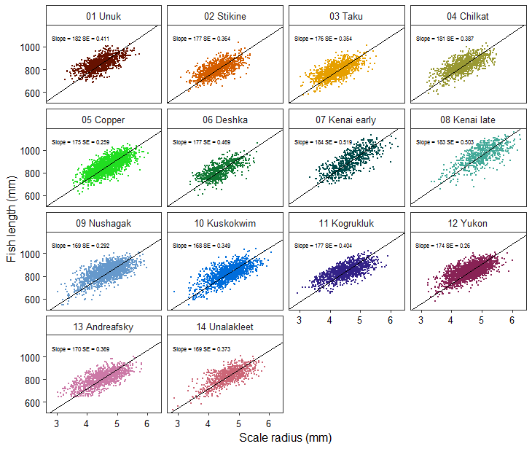

Supplemental Table 1: Salmon scale sampling project description and gear type used to sample Chinook salmon scales from 14 study populations in Alaska. For the project description, Com. = Commercial and Esc. = Escapement. Study populations are Unuk (UU), Stikine, (SK), Taku (TC), Chilkat (CT), Copper (CP), Deshka (DC), Kenai early (KE), Kenai late (KL), Nushagak (NC), Kuskokwim (BC), Kogrukluk (KO), Yukon (FY), Andreafsky (AY), and Unalakleet (UK).
 |  | Population
Project, Gear |  | UU | SK | TC | CT | CP | DC | KEª | KLª | NC | BC | KO | FY | AY | UK | Total
Com. | Drift gillnet |  |  | 24 |  | 1,886 |  |  |  | 647 | 812 |  | 13 |  |  | 3,382
 | Set gillnet |  |  | 13 |  |  |  |  |  | 33 | 59 |  | 454 |  | 554 | 1,113
 | Not recorded |  |  |  |  |  |  |  |  | 5 |  |  |  |  |  | 5
Test | Drift gillnet |  |  | 16 |  |  |  |  |  |  | 254 |  | 50 |  |  | 320
 | Set gillnet |  |  |  |  |  |  |  |  |  |  |  | 1,647 |  | 282 | 1,929
 | Hand troll |  |  |  |  |  |  |  |  |  |  |  |  |  | 1 | 1
Subsistence Harvest |  |  |  |  |  |  |  |  |  |  |  |  |  |  | 8 | 8
Esc. | Beach seine |  |  |  |  |  |  |  |  | 33 |  |  |  | 9 | 43 | 85
 | Drift gillnet |  | 900 | 3 | 656 |  |  |  |  | 1,049 |  |  |  |  |  | 2,608
 | Set Gillnet | 553 | 9 | 165 | 70 |  |  |  |  |  |  |  |  |  |  | 797
 | Fish wheel |  |  | 757 | 266 |  |  |  |  |  |  |  |  |  |  | 1,023
 | Sport hook and line | 62 |  |  |  |  |  |  |  |  |  |  |  |  |  | 62
 | Handpicked | 225 | 147 | 18 | 67 |  |  |  |  | 15 |  |  |  | 423 |  | 895
 | Dip net | 35 |  |  | 62 |  |  |  |  |  |  |  |  |  |  | 97
 | Weir | 108 | 56 | 109 | 21 |  | 383 |  |  |  | 122 | 1,141 |  | 767 | 37 | 2,744
 | Snag |  |  |  | 30 |  |  |  |  |  |  |  |  |  |  | 30
 | Not recorded |  | 49 | 67 |  |  | 340 |  |  | 47 |  |  |  | 9 |  | 512
 | Set gillnet |  |  |  |  |  |  | 665 | 583 |  |  |  |  |  |  | 1,248
 | Handpicked |  |  |  |  |  |  |  |  |  |  |  |  |  | 1 | 1
 | Spawning grounds |  |  | 144 |  |  |  |  |  |  |  |  |  |  |  | 144
Sport | Set gillnet (marine) |  |  |  |  |  |  |  |  |  |  |  | 1 |  |  | 1
Sport | Hook and line (fresh water) |  |  |  |  |  |  | 41 | 97 |  |  |  |  |  |  | 138
Population total |  | 983 | 1,161 | 1,316 | 1,172 | 1,886 | 723 | 706 | 680 | 1,829 | 1,247 | 1,141 | 2,165 | 1,208 | 926 | 17,143
ª Most years were >80% escapement samples. Exceptions in the early run were 85% sport-sampled in 1986, 45% in 2004, 23% in 2006, and 40% in 2010. Exceptions in the late run were 100% sport in 1986, 27% in 1990, 33% in 1993, 100% in 2004, and 27% in 2009. Length distributions of fish with scales sampled in 1986 and 2004 were not different when compared to previous and next year (KS test P > 0.05) or with sport-sampled scales were compared to escapement-sampled scales within the same year in all years (KS test P > 0.05).
Supplemental Table 2: Average percent of females by age class sampled in the return for 14 Chinook salmon populations in Alaska. Years sampled are in manuscript Table 1. Sampling projects are described in Supplemental Table 1.
 | Percent of female return
Population | Age 4 | Ages 5 and 6 | Age 7
Unuk | 6.9% | 91.7% | 1.1%
Stikine | 2.5% | 96.4% | 0.9%
Taku | 8.9% | 90.2% | 0.7%
Chilkat | 1.4% | 97.0% | 1.6%
Copper | 7.5% | 90.8% | 1.6%
Deshka | 10.5% | 89.3% | 0.2%
Kenai early | 3.6% | 93.7% | 2.7%
Kenai late | 4.2% | 91.4% | 4.4%
Nushagak | 10.7% | 86.2% | 3.1%
Kuskokwim | 2.7% | 89.7% | 7.5%
Kogrukluk | 0.1% | 93.5% | 6.4%
Yukon | 0.7% | 90.0% | 9.2%
Andreafsky | 7.4% | 87.4% | 5.2%
Unalakleet | 7.4% | 82.7% | 5.7%
Average | 5.3% | 90.7% | 3.6%

Supplemental Table 3: Random effect models showing the difference in AIC_{C} (ΔAIC_{C}) relative to the model with the lowest AIC_{C.} Header rows are: random effects (RE, intercepts) included in each model, variance explained by the random effect (Var) and the standard deviation (SD) of the RE variance. Also shown is the percent of variation explained by fish. Models are sorted top to bottom from lowest to highest ΔAIC_{C}.
Model | ΔAIC_{C} | RE | Var | SD | RE | Var | SD | RE | Var | SD | RE | Var | SD | % Fish
1 | 0 | Pop:Inc:Time | 0.0029 | 0.0540 | Pop:Inc:Mat | 0.0073 | 0.0852 | Inc:Pop | 0.1252 | 0.3539
2 | 1.29 | Pop:Inc:Time | 0.0029 | 0.0540 | Pop:Inc:Mat | 0.0073 | 0.0851 | Inc:Pop | 0.1252 | 0.3538 | Fish | 0.0001 | 0.0079 | 0.05%
3 | 133.35 | Pop:Inc:Time | 0.0029 | 0.0540 | Pop:Inc:Mat | 0.1431 | 0.3783
4 | 134.65 | Pop:Inc:Time | 0.0029 | 0.0540 | Pop:Inc:Mat | 0.1431 | 0.3783 | Fish | 0.0001 | 0.0079 |  |  |  | 0.04%
5 | 2323.38 | Pop:Time | 0.0011 | 0.0332 | Pop:BY | 0.0004 | 0.0188 | Pop:Inc:Mat | 0.0072 | 0.0849 | Inc:Pop | 0.1260 | 0.3550
6 | 3380.15 | Pop:Inc:Mat | 0.0074 | 0.0861 | Inc:Pop | 0.1262 | 0.3552 | Time | 0.0005 | 0.0227
7 | 3614.03 | Pop:BY | 0.0005 | 0.0225 | Pop:Inc:Mat | 0.0072 | 0.0851 | Inc:Pop | 0.1259 | 0.3548
8 | 4027.08 | Pop:Inc:Mat | 0.0074 | 0.0858 | Inc:Pop | 0.1258 | 0.3547 | BY | 0.0002 | 0.0154
9 | 4279.36 | Pop:Inc:Mat | 0.0072 | 0.0849 | Inc:Pop | 0.1259 | 0.3548
10 | 4413.29 | Pop:Inc:Mat | 0.1439 | 0.3794
11 | 7145.63 | Inc:Pop | 0.1259 | 0.3548 | Mat | 0.0047 | 0.0688
12 | 7258.18 | Pop:Inc:Time | 0.0032 | 0.0568 | Inc:Pop | 0.1255 | 0.3543 | Fish | 0.0014 | 0.0380 |  |  |  | 1.11%
13 | 7527.18 | Pop:Inc:Time | 0.0032 | 0.0569 | Inc:Pop | 0.1256 | 0.3545
14 | 11156.72 | Inc:Pop | 0.1265 | 0.3557 | Time | 0.0005 | 0.0223
15 | 11610.29 | Inc:Pop | 0.1262 | 0.3553 | Fish | 0.0015 | 0.0384 |  |  |  |  |  |  | 1.15%
16 | 11640.87 | Inc:Pop | 0.1263 | 0.3553 | BY | 0.0002 | 0.0158
17 | 11847.55 | Inc:Pop | 0.1263 | 0.3554
18 | 14603.36 | Inc:Pop:Time | 0.1288 | 0.3588 | Fish | 0.0014 | 0.0379 |  |  |  |  |  |  | 1.11%
19 | 14870.56 | Pop:Inc:Time | 0.1287 | 0.3588
20 | 18169.53 | Inc:Time | 0.1198 | 0.3461 | Mat | 0.0048 | 0.0691
21 | 21296.14 | Inc:Time | 0.1201 | 0.3465 | Pop | 0.0006 | 0.0239
22 | 22308.13 | Inc:Time | 0.1201 | 0.3466 | Fish | 0.0008 | 0.0288 |  |  |  |  |  |  | 0.68%
23 | 22367.85 | Inc:BY | 0.1201 | 0.3466
24 | 22367.85 | Inc:Time | 0.1201 | 0.3466
-Continued-
Supplemental Table 3.-Continued.
Model | ΔAIC_{C} | RE | Var | SD | RE | Var | SD | RE | Var | SD | RE | Var | SD | % Fish
25 | 22904.84 | Inc | 0.1485 | 0.3854 | Time | 0.0006 | 0.0246
26 | 23374.46 | Inc | 0.1480 | 0.3847 | BY | 0.0003 | 0.0182
27 | 23591.79 | Inc | 0.1480 | 0.3847 | Fish | 0.0007 | 0.0266 |  |  |  |  |  |  | 0.47%
28 | 23632.11 | Inc | 0.1480 | 0.3847
29 | 134737.9 | Pop:Mat:Time | 0.0227 | 0.1508
30 | 136667.15 | Pop:Time | 0.0136 | 0.1168
31 | 137179.31 | Time:Mat | 0.0091 | 0.0954
32 | 137847 | Mat | 0.0048 | 0.0694
33 | 138014.93 | BY:Mat | 0.0028 | 0.0527
34 | 138346.37 | Time | 0.0036 | 0.0601
35 | 138497.54 | Pop:Mat:BY | 0.0022 | 0.0473
36 | 138658.95 | Pop | 0.0006 | 0.0237
37 | 138820.15 | Pop:BY | 0.0005 | 0.0228
38 | 138820.15 | BY:Pop | 0.0005 | 0.0228
39 | 138869.74 | BY | 0.0001 | 0.0100
Note: Pop = population, Inc = increment (fresh water, and first through fourth year at sea; FW, and SW1–SW4), calendar year of growth (Time), brood year (BY), age at maturity (Mat, 5 or 6), and individual fish.
Note: Many models that included Fish as a random effect are not shown because they had a singular fit (meaning one or more variances are zero or very close to zero), including a model with a single random effect for fish and a model with a random effect for population and a random effect for fish.

