Electronic Supplementary Material (ESM):
Regime shifts in satellite-derived chlorophyll within the Laurentian Great Lakes

Nikolay P. Nezlin^{1,2}*, SeungHyun Son^{1,3}, Christopher W. Brown^{1,2,3}, Prasanjit Dash^{1,4},
Caren E. Binding⁵, Ashley K. Elgin⁶, Andrea VanderWoude⁷

¹ NOAA/NESDIS Center for Satellite Applications and Research, College Park, Maryland, USA
² Global Science & Technology, Inc., Greenbelt, Maryland, USA
³ Cooperative Institute for Satellite Earth System Studies (CISESS)/Earth System Science Interdisciplinary Center (ESSIC), University of Maryland, College Park, MD, USA
⁴ Cooperative Institute for Research in the Atmosphere (CIRA), Colorado State University, Fort Collins, Colorado, USA
⁵ Environment and Climate Change Canada, Canada Centre for Inland Waters, Burlington, Ontario, Canada
⁶ NOAA Great Lakes Environmental Research Laboratory, Lake Michigan Field Station, Muskegon, MI, USA
⁷ NOAA Great Lakes Environmental Research Laboratory, Ann Arbor, MI, USA

*Corresponding author: nikolay.nezlin@noaa.gov; +1-(310)-770-1302

ESM Appendix S1. Colonization of the Laurentian Great Lakes by dreissenids
The steps of colonization of dreissenids in the Great Lakes are described in publications (Karatayev et al., 2021; Karatayev & Burlakova, 2022; Nalepa et al., 2010, 2009; Strayer et al., 2019). Figures S1a and S1b (source: Fig. 3 and Fig. 6 from Lake morphometry determines Dreissena invasion dynamics, Karatayev et al., Biological Invasions, Volume 23, Springer Nature, 2021, reproduced with permission from SNCSC) demonstrate how the two species of mussels (zebra mussels at upper panels and quagga mussels at lower panels) spread across the entire bottom of shallow (Figure S1a) and deep (Figure S1b) basins.

Figure S1a. Source: Fig. 3 from (Lake morphometry determines Dreissena invasion dynamics, Karatayev et al., Biological Invasions, Volume 23, Springer Nature, 2021, reproduced with permission from SNCSC). Spatial distribution of Dreissena polymorpha (upper rows within each lake panel) and D. rostriformis bugensis (lower rows) in shallow lakes/regions of Lake Erie-Western Basin, Lake St. Clair, and Huron Lake-Saginaw Bay. Dreissenid density is expressed as individuals m⁻². Red dots indicate sampling stations.
Figure S1b. Source: Fig. 6 from (Lake morphometry determines Dreissena invasion dynamics, Karatayev et al., Biological Invasions, Volume 23, Springer Nature, 2021, reproduced with permission from SNCSC). Spatial distribution of Dreissena polymorpha (upper rows within each lake panel) and D. rostriformis bugensis (lower rows) in deep Lake Huron, Lake Michigan, and Lake Ontario. Dreissenid density is expressed as individuals m⁻². Red dots indicate sampling stations.
ESM Appendix S2. Inter-mission differences and biases between satellite sensors misinterpreted as regime shifts
Although in the OC-CCI dataset the biases between the data collected by different satellites were corrected, a significant number of artifacts remained and could be misinterpreted as regime shifts. However, OC-CCI Chl-a data reveal the basic patterns of regime shifts in the Great Lakes because the scale of these transformations is higher than the differences between bias-corrected Chl-a collected by different satellites.
The chance to detect regime shifts (both positive and negative) by STARS algorithm in all cells of 12-km grids in each of the five lakes demonstrate four maxima: in 2002, 2005, 2013 and 2020 (Figure S2b), and three of them coincide with the periods when the sources of data from satellite sensors integrated in the OC-CCI dataset changed (Figure S2a). Specifically, in 2002, SeaWiFS had been operational for five years when MODIS-Aqua and MERIS were launched, and the total number of collected images dramatically increased. From 2012 to 2013, MERIS ceased operations, and VIIRS-SNPP was launched. Starting in 2020, MODIS-Aqua and VIIRS-SNPP were not used in the OC-CCI dataset due to sensor degradation problems. These periods of changes in the origin of satellite data used in the OC-CCI dataset resulted in Chl-a discontinuities remaining after bias-correction procedures (Garnesson et al., 2019; Hammond et al., 2018; Yu et al., 2023) and could be misinterpreted as regime shifts.
The highest number of regime shifts in 2013 (when MERIS was replaced by SNPP VIIRS) and 2020 (when MODIS-Aqua and VIIRS-SNPP ceased being used) was detected in Lake Superior (gray bars in Figure S2b), where no regime transformation took place and all detected regime shifts should be treated as artifacts.
It is worth mentioning that some periods when the chance to detect regime shift in the Great Lakes was higher than during other years had reasonable explanations not necessarily associated with the change of sensors. In 2011-2013, the change in observing satellites (MERIS replaced by SNPP VIIRS) coincided with extreme weather conditions. After warm winter of 2011–2012, late winter cooling and an early spring warming resulted in incomplete fall overturning facilitating cross-shelf circulation delay, reducing deep-water ventilation and limiting the supply of nutrients to the sunlit surface layers (Fichot et al., 2019). During the next winter 2012-2013, the Great Lakes endured the most persistent, lowest temperatures and highest ice cover in recent history (Gronewold et al., 2015), which could result in discontinuities in Chl-a time series. The period 2004-2005 was noted by other authors as a point when the most dramatic drop in water quality parameters occurred in the Great Lakes, including a decrease of water turbidity in Lakes Michigan and Huron (Zheng & DiGiacomo, 2022) and a decline in phytoplankton biomass in the southern basin of Lake Michigan (Reavie et al., 2014).

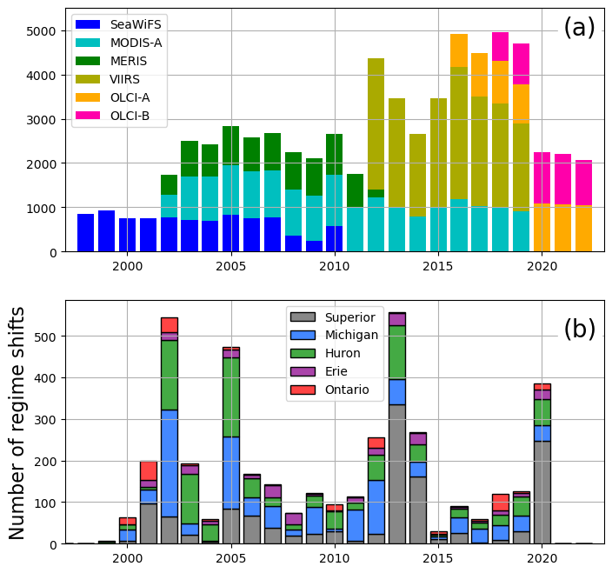
Figure S2. The relationship between (a) the number of images collected over the Great Lakes by different satellite sensors used in the OC-CCI dataset and (b) the number of regime shifts (both positive and negative) detected by the integrated STL-STARS method during every year in all grid cells of the five Great Lakes.

Supplement 3. Different number of images collected during different seasons

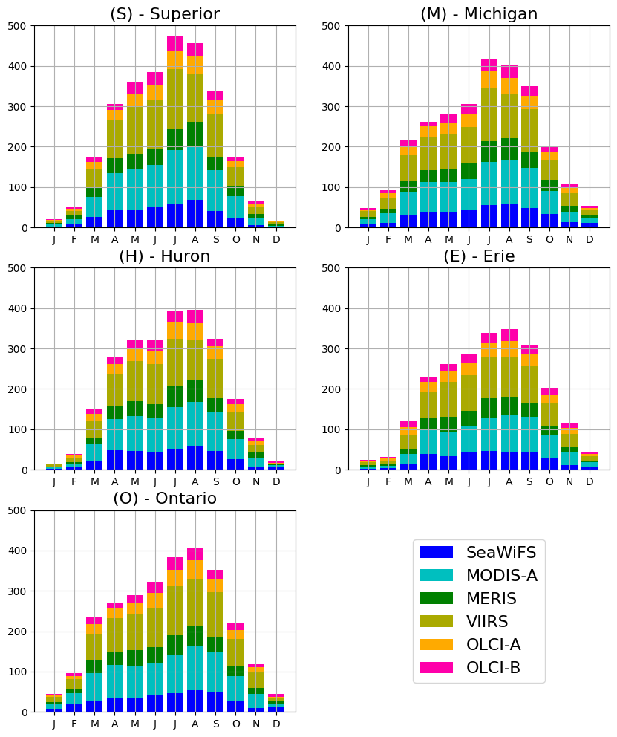
Figure S3. The mean numbers of images collected over the lakes Superior (S), Michigan (M), Huron (H), Erie (E), and Ontario (O) by different satellite sensors used in the OC-CCI dataset during different months.
Supplement 4. Preliminary comparison between in-situ and satellite Chl-a measurements in the Great Lakes.
At the preliminary step preceding this study, we compared in-situ Chl-a measurements in the Great Lakes from Environmental Protection Agency (EPA) Great Lakes Environmental Database System (GLENDA) with VIIRS-SNPP Level-2 Chl-a products using OC3V algorithm (at 1×1 km spatial resolution) from 2018 to 2023. The matchup comparison is shown in the following Figure S4. As mentioned, VIIRS OC3V Chl-a data are underestimated, but more systematically.
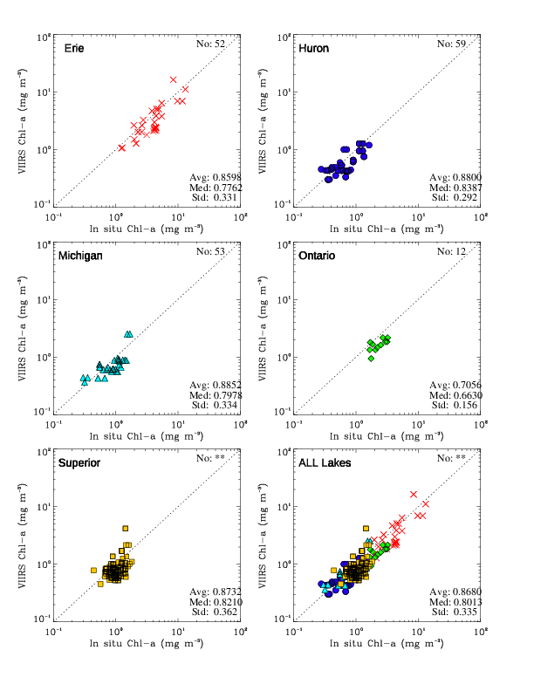
Figure S4. Comparison between in-situ and satellite Chl-a measurements in the Great Lakes.

References
Fichot, C. G., Matsumoto, K., Holt, B., Gierach, M. M., & Tokos, K. S. (2019). Assessing change in the overturning behavior of the Laurentian Great Lakes using remotely sensed lake surface water temperatures. Remote Sens. of Environ., 235, 111427. https://doi.org/https://doi.org/10.1016/j.rse.2019.111427
Garnesson, P., Mangin, A., Fanton d'Andon, O., Demaria, J., & Bretagnon, M. (2019). The CMEMS GlobColour chlorophyll a product based on satellite observation: multi-sensor merging and flagging strategies. Ocean Science, 15(3), 819-830. https://doi.org/10.5194/os-15-819-2019
Gronewold, A. D., Anderson, E. J., Lofgren, B., Blanken, P. D., Wang, J., Smith, J., Hunter, T., Lang, G., Stow, C. A., Beletsky, D., & Bratton, J. (2015). Impacts of extreme 2013–2014 winter conditions on Lake Michigan's fall heat content, surface temperature, and evaporation. Geophysical Res. Letters, 42(9), 3364-3370. https://doi.org/10.1002/2015GL063799
Hammond, M. L., Beaulieu, C., Henson, S. A., & Sahu, S. K. (2018). Assessing the Presence of Discontinuities in the Ocean Color Satellite Record and Their Effects on Chlorophyll Trends and Their Uncertainties. Geophysical Res. Letters, 45(15), 7654-7662. https://doi.org/10.1029/2017GL076928
Karatayev, A., Karatayev, V., Burlakova, L., Mehler, K., Rowe, M., Elgin, A., & Nalepa, T. (2021). Lake morphometry determines Dreissena invasion dynamics. Biological Invasions, 23, 2489–2514. https://doi.org/10.1007/s10530-021-02518-3
Karatayev, A. Y., & Burlakova, L. E. (2022). Dreissena in the Great Lakes: what have we learned in 30 years of invasion. Hydrobiologia. https://doi.org/10.1007/s10750-022-04990-x
Nalepa, T. F., Fanslow, D. L., & Lang, G. A. (2009). Transformation of the offshore benthic community in Lake Michigan: recent shift from the native amphipod Diporeia spp. to the invasive mussel Dreissena rostriformis bugensis. Freshw. Biology, 54(3), 466-479. https://doi.org/10.1111/j.1365-2427.2008.02123.x
Nalepa, T. F., Fanslow, D. L., & Pothoven, S. A. (2010). Recent changes in density, biomass, recruitment, size structure, and nutritional state of Dreissena populations in southern Lake Michigan. J. of Great Lakes Res., 36, 5-19. https://doi.org/10.1016/j.jglr.2010.03.013
Reavie, E. D., Barbiero, R. P., Allinger, L. E., & Warren, G. J. (2014). Phytoplankton trends in the Great Lakes, 2001–2011. J. of Great Lakes Res., 40(3), 618-639. https://doi.org/10.1016/j.jglr.2014.04.013
Strayer, D. L., Adamovich, B. V., Adrian, R., Aldridge, D. C., Balogh, C., Burlakova, L. E., Fried-Petersen, H. B., G.-Tóth, L., Hetherington, A. L., Jones, T. S., Karatayev, A. Y., Madill, J. B., Makarevich, O. A., Marsden, J. E., Martel, A. L., Minchin, D., Nalepa, T. F., Noordhuis, R., Robinson, T. J., . . . Jeschke, J. M. (2019). Long-term population dynamics of dreissenid mussels (Dreissena polymorpha and D. rostriformis): a cross-system analysis. Ecosphere, 10(4), e02701. https://doi.org/10.1002/ecs2.2701
Yu, S., Bai, Y., He, X., Gong, F., & Li, T. (2023). A new merged dataset of global ocean chlorophyll-a concentration for better trend detection [Original Research]. Frontiers in Marine Science, 10. https://doi.org/10.3389/fmars.2023.1051619
Zheng, G., & DiGiacomo, P. M. (2022). A simple water clarity-turbidity index for the Great Lakes. J. of Great Lakes Res., 48(3), 686-694. https://doi.org/10.1016/j.jglr.2022.03.005

