Supplementary Materials

Supplemental Table 1. Dynamic energy budget (DEB) parameters used for model simulations (if not otherwise specified in the manuscript). $δ_{M}$, T_{A}, $\{{\dot{F}}_{m}\}$, κ_{X}, and [${\dot{p}}_{M}]$ were estimated in the current study. Other unestimated parameters are inferred from the AmP Zebra Mussel (AmP Collection, 2024), or from known common values.
Symbol | Description | Value | Units | Reference
$$δ_{M}$$ | Shape coefficient | 0.225 | - | This study (Section 3.2.1)
T_{A} | Arrhenius temperature | 6000 | K | This study (Section 3.2.3)
T_{H} | Upper thermal limit | 303.15 | K | Garton et al. (2014)
T_{AH} | Arrhenius temperature for the rate of decrease at upper boundaries | 80,000 | K | T_{A} * 10
z | Zoom factor | 0.58* | - | AmP Collection (2024)- Zebra Mussel corrected for difference in shape coefficients
$$\{{\dot{F}}_{m}\}$$ | Maximum specific searching rate | 150 | L day⁻¹ cm⁻² | This study (Section 3.2.4)
κ_{X} | Digestion efficiency of food to reserve | 0.09 | - | This study
$$\dot{v}$$ | Energy conductance | 0.02 | cm day⁻¹ | AmP common value
κ | Allocation fraction to soma | 0.99269 | - | AmP Collection (2024)- Zebra Mussel
κ_{R} | Reproduction efficiency | 0.95 | - | AmP Collection (2024)- Zebra Mussel
[${\dot{p}}_{M}]$ | Volumetric-specific maintenance | 154.2** | J day⁻¹ cm⁻³ | This study
{${\dot{p}}_{T}$} | Surface area-specific maintenance | 0 | J day⁻¹ cm⁻² | Exothermic animal
$${\dot{k}}_{j}$$ | Maturity maintenance rate coefficient | 0.002 | 1 day⁻¹ | AmP Collection (2024)- Zebra Mussel
E_{G} | Specific cost for structure | 2349.0525 | J cm⁻³ | AmP Collection (2024)- Zebra Mussel
$$E_{H}^{b}$$ | Maturity at birth | 2.203e-6 | J | AmP Collection (2024)- Zebra Mussel
$$E_{H}^{j}$$ | Maturity at metamorphosis | 8.376e-6 | J | AmP Collection (2024)- Zebra Mussel
$$E_{H}^{p}$$ | Maturity at puberty | 5.868e-1 | J | AmP Collection (2024)- Zebra Mussel
$${\dot{h}}_{a}$$ | Weibull aging acceleration | 1.937e-9 | 1 day⁻² | AmP Collection (2024)- Zebra Mussel
S_{G} | Gompertz stress coefficient | 0.0001 | - | AmP Collection (2024)- Zebra Mussel
*z = 0.58, calculated from Zebra Mussel z (0.8787) multiplied by Zebra Mussel shape coefficient (0.34) and divided by Quagga Mussel shape coefficient (0.225, estimated in this study).
**[${\dot{p}}_{M}]$ = 129.96, calculated based on the values of z, $\dot{v}$, κ, and $[E_{m}]$: $[{\dot{p}}_{M}]$ = κ * $\{{\dot{p}}_{Am}\}$ / z = κ * $[E_{m}]$ * $\dot{v}$ / z
(κ_{p} only needed for calculating nutrient flux).

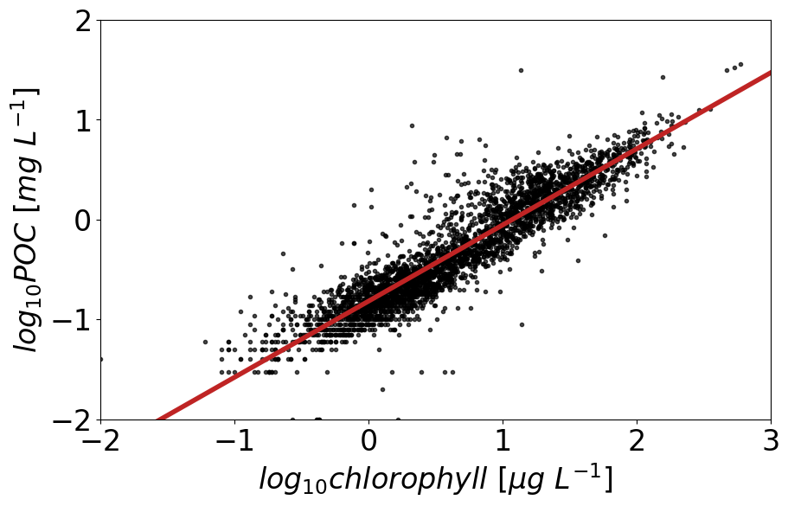
Supplemental Figure 1. Linear regressions between chlorophyll and particulate organic carbon (POC) concentrations. Black points are measurements from Lake Huron’s Saginaw Bay, Lake Erie, and Lake Michigan. Chlorophyll and POC data were collected by the National Atmospheric and Ocean Administration Great Lakes Environmental Research Laboratory as part of a harmful algal bloom monitoring program (NOAA GLERL, 2024) and a long-term research program in Lake Michigan (Pothoven unpub. data). The red line is the ordinary least squares regression. The regression equation is: $log_{10}POC [mg L^{-1}] = (0.76 ± 0.005) ×log_{10}chl [ug L^{-1}]-0.82 ± 0.005$ (regression $r^{2} = 0.85$, numbers of observations = 3444, degrees of freedom = 1).

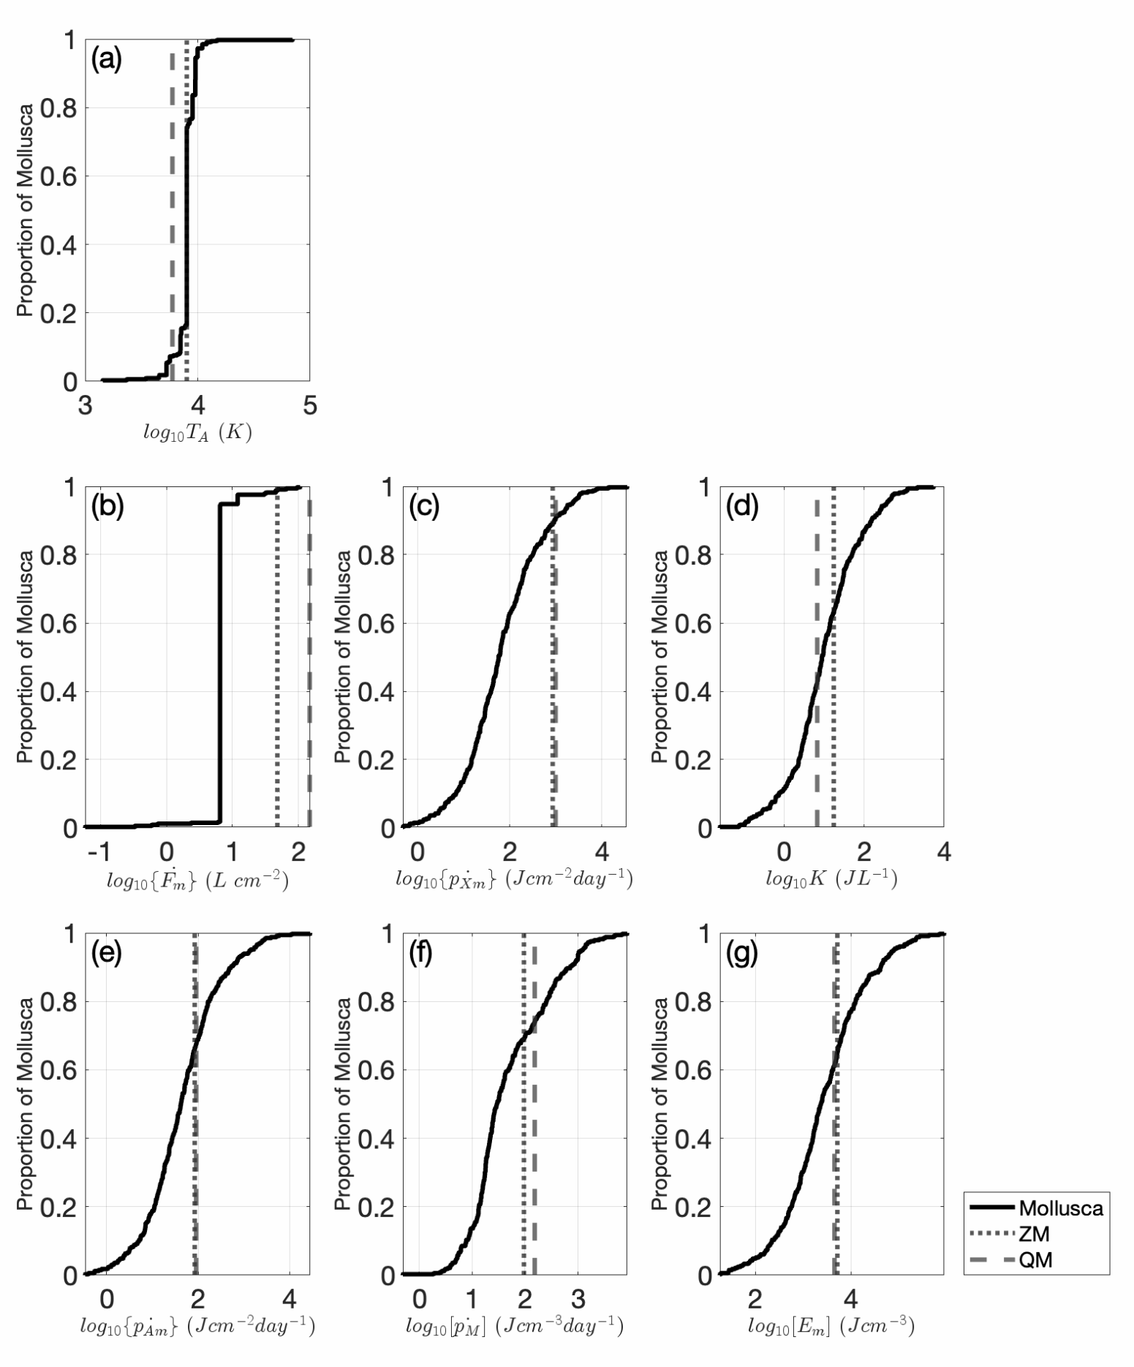
Supplemental Figure 2. Empirical Cumulative Distribution Function plots comparing the parameter estimates of eight dynamic energy budget parameters estimated in the current study to mollusk species obtained from the AmP Collection (2024). Parameters shown are (a) Arrhenius temperature (T_{A}), (b) maximum surface area-specific searching rate ($\{{\dot{F}}_{m}\}$), (c) maximum surface area-specific ingestion rate ($\{{\dot{p}}_{Xm}$}), (d) half saturation coefficient (K), (e) maximum surface area-specific assimilation rate ($\{{\dot{p}}_{Am}$}), (f) volume-specific maintenance ([${\dot{p}}_{M}]$), and (g) energy density ([E_{M}]). Black lines denote the spread of parameter estimates for mollusks in the AmP collection. Vertical lines indicate the log of the parameter estimate in our study for Quagga Mussels (dashed; QM; Dreissena rostriformis bugensis) and parameter estimate from AmP for Zebra Mussels (dotted; ZM; D. polymorpha).

