Supplementary Tables

Supplementary Table S1. PERMANOVA model results for oyster larvae survival between 24 hpf and 15 dpf. Significant model effects are in bold (P < 0.05).

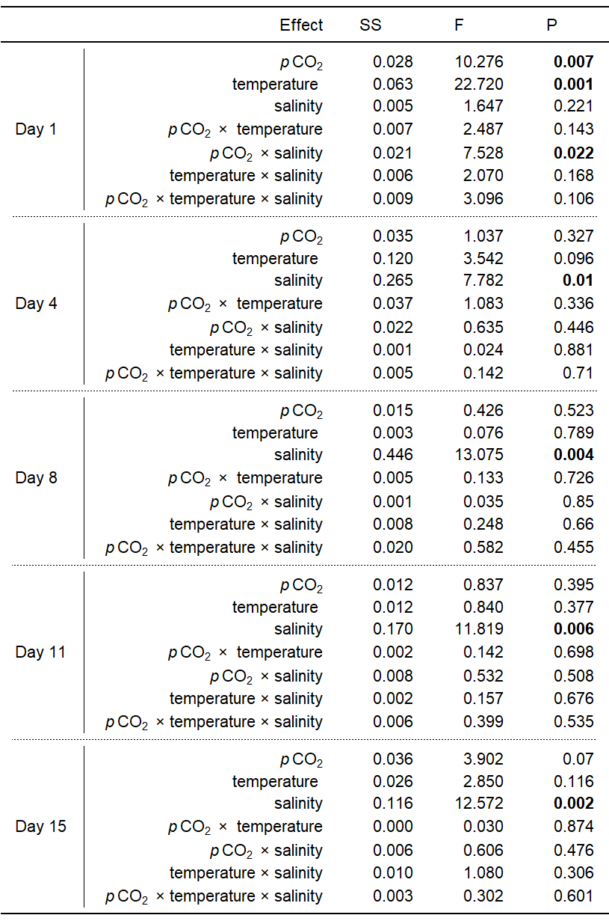

Supplementary Table S2. PERMANOVA model results for oyster larvae lengths between 24 hpf and 15 dpf. Significant model effects are in bold (P < 0.05).

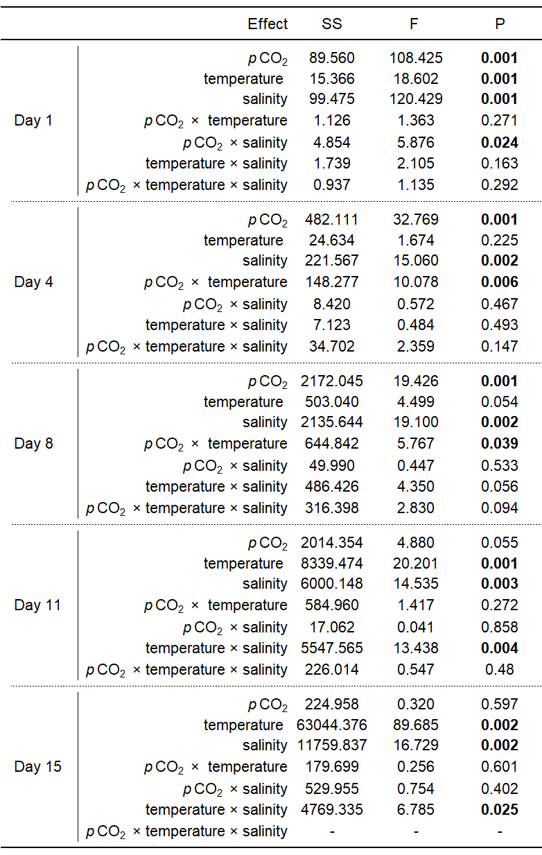

Supplementary Table S3. PERMANOVA model results for respiration rates of 24-hour oyster larvae. A significant model effect is in bold (P < 0.05).
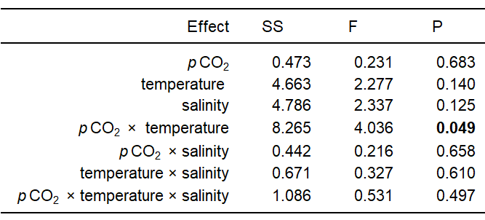

Supplementary Table S4. KEGG enrichment analysis of WGCNA data. Table is sorted alphabetically by module color.

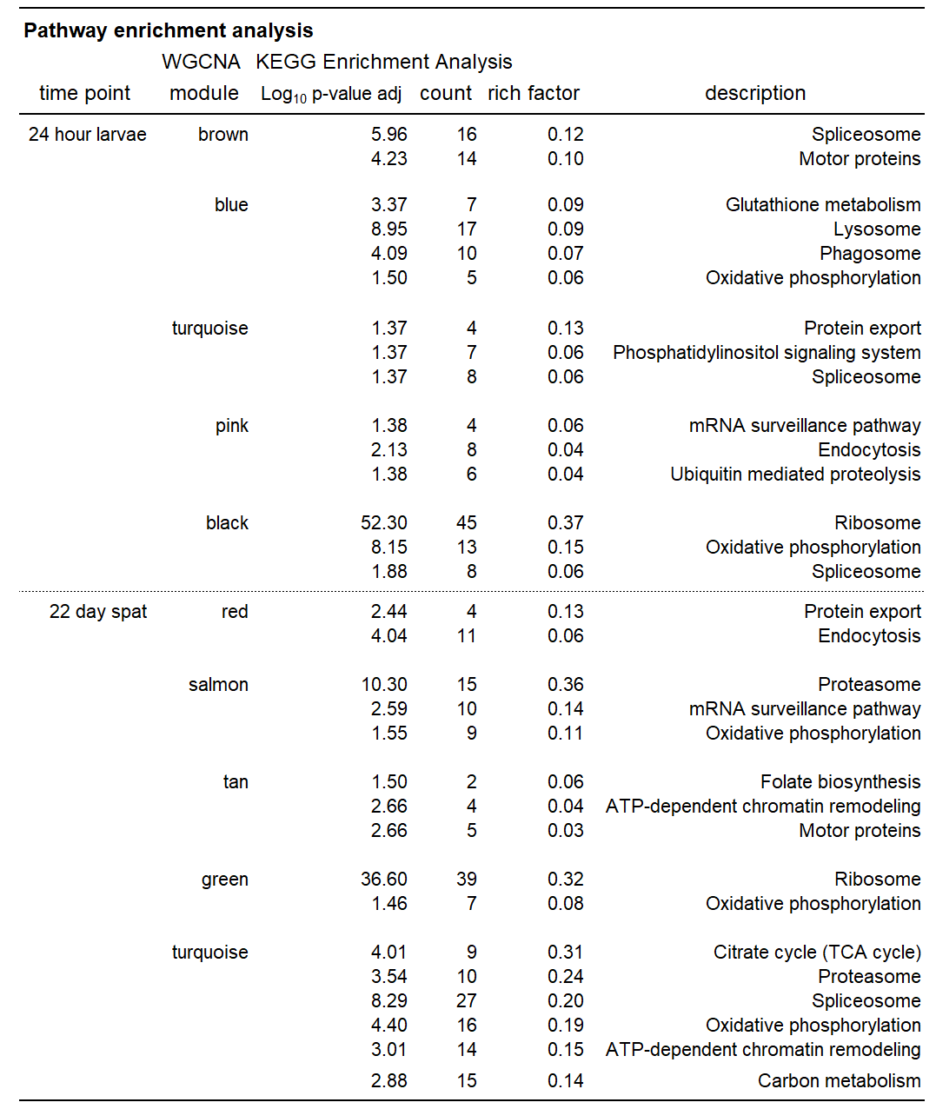

Supplementary Figures
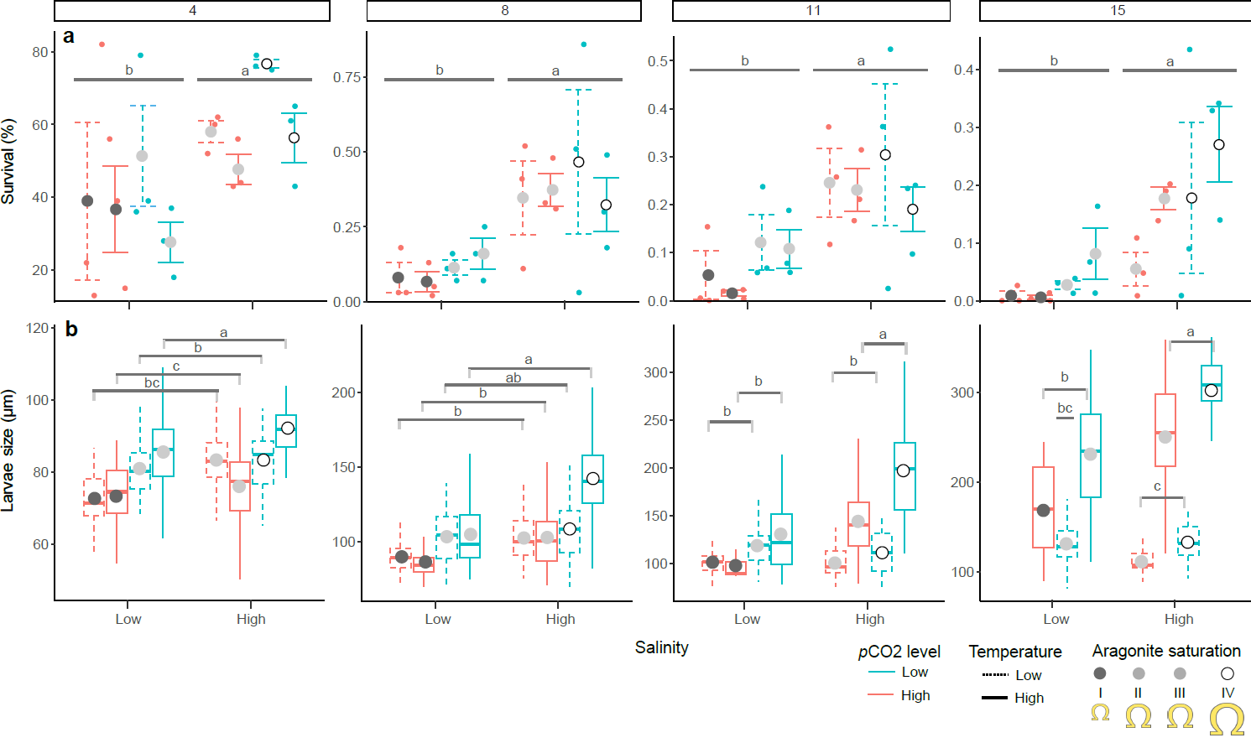

Figure S1. Survival (a) and length (b) of oyster larvae from 4 to 15 dpf; plots are organized by age in days. Survival is shown as mean ± SE (N=3 tanks treatment⁻¹) and boxplots for length data with 25-75th percentile (boxes) and 1.5x interquartile range of all data (whiskers), mean (circles), and median length (horizontal line). Lower case letters represent pairwise differences from significant PERMANONA interaction terms.

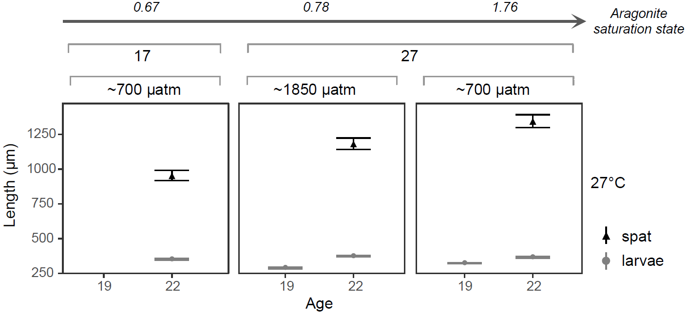

Supplementary Figure S2. Shell length (mean ± SEM) of oyster larvae and spat on days 19 and 22 post fertilization (mean ± SD; N = 20±8 and 45±25 larvae replicate tank⁻¹). No spat or larvae lived to 19 dpf under low temperature and low Ωar.

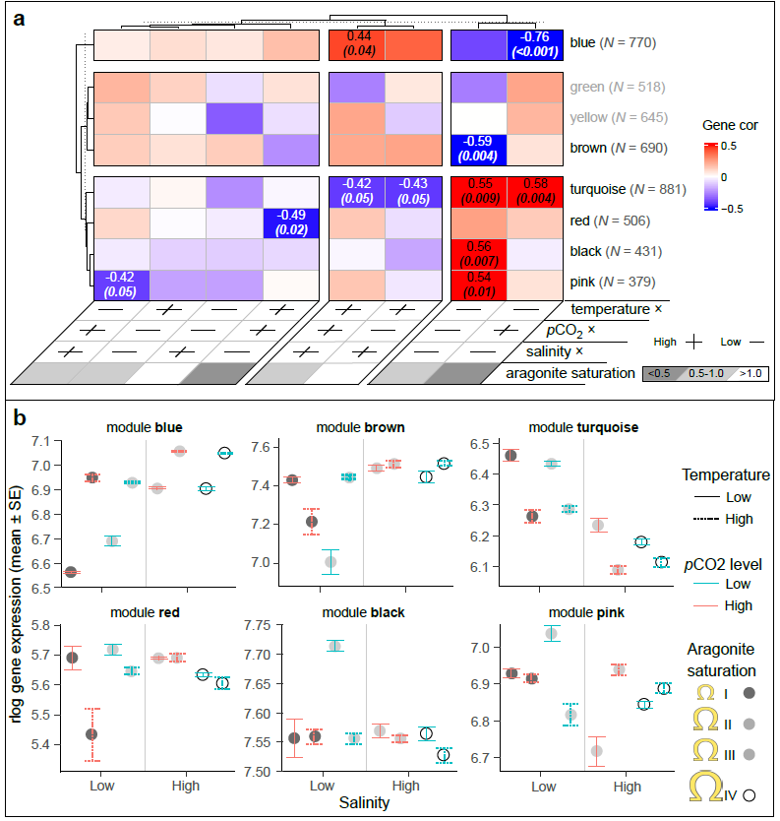

Supplementary Figure S3. WGCNA results for 24-hour larval oyster larvae. Heatmap represents gene-module correlations with temperature, salinity, and pCO₂ treatment with the correlation coefficient and p-value shown for each significant module-treatment relationship (A); a module with an asterisk (i.e. module yellow) contains only main treatment correlation(s). rlog transformed gene expression data (mean ± SEM) is shown for all genes in significant modules (B; review A for N genes module⁻¹), with data ordered by the four major treatment groups based on drivers of reduced aragonite saturation (roman numerals in module ‘blue’).

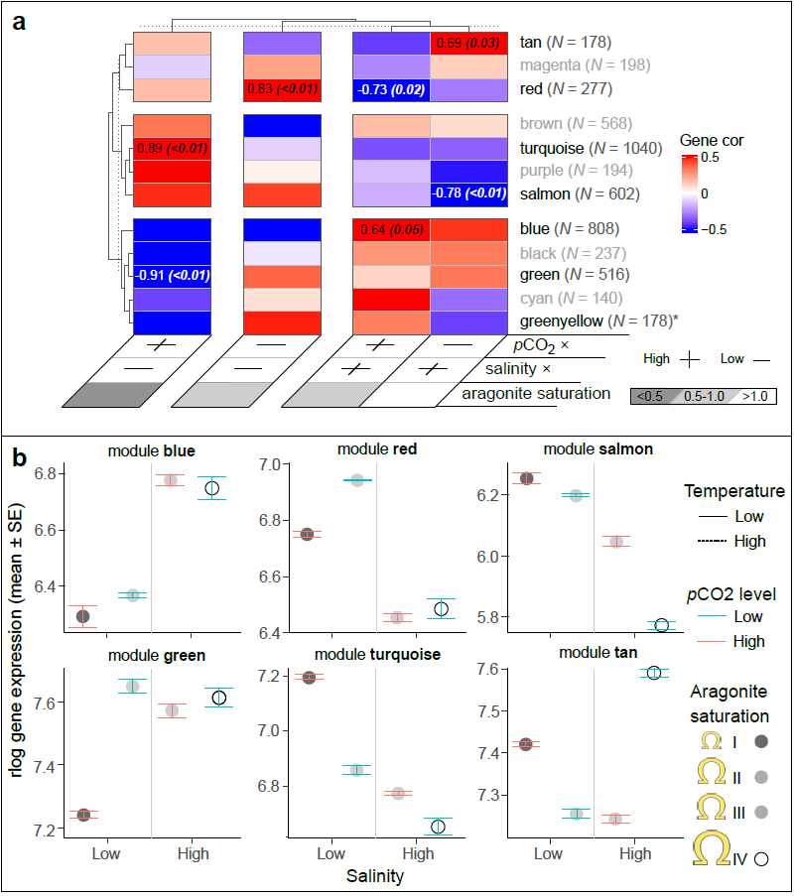

Supplementary Figure S4. WGCNA results for 22-day oyster spat, including only oysters under high temperature. Heatmap represents gene-module correlations with salinity and pCO₂ treatment with the correlation coefficient and p-value shown for each significant module-treatment relationship (A); modules(s) with an asterisk (i.e. module pink) contain only main treatment correlation(s). rlog transformed gene expression data (mean ± SEM) is shown for all genes in significant modules (B; review A for N genes module⁻¹), with data ordered by the four major treatment groups based drivers of reduced aragonite saturation (roman numeral in module ‘blue’).

