Supplementary Online Material

S1.1 Species Groupings Used for Fishery Diversification Indices
We follow Kasperski and Holland (2013) in defining the species groups used to construct fishery diversification indices. The groupings are shown below in table S1. West Coast fisheries are defined coast-wide for diversification indices. Alaska fisheries are divided by region (Alaska state waters, Gulf of Alaska and Bering Sea & Aleutian Island) though not all species groups occur in all regions
Table S1.1: Species groupings for fishery diversification indices.
West Coast | Alaska
Pacific Whiting | Pacific Cod
Dover Sole, Thornyheads, Sablefish | Flatfish
Rockfish and Flatfish | Rockfish
Skate, Dogfish, Sharks | Atka Mackerel
Pacific Halibut | Pollock
California Halibut, Croaker | Other Groundfish
Pink Shrimp | Sablefish
Other Prawns and Shrimp | Pacific Halibut
Crab | Herring
Salmon | Chinook Salmon
Tuna | Sockeye Salmon
Herring | Coho Salmon
Coastal Pelagics | Pink Salmon
Echinoderms | Chum Salmon
Other Shellfish | Other Salmon
Squid | Red King Crab
Other Species | Other King Crab
 | Opilio Crab
 | Other Snow Crab (Bairdi)
 | Other Crab
 | Scallops
 | Other Shellfish
 | Other Species

S2. Analysis of changes in temporal diversification and CV of inter-annual revenue after 2015

We tested for changes in the trend in temporal diversification across three periods using both OLS and vessel fixed effects regressions that controls of compositional effects. In this regression we test for changes in the trend over three period – post 2014 (2015-2022), and two equal-length periods prior to that (1981-1997 and 1998-2014):

(S2.1)

where α_{i} is the vessel fixed effect and D_{p} is dummy variable for the two latter periods (1998-2014 and 2015-2022), p, and trend is as simple time trend variable taking a value of 1 in 1981 and increasing by one each successive year.

The trend in temporal diversification became negative after 2014 for both Alaska and West Coast fleets as indicated by regressions of vessel-level temporal diversification with time trends modeled over three separate period (1981-1997; 1998-2014; and 2015—2022) using both fixed effects and OLS models (Table S2.1). The fixed effects models predict 15% and 18% declines in temporal diversification between 2014 and 2021 for the Alaska and West Coast fleets respectively while the OLS models predict 10% declines in both regions. There is a significant drop in average temporal diversification at the individual level between the 2007-2014 period and the 2015-2022 period as confirmed by paired t-tests and Wilcoxon sign rank tests (Table S2.2).

In their study of diversification of West Coast fishing vessels over the 1990-2015 period, Abbott et al. (2023) found that while fishery diversification tended to decline, temporal diversification increased over that period, and the effect of increasing temporal diversification reducing interannual variation revenue more than offset the effect offset the effect of lower fishery diversification which would tend to increase revenue variation. However, after 2015 the trend in temporal diversification reversed and observed variation in revenue increased relative to the 8-year period prior to 2015. Paired t-tests and Wilcoxon sign rank tests indicate a significant increase in CV of inter-annual revenue at the vessel level between the 2007-2014 period and the 2015-2022 period (Table S2.2)

Table S2.1: Regressions of the trend in temporal diversification indicating trend and intercept shifts for the 1990-2014 period and the 2015-2022 period
Region - Model | Alaska Fixed Effects | Alaska OLS | West Coast Fixed Effects | West Coast OLS
Intercept | 7.367*** | 6.446*** | 10.847*** | 9.186***
1998-2014 Intercept Shift | -0.935*** | -0.236* | -1.237*** | 1.012***
Post 2014 Intercept Shift | 4.817*** | 5.113*** | -1.237*** | 3.204***
Trend | -0.025*** | 0.028*** | -0.001 | 0.113***
1998-2014 Trend Shift | 0.043*** | 0.013** | 0.040** | -0.071***
Post 2014 Trend Shift | -0.124*** | -0.141*** | -0.136*** | -0.157***
Predicted % Change 2014-2021 | -15% | -10% | -18% | -10%

***p < .001.; **p<.01; *p < .05.

Table S2.2: Paired t-tests and Wilcoxon sign tests for changes in average temporal diversification, fishery diversification, the ratio of temporal over fishery diversification, and coefficient of variation of inter-annual revenue for the 2007-2014 vs. 2015-2022 periods.
Fleet | Alaska Fleet | West Coast Fleet | Combined Fleet
Number of matched vessels | 5711 | 4294 | 8245
Paired t-test change in temporal diversification | Decreased*** | Decreased*** | Decreased***
Paired Wilcoxon test change in temporal diversification | Decreased*** | Decreased*** | Decreased***
Paired t-test change in fishery diversification | Decreased*** | Decreased*** | Decreased***
Paired Wilcoxon test change in fishery diversification | Decreased*** | Decreased*** | Decreased***
Paired t-test change in ratio temporal/fishery diversification | Decreased*** | Decreased*** | Decreased***
Paired Wilcoxon change in ratio temporal/fishery diversification | Decreased*** | Decreased*** | Decreased***
Paired t-test change CV of Inter-annual Revenue | Increased*** | Increased*** | Increased***
Paired Wilcoxon change in CV of Inter-annual Revenue | Increased*** | Increased*** | Increased***

***p < .001.; **p<.01; *p < .05.

The decline in average temporal diversification between the 2007-2014 period and the 2016-2022 period is due mainly to the decline in temporal diversification of fishers that had relatively high levels of diversification in the 2008-2014 period. (Figures S2.1 &2.2). The distribution of temporal diversification scores shift left and become more compact as the density of scores with in the 5-15 range falls (Figure S2.1). The QQ plot shows that for Alaska there was decline in the number of vessels with very high scores (over25) as well as the 5-20 range. For the West Coast there was a broader shift in the distribution with the percentile scores at all levels shifting down (Figure S2.2).

Figure S2.1: Kernel density plots of fishery diversification for (a) Alaska and (b) West Coast vessels for the 2008-2014 and 2016-2022 periods.
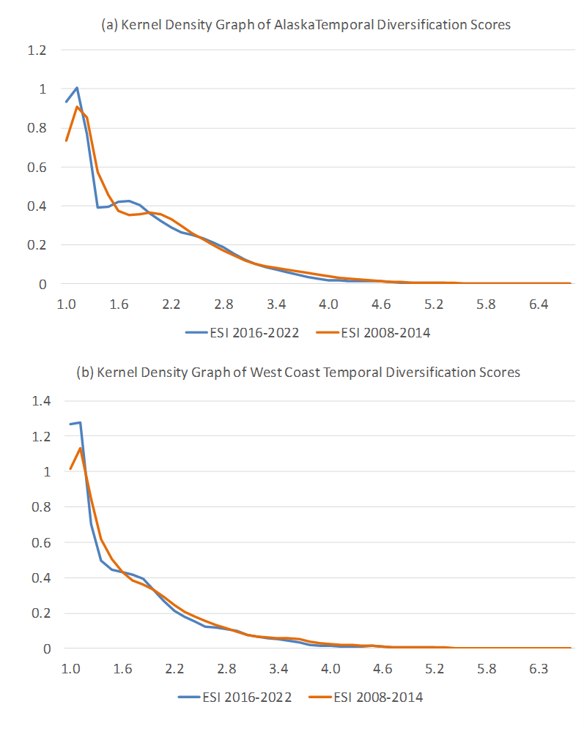
Figure S2.2: Kernel density plots of temporal diversification for (a) Alaska and (b) West Coast vessels for the 2008-2014 and 2016-2022 periods.

Figure S2.3: Quantile-Quantile plots comparing distributions of average vessel temporal diversification for (a) Alaska and (b) West Coast vessels for the 2008-2014 and 2016-2022 periods.
S3. Ratio of Fishery and Temporal Diversification
We can see a shift in the form of diversification occurring at the individual level with individuals shifting to greater temporal diversification relative to fishery diversification. We calculate the ratio of temporal to fishery diversification annually at the individual level and evaluate trends in this metric using a fixed effects model (Figure S3.1). For the Alaska fleet there in an increasing trend in this ratio both in the individual and compositional effects from the 1990s until around 2003. After 2014 the ratio begins to decline for individuals persisting in the fishery though the compositional effect slows the decline. For the West Coast fleet the ratio declines into the late 1990s, increases in the early 2000s,and then declines after 2014 – both individual and compositional effects.
Figure S3.1: Trends in the ratio of temporal diversification to fishery diversification for a) Alaska and (b) West Coast commercial fishing fleets (excluding catcher-processors and vessels with average revenue less than $5,000)

S4. Distribution of revenue
While limited access and particularly catch share programs offered the promise of increased economic efficiency and biological sustainability (Costello et al. 2008, Birkenbach et al. 2017), they also raised concerns about negative social consequences associated with consolidation (Schelle and Muse 1986; Copes 1986). These programs have sometimes impacted communities unequally, favoring those with more advantageous locations, infrastructure, and proximity to markets (Szymkowiak et al. 2019a, 2019b). They may also favor individuals and companies with greater access to capital and have raised concerns that owner-operators would be replaced with corporate entities, changing the culture of the industry and the perhaps the allure of a job where an individual can be their own boss (Olson 2011). In many cases quota was allocated directly to large firms including processors (e.g., Pacific Whiting, and BSAI pollock and crab).
In this appendix we break down trends in revenue per vessels by quartile and explore concentration of revenues among vessels and also among ports. We also show how contributions of different fisheries to total revenues have changed over time. Trends in revenue per vessel (in 2005 dollars) for the combined Alaskan and West Coast fleets between 1981 and 2022 have varied between lower and higher revenue vessels and regions. For the 25th quartile of the Alaska vessels, vessel-level revenue is variable without a clear trend over the last few decades. For the 50th and 75th quartile there were decreases in real annual revenues in the 1990s followed by an increasing (though highly variable) trend. These increases in upper percentiles have caused average revenue to rise in the early 2000s before stabilizing in the most recent decade. (Figure S4.1). For the West Coast fleet there has been an upward trend in real annual revenues for all quartiles.

To evaluate trends in revenue inequality across vessels, we calculate a Gini coefficient which can be written as:

(S4.1)
where y_{i} is vessel revenue and n is the total number of vessels.
Total ex-vessel revenues (adjusted for inflation) for Alaska and the West Coast have not changed dramatically over the last forty years but the distribution of revenues across fisheries has shifted (Figure S4.2), and this has led to shifts in distribution across fishing ports and across subfleets. Trends in inequality of vessel revenue over time measured with a Gini coefficient have differed for the Alaskan and West Coast fleets (Figure S4.3). The Alaskan fleet saw a substantial and fairly steady increases in inequality of vessel revenue from the early 1980s to around 2002 followed by a general decline in the last few decades though inequality still remains higher than in the early 1980s. For the West Coast fleet, vessel revenue inequality has been fairly stable with only a moderate increase between the late 1980s and 2008 and then a small decline thereafter.

Figure S4.1: Trends in vessel revenue for 25th, 50th and 75th percentile vessels in (a) Alaska and (b) West Coast commercial fishing fleets (excluding catcher-processors and vessels with average revenue less than $5,000). Revenues are in 2005 dollars.

Figure S4.2 Total ex-vessel revenues for (a) Alaska and (b) West Coast by fishery

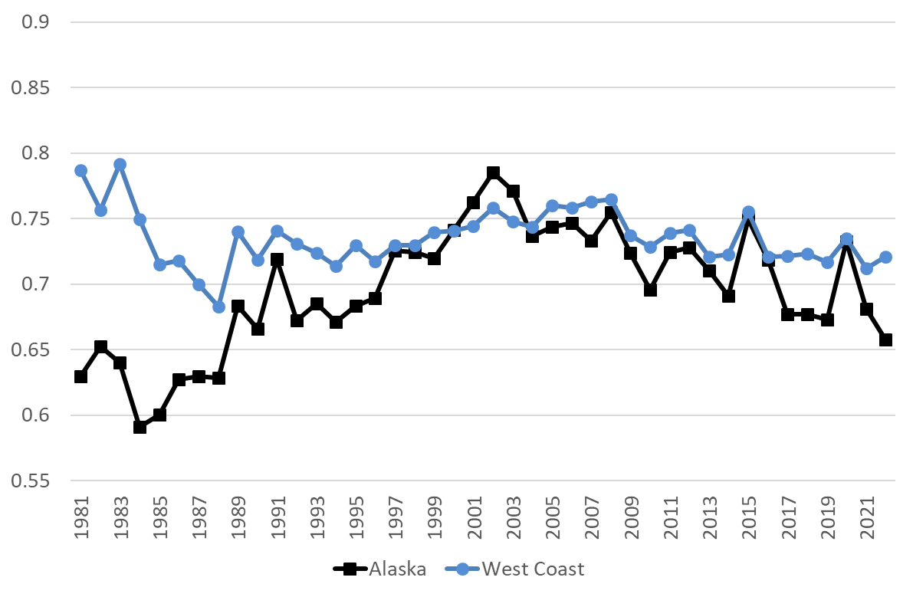
Figure S4.3 Annual Gini coefficient by fleet showing trends in revenue inequality for West Coast (blue line) and Alaska (black line) commercial fishing fleets (excluding catcher-processors and vessels with average revenue less than $5,000)

To measure spatial consolidation in fisheries (an indicator of impacts on communities) we calculate a Theil index following Speir and Lee (2021). Let L_{pt} denote the revenue landed in port p in year t and L_{t} represent the total revenue in the region in year t. The Theil index is calculated for each of the two geographic regions (Alaska and West Coast) each year as:

(S4.2)
(S4.3)
Where λ_{pt} is the share of region-wide ex-vessel revenue for all fisheries combined landed at port p in year t , also known as the local or location quotient, and P is the total number of ports. The absolute values of the Theil index are sensitive to the number of ports. To make the Alaska and West Coast indices comparable, and since we are interested only in the trends over time, we normalize the Theil indices from each region by the mean of the index from that region over the time period evaluated (1985-2022).
Theil indices measuring spatial concentration of revenues across ports show differing trends for Alaska and the West Coast (Figure S4.4). For Alaska there was increase in spatial concentration until the mid-1990s, then some decline to a low in 2010 followed by increases in the last decade. However, spatial concentration was still as low in Alaska during the last decade as it was in the early 1990s. For West Coast ports there was a major reduction in spatial concentration in the 1980s which was due primarily to the decline in tuna revenues in Southern California. Since 1990 spatial concentration has generally been increasing. There has also been a northward shift of revenues with the mean latitude of revenues shifting north over 200 miles (Figure S4.5). Much of this shift occurred in the early 1980s with the decline of the tuna fishery in Southern California. The shift is more pronounced if shellfish (oysters and clams) are included in revenues, but it should be noted that these are primarily aquaculture as opposed to capture fisheries.
Figure S4.4 Theil index showing trends in revenue inequality across West Coast (blue line) and Alaska (black line) ports
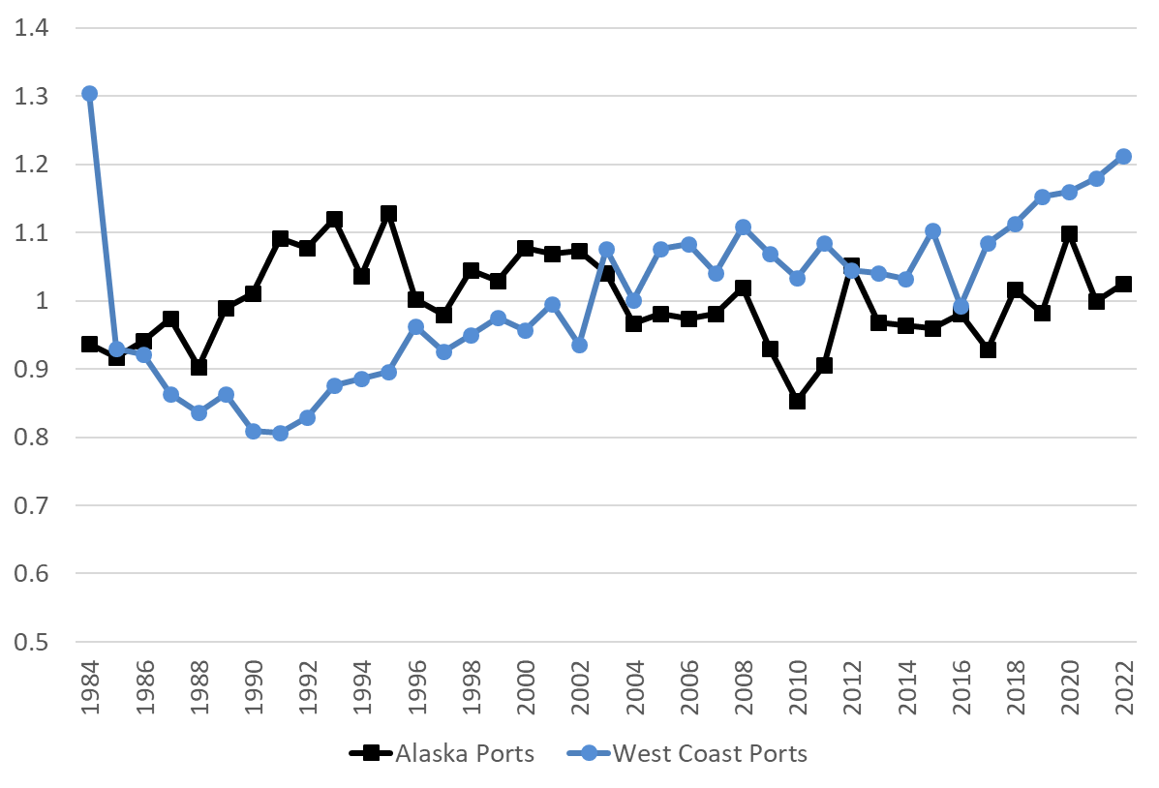

Figure S4.5 Average latitude of commercial fishing revenue for West Coast commercial landings weighted by annual revenue by port

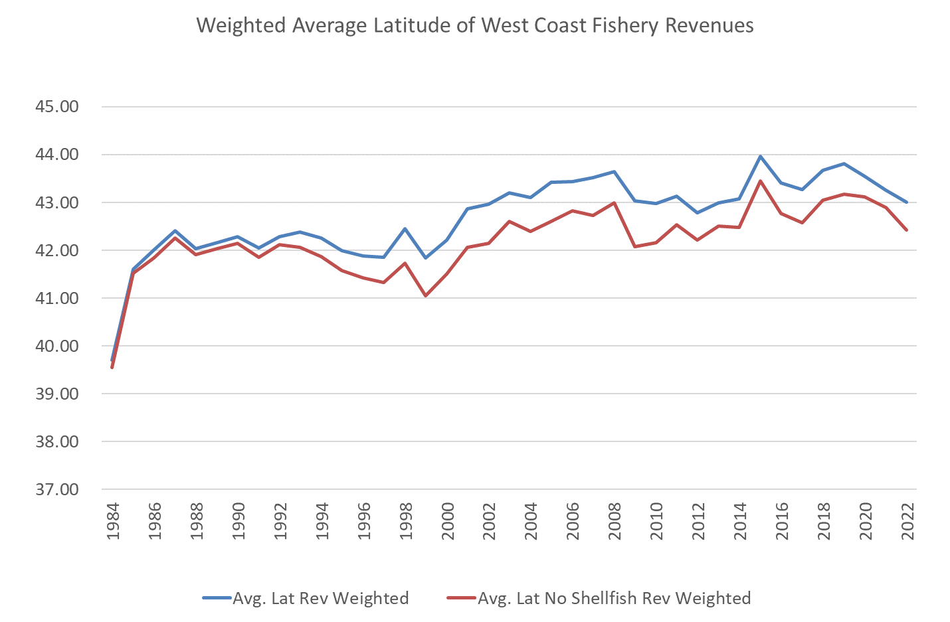

References
Birkenbach, A.M., Kaczan, D.J. and Smith, M.D., 2017. Catch shares slow the race to fish. Nature, 544(7649), pp.223-226.
Copes P 1986. A critical review of the individual quota as a device in fisheries management. Land Econ 62(3):278-291.
Costello, C., Gaines, S. D. & Lynham, J. 2008. Can catch shares prevent fisheries collapse? Science 321, 1678–1681.
Kasperski, S., and Holland, D.S. 2013. Income diversification and risk for fishermen. Proceedings of the National Academy of Science 100(6):2076-2081.
Oken, K.L., Holland, D.S., and Punt A.E. 2021. The effects of population synchrony, life history, and access constraints on benefits from fishing portfolios. Ecological Applications 31(4) e2307.
Olson, J. (2011) Understanding and contextualizing social impacts from the privatization of fisheries: an overview. Ocean Coast Manage 54(5):353-363.
Richerson, K., and Holland, D.S. 2017. Quantifying and predicting responses to a West Coast salmon fishery closure. ICES Journal of Marine Science 74(9):2364-2378.
Schelle, K. and Muse, B., 1986. Efficiency and distributional aspects of Alaska's limited entry program. Fishery access control programs worldwide, pp.317-352.
Speir, C. and Lee, M.Y., 2021. Geographic distribution of commercial fishing landings and port consolidation following ITQ implementation. NOAA Repository.
Szymkowiak, M., Kasperski, S. and Lew, D.K., 2019a. Identifying community risk factors for quota share loss. Ocean & Coastal Management, 178, p.104851.
Szymkowiak, M., Marrinan, S. and Kasperski, S., 2019b. The Pacific Halibut, Hippoglossus stenolepis, and Sablefish, Anoplopoma fimbria, Individual Fishing Quota Program: A Twenty-year Retrospective. Marine Fisheries Review, 82(1-2), pp 1-16.

