*Journal of Geophysical Research: Oceans*

Supporting Information for

**Physical Connectivity Between Mesophotic Areas in the Northern Gulf of Mexico**

**Luisa Lopera1,2, Annalisa Bracco1,2, and Santiago Herrera3**

1 School of Earth and Atmospheric Sciences, Georgia Institute of Technology, Atlanta, GA, United States

2 Program in Ocean Science and Engineering, Georgia Institute of Technology, Atlanta, GA, United States

3 Department of Biological Sciences, Lehigh University, Bethlehem, PA, United States

**Corresponding author:** Luisa Lopera ([lgarcia64@gatech.edu)](mailto:lgarcia64@gatech.edu))

**Introduction**

This supplementary information includes model validation at various levels of the water column, wind climatology, seasonal ensemble connectivity matrices for both simulated years, and a sensitivity analysis performed using random walk schemes in the low-resolution scenarios.

Validation

***Surface currents***

The model does not assimilate any observation but is forced at the boundaries by the HYCOM hindcast, maintaining some similarity in the Loop Current evolution with the observations. This is quantified by the time series of monthly integrated averaged zonal, meridional, and total kinetic energy and its components shown in Supp. Material. Figure S1 and calculated as follows:

$$KE=\frac{1}{2}\left({u^{2}+v}^{2}\right)$$

where u and v are the zonal and meridional velocity components, respectively. Mean and variance (therefore overall patterns and their variability) is captured by CROCO.

**Figure S1:** Monthly integrated kinetic energy at surface and bottom boundary layers for the GoM basin in CROCO and at the surface in the HYCOM analysis to highlight similarities/differences associated with the Loop Current and main eddies. The CROCO simulation does not perform any data assimilation but captures the kinetic energy intensity and overall time variability found in the HYCOM hindcast.

The Loop Current as simulated by CROCO displays a tendency for detaching Loop Eddies slightly more often than observed. This is a common occurrence in ocean model affecting also HYCOM (see e.g., Liu, Falasca, et al., 2021), but the hindcast can correct at later times when altimeter data indicate otherwise. As a result, the CROCO Loop Current tend to detach eddies about 2-3 week earlier than observed. Figure S2 illustrates typical differences between CROCO output and Jason satellite data (Lillibridge & US DOC/NOAA/NESDIS > Office of Satellite Data Processing and Distribution, 2019) focusing on January 2015 and July 2015. Overall, the representation of the mean currents and of the Loop Current northward propagation is well captured (see also Sun et al., 2022). CROCO data was interpolated to match the resolution of the Jason satellite (~25 km).

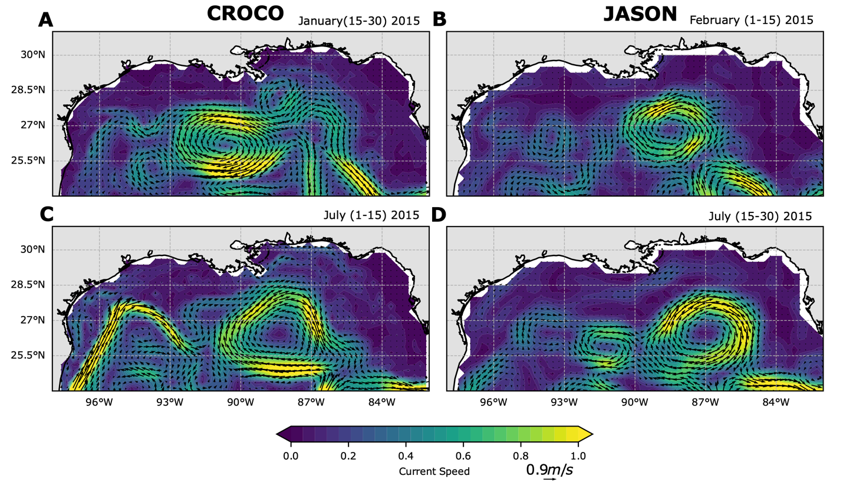

**Figure S2:** Surface currents from CROCO output during January 2015 (top) and July 2015 (bottom) interpolated to 25 km. Jason satellite data (B and D) are shown with a two-weeks lag compared to CROCO.

***Near bottom time series***

For the goal of this work, it is important to validate near bottom currents at depths relevant to the mesophotic corals. Over the period simulated, measurements of near bottom velocities at those depths are not abundant. We found multiple nearby sites to the west and one site to the east of the Mississippi Fan that satisfy our criteria. Figures S3 and S4 compare CROCO and in-situ data time series of near-bottom velocities (Kuehl, 2021) near 27.44°N, 96.47°W (one site picked based on its depth range among the few available), and 27.76°N, 90.52°W, respectively. Despite the absence of any data assimilation, CROCO represents well, in a statistical sense, average and standard deviation of observed currents, as also shown for previous configurations (Cardona et al., 2016). To our knowledge, no direct measurements of submesoscale circulations in the bottom boundary layer are available for the region. Indirectly, however, modeling work has shown that in the Gulf of Mexico they are key to explain the vertical mixing observed during the Deepwater Horizon oil spill and a subsequent deep release experiment (Bracco et al., 2018), the genetic connectivity of deeper coral species(Liu, Bracco, & Sitar, 2021; Liu, Bracco, Quattrini, et al., 2021), the measured sinking of particulate organic carbon from the surface to deeper layers (Liu et al., 2018) and vertical exchanges in frontal areas (Qu et al., 2022).

Figure S3 presents time series of near-bottom velocity (zonal and meridional components) near 27.44°N, 96.47°W during June 2016, comparing in-situ measurements and CROCO model output. The in-situ data were resampled at 30-minute intervals.

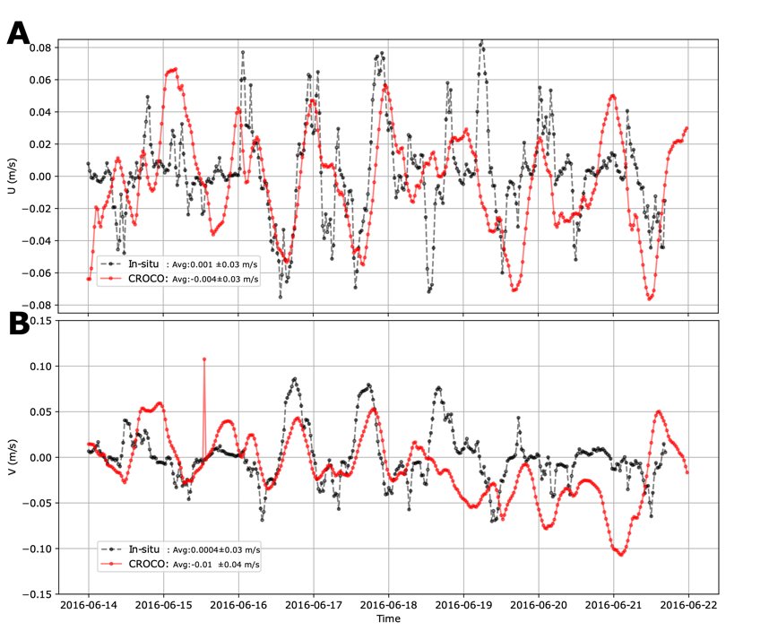

**Figure S3:** Near-bottom zonal (A) and meridional (B) velocities near 27.44°N - 96.47°W for: In-situ data and CROCO simulations.

Figure S4 shows time series of near-bottom velocity (zonal and meridional components) near 27.76°N, 90.52°W during April-May 2015, comparing in-situ measurements and CROCO model output. The in-situ data were resampled at 30-minute intervals.

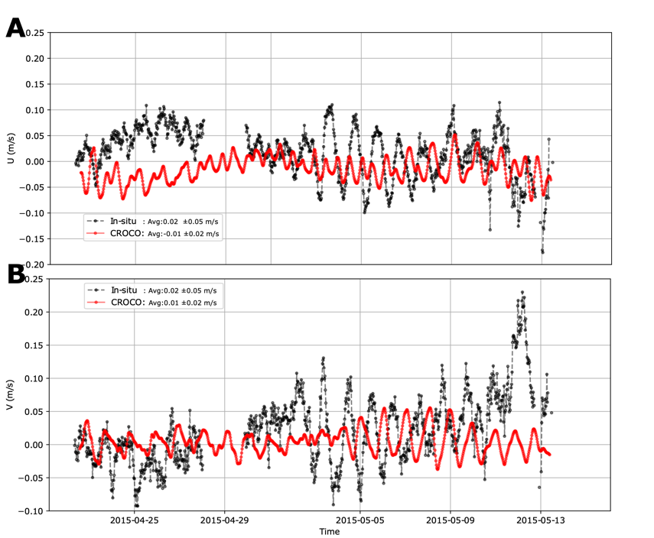

**Figure S4:** Near-bottom zonal (A) and meridional (B) velocities near 27.76°N - 90.52°W for: In-situ data and CROCO simulations.

***Temperature and salinity validation along the water column***

Output temperature data in the upper 200 m of the water column was compared with in-situ measurements from the World Ocean Database (WOD) (Boyer et al., 2016). The WOD provides a multi-year average. Figure S5 shows average temperature profiles during summer (JA) and winter (DJ) seasons in the FGBNMS surroundings.

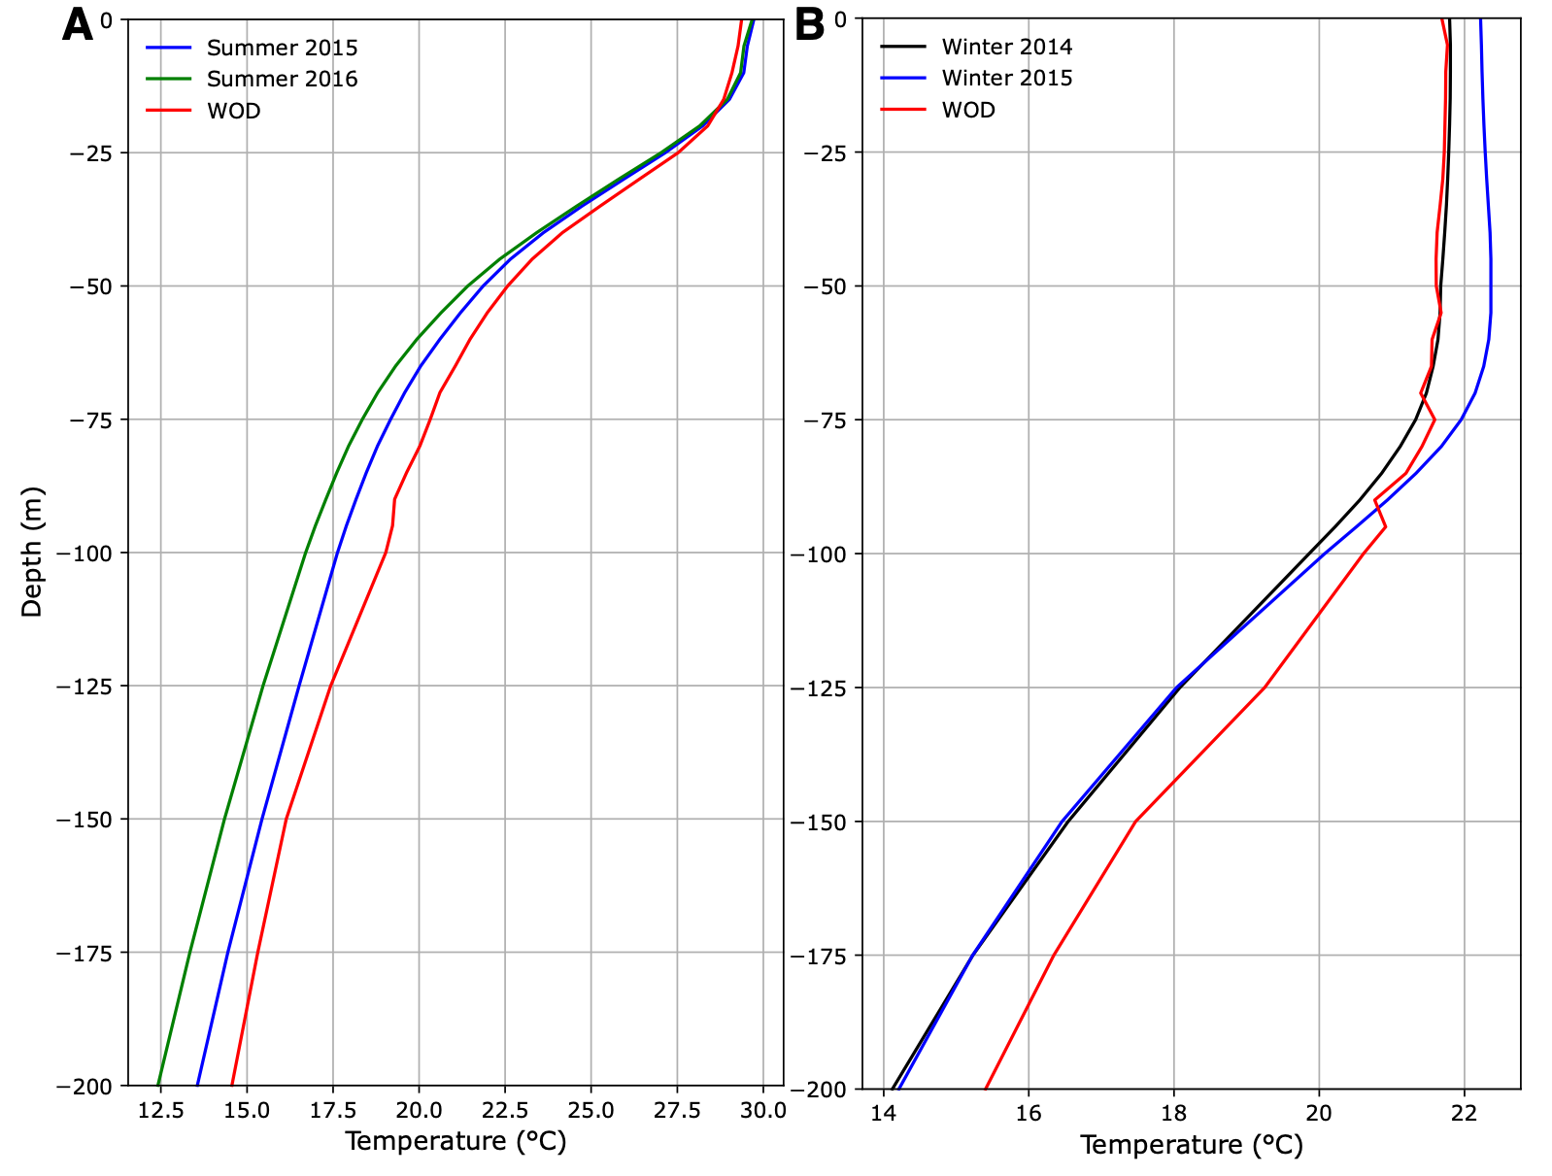

**Figure S5:** Average temperature profiles in the upper 200 m comparing CROCO output and WOD in-situ data in the FGBNMS surroundings. (A) Temperature profiles for July and August 2015 and 2016. (B) Temperature profiles for December and January 2014 and 2015.

***Inertial oscillations***

Particles were also deployed near the ocean surface on the eastern side of the Mississippi River Mouth, over the Alabama and Mississippi continental shelf during Summer 2015, to validate how the model represents tidal motions. In this area, the Grand LAgrangian Deployment (GLAD) project took place during Summer 2012 (Poje et al., 2014). Figure S6 shows the 20 days trajectories for some particles together with power spectra associated with their zonal Lagrangian velocities. The spectra calculated using GLAD drifters are shown by Beron-Vera & LaCasce (2016). Our model is able to fully capture the effect of inertial oscillations seen as anticyclonic loops. Similarly, the power spectrum of the particle zonal velocities shows a significant peak at the local inertial period (~ 1 day).

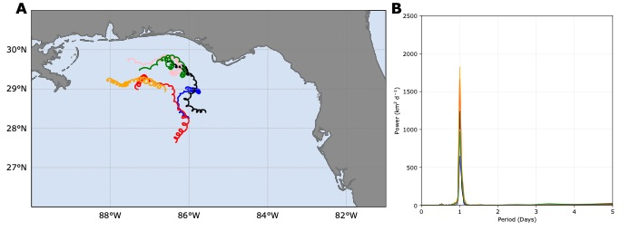

**Figure S6:** (A) Anticyclonic loops identified in summer 2015. (B) Power spectrum of associated zonal velocities for trajectories shown in (A).

Wind Variability

The characteristic wind rose for November 2014, is shown in Figure S7.

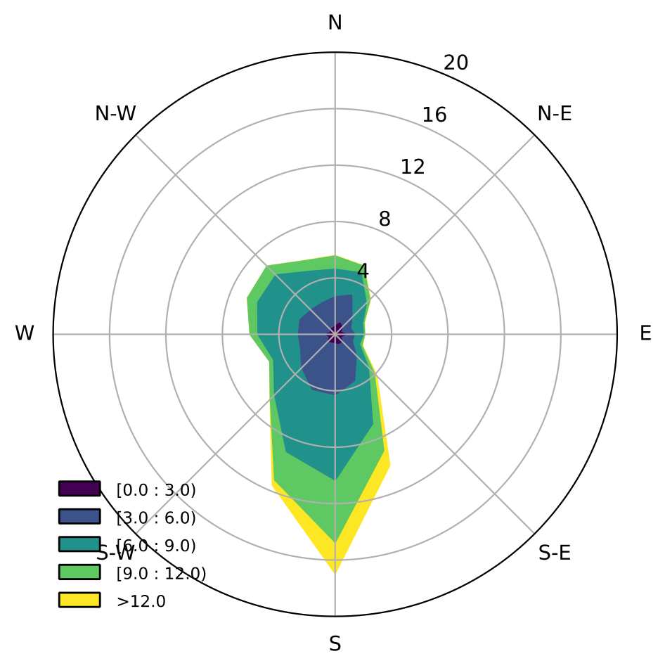

**Figure S7:** Wind rose (m/s) variability for the northern GoMx (North of 27.5N) during November 2014.

Figure S8 displays the corresponding averaged zonal (A) and meridional (B) surface ocean currents near the areas of the FGBNMS and the Pinnacles Trend in the CROCO simulations. Despite the prevailing southward winds during November 2014, variability in the wind intensity and direction induces high standard deviations in the current field, particularly evident in the zonal velocities near FGBNMS.

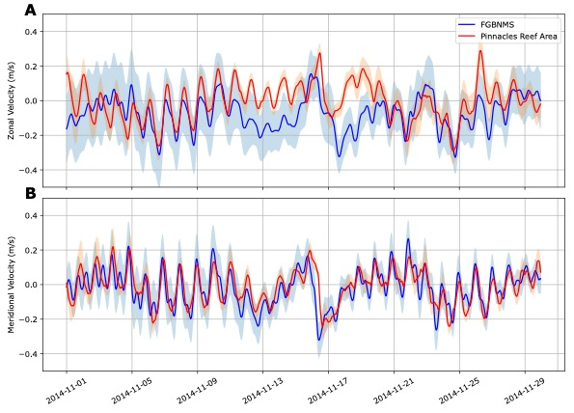

**Figure S8:** Mean and standard deviations of (A) zonal and (B) meridional surface currents near FGBNMS and Pinnacles Reef Area during November 2014.

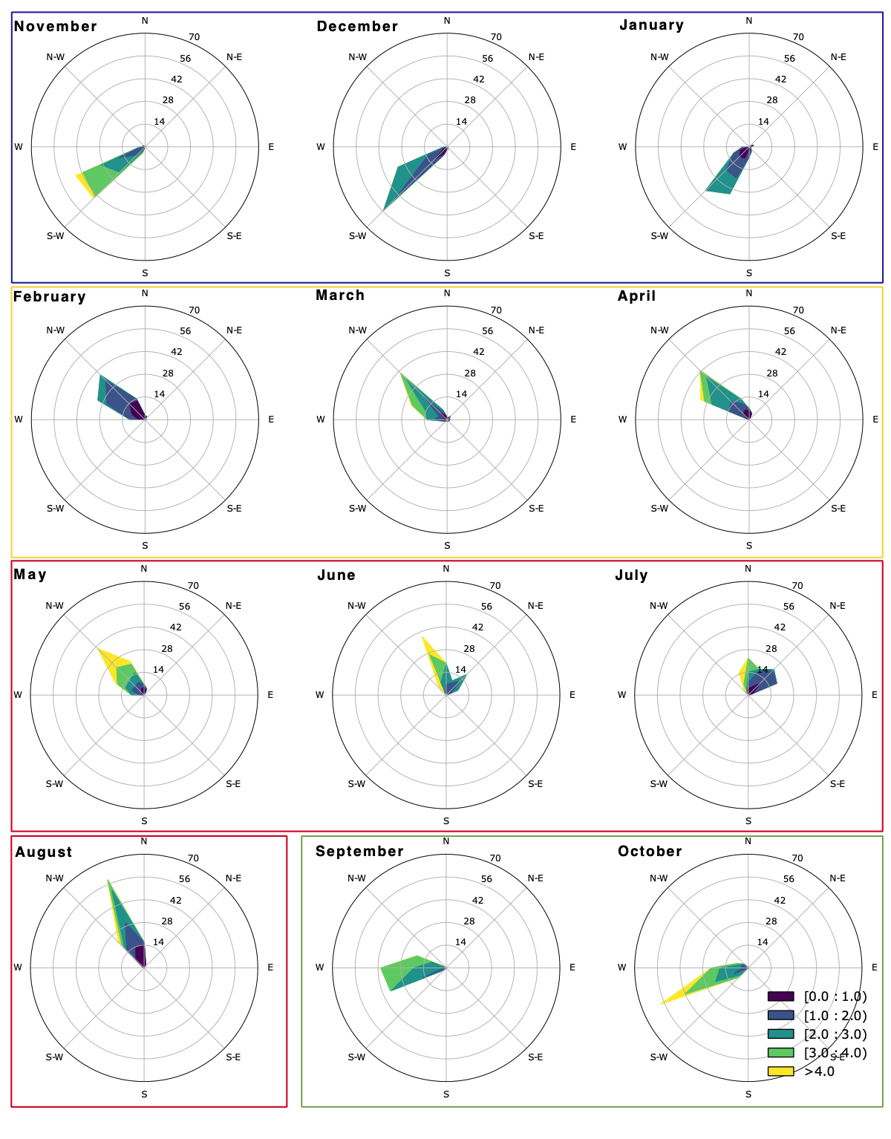

**Figure S9:** Monthly average wind roses calculated from 2013 to 2022 north of 27.5°N using NAVGEM daily data from 2013 to 2022 for the area north of 27.5°N.

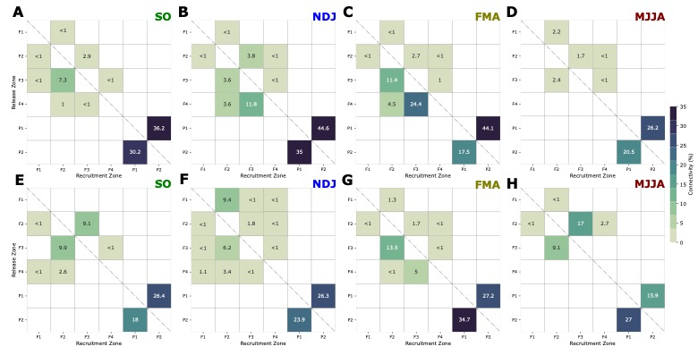

**Figure S10:** Ensemble seasonal connectivity matrices for the first (top panel) and second (bottom panel) year of simulations.

Random walk sensitivity

A sensitivity analysis was performed to evaluate if a random walk scheme could aid in replacing the impact of submesoscale circulations in the connectivity metrics when averaged fields are used to advect the particles during January and July 2015. In those sensitivity simulations, the horizontal dispersion module follows Peliz et al. (2007) while the vertical diffusivity coefficient was set to *Kz* = 10-3 m2/s based on the analysis in Liu, Bracco, & Sitar (2021) (see their Figure 13). Particles were deployed within the polygons shown in Figure 1 on the 1st and 2nd of each month and were tracked for 30 days. Figure S11 presents the ensemble connectivity matrices for January and July 2015, comparing the 24 h, and 24 h + Avg scenarios with and without the random walk scheme.

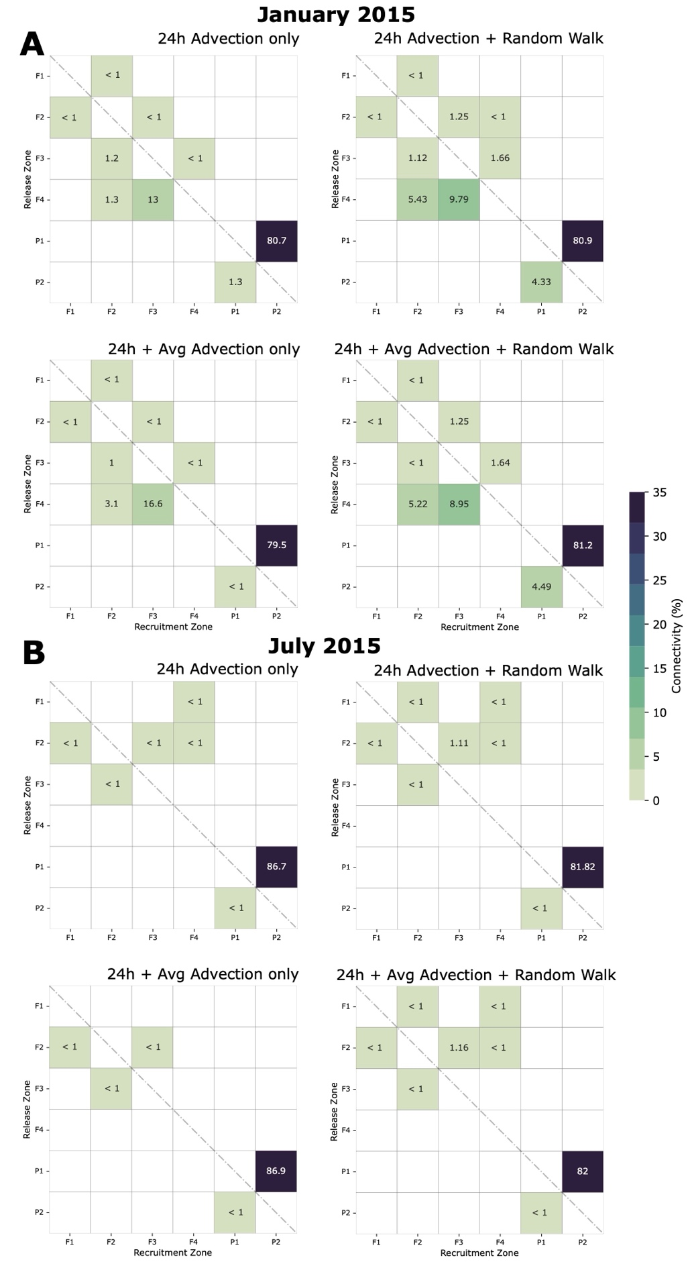

**Figure S11:** Ensemble connectivity matrices for (A) January and (B) July 2015, comparing purely advective simulations in low-frequency scenarios to simulations incorporating random walk scheme.

**Table S1:** Average percentages of particles received (sink) and contributed (source) by each zone during the two years of simulation. The percentages were calculated based on the total number of released particles.

|  |  |  |
| --- | --- | --- |
|  | Sink (%) | Source (%) |
| F1 | 0.05 | 1.7 |
| F2 | 2.0 | 7.0 |
| F3 | 1.9 | 8.0 |
| F4 | 0.2 | 7.1 |
| P1 | 3.9 | 31.0 |
| P2 | 4.7 | 25.0 |

**Table S2:** Onshore and off-shore transport (%) in FGBNMS during January and July 2015.

|  |  |  |  |  |  |  |  |
| --- | --- | --- | --- | --- | --- | --- | --- |
| **FGBNMS** | | | | | | | |
| **Onshore (%)** | | **Offshore (%)** | | **Onshore (%)** | | **Offshore (%)** | |
| **January** | | | | **July** | | | |
| **30min** | | **30min** | | **30min** | | **30min** | |
| 39 | | 61 | | 83 | | 17 | |
| **6h** | | **6h** | | **6h** | | **6h** | |
| 36 | | 64 | | 74 | | 26 | |
| **12h** | **12h+Avg** | **12h** | **12h+Avg** | **12h** | **12h+Avg** | **12h** | **12h+Avg** |
| 34 | 32 | 66 | 68 | 71 | 72 | 29 | 28 |
| **24h** | **24h+Avg** | **24h** | **24h+Avg** | **24h** | **24h+Avg** | **24h** | **24h+Avg** |
| 28 | 25 | 72 | 75 | 66 | 67 | 34 | 33 |

**Table S3:** Onshore and offshore transport (%) in Pinnacles Reef area during January and July 2015.

|  |  |  |  |  |  |  |  |
| --- | --- | --- | --- | --- | --- | --- | --- |
| **Pinnacles** | | | | | | | |
| **Onshore (%)** | | **Offshore (%)** | | **Onshore (%)** | | **Offshore (%)** | |
| **January** | | | | **July** | | | |
| **30min** | | **30min** | | **30min** | | **30min** | |
| 55 | | 45 | | 89 | | 11 | |
| **6h** | | **6h** | | **6h** | | **6h** | |
| 51 | | 49 | | 66 | | 34 | |
| **12h** | **12h+Avg** | **12h** | **12h+Avg** | **12h** | **12h+Avg** | **12h** | **12h+Avg** |
| 48 | 29 | 52 | 71 | 36 | 5 | 65 | 95 |
| **24h** | **24h+Avg** | **24h** | **24h+Avg** | **24h** | **24h+Avg** | **24h** | **24h+Avg** |
| 42 | 18 | 58 | 82 | 35 | 23 | 65 | 77 |

**References**

Boyer, T. P., Antonov, J. I., Baranova, O. K., Coleman, C., García, H. E., Grodsky, A., Johnson, D. R., Locarnini, R. A., Mishonov, A. V, O’Brien, T. D., Paver, C. R., Reagan, J. R., Seidov, D., Smolyar, I. V, & Zweng, M. M. (2016). *NCEI Standard Product: World Ocean Database (WOD)*.

Bracco, A., Choi, J., Kurian, J., & Chang, P. (2018). Vertical and horizontal resolution dependency in the model representation of tracer dispersion along the continental slope in the northern Gulf of Mexico. *Ocean Modelling*, *122*, 13–25. https://doi.org/10.1016/j.ocemod.2017.12.008

Cardona, Y., Ruiz-Ramos, D. V., Baums, I. B., & Bracco, A. (2016). Potential connectivity of coldwater black coral communities in the northern Gulf of Mexico. *PLoS ONE*, *11*(5). https://doi.org/10.1371/journal.pone.0156257

Kuehl, J. (2021). Bottom boundary layer velocity measurements at the Texas shelf and shelf-break, 2016-05-17 to 2016-06-21. In *Gulf of Mexico Research Initiative Information and Data Cooperative (GRIIDC), Harte Research Institute, Texas A&M University–Corpus Christi*.

Lillibridge, J., & US DOC/NOAA/NESDIS  > Office of Satellite Data Processing and Distribution. (2019). *Jason-3 Level-2 Operational, Interim and Final Geophysical Data Records (X-GDR), 2016 to present (NCEI Accession 0122595)*. NOAA National Centers for Environmental Information.

Liu, G., Bracco, A., & Passow, U. (2018). The influence of mesoscale and submesoscale circulation on sinking particles in the. *ELEMENTA Science of the Anthropocene*, *6*(36). https://doi.org/10.1525/elementa.292/483030/292-5107-3-pb.pdf

Liu, G., Bracco, A., Quattrini, A. M., & Herrera, S. (2021). Kilometer-Scale Larval Dispersal Processes Predict Metapopulation Connectivity Pathways for Paramuricea biscaya in the Northern Gulf of Mexico. *Frontiers in Marine Science*, *8*. https://doi.org/10.3389/fmars.2021.790927

Liu, G., Bracco, A., & Sitar, A. (2021). Submesoscale Mixing Across the Mixed Layer in the Gulf of Mexico. *Frontiers in Marine Science*, *8*. https://doi.org/10.3389/fmars.2021.615066

Liu, Guangpeng., Falasca, Fabrizio., & Bracco, Annalisa. (2021). Dynamical Characterization of the Loop Current Attractor. In *Geophysical Research Letters* (Vol. 48, Issue 24). John Wiley and Sons Inc. https://doi.org/10.1029/2021GL096731

Peliz, A., Marchesiello, P., Dubert, J., Marta-Almeida, M., Roy, C., & Queiroga, H. (2007). A study of crab larvae dispersal on the Western Iberian Shelf: Physical processes. *Journal of Marine Systems*, *68*(1–2), 215–236. https://doi.org/10.1016/j.jmarsys.2006.11.007

Qu, L., Thomas, L. N., Wienkers, A. F., Hetland, R. D., Kobashi, D., Taylor, J. R., Hsu, F. H. W., MacKinnon, J. A., Shearman, R. K., & Nash, J. D. (2022). Rapid vertical exchange at fronts in the Northern Gulf of Mexico. *Nature Communications*, *13*(1). https://doi.org/10.1038/s41467-022-33251-7

Sun, D., Bracco, A., & Liu, G. (2022). The Role of Freshwater Forcing on Surface Predictability in the Gulf of Mexico. *Journal of Geophysical Research: Oceans*, *127*(5). https://doi.org/10.1029/2021JC018098