Supplementary Figures

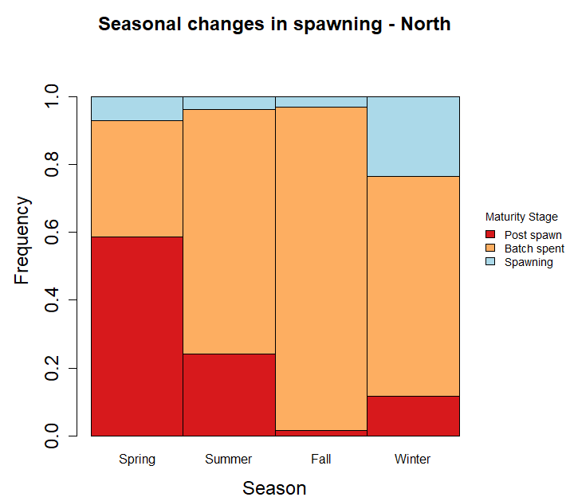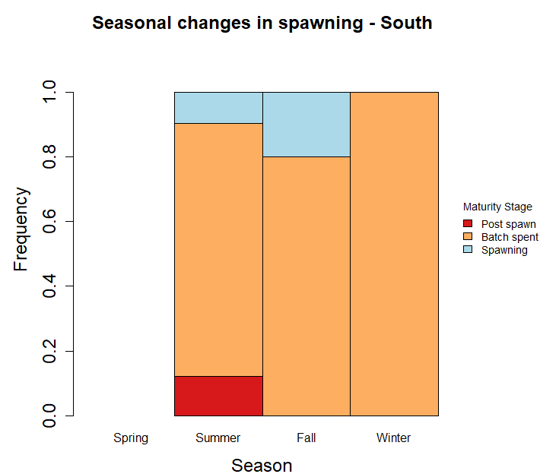

*n*=17

*n*=63

*n*=520

*n*=380

*n*=1

*n*=41

*n*=20

Supplementary Fig 1. The seasonal change in spawning (blue), batch spent (orange), and post spawning (red) females between north (top panel) and south (bottom panel) of Pt. Conception, CA. Frequency of samples encountered is shown on the y-axis and season on the x-axis. Number of samples (*n*) that were in this maturity stages are provided at the top of each bar.

Supplementary Images

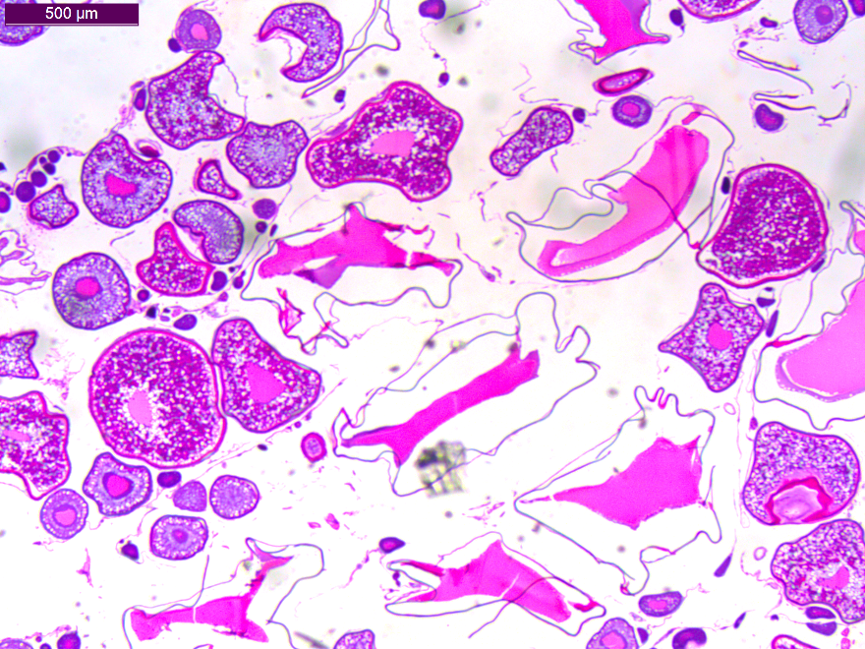

Stage 9

Stage 5

Stage 4.1

Supplementary Image 1. Multiple modes of egg development in Pacific hake, *Merluccius productus,* ovary. Oocyte developmental stage 9, 5, and 4.1 indicating multiple batches of eggs to be discreetly spawned.

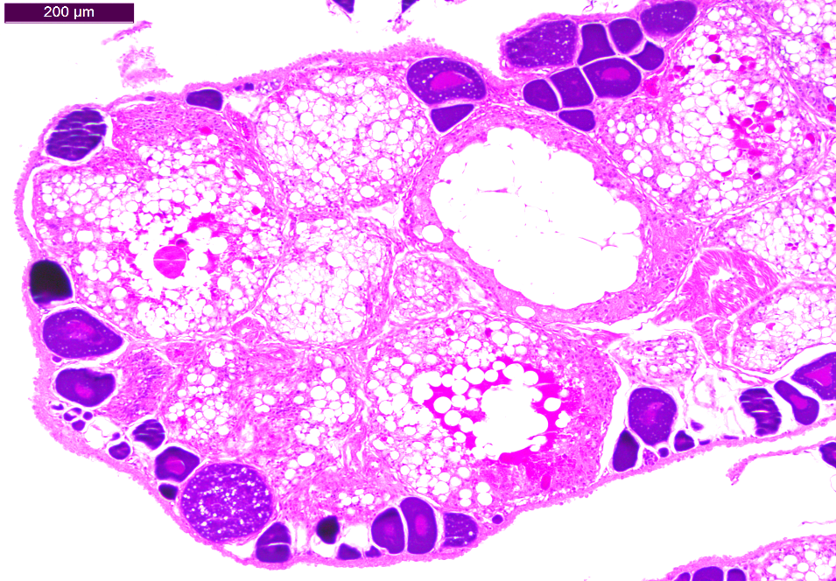

Hydrated atresia

Supplementary Image 2. Mass atresia of hydrated oocytes present in the ovary of a Pacific hake (left). Mass atresia and deterioration of the ovary in a 14 year old female, possibly indicating advancement toward senescence (right).

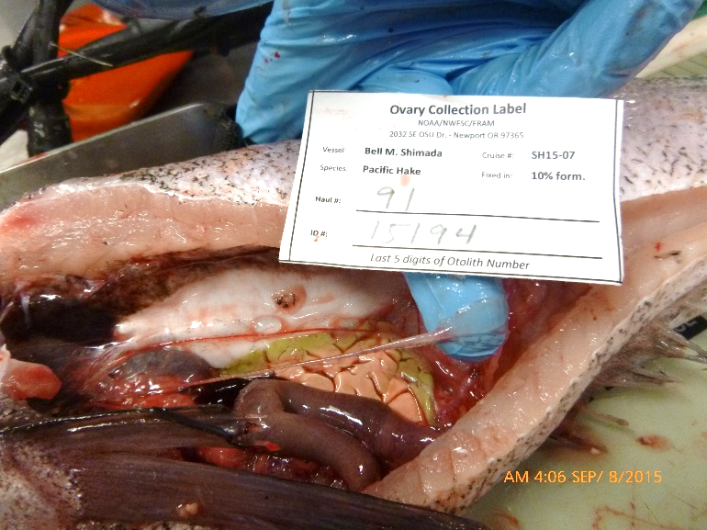

Supplementary Image 3. Complete deterioration of the ovary from a 16 year old female (left). Macroscopic image of the same ovary taken at time of collection (right). Ovary is shrunken and transparent.