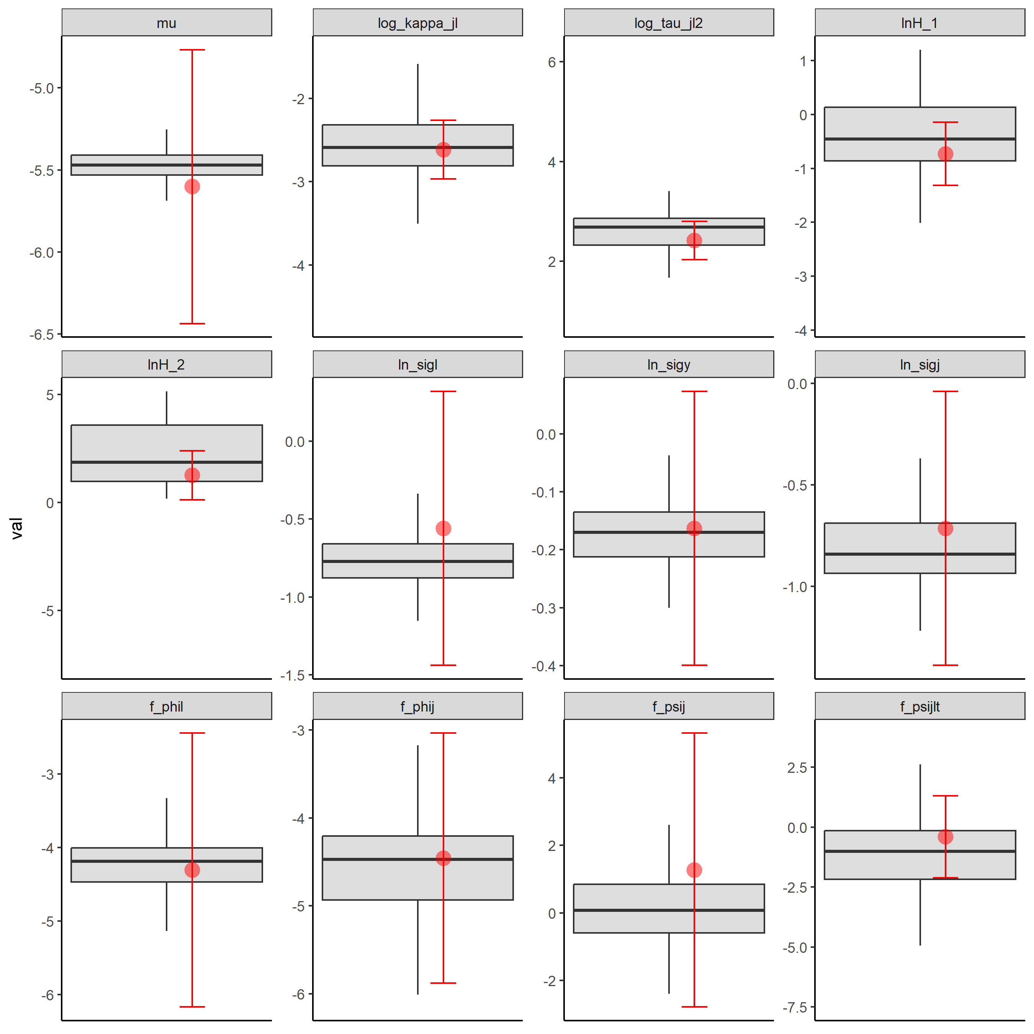

Supplemental Figure S1. Distributions for the parameter estimates for the simulated data from the operating model (box and whisker plots where whiskers represented the 90% quantiles) and the maximum likelihood estimates and 90% C.I. for the parameters (red dots and lines) for Model 1 (Table 1).

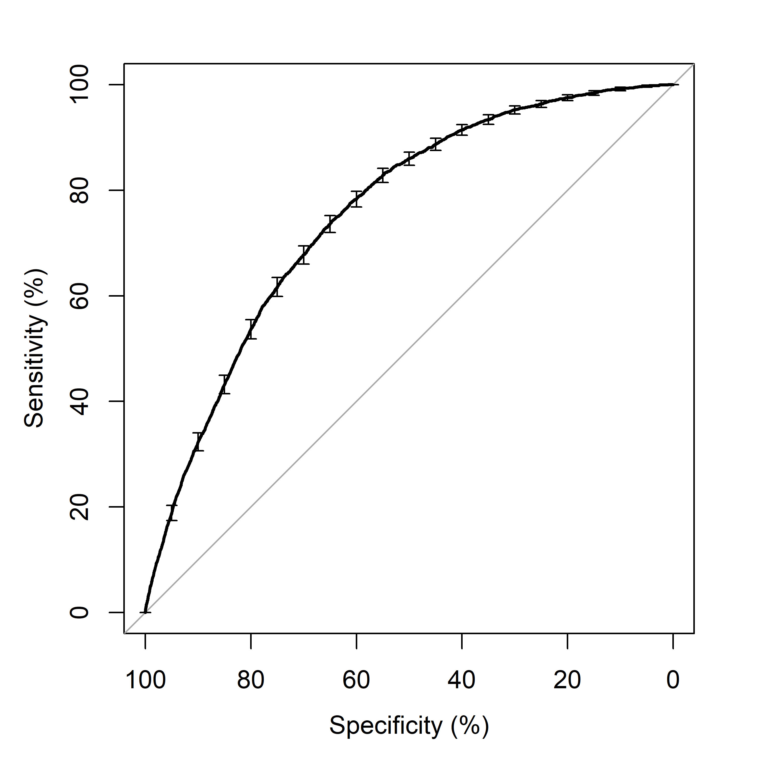

Supplemental Figure S2. Area under the curve plot (AUC = 0.7556) for the receiver operator curve (ROC).

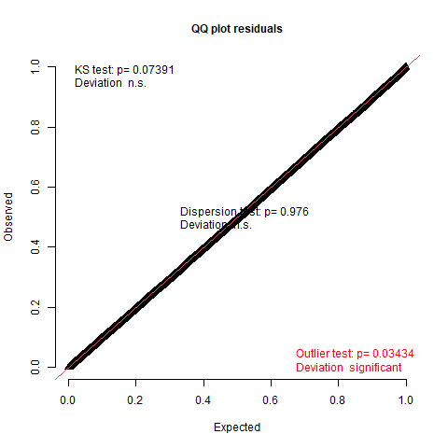

Supplemental Figure S3. QQplot showing little deviation from the expected distribution for the simulated SAR values for the model with the lowest AIC value. Additionally, using the DHARMa package in R, the p-values show no significant deviations based on the K-S test and dispersion test.

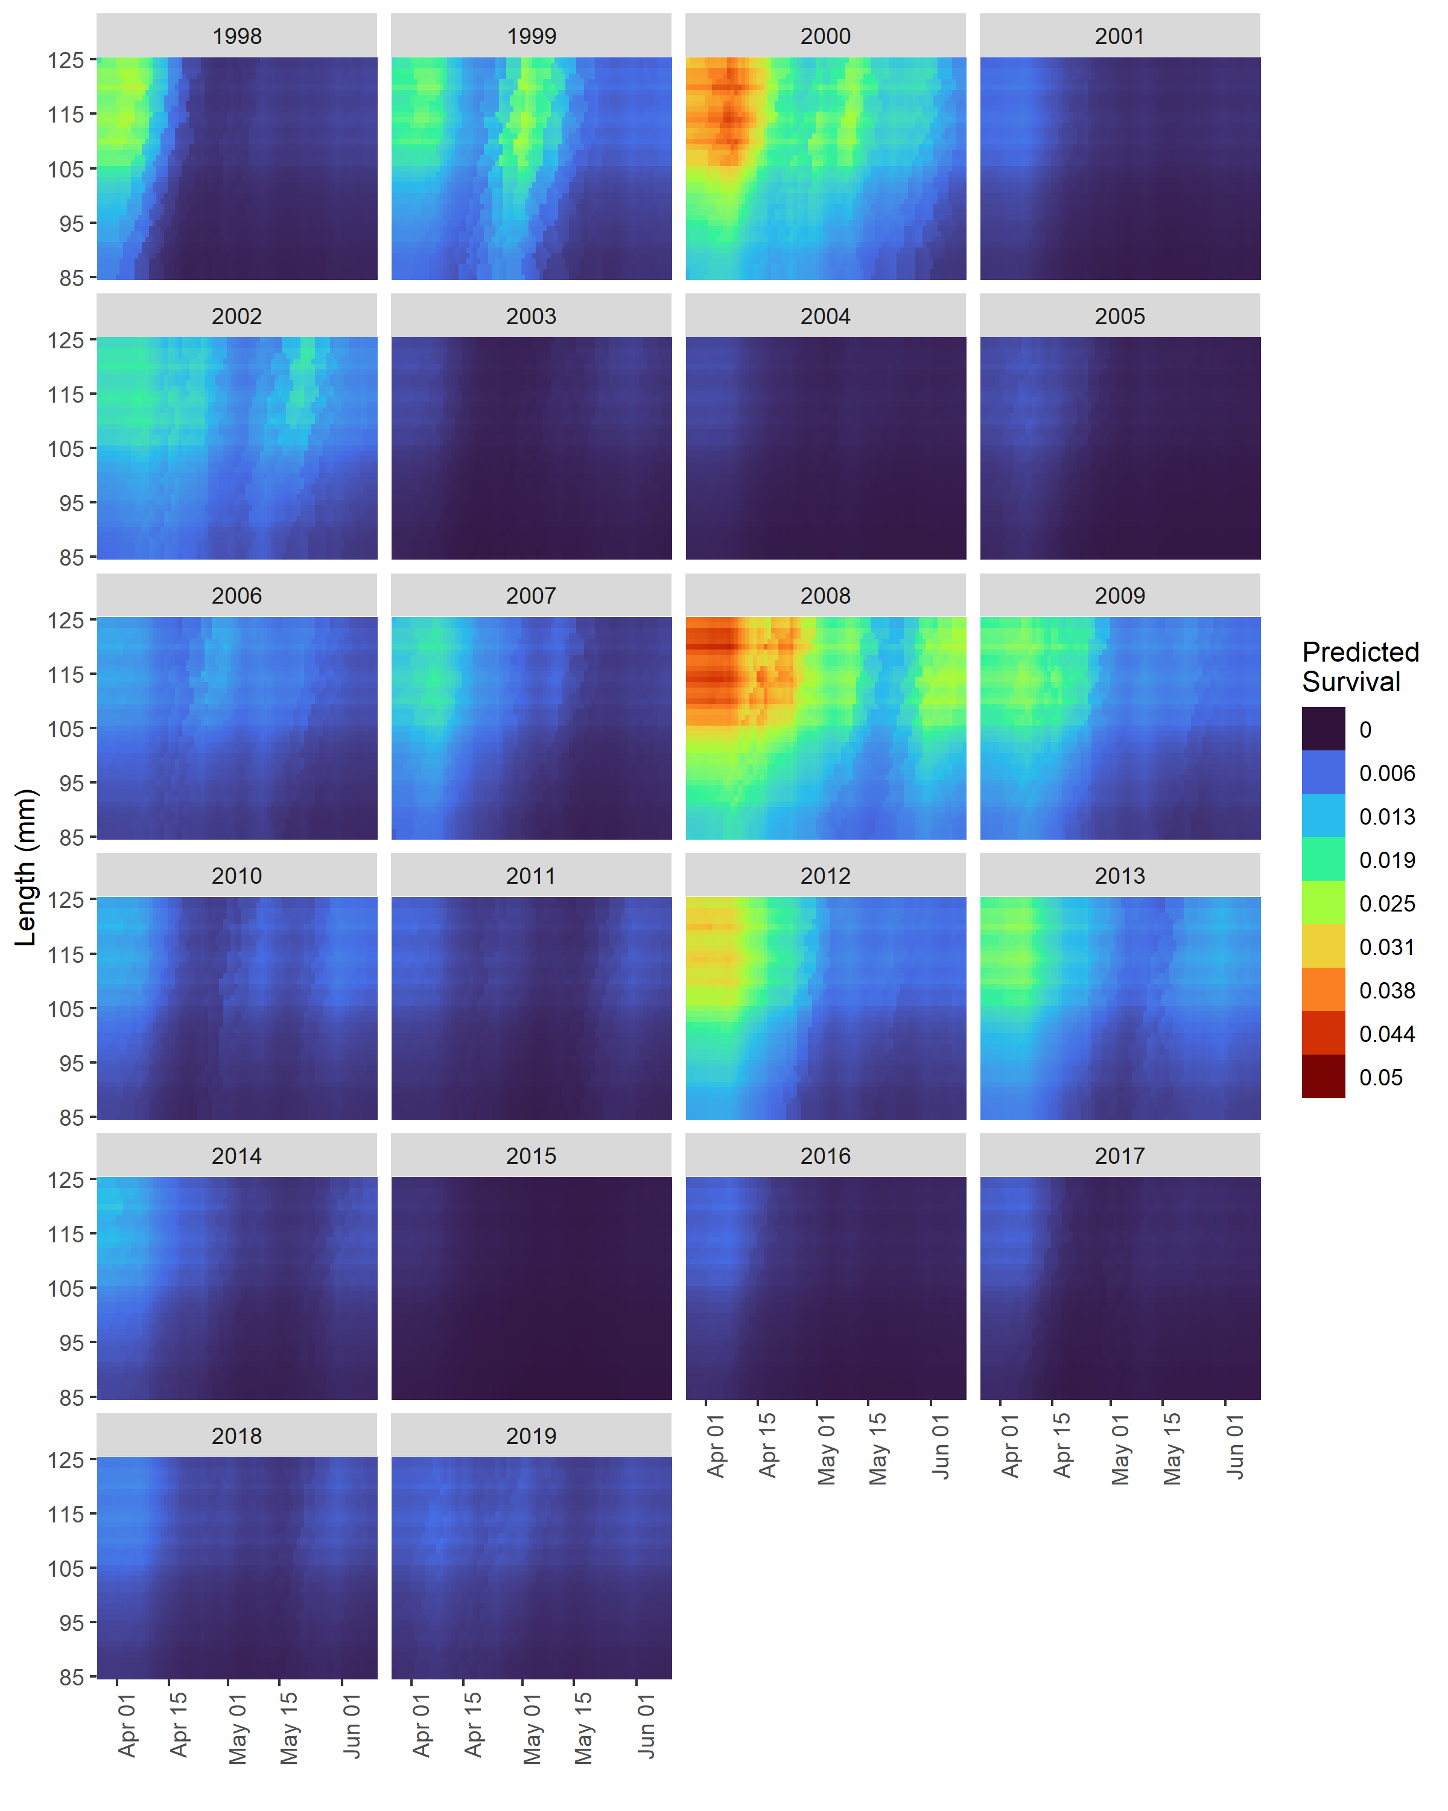

Supplemental Figure S4. Estimated survival for spring/summer Chinook salmon tagged at Lower Granite Dam as smolts between 1998 and 2019 using the model with the lowest AIC value in Table 1.

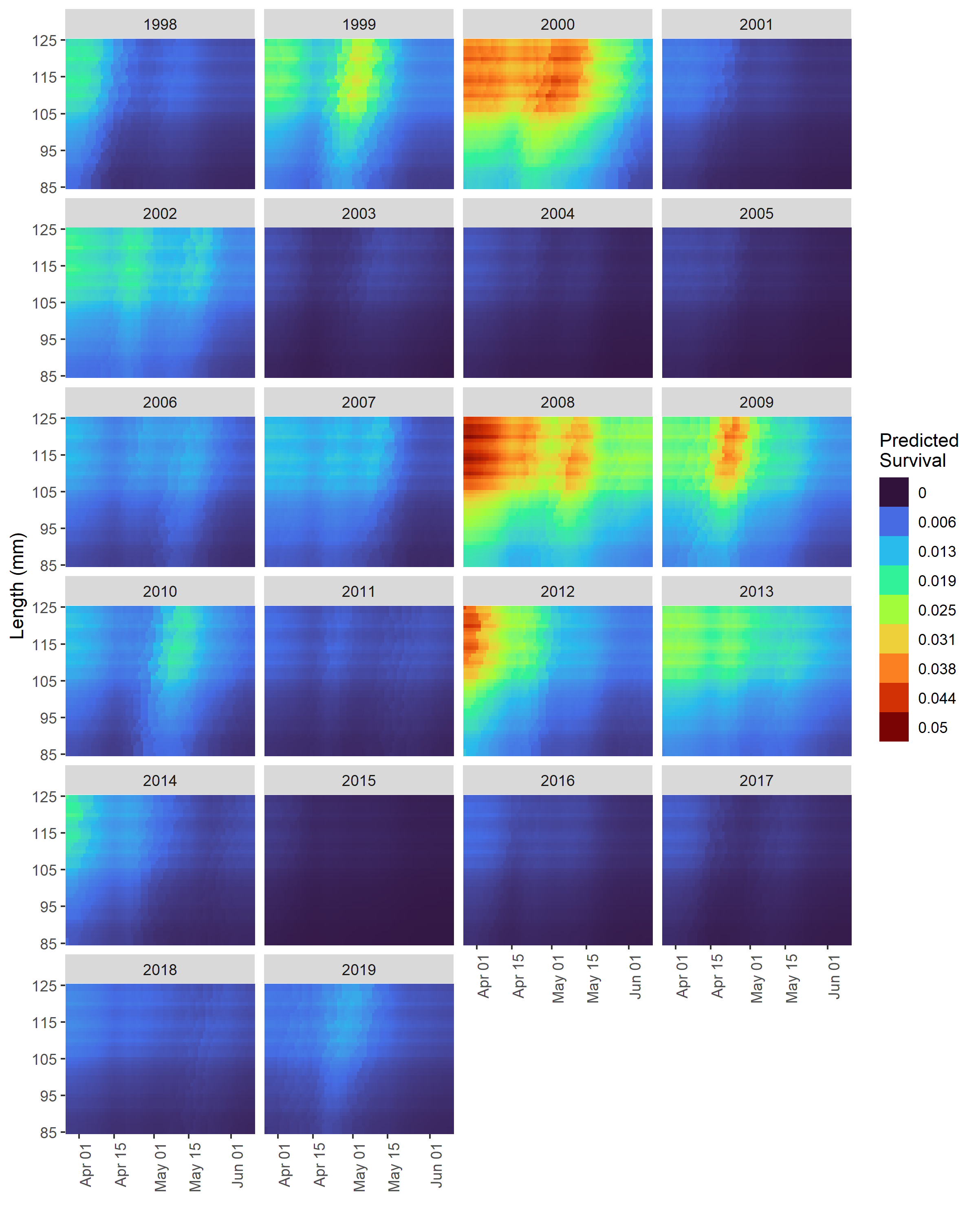

Supplemental Figure S5. Estimated survival for spring/summer Chinook salmon tagged above Lower Granite Dam (LGR) and detected at LGR within two weeks of tagging for smolt migration years 1998 to 2019 using the model with the lowest AIC value in Table 1.

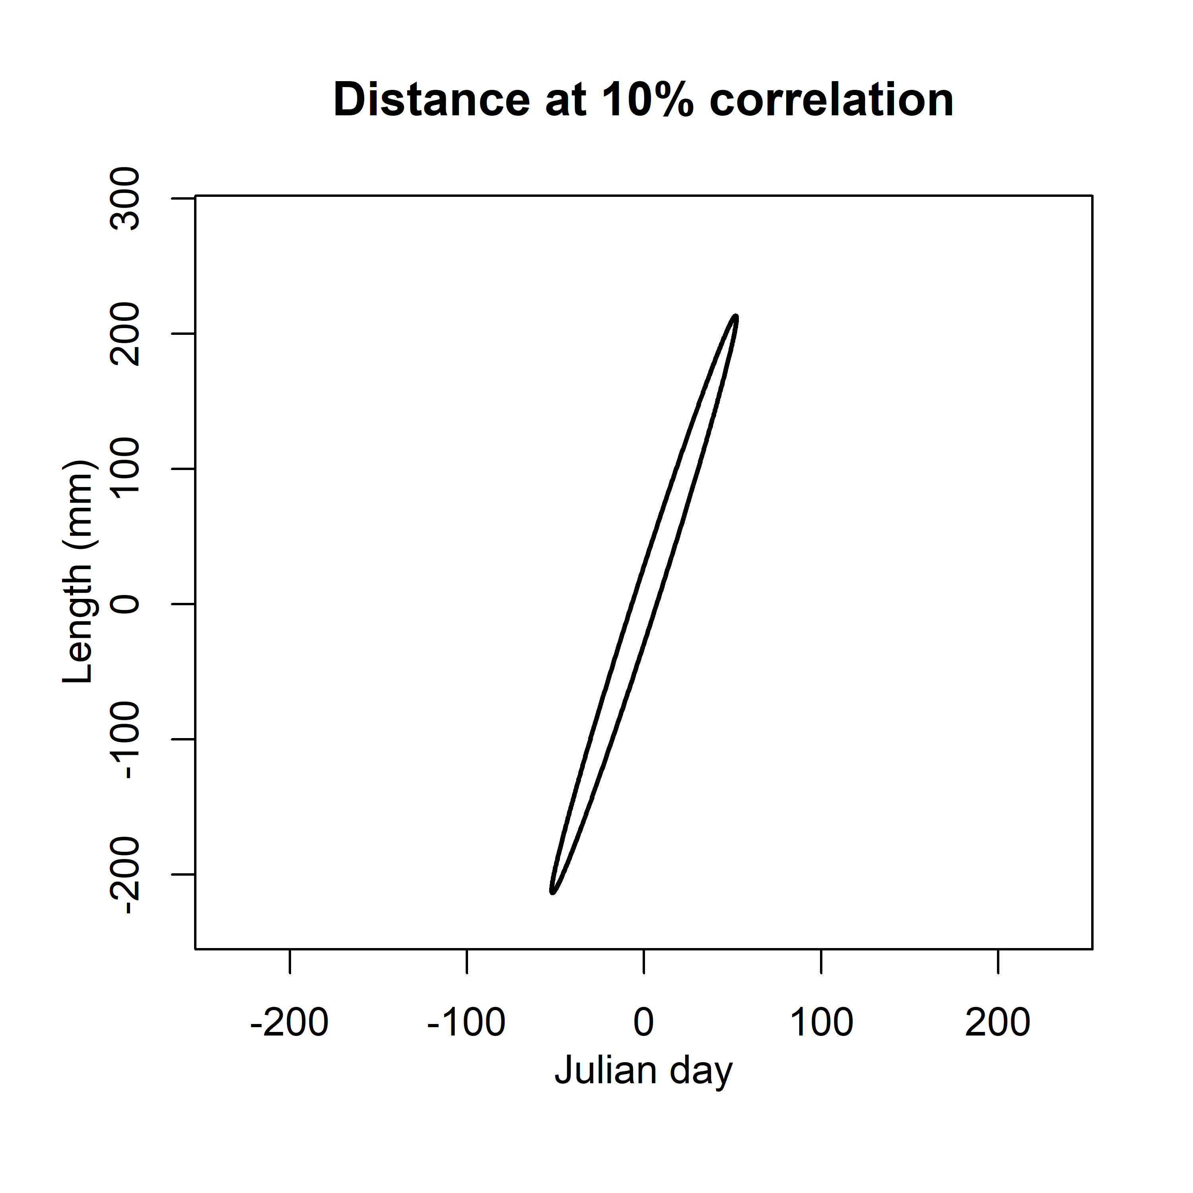

Supplemental Figure S6. Estimated anisotropy in the length/day domain as represented by the 10% decorrelation along length and day axes.

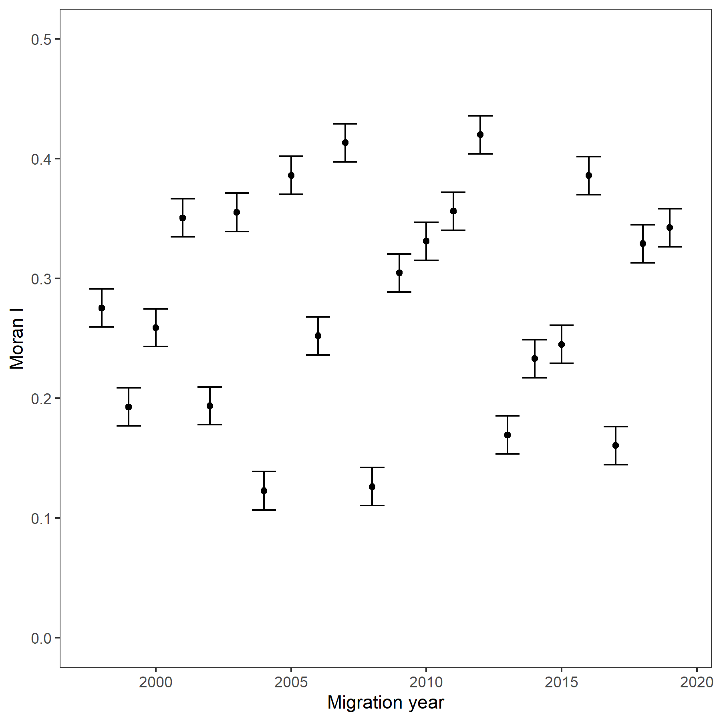

Supplemental Figure S7. Moran statistic values for the spatial autocorrelation in fish length and migration date deviates (See figure S8 for the 2d fields for each year) for fish tagged at LGR. Whiskers indicate global standard deviations based on permutation sample means.

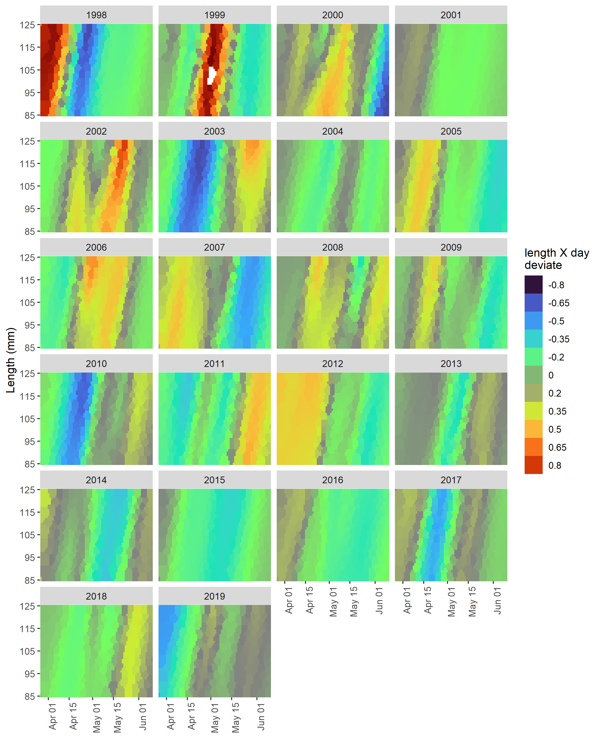

Supplemental Figure S8. Estimated length/day deviates for spring/summer Chinook salmon tagged at Lower Granite Dam as smolts between 1998 and 2019 using the model with the lowest AIC value in Table 1.

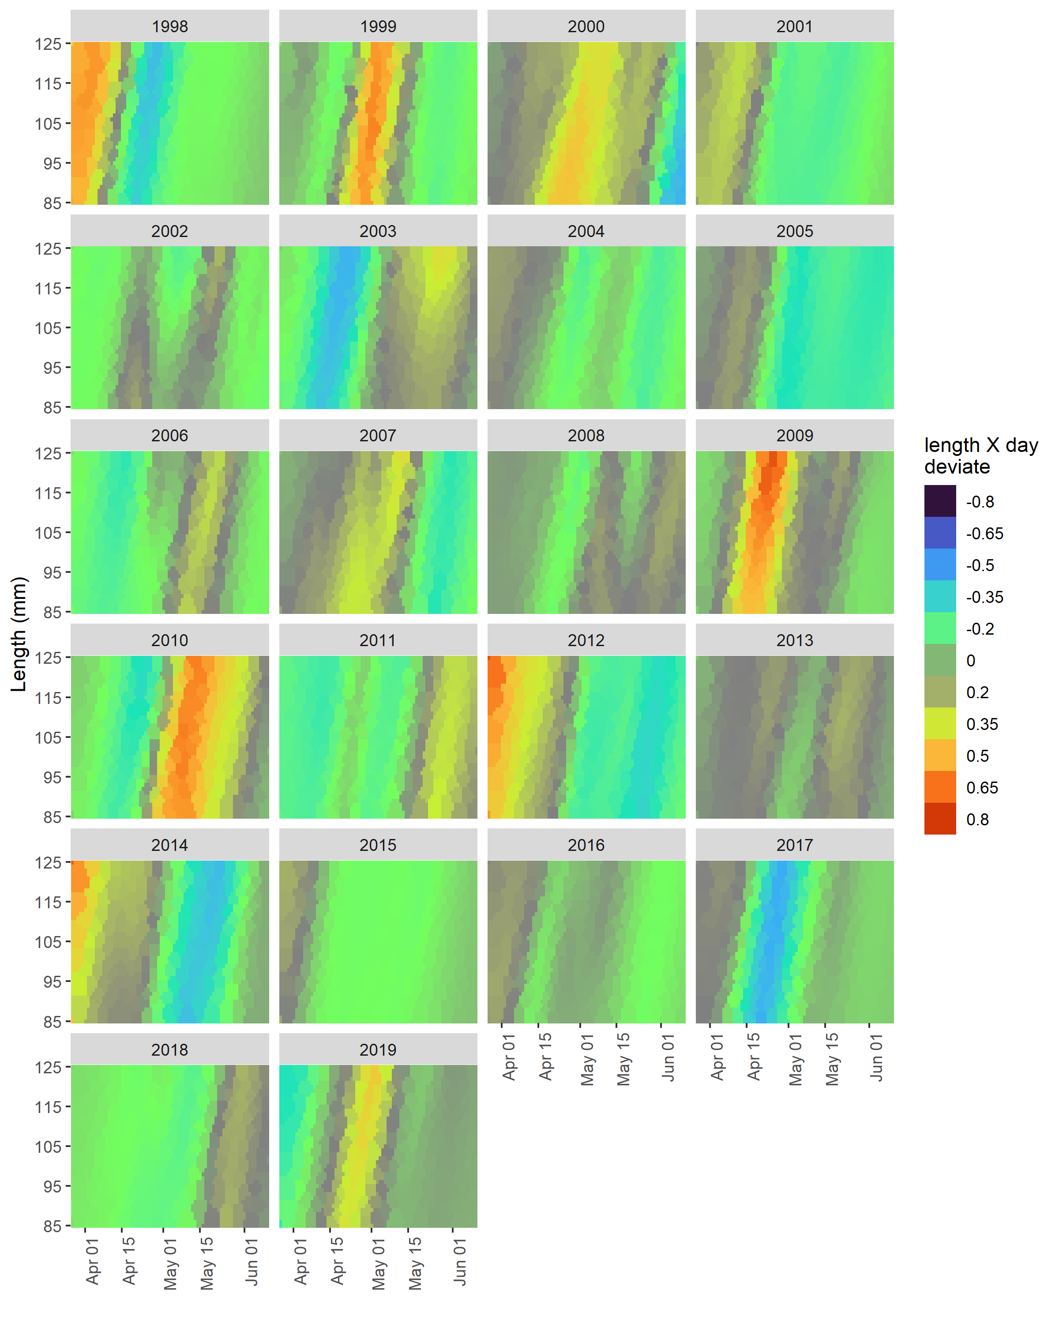

Supplemental Figure S9. Estimated length/day deviates for spring/summer Chinook salmon tagged above Lower Granite Dam as smolts between 1998 and 2019 using the model with the lowest AIC value in Table 1.

Supplemental Table 1. Annual sample sizes for the number of smolts tagged at and above Lower Granite Dam, and the number of adults that survived and return two to three years later. No fish were tagged at LGR in 2001 or above LGR in 19998 and 1999.

|  |  |  |  |  |  |
| --- | --- | --- | --- | --- | --- |
|  | At LGR |  |  | Above LGR | |
| Year | Survivors | Total |  | Survivors | Total |
| 1998 | 53 | 8 635 |  | NA | NA |
| 1999 | 164 | 11 497 |  | NA | NA |
| 2000 | 1 031 | 57 333 |  | 44 | 1 383 |
| 2001 | NA | NA |  | 8 | 2 335 |
| 2002 | 348 | 33 753 |  | 5 | 717 |
| 2003 | 73 | 42 996 |  | 5 | 1 672 |
| 2004 | 11 | 9 171 |  | 6 | 3 123 |
| 2005 | 12 | 6 719 |  |  | 1 754 |
| 2006 | 76 | 9 809 |  | 8 | 1 423 |
| 2007 | 98 | 14 364 |  | 14 | 1 504 |
| 2008 | 182 | 9 257 |  | 28 | 1 090 |
| 2009 | 117 | 13 788 |  | 48 | 2 319 |
| 2010 | 71 | 17 028 |  | 14 | 1 122 |
| 2011 | 45 | 16 011 |  | 12 | 3 068 |
| 2012 | 149 | 16 712 |  | 34 | 2 248 |
| 2013 | 84 | 11 545 |  | 22 | 1 394 |
| 2014 | 70 | 17 826 |  | 21 | 3 414 |
| 2015 | 1 | 5 336 |  | 2 | 698 |
| 2016 | 38 | 22 117 |  | 9 | 2 523 |
| 2017 | 30 | 14 209 |  | 2 | 1 607 |
| 2018 | 41 | 11 703 |  | 5 | 1 358 |
| 2019 | 22 | 6 272 |  | 5 | 550 |