Supplementary Material

1) Boundary conditions for biogeochemical parameters other than NO₃, DIC, and TA
We do not have sufficient information to directly construct boundary conditions for biogeochemical variables other than NO₃, DIC and TA. Therefore we chose to use the results from the CoSINE model instead. This model simulation ends in 2007 and therefore we chose the results for the last two year (2006-2007) for our model period 2011-2012. This choice of different model periods, however, shall not significantly affect the bottom carbonate chemistry parameters in the model for two reasons. First of all, the CoSINE model concentration of particulate organic matter in the Gulf of Mexico offshore waters is typically small with, e.g., POC < 5 µ molC/kg. This is consistent with the observed POC concentration for the upper 150 m along a shelf slope transect off Jacksonville, Florida during the ECOA cruise in July 2017 (https://www.nodc.noaa.gov/oads/data/0157080.xml), which is about 100 mile north of our northern model boundary. Similarly, observed chlorophyll concentration in the Gulf of Mexico offshore waters and in the Florida Strait is also typically lower than <1 µg/l, which is equivalent to < 4 µmolC/kg using a carbon-to-chlorophyll ratio of 50 (Figure S2; Llopiz, 2018). Therefore, POC is unlikely to be a major factor contributing to the variability of modeled bottom DIC and TA concentrations (magnitudes of both up >40 µmol/kg on daily to monthly timescales), which are dominated by the meandering of Florida Current and associated eddies. Secondly, the typical DOC concentration in the GOM and Florida Straits region is about 40-50 µmolC/kg based on limited measurements during GOMECC2 cruise, and the CoSINE model results show a similar range. Importantly, the range of the CoSINE model DOC along our western boundary on seasonal and inter-annual time-scale is <10 µmolC/kg (Figure S3). Given the slow remineralization (e.g. 0.03 day⁻¹) of DOC in deep waters and assuming a 10-day transit time for GOM waters to our study area, we expect this variability translates to less than 3 µmolC/kg of DIC variability in the Florida Straits, much smaller than the modeled DIC variability. Therefore, the uncertainty of model results due to this boundary choice shall be small.

2) Sensitivity of mesoscale eddies to the cut-off period using high-pass filtering
The magnitudes of temporal variability of bottom water properties due to mesoscale eddies are somewhat depending on the cut-off period of high-pass filtering because there is no clear-cut definition of mesoscale timescales. In the manuscript, we chose an arbitrary cut-off period of 11 day and any variability shorter than that is considered meso-scale variability. However, the general conclusions we draw shall remain valid for a cut-off period ranging from 7 to 15 day. An example of this is shown in Figure S4, which shows the model vorticity and bottom temperature at the two slope stations in Pourtales Terrace and Miami Terrace, same as Figure 15 but with a cut-off period of 15-day for low-passed filtering. The results show similar but slightly increased correlations between the vorticity and temperature anomaly (more energy) and slightly weaker correlations between low-passed vorticity and temperature (less energy).

3) Sensitivity of model results to boundary conditions and horizontal mixing
We have tested the sensitivity of model results to various model treatments including boundary conditions and mixing parameterizations (mixing rate and mixing scheme). The results indicate that the modeled key features including mesoscale eddies and temporal and spatial variability of key variables are robust to these treatments in general. There are, however, significant changes in the magnitudes of temporal-spatial variability and timing and locations of meso-scale eddies. An example of these is shown in Figure S5-S6 in which modeled bottom temperature, DIC and TA concentrations are shown for three case: Control, reduced horizontal mixing coefficient from 10 m²/sec to 5 m²/sec (Low Mixing), and increased the western boundary flow by 5% (sea level gradient was adjusted accordingly) (Obc). The results indicate that reduced horizontal mixing could significantly increase temporal variability of these parameters, ~10% changes in standard deviation (Table S1), likely due to the increased horizontal gradients. On the other hand, model results appear to be less sensitivity to the small changes of boundary currents with <5% changes in standard deviation. A systematic analysis of model sensitivity, however, is yet to be carried out in the future.

Table S1. Standard deviation of modeled bottom temperature, DIC and TA at the two slope stations on the Pourtales Terrace and Miami Terrace.
 |  | Control | Low Mixing | Obc
Pourtales Terrace  (296 m) | T (ºC) | 1.04 | 1.02 | 1.05
Pourtales Terrace  (296 m) | DIC (µmol/kg) | 4.47 | 4.01 | 4.4
Pourtales Terrace  (296 m) | TA (µmol/kg) | 5.13 | 4.7 | 5.15
Miami Terrace  (417 m) | T (ºC) | 0.74 | 0.82 | 0.77
Miami Terrace  (417 m) | DIC (µmol/kg) | 1.41 | 1.60 | 1.48
Miami Terrace  (417 m) | TA (µmol/kg) | 1.93 | 2.04 | 1.9

Captions
Figure S1. Observed relationships of NO₃, DIC and TA with temperature and salinity along the WFL transect during GOMECC2. The correlation coefficient of best polynomial fit for each pair is shown in the respective panel.

Figure S2. Left panel: modeled mean and standard deviation of chlorophyll concentration (blue line) along the GOMECC2 EFL transect and observed chlorophyll concentration (dots). Right pane: point-to-point correlation (red dots) and the linear regression (blue line) by excluding the 6 data points where modeled chlorophyll concentration is greater than 0.5 ug/l (upper left corner).

Figure S3. Boundary (a) chlorophyll, (b) NO3, (c) POC, (d) DOC, (e) DIC and (f) TA on the on the west Florida Slope (26.8ºN, 84.9ºW) in 2011-2012.

Figure S4. Modeled time-series of relative vorticity ($ς$) and near bottom temperature in 2012 for two sites on Pourtalès Terrace (296 m) and Miami Terrace (417 m): (a) $ς$ at 150m and (c) bottom temperature on Pourtalès Terrace, (e) $ς$ at 350 m and (g) bottom temperature on Miami Terrace. Their respective $ς$ -T correlations for low-passed time-series (b and f) and anomalies (d, h) are shown on the right panels. Red lines on the right panels are the linear best fits for each pair. This is same as Figure 15 except that here the cut-off period for the Lanczos filter is 15 day.

Figure S5. (a) Temperature, (b) DIC, and (c) TA on the upper slope of the Pourtales Terrace under Control (blue), Low Mixing (green), and Obc (magenta) scenarios.

Figure S6. (a) Temperature, (b) DIC, and (c) TA on the slope of Miami Terrace under Control (blue), Low Mixing (green), and Obc (magenta) scenarios.

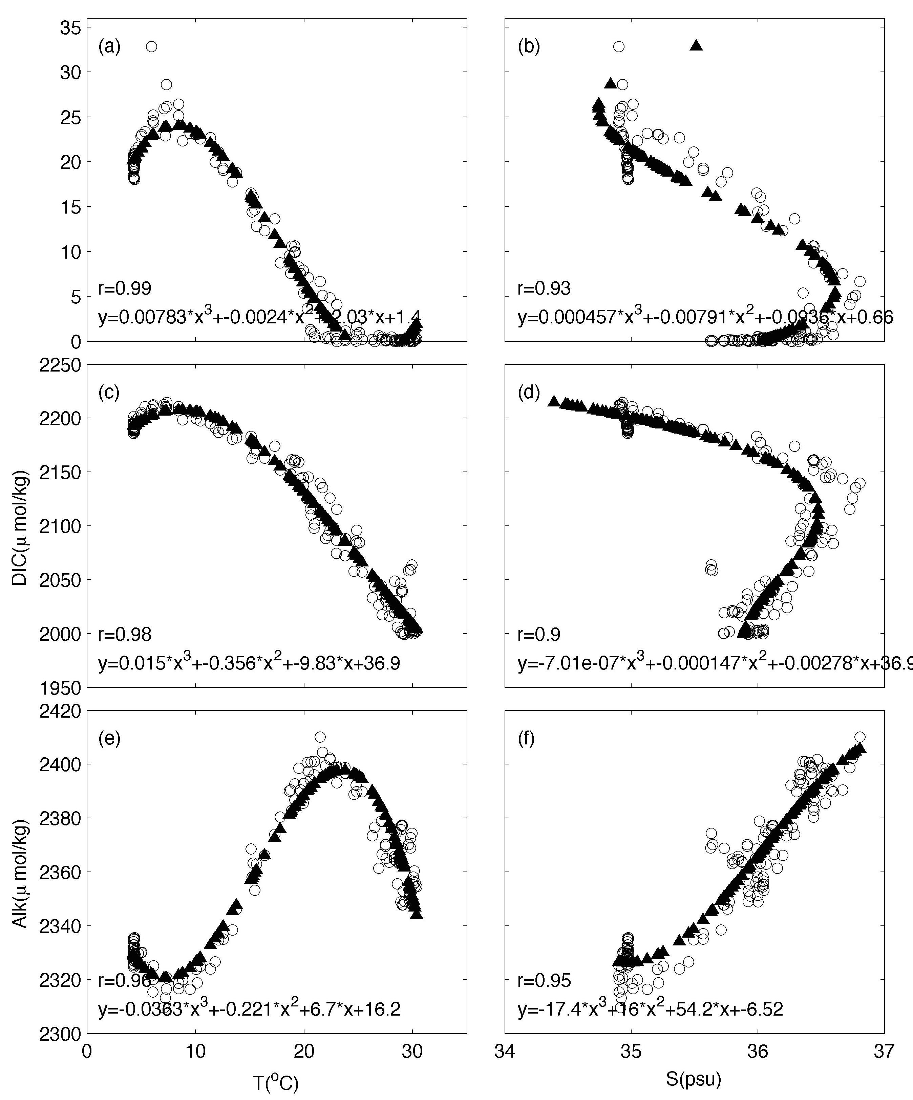

Figure S1. Observed relationships of NO₃, DIC and TA with temperature and salinity along the WFL transect during GOMECC2. The correlation coefficient of best polynomial fit for each pair is shown in the respective panel.

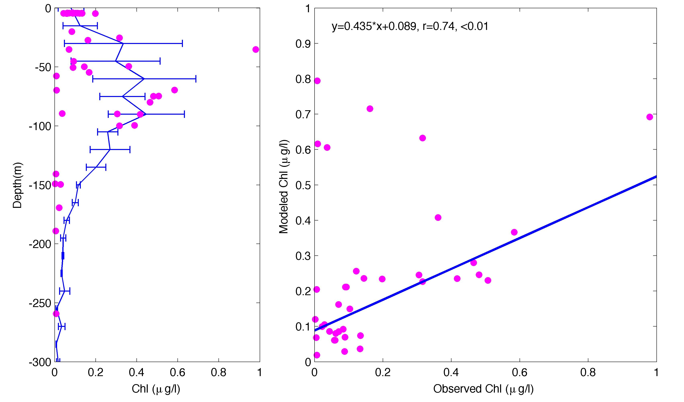

Figure S2. Left panel: modeled mean and standard deviation of chlorophyll concentration (blue line) along the GOMECC2 EFL transect and observed chlorophyll concentration (dots). Right pane: point-to-point correlation (red dots) and the linear regression (blue line) by excluding the 6 data points where modeled chlorophyll concentration is greater than 0.5 ug/l (upper left corner).

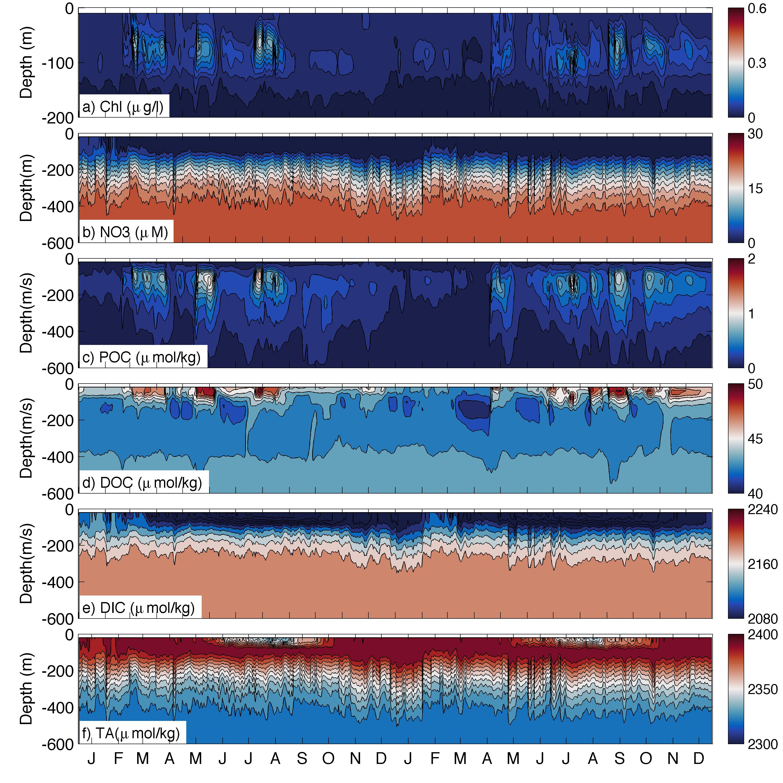

Figure S3. Boundary (a) chlorophyll, (b) NO3, (c) POC, (d) DOC, (e) DIC and (f) TA on the on the west Florida Slope (26.8ºN, 84.9ºW) in 2011-2012.
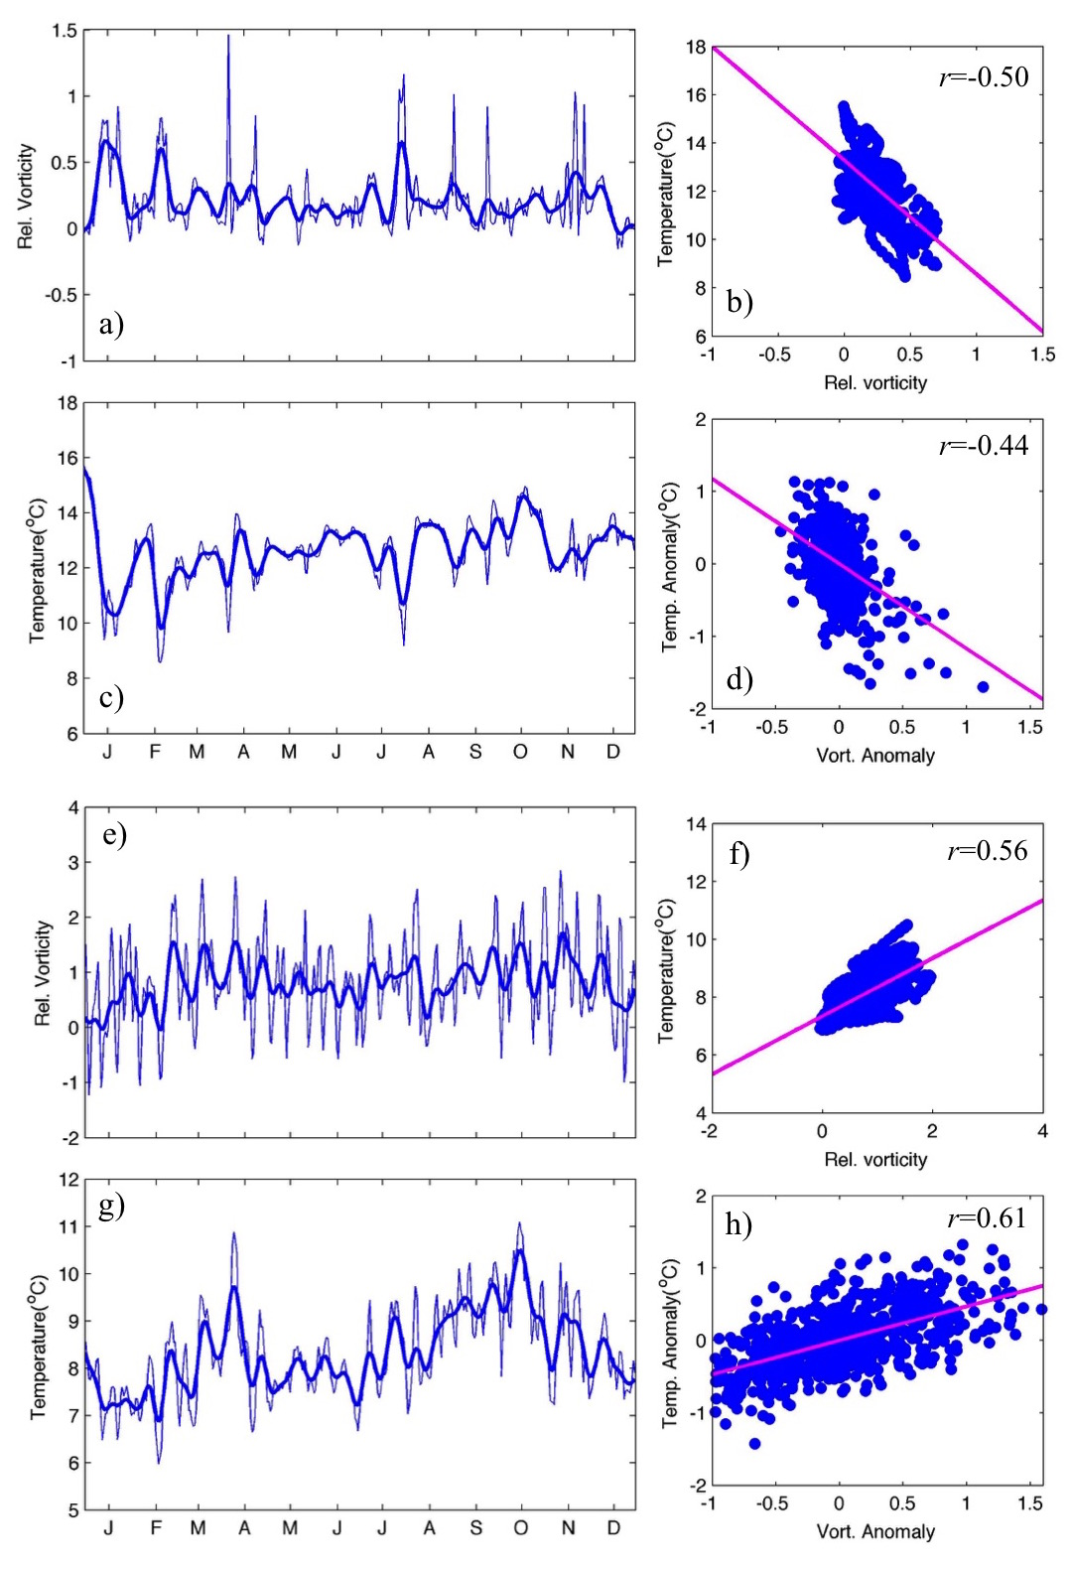
Figure S4. Modeled time-series of relative vorticity ($ς$) and near bottom temperature in 2012 for two sites on Pourtalès Terrace (296 m) and Miami Terrace (417 m): (a) $ς$ at 150m and (c) bottom temperature on Pourtalès Terrace, (e) $ς$ at 350 m and (g) bottom temperature on Miami Terrace. Their respective $ς$ -T correlations for low-passed time-series (b and f) and anomalies (d, h) are shown on the right panels. Red lines on the right panels are the linear best fits for each pair. This is same as Figure 15 except that here the cut-off period for the Lanczos filter is 15 day.

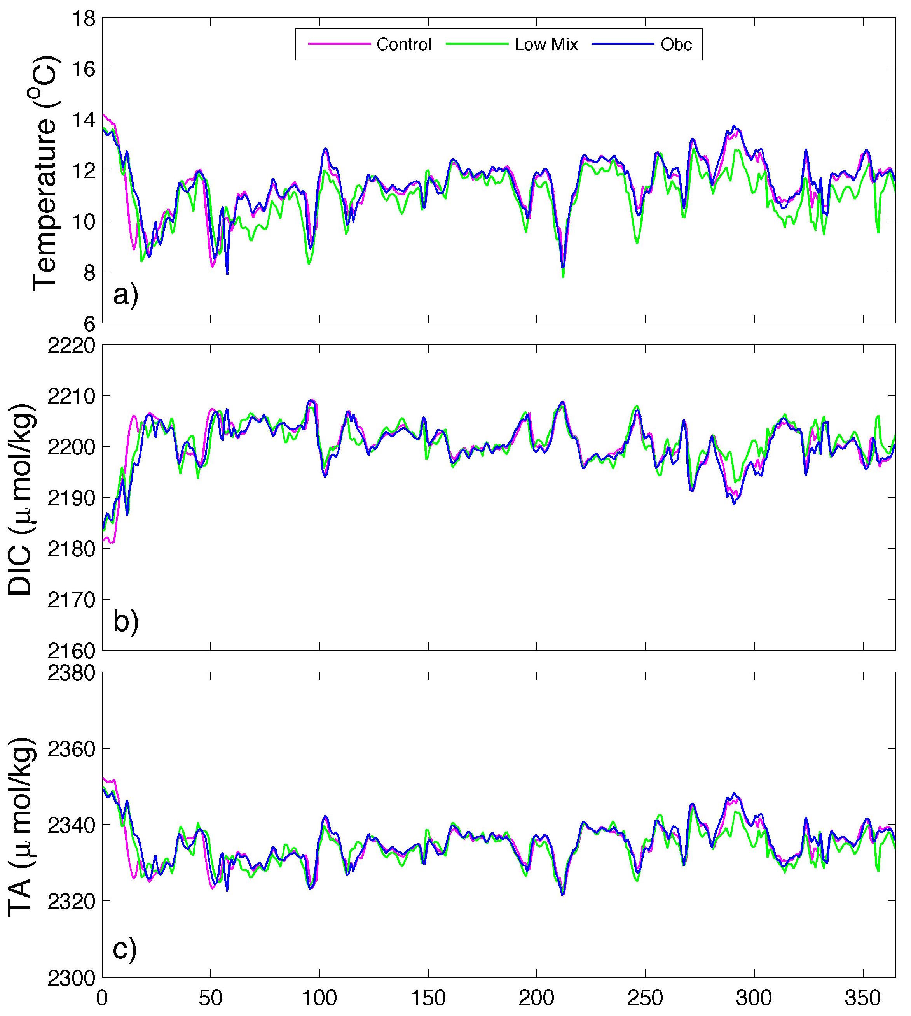
Figure S5. (a) Temperature, (b) DIC, and (c) TA on the upper slope of the Pourtales Terrace under Control (blue), Low Mixing (green), and Obc (magenta) scenarios.

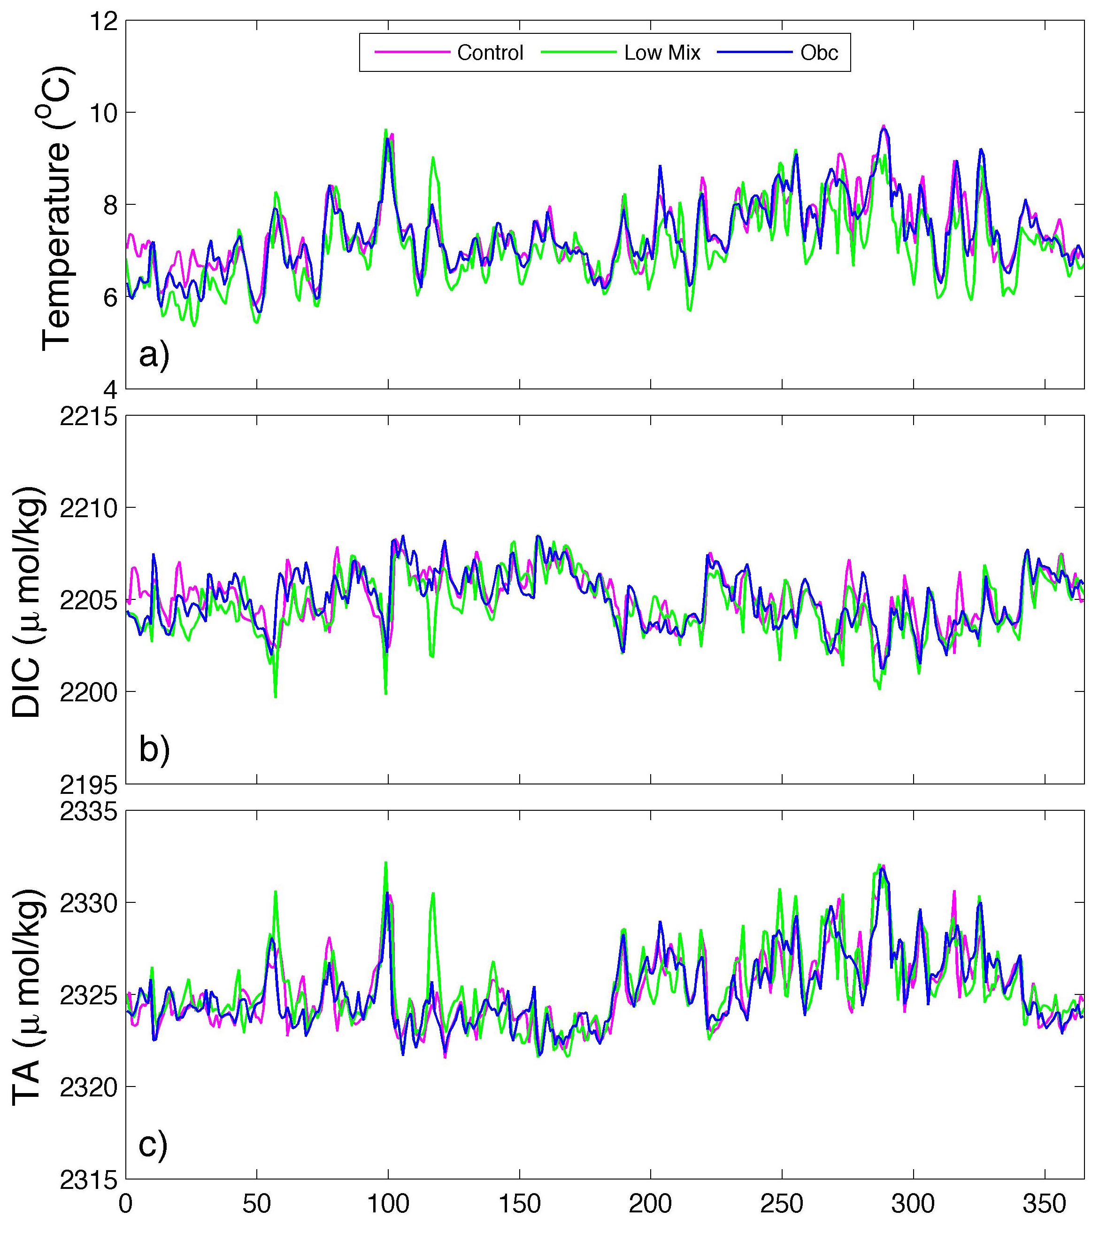
Figure S6. (a) Temperature, (b) DIC, and (c) TA on the slope of Miami Terrace under Control (blue), Low Mixing (green), and Obc (magenta) scenarios.

