Supplementary Online Material
for
Intensified Positive Arctic - Methane Feedback under IPCC Climate Scenarios in the 21st Century

This file contains Figure S1-S14 and Table S1-S6.
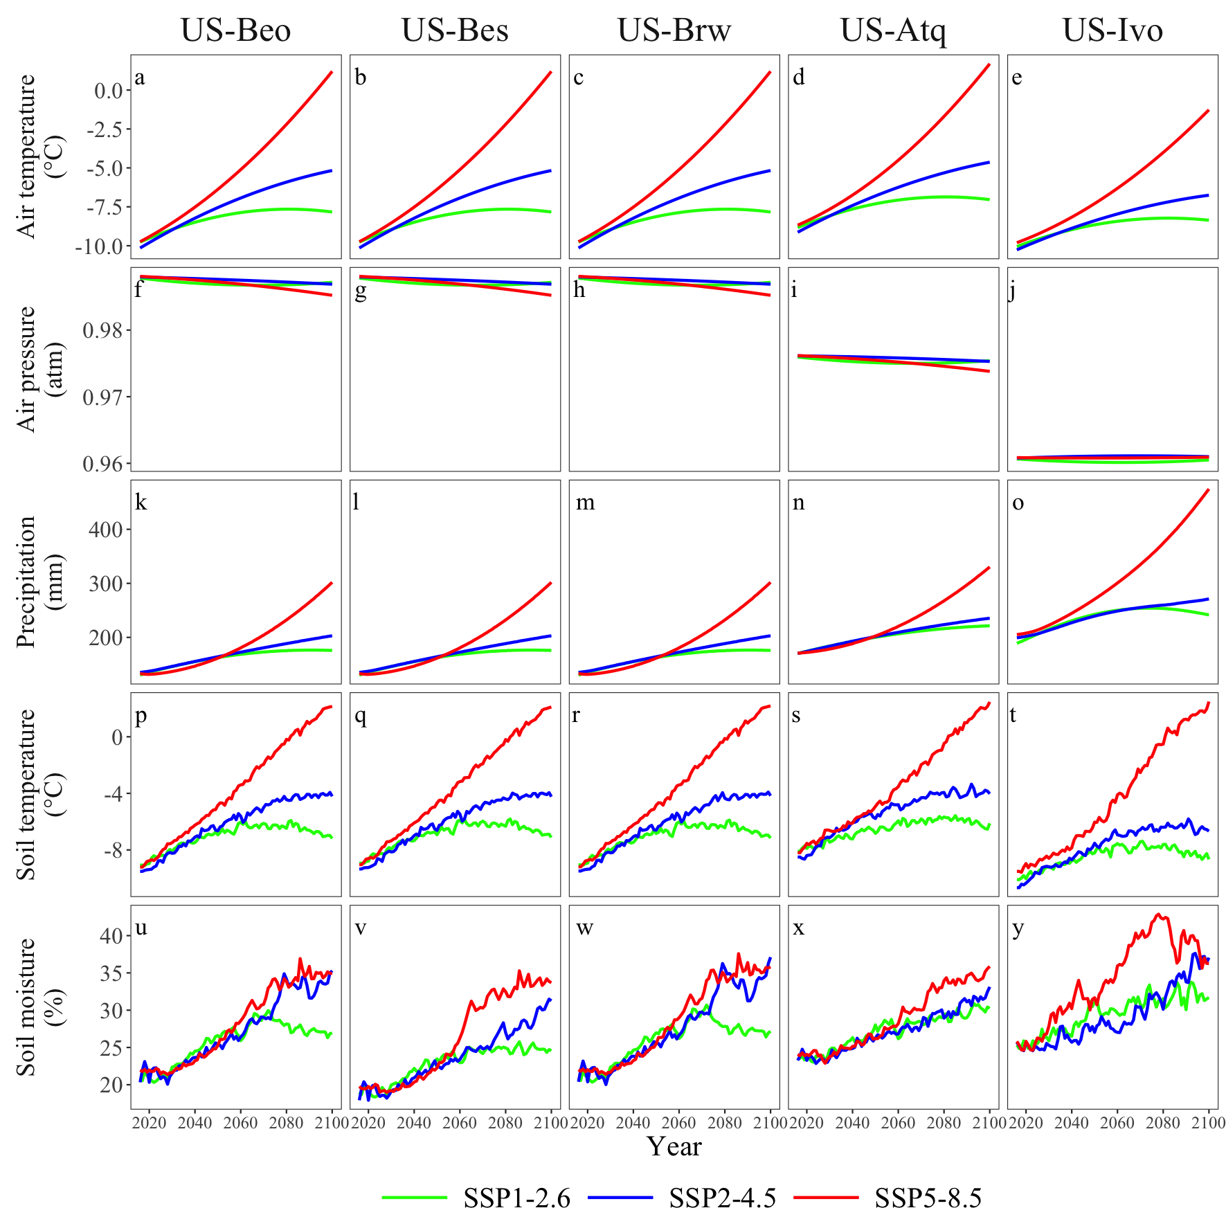
Figure S1. Projected dynamics of air temperature, air pressure, precipitation, soil temperature and soil moisture at top 10 cm soil depth during 2016-2100 at (a, f, k, p, u) US-Beo, (b, g, l, q, v) US-Bes, (c, h, m, r, w) US-Brw, (d, i, n, s, x) US-Atq and (e, j, o, t, y) US-Ivo under SSP1-2.6, SSP2-4.5 and SSP5-8.5 scenarios.

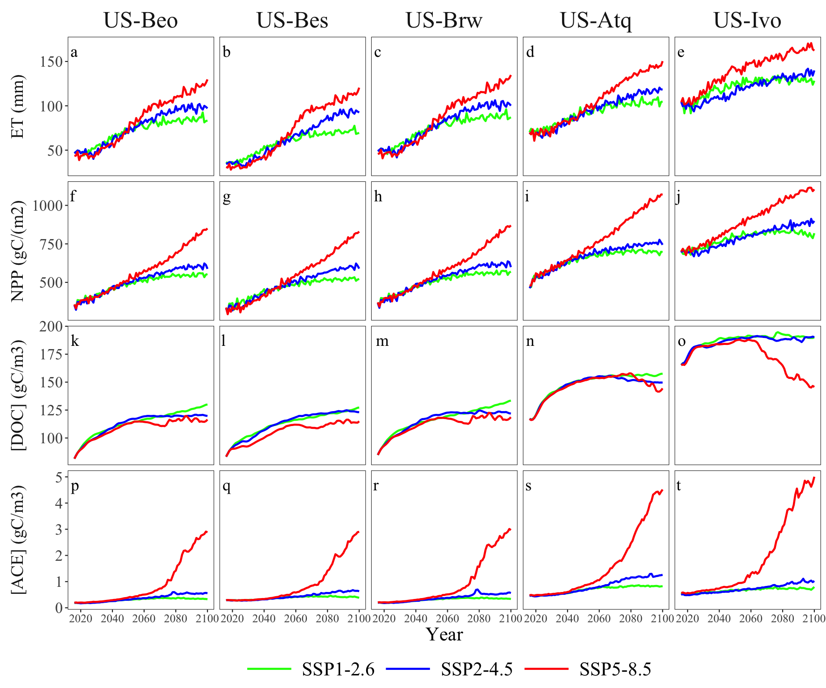
Figure S2. Projected dynamics of canopy evapotranspiration (ET), net primary production (NPP), soil dissolved organic carbon concentration ([DOC]) and soil acetic acid concentration ([ACE]) during 2016-2100 at (a, f, k, p) US-Beo, (b, g, l, q) US-Bes, (c, h, m, r) US-Brw, (d, i, n, s) US-Atq and (e, j, o, t) US-Ivo under SSP1-2.6, SSP2-4.5 and SSP5-8.5 scenarios.

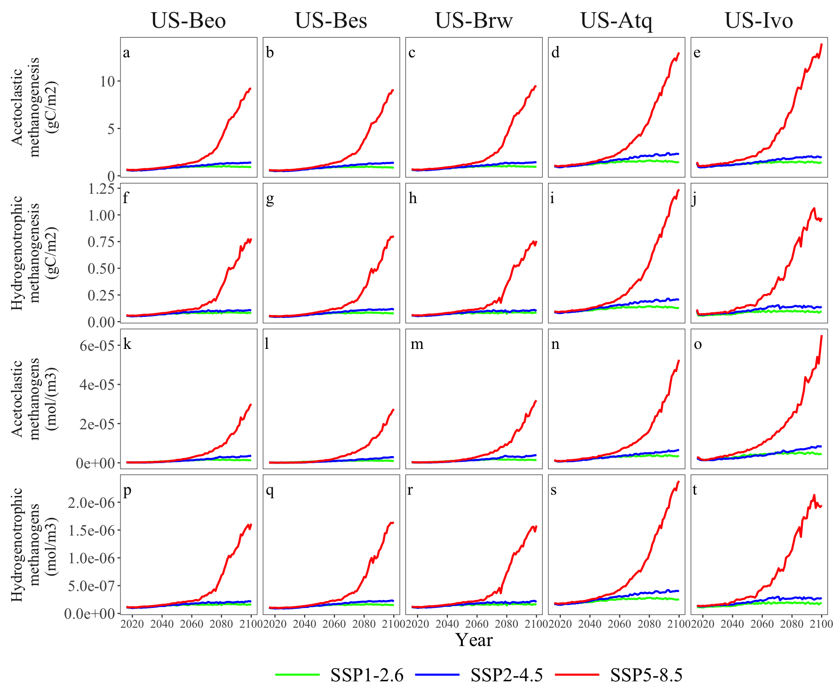
Figure S3. Projected dynamics of acetotrophic methanogenesis, hydrogenotrophic methanogenesis, biomass of acetotrophic methanogens and biomass of hydrogenotrophic methanogens during 2016-2100 at (a, f, k, p) US-Beo, (b, g, l, q) US-Bes, (c, h, m, r) US-Brw, (d, i, n, s) US-Atq and (e, j, o, t) US-Ivo under SSP1-2.6, SSP2-4.5 and SSP5-8.5 scenarios.

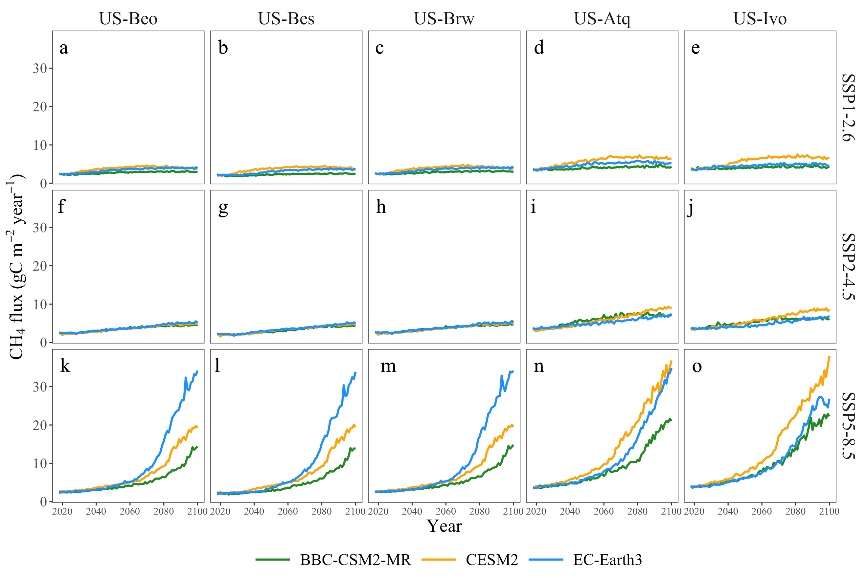
Figure S4. Projected dynamics of CH₄ fluxes during 2016-2100 at (a, f, k) US-Beo, (b, g, l) US-Bes, (c, h, m) US-Brw, (d, i, n) US-Atq and (e, j, o) US-Ivo under SSP1-2.6, SSP2-4.5 and SSP5-8.5 scenarios using climate data from BBC-CSM2-MR, CESM2 and EC-Earth3 in CMIP6.
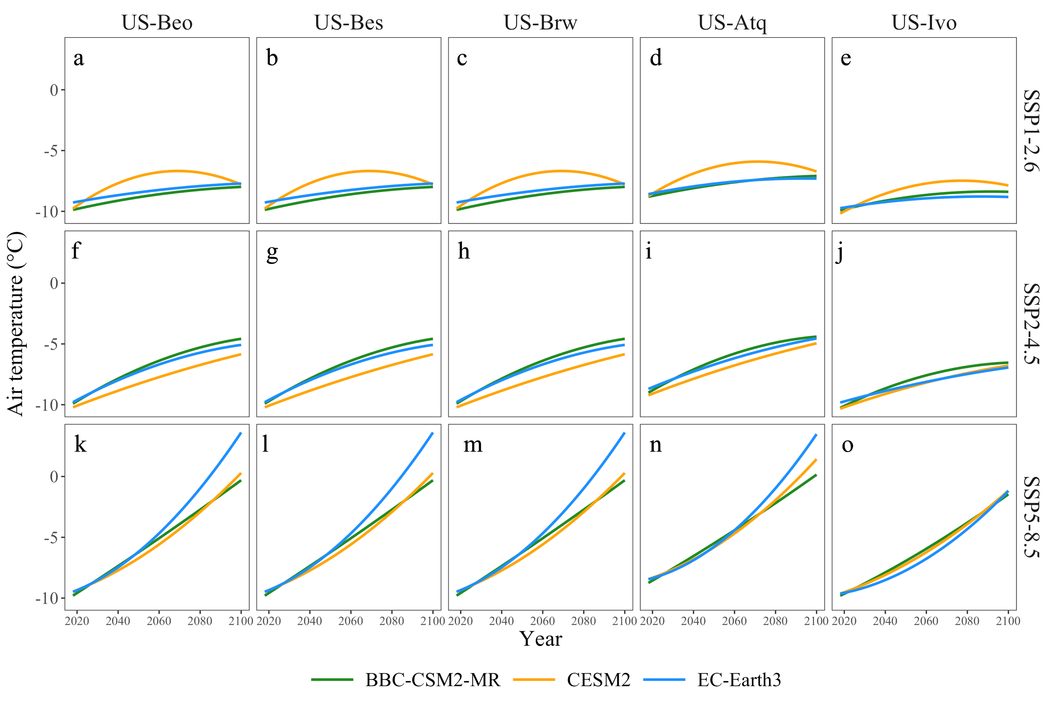Figure S5. Projected dynamics of air temperature during 2016-2100 at (a, f, k) US-Beo, (b, g, l) US-Bes, (c, h, m) US-Brw, (d, i, n) US-Atq and (e, j, o) US-Ivo under SSP1-2.6, SSP2-4.5 and SSP5-8.5 scenarios using climate data from BBC-CSM2-MR, CESM2 and EC-Earth3 in CMIP6.
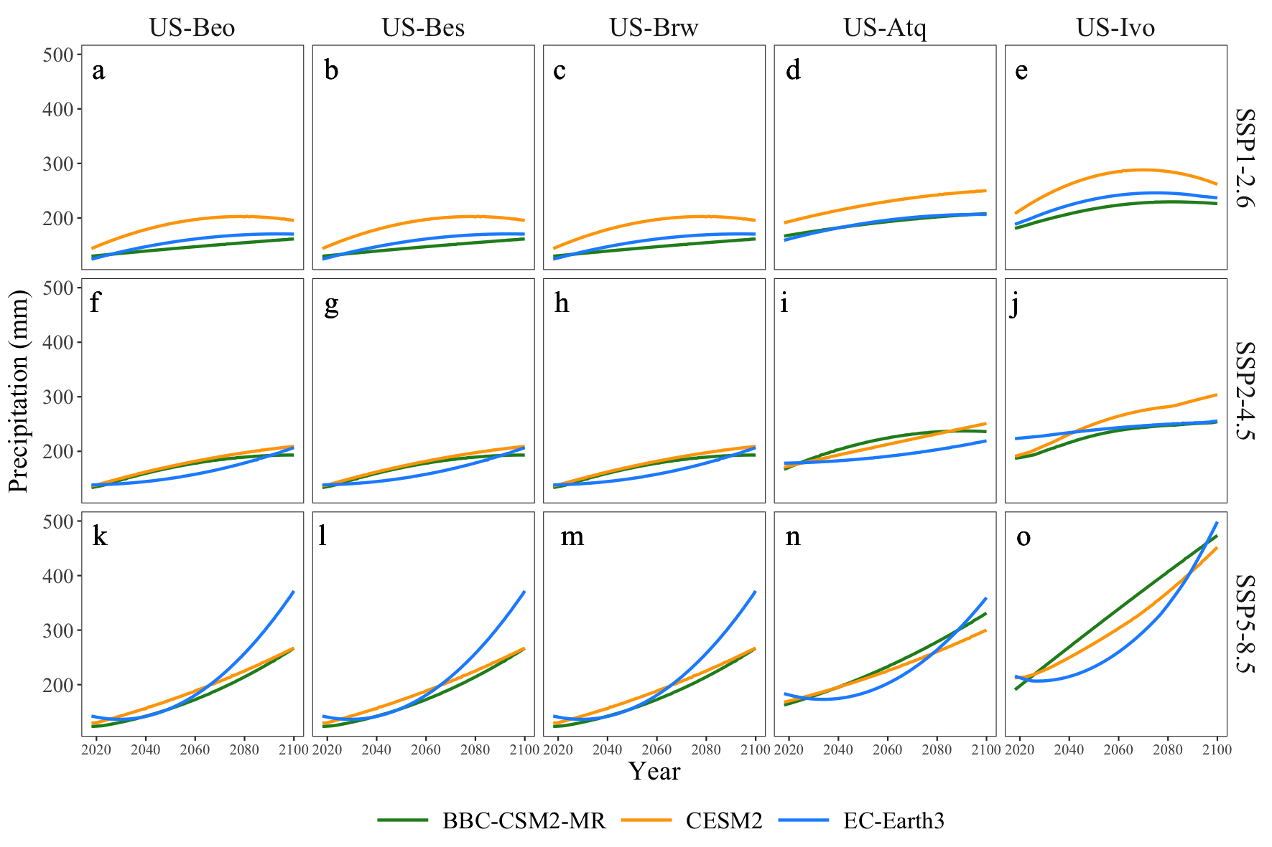
Figure S6. Projected dynamics of precipitation during 2016-2100 at (a, f, k) US-Beo, (b, g, l) US-Bes, (c, h, m) US-Brw, (d, i, n) US-Atq and (e, j, o) US-Ivo under SSP1-2.6, SSP2-4.5 and SSP5-8.5 scenarios using climate data from BBC-CSM2-MR, CESM2 and EC-Earth3 in CMIP6.
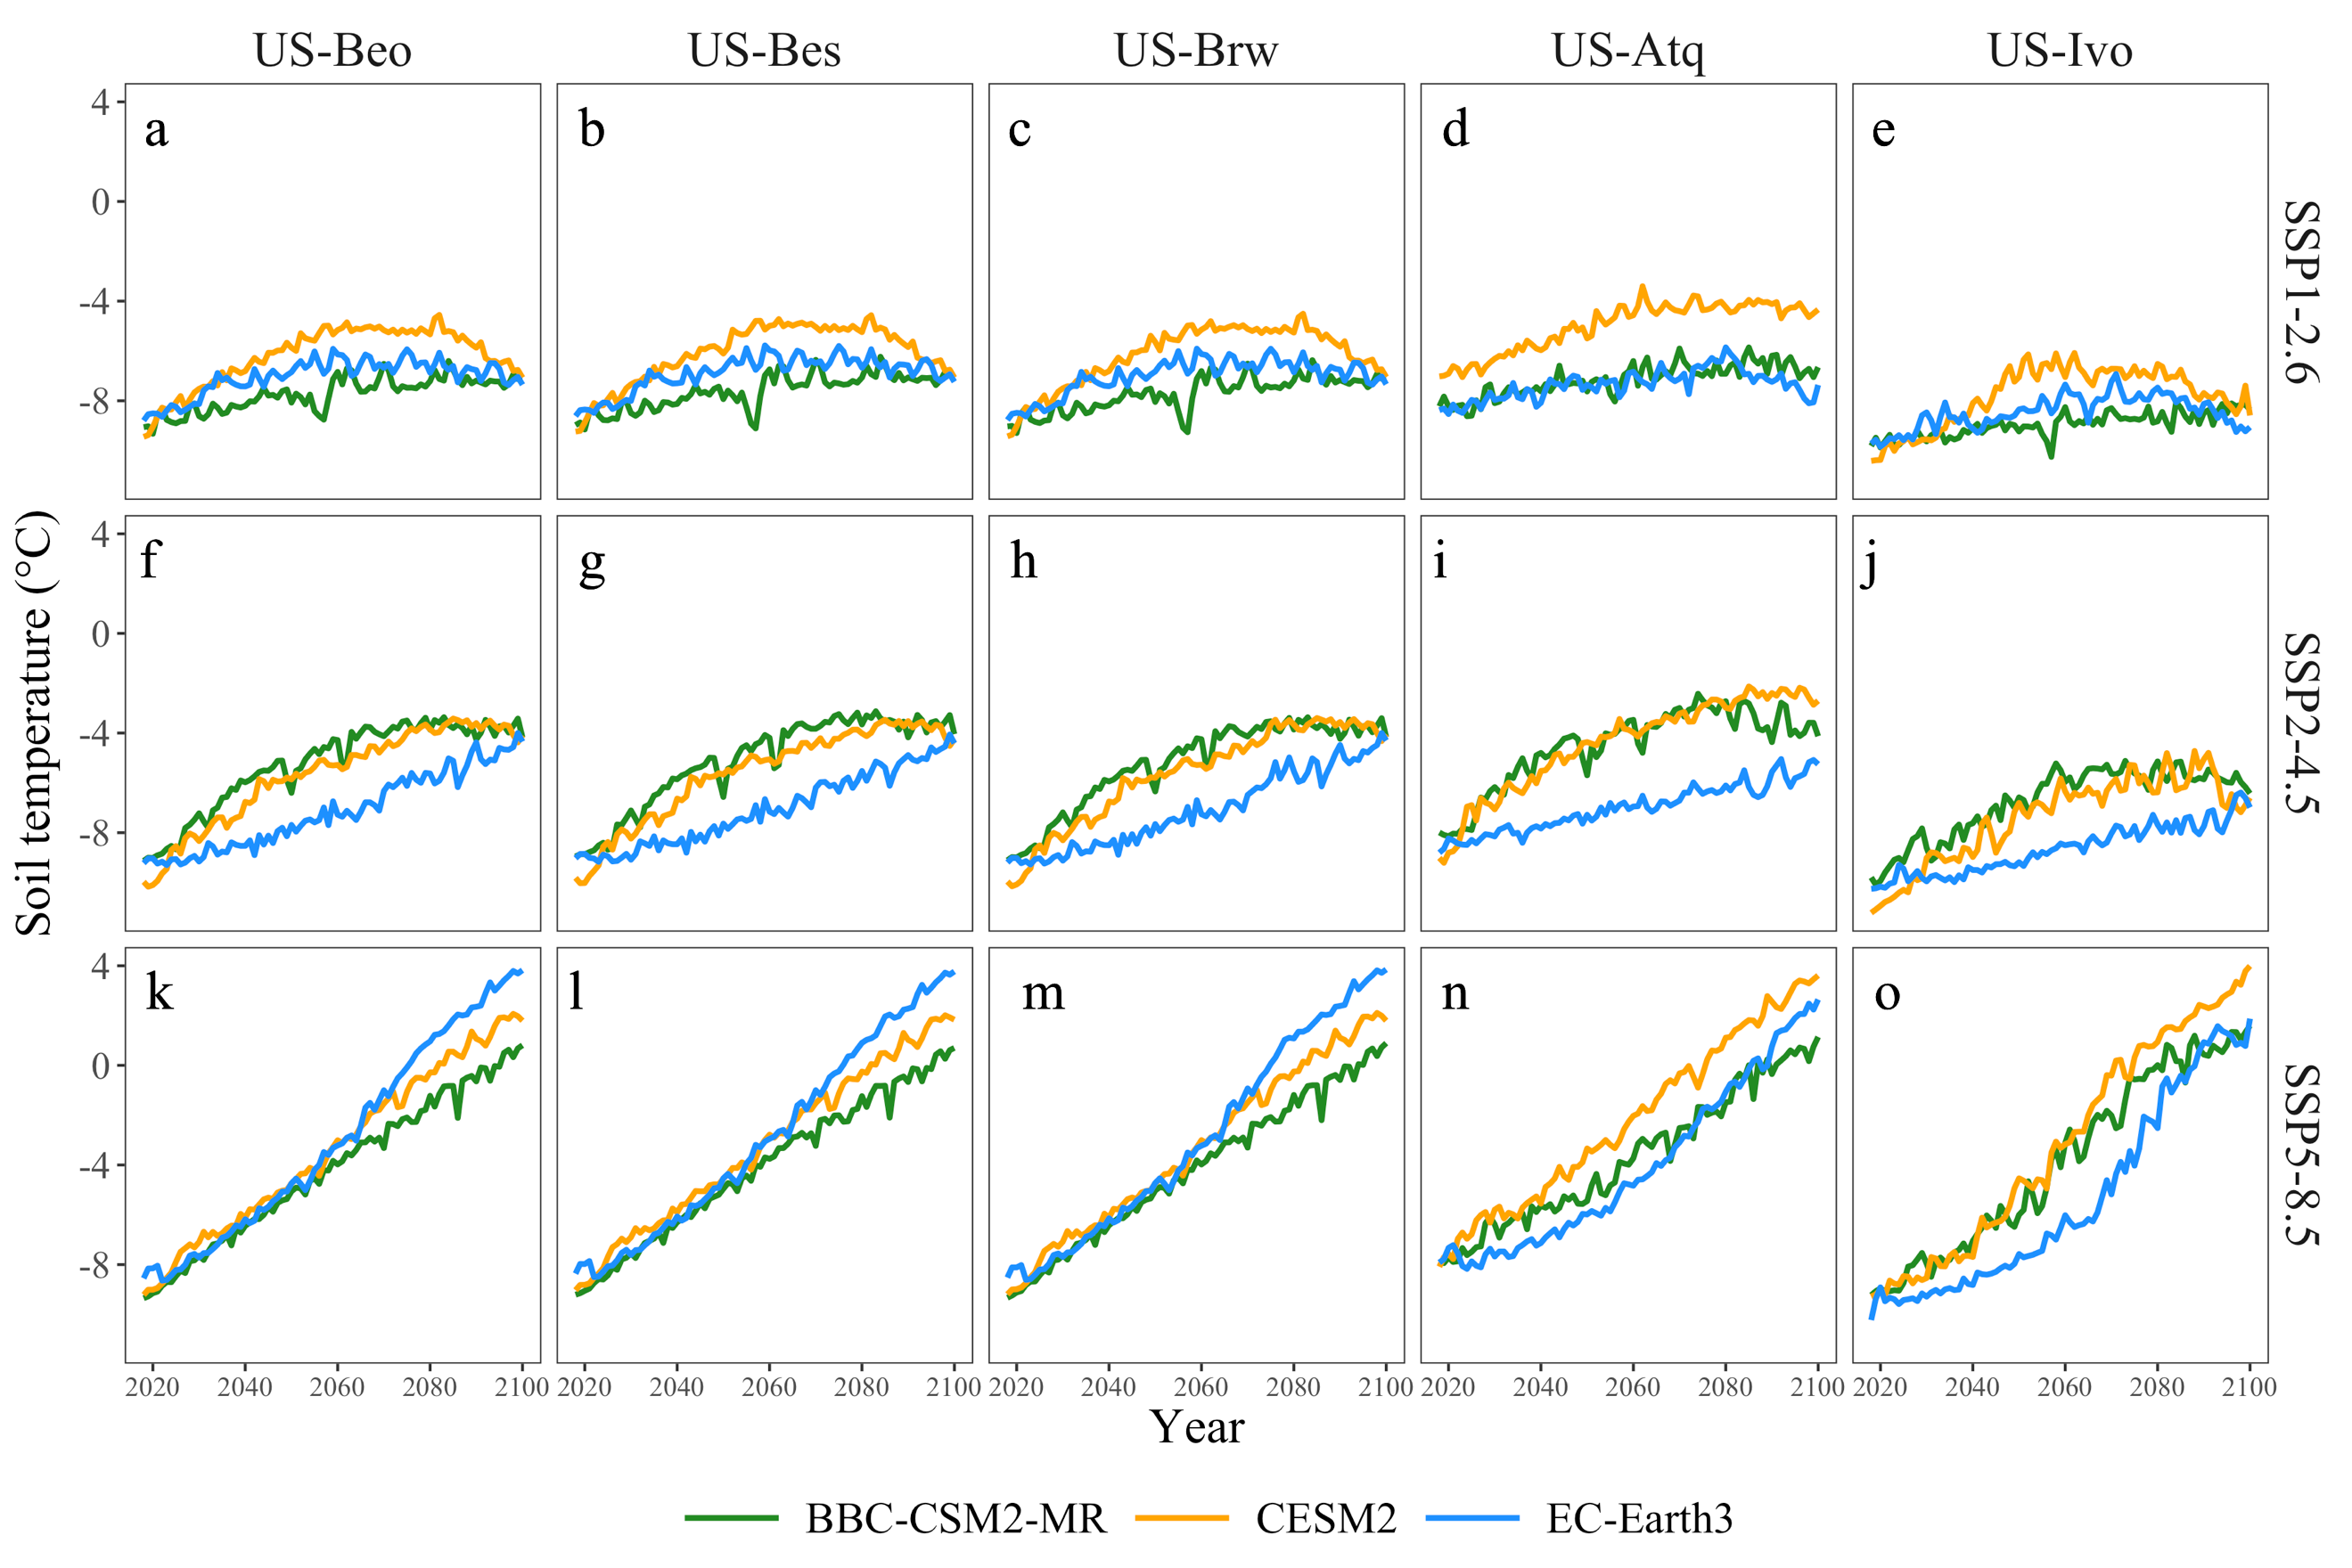
Figure S7. Projected dynamics of soil temperature during 2016-2100 at (a, f, k) US-Beo, b, g, l) US-Bes, (c, h, m) US-Brw, (d, i, n) US-Atq and (e, j, o) US-Ivo under SSP1-2.6, SSP2-4.5 and SSP5-8.5 scenarios using climate data from BBC-CSM2-MR, CESM2 and EC-Earth3 in CMIP6.
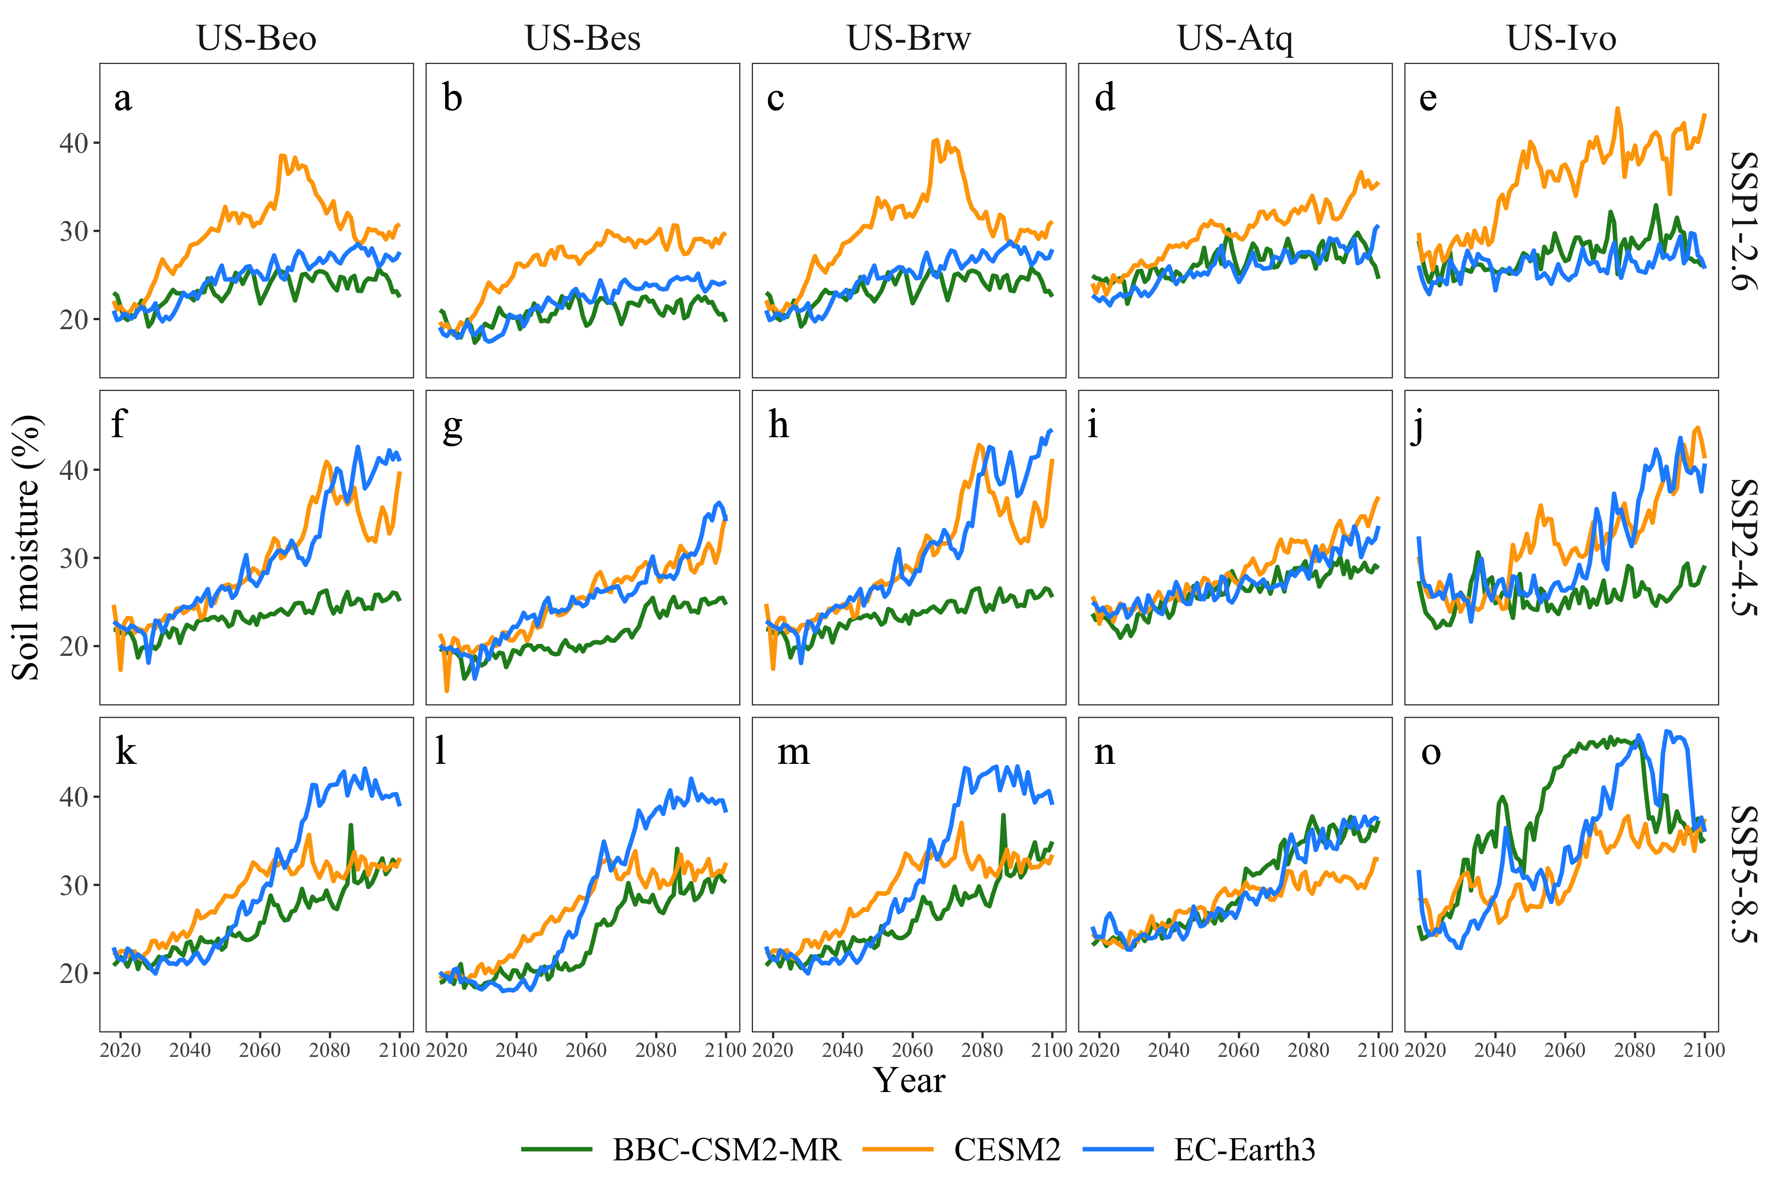
Figure S8. Projected dynamics of soil moisture during 2016-2100 at (a, f, k) US-Beo, (b, g, l) US-Bes, (c, h, m) US-Brw, (d, i, n) US-Atq and (e, j, o) US-Ivo under SSP1-2.6, SSP2-4.5 and SSP5-8.5 scenarios using climate data from BBC-CSM2-MR, CESM2 and EC-Earth3 in CMIP6.
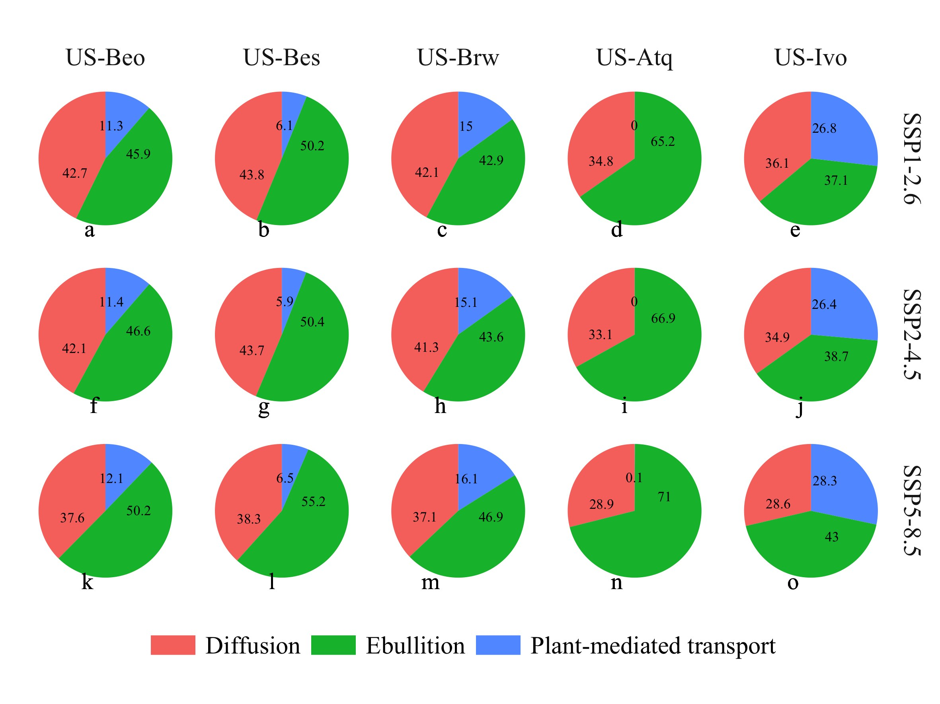
Figure S9. The pie charts represent the contributions of three transport pathways to total CH₄ fluxes in the 2050s at (a, f, k) US-Beo, (b, g, l) US-Bes, (c, h, m) US-Brw, (d, I, n) US-Atq and (e, j, o) US-Ivo under SSP1-2.6, SSP2-4.5 and SSP5-8.5 scenarios. Red indicates diffusion, green indicates ebullition, and blue indicates plant-mediated transport.

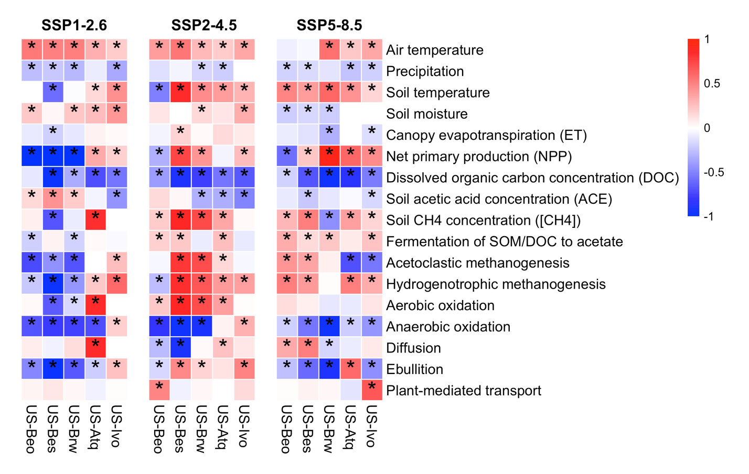
Figure S10. Partial correlation analysis between projected CH₄ fluxes and 17 factors and processes: air temperature, precipitation, soil temperature, soil moisture, canopy evapotranspiration (ET), net primary production (NPP), dissolved organic carbon concentration (DOC), soil acetic acid concentration (ACE), soil CH₄ concentration ([CH₄]), rates of acetoclastic methanogenesis, hydrogenotrophic methanogenesis, aerobic oxidation, anaerobic oxidation, diffusion, ebullition, and plant-mediated transport at US-Beo, US-Bes, US-Brw, US-Atq and US-Ivo under SSP1-2.6, SSP2-4.5 and SSP5-8.5. The symbol "*" indicates the significance level at of α = 0.05. Darker red and darker blue indicate a stronger positive or negative correlation with CH₄ fluxes.

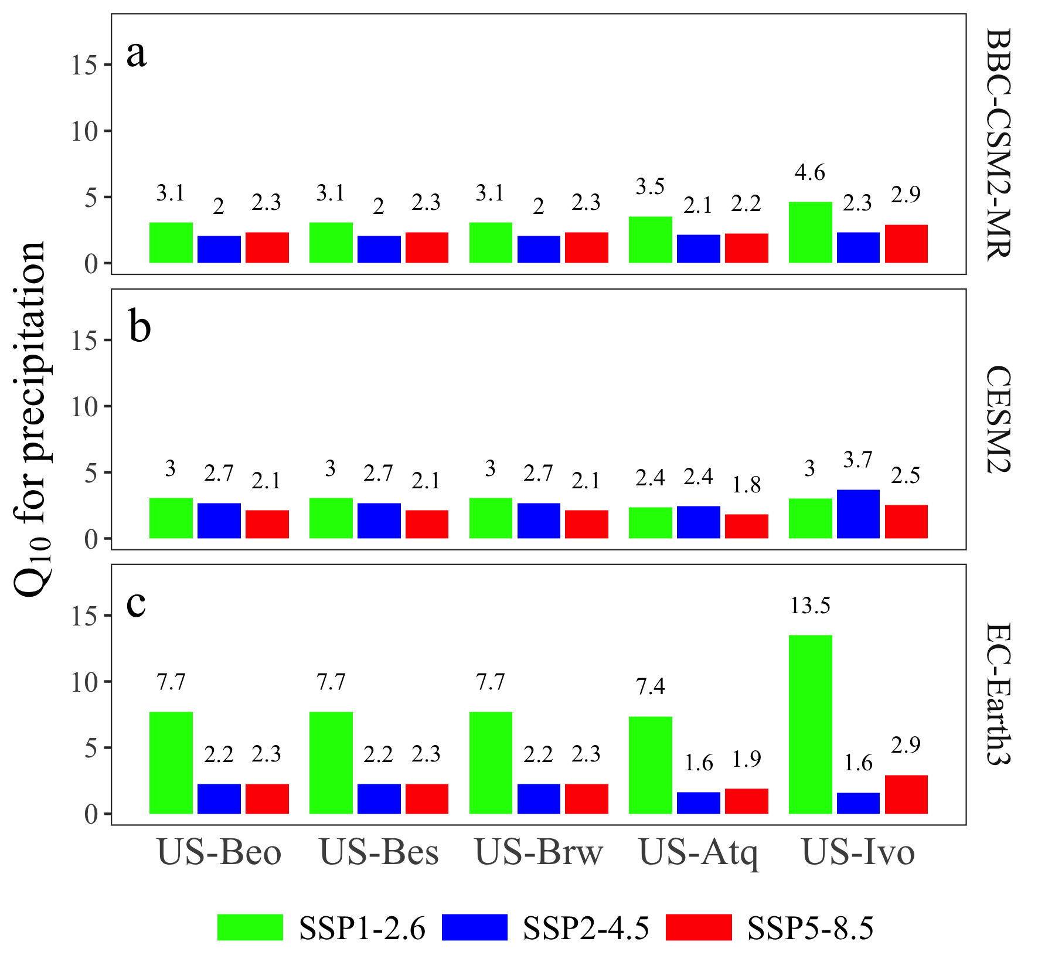
Figure S11. Temperature sensitivity (Q₁₀) of precipitation at US-Beo, US-Bes, US-Brw, US-Atq, and US-Ivo under SSP scenarios derived from a) BBC-CSM2-MR, b) CESM2, and c) EC-Earth3 models. Green indicates SSP1-2.6 scenario, blue indicates SSP2-4.5 scenario, and red indicates SSP5-8.5 scenario. Numbers above the rectangular bar are values of Q₁₀.

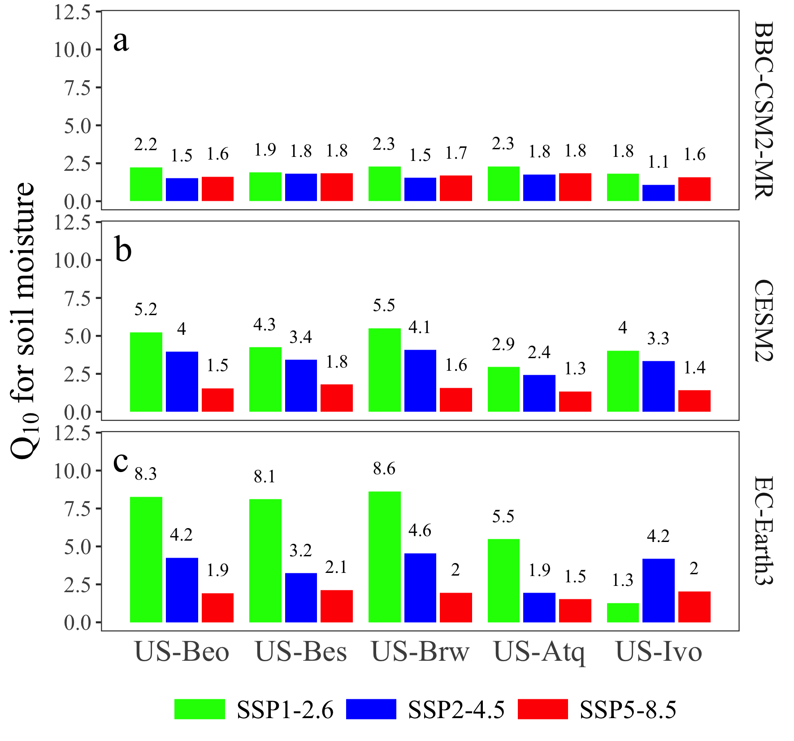
Figure S12. Temperature sensitivity (Q₁₀) of soil moisture at US-Beo, US-Bes, US-Brw, US-Atq, and US-Ivo under SSP scenarios derived from a) BBC-CSM2-MR, b) CESM2, and c) EC-Earth3 models. Green indicates SSP1-2.6 scenario, blue indicates SSP2-4.5 scenario, and red indicates SSP5-8.5 scenario. Numbers above the rectangular bar are values of Q₁₀.

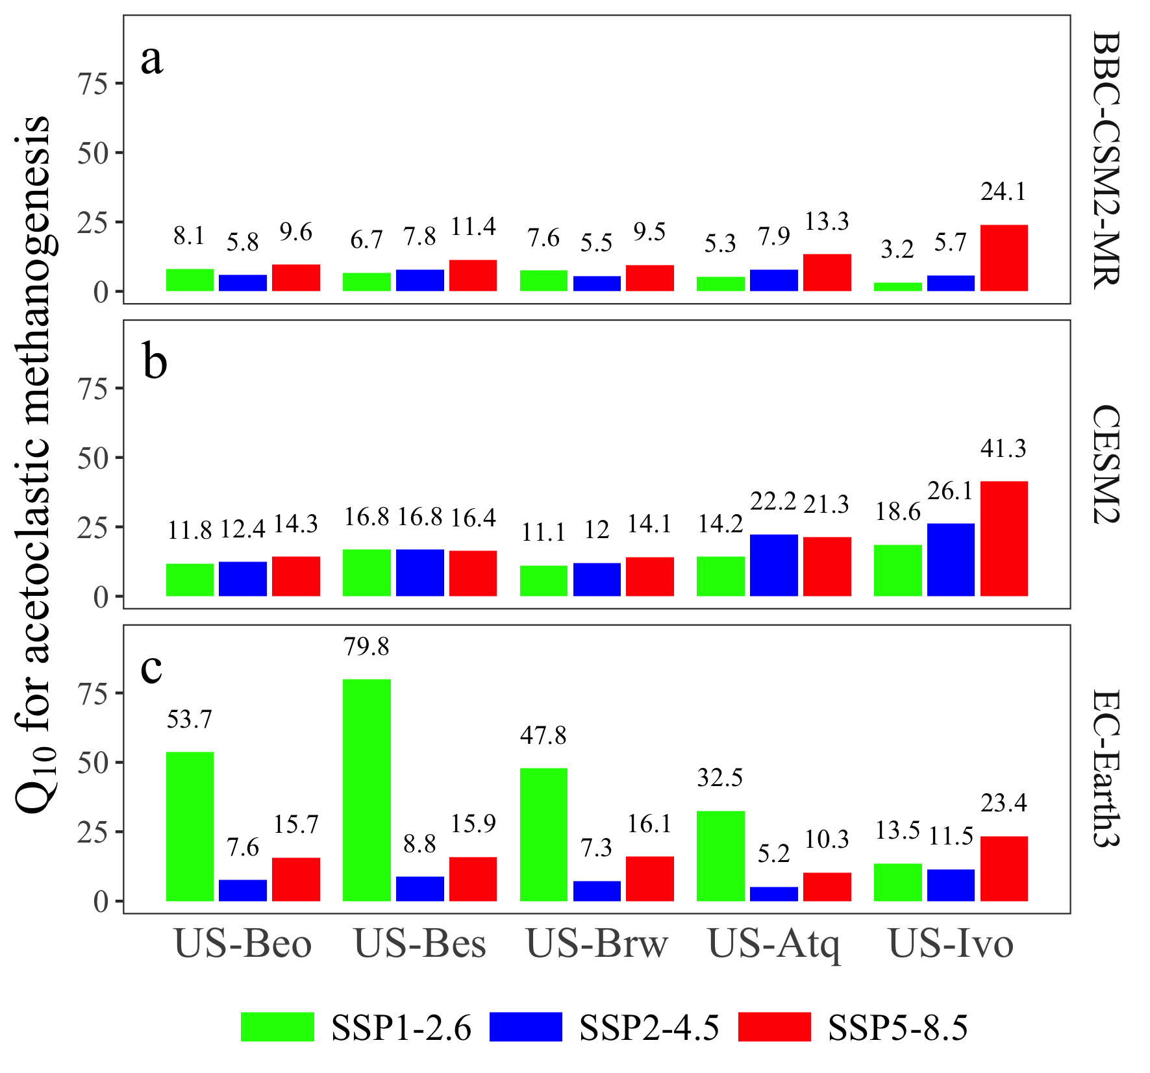
Figure S13. Temperature sensitivity (Q₁₀) of acetoclastic methanogenesis at US-Beo, US-Bes, US-Brw, US-Atq, and US-Ivo under SSP scenarios derived from a) BBC-CSM2-MR, b) CESM2, and c) EC-Earth3 models. Green indicates SSP1-2.6 scenario, blue indicates SSP2-4.5 scenario, and red indicates SSP5-8.5 scenario. Numbers above the rectangular bar are values of Q₁₀.

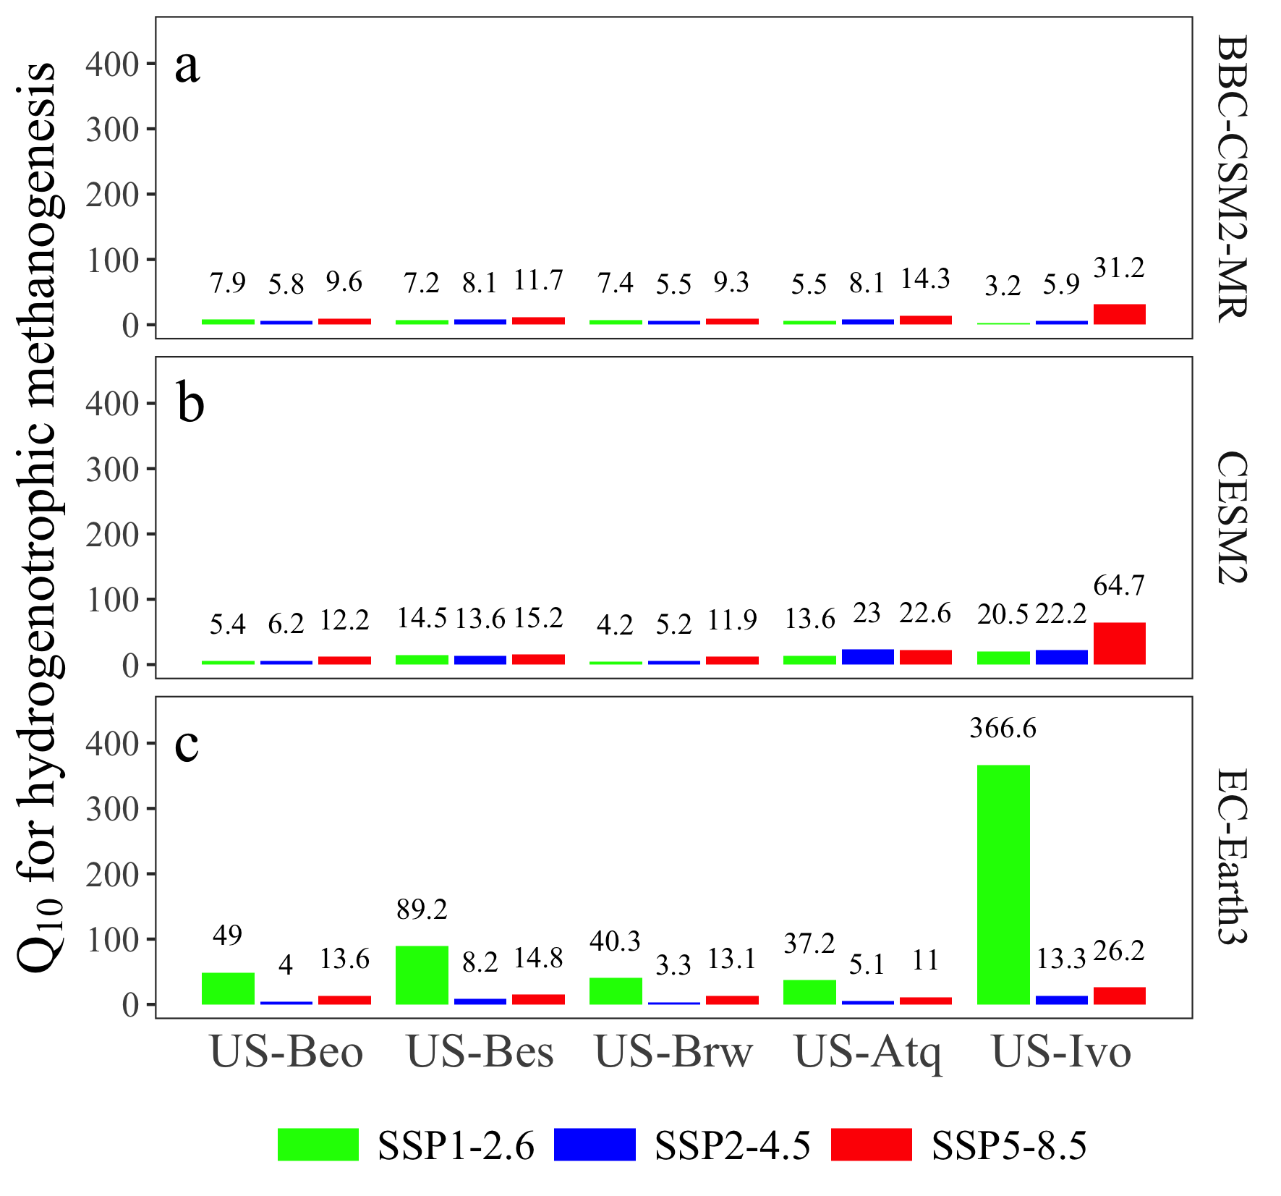
Figure S14. Temperature sensitivity (Q₁₀) of hydrogenotrophic methanogenesis at US-Beo, US-Bes, US-Brw, US-Atq, and US-Ivo under SSP scenarios derived from a) BBC-CSM2-MR, b) CESM2, and c) EC-Earth3 models. Green indicates SSP1-2.6 scenario, blue indicates SSP2-4.5 scenario, and red indicates SSP5-8.5 scenario. Numbers above the rectangular bar are values of Q₁₀.

Table S1. Climate variables of BCC-CSM2-MR in CMIP6 corresponding to required variables of CRUNCEP for CH₄ projections
CRUNCEP |  | BCC-CSM2-MR in CMIP6 |  | Units
Variable | Description | Variable | Description | Units
FSDS | Total incident solar radiation | rsds | Surface downwelling shortwave Radiation | W·m⁻²
PRECTmms | Total precipitation | pr | Precipitation | kg·m⁻²·s⁻¹
FLDS | Incident longwave radiation | rlds | Surface downwelling longwave Radiation | W·m⁻²
PSRF | Surface pressure at the lowest atmospheric level | ps | Surface ir pressure | Pa
QBOT | Specific humidity at the lowest atmospheric level | huss | Near‐surface specific humidity | kg·kg⁻¹
TBOT | Temperature at the lowest atmospheric level | tas | Near‐surface air temperature | K
WIND | Wind at the lowest atmospheric level | uas | Eastward near-surface wind speed | m·s⁻¹
WIND | Wind at the lowest atmospheric level | vas | Northward near-surface wind speed | m·s⁻¹

Table S2. Climate variables of CESM2 in CMIP6 corresponding to required variables of CRUNCEP for CH₄ projections
CRUNCEP |  | CESM2 in CMIP6
Variable | Description | Variable | Description | Units
WIND | Wind at the lowest atmospheric level | a2x3h_Sa_u | Zonal wind at the lowest model | m·s⁻¹
WIND | Wind at the lowest atmospheric level | a2x3h_Sa_v | Meridional wind at the lowest model level | m·s⁻¹
TBOT | Temperature at the lowest atmospheric level | a2x3h_Sa_tbot | Temperature at the lowest model level | K
 |  | a2x3h_Sa_ptem | Potential temperature at the lowest model level | K
QBOT | Specific humidity at the lowest atmospheric level | a2x3h_Sa_shum | Specific humidity at the lowest model level | kg·kg⁻¹
 |  | a2x3h_Sa_dens | Density at the lowest model level | kg·m⁻³
PSRF | Surface pressure at the lowest atmospheric level | a2x3h_Sa_pbot | Pressure at the lowest model level | Pa
 |  | a2x3h_Sa_pslv | Sea level pressure | Pa
FLDS | Incident longwave radiation | a2x3h_Faxa_lwdn | Downward longwave heat flux | W·m⁻²
PRECTmms | Total precipitation | a2x3h_Faxa_rainc | Convective precipitation rate | kg·m⁻²·s⁻¹
PRECTmms | Total precipitation | a2x3h_Faxa_rainl | Large-scale (stable) precipitation rate | kg·m⁻²·s⁻¹
PRECTmms | Total precipitation | a2x3h_Faxa_snowc | Convective snow rate (water equivalent) | kg·m⁻²·s⁻¹
PRECTmms | Total precipitation | a2x3h_Faxa_snowl | Large-scale (stable) snow rate (water equivalent) | kg·m⁻²·s⁻¹
FSDS | Total incident solar radiation | a2x3h_Faxa_swndr | Direct near-infrared incident solar radiation | W·m⁻²
FSDS | Total incident solar radiation | a2x3h_Faxa_swvdr | Direct visible incident solar radiation | W·m⁻²
FSDS | Total incident solar radiation | a2x3h_Faxa_swndf | Diffuse near-infrared incident solar radiation | W·m⁻²
FSDS | Total incident solar radiation | a2x3h_Faxa_swvdf | Diffuse visible incident solar radiation | W·m⁻²

Table S3. Climate variables of EC-Earth3 in CMIP6 corresponding to required variables of CRUNCEP for CH₄ projections
CRUNCEP |  | EC-Earth3 in CMIP6 |  | Units
Variable | Description | Variable | Description | Units
FSDS | Total incident solar radiation | rsds | Surface Downwelling Shortwave Radiation | W·m⁻²
PRECTmms | Total precipitation | pr | Precipitation | kg·m⁻²·s⁻¹
FLDS | Incident longwave radiation | rlds | Surface Downwelling Longwave Radiation | W·m⁻²
PSRF | Surface pressure at the lowest atmospheric level | ps | Surface Air Pressure | Pa
QBOT | Specific humidity at the lowest atmospheric level | huss | Near‐Surface Specific Humidity | kg·kg⁻¹
TBOT | Temperature at the lowest atmospheric level | tas | Near‐Surface Air Temperature | K
WIND | Wind at the lowest atmospheric level | sfcWind | Near‐Surface Wind | m·s⁻¹

Table S4. Averages of CH₄ fluxes (mean ± sd) in the periods of 2006-2015, 2016-2025, 2050s and 2090s at US-Beo, US-Bes, US-Brw, US-Atq and US-Ivo under SSP1-2.6, SSP2-4.5 and SSP5-8.5 scenarios (Note: Different letters indicate significant differences among different sites under each scenario based on Duncan’s multiple range test at the 0.05 level.)

Period | Scenarios | US-Beo | US-Bes | US-Brw | US-Atq | US-Ivo
2006-2015 | Historical | 2.52±0.20^{bc} | 2.49±0.16^{c} | 2.64±0.21^{bc} | 3.03±0.14^{b} | 5.31±0.50ª
2016-2025 | SSP1-2.6 | 2.41±0.11^{d} | 2.12±0.13^{d} | 2.50±0.11^{c} | 3.63±0.18^{b} | 3.81±0.37ª
2016-2025 | SSP2-4.5 | 2.41±0.15^{c} | 2.09±0.15^{c} | 2.50±0.15^{b} | 3.52±0.26ª | 3.74±0.39ª
2016-2025 | SSP5-8.5 | 2.58±0.12^{d} | 2.25±0.13^{d} | 2.68±0.13^{c} | 3.88±0.20^{b} | 4.12±0.39ª
2050s | SSP1-2.6 | 3.48±0.54^{b} | 3.17±0.69^{b} | 3.59±0.56^{ab} | 5.11±0.88ª | 4.97±0.98ª
2050s | SSP2-4.5 | 3.51±0.16^{b} | 3.16±0.25^{b} | 3.62±0.16^{b} | 5.45±0.53ª | 5.05±0.58ª
2050s | SSP5-8.5 | 4.35±0.49^{b} | 3.99±0.69^{b} | 4.47±0.49^{b} | 7.09±1.03ª | 7.43±1.16ª
2090s | SSP1-2.6 | 3.65±0.46^{c} | 3.38±0.64^{c} | 3.73±0.45^{abc} | 5.42±0.93ª | 5.31±1.02^{ab}
2090s | SSP2-4.5 | 4.78±0.32^{b} | 4.61±0.32^{b} | 4.87±0.30^{b} | 7.61±0.93ª | 7.07±1.09ª
2090s | SSP5-8.5 | 19.72±8.00^{b} | 19.18±7.62^{b} | 20.13±8.11^{ab} | 26.88±6.00ª | 26.00±4.67^{ab}

Table S5. Fluxes and concentrations of different variables in CH₄ processes at US-Beo, US-Bes, US-Brw, US-Atq, and US-Ivo in 2016-2025, 2050s and 2090s under SSP1-2.6, SSP2-4.5 and SSP5-8.5

Site | Variable |  | 2016-2025 |  |  | 2050s |  |  | 2090s
Site | Variable | SSP1-2.6 | SSP2-4.5 | SSP5-8.5 | SSP1-2.6 | SSP2-4.5 | SSP5-8.5 | SSP1-2.6 | SSP2-4.5 | SSP5-8.5
US-Beo | NPP | 377.881 | 366.410 | 371.440 | 501.760 | 514.519 | 541.840 | 550.172 | 603.568 | 810.542
 | [DOC] | 91.327 | 90.211 | 89.914 | 114.631 | 117.483 | 114.179 | 127.539 | 120.371 | 115.578
 | [ACE] | 0.188 | 0.185 | 0.203 | 0.323 | 0.340 | 0.439 | 0.345 | 0.546 | 2.637
 | [CH₄] | 0.700 | 0.692 | 0.710 | 0.788 | 0.801 | 0.893 | 0.805 | 0.934 | 6.356
 | Process (a) | 0.458 | 0.467 | 0.485 | 0.695 | 0.684 | 0.824 | 0.730 | 0.975 | 2.410
 | Process (b) | 0.590 | 0.579 | 0.634 | 0.916 | 0.954 | 1.222 | 0.949 | 1.356 | 8.035
 | Process (c) | 0.054 | 0.053 | 0.058 | 0.079 | 0.085 | 0.107 | 0.083 | 0.105 | 0.680
 | Process (d) | 1.251 | 1.261 | 1.295 | 1.489 | 1.477 | 1.634 | 1.532 | 1.782 | 3.012
 | Process (e) | 0.957 | 0.945 | 1.066 | 1.600 | 1.636 | 2.187 | 1.689 | 2.379 | 14.341
 | Process (f) | 0.201 | 0.203 | 0.224 | 0.395 | 0.399 | 0.529 | 0.428 | 0.621 | 2.364
 | Process (g) | 1.87E-10 | 1.84E-10 | 1.89E-10 | 2.14E-10 | 2.20E-10 | 2.50E-10 | 2.19E-10 | 2.62E-10 | 1.22E+00
 | Process (h) | 2.17E-13 | 2.16E-13 | 2.17E-13 | 2.24E-11 | 2.39E-12 | 2.16E-05 | -2.89E-03 | -3.86E-02 | 2.24E-01
US-Bes | NPP | 349.984 | 337.669 | 326.309 | 477.569 | 487.883 | 508.463 | 522.997 | 598.578 | 788.653
 | [DOC] | 92.010 | 91.146 | 89.365 | 114.552 | 115.952 | 110.223 | 125.037 | 123.981 | 114.520
 | [ACE] | 0.290 | 0.286 | 0.292 | 0.396 | 0.397 | 0.502 | 0.414 | 0.637 | 2.544
 | [CH₄] | 0.701 | 0.694 | 0.710 | 0.795 | 0.807 | 0.909 | 0.812 | 0.957 | 6.184
 | Process (a) | 0.396 | 0.397 | 0.411 | 0.613 | 0.598 | 0.725 | 0.665 | 0.910 | 2.311
 | Process (b) | 0.546 | 0.528 | 0.581 | 0.861 | 0.891 | 1.176 | 0.899 | 1.339 | 7.705
 | Process (c) | 0.049 | 0.047 | 0.052 | 0.077 | 0.080 | 0.105 | 0.080 | 0.115 | 0.685
 | Process (d) | 1.131 | 1.129 | 1.163 | 1.387 | 1.379 | 1.526 | 1.453 | 1.721 | 2.986
 | Process (e) | 0.901 | 0.874 | 0.997 | 1.591 | 1.595 | 2.203 | 1.712 | 2.544 | 14.797
 | Process (f) | 0.085 | 0.084 | 0.093 | 0.192 | 0.188 | 0.259 | 0.215 | 0.342 | 1.399
 | Process (g) | 1.88E-10 | 1.85E-10 | 1.90E-10 | 2.16E-10 | 2.22E-10 | 2.54E-10 | 2.20E-10 | 2.68E-10 | 1.16E+00
 | Process (h) | 5.89E-04 | 6.21E-04 | 5.48E-04 | 6.10E-04 | 4.52E-04 | 2.20E-04 | 6.75E-04 | -8.63E-04 | 1.25E-01
US-Brw | NPP | 390.491 | 379.344 | 384.480 | 516.067 | 529.769 | 557.739 | 565.051 | 617.480 | 831.032
 | [DOC] | 94.765 | 93.662 | 93.342 | 117.645 | 120.931 | 117.526 | 130.955 | 122.998 | 117.464
 | [ACE] | 0.197 | 0.193 | 0.212 | 0.333 | 0.352 | 0.449 | 0.352 | 0.539 | 2.719
 | [CH₄] | 0.704 | 0.697 | 0.715 | 0.790 | 0.803 | 0.893 | 0.808 | 0.937 | 6.436
 | Process (a) | 0.472 | 0.482 | 0.501 | 0.717 | 0.705 | 0.849 | 0.747 | 1.000 | 2.482
 | Process (b) | 0.615 | 0.604 | 0.661 | 0.940 | 0.983 | 1.250 | 0.972 | 1.383 | 8.280
 | Process (c) | 0.056 | 0.055 | 0.060 | 0.080 | 0.088 | 0.108 | 0.085 | 0.105 | 0.672
 | Process (d) | 1.267 | 1.279 | 1.314 | 1.511 | 1.492 | 1.655 | 1.544 | 1.795 | 3.029
 | Process (e) | 0.947 | 0.933 | 1.054 | 1.538 | 1.580 | 2.098 | 1.612 | 2.252 | 14.000
 | Process (f) | 0.283 | 0.286 | 0.315 | 0.539 | 0.547 | 0.719 | 0.579 | 0.828 | 3.099
 | Process (g) | 1.88E-10 | 1.85E-10 | 1.91E-10 | 2.15E-10 | 2.21E-10 | 2.50E-10 | 2.20E-10 | 2.63E-10 | 1.27E+00
 | Process (h) | 2.17E-13 | 2.16E-13 | 2.17E-13 | 6.16E-13 | 1.48E-12 | -1.24E-04 | -8.41E-03 | -7.24E-02 | 2.91E-01
US-Atq | NPP | 528.024 | 520.393 | 530.191 | 669.013 | 684.279 | 731.173 | 696.824 | 756.616 | 1035.635
 | [DOC] | 123.610 | 123.168 | 122.686 | 153.338 | 153.899 | 152.859 | 156.369 | 149.947 | 145.171
 | [ACE] | 0.470 | 0.458 | 0.489 | 0.729 | 0.730 | 0.930 | 0.828 | 1.224 | 4.169
 | [CH₄] | 0.864 | 0.853 | 0.875 | 1.103 | 1.305 | 1.659 | 1.162 | 1.911 | 7.889
 | Process (a) | 0.653 | 0.643 | 0.684 | 0.915 | 0.914 | 1.127 | 0.985 | 1.254 | 3.079
 | Process (b) | 0.990 | 0.956 | 1.052 | 1.413 | 1.602 | 2.063 | 1.502 | 2.279 | 11.301
 | Process (c) | 0.088 | 0.085 | 0.094 | 0.125 | 0.145 | 0.185 | 0.134 | 0.205 | 1.068
 | Process (d) | 1.496 | 1.478 | 1.538 | 1.775 | 1.799 | 2.046 | 1.868 | 2.180 | 3.720
 | Process (e) | 2.130 | 2.041 | 2.342 | 3.331 | 3.645 | 5.043 | 3.547 | 5.422 | 23.039
 | Process (f) | 3.26E-04 | 1.88E-04 | 2.27E-04 | 2.08E-03 | 1.57E-03 | 4.64E-03 | 2.68E-03 | 7.68E-03 | 1.26E-01
 | Process (g) | 2.28E-10 | 2.23E-10 | 2.31E-10 | 2.90E-10 | 3.44E-10 | 4.26E-10 | 3.06E-10 | 4.84E-10 | 2.24E+00
 | Process (h) | 9.52E-07 | 8.78E-07 | 7.45E-07 | 1.02E-03 | 7.59E-05 | 3.63E-04 | 4.16E-03 | 2.16E-03 | 8.54E-01
US-Ivo | NPP | 702.271 | 695.663 | 709.759 | 805.405 | 791.636 | 886.374 | 813.459 | 885.275 | 1097.918
 | [DOC] | 173.224 | 174.018 | 171.862 | 190.482 | 189.166 | 187.396 | 190.242 | 188.936 | 149.882
 | [ACE] | 0.563 | 0.541 | 0.609 | 0.681 | 0.694 | 1.015 | 0.734 | 1.005 | 4.620
 | [CH₄] | 0.911 | 0.895 | 0.940 | 0.933 | 1.010 | 1.445 | 0.977 | 1.439 | 7.981
 | Process (a) | 0.782 | 0.761 | 0.815 | 1.006 | 0.949 | 1.331 | 1.085 | 1.351 | 3.155
 | Process (b) | 1.007 | 0.974 | 1.106 | 1.338 | 1.410 | 2.155 | 1.435 | 2.001 | 12.138
 | Process (c) | 0.063 | 0.071 | 0.076 | 0.092 | 0.111 | 0.169 | 0.093 | 0.137 | 0.973
 | Process (d) | 1.556 | 1.550 | 1.609 | 1.796 | 1.761 | 2.122 | 1.857 | 2.096 | 3.420
 | Process (e) | 1.347 | 1.296 | 1.512 | 1.843 | 1.952 | 3.203 | 1.983 | 2.957 | 15.992
 | Process (f) | 0.910 | 0.898 | 0.999 | 1.333 | 1.333 | 2.105 | 1.470 | 2.015 | 6.592
 | Process (g) | 2.32E-10 | 2.27E-10 | 2.41E-10 | 2.42E-10 | 2.62E-10 | 3.67E-10 | 2.50E-10 | 3.63E-10 | 2.50E+00
 | Process (h) | -2.73E-03 | -7.54E-03 | -9.15E-03 | 2.96E-03 | 3.18E-03 | -2.20E-02 | -5.75E-02 | -5.56E-02 | 5.09E-01
Note: These variables are corresponding to that in conceptual models of changes in CH₄ processes, include net primary production (NPP, gC ·m⁻²·year⁻¹), soil dissolved organic carbon concentration ([DOC], gC ·m⁻²·year⁻¹), soil acetate concentration ([ACE], gC ·m⁻²·year⁻¹), soil CH₄ concentration (gC ·m⁻²·year⁻¹), and process (a) fermentation of soil organic matter (SOM)/DOC to acetate (gC ·m⁻²·year⁻¹), process (b) acetoclastic methanogenesis (gC ·m⁻²·year⁻¹), process (c) hydrogenotrophic methanogenesis (gC ·m⁻²·year⁻¹), process (d) diffusion (gC ·m⁻²·year⁻¹), process (e) ebullition (gC ·m⁻²·year⁻¹), process (f) the plant-mediated transport (gC ·m⁻²·year⁻¹), process (g) aerobic oxidation (gC ·m⁻²·year⁻¹), and process (h) anaerobic oxidation of CH₄ (gC ·m⁻²·year⁻¹).

Table S6. General linear regression analysis for CH₄ fluxes with air temperature, precipitation, soil temperature (at 10 cm), soil moisture (at 10 cm), canopy evapotranspiration (ET), and net primary production (NPP), biomass of acetoclastic methanogens and hydrogenotrophic methanogens. Significant level: ‘***’ indicates < 0.0001.
Variable | Intercept | Estimate | R² | P value
Air temperature | -0.0538±0.0023 | 0.6611±0.0075 | 0.6691 | <0.0001***
Precipitation | -0.0401±0.0024 | 0.7473±0.0096 | 0.6114 | <0.0001***
Soil temperature | -0.1086±0.0031 | 0.5977±0.0074 | 0.6298 | <0.0001***
Soil moisture | -0.0703±0.0044 | 0.4709±0.0101 | 0.3595 | <0.0001***
ET | -0.0639±0.0039 | 0.4722±0.0094 | 0.3963 | <0.0001***
NPP | -0.1159±0.0039 | 0.5895±0.0092 | 0.5135 | <0.0001***
Acetoclastic methanogens | 0.0465±0.0008 | 1.5571±0.0081 | 0.9045 | <0.0001***
Hydrogenotrophic methanogens | 0.0325±0.0005 | 0.9979±0.0030 | 0.9666 | <0.0001***

