Supplemental Information for

Inferred Vehicular Emissions at a Near-Road Site: Impacts of COVID-19 Restrictions, Traffic Patterns, and Ambient Air Temperature
Dolly L. Hall-Quinlan¹, Hao He^{1,2}, Xinrong Ren^{1,3}, Timothy P. Canty^{1,4}, Ross J. Salawitch^{1,2,5}, Phillip Stratton¹, Russell R. Dickerson^{1,2,5}
¹Department of Atmospheric and Oceanic Science, University of Maryland, College Park, Maryland, USA
²Earth System Science Interdisciplinary Center, University of Maryland, College Park, Maryland, USA
³Resources Laboratory, National Oceanic and Atmospheric Administration, College Park, Maryland, USA
⁴Marine Estuarine Environmental Sciences, University of Maryland, College Park, Maryland, USA
⁵Department of Chemistry and Biochemistry, University of Maryland, College Park, Maryland, USA
Correspondence to: Dolly Hall-Quinlan (dahall01@umd.edu)
Keywords: On-road Emissions; Air Quality; COVID-19; Ambient Temperature; Emission Model; Black Carbon; NOx; CO; CO₂
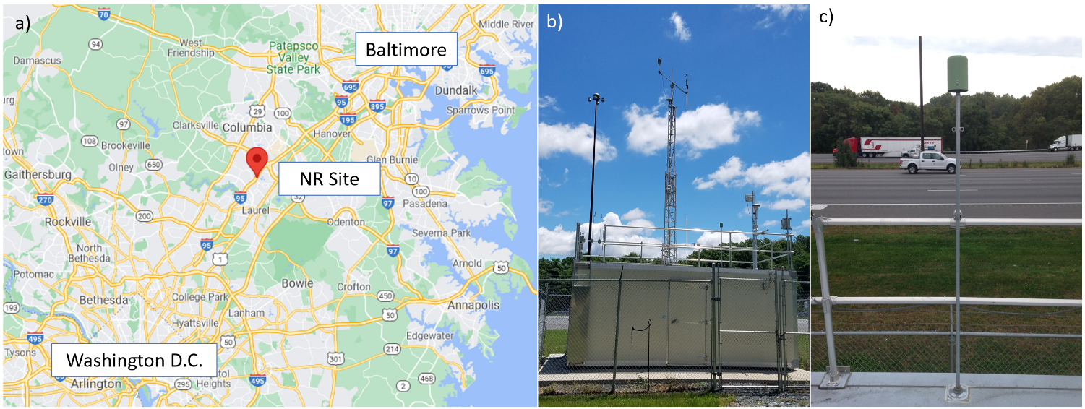
Figure S1. Location of the I-95 near-road (NR) monitoring site within the Baltimore-Washington Region (a). The trailer housing the ambient measurement analyzers is shown in (b). A rooftop view of the proximity of the trailer to the adjacent major highway is presented in (c).

Section S1: Instrument Details
The observations used in this study were collected between January 2017 and December 2018, then again from March 2020 through December 2020. Meteorological variables including temperature, pressure, relative humidity, and wind direction were sampled using a Vaisala WXT 520 instrument. Mixing ratios of NO_{x} were measured by chemiluminescence using a Teledyne Advanced Pollution Instrumentation (API) Model 200 U analyzer (API, 2013). The analyzer is equipped with a hot molybdenum converter that is also sensitive to reactive nitrogen species other than NO_{x} (Dickerson et al., 2019; Fehsenfeld et al., 1987); however, fresh NO_{x} emissions from the adjacent highway dominate NR reactive nitrogen (Hall et al., 2020). The mean relative calibration accuracy of the NO_{x} analyzer, defined here as the mean relative difference between analyzer measurements and a calibration standard at set concentrations, was 4.7% for abundances between 9 and 12 parts per billion by volume (ppbv) following routine quality control checks performed twice a month as outlined in the CFR for AQS sites. Carbon monoxide mixing ratios were quantified by infrared radiation absorption using a Teledyne API 300 U analyzer and exhibited a mean relative calibration accuracy of 2.3% at 500 ppbv. Ambient measurements of CO₂ concentrations prior to March 22, 2020 were collected using a Los Gatos Research (LGR) Fast Greenhouse Gas Analyzer (FGGA) with the Enhanced Performance Option (Los Gatos Research, 2013). The relative accuracy of CO₂ measurements collected with the LGR analyzer is 0.089% at 516 parts per million by volume (ppmv) by comparison to known concentrations from the National Institute of Standards and Technology. Starting March 23, 2020, CO₂ mixing ratios were measured by cavity ringdown spectroscopy using a Picarro Model G2301 CO₂/CH₄/H₂O Analyzer with a manufacturer’s stated relative accuracy of better than 0.025% between 300 and 500 ppmv for CO₂. An intercomparison of CO₂ abundances measured by the LGR and Picarro analyzers is presented in Figure S2 and shows excellent correlation between 400 and 580 ppmv (r² =0.99994) and nearly identical mixing ratios with relative differences of less than 0.06%. More details about the analyzers used to measure NO_{x}, CO, and CO₂ mixing ratios at this site are given by Hall et al. (2020) and Martin et al. (2017). While the accuracy of the analyzers is important, the conclusions of this study depend more on precision and repeatability because we compare differences in emission ratios before and during COVID restrictions, and as a function of temperature. The overall precision of the BC, CO, NO_{x}, and CO₂ analyzers is better than 10% (API, 2013; Grimes & Dickerson, 2021; Los Gatos Research, 2018; Martin et al., 2017; Picarro, 2019).
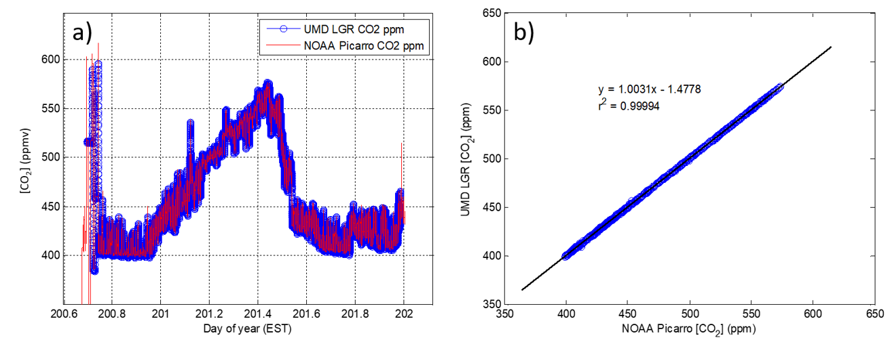
Figure S2. Comparison of ambient CO₂ mixing ratios (ppmv) measured with a Los Gatos Research (LGR) FGGA analyzer and a Picarro Greenhouse Gas Analyzer, shown as a function of day of year (a) and as a scatterplot (b). The intercomparison data were collected at the I-95 NR site on July 18−19, 2020.

Black carbon concentrations, [BC], were collected with a Magee Scientific TAPI M633 (AE33) Aethalometer following standard EPA AQS operating and quality control procedures outlined in the CFR. The Aethalometer measures light attenuation at seven wavelengths, but 880 nm is typically chosen to represent BC concentration from fossil fuel emissions. The AE33 analyzer uses the dual-spot technique, in which aerosols are simultaneously collected on two spots of filter paper at different flow rates, to minimize the filter loading effect (Magee Scientific, 2018). While Aethalometers are widely used to measure [BC] within the AQS network, assessing the uncertainty of [BC] can be challenging due to a number of factors including the lack of calibration standards. Grimes & Dickerson (2021) used BC surrogate particles to show that [BC] measured by a Magee AE 31 Aethalometer at 880 nm was within 5% of concentrations derived from a particle counting technique for mass concentrations less than 2.5 μg m⁻³ (for reference, the 75th percentile [BC] at the I-95 NR site in all of 2017 and 2018 was 1.8 μg m⁻³).
Comparison of Fuel-Based Emission Factors to Literature
Here we examine the agreement between our estimated emission ratios and fuel-based emission factors in the literature using two approaches of calculating the median emission factors (mass of pollutant kg⁻¹_{fuel}) along I-95 in April of 2017 and 2018:
Approach a: Estimate BC and NO_{x} emission factors using the ∆BC/∆CO₂ and ∆BC/∆NO_{x} emission ratios presented in Table 3 (considering all days and hours). To do this, we assume that >99% of the carbon from the fuel is oxidized to CO₂ (https://www.epa.gov/greenvehicles/light-duty-vehicle-emissions) and that the average formula for gasoline is C₈H₁₈ with a molecular weight of 114 g mol⁻¹. Additionally, we use the split between nitrogen oxide (NO) and nitrogen dioxide (NO₂) at the I-95 NR site for the month of April to estimate a weighted average molecular mass of NO_{x}. With a NO/NO₂ ratio of 0.635, the weighted average molecular mass of NO_{x} is:
0.635·30 gr_{NO} mol⁻¹ + (1−0.635)·46 gr_{NO2} mol⁻¹ = 35.8 gr mol⁻¹ NO_{x}.
Approach b: Similar to the method used in Ban-Weiss et al. (2008) and Wang et al. (2018), we estimate emission factors using
$$Fuel-based emission factor (BC or {NO}_{x})=\left(\frac{∆BC or ∆{NO}_{x}}{∆CO+∆{CO}_{2}}\right)∙w_{s}$$
Where ∆ represents the enhancement above background (concentration – background) and w_{s} is the fuel carbon mass fraction, taken to be 0.86 (Ban-Weiss et al., 2008). The method for background calculation is discussed in Section S2.

Table S1. Comparison of fuel-based emission factors calculated from this study and other references in the literature.
Reference | BC Emission Factor  (mg kg⁻¹_{fuel}) | NO_{x} Emission Factor  (g kg⁻¹_{fuel})
This study (approach a) | 157 | 5.16
This study (approach b) | 126 | 4.85
Wang et al. (2018; springtime)  (Measurable emitters only) | 210 | 2.75
Ban-Weiss et al. (2008) | 860-920 (MD and HD) 22-26 (LD)* | 40 (MD and HD)  3 (LD)*
Bishop et al. (2022) | --- | 18.5 (HD only)

*MD = medium-duty, HD = heavy-duty, and LD = light duty. Assuming a 10% MD/HD and 90% LD split at the I-95 NR site and the mean emission factors from Ban-Weiss et al. (2008), the weighted-mean emission factors for I-95 would be 111 mg BC kg⁻¹_{fuel} and 6.7 mg NO_{x} kg⁻¹_{fuel}.

Comparison of Summer and Winter MOVES3 ∆BC/∆CO and ∆BC/∆CO₂ Emission Ratios
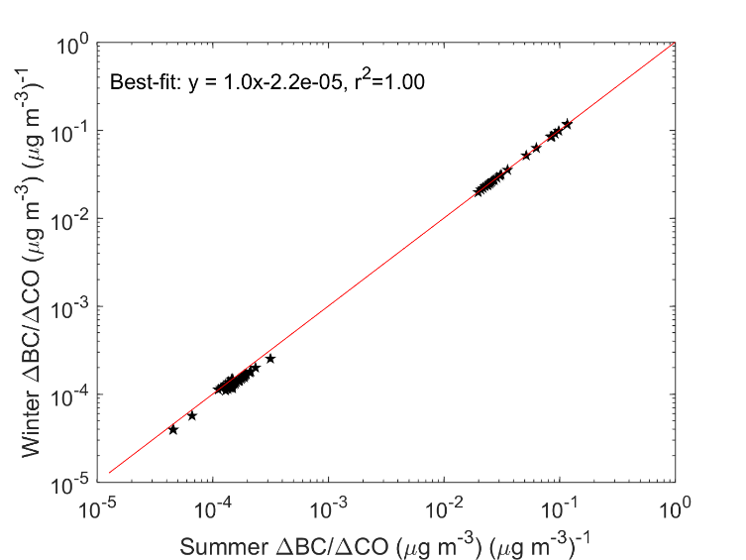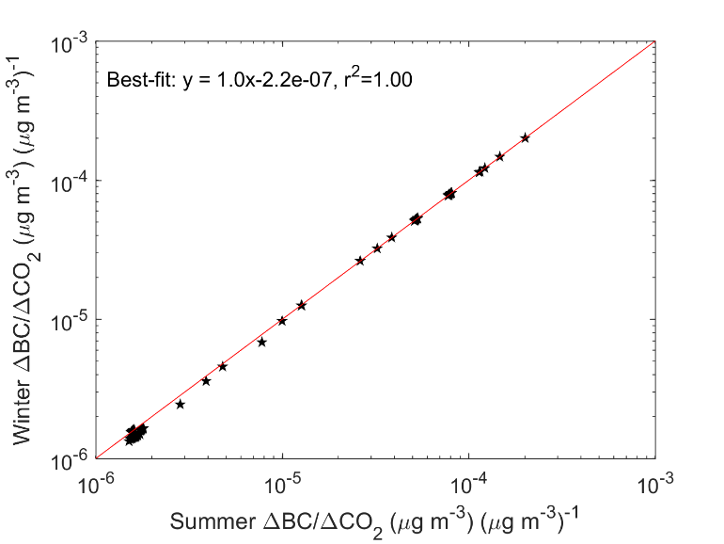
a.
b.
Figure S3. Comparison of summer (June) and winter (December) ∆BC/∆CO (a) and ∆BC/∆CO₂ (b) emission ratios from MOVES3. Emissions were simulated for Howard County, MD using 2017 input data (as described in text) for June and December. The near-unity slope indicates no significant seasonality in BC emissions from MOVES3.

Details Regarding MOVES3-Required Input Data
Table S2. Input data required for MOVES3 county-level simulations used in this study. Data for Howard County, MD, are compiled by the Maryland Department of the Environment.
Input Group | MOVES3 Input
VMT by: | Road Type
VMT by: | Hour
VMT by: | Day
VMT by: | Month
VMT by: | Source Type
Fuel Information | Fuel Supply
Fuel Information | Fuel Formulation
Fuel Information | Alternative Vehicle Fuel Technologies (AVFT)
Fuel Information | Fuel Usage Fraction
 | Average Speed Distribution
 | Source Type Population
 | Vehicle Age Distribution
 | I/M Coverage
 | Meteorology Data

Daily Total Traffic Volume Passing the I-95 Near-Road Site

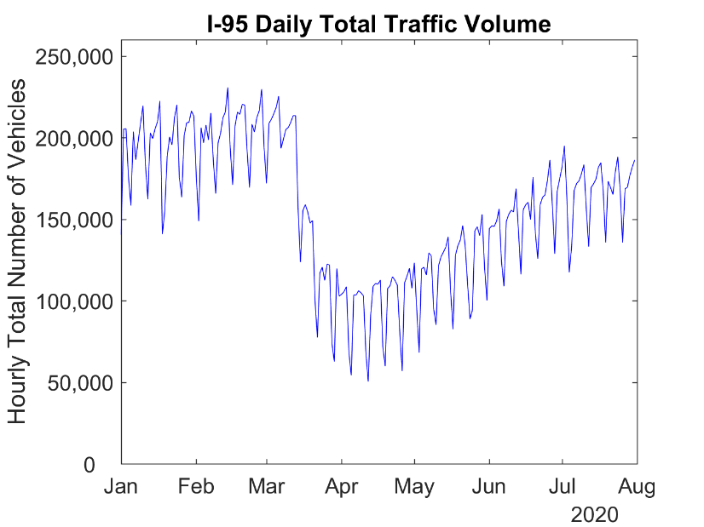
Figure S4. Daily total number of vehicles passing the I-95 NR site in Howard County, MD, from January through July 2020.

Traffic Composition of Vehicle Fleet Passing I-95 NR site by Time and Weekday
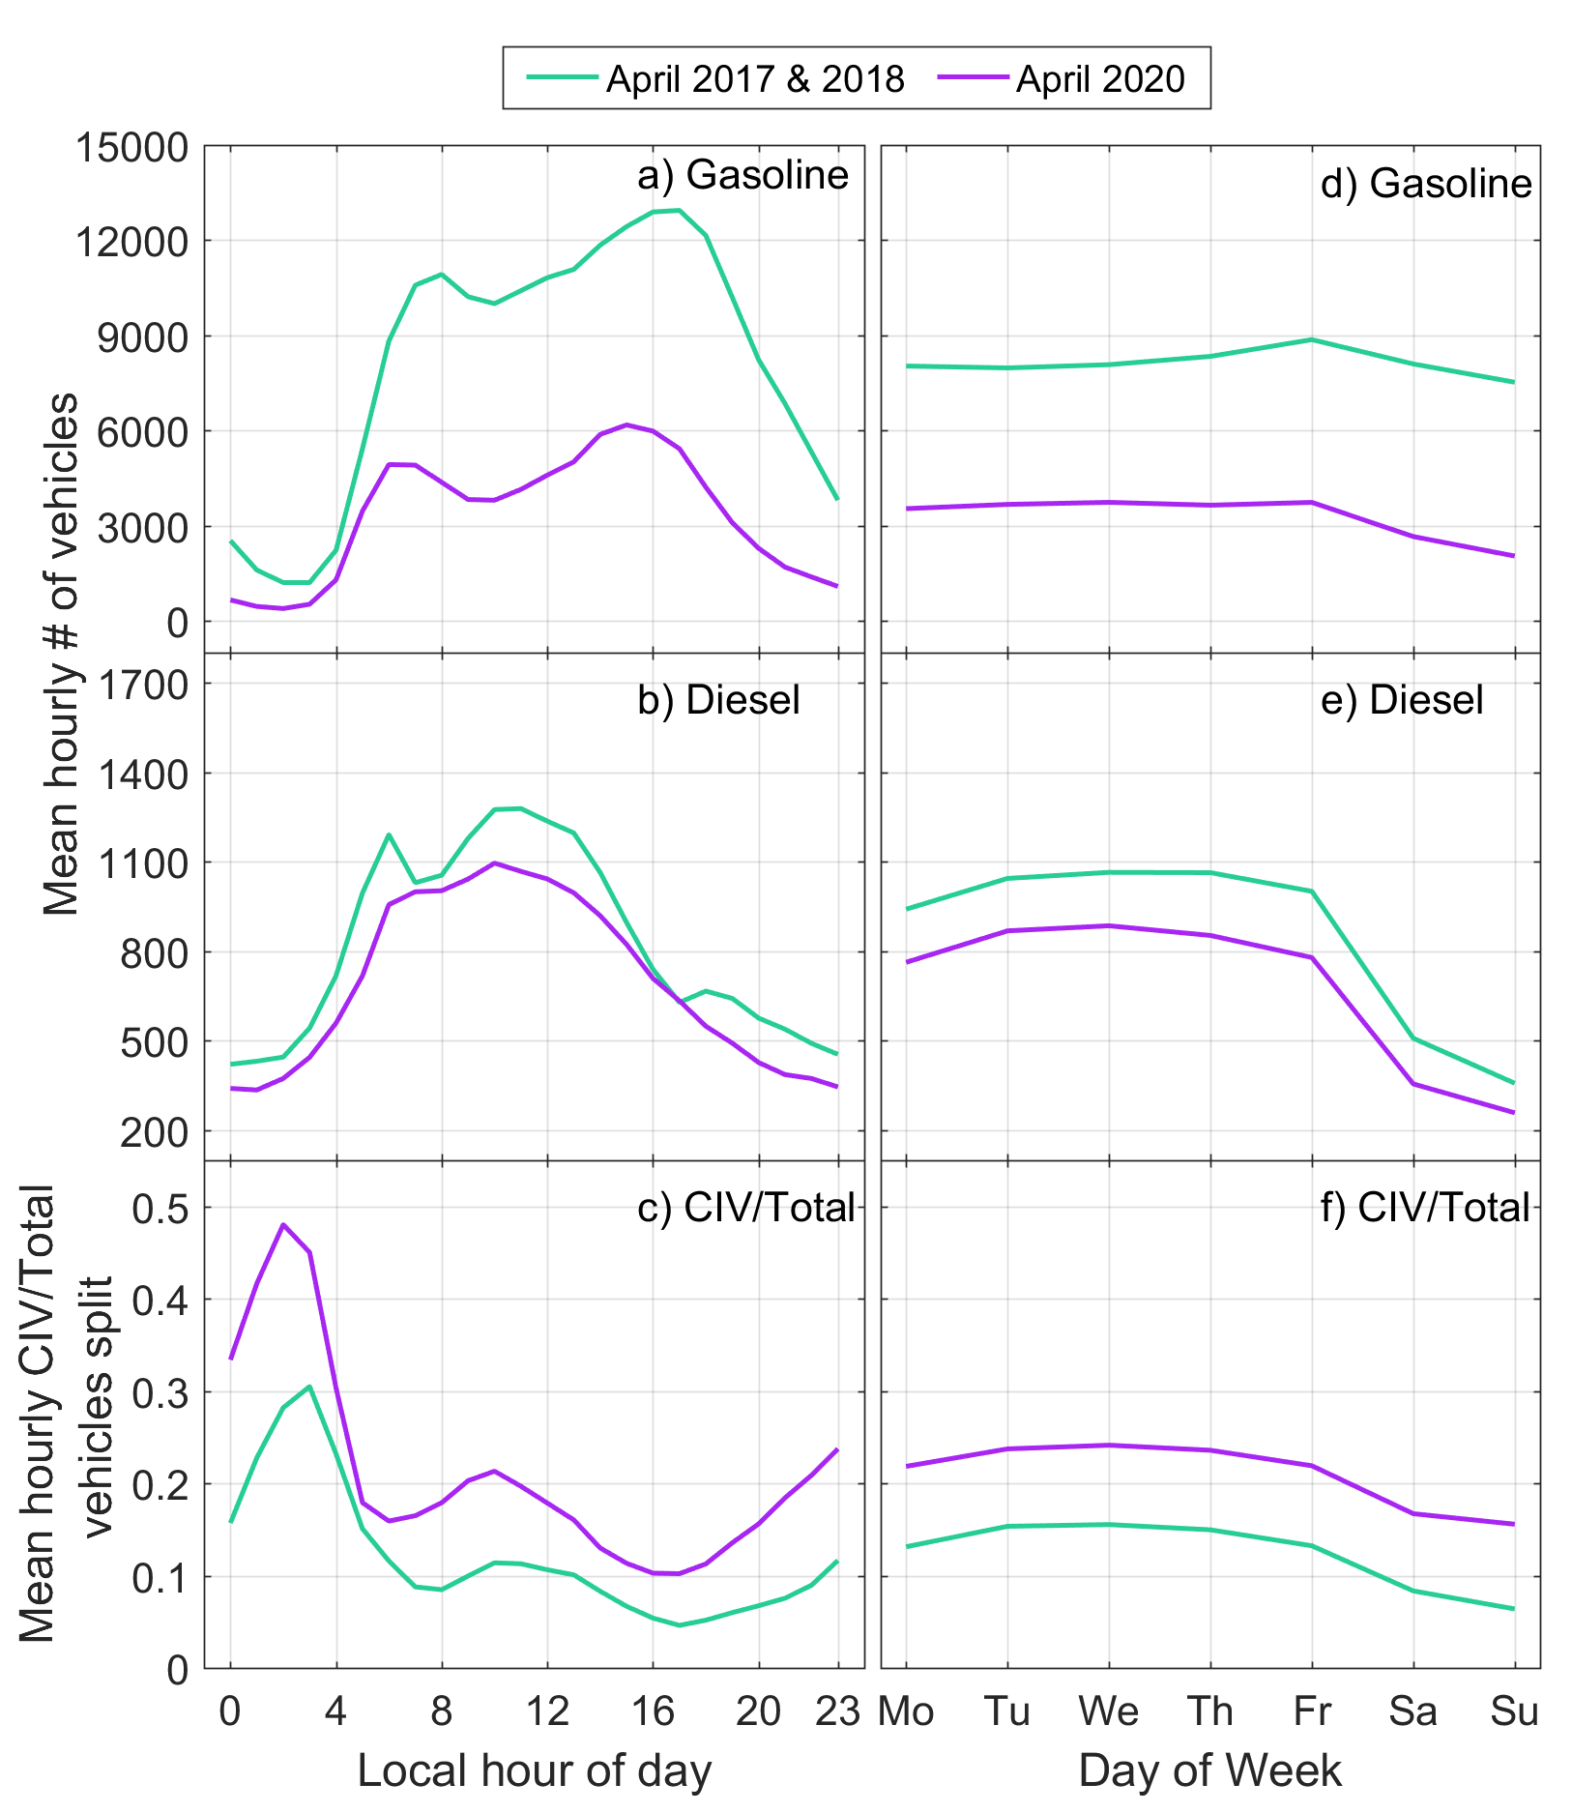
Figure S5. Traffic composition by local time (a-c) and weekday (d-f) of vehicles passing the I-95 NR site pre-COVID (April 2017 & 2018) and in April 2020. Changes in total gasoline (a, d) and diesel (b, e) vehicle counts are represented by the average hourly number of vehicles at each hour or day of the week. The CIV-to-total vehicle split is shown as a fraction by time of day (c) and also by weekday (f).

Vehicle Speed and Frequency of Stop-and-Go Traffic at I-95 Site in April 2020 and April 2017 & 2018 by Time and Weekday
Table S3. Weighted average vehicle speeds (μ in m s⁻¹) and the fraction of vehicles driving under 22 m s⁻¹ (frac_{<22mps}) at the I-95 traffic counter site for all data and also separated by weekday and local time, pre-COVID and April of 2020.
 | April 2017 and 2018 | April 2020
All days and hours  (Shown in Figure 2 in main paper) | μ=26.6 m s⁻¹  frac_{<22mps} = 23.6% | μ=30.3 m s⁻¹  frac_{<22mps} = 1.40%
Weekdays (Mo − Fr) | μ=26.4 m s⁻¹  frac_{<22mps} = 24.3% | μ=30.2 m s⁻¹  frac_{<22mps} = 1.28%
Weekends (Sa and Su) | μ=28.6 m s⁻¹  frac_{<22mps} = 11.0% | μ=31.0 m s⁻¹  frac_{<22mps} = 1.97%
23:00 – 04:59 (early morning) | μ=30.3 m s⁻¹  frac_{<22mps} = 0.80% | μ=30.3 m s⁻¹  frac_{<22mps} = 1.40%
05:00 – 09:59 (morning rush) | μ=26.6 m s⁻¹  frac_{<22mps} = 24.1% | μ=30.3 m s⁻¹  frac_{<22mps} = 1.23%
14:00 – 20:59 (afternoon rush) | μ=24.9 m s⁻¹  frac_{<22mps} = 35.4% | μ=30.5 m s⁻¹  frac_{<22mps} = 1.54%

Summary of Five-Minute Ambient [BC], [CO], [NO_{x}], and [CO₂] Observations
Table S4. Summary of five-minute averaged ambient measurements of [BC], [CO], [NO_{x}], and [CO₂] at the I-95 NR site in Howard County, MD for pre-COVID (April 2017 and 2018) and April 2020.
I-95 Site five-min data | Number of valid data points |  | 5th percentile |  | 95th percentile |  | Median |  | Mean |  | Standard deviation
April 2017 and 2018
[BC] (μg m⁻³) |  | 17,225 |  | 0.060 |  | 3.04 |  | 0.80 |  | 1.05 |  | 1.02
[CO] (ppbv) |  | 15,554 |  | 150 |  | 433 |  | 238 |  | 259 |  | 94.1
[NO_{x}] (ppbv) |  | 16,531 |  | 4.90 |  | 71.5 |  | 25.6 |  | 30.8 |  | 22.3
[CO₂] (ppmv) |  | 13,075 |  | 417 |  | 491 |  | 439 |  | 444 |  | 25.4
April 2020
[BC] (μg m⁻³) |  | 8,629 |  | 0.076 |  | 2.0 |  | 0.44 |  | 0.67 |  | 0.71
[CO] (ppbv) |  | 7,844 |  | 131 |  | 351 |  | 205 |  | 218 |  | 78.1
[NO_{x}] (ppbv) |  | 8,381 |  | 2.52 |  | 64.1 |  | 14.8 |  | 22.0 |  | 20.5
[CO₂] (ppmv) |  | 8,455 |  | 420 |  | 488 |  | 434 |  | 442 |  | 21.9

MOVES3 simulated ∆CO/∆CO₂ for Howard County, MD
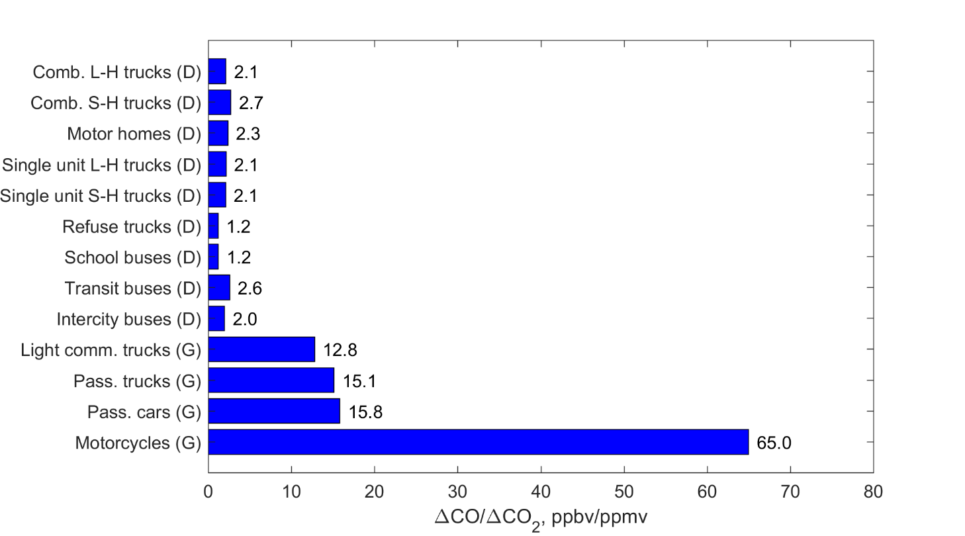
Figure S6. MOVES3 simulated ∆CO/∆CO₂ for Howard County, MD using 2017 input data, the latest year with available data. Emission ratios represent an average from −5 to 20 °C.

MOVES CO, NO_{x}, CO₂, and BC Emission Factors
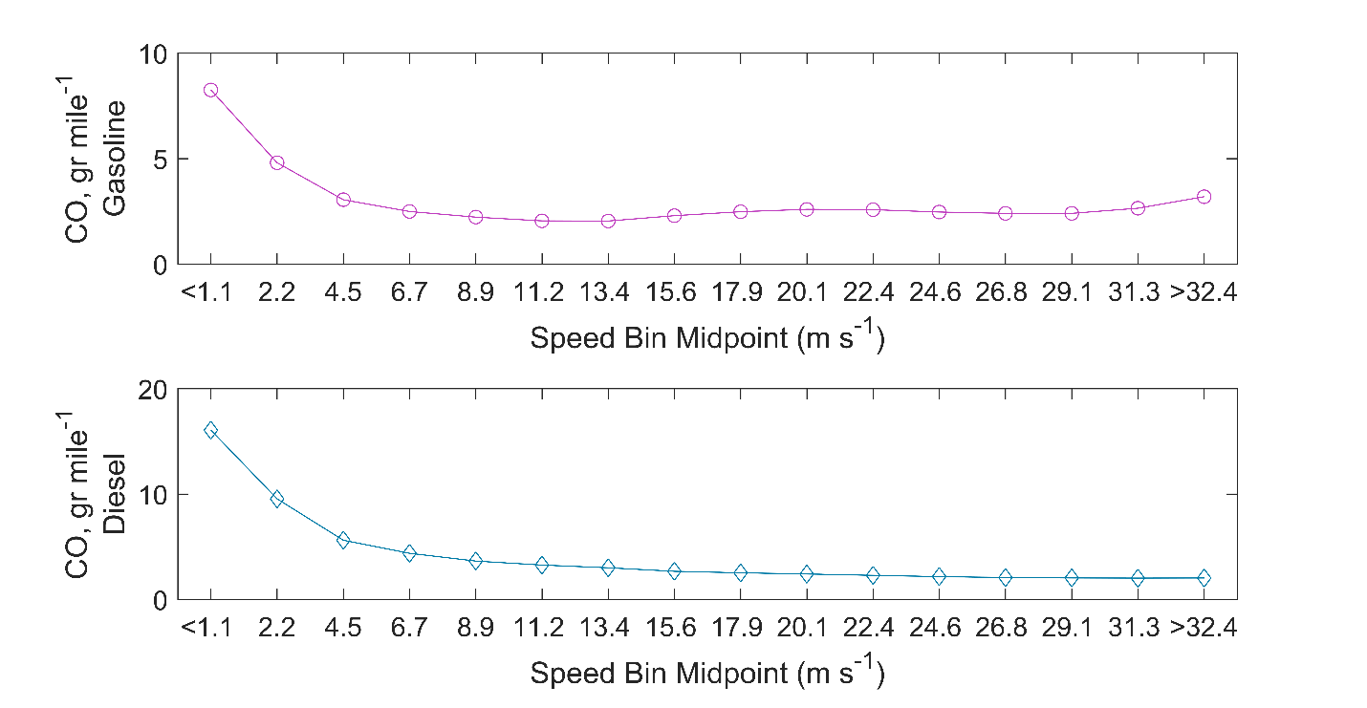
Figure S7. CO emission factors (grams mile⁻¹) estimated from MOVES output using 2017 Howard County, MD, input data. SIV represents motorcycles, passenger cars, and passenger trucks, while CIV represents commercial trucks, buses, single-unit trucks, and combination-unit trucks. Weighted-average emission factors were calculated using traffic count observations.

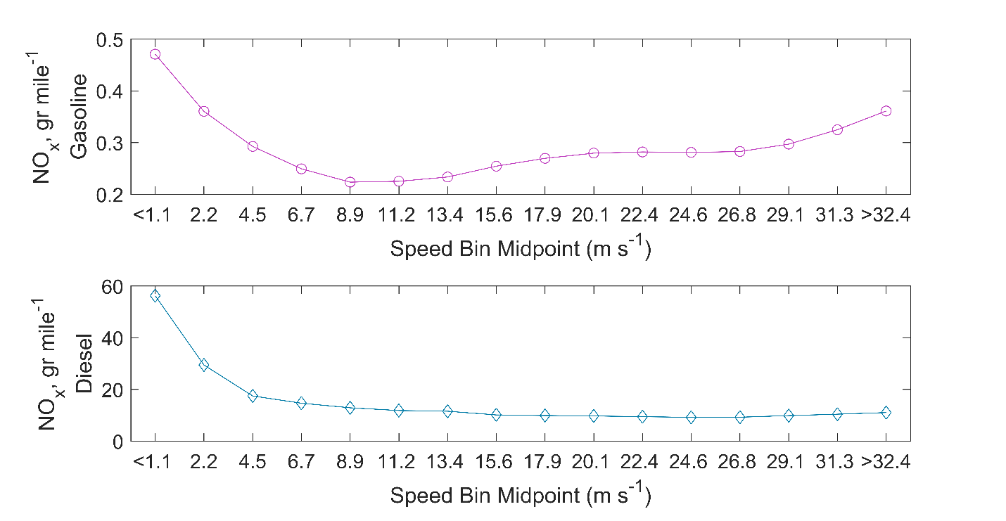
Figure S8. NO_{x} emission factors (grams mile⁻¹) estimated from MOVES output using 2017 Howard County, MD, input data. Note the difference in the y-axis scale since diesel vehicles emit more NO_{x} per mile traveled than gasoline vehicles.

Table S5. Fraction of vehicles driving at speeds faster than 32.4 m s⁻¹ along I-95.
Time Period | April 2017 and 2018 | April 2020
All Days and Hours | 12.2 | 24.9
Weekdays Only | 11.6 | 23.3
Weekends Only | 13.6 | 31.9
Overnight | 22.8 | 24.9
Morning Rush Hours | 12.9 | 24.8
Afternoon Rush Hours | 8.2 | 26.4

Comparison of Default Temperature Adjustments in MOVES2014b and MOVES3
Table S6. Temperature adjustments in MOVES2014b and MOVES3 for hot-running emissions of BC, CO, and NO_{x} from gasoline and diesel vehicles.
(See https://nepis.epa.gov/Exe/ZyPDF.cgi?Dockey=P1010M29.pdf for more information)

 | MOVES2014b | MOVES3
Gasoline
BC | Model Year 2004 and earlier | None
CO | None | None
NO_{x} | None | None
Diesel
BC | None | None
CO | None | None
NO_{x} | None | None

Section S2. Estimating Emission Ratios using Background Subtraction Method
The emission ratios calculated in the main manuscript can also be estimated after applying a time-series-based background subtraction technique. To do this, background mixing ratios of BC, CO, NO_{x}, and CO₂ were calculated using the steps outlined below, in a method following that discussed in Brantley et al. (2014):
- Starting with vetted 1-minute pollutant measurements, calculate moving 10-minute mean values with the center point marking the timestamp of the average.
- Divide the 1-minute rolling mean values into 30-minute time windows, then find the minimum value of each bin.
- Estimate the 1-minute background mixing ratios by conducting a linear interpolation of the minima from the 30-minute windows.
An example showing original 1-minute observations, 10-minute rolling mean values, and the calculated background concentrations is shown in Figure S9. Repeating the analysis used in Table 3 of the manuscript for these delta values (1-minute observation – background concentration), yields similar results as those discussed in the manuscript and does not change our conclusions (Table S6).
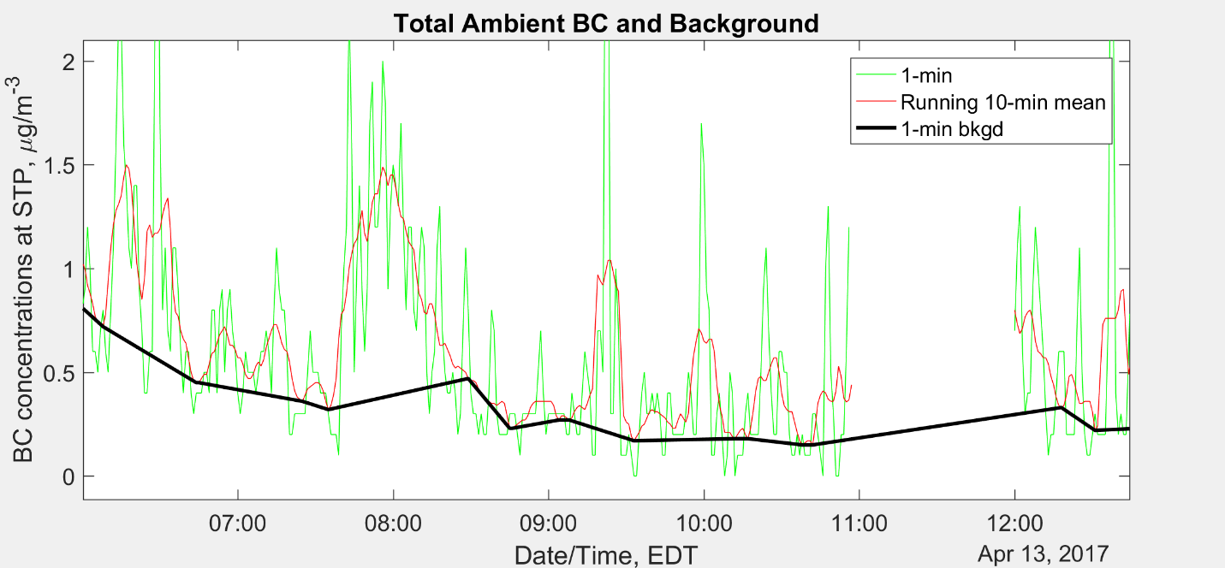
Figure S9. Portion of a time series showing an example of 1-minute observations of BC, the 10-minute running mean values, as well as the inferred background concentrations at the I-95 NR site in Howard County, MD.

Table S7. Median inferred emission ratios for April 2017 & 2018 (“pre-COVID”) and April 2020 (“2020”) at the I-95 NR site. Emission ratios were calculated using the background subtraction approach discussed above. Also provided is the relative difference (%), with the statistical significance indicated by p-value, between each pair of median values for each emission ratio and time period considered. Percentages of CIVs and SIVs provided are for typical pre-COVID traffic composition.
 | Temperature (°C) |  | ∆BC/∆CO  (μg m⁻³) ppbv⁻¹ | ∆BC/∆CO₂  (μg m⁻³) ppmv⁻¹ | ∆NO_{x}/∆CO  ppbv ppbv⁻¹ | ∆CO/∆CO₂  ppbv ppbv⁻¹ | ∆NO_{x}/∆CO₂  ppbv ppbv⁻¹
All Days and Hours (Pre-COVID: 12% CIV, 88% SIV)
Pre−COVID |  | 14.4 | 0.0129 | 0.108 | 0.246 | 0.00895 | 0.00225
2020 |  | 12.2 | 0.00805 | 0.0785 | 0.255 | 0.0103 | 0.00244
Relative Change (%) |  |  | −37.6 (p<0.05) | −27.3 (p<0.05) | 3.66% (p=0.66) | 15.1 (p<0.05) | 8.44  (p<0.05)
Weekdays Only (Pre-COVID: 14% CIV, 86% SIV)
Pre−COVID |  | 13.9 | 0.0154 | 0.124 | 0.276 | 0.00848 | 0.00239
2020 |  | 11.7 | 0.0104 | 0.0913 | 0.294 | 0.00825 | 0.00256
Relative Change (%) |  |  | −32.5 (p<0.05) | −26.4 (p<0.05) | 6.5  (p=0.19) | −2.7  (p=0.84) | 7.1  (p=0.23)
Weekends Only (Pre-COVID: 7.4% CIV, 92.6% SIV)
Pre−COVID |  | 15.3 | 0.00729 | 0.0711 | 0.152 | 0.0103 | 0.00164
2020 |  | 12.2 | 0.00451 | 0.0643 | 0.163 | 0.0144 | 0.00214
Relative Change (%) |  |  | −38.1 (p<0.05) | −9.6 (p=0.37) | 7.24  (p=1) | 39.8 (p<0.05) | 30.5  (p<0.05)
23:00 – 4:59 AM Local Time (Pre-COVID: 22% CIV, 78% SIV)
Pre−COVID |  | 11.7 | 0.0197 | 0.157 | 0.375 | 0.0084 | 0.00326
2020 |  | 10.0 | 0.0161 | 0.0959 | 0.468 | 0.0067 | 0.00292
Relative Change (%) |  |  | −18.3 (p=0.45) | −38.9 (p<0.05) | 24.8 (p=0.15) | −20.2 (p=0.38) | −10.4 (p=0.64)
5:00 – 9:59 AM Local Time (Pre-COVID: 11% CIV, 89% SIV)
Pre−COVID |  | 11.7 | 0.0152 | 0.104 | 0.291 | 0.00782 | 0.00222
2020 |  | 10.0 | 0.0103 | 0.0745 | 0.291 | 0.00699 | 0.00238
Relative Change (%) |  |  | −32.2 (p<0.05) | −28.4 (p<0.05) | 0  (p=1.0) | −10.6 (p=0.38) | 7.2  (p=0.54)
14:00 – 20:59 Local Time (Pre-COVID: 7.3% CIV, 92.7% SIV)
Pre−COVID |  | 18.3 | 0.00836 | 0.0888 | 0.176 | 0.00974 | 0.00175
2020 |  | 14.4 | 0.00382 | 0.067 | 0.132 | 0.01580 | 0.00220
Relative Change (%) |  |  | −54.3 (p<0.05) | −24.5 (p=0.08) | −25.0 (p<0.05) | 62.2 (p<0.05) | 25.7  (p=0.06)

Section S3: Analysis of Emission Ratios in August 2020
The results below show a traffic and emission ratio analysis for August 2020, after COVID restrictions had eased in Maryland. In general, fleet characteristics in August 2020 resembled pre-pandemic conditions more so than conditions in April 2020 resembled pre-pandemic traffic. For example, the fraction of SIV/CIV in August 2020 was almost the same as in August of 2017 and 2018 in all the periods of study (Table S8). While vehicle speeds in August 2020 were still faster than pre-COVID, speeds in August 2020 were lower than in April 2020 as more vehicles were traveling on roads in August (Table S9). Stop-and-go traffic exhibited a similar pattern; August 2020 had more traffic congestion than in April 2020, but congestion was still improved in August 2020 relative to August 2017 and 2018 (Table S8).

Table S8. Fraction of SIV and CIV in August 2017 and 2018, August 2020, and April 2020.
August | August 2017 & 2018  SIV (CIV) | August 2020  SIV (CIV) | April 2020  SIV (CIV)
All Days and Hours | 88% (12%) | 86% (14%) | 79% (21%)
Weekdays Only  (M-F) | 86% (14%) | 84% (16%) | 77% (23%)
Weekends Only  (S-S) | 93% (7%) | 91% (9%) | 84% (16%)
Overnight Hours  (23:00 – 4:59 AM Local) | 79% (21%) | 74% (26%) | 63% (37%)
Morning Rush Hours  (5:00 – 9:59 AM Local) | 89% (11%) | 88% (12%) | 82% (18%)
Afternoon Rush Hours (14:00 – 20:59 Local) | 94% (6%) | 93% (7%) | 88% (12%)

Table S9. I-95 NR speed distribution during the month of August, similar to Table S3 that shows the weighted average speed and fraction of slow-moving vehicles for the month of April.
August | August 2017 and 2018 | August 2020
All days and hours | μ=26.2 m s⁻¹  frac_{<22mps} = 24.7% | μ=29.5 m s⁻¹  frac_{<22mps} = 6.60%
Weekdays (Mo − Fr) | μ=25.6 m s⁻¹  frac_{<22mps} = 28.6% | μ=28.8 m s⁻¹  frac_{<22mps} = 9.29%
Weekends (Sa and Su) | μ=28.1 m s⁻¹  frac_{<22mps} = 12.7% | μ=30.8 m s⁻¹  frac_{<22mps} = 1.43%
23:00 – 04:59 (early morning) | μ=30.1 m s⁻¹  frac_{<22mps} = 1.0% | μ=30.9 m s⁻¹  frac_{<22mps} = 1.19%
05:00 – 09:59 (morning rush) | μ=26.2 m s⁻¹  frac_{<22mps} = 25.8% | μ=30.0 m s⁻¹  frac_{<22mps} = 4.83%
14:00 – 20:59 (afternoon rush) | μ=24.3 m s⁻¹  frac_{<22mps} = 38.1% | μ=28.6 m s⁻¹  frac_{<22mps} = 11.0%

We assessed the impact of these traffic changes on emission ratios in August 2020 compared to previous years. Table S10 presents a comparison of ∆BC/∆CO, ∆BC/∆CO₂, ∆NO_{x}/∆CO, ∆CO/∆CO₂, and ∆NO_{x}/∆CO₂ emission ratios in August 2020 and August 2017 and 2018, similar to Table 3 in the manuscript. In general, the decreases in ∆BC/∆CO and ∆BC/∆CO₂ from August 2017 and 2018 to August 2020 were smaller and less significant in all time periods compared to the decreases observed in April 2020 (Table 3). With more traffic congestion in August than in April of 2020, the results shown in Table 3 in the manuscript and Table S10 support our finding that the largest decline in ∆BC/∆CO and ∆BC/∆CO₂ occurred when stop-and-go traffic was most improved (April 2020).
With more on-road travel in August 2020 than in April 2020, fleet conditions such as vehicular speeds and stop-and-go traffic were more similar to pre-pandemic conditions in August than in April of 2020. A combination of slower mean vehicle speeds and more frequent traffic congestion in August 2020 than in April 2020 may explain the smaller increases in ∆CO/∆CO₂ and ∆NO_{x}/∆CO₂ (2020 compared to pre-COVID) observed during August 2020 relative to April 2020. While most of these emission ratios were still higher in August 2020 compared to prior Augusts, the observed increases were generally smaller than those observed in Table 3, especially on weekends and during the afternoon rush hours; As traffic conditions began to return to pre-COVID levels, so too did ∆CO/∆CO₂ and ∆NO_{x}/∆CO₂. One explanation for this finding is that more on-road vehicles in August 2020 resulted in slower vehicle speeds (Table S10), and this led to smaller increases in CO and NO_{x} emissions from high vehicular speeds than in April 2020.

Table S10. Median inferred emission ratios for August 2017 & 2018 (“pre-COVID”) and August 2020 (“2020”) at the I-95 NR site. Emission ratios were calculated using the background subtraction approach discussed in Section S2 of the SI. Also provided is the relative difference (%), with the statistical significance indicated by p-value, between each pair of median values for each emission ratio and time period considered. Percentages of CIVs and SIVs provided are for typical pre-COVID traffic composition.
August |  |  | ∆BC/∆CO |  | ∆BC/∆CO₂ |  | ∆NO_{x}/∆CO | ∆CO/∆CO₂ | ∆NO_{x}/∆CO₂
August |  |  | (μg m⁻³) ppbv⁻¹ |  | (μg m⁻³) ppmv⁻¹ |  | ppbv ppbv⁻¹ | ppb ppm⁻¹ | ppb ppm⁻¹
All Days and Hours (Pre-COVID: 12% CIV, 88% SIV)
Pre−COVID |  |  | 0.0157 | 0.0951 |  | 0.210 |  | 6.13 | 1.30
2020 |  |  | 0.0137 | 0.0956 |  | 0.207 |  | 6.93 | 1.39
Relative Change (%) |  |  | −12.7 (p=0.083)" | 0.53  (p=0.78) |  | −1.4 (p=0.67) |  | 13.1  (p<0.05) | 6.9  (p=0.22)
Weekdays Only (Pre-COVID: 14% CIV, 86% SIV)
Pre−COVID |  |  | 0.0176 | 0.103 |  | 0.237 |  | 6.01 | 1.46
2020 |  |  | 0.0177 | 0.114 |  | 0.244 |  | 6.18 | 1.51
Relative Change (%) |  |  | 0.57 (p=0.93) | 10.7  (p=0.18) |  | 3.0 (p=0.79) |  | 2.8  (p=0.74) | 3.4  (p=0.37)
Weekends Only (Pre-COVID: 7.4% CIV, 92.6% SIV)
Pre−COVID |  |  | 0.0076 | 0.0621 |  | 0.121 |  | 6.36 | 0.79
2020 |  |  | 0.0075 | 0.0536 |  | 0.128 |  | 8.98 | 1.01
Relative Change (%) |  |  | −1.3 (p=0.81) | −13.7  (p=0.62) |  | 5.8 (p=0.64) |  | 41.2  (p<0.05) | 27.8 (p<0.05)
23:00 – 4:59 AM Local Time (Pre-COVID: 22% CIV, 78% SIV)
Pre−COVID |  |  | 0.0245 | 0.0986 |  | 0.427 |  | 4.61 | 1.76
2020 |  |  | 0.0185 | 0.0995 |  | 0.415 |  | 4.79 | 2.03
Relative Change (%) |  |  | −24.5 (p<0.05) | 0.91  (p=0.93) |  | −2.8 (p=0.48) |  | 3.9  (p=0.82) | 15.3 (p=0.12)
5:00 – 9:59 AM Local Time (Pre-COVID: 11% CIV, 89% SIV)
Pre−COVID |  |  | 0.0166 | 0.0869 |  | 0.227 |  | 4.70 | 1.14
2020 |  |  | 0.0179 | 0.0899 |  | 0.231 |  | 6.24 | 1.24
Relative Change (%) |  |  | 7.8  (p=0.66) | 3.5  (p=0.81) |  | 1.8 (p=0.67) |  | 32.8  (p<0.05) | 8.8  (p=0.24)
14:00 – 20:59 Local Time (Pre-COVID: 7.3% CIV, 92.7% SIV)
Pre−COVID |  |  | 0.0097 | 0.0855 |  | 0.136 |  | 9.12 | 1.24
2020 |  |  | 0.0095 | 0.0947 |  | 0.121 |  | 9.53 | 1.23
Relative Change (%) |  |  | −2.1 (p=0.76) | 10.8  (p=0.29) |  | −11.0 (p=0.18) |  | 4.5  (p=0.20) | −0.81 (p=0.85)

Section S4 – Comparison of temperature sensitivity upwind and downwind of NR site
We repeated the temperature dependence analysis of ∆BC/∆CO and ∆BC/∆CO₂ for the upwind corridor to determine if inferred BC emissions in the upwind portion of the I-95 NR site also exhibited a temperature sensitivity. Figure S10 shows the impact of temperature on ∆BC/∆CO and ∆BC/∆CO₂ during all days and hours when winds originated from upwind of the highway (225 to 360°) and wind speeds were greater than the mean wind speed of the time period (1.1 meters per second). The inclusion of the wind speed filter does not affect the results of the analysis but does help to exclude hours where low wind speeds would lead to slower air circulation and a greater influence of highway and rest area emissions on the upwind region. Figure S10 shows that the slope values and relative changes in ∆BC/∆CO and ∆BC/∆CO₂ with rising temperatures were significantly lower when winds came from the upwind portion than when winds blew from the highway (Figure 4 in the manuscript). Without the wind speed filter, the temperature dependence was 7.6x10⁻⁵ (μg m⁻³) ppbv⁻¹ °C⁻¹ for ∆BC/∆CO and −2.2x10⁻⁴ (μg m⁻³) ppmv⁻¹ °C⁻¹ for ∆BC/∆CO₂, slightly higher than with a wind speed filter and supportive of a temperature impact from highway emissions. These results indicate that the temperature impact of regional BC emissions is minimal at the NR site, and that fresh vehicular emissions are the dominant source of the temperature sensitivity.
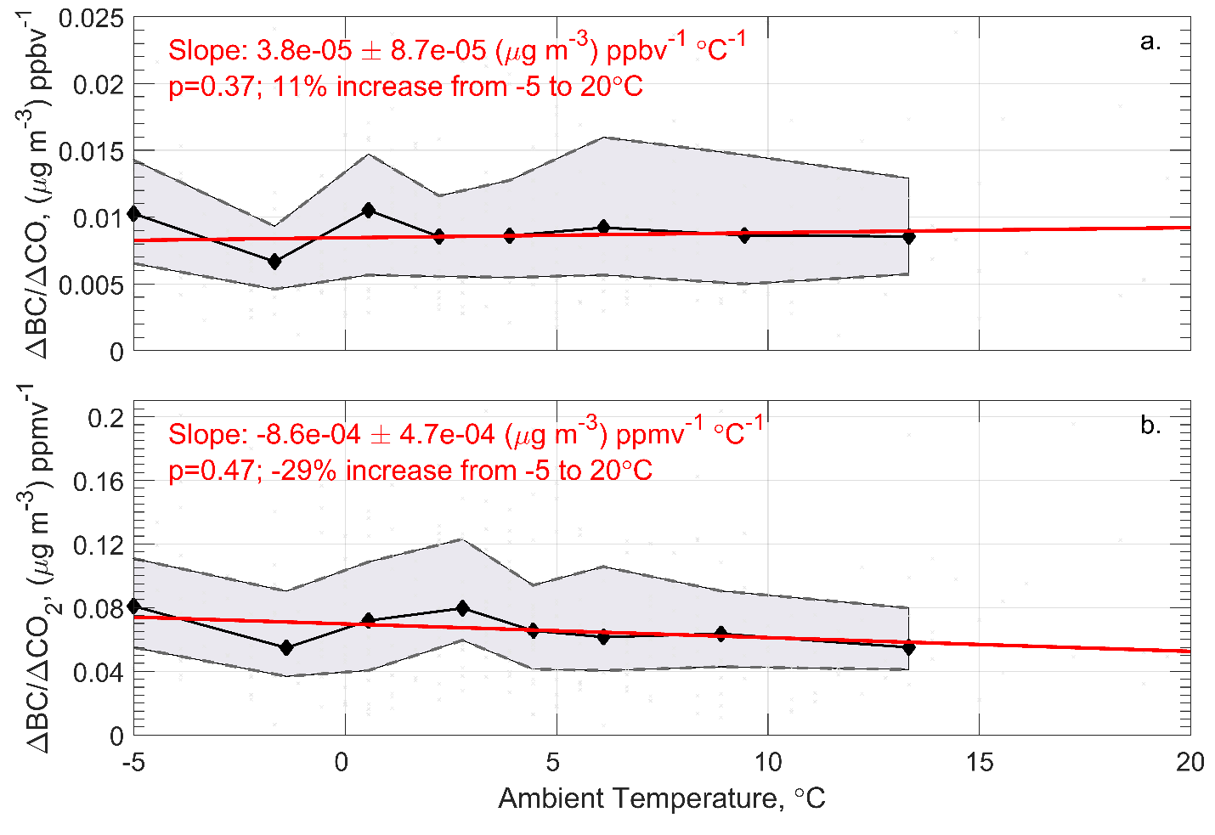
Figure S10. Hourly ∆BC/∆CO (a) and ∆BC/∆CO₂ (b) inferred from I-95 NR observations as a function of ambient temperature for the months of November, December, January, and February in 2017 and 2018. Hourly ratios (light gray points) were estimated from the slope values of linear geometric mean regressions (±standard error) performed on five-minute mean data within each hour. Only hours with winds originating from upwind of the highway (225 to 360°) were included in this figure. Hourly data were compiled into ten equal-sized bins, with the median value of each bin represented by the black diamonds, and the 25th and 75th percentile values by the dashed black line. An ordinary least-squares regression was fit to the binned median values (red line) and the details of the regression provided in the top left of each plot. The statistical significance of each trend was determined by the non-parametric Mann-Kendall test (Gilbert, 1987; Kendall, 1975; Mann, 1945).

Bibliography
API, T. (2013). Manual Addendum Ultra Sensitivity Model T200U NO/NO₂/NO_{x}. http://www.teledyne-api.com/prod/Downloads/T200U Manual Addendum - 06861.pdf
Ban-Weiss, G. A., McLaughlin, J. P., Harley, R. A., Lunden, M. M., Kirchstetter, T. W., Kean, A. J., Strawa, A. W., Stevenson, E. D., & Kendall, G. R. (2008). Long-term changes in emissions of nitrogen oxides and particulate matter from on-road gasoline and diesel vehicles. Atmospheric Environment, 42(2), 220–232. https://doi.org/https://doi.org/10.1016/j.atmosenv.2007.09.049
Bishop, G. A., Haugen, M. J., McDonald, B. C., & Boies, A. M. (2022). Utah Wintertime Measurements of Heavy-Duty Vehicle Nitrogen Oxide Emission Factors. Environmental Science & Technology, 56(3), 1885–1893. https://doi.org/10.1021/acs.est.1c06428
Brantley, H. L., Hagler, G. S. W., Kimbrough, E. S., Williams, R. W., Mukerjee, S., & Neas, L. M. (2014). Mobile air monitoring data-processing strategies and effects on spatial air pollution trends. Atmospheric Measurement Techniques, 7(7), 2169–2183. https://doi.org/10.5194/amt-7-2169-2014
Dickerson, R. R., Anderson, D. C., & Ren, X. (2019). On the use of data from commercial NO_{x} analyzers for air pollution studies. Atmospheric Environment, 214. https://doi.org/10.1016/j.atmosenv.2019.116873
Fehsenfeld, F. C., Dickerson, R. R., Hübler, G., Luke, W. T., Nunnermacker, L. J., Williams, E. J., Roberts, J. M., Calvert, J. G., Curran, C. M., Delany, A. C., Eubank, C. S., Fahey, D. W., Fried, A., Gandrud, B. W., Langford, A. O., Murphy, P. C., Norton, R. B., Pickering, K. E., & Ridley, B. A. (1987). A Ground-Based Intercomparison of NO, NO_{x}, and NO_{y} Measurement Techniques. Journal of Geophysical Research, 92(12), 14710–14722. https://doi.org/10.1029/JD092iD12p14710
Grimes, C. D., & Dickerson, R. R. (2021). Evaluation of a filter-based black carbon (BC) instrument using a brown carbon (BrC) surrogate as well as pure and coated BC surrogates. Aerosol Science and Technology, 55(5), 501–511. https://doi.org/10.1080/02786826.2021.1878096
Hall, D. L., Anderson, D. C., Martin, C. R., Ren, X., Salawitch, R. J., He, H., Canty, T. P., Hains, J. C., & Dickerson, R. R. (2020). Using near-road observations of CO, NO_{y}, and CO₂ to investigate emissions from vehicles: Evidence for an impact of ambient temperature and specific humidity. Atmospheric Environment, 232(x), 117558. https://doi.org/10.1016/j.atmosenv.2020.117558
Los Gatos Research. (2013). Greenhouse Gas Analyzer and Fast Greenhouse Gas Analyzer Rackmount – Enhanced Performance User Manual.
Los Gatos Research. (2018). Greenhouse Gas Analyzer Data Sheet. http://www.lgrinc.com/documents/LGR_FGGA_Datasheet - 20180101.pdf
Magee Scientific. (2018). Aethalometer Model AE33 User Manual (pp. 1–153).
Martin, C. R., Zeng, N., Karion, A., Dickerson, R. R., Ren, X., Turpie, B. N., & Weber, K. J. (2017). Evaluation and environmental correction of ambient CO₂ measurements from a low-cost NDIR sensor. Atmospheric Measurement Techniques, 10(7), 2383–2395. https://doi.org/10.5194/amt-10-2383-2017
Picarro. (2019). Picarro CO₂, CH₄, H₂O Data Sheet. https://www.semi.picarro.com/sites/default/files/product_documents/Datasheet G2301 CRDS Analyzer for CO2 CH4 H2O in Air OCT15.pdf
Wang, J. M., Jeong, C. H., Hilker, N., Shairsingh, K. K., Healy, R. M., Sofowote, U., Debosz, J., Su, Y., McGaughey, M., Doerksen, G., Munoz, T., White, L., Herod, D., & Evans, G. J. (2018). Near-Road Air Pollutant Measurements: Accounting for Inter-Site Variability Using Emission Factors. Environmental Science and Technology, 52(16), 9495–9504. https://doi.org/10.1021/acs.est.8b01914

