NOAA Fisheries Equity and Environmental Justice Internal Workshop Guide: Step-by-Step Activity Workbook
Danika Kleiber¹
Michelle Chow²

¹ Pacific Islands Fisheries Science Center
National Marine Fisheries Service
1845 Wasp Boulevard
Honolulu, HI 96818

² Pacific Islands Regional Office
National Marine Fisheries Service
1845 Wasp Boulevard
Honolulu, HI 96818

March 2024

Co-authors provided an equal effort in the development of the workshop structure, materials, and development of the workshop guide.

About this Step-by-Step Activity Workbook
An important component of long-term integration of equity and environmental justice (EEJ) is the development of staff understanding and capacity to advance EEJ. To meet this need, the NOAA Fisheries Pacific Islands Regional Office (PIRO) and Pacific Islands Fisheries Science Center (PIFSC) jointly developed a workshop program that engaged leadership and staff from all divisions. The workshop program was designed to provide foundational training on EEJ, and identifying EEJ actions relevant to daily operations, strategic planning, and other aspects of NOAA Fisheries work.
This Workbook is intended to be used in tandem with the NOAA Fisheries Equity and Environmental Justice Internal Workshop Guide. It provides a step-by-step process for internal EEJ Workshops that help staff understand the connections between EEJ, communities, and their own work. This Workbook corresponds with the sample agenda provided in Appendix B of the Workshop Guide.
The Workbook includes an explanation of each step and a printable packet of worksheets at the end.

Overview of steps
This workbook outlines four discrete steps. While we recommend following the process in order, it can be also be adapted.
These activities can be done by individuals followed by sharing with a group, or in small groups (as outlined in Appendix B), or with a whole division. We have completed this activity with groups of varying sizes and have found success in all forms. While we recommend in person meetings if possible, we have also had success with virtual meetings using Jamboard or other sharing platform to collect participant responses. If you do have a larger group, we recommend identifying a facilitator to lead the group through each step.

Step 1: Build your EEJ support system

Purpose
To successfully implement EEJ in your office, you must identify a support system. This system will differ among offices and may include leadership, champions, allies, and general supporters.

Activity: Identify 3 key components of your support system
Timing considerations: This activity can be completed in a short timeframe depending on your group size. We recommend 1-5 minutes.
Our regional example of a support system:
- Set up an EEJ workgroup representative of community and divisions
- Identify co-chairs and leadership sponsors responsible for ensuring work is done
- Host a leadership workshop to set direction, identify boundaries, and discuss visions for EEJ implementation

Step 2: Understand how EEJ fits into your work

Purpose
A key component for implementing EEJ is helping staff recognize the connection between their work, no matter the position, and the communities they strive to serve. This will help increase overall buy-in for EEJ among all levels of staff.

Activity: Recognize EEJ in your work
- This step can be taken at any level of your organization—at the NOAA level, your line office, your program office, or even your own role. Depending on the amount of time allotted and the makeup of your group, select the level that would allow maximum participation.
- Depending on the group size and level, you can do this activity for a discrete project or entire portfolio of work. See notes on our regional example below.
- You may repeat this activity for multiple levels, but we recommend you complete one level at a time.
- There are four exercises in this step, intended to be completed in the following order:
- Our work: Identify examples of work that impacts human communities
- Human communities: Who are the human communities impacted by the work?
- Impacts: What are the impacts of the work on human communities (e.g., social, economic, cultural, or other)?
- EEJ integration: How can the work integrate EEJ into (and improve upon) this work?

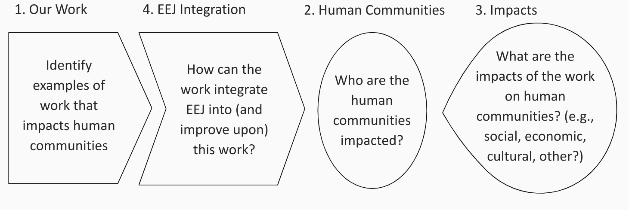
Figure 1. Diagram of Step 2.
Timing Considerations: We recommend dedicating a significant amount of time and discussion to this step, 30 minutes–1 hour depending on group size.
Our regional example:
- We hosted paired program workshops (as described in the Internal Workshop Guide). In these workshops, an entire division worked together on this activity and in mixed breakout groups around a case study example (Appendix B). While both structures achieved the ultimate goal of walking staff through these impact pathways, we found limiting the scope to a case study example was less overwhelming in some cases.

Step 3: Understand and connect with your community

Purpose
One of the most important parts of EEJ work is understanding and connecting with the communities you serve. This step can look very different for different offices. For example, regional offices may already have good working relationships with communities and infrastructure for outreach. National offices may have more indirect connections with communities, and their target outreach audience may be the regional offices they support.
Direct and meaningful engagement with communities is essential to developing EEJ actions that reflect the needs of the communities you serve. However, engagement should be done thoughtfully and following best practices that are culturally appropriate (see EPA guide). Without these steps, outreach can overburden communities. Work with outreach experts in your office or agency.

Activity: Brainstorm how community outreach could look for your work.
Timing Considerations: If working in a group, this activity could take 15–30 minutes.
Our regional examples:
- We started with listening sessions and targeted partner meetings across the region. We summarized the feedback and suggestions provided by partners and shared it with all staff.
- We started with open ended engagements and subsequently conducted more target engagements based on the interests and feedback we received from the community.
- In developing our EEJ Implementation Plan, we hosted a special workshop with our Regional Fisheries Management Council that included jurisdictional agency leads, key stakeholders, fishermen, etc. to discuss what EEJ looks like across partners.
- We are investing in continued engagement around portfolio areas such as attending fishing tournaments to connect with the fishing community.

Step 4: Identify specific actions for implementing EEJ

Purpose
- The next step after from visioning in Steps 1, 2, and 3 is to sit down and really identify some specific and tangible actions individuals, divisions, and offices can take towards achieving EEJ.
- The NMFS EEJ National Strategy identified six core areas of EEJ to demonstrate the breadth of EEJ’s potential—it’s not just outreach and engagement!
  - Empowering Environment provides the institutional support, including training and resources, needed to implement multiple EEJ approaches at NOAA Fisheries. Internal leadership and management will identify EEJ as priorities and encourage staff to consider EEJ in every aspect of their work.
  - Policy and Plans include ensuring that our policies promote equal opportunities for all and do not create unintended inequities or unequal burdens for underserved communities.
  - Research and Monitoring include identifying underserved communities and their needs, conducting collaborative research, and assessing impacts of management decisions.
  - Outreach and Engagement includes building relationships with underserved communities to better understand their engagement preferences and improve information sharing with all communities.
  - Benefits include distributing benefits equitably among communities by increasing the access to opportunities for underserved communities.
  - Inclusive Governance includes enabling the meaningful involvement of underserved communities in decision-making processes.

Activity: Identify EEJ actions
- Identify EEJ actions in each core area that you or your program can take to advance EEJ. Actions should be specific and tangible, and include metrics of community impact.
Timing Considerations: This activity is not easy and may take a long time to complete. If completing this step during a workshop, we recommend dedicating about an hour to it. See our regional example below for other options.

Our regional examples:
- Following our workshop focused on Steps 1–3, we assigned Step 4 as homework. We encouraged actions that both were in the “dream space”—the ideal actions with no resource or capacity limitations—and those you can do in your current work with no additional resources to advance EEJ. Excluding the dream space seemed too limiting and would suppress ideas of goals that would truly help achieve EEJ.
- After programs identified actions, our EEJ workgroup organized, synthesized, and prioritized those to include in our EEJ Implementation Plan.

Printable Packet:
The following pages include worksheets for each Step. You can print pages 7-12 for workshop participants.

Step 1: Build your EEJ support system
Identify three key components of your support system:

Step 2: Recognize how EEJ fits into your work
In the context of your work at NOAA (at program office, division, or individual level)
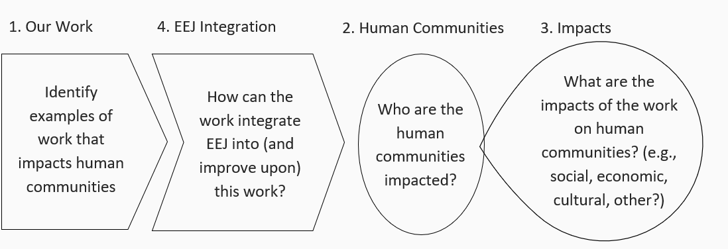
In the context of your work at NOAA (at program office, division, or individual level), complete this activity in numerical order.
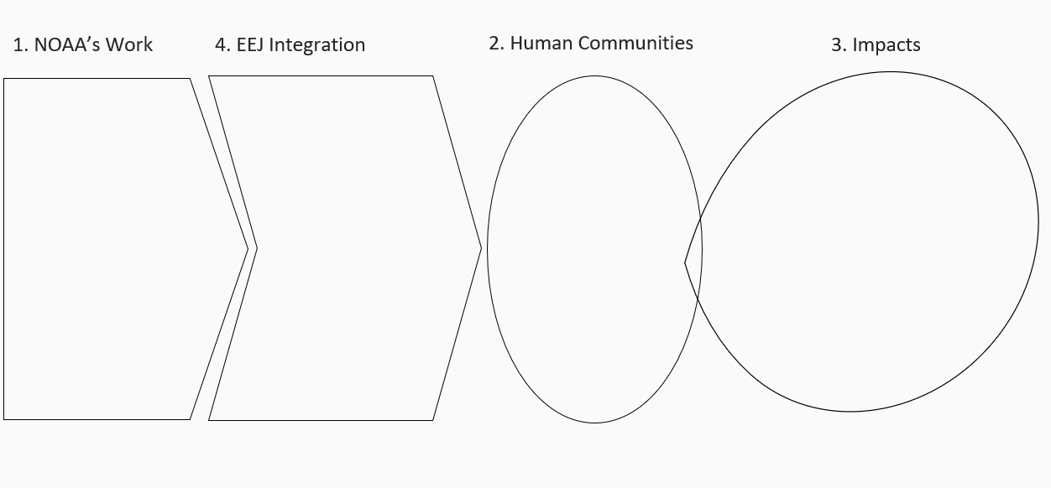

Step 3: Understand and connect with your community
Brainstorm what community outreach could look like for your work.

Step 4: Identify specific actions for EEJ implementation
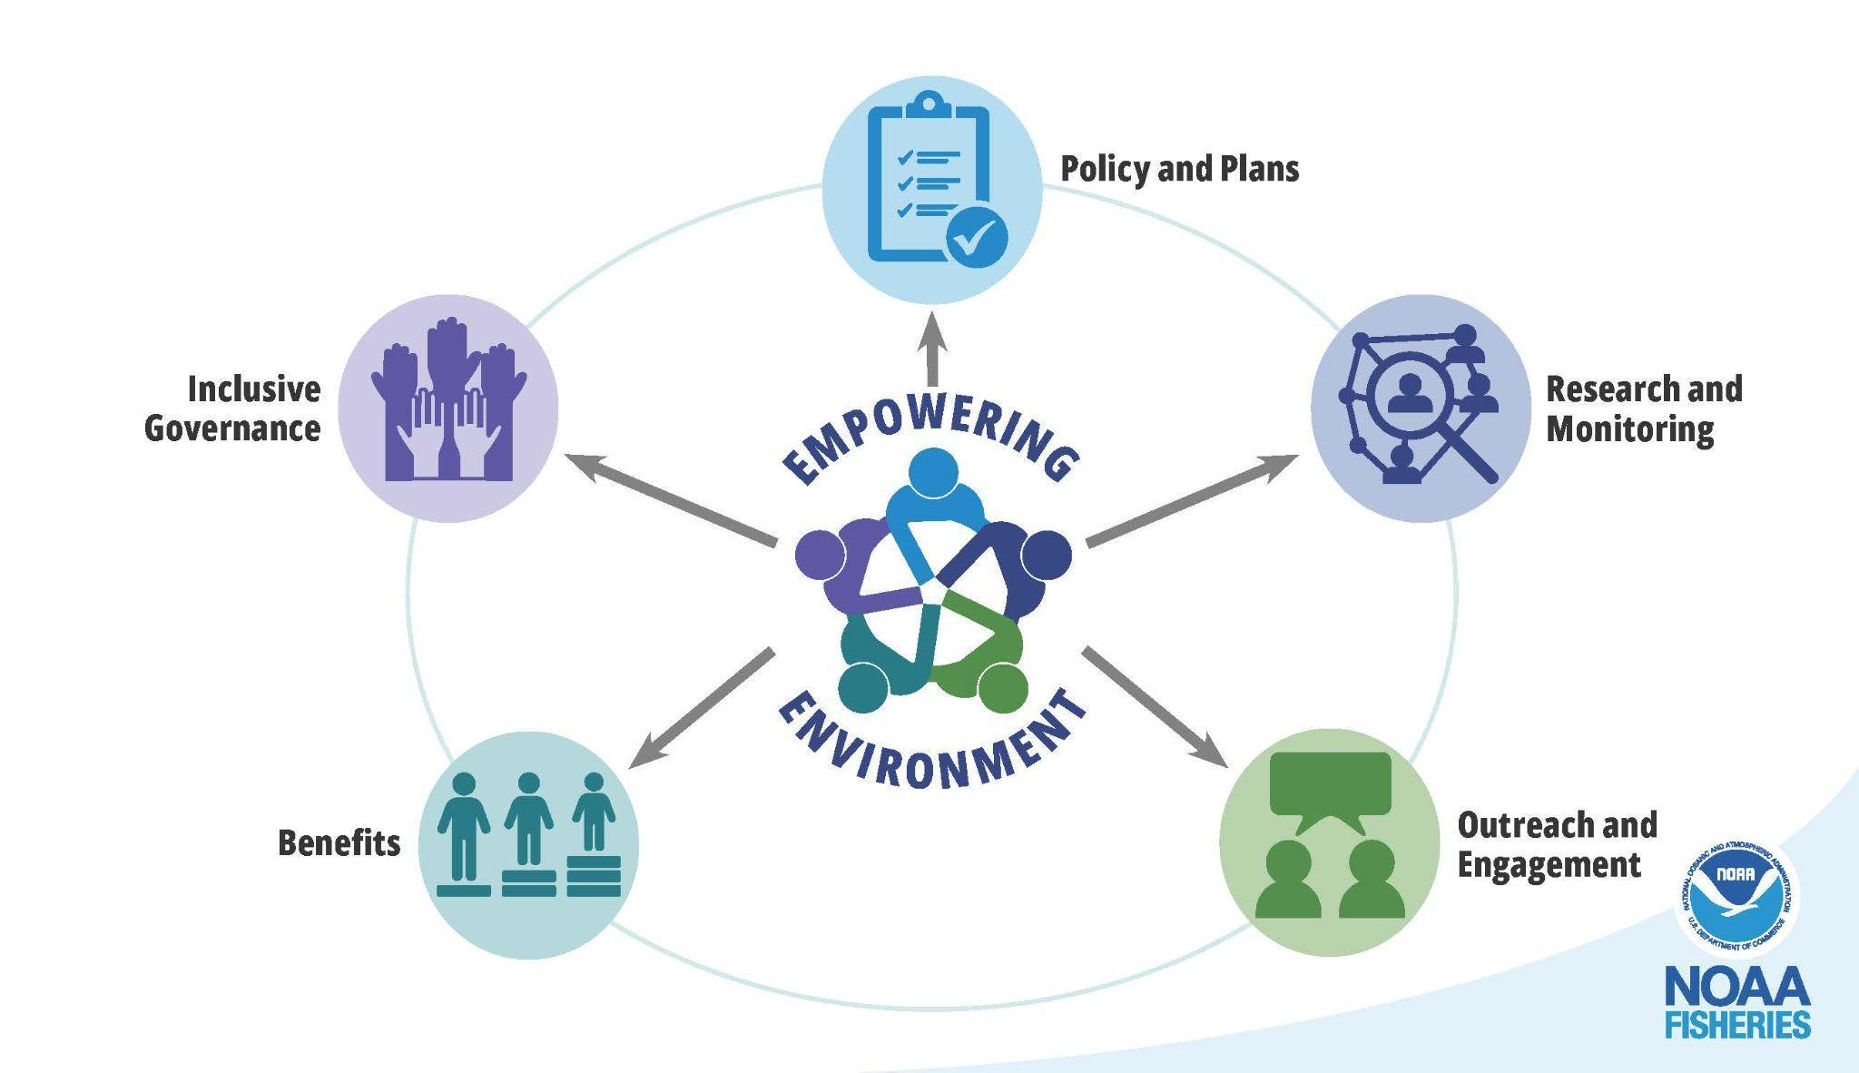

Step 4: Identify specific actions for EEJ implementation
