Appendix A: Investigating the Importance of the Growth Process – An Example

This appendix provides a brief example of sensitivity diagnostics examining the importance of the growth process to assessment results. It uses the Pacific bluefin tuna (Thunnus orientalis) stock assessment (ISC, 2022) as an example. Three sensitivity runs were conducted as diagnostics to determine the influence of a misspecified growth process. The example assessment is a fully integrated, single-sex, age-structured model (Stock Synthesis (SS) v3.30; Methot and Wetzel, 2013) fitted to catch (retained and discarded), size-composition, and catch-per unit of effort (CPUE) index data. The CPUE indices of abundance include two adult indices and one age-0 recruitment index. The assessment model is a single-area model and assumes "areas-as-fleets" fishery selectivity. The original length-at-age was derived from a time-invariant, single-sex estimate of length-at-age using otolith-derived ages (Appendix Figure 1 black line).
Sensitivity run 1: Conversion of catch in weight to catch in numbers
In this sensitivity diagnostic, an age-structured production model (ASPM; Maunder and Piner, 2015; Carvalho et al., 2017) was developed from the full assessment (Appendix Table 1). Only catches and indices of abundance were used in the fitting, the ASPM eliminated the influence in model fits of length composition data. In the model, selectivity parameters are fixed to the full assessment maximum likelihood estimates (so that catch is removed at approximately the correct ages). Recruitment deviations are not estimated, instead annual recruitment is the expectation of the spawner-recruit relationship specified in the model. Because recruitment is deterministic, the age-0 index is not used in the ASPM. Other life history parameters are specified the same as the full assessment. Only scaling parameters are estimated in the model (unfished recruitment, initial fishing mortality rates, and catchability).
Three runs are conducted using the ASPM: 1) observed length-at-age, 2) misspecified faster growth and smaller maximum size, and 3) misspecified slower growth with larger maximum size (Appendix Figure 1). In each of the three ASPM runs, the model produced an estimate of the catch in number by fleet (original catch was in weight). Those estimates of catches in numbers by fleet were then input into the ASPM with the original growth curve (option 1) and the ASPM model re-fit to the indices. This procedure isolated the effects of misspecifying the growth curve to the conversion of catches in weight to catches in numbers, as all other components of the model were the same. The effects of misspecifying the growth process on spawning biomass and depletion are minor (Appendix Figure 2). The effects of misspecifying the growth process on calculating biomass from model estimates of numbers-at-age is included in the sensitivity diagnostic below.
Sensitivity run 2: Production function and abundance sensitivity
An ASPM was developed from the full assessment that eliminated the influence of length compositions in fitting the same as in Sensitivity run 1. Catches were inputted as numbers based on the first sensitivity ASPM model to eliminate the conversion from weight to numbers effect. Three runs are conducted using the ASPM: 1) observed length-at-age, 2) misspecified faster growth and smaller maximum size, and 3) misspecified slower growth with larger maximum size (Appendix Figure 1). These models isolated the effect of misspecifying the growth process to the calculation of population biomass from numbers-at-age and effects of the shape of the production function. The effects of misspecifying the growth process on spawning biomass and depletion are minor (Appendix Figure 3). In particular, these changes to the growth process had little effect on the management quantity (i.e., depletion in Appendix Figure 3B) or the location of maximum yield (Appendix Figure 3C).
Sensitivity run 3: Fit to length composition and abundance
In the third sensitivity diagnostic, the full assessment model (all data and recruitment deviations estimated) is used except that indices of abundance are not used in the fitting. This diagnostic model is similar to the catch curve diagnostic from Carvalho et al. (2017). It removes the production function effects on abundance estimates. Three runs are conducted using the reduced full model: 1) observed length-at-age, 2) misspecified faster growth and smaller maximum size, and 3) misspecified slower growth with larger maximum size (Appendix Figure 1). All three models inputted the same catch in numbers estimated in the observed model (model 1). These models isolated the effect of misspecifying the growth process to calculation of population biomass from numbers-at-age and effects of fitting length composition data. The effects of the misspecification of the growth process on the spawning biomass and depletion are more substantial than the previous sensitivity diagnostics (Appendix Figure 4). The absolute abundance, variability in abundance by growth process, and depletion trends are more impacted by changes in the growth process.
Diagnostic conclusions
Misspecification of the growth process may have little effect on the Pacific bluefin tuna assessment estimates of abundance or depletion through conversion of weight to numbers (or vice versa), calculation of biomass from numbers-at-age, or through changes in the shape of the production function. In contrast, the assessment results could be sensitive to the growth process if population abundance is strongly influenced by fits to the length composition data. The importance of the growth process is likely reduced because catch is overwhelmingly of juveniles (ages 0-2) where growth is rapid and length modes are good predictors of age, and the assessment focuses on deriving absolute abundance estimates from the production function (ISC, 2022). Although estimates of recruitment are also important and should be considered in these kinds of diagnostics, recruitment was not addressed here because the bluefin tuna assessment has a reliable recruitment index due to historically high fishing pressure on young juveniles. In our application, mean length-at-age for young fish was similar in all scenarios, which is common since aging of young individuals is usually ample and accurate, but the results may differ in applications where this is not true.
Although this example is somewhat simplified, it would be possible to do these same kinds of diagnostics incorporating temporal, individual, or other forms of variability. But given the evaluation of relatively large errors in asymptotic sizes, it seems reasonable to conclude that focusing on improving the growth process is not a high priority for the bluefin application. However, attention still needs to be paid to minimizing the influence of any residual misfit to length composition data. In the bluefin application focusing modeling efforts on other observation and system processes (e.g., natural mortality rate) are more likely to improve the assessment.

References
ISC., 2022. Stock assessment of Pacific bluefin tuna in the Pacific Ocean in 2022. ISC/22/Annex 13. https://isc.fra.go.jp/pdf/ISC22/ISC22_ANNEX13_Stock_Assessment_for_Pacific_Bluefin_Tuna.pdf
Carvalho, F., Punt, A. E., Chang, Y.-J., Maunder, M. N., Piner, K. P., 2017. Can diagnostic tests help identify model misspecification in integrated stock assessments? Fisheries Research, 192, 28-40. https://doi.org/10.1016/j.fishres.2016.09.018
Maunder, M. N., Piner, K. R., 2015. Contemporary fisheries stock assessment: many issues still remain. ICES Journal of Marine Science, 72(1), 7–18. https://doi.org/10.1093/icesjms/fsu015
Methot, R. D., Wetzel, C. R., 2013. Stock synthesis: A biological and statistical framework for fish stock assessment and fishery management. Fisheries Research, 142, 86–99. https://doi.org/10.1016/j.fishres.2012.10.012

Appendix Table 1. Summary of data types used and parameters estimated or fixed for each model. N.A. denotes that the parameter is not applicable to the model.
 | Full dynamic model | ASPM
Data
All size composition | Yes | No
Adult indices | Yes | Yes
Age-0 index | No | No
Parameters
Log of unfished recruitment | Estimated | Estimated
Log of recruitment deviations | Estimated | Fixed at 0
Spawner-recruit steepness | Fixed at 0.999 | Fixed at 0.999
Standard deviation for recruitment in log space | Fixed at 0.6 | N.A.
Initial fishing mortality | Estimated | Estimated
Selectivity parameters | Estimated | Fixed at estimates from the full dynamic model
Growth | Fixed (see Appendix Figure 1) | Fixed (see Appendix Figure 1)
Natural mortality | Fixed for age 0 and 1 and estimated for age 2 and older | Fixed at the same values as the full dynamic model
Proportion maturity-at-age | Fixed (0.2 at age 3, 0.5 at age 4, 1 at age 5 and older) | Fixed at the same values as the full dynamic model

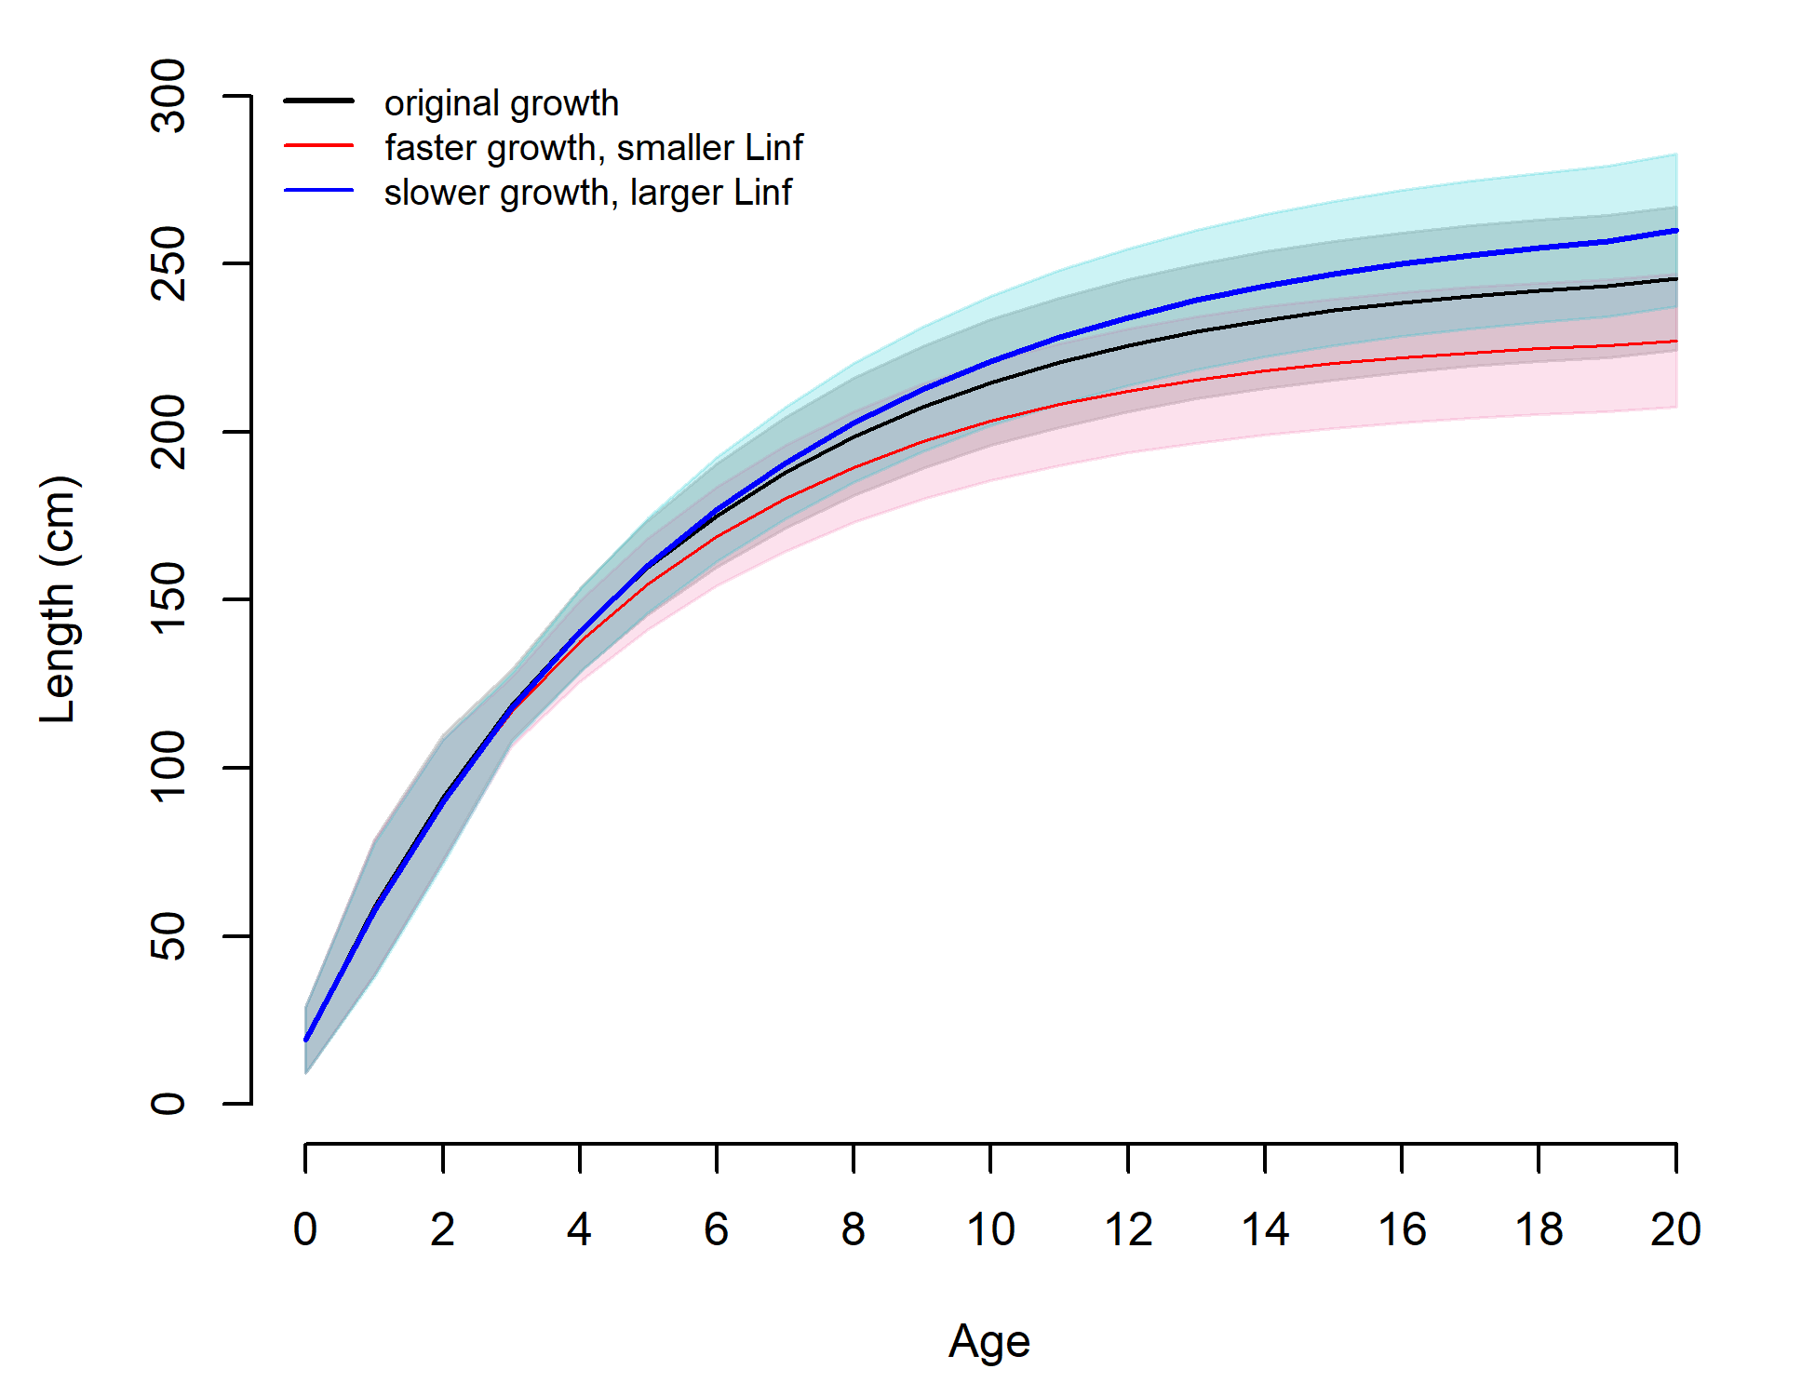 Appendix Figure 1. The original and alternative length-at-age curves used in the diagnostic sensitivity analyses. The original lengths-at-ages are depicted in black (von Bertalanffy growth parameters: k=0.188, Linf=249.917, t0=-0.422). Faster growing and smaller maximum size (k=0.2068, Linf=229.909, t0=-0.418) is depicted in red and slower growing and larger size (k=0.1692, Linf=266.687, t0=- 0.438) is in blue.

A.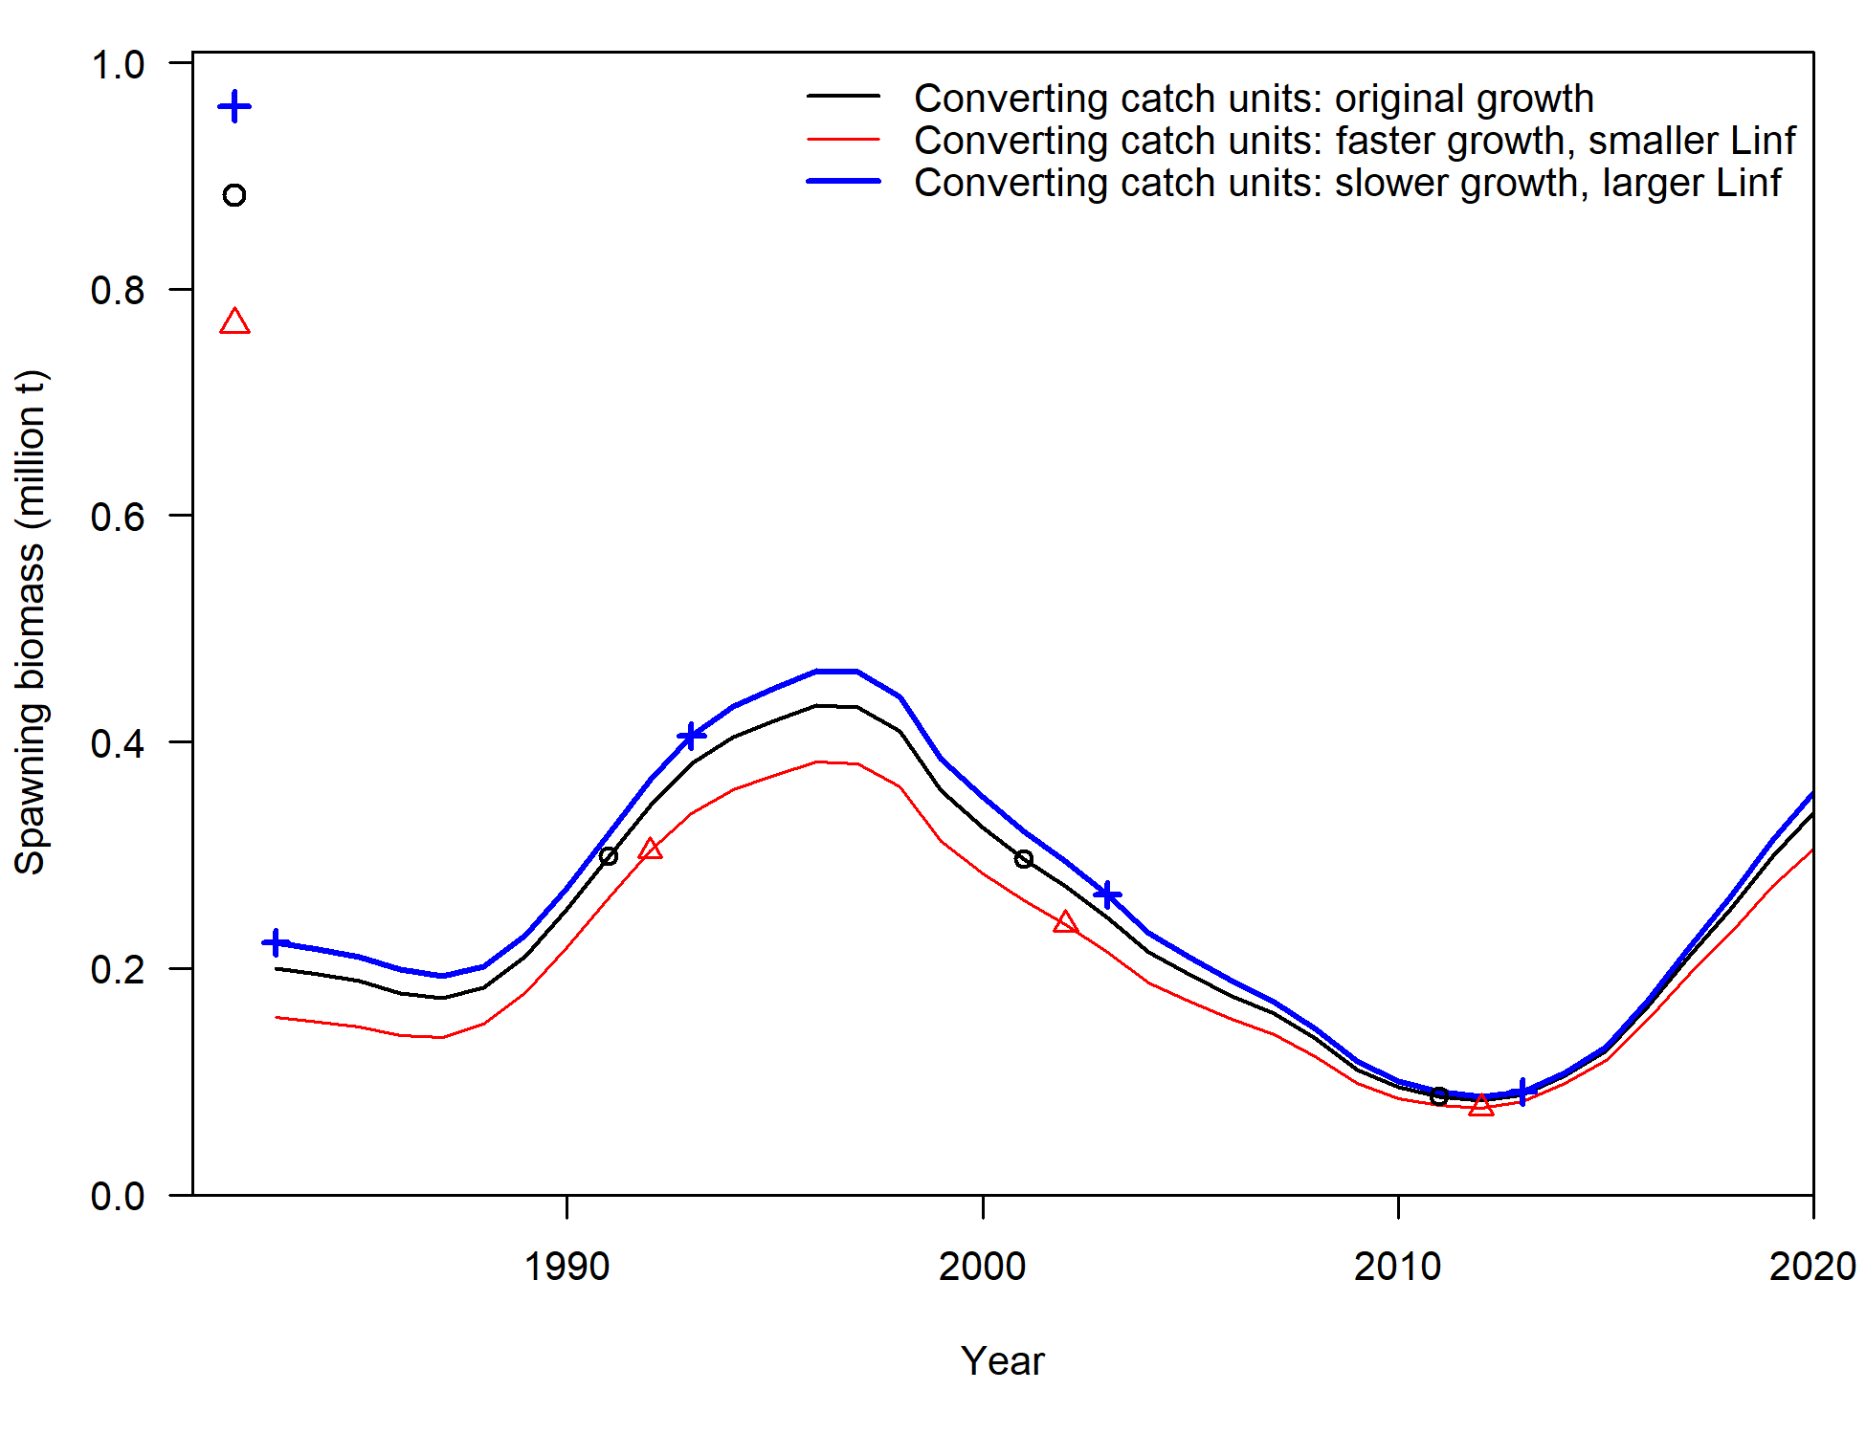 | B.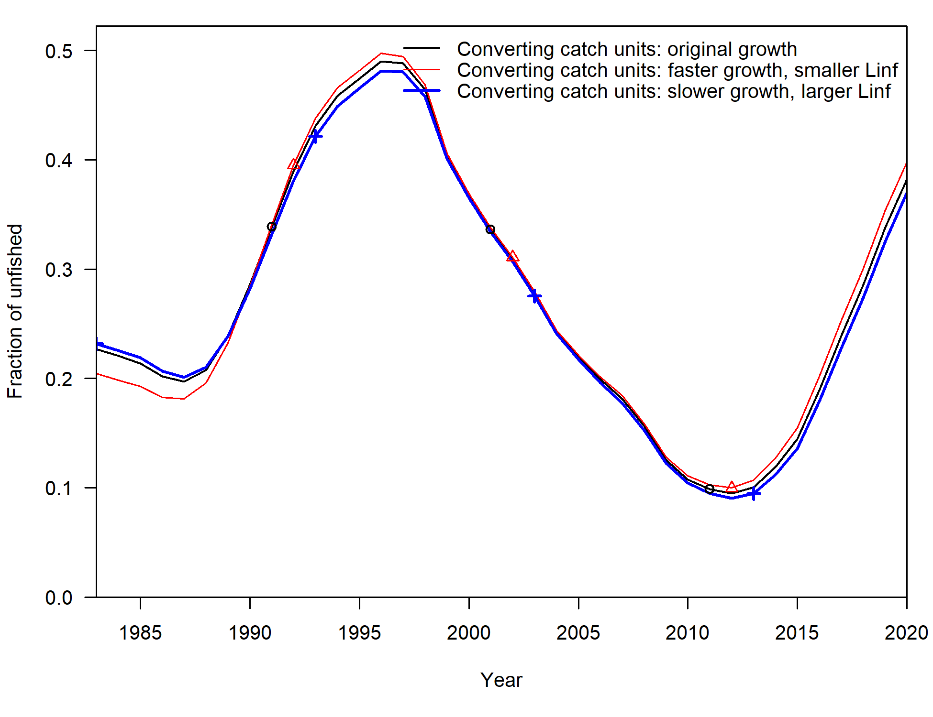
Appendix Figure 2. Sensitivity diagnostic results from misspecifying the growth process on converting numbers into weight (Sensitivity run 1) in the Pacific Bluefin tuna stock assessment. Panel A is spawning biomass and B is fraction unfished biomass (depletion level). The three lines in each plot are ASPM models specifying faster growth and smaller Linf (red), original length-at-age (black), and slower growth and larger Linf (blue). Unfished spawning biomass estimates for model runs are given in panel A as triangle, circle, and cross, respectively.

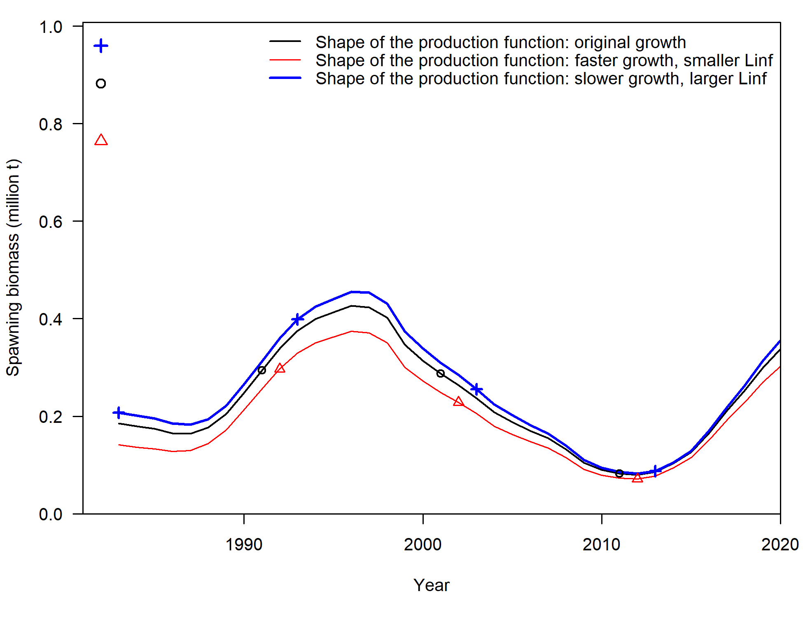  A. | 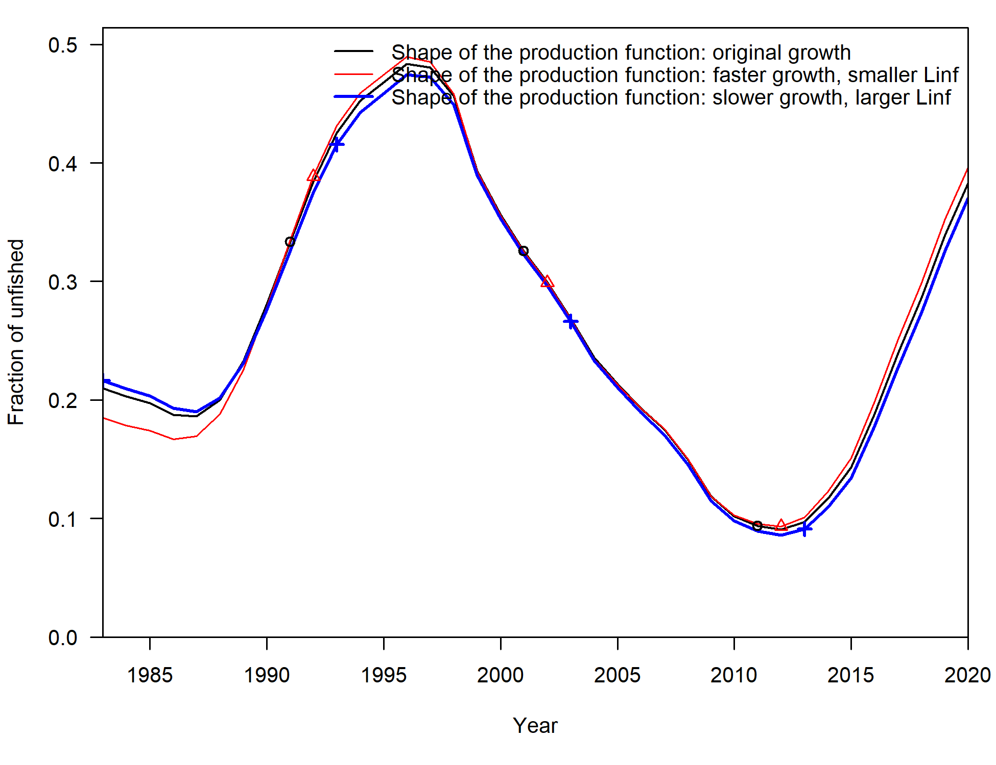  B.
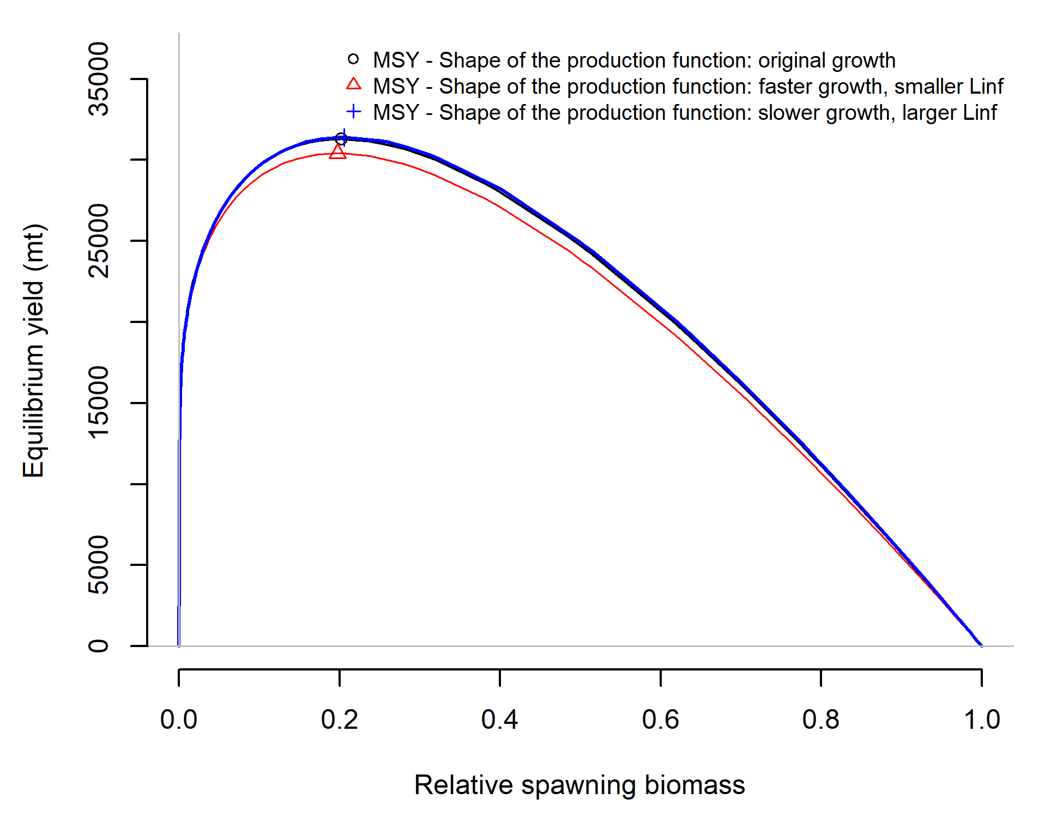
C.

Appendix Figure 3. Sensitivity diagnostic results from misspecifying the growth process on the shape of the production function and calculation of biomass from model estimates of numbers-at-age (Sensitivity run 2). Panel A is spawning biomass, B is fraction unfished (depletion level), and C is the production curve. The three lines in each plot are ASPM models specifying faster growing and smaller Linf (red), original length-at-age (black), and slower growth and larger Linf (blue). Unfished spawning biomass estimates for model runs are given in panel A as triangle, circle and cross, respectively.

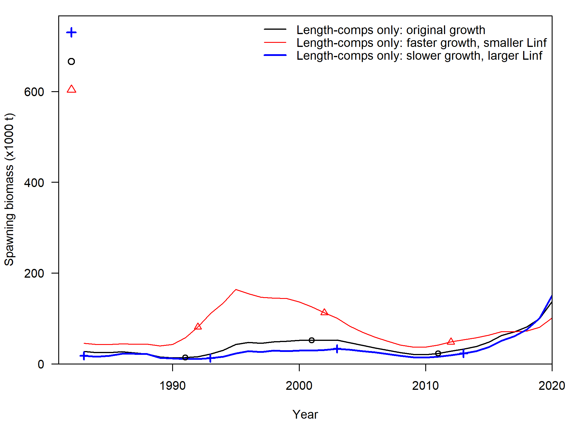  A. | 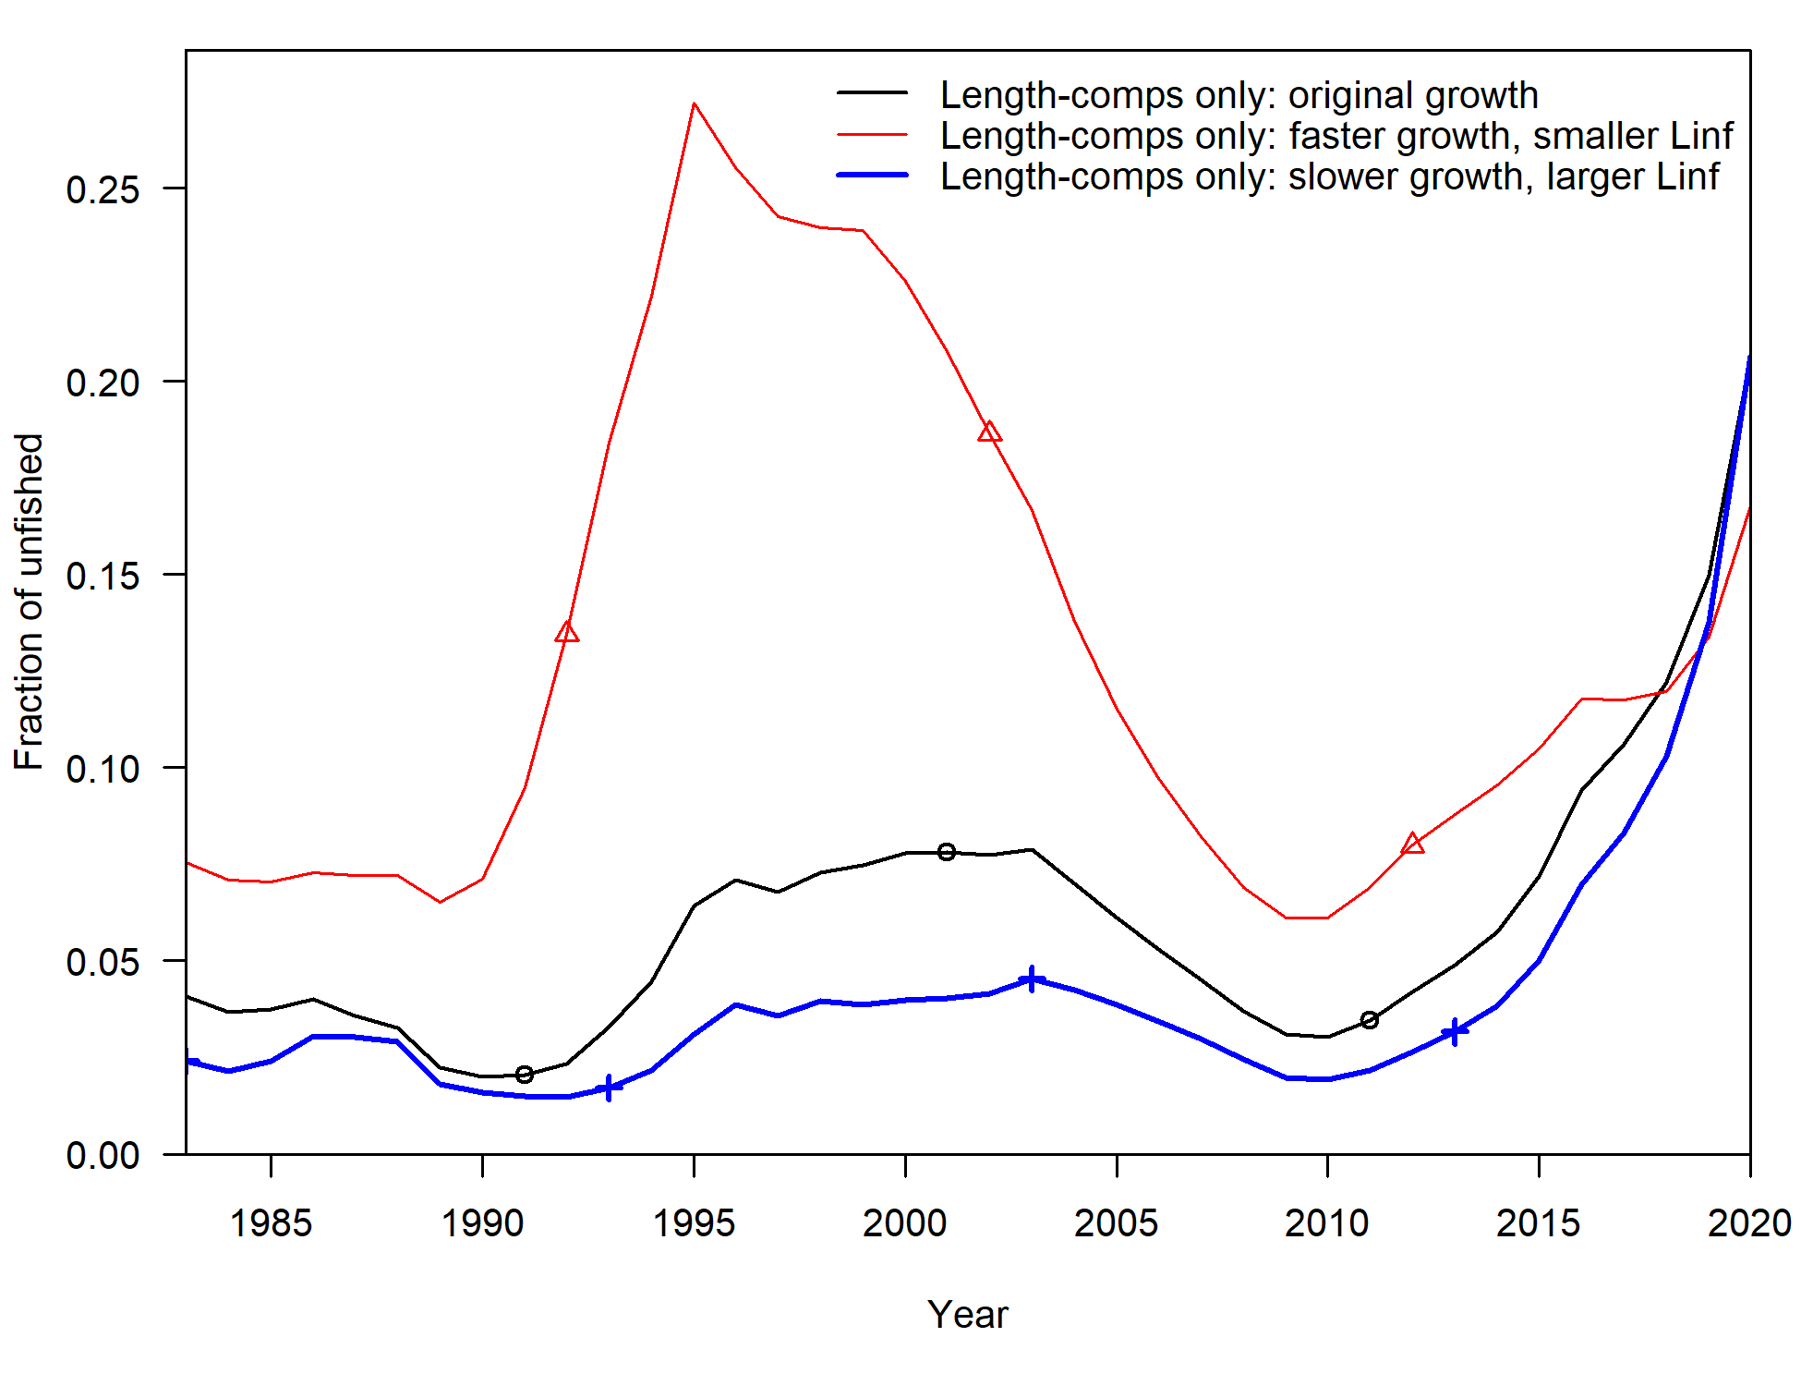  B.
Appendix Figure 4. Sensitivity diagnostic results from misspecifying the growth process in the Pacific Bluefin tuna stock assessment that fits to length compositions only (Sensitivity run 3). Panel A is spawning biomass and B is fraction unfished (depletion level). The three lines in each plot are the models specifying faster growth and smaller Linf (red), original length-at-age (black), and slower growth and larger Linf (blue). Unfished spawning biomass estimates for model runs are given in panel A as triangle, circle and cross, respectively.

