## Supplementary Figures

Fig. S1. Plot depicting examples of truncated probability distributions for an individual in R10_K30 scenario and a Precisions of either 0 (red line), 0.05 (blue line), 0.2 (green line, or 1 (black line). (Left) Depicts situation wherethe maximum temperature that day within *Knowledge* at 25 m bottom depth. (Right) The maximum temperature that day within *Knowledge* was at 0 m, which lies outside the *Range*.

Fig. S2. Number of FVCOM-GOM grid cells in each 20 m (0 – 280 m) depth bin requiring a minimum horizontal distance of X km to change depth by 15 m. The bolded black line is the mean of all model grid cells.

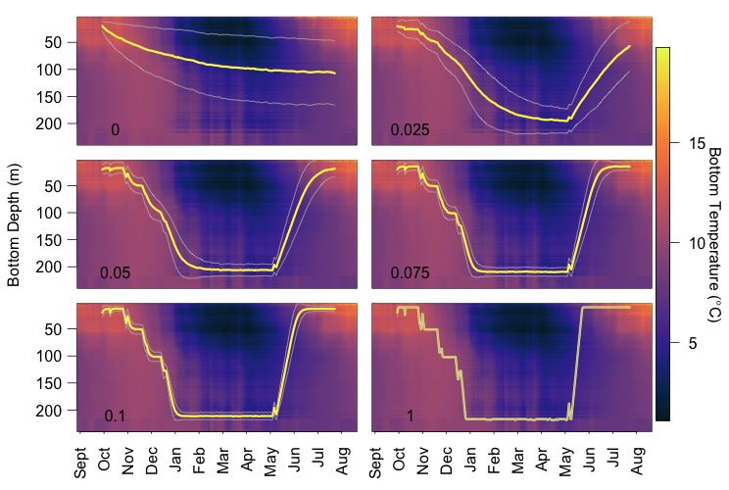

B

A

C

D

E

F

Fig. S3. Depth of simulated lobsters from October 1st 2013 to July 31st 2014 plotted over the Hovmöller plot of bottom temperature from September 2013 to August 2014, extracted from FVCOM. The mean and standard deviation of daily depths of 1000 lobsters simulated in six movement scenarios where individuals have realistic movement capacities (Range = ±15 m), have global temperature information (Knowledge = ±220 m), but different temperature seeking precision: (A) 0, (B) 0.025, (C) 0.05, (D) 0.075, (E) 0.1, and (F) 1. To investigate the Precision exponent, each day the individual’s Knowledge was ±220 m (i.e., individual was able to perceive differences in temperature up to 220 m shallower or deeper than its current depth) and Range was set to ±15 m (i.e., individual had the ability to move up to 15 m shallower or deeper than its current depth in a single time step). Note that when Precision is zero, Knowledge is not relevant; lobsters are not responding to temperature at all, and the resulting behavior corresponds to a random walk. For Precision above zero we found that the movement trajectory changed little, only that the deviation from the mean became smaller as Precision approached one. Therefore, we made the decision to present scenarios for an intermediate Precision exponent of 0.05 for subsequent simulations as this value gives individuals the ability to move to depths of warmer waters accurately while retaining some variability between simulations within the ensemble of particular values of Knowledge and Range. Retaining some variability allows us to somewhat account for imperfect decisions a lobster might make and for the variability that exists in temperature-at-depth in the Bay of Fundy.

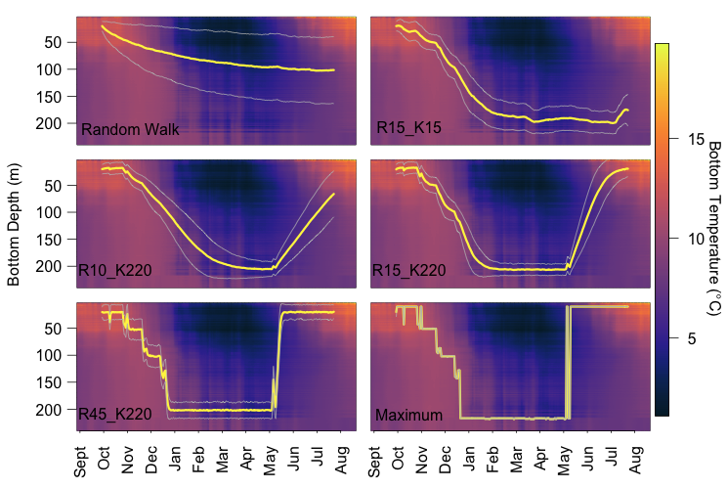

B

A

C

D

E

F

Fig. S4. Depth of simulated lobsters from October 1st 2013 to July 31st 2014 plotted over the Hovmöller plot of bottom temperature from September 2013 to August 2014, extracted from FVCOM. The mean and standard deviation of daily depths of 1000 lobsters simulated in six movement scenarios shown in Figure 5: (A) Random Walk (R15_K0), Precision = 0; (B) R15_K15, (C) R10_K220, (D) R15_K220, and (E) R45_K220, all with Precision 0.05; and (F) Maximum (R220_K220), Precision = 1.