APPENDIX
Category | Corresponding Event Types in the NCEI Storm Events Database and the US Drought Monitor Database
Extreme heat waves | Excessive Heat  Heat
Extreme cold temperatures | Cold/Wind Chill  Extreme Cold/Wind Chill
Extreme snow (or ice) storms | Blizzard  Heavy Snow  High Snow  Ice Storm  Lake-Effect Snow  Winter Storm  Winter Weather
Tornadoes | Tornado
Floods | Coastal Flood  Flash Flood  Flood  Lakeshore Flood  Surge/Tide
Hurricanes | Hurricane, Hurricane (Typhoon)  Marine Hurricane/Typhoon  Marine Tropical Depression  Marine Tropical Storm  Tropical Depression  Tropical Storm
Wildfires | Wildfire
Drought | D1 (Moderate Drought)  D2 (Severe Drought)  D3 (Extreme Drought)  D4 (Exceptional Drought)
Table A1: The storm event types from the NOAA NCEI Storm Events Database and the US Drought Monitor that we associate with each category of hazard.
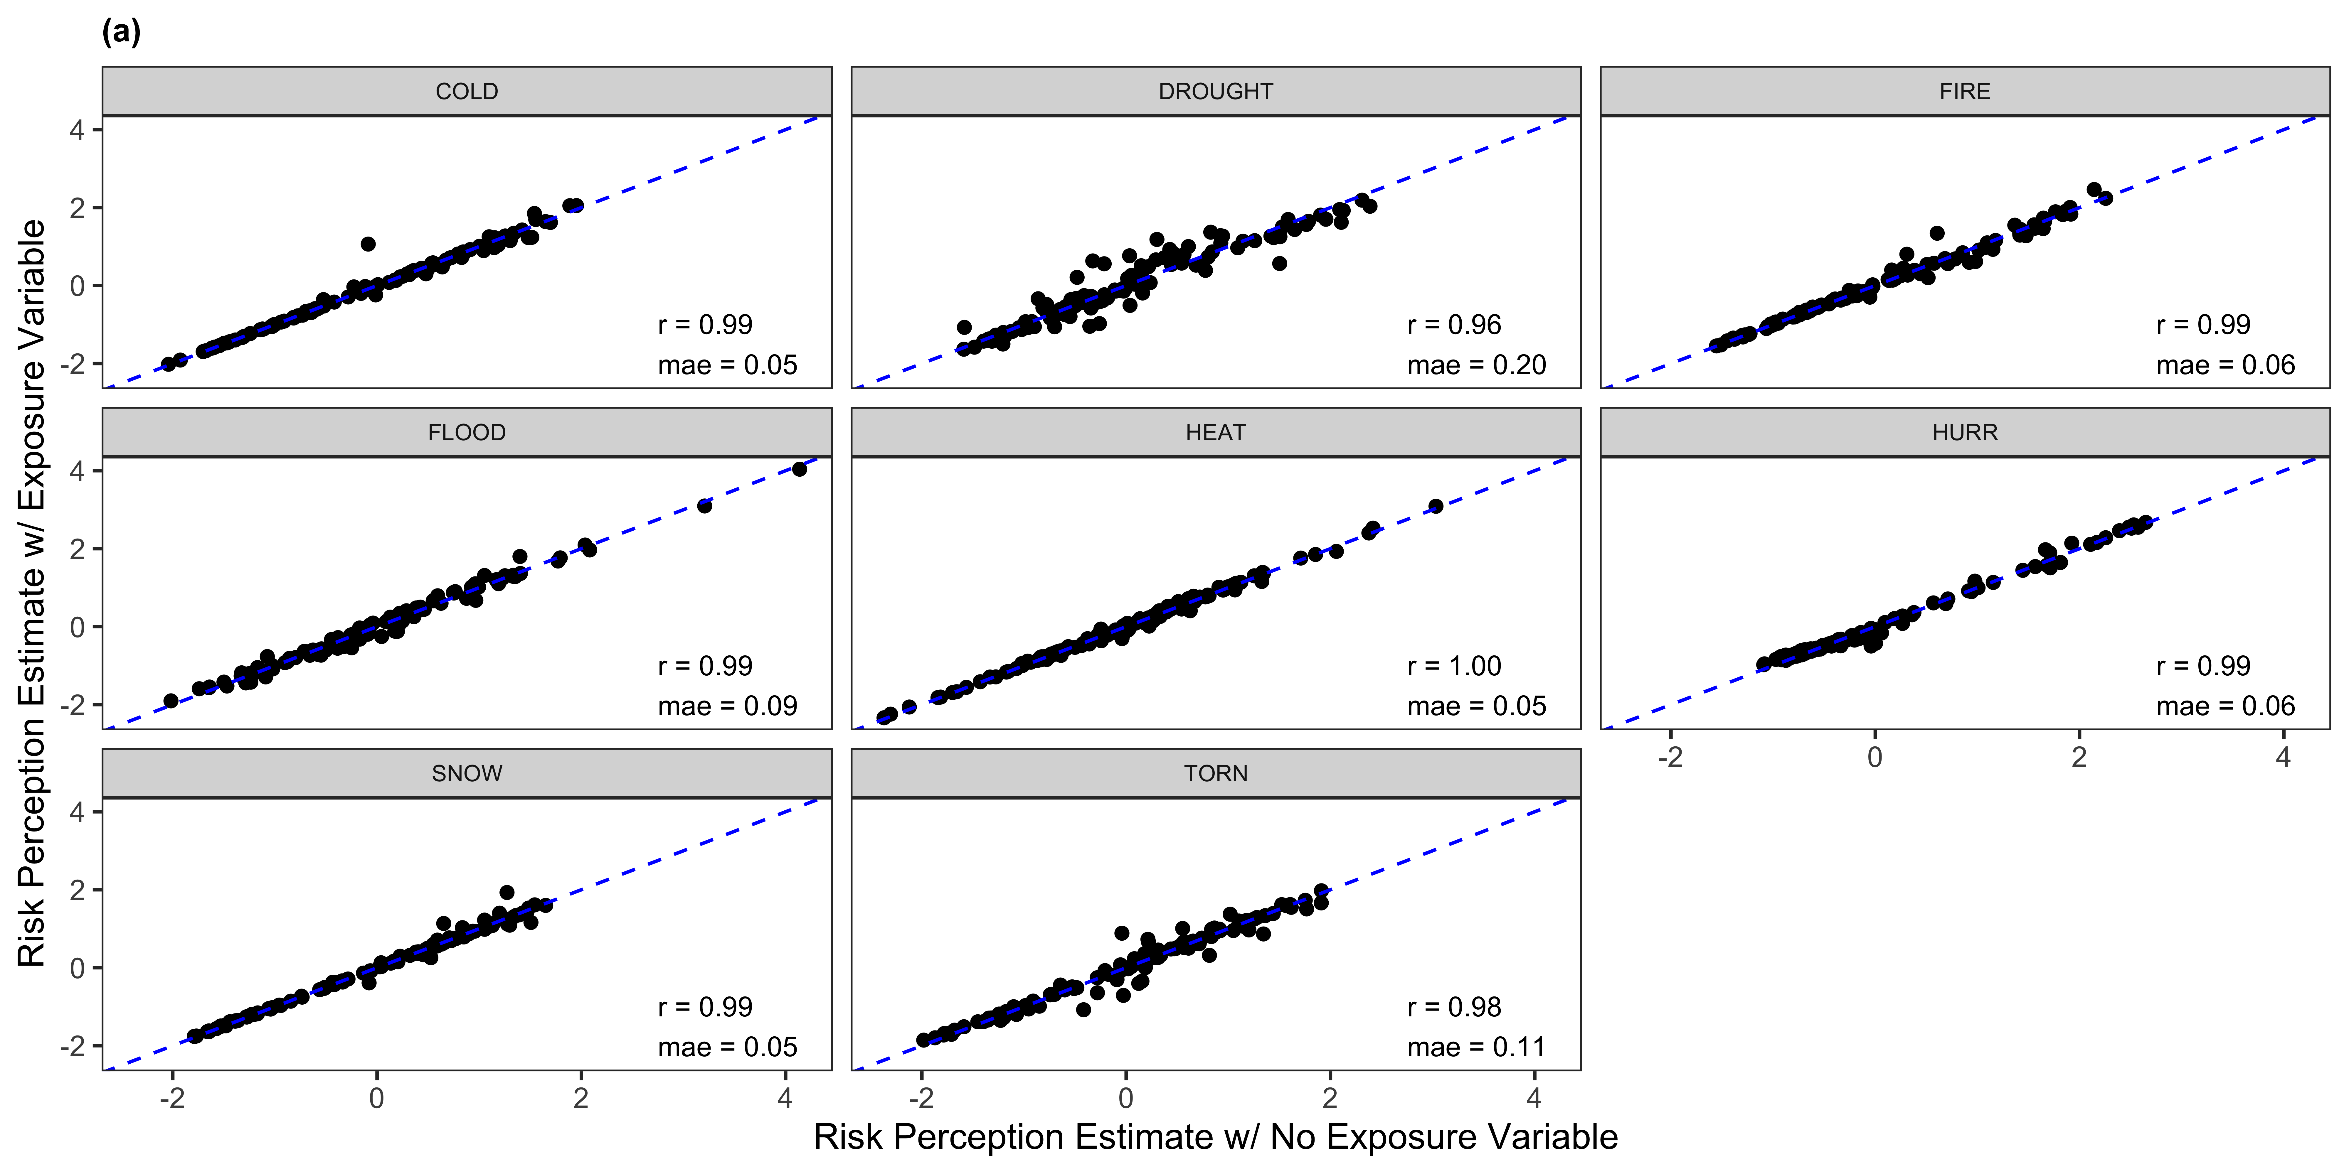
Figure A1. Comparison of MRP with and without exposure variable as predictor.
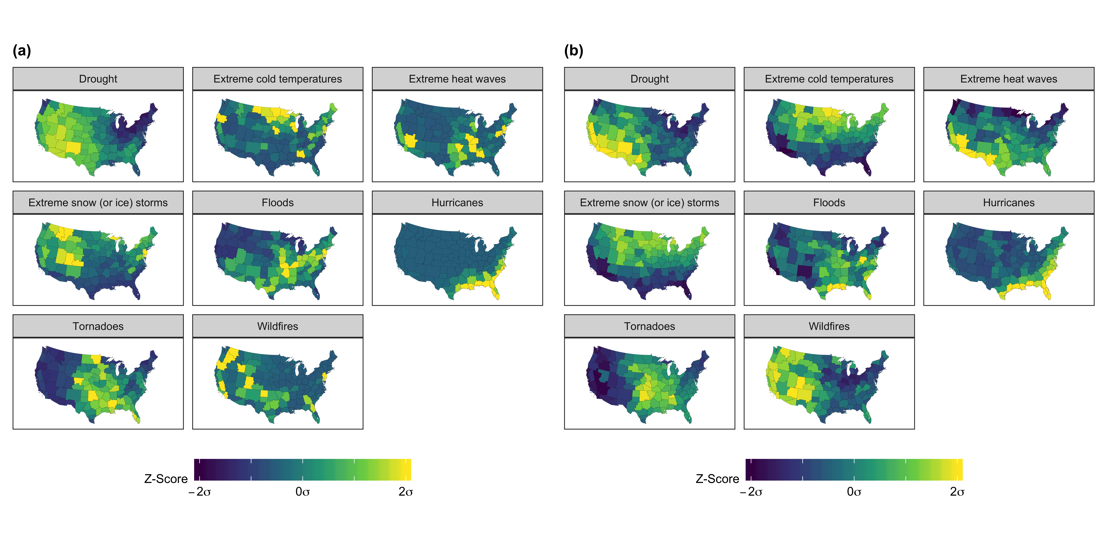
Figure A2. Replication of Figure 1 without Exposure variable as predictor.
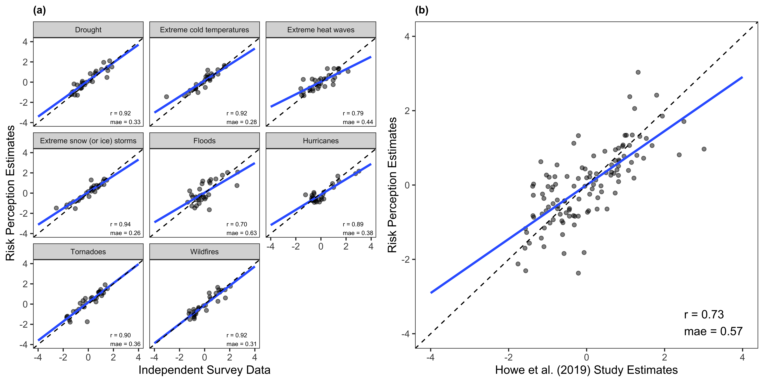
Figure A3. Replication of Figure 2 without Exposure variable as predictor.
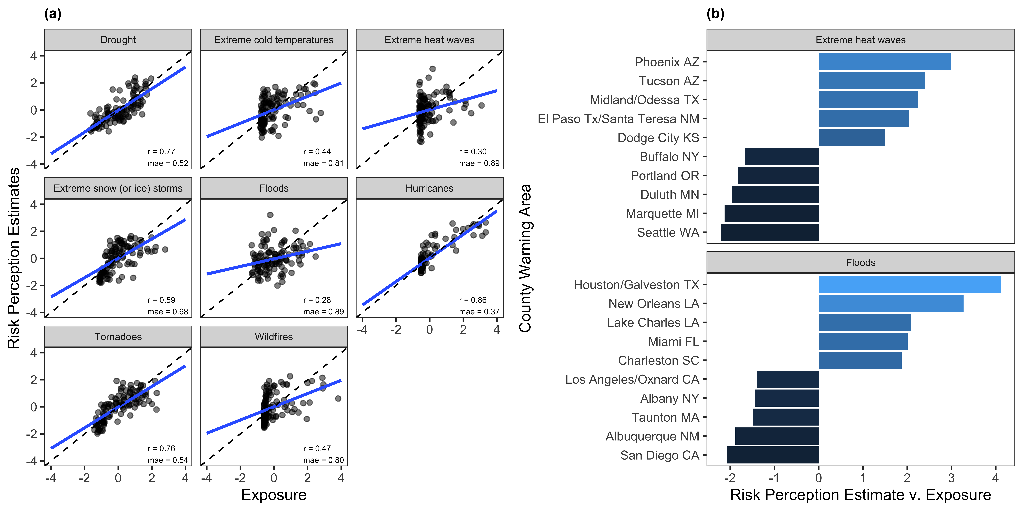
Figure A4. Replication of Figure 3 without Exposure variable as predictor.

