Appendix B: Model Description of the 2021 Federal Sablefish Stock Assessment Model

General Model Description

The 2021 federal sablefish stock assessment is fit using an age-and sex-structured integrated model assuming a homogenous population in AD Model Builder. Hereafter, several equations will be presented, and definitions of symbols and variables can be found in Table 1 in this appendix. Initial abundance-at-age was determined by the following equation:
$$\begin{aligned}N_{1,a,s}=\left\{\begin{matrix}R_{1}, & a=a_{0} \\ e^{\left(μ_{R}+ψ_{y}\right)}e^{-\left(a-a_{0}\right)\left(M+F_{hist}^{HAL} * s_{a,s}^{HAL_{1960-1995}}\right),} & a_{0}<a<a_{+} \\ e^{\left(μ_{R}\right)}e^{-\left(a_{+}-1\right)\left(M+F_{hist}^{HAL} * s_{a-1,s}^{HAL_{1960-1995}}\right)}{\left[1-e^{-\left(M+F_{hist}^{HAL} * s_{a-1,s}^{HAL_{1960-1995}}\right)}\right]}^{-1} & a=a_{+}\end{matrix}\right.\#\left(Eq. B1\right)\end{aligned}$$
where recruitment deviations are estimated for each cohort, and is decremented by natural mortality and historical fishing mortality rates resulting from the hook-and-line fishery up until the start of the assessment model (1960) (Goethel et al., 2021). The assessment assumes that a stock-recruitment relationship is not estimable (i.e., recruitment is independent of spawning stock biomass):
$$\begin{aligned}R_{y}=\left\{\begin{matrix}e^{{(μ}_{R}+ψ_{y})}, & y≠2021 \\ e^{\left(μ_{R}\right)}, & y=2021\end{matrix}\right., ψ_{y}\sim \ln\left(0,σ_{R}\right)\#\left(Eq. B2\right)\end{aligned}$$
where recruitment deviates are constrained by a penalized likelihood following a lognormal distribution, with $σ_{R}$ fixed at 1.2. Numbers-at-age starting in 1960 are determined by:
$$\begin{aligned}N_{y,a,s}=\left\{\begin{matrix}R_{y} & a=2 \\ N_{y-1,a-1}e^{-Z_{y,a,s}} & 2<a<31 \\ N_{y-1,a-1}e^{-Z_{y-1,a-1}}+N_{y-1,a}e^{-Z_{y-1,a}} & a=31\end{matrix}\right.\#\left(Eq. B3.1\right)\end{aligned}$$

$\begin{aligned}Z_{y,a,s}=\sum_{f}{F_{y,a,s,f}+M}\#\left(Eq. B3.2\right)\end{aligned}$where numbers-at-age in Eq. B3.1 are decremented by total mortality (sum of fishing and natural mortality; Eq. B3.2) and follows a forward projection method. Natural mortality in the assessment is estimated with an informative prior (mean = 0.1, CV = 10%). Catch data in the assessment is predicted using Baranov’s catch equation:
$$\begin{aligned}C_{y,a,s,f}=\frac{F_{y,a,s,f}}{Z_{y,a,s}}N_{y,a,s}\left(1-e^{-Z_{y,a,s}}\right)w_{a,s}\#\left(Eq. B4.1\right)\end{aligned}$$

$$\begin{aligned}F_{y,a,s,f}=e^{\left(μ_{f}+ρ_{y,f}\right)}*s_{y,a,s,f}\#\left(Eq. B4.2\right)\end{aligned}$$

where Eq. B4.1 is Baranov’s catch equation and describes predicted catch as the ratio of fishing mortality and total mortality multiplied by the number of individuals that experienced mortality in year y. Eq. B4.2 imposes a separability assumption, where annual fishing mortality rates are multiplied by the selectivity of fleet f, to estimate age-specific vulnerabilities. Catch data for a given fleet were assumed to follow a lognormal distribution. Predicted catch-at-age and catch-at-length was given by:
$$\begin{aligned}P_{y,a,s,f}=N_{y,a,s}s_{y,a,s,f}{\left(\sum_{a=2}^{a=31}{N_{y,a,s}s_{y,a,s,f}}\right)}^{-1}A_{s}\#\left(Eq. B5.1\right)\end{aligned}$$
$$\begin{aligned}P_{y,a,s,f}=N_{y,a,s}s_{y,a,s,f}{\left(\sum_{a=2}^{a=31}{N_{y,a,s}s_{y,a,s,f}}\right)}^{-1}A_{s}^{l}\#\left(Eq. B5.2\right)\end{aligned}$$
where catch-at-age is multiplied by an ageing error matrix (Fig. B1) to account for uncertainty in the ageing process (Eq. B5.1). For predicted catch-at-length, proportions were determined following Eq. B5.2 and was multiplied by an age-to-length transition matrix, to allow for the age-structured model to fit to sex-structured length-composition data. Age-and length-composition for all fisheries were assumed to follow multinomially distributed errors, with assumed input sample sizes of 20. Given inherent correlations in composition data, input sample sizes were smaller than observed sample sizes to reflect reduced information content resulting from such correlations (Pennington and Volstad, 1994; Francis, 2011). Integrated stock assessments are fit a variety of data sources and are sensitive to input data weights (Maunder and Piner, 2017). Furthermore, multinomial distributions do not allow for correlations that are commonly observed in age-or length-composition data (Francis, 2017). To reconcile these complexities, we applied Francis-reweighting to all explored model variants (Francis, 2011). Data weights for compositional data were determined following a 2-stage approach using method TA1.8 and weighting assumption T3.4 (multiplicative weighting) as described in Francis, 2011. The 2-stage reweighting approach was conducted until data weights and key management quantities appeared converged (Francis, 2017). Preliminary explorations indicated that the relative weights (weights are applied on an aggregate dataset) determined by Francis-reweighting and resulting model estimates were fairly insensitive to the assumed input sample sizes. Abundance/biomass indices were also assumed to follow a lognormal distribution, and the predicted index for a given year was given by:
$$\begin{aligned}\hat{I_{y,f}}=q_{y,f}\sum_{a=2}^{a=31}{\sum_{1}^{s}{N_{y,a,s }s_{y,a,s,f}w_{a,s}} }\#\left(Eq. B6\right)\end{aligned}$$
For indices of abundance that are represented as numbers, weight-at-age for sex s was not included in Eq. B6. Fishery-dependent indices in the current study assumed a coefficient of variation of 10%, as is done in the 2021 federal sablefish stock assessment.
Several data sources are fit within the assessment model. Here, we only describe those that represent an important component of the assessment, but readers should refer to (Goethel et al., 2021) Specifically, the assessment is fit to age-and length-composition data from both the fixed-gear fishery (hook-and-line and pot) and the annual sablefish longline survey, both of which assume logistic selectivity:
$$\begin{aligned}s_{y,a,s,f}={\left[1+e^{-δ_{y,s,f}\left(a-a_{y,s,f }^{50\%}\right)}\right]}^{-1}\#\left(Eq. B7\right)\end{aligned}$$

where the fixed-gear fishery assumes three time-blocks in both selectivity and catchability (1960-1994, 1995-2015, 2016-2020) to account for various shifts in management structure and large recruitment events. The assessment is also fit to catch data and length-composition data resulting from the trawl fishery following a re-parameterized gamma function:
$$\begin{aligned}s_{y,a,s,f}={\left(\frac{a}{a_{y,s,f}^{max} }\right)}^{\left(\frac{a_{y,s,f}^{max}}{p}\right)}e^{\frac{a_{y,s,f}^{max}-a}{p}}\#\left(Eq. B8.1\right)\end{aligned}$$

$$\begin{aligned}p=0.5*\left[\sqrt{{a_{y,s,f}^{max}}^{2}+4γ_{y,s,f}^{2}}-a_{y,s,f}^{max}\right]\#\left(Eq.B8.2\right)\end{aligned}$$

where $γ$ (shape parameter) is shared between sexes, to achieve stable model results. Finally, the model is also fit to a biomass index and length-composition from a biennial bottom trawl survey, which assumes a one parameter power function for selectivity:
$$\begin{aligned}s_{y,a,s,f}=a^{ϕ_{f,s}}\#\left(Eq.B9\right)\end{aligned}$$
All selectivities that are included in the model are scaled to have a maximum of 1.

Tier 3 North Pacific Fishery Management Council (NPFMC) Harvest Control Rule

Alaska sablefish are managed under the Tier 3 NPFMC harvest control rule (sloping control rule), which utilizes proxy reference points for maximum sustainable yield (MSY). Specifically, these references points are B40%, which represents the long-term average biomass that would be expected under mean recruitment conditions and fishing mortality rates occurring at F40%. These reference points are determined from spawning per recruit ratios which represent the ratio between two lifetime egg productions (fished cohort divided by unfished cohort), and ranges between 0 and 1. The resulting catch advice is:
$$\begin{aligned}F_{ABC}=\left\{\begin{matrix}F40\% & if\frac{SSB_{y+1}}{B40\%}>1 \\ \frac{F40\% \left(\frac{SSB_{y+1}}{B40\%}\right)-λ}{1-λ} & if\frac{SSB_{y+1}}{B40\%}<1 \\ 0 & if\frac{SSB_{y+1}}{B40\%}<λ\end{matrix}\right.\#\left(Eq.B10\right)\end{aligned}$$
where the total $SSB_{y+1}$ is the projected spawning stock biomass in the year following the terminal year of the assessment, while assuming mean recruitment and mortality rates from the terminal year of the assessment (fishing and natural mortality). $λ$ is defined as the fraction of $\frac{SSB_{y+1}}{B40\%}$ below which fishing does not occur, and is defined as 0.05 here.

Table 1. Symbols and descriptions of variables for equations used for the sablefish stock assessment model in this study.
Symbol | Description
$$N_{y,a,s}$$ | Abundance for year y (1960-2021), age $a$ (2, 3, 4 … 31₊) and sex s (male or female)
$$a_{0},a_{+}$$ | Age at recruitment (age 2) and age of plus-group (age 31) respectively
$$R_{y}$$ | Recruitment for year y
$$μ_{R}$$ | Mean log recruitment
$$ψ_{y}$$ | Annual recruitment deviation
$$σ_{R}$$ | Recruitment variability fixed at 1.2
$$M$$ | Time-invariant natural mortality
$$μ_{f}$$ | Mean log fishing mortality rate for fleet f (hook-and-line, trawl, or pot)
$$ρ_{y,f}$$ | Annual fishing mortality deviation for year and fleet f
$$F_{hist}^{HAL}$$ | Historical fishing mortality from the hook-and-line fishery
$$F_{y,a,s,f}$$ | Instantaneous fishing mortality rate for year y, age a, sex s, and fleet f
$$s_{y,a,s,f}$$ | Proportion selected for year y (estimated as time-blocks), age a, sex s, and fleet f
$$a^{50\%}$$ | Midpoint parameter for a logistic function describing age at 50% selection
$$δ$$ | Shape parameter describing the rate of increase for a logistic function
$$a^{max}$$ | Parameter for a re-parameterized gamma function describing age at maximum selection
$$γ$$ | Shape parameter for a re-parameterized gamma function describing rate of decrease for the descending limb
$$p$$ | Derived power parameter for a reparametrized gamma function
$$ϕ$$ | Parameter that determines the slope of the power function
$$C_{y,a,s,f}$$ | Predicted catch (tons) for year y, age a, sex s, and fleet f
$$Z_{y,a,s}$$ | Total instantaneous mortality for year y, age a, sex s
$$w_{a,s}$$ | Average weight at age a and sex s
$$P_{y,a,s,f}{,P}_{y,l,s,f}$$ | Predicted proportions at age a or length l (41, 43, 45 … 99) respectively, for year y, sex, s, and fleet f
$$A_{s}{,A}_{s}^{l}$$ | Ageing error matrix and age-to-length transition matrix for sex s, respectively

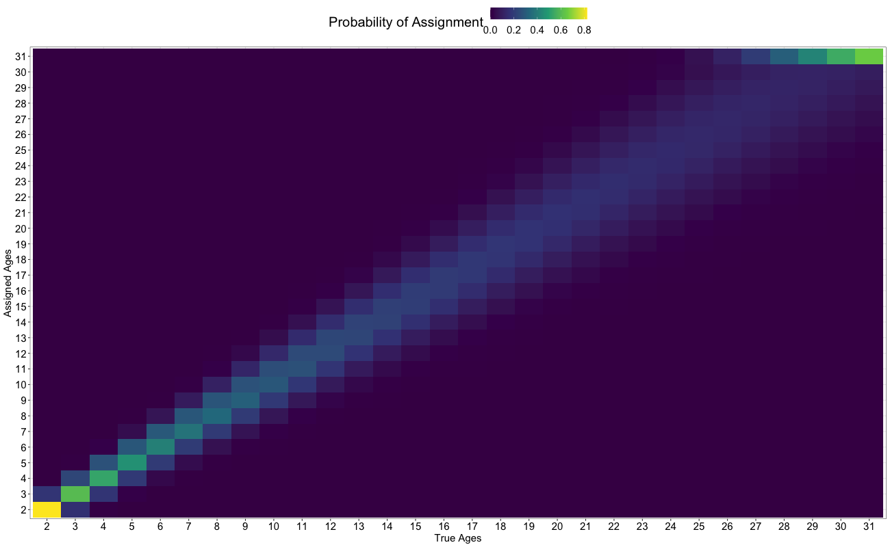
Figure B1. Ageing error matrix used in the 2021 operational sablefish assessment model. True ages are denoted on the x-axis, while reader assigned ages are denoted on the y-axis. Colors represent the probability of assignment to a given age-class.

Appendix B: References
Francis, R. I. C. C. 2011. Data weighting in statistical fisheries stock assessment models. Canadian Journal of Fisheries and Aquatic Sciences, 68: 1124–1138.
Francis, R. I. C. C. 2017. Revisiting data weighting in fisheries stock assessment models. Fisheries Research, 192: 5–15.
Goethel, D., Hanselman, D., Rodgveller, C., Echave, K. B., Williams, B., Shotwell, S. K., Sullivan, J., et al. 2021. 3. Assessment of the Sablefish Stock in Alaska: 347.
Maunder, M. N., and Piner, K. R. 2017. Dealing with data conflicts in statistical inference of population assessment models that integrate information from multiple diverse data sets. Fisheries Research, 192: 16–27.
Pennington, M., and Volstad, J. H. 1994. Assessing the Effect of Intra-Haul Correlation and Variable Density on Estimates of Population Characteristics from Marine Surveys. Biometrics, 50: 725.

