Appendix A: Supplementary Figures
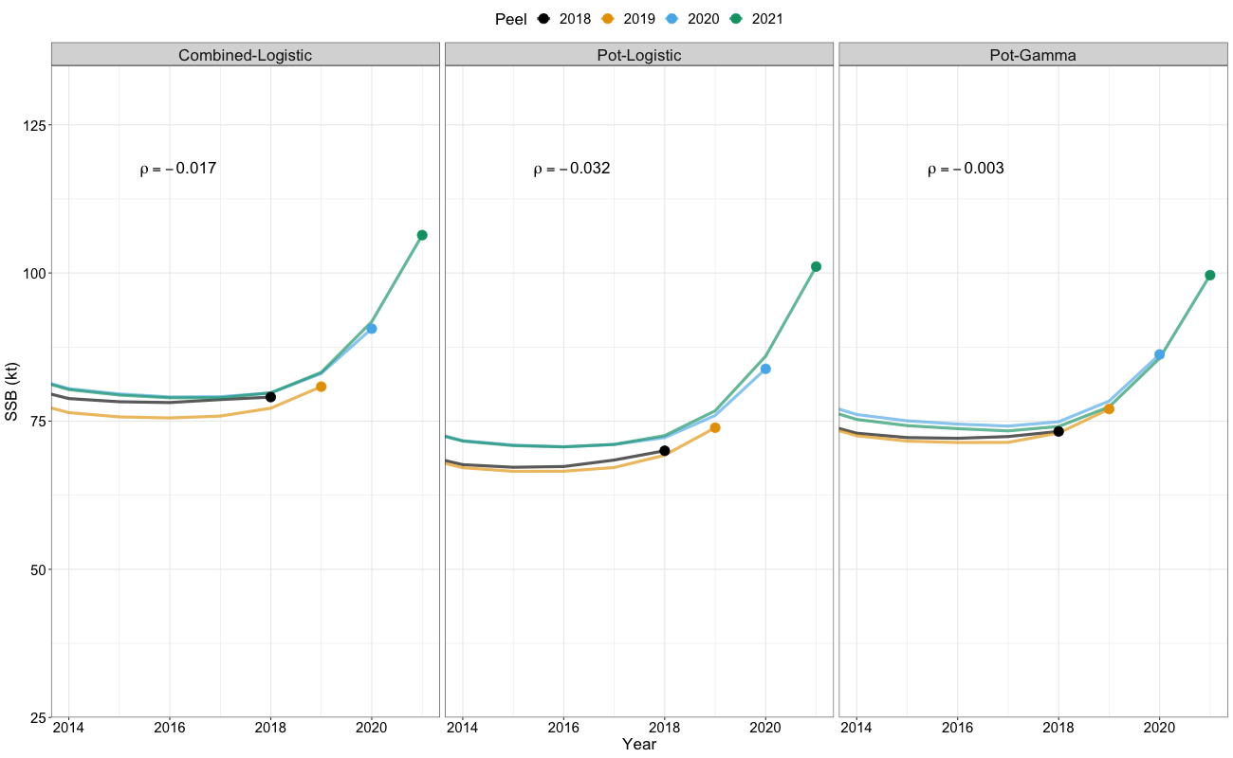
Figure A1. Retrospective patterns from 3-year “peels” of spawning stock biomass (SSB) for sablefish across model variants. Corresponding Mohn’s $ρ$ values from retrospective analysis are shown in each panel. Different colors represent estimates for individual “peels” and the estimates from the terminal year assessment (2021) are displayed in green.

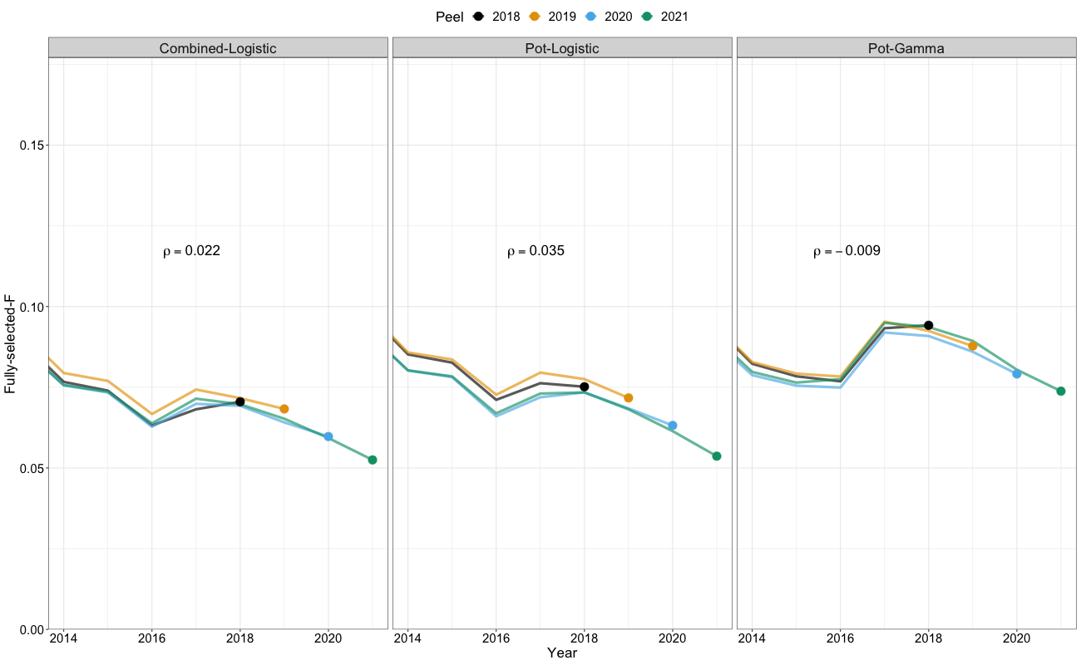
Figure A2. Retrospective patterns from 3-year “peels” of fully-selected fishing mortality rates for sablefish across model variants. Corresponding Mohn’s $ρ$ values from retrospective analysis are shown in each panel. Different colors represent estimates for individual “peels” and the estimates from the terminal year assessment (2021) are displayed in green.

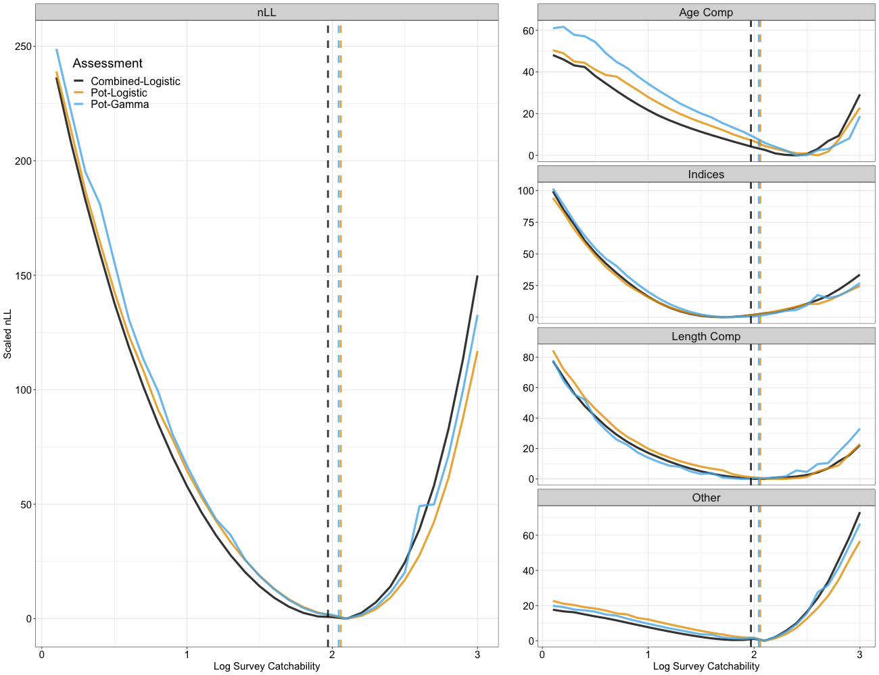
Figure A3. Likelihood profiles for the NMFS longline survey catchability. Catchability values were profiled across values of 0 – 3 in increments of 0.1. Negative log-likelihood (nLL) values for a given data type were scaled by their minimum value to ensure nLL values minimized at 0. Model variants are displayed in different colors, solid lines represent the likelihood profile, and dashed lines represent the maximum likelihood estimate of survey catchability for a given model.

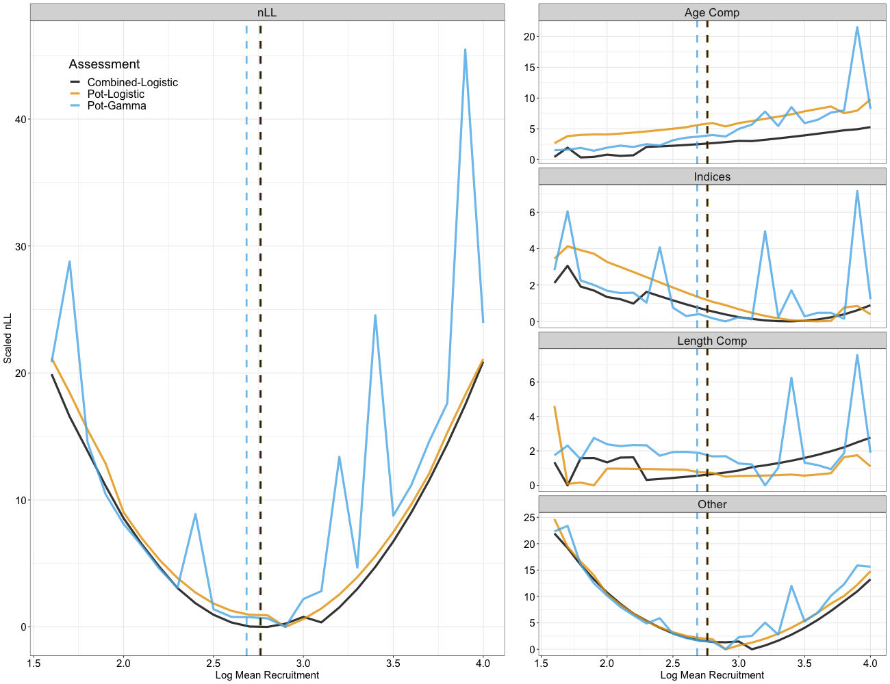
Figure A4. Likelihood profiles for the mean recruitment. Recruitment values were profiled across values of 1.5 – 4 in increments of 0.1. Negative log-likelihood (nLL) values for a given data type were scaled by their minimum value to ensure nLL values minimized at 0. Model variants are displayed in different colors, solid lines represent the likelihood profile, and dashed lines represent the maximum likelihood estimate of mean recruitment for a given model.

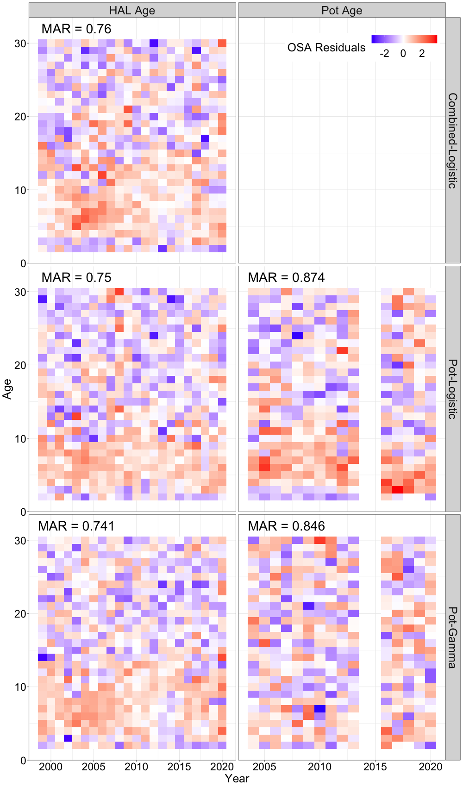
Figure A5. One-step ahead residuals across hook-and-line (HAL) and pot age-composition data (columns) across time (x-axis) and ages (y-axis) for all models evaluated in the study. Red colors are positive residuals and blue colors denote negative residuals. Mean absolute residuals (MAR) presented in the upper left corner of each panel represent the average absolute residuals for a given composition type and assessment model. Larger MAR values are indicative of a worse fit for a given assessment model to a composition type on average.
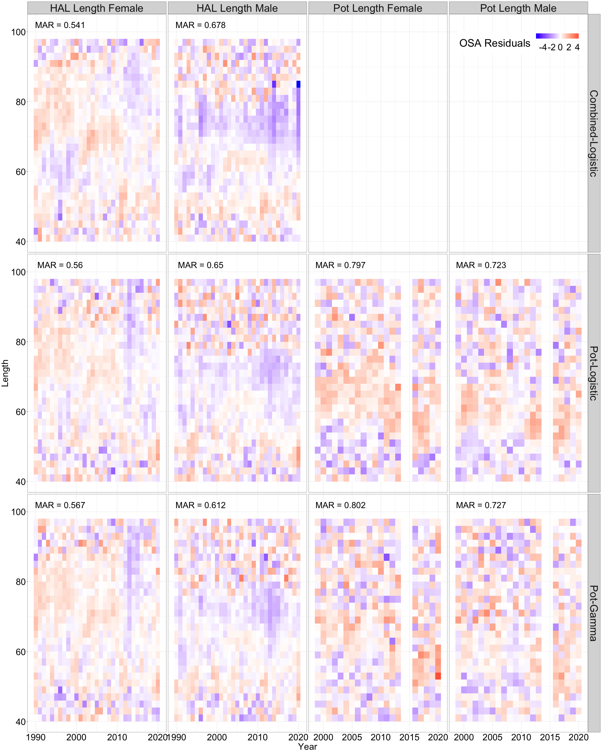
Figure A6. One-step ahead residuals across hook-and-line (HAL) and pot length-composition data (columns) across time (x-axis) and lengths (y-axis) for all models evaluated in the study. Red colors are positive residuals and blue colors denote negative residuals. Mean absolute residual (MAR) values presented in the upper left corner of each panel. Larger MAR values are indicative of a worse fit for a given assessment model to a composition type on average.

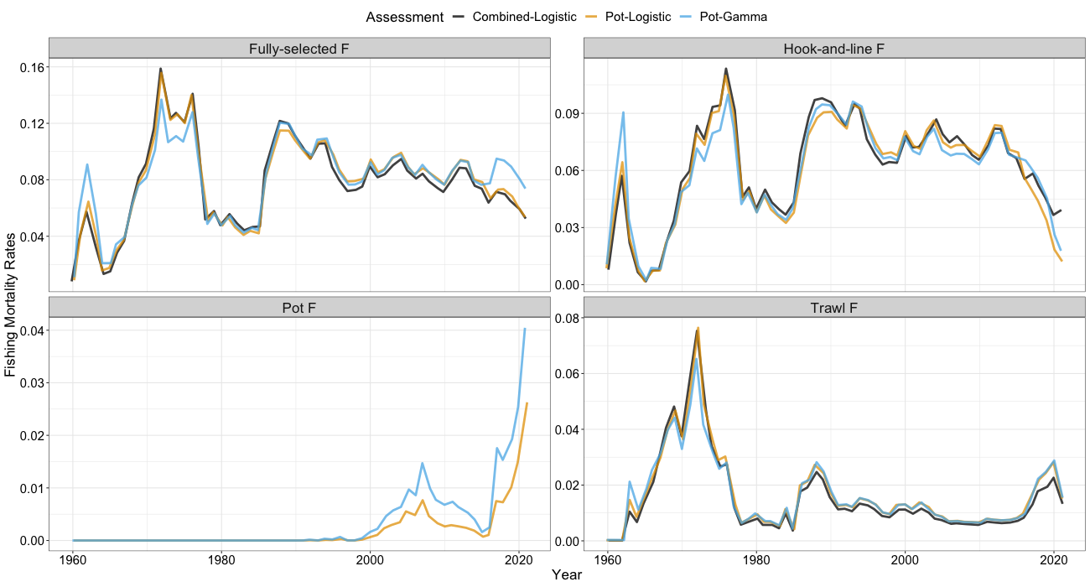

Figure A7. Time-series of fishing mortality rates from 1960-2021 across model variants. The panel denoted as “Fully-selected F” represents the sum of the fishing mortality rates across all fleets. Panels denoted by “Hook-and-line F”, “Pot F”, and “Trawl F” represent estimated fishing mortality rates for the hook-and-line (or fixed-gear fleet for model Combined-Logistic), pot, and trawl fishery, respectively. Note that the scale of the y-axis differs across panels.

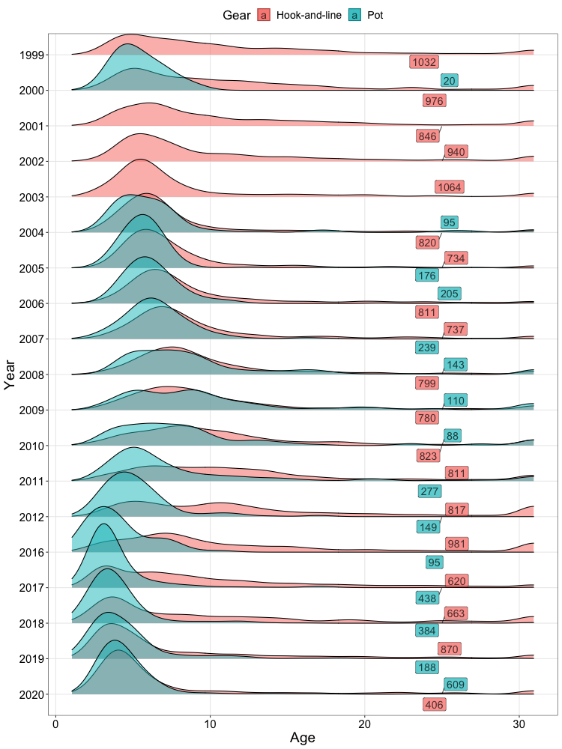
Figure A8. Distribution of ages sampled by hook-and-line gear and pot-gear. Colored labels denote the number of individuals aged for a given gear type.

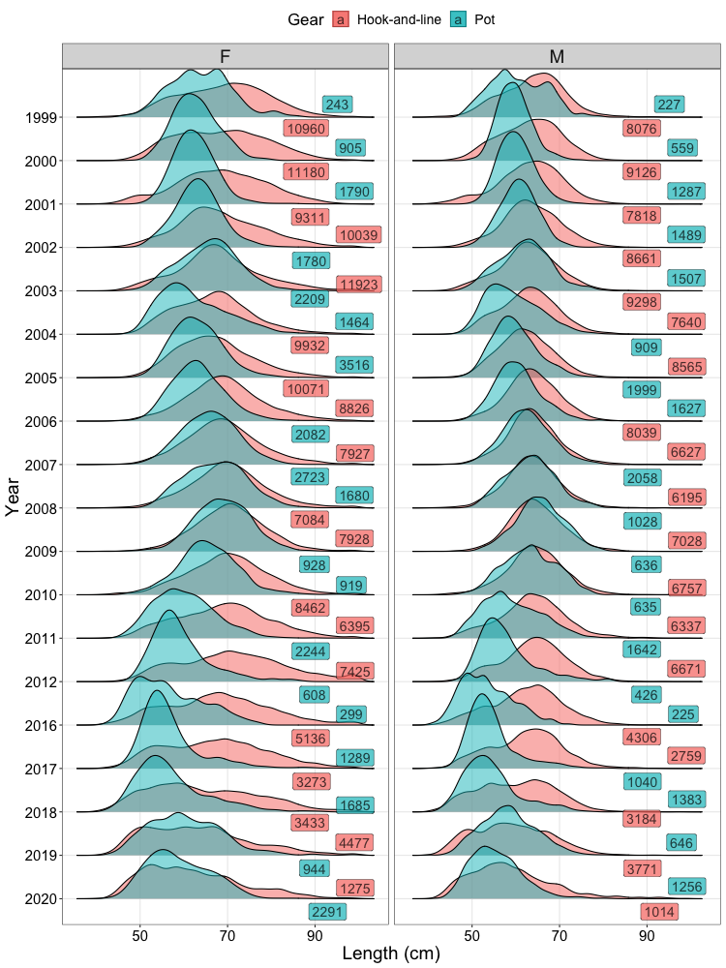
Figure A9. Distribution of lengths sampled by hook-and-line gear and pot-gear across sexes. Colored labels denote the number of individuals aged for a given gear type.

