Supplement
Eelgrass surveys
Table S1. Dates and methods of surveys used in our analysis.
Site | Year | Date | Observation method
Choked Pass | 2014 | 7/31 | UAV
Choked Pass | 2016 | 8/3 | UAV
Choked Pass | 2017 | 7/23 | UAV
Choked Pass | 2018 | 8/16 | UAV
Choked Pass | 2019 | 8/16 | UAV
Choked Pass | 2020 | 7/20 | UAV
Elkhorn Slough | 1934 | 1931 & 1937 (composite) | Aerial
Elkhorn Slough | 1966 | 1956, 1966, 1976 (composite) | Aerial
Elkhorn Slough | 1986.333 | 1980, 1987, 1992 (composite) | Aerial
Elkhorn Slough | 2002.667 | 2000, 2003, 2005 | Aerial
Elkhorn Slough | 2008 | 2007, 2008, 2009 | Aerial
Elkhorn Slough | 2014 | Feb (GE), Jan 13 (aerial) | Aerial & Google Earth
Elkhorn Slough | 2015.5 | Mar 2015, Apr 2015, Apr 2016 | Google Earth
Elkhorn Slough | 2018 | Feb - Nov | Google Earth
Estero Americano | 2014 | Jun, Sep | Visual
Estero Americano | 2016 | Jul | Visual
Estero Americano | 2017 | Aug | Visual
Estero Americano | 2018 | Aug | Visual
Estero de San Antonio | 2016 | Aug | Visual
Estero de San Antonio | 2017 | Aug | Visual
Estero de San Antonio | 2018 | Aug | Visual
Gibsons Harbour | 2004 | Sep | Underwater camera
Gibsons Harbour | 2013 | Sep | Underwater camera
Gibsons Harbour | 2019 | Sep | Underwater camera
Goose | 2015 | 9/13 | UAV
Goose | 2017 | 8/13 | UAV
Goose | 2019 | 8/2 | UAV
Goose | 2020 | 7/24 | UAV
McMullin North | 2015 | 9/4 | UAV
McMullin North | 2017 | 7/24 | UAV
McMullin North | 2018 | 7/4 | UAV
McMullin North | 2020 | 7/24 | UAV
Mission Bay | 1988 | Oct | Sonar, visual
Mission Bay | 1992 | Oct | Sonar, visual
Mission Bay | 1997 | Oct | Sonar, visual
Mission Bay | 2003 | Oct | Sonar, visual
Mission Bay | 2007 | Oct | Sonar, visual
Mission Bay | 2013 | May | Sonar, visual
Morro Bay | 2002 | 11/25 | Aerial
Morro Bay | 2003 | 11/21 | Aerial
Morro Bay | 2004 | 11/24 | Aerial
Morro Bay | 2006 | 11/6 | Aerial
Morro Bay | 2007 | 11/24 | Aerial
Morro Bay | 2009 | 11/13 | Aerial
Morro Bay | 2010 | 11/4 | Aerial
Morro Bay | 2013 | 5/28 | Aerial
Morro Bay | 2017 | 12/1 & 12/4 | UAV
Morro Bay | 2018 | Dec | UAV
Morro Bay | 2019 | Dec | UAV
Morro Bay | 2020 | 11/14, 11/15, 11/16, 12/14, 12/15 | UAV
Morro Bay | 2021 | 12/2, 12/3, 12/4, 1/1/22 | UAV
Newport Bay | 2007 | Sep 2006 - Nov 2008 | Sonar, visual
Newport Bay | 2009.5 | Aug 2009 - Oct 2010 | Sonar, visual
Newport Bay | 2013.5 | Mar 2013 - Apr 2014 | Sonar, visual
Newport Bay | 2016 | Jun-Oct (Dec for one portion) | Sonar, visual
Newport Bay | 2020 | 6/19-11/9 | Sonar, visual
Padilla Bay | 1989 | 6/3 | Aerial
Padilla Bay | 2000 | 7/30 | Aerial
Padilla Bay | 2004 | 6/4 | Aerial
Pruth Bay | 2012 | 8/5 | UAV
Pruth Bay | 2015 | 8/1 | UAV
Pruth Bay | 2016 | 8/5 | UAV
Pruth Bay | 2017 | 6/26 | UAV
Pruth Bay | 2018 | 8/5 | UAV
Pruth Bay | 2019 | 7/30 | UAV
Pruth Bay | 2020 | 7/20 | UAV
Richardson Bay | 2014 | Oct-Nov | Aerial, Sonar
Richardson Bay | 2019 | Jun-Jul | Aerial, Sonar
San Diego Bay | 1993 | Mar-Apr; Sep-Oct | Sonar, visual
San Diego Bay | 1999 | Mar-Apr; Sep-Oct | Sonar, visual
San Diego Bay | 2004 | 10/5, 7-8, 12-15, 18-19, 25-30, & 11/1-4 | Sonar, visual
San Diego Bay | 2008 | Jun-Aug | Sonar, visual
San Diego Bay | 2014 | May-July | Sonar, visual
San Diego Bay | 2017 | May-July | Sonar, visual
San Diego Bay | 2020 | Aug-Oct | Sonar, visual
San Francisco Bay | 2004 | Jun-Oct | Aerial, Sonar
San Francisco Bay | 2009 | Oct-Nov | Aerial, Sonar
San Francisco Bay | 2014 | Oct-Nov | Aerial, Sonar
Superstition Pt | 2019 | 8/3 | UAV
Superstition Pt | 2020 | 7/23 | UAV
Triquet Bay | 2016 | 7/5 | UAV
Triquet Bay | 2018 | 8/13 | UAV
Triquet Bay | 2019 | 8/1 | UAV
Triquet Bay | 2020 | 7/25 | UAV
Underhill | 2019 | 7/31 | UAV
Underhill | 2020 | 7/21 | UAV

Quantifying water quality in San Francisco Bay
We examined San Francisco Bay, where eelgrass meadow ranges appeared to respond to drought. We expected low freshwater inflow via drought to create favorable conditions for eelgrass in the northeast by shifting marine waters toward the delta but also create unfavorable conditions in the south by increasing turbidity (following Jassby et al. 1995 and Livsey et al. 2021).
For this case study, we compiled data quantifying salinity and extinction coefficients (i.e., decay rate of photosynthetically active radiation with depth) from monitoring stations closest to the most northeast and southern extent of eelgrass observed (Schraga and Cloern 2017; see Fig. S1 for locations) as well as data quantifying water year indices (i.e., a measure of annual unimpaired runoff) (CDWR 2021). Then, we used linear mixed effects models to quantify the relationship between water quality and annual runoff from April to October (i.e., the eelgrass growing season, as well as the dry season, in this Mediterranean-climate system, NOAA 2014), while accounting for seasonality, and employed backwards model selection following Zuur et al. (2009). Formally, the full models were parameterized as
log(μ_{y}) = β₀ + β₁x₁ + β₂x₂ + β₃x₁x₂ + a_{y}
a_{y}~N(0,σ²_{y})
That is, the logarithm of a water quality variable (salinity or extinction coefficient) value μ in year y was a function of intercept β₀, effects β₁₋₃ of water year index x₁, day of year x₂, and their interaction, and a random effect a of year y. We included an interaction effect of water year index and day of year because we expected the influence of annual runoff on water quality to vary as California’s potentially wet season (~November to March) transitions to its dry season (~April to October).

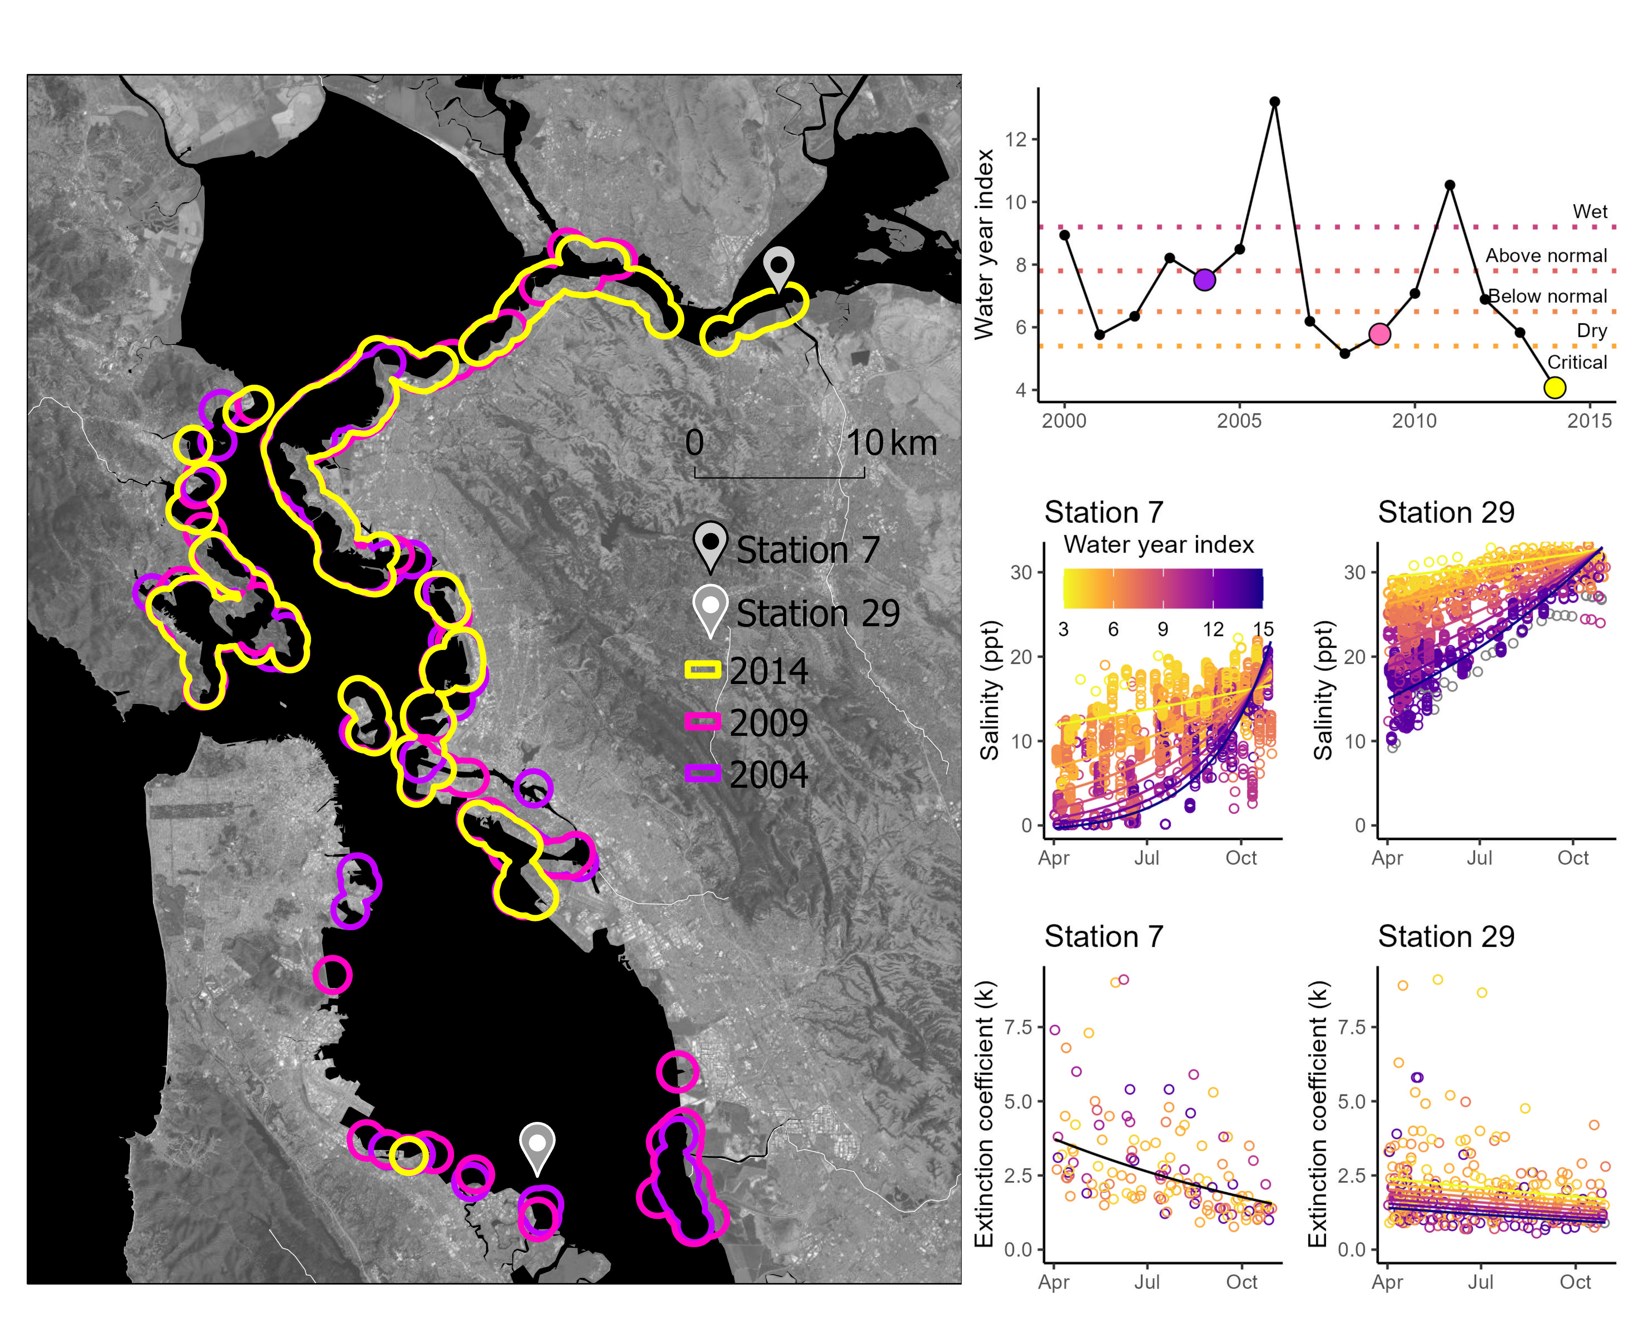
Figure S1. Eelgrass in San Francisco Bay (USA) shifts toward the northeast when drought creates beneficial, saline conditions in the northeast but detrimental, turbid conditions in the south. Left: 1 km buffers around eelgrass in 2004, 2009, and 2014. Freshwater enters the bay from the northeast and mixes with the ocean to the west. Station numbers reference Schraga and Cloern (2017). Top right: Timing of surveys (color circles) relative to water year index (a measure of annual runoff) in the surrounding time period. Descriptors on the right are long-term (1901-present) water year index classifications and colors correspond to water year index values below (CDWR 2021). Bottom right: Salinity and extinction coefficients (a measure of turbidity) compared across water year classifications and between stations closest to the northeastern and southernmost extent of observed eelgrass (Schraga and Cloern 2017). Lines show linear mixed effects model predictions relating water quality variables to water year indexes (if final models included this parameter) and day of year. Parameter estimates: Table S2.
San Francisco Bay represents an ecosystem that expresses a wide range of physical and biological configurations (Fig. S1). Variable freshwater input from the Sacramento-San Joaquin River Delta shifted optimal eelgrass habitat conditions across space. During drought, preferable saline conditions emerge in the northeast, but detrimental turbid conditions emerge in the south. Accordingly, during droughts in 2009 and 2014, habitat patches in the northeast appeared to change from temporarily uninhabitable to inhabited while patches in the south changed from inhabited to temporarily uninhabitable in the south.

Table S2. Summary statistics and parameter estimates of linear mixed effects models describing water quality at two stations within San Francisco Bay.

Model | Effect | Group | Term | Estimate | Std. error | T value | p value
Station 7 salinity | fixed |  | Intercept | 3.51 | 0.109 | 32.1 | <0.001
 | fixed |  | Water year index | -0.361 | 0.0122 | -29.6 | <0.001
 | fixed |  | Day | -0.00232 | 3.70E-04 | -6.28 | <0.001
 | fixed |  | Water year index x day | 0.00127 | 4.43E-05 | 28.5 | <0.001
 | random | year | sd: Intercept | 0.286
 | random | residual | sd: Observation | 0.378
Station 29 salinity | fixed |  | Intercept | 3.6 | 0.0144 | 249 | <0.001
 | fixed |  | Water year index | -0.0764 | 0.00142 | -53.9 | <0.001
 | fixed |  | Day | -2.78E-04 | 3.78E-05 | -7.35 | <0.001
 | fixed |  | Water year index x day | 2.56E-04 | 4.60E-06 | 55.7 | <0.001
 | random | year | sd: Intercept | 0.0595
 | random | residual | sd: Observation | 0.0573
Station 29 extinction coefficient | fixed |  | Intercept | 1.41 | 0.0831 | 17 | <0.001
 | fixed |  | Water year index | -0.0287 | 0.00838 | -3.42 | 0.002
 | fixed |  | Day | -0.0011 | 2.55E-04 | -4.31 | <0.001
 | random | year | sd: Intercept | 0.118
 | random | residual | sd: Observation | 0.281
Station 7 extinction coefficient | fixed |  | Intercept | 1.82 | 0.0889 | 20.4 | <0.001
 | fixed |  | Day | -0.00292 | 3.99E-04 | -7.33 | <0.001
 | random | year | sd: Intercept | 0.15
 | random | residual | sd: Observation | 0.278

References
Beaty. F., Sanford, D. 2019. Town of Gibsons and Howe Sound/Atl’ka7tsem Eelgrass Survey Report. 41 pp.
Beheshti, K.M., Williams, S.L., Boyer, K.E., Endris, C., Clemons, A., Grimes, T., Wasson, K., Hughes, B.B., 2022. Rapid enhancement of multiple ecosystem services following the restoration of a coastal foundation species. Ecological Applications, 32(1):e02466. doi:10.1002/eap.2466
CDWR (California Department of Water Resources) (2021). Chronological Reconstructed Sacramento and San Joaquin Valley Water Year Hydrologic Classification Indices. https://cdec.water.ca.gov/reportapp/javareports?name=WSIHIST
Coastal Resources Management, Inc. (CRM) (2010). Results of the second Newport Bay eelgrass (Zostera marina) bay-wide habitat mapping survey: Status and distribution between 2006-2008 and oceanographic conditions in Newport Bay between 2008 and 2009. Prepared for the City of Newport Beach Harbor Resources Division. August 18th, 2010. 126 pp.
Coastal Resources Management, Inc. (CRM) (2012). Results of the third Newport Bay eelgrass (Zostera marina) bay-wide habitat mapping survey: Status and distribution between 2009-2010 with additional observations in 2011. Prepared for the City of Newport Beach Harbor Resources Division. January 2012. 52 pp.
Coastal Resources Management, Inc. (CRM) (2015). Results of the fourth Newport Bay eelgrass (Zostera marina) bay-wide habitat mapping survey: Status and distribution between 2013-2014. Prepared for the City of Newport Beach Harbor Resources Division. January 2015. 66 pp.
Coastal Resources Management, Inc. (CRM) (2017). Results of the Fifth Eelgrass (Zostera marina) mapping survey: status and distribution in Newport Bay, Newport Beach, California 2016 Survey. Prepared for the City of Newport Beach Harbor Resources Division. June 2017. 88pp.
Jassby, A. D., Kimmerer, W. J., Monismith, S. G., Armor, C., Cloern, J. E., Powell, T. M., ... & Vendlinski, T. J. (1995). Isohaline position as a habitat indicator for estuarine populations. Ecological Applications, 5(1), 272-289.
Livsey, D. N., Downing-Kunz, M. A., Schoellhamer, D. H., & Manning, A. (2021). Suspended-sediment Flux in the San Francisco Estuary; Part II: the Impact of the 2013–2016 California Drought and Controls on Sediment Flux. Estuaries and Coasts, 44(4), 972-990.
Marine Taxonomic Services (2020). 2020 monitoring of eelgrass resources in Newport Bay Newport Beach, California. Prepared for City of Newport Beach Public Works Department.
Merkel and Associates (2013). Mission Bay park 2013 bathymetry and eelgrass inventory. Prepared for City of San Diego Public Works, W&CP, AEP Division.
Merkel and Associates. (2014). Southern California Bight Regional Eelgrass Surveys. Prepared for NOAA/National Marine Fisheries Service West Coast Region Protected Resources Division.
Merkel and Associates. (2015). San Francisco Bay Eelgrass Inventory October 2014. Submitted to National Marine Fisheries Service.
Merkel and Associates. (2019). Ecologically-Based Mooring Feasibility and Planning Study Richardson’s Bay Regional Agency. Prepared for Richardson’s Bay Regional Agency.
Merkel and Associates. (2020). Evaluation of temporal and spatial changes of eelgrass beds within San Diego Bay using permanently monitored transects. Prepared for Naval Facilities Engineering Command Southwest Environmental Core.
Munsch, S. H., Beaty, F. L., Beheshti, K. M., Chesney, W. B., Endris, C. A., Gerwing, T. G., ... & Walter, R. K. (2023). Northeast Pacific eelgrass dynamics: interannual expansion distances and meadow area variation over time. Marine Ecology Progress Series, 705, 61-75.
Schraga, T. S., & Cloern, J. E. (2017). Water quality measurements in San Francisco Bay by the US Geological Survey, 1969–2015. Scientific Data, 4(1), 1-14.
Team, H. G. T., Reshitnyk, L., & Hakai Institute. (2020). Eelgrass (Z. marina) extent at sites along the Central Coast, British Columbia [Data set]. https://doi.org/10.21966/03pw-2190
Walter, R. K., O'Leary, J. K., Vitousek, S., Taherkhani, M., Geraghty, C., & Kitajima, A. (2020). Large-scale erosion driven by intertidal eelgrass loss in an estuarine environment. Estuarine, Coastal and Shelf Science, 243, 106910.
Zuur AF, Ieno EN, Walker N, Saveliev AA, Smith GM (2009) Mixed effects models and extensions in ecology with R. Springer-Verlag, Berlin

