Appendix A

This appendix presents examples of operational text and graphical products that include TC outer size and structure information. Examples of wind radii at the analysis time in ocean wind warnings from the JTWC and BoM are shown in Tables A.1 and A.2. The format of ocean wind warnings from RSMC Nadi and TCWC Wellington is similar to that shown in Table A.2. An example of a BoM technical bulletin with wind radii and ROCI is shown in Table A.3.

Examples of cyclone warning graphics, including a depiction of the wind field, from RSMC Nadi, TCWC Wellington, the NHC, and RSMC Tokyo are shown in Figs. A.1, A.2, A.3, and A.4, respectively. Figs. A.5 and A.6 from JTWC depict post-storm wind radii reanalyses for different portions of the track for Super Typhoon 12W. Fig. A.5 shows the R34, R50, and R64 that were adjusted for consistency from those issued operationally. Fig. A.6 shows the full reanalysis of the R34 wind radii for the entire track of the system, including the rapid expansion of R34 as the system stalled and then recurved to the east of Taiwan.

Table A.1. Excerpt from a JTWC warning showing wind radii information for Typhoon Kulap on 28 Sep 2022.
PRESENT WIND DISTRIBUTION:
MAX SUSTAINED WINDS - 065 KT, GUSTS 080 KT
WIND RADII VALID OVER OPEN WATER ONLY
RADIUS OF 064 KT WINDS - 045 NM NORTHEAST QUADRANT
045 NM SOUTHEAST QUADRANT
000 NM SOUTHWEST QUADRANT
000 NM NORTHWEST QUADRANT
RADIUS OF 050 KT WINDS - 065 NM NORTHEAST QUADRANT
090 NM SOUTHEAST QUADRANT
060 NM SOUTHWEST QUADRANT
000 NM NORTHWEST QUADRANT
RADIUS OF 034 KT WINDS - 125 NM NORTHEAST QUADRANT
145 NM SOUTHEAST QUADRANT
130 NM SOUTHWEST QUADRANT
120 NM NORTHWEST QUADRANT

Table A.2. Excerpt from a BoM ocean wind warning for Severe Tropical Cyclone Vernon on 26 Feb 2022.
Maximum winds to 100 knots near the centre easing to 60 knots by 0000 UTC 27
February.

Winds above 64 knots within 15 nautical miles of centre with very high to
phenomenal seas.

Winds above 48 knots within 25 nautical miles of centre with high seas and
moderate to heavy swell.

Winds above 34 knots within 40 nautical miles in NE quadrant
and within 65 nautical miles in SE quadrant
and within 65 nautical miles in SW quadrant
and within 40 nautical miles in NW quadrant with rough to very rough seas and moderate swell.

Table A.3. Excerpt from an example of a BoM TC Technical Bulletin including wind radii and ROCI.
Radius of 34-knot winds NE quadrant: 120 nm (220 km)
Radius of 34-knot winds SE quadrant: 100 nm (185 km)
Radius of 34-knot winds SW quadrant: 60 nm (110 km)
Radius of 34-knot winds NW quadrant: 120 nm (220 km)
Radius of 48-knot winds NE quadrant: 40 nm (75 km)
Radius of 48-knot winds SE quadrant: 40 nm (75 km)
Radius of 48-knot winds SW quadrant: 40 nm (75 km)
Radius of 48-knot winds NW quadrant: 40 nm (75 km)
Radius of 64-knot winds: 25 nm (45 km)
Radius of Maximum Winds:
Dvorak Intensity Code: T5.0/5.0/D1.5/24HRS
Pressure of the outermost isobar: 1000 hPa
Radius of the outermost closed isobar: 150 nm (280 km)

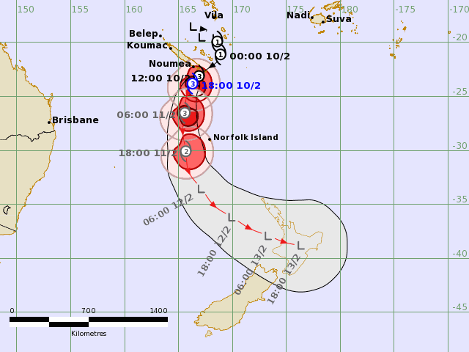
Fig. A.1. Example of a TC track map from RSMC Nadi in which the pink, red, and dark red shading depict the areas of the gale, storm, and hurricane-force winds for Severe Tropical Cyclone Dovi on 10 Feb 2022. Figure courtesy of RSMC Nadi.
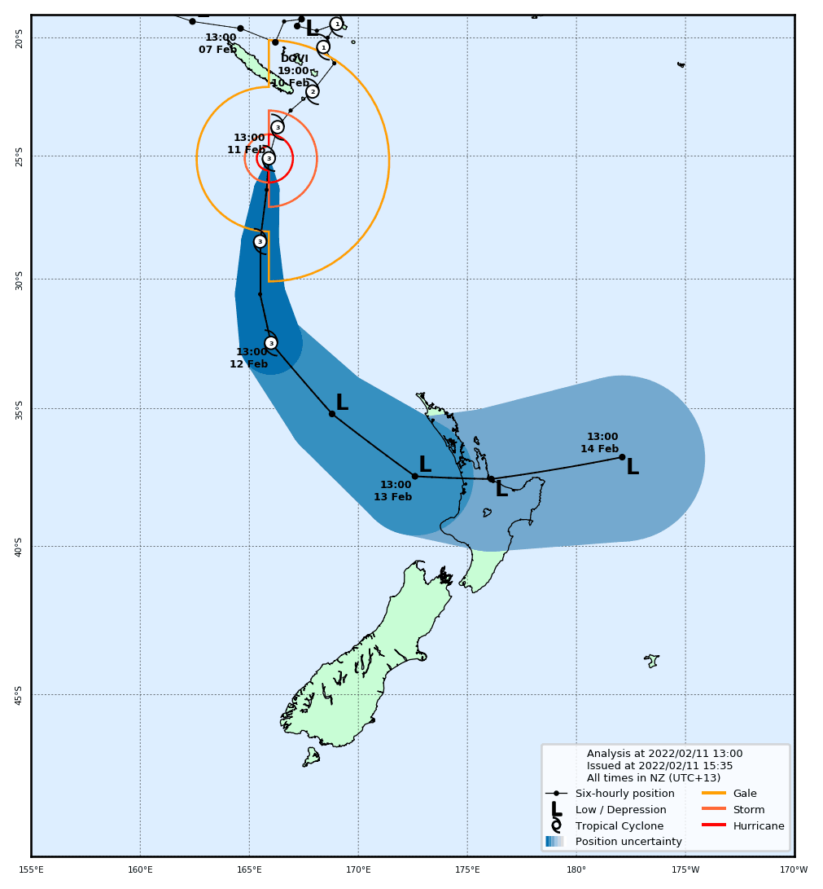
Fig. A.2. Example of a TC track map from TCWC Wellington in which the orange, dark orange, and red sector outlines depict the areas of the gale, storm, and hurricane-force winds for Severe Tropical Cyclone Dovi on 11 Feb 2022. Figure courtesy of Chris Noble (TCWC Wellington).

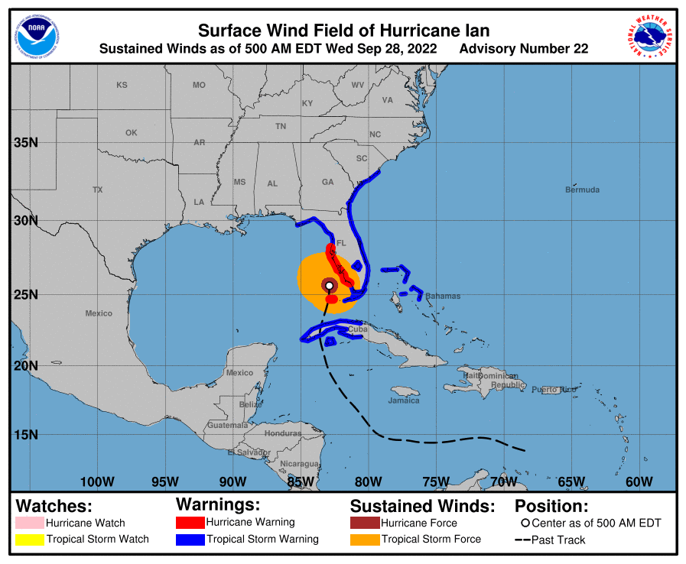
Fig. A.3. Example of the NHC surface wind field graphic at analysis time. The orange and brown shading depict the areas of tropical storm-force and hurricane-force winds, respectively, for Hurricane Ian on 28 Sep 2022. Figure courtesy of the NHC.

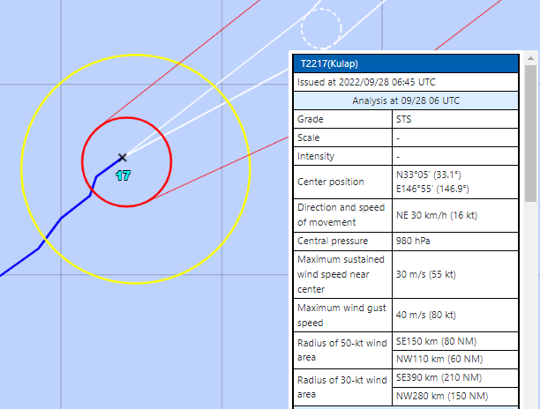
Fig. A.4. Example analysis of 30-kt (yellow) and 50-kt (red) wind circles for the analysis of Severe Tropical Storm Kulap on 28 Sep 2022 from RSMC Tokyo. The wind radii are slightly offset from the TC center to denote asymmetries and the wind radii are reported as semi-circles in the text insert. Figure courtesy of RSMC Tokyo.

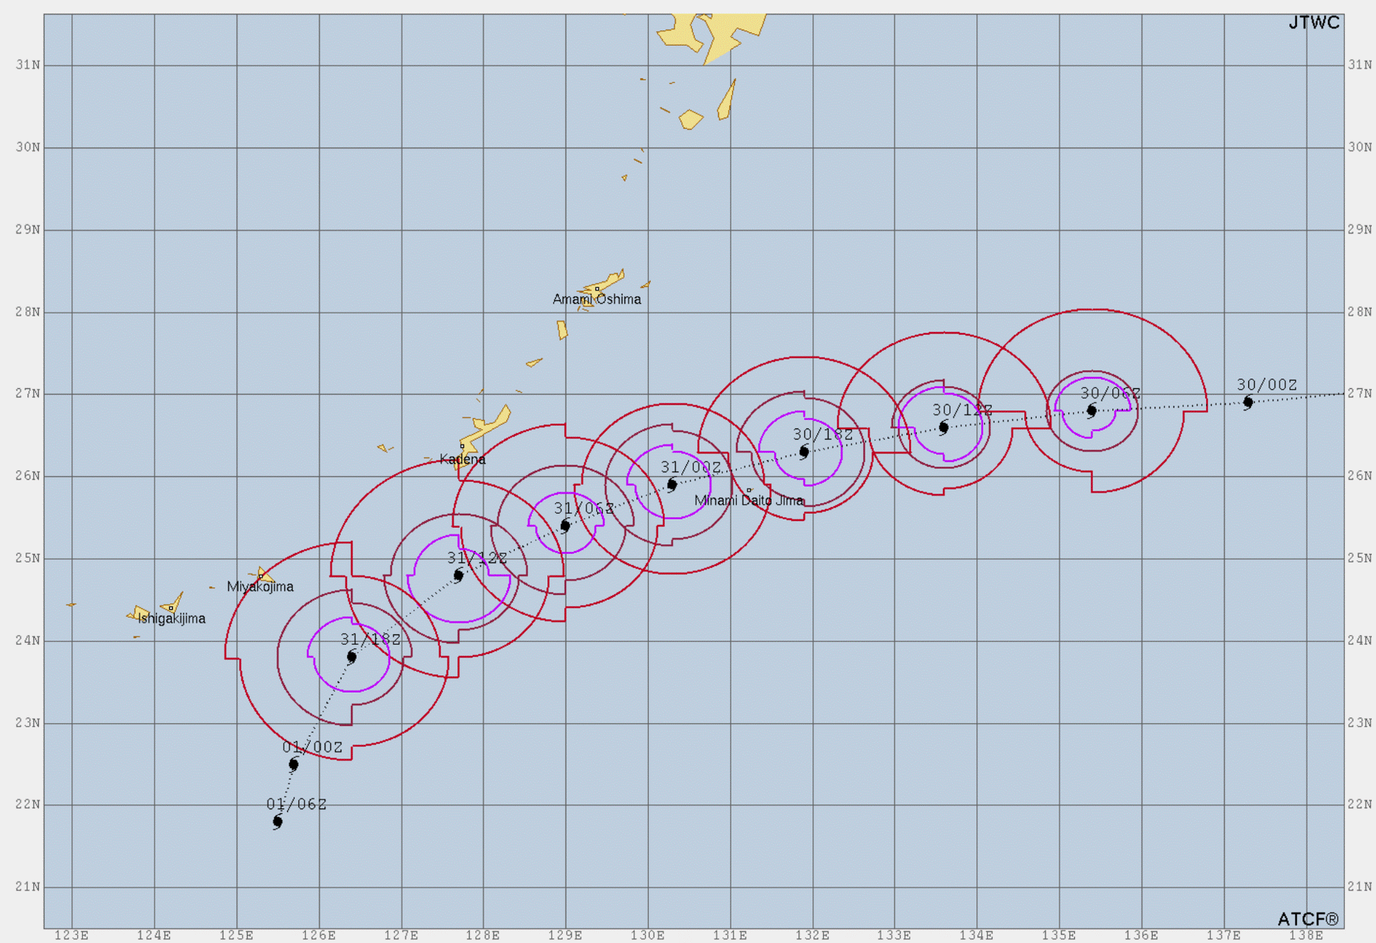
Fig. A.5. Post-storm R34, R50, and R64 reanalyses of Super Typhoon 12W on approach to Okinawa, Japan from 30 August 2022 to 01 Sep 2022. Note the radii have been adjusted for consistency based on the wind speed images and surface observations. Figure courtesy of Stephen Barlow (JTWC).
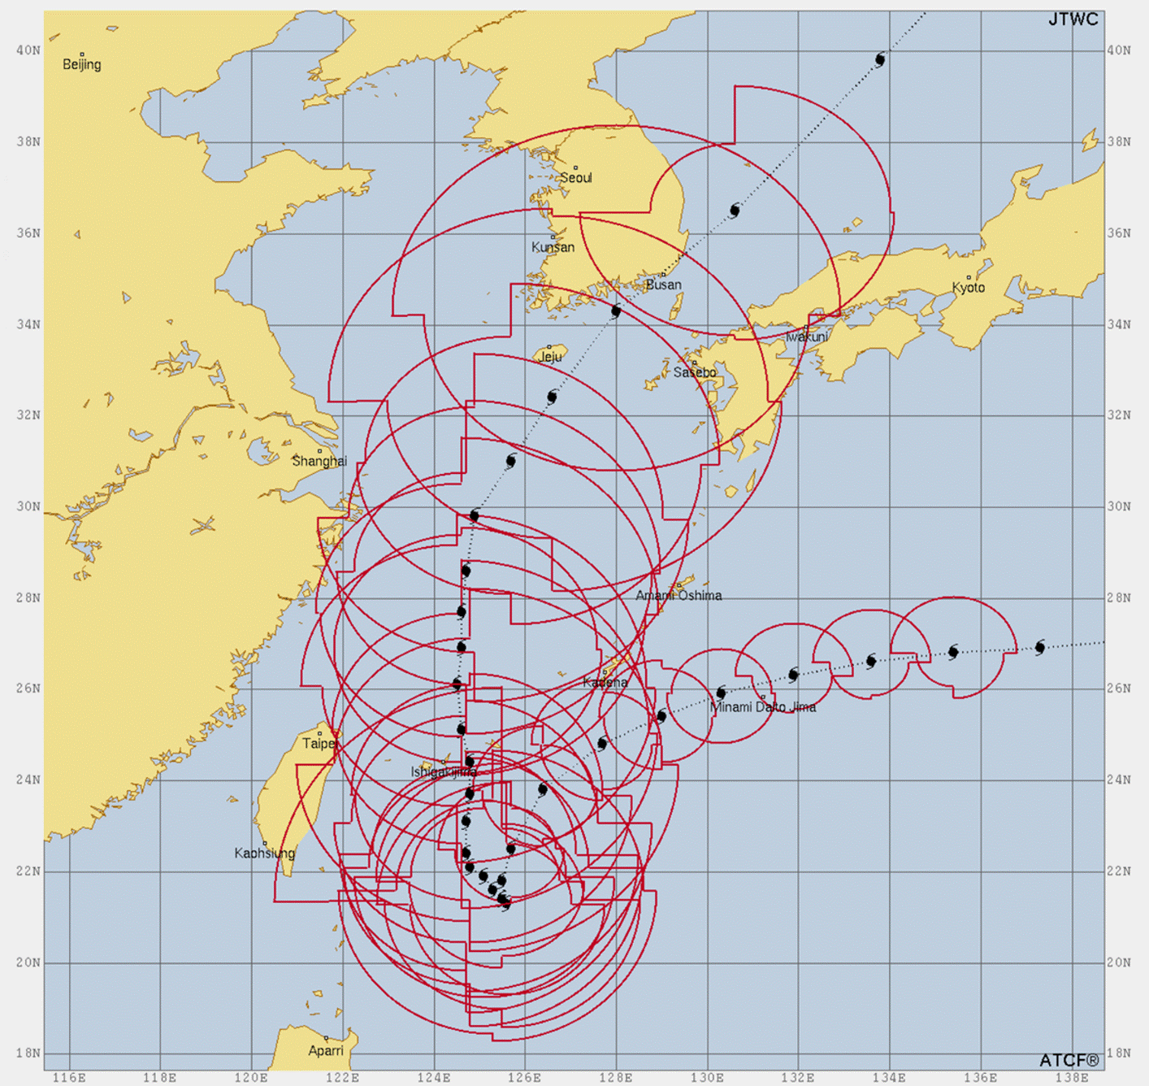Fig. A.6. Post-storm R34 wind radii reanalyses of Super Typhoon 12W. Figure courtesy of Stephen Barlow (JWTC).

