

*Earth and Space Science*

Supporting Information for

**Comparison of the AIRS, IASI and CrIS Infrared Sounders Using Simultaneous Nadir Overpasses: Novel Methods Applied to Data from Oct 1st, 2019, to Oct 1st, 2020**

M. Loveless1, R. Knuteson1, H. Revercomb1, L. Borg1, D. DeSlover1, G. Martin1, J. Taylor1, F. Iturbide-Sanchez2, and D. Tobin1

1 University of Wisconsin – Madison, Space Science and Engineering Center, 2 NOAA/NESDIS/Center for Satellite Applications and Research (STAR)

**Contents of this file**

Figures S1 to S6

**Introduction**

This supporting information includes figures which show sources of errors in the analysis methodology which do not affect the conclusions of this paper but are important to consider in this work.

It also includes figures which help visually characterize the geographic distribution of the hyperspectral infrared sounder SNOs analyzed in the main text and also shows the time difference histograms of the SNO datasets. The similarity between the histograms of NOAA-20 CrIS with AIRS/IASI and SNPP CrIS with AIRS/IASI supports the rationality for double differencing the NOAA-20 and SNPP SNO results as shown in the main text.

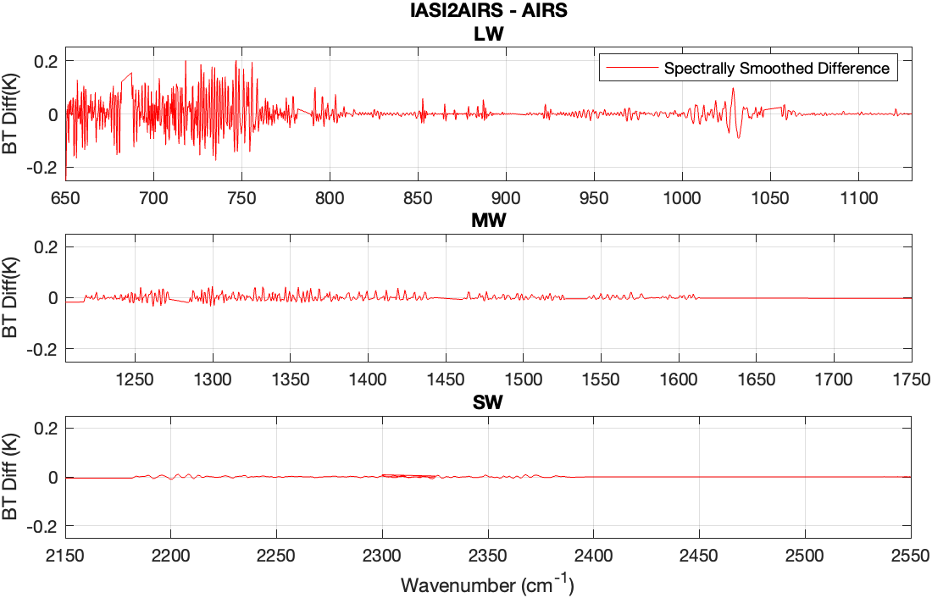

**Figure S1.** Errors of the IASI-to-AIRS spectral resolution conversion. A single monochromatic radiance calculation was converted 1] directly to AIRS spectral resolution and 2] to IASI spectral resolution first and then to AIRS using the IASI-to-AIRS spectral resolution conversion method detailed in the main text Section 3.2. The spectrally smoothed difference of 2] minus 1] is shown in this figure and represents the error induced by our spectral conversion methodology for IASI-to-AIRS. The spectral smoothing applied is the same Hamming apodization which is done to the AIRS-IASI biases shown in the main manuscript. As noted in the main text, the error shown in Figure S1 does not account for the broad spectral deviations from zero that are seen in the AIRS-IASI biases in Section 5.

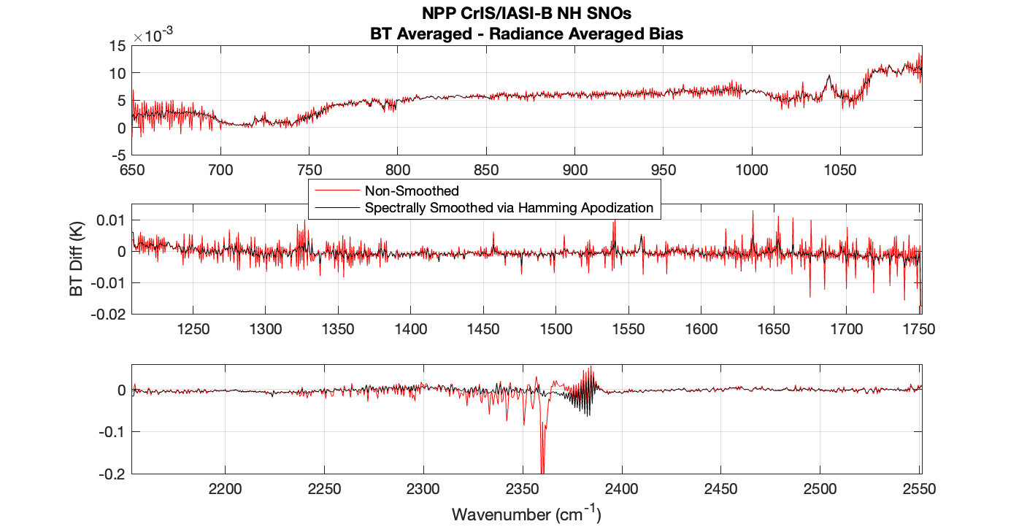

Figure S2. NPP CrIS and IASI-B Northern Hemisphere SNO analysis showing the effect of averaging over CrIS-IASI difference spectra in either radiance or brightness temperature (BT) units. The differences shown are computed as A minus B, where A is the weighted bias computed by averaging over BT spectra and B is the weighted bias computed by averaging over radiance spectra (and then converting to BT using the average scene temperature). Both the non-spectrally smoothed (red) and spectrally smoothed via Hamming apodization (black) results are shown overlaid. See Section 3.3 for further description.



Figure S3. Maps showing geographic distributions of SNO locations from October 1st, 2019 to October 1st, 2020. Northern Hemisphere (top row) and Southern Hemisphere (bottom row) maps shown for CrIS/AIRS SNOs (left column), AIRS/IASI (middle column), and CrIS/IASI (right column). Note that a latitude restriction was imposed on the CrIS/AIRS SNO dataset to subset it to similar latitudinal extents as the CrIS/IASI and AIRS/IASI dataset. Only SNOs which are included in the high-latitude analysis are plotted (quality control screens and randomized selections to obtain symmetric time difference histograms are applied).

Figure S4. Histograms of SNO latitude for the high-latitude comparisons. Corresponding maps shown in Figure S3. See text for information about time difference and latitude restrictions imposed on the SNO datasets. The number of SNOs, N, analyzed for each instrument combination is noted in the legend for each the Northern Hemisphere (NH) and Southern Hemisphere (SH).

Figure S5. Same as Figure S4, except showing histograms of longitude.

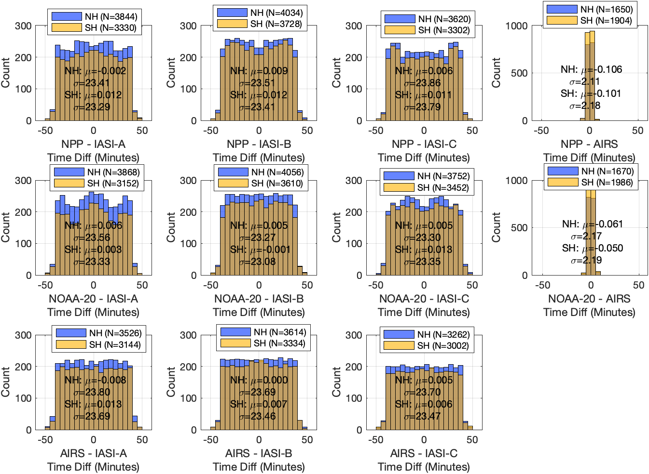

Figure S6. Same as Figure S4, except showing histograms of overpass time differences as well as the mean and standard deviation of the time differences for each hemisphere.