**Supplementary Information**

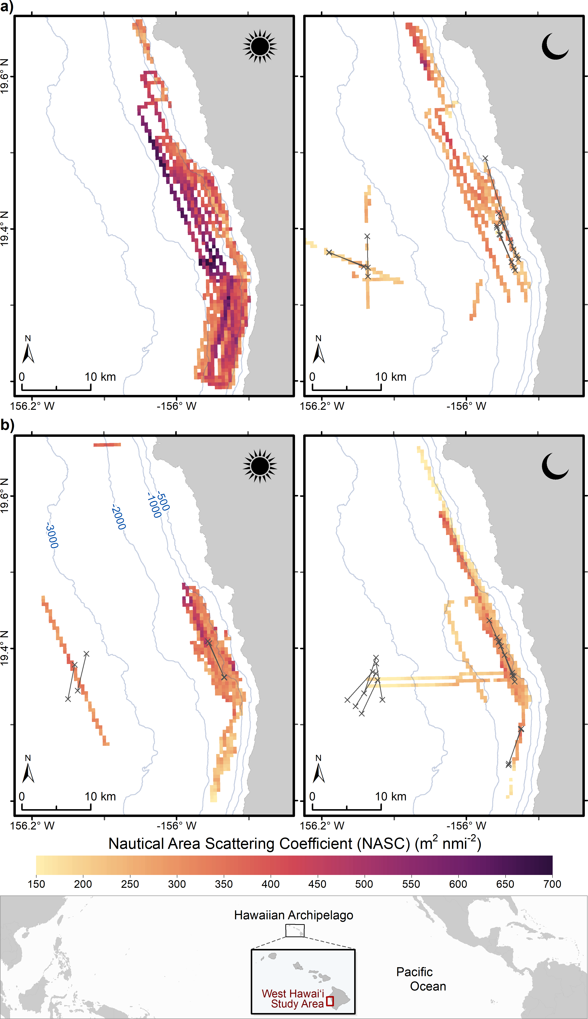

**Supplemental Figure 1.** 38 kHz day time and night time acoustics transects in a) September 2016 (pulse length of 1024 μs) and b) April 2017 (pulse length of 512 μs) showing mean deep-scattering layer nautical area scattering coefficient (NASC; m2 nmi-2) at 400 – 600 m depth along West Hawai`i (cell size of 500x500 meters in UTM 5N projection). Cutaway shows the location of West Hawai`i in the Pacific Ocean. ‘X’ marks start and end of trawls, with the line representing the trawl distance at each location. Depth contour lines (or isobaths) are shown in blue and labeled with depth in meters in the bottom left panel.

Supplementary Figure 2. Mean (with standard deviation) of 38 kHz acoustic NASC values in offshore and nearshore areas in 2016 and 2017. Values are presented for both day and night.

**a) b)**



**Supplemental Figure 3.** Mesopelagicmicronektonassemblage a) abundance (number of organisms tow-hr-1) and b) biomass(g tow-hr-1) during the day time trawls (tow identifier at the bottom of each column) at offshore and nearshore locations (average 24.2 km and 4.1 km from nearest shoreline, respectively) along West Hawaiʻi in 2017.



**a)**

**b)**

**Supplemental Figure 4.** a) Total abundance (number of organisms tow-hr-1) and b) biomass(g tow-hr-1) of fish taxa identified to contribute significant dissimilarity at night between offshore and nearshore locations in 2016 and 2017. Averages are shown in grey bars with standard deviation as whiskers. Bar tops for Serrivomeridae nearshore are not shown as the values are out of scale with the other taxa. Instead the values and standard deviation are given as values. Significant differences are given in Table 1.

**Supplemental Table 1.** PERMANOVA test statistics for comparisons of fish family abundance and biomass (Table 1) between nearshore and offshore stations in 2016 and 2017. Tests were performed if SIMPER analysis identified the taxa as contributing more than 5% to the total dissimilarity between the stations. ND – no test performed.

|  |  |  |  |  |  |  |  |  |
| --- | --- | --- | --- | --- | --- | --- | --- | --- |
|  | **2016** | | | | **2017** | | | |
|  | **biomass** | | **abundance** | | **biomass** | | **abundance** | |
| **Fish Family** | **Psuedo-F** | **P-value** | **Psuedo-F** | **P-value** | **Psuedo-F** | **P-value** | **Psuedo-F** | **P-value** |
| Anoplogasteridae | 23.186 | 0.006 | ND |  | ND |  | ND |  |
| Bregmacerotidae | ND |  | ND |  | 3.700 | 0.079 | ND |  |
| Gonostomatidae | 1.013 | 0.356 | 4.100 | 0.08 | 1.672 | 0.243 | ND |  |
| juv. shore fish | ND |  | ND |  | 2.564 | 0.089 | ND |  |
| Melamphaeidae | 25.922 | 0.010 | 97.138 | 0.01 | ND |  | 15.196 | 0.002 |
| Myctophidae | 0.224 | 0.687 | ND |  | 0.747 | 0.397 | 1.138 | 0.306 |
| Nemichthyidae | 10.326 | 0.019 | 8.178 | 0.037 | ND |  | ND |  |
| Serrivomeridae | 10.561 | 0.012 | 6.194 | 0.046 | 9.199 | 0.026 | 8.931 | 0.016 |
| Sternoptychidae | 2.503 | 0.148 | 5.803 | 0.033 | 13.513 | 0.011 | 5.734 | 0.037 |
| Stomiidae | 0.691 | 0.459 | 1.796 | 0.214 | 0.166 | 0.704 | 7.150 | 0.014 |
| Stylophoridae | ND |  | ND |  | ND |  | 14.786 | 0.010 |