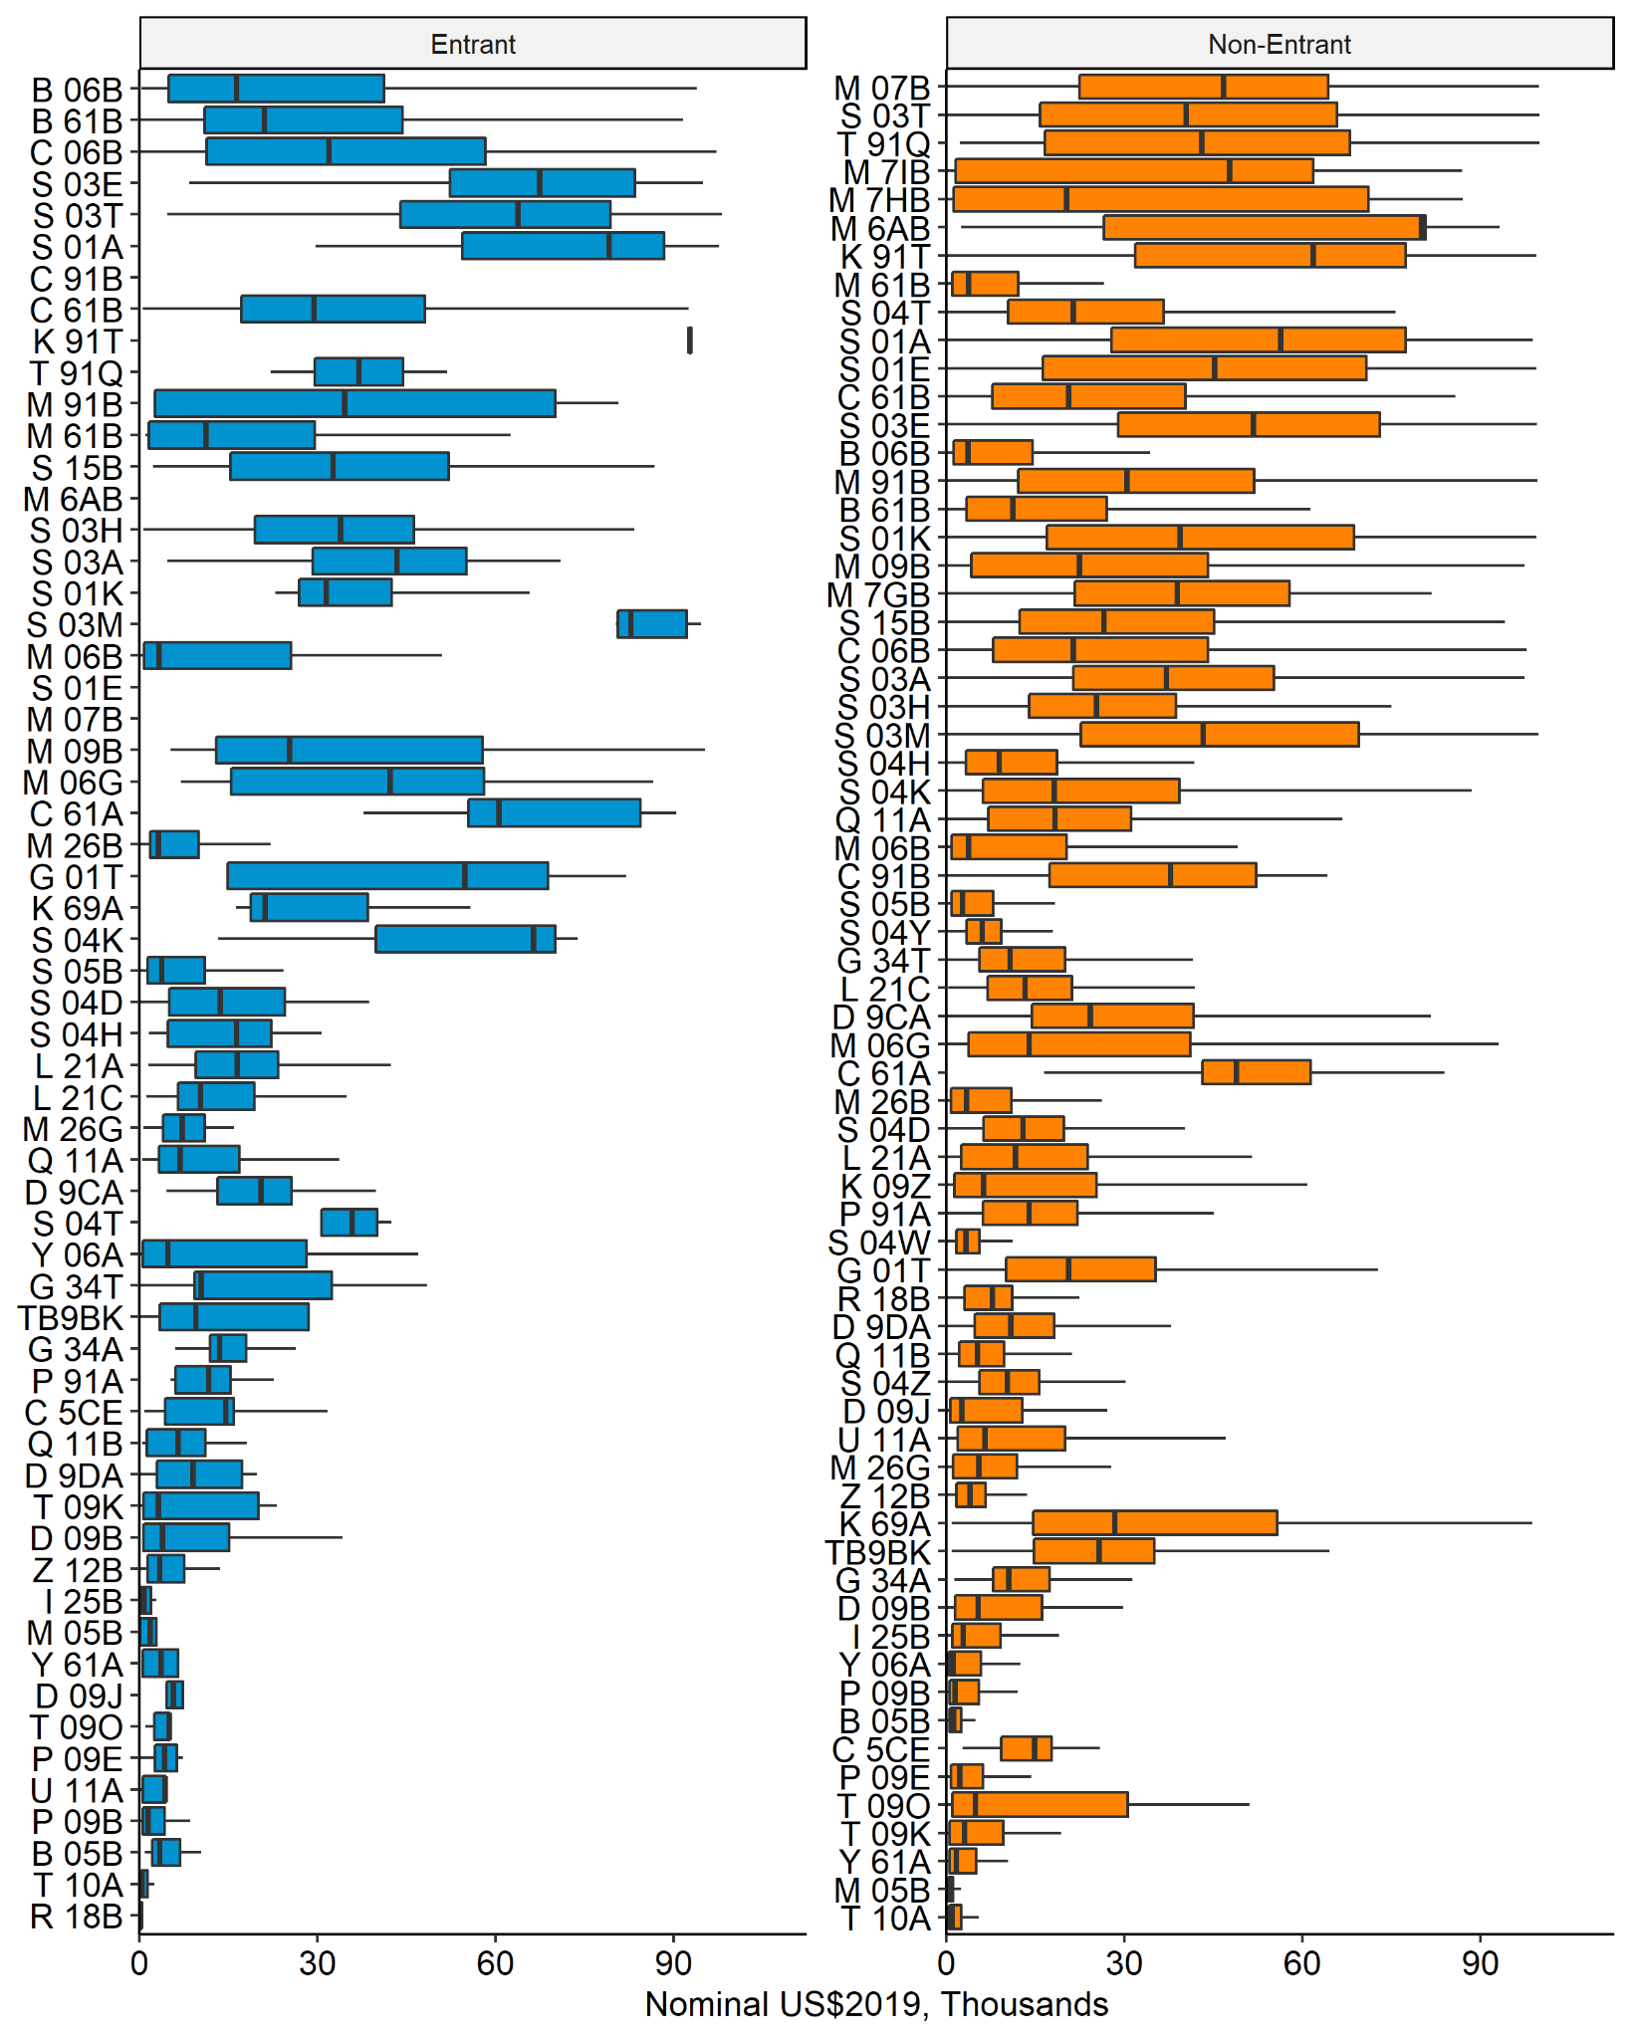
Figure A1. Distributions of earnings for entrants and non-entrants for fisheries defined on species group, gear, and area. Only fisheries with at least three participants in each group and participants or earnings of at least 1% of the total for each group are shown. Distributions feature the median in a horizontal bar, the interquartile range in a box, and extreme observations in whiskers. Earnings appear without the top decile to feature the distribution of earners around the median. With the top decile, outliers include participants earning one to three million US$2019. Fisheries are ordered by decreasing total earnings across participants of both groups. This visualization extends Panel B of Figure 2.
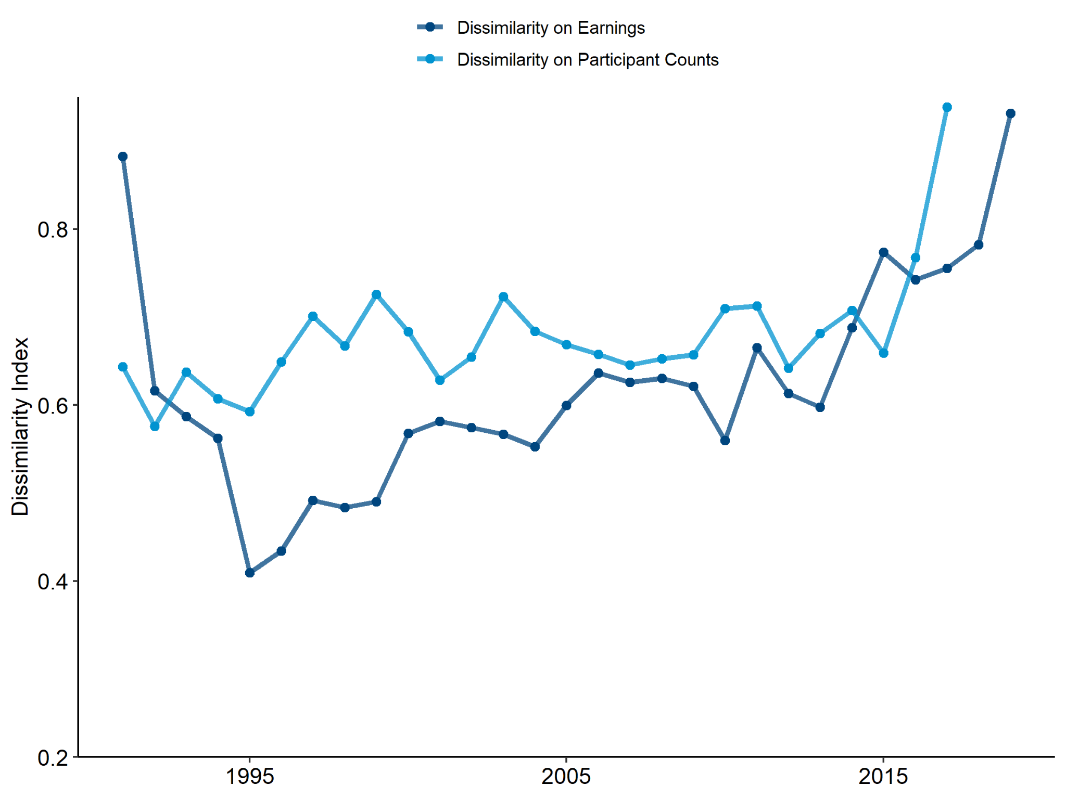
Figure A2. Dissimilarities of entrants and non-entrants in each year calculated from each group’s earnings and count of participants by fishery defined on species group, gear, and area. This visualization extends Panel A of Figure 3.
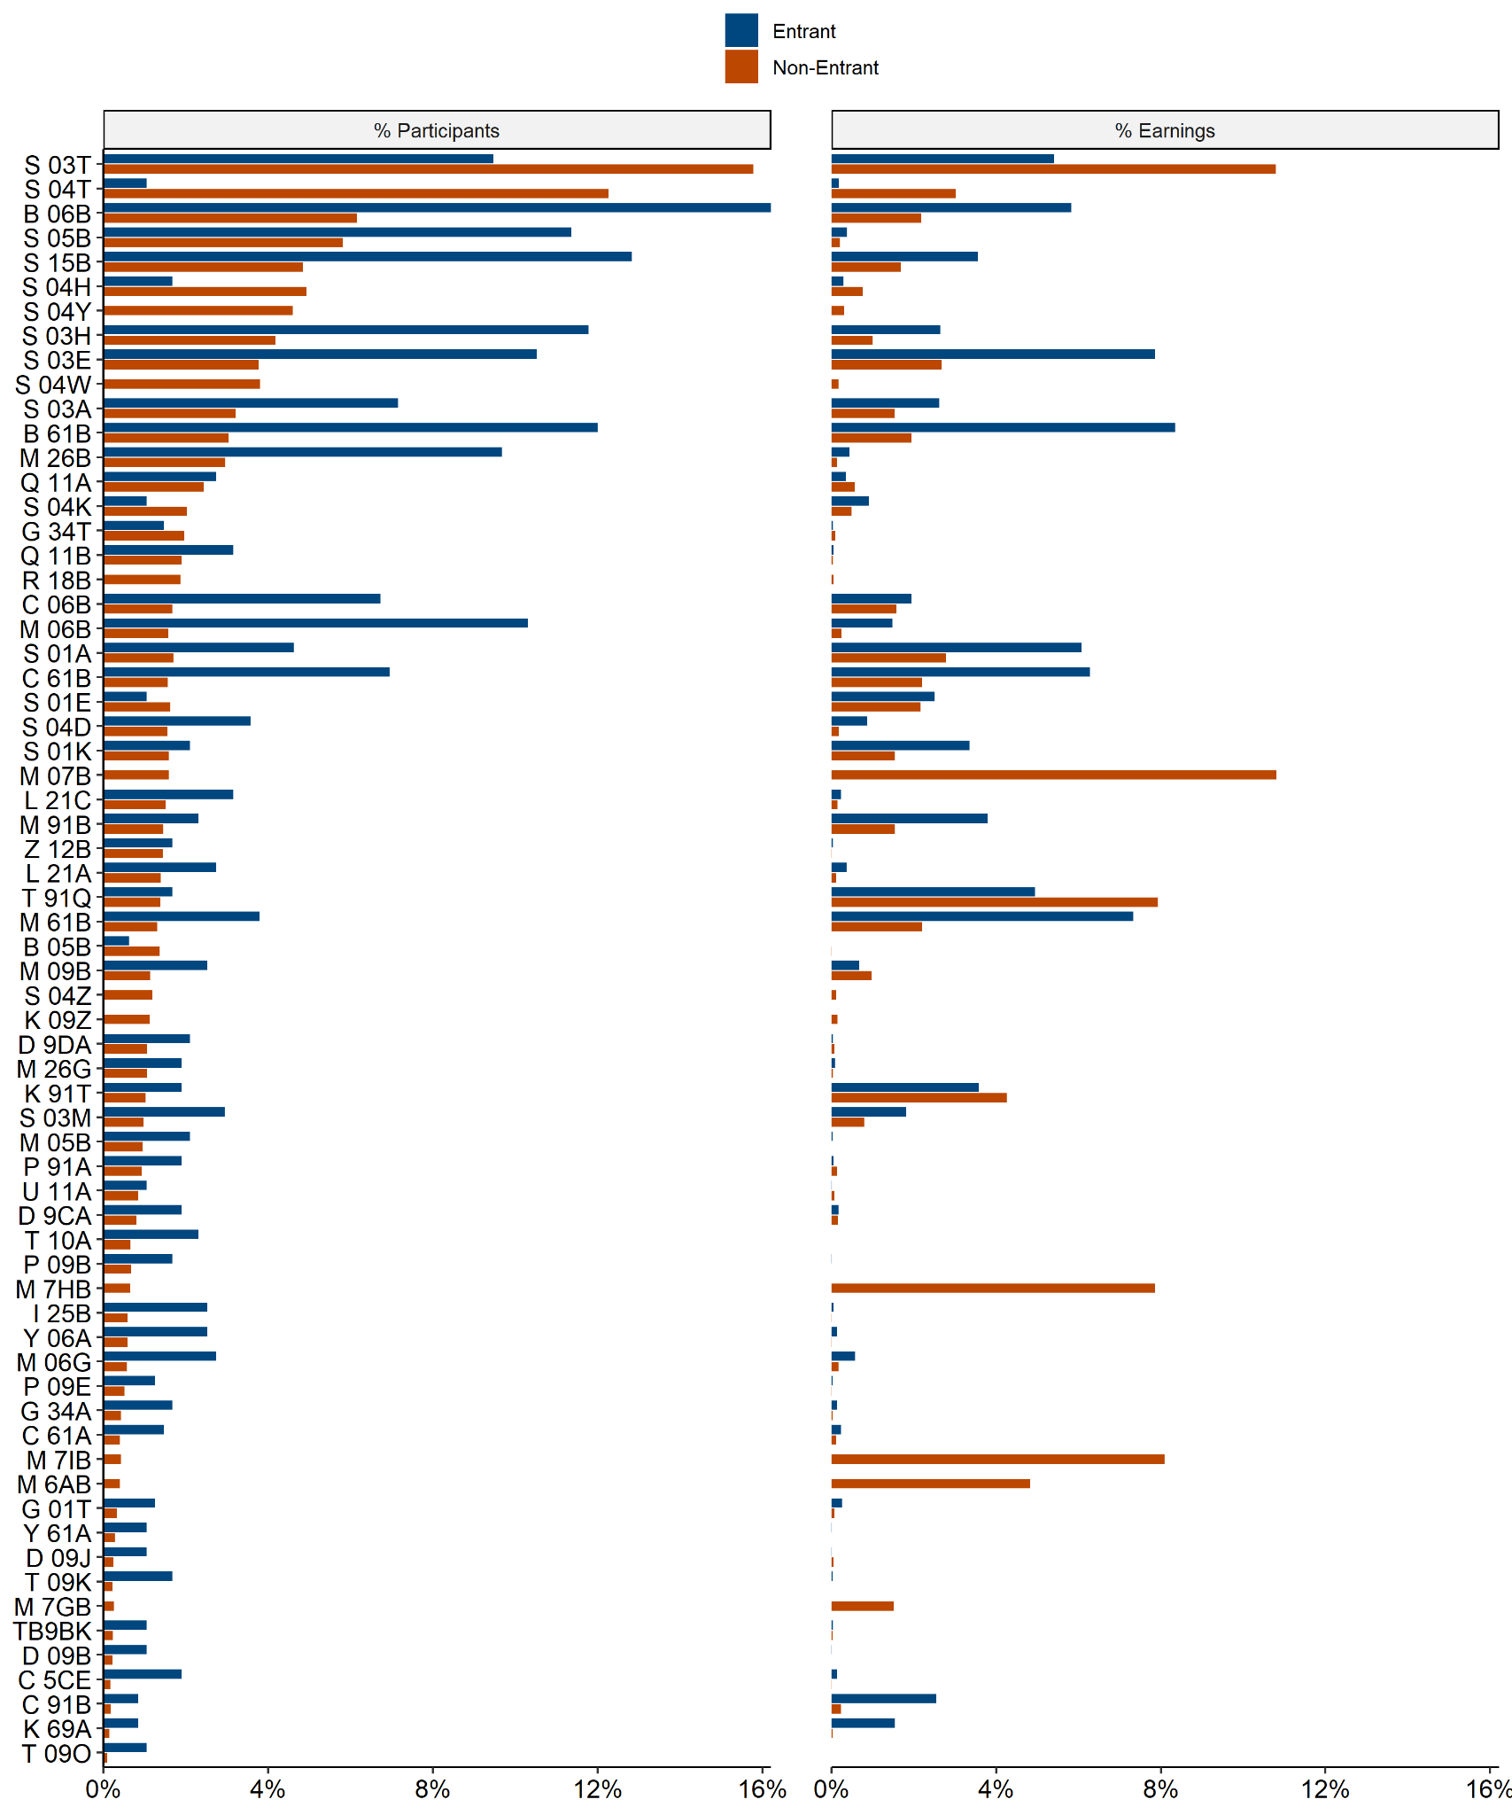
Figure A3. Dissimilarities of entrants and non-entrants calculated from each group’s earnings and counts of participants by fishery. Percentages of counts of participants sum to more than one due to cross-participation; percentages of earnings sum to one. Only fisheries with at least three participants in each group and participants or earnings of at least 1% of the total for each group are shown. This visualization extends Panel B of Figure 3.
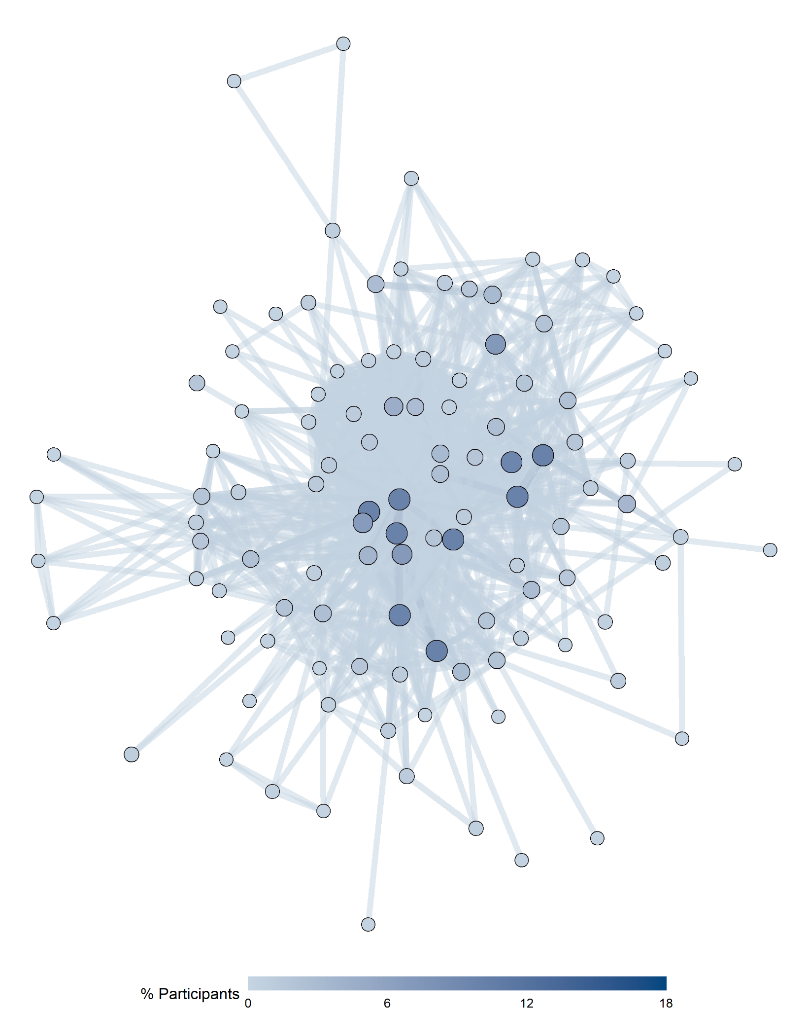
Figure A4. A network graph of entrants’ fisheries participation prior to quota share acquisition. Each node counts cumulative participants over the time series, with each node’s size and color illustrating the percentage of all participants appearing in that node’s fishery in at least one year. Each edge counts individuals who participated in both groups of fisheries corresponding to that edge, with symbology matching nodes. This visualization extends Panel A of Figure 4.
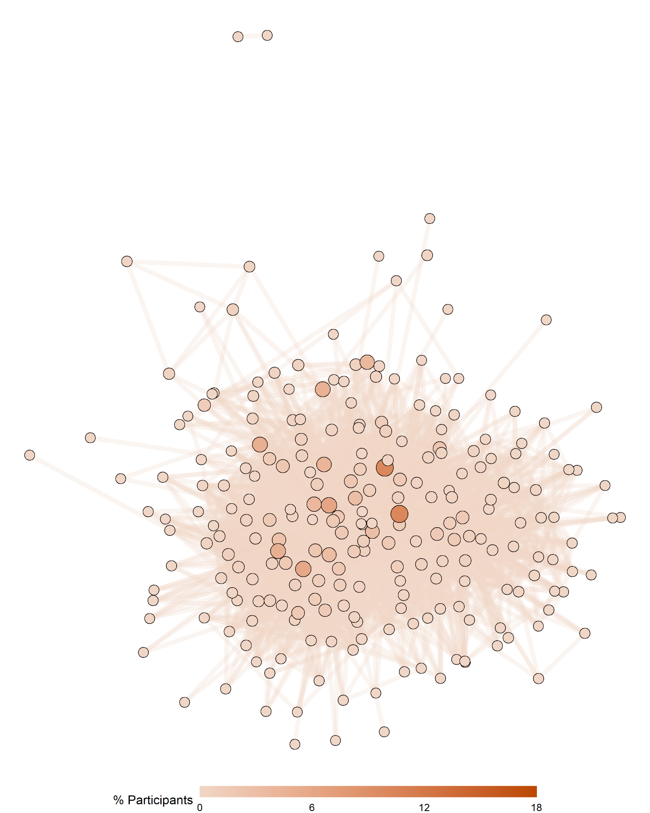
Figure A5. A network graph of non-entrant fisheries participation. Each node counts cumulative participants over the time series, with each node’s size and color illustrating the percentage of all participants appearing in that node’s fishery in at least one year. Each edge counts individuals who participated in both groups of fisheries corresponding to that edge, with symbology matching nodes. This visualization extends Panel B of Figure 4.
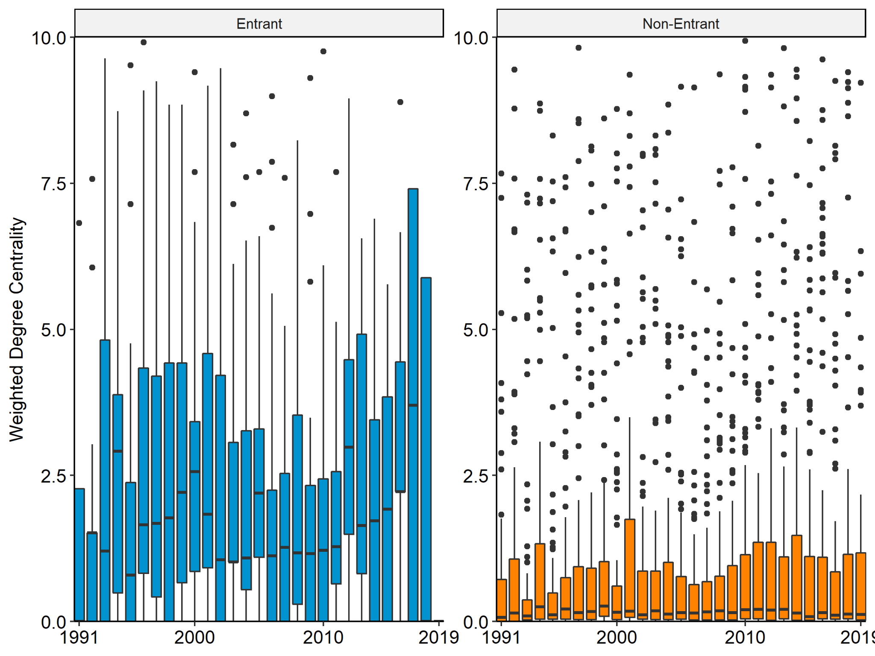
Figure A6. Time series of distributions of weighted degree centralities for nodes in networks of fisheries participation. Distributions feature medians in horizontal bars, interquartile ranges in boxes, and extreme observations in whiskers. Each observation represents a node and a fishery. Each observation’s y-axis coordinate indicates the node’s degree centrality with weights for counts of participants in each year. Nodes with weighted degree centralities greater than 10 are omitted to highlight the outcome of visualizing at a lower-level fishery definition, which reveals trends in lower-participation fisheries. This visualization extends Figure 5.

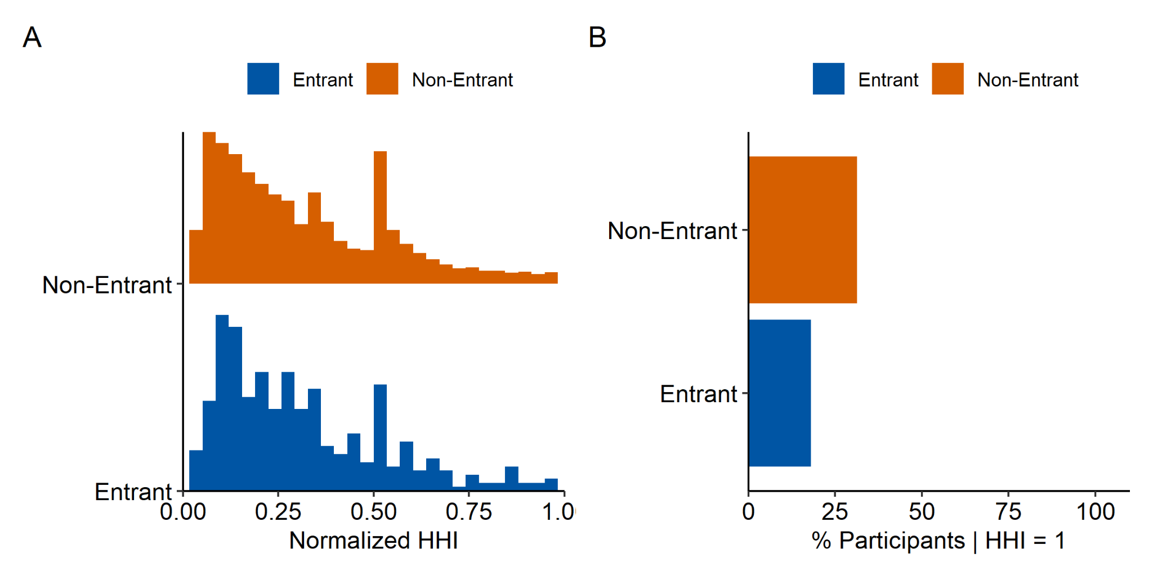
Figure A7. Distributions of normalized Herfindahl-Hirschman Index (HHI) values for individuals for individuals for whom HHI < 1 (A) and proportions of participants for whom HHI = 1 (B) over the time series, such that an individual’s earnings in a fishery are the sum of their earnings in that fishery in all years of their participation. Individuals with higher HHI values participate in a less diverse earnings-weighted portfolio of fisheries; individuals for whom HHI = 1 participate in just one fishery. Here, fisheries are defined on lower-level aggregations of species group, gear, and area.

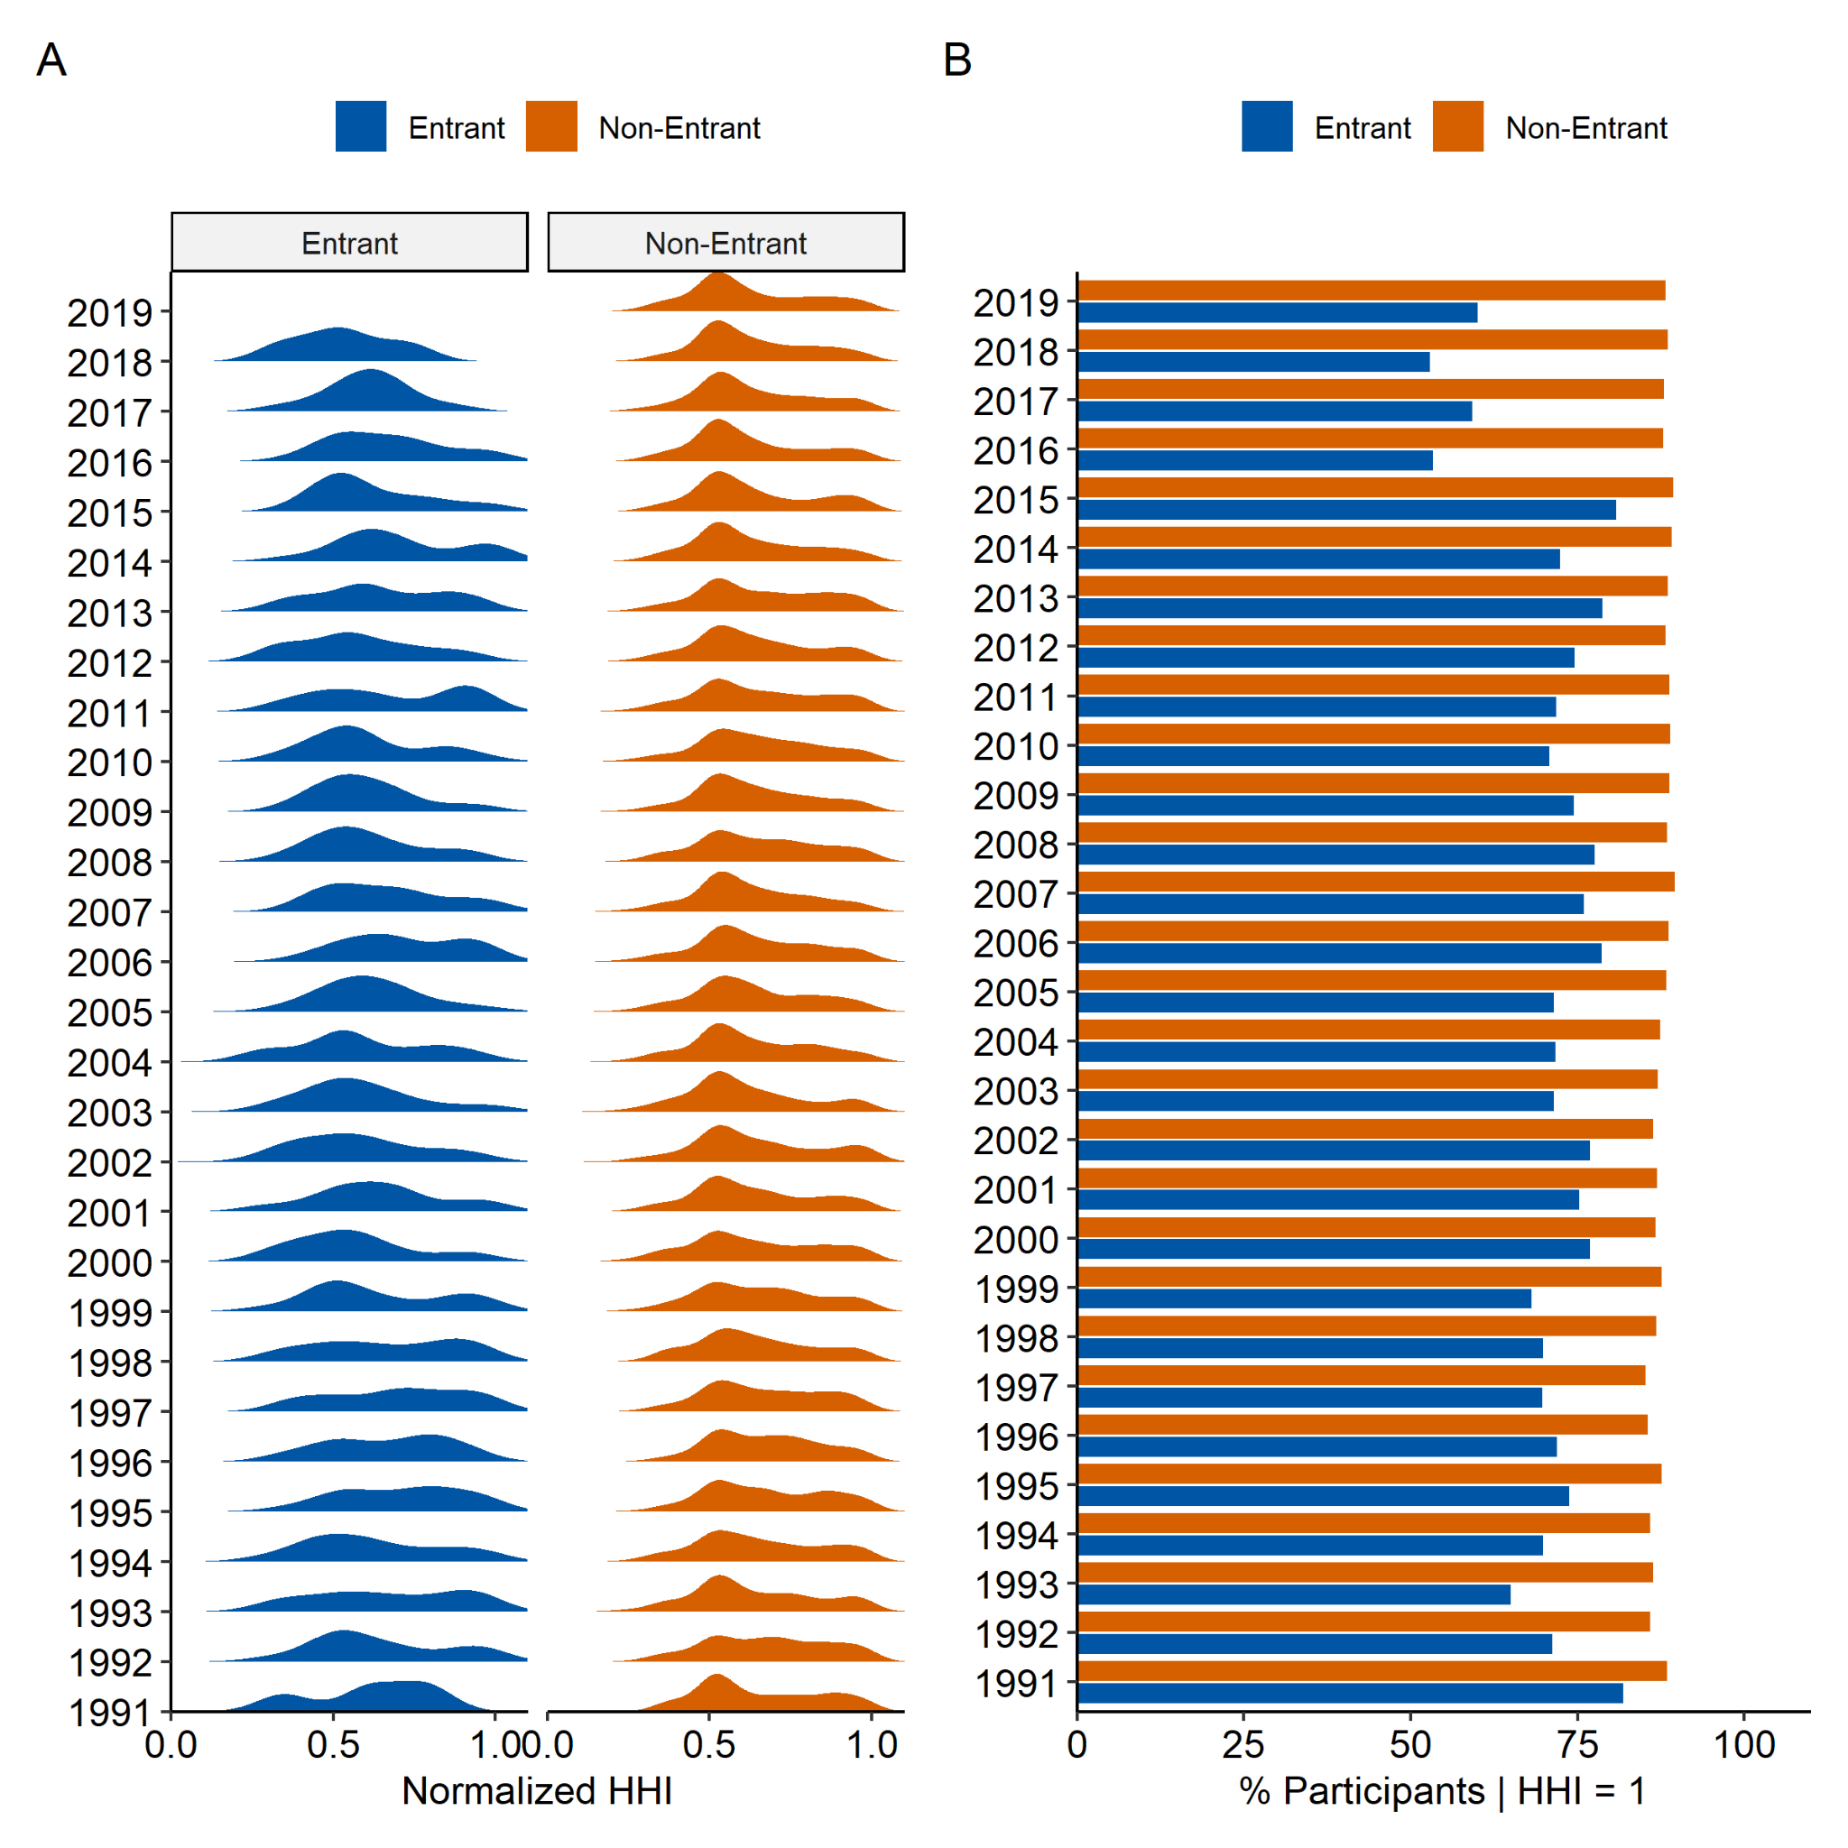
Figure A8. Annual distributions of normalized Herfindahl-Hirschman Index (HHI) values for individuals for whom HHI < 1 (A) and annual proportions of participants for whom HHI = 1 (B). Individuals with higher HHI values participate in a less diverse earnings-weighted portfolio of fisheries; individuals for whom HHI = 1 participate in just one fishery. Here, fisheries are defined on lower-level aggregations of species group, gear, and area.

Table A1. Weights of nodes illustrated in Figure 4 of the manuscript.
Group | Fishery | Participants (Count) | Participants (Percentage of Group)
Non-Entrant | Chinook | 10537 | 55
Non-Entrant | Coho | 9493 | 49
Non-Entrant | Halibut | 1972 | 10
Non-Entrant | Herring | 1634 | 8
Non-Entrant | Invertebrates | 2988 | 15
Non-Entrant | Lingcod & Rockfish | 2336 | 12
Non-Entrant | Other | 2301 | 12
Non-Entrant | Pacific Cod | 2167 | 11
Non-Entrant | Pink & Chum | 13154 | 68
Non-Entrant | Sablefish | 1017 | 5
Non-Entrant | Sockeye | 11857 | 62
Entrant | Chinook | 291 | 61
Entrant | Coho | 300 | 63
Entrant | Halibut | 126 | 27
Entrant | Herring | 45 | 9
Entrant | Invertebrates | 100 | 21
Entrant | Lingcod & Rockfish | 164 | 35
Entrant | Other | 119 | 25
Entrant | Pacific Cod | 122 | 26
Entrant | Pink & Chum | 321 | 68
Entrant | Sablefish | 76 | 16
Entrant | Sockeye | 304 | 64

Table A2. Weights of edges illustrated in Figure 4 of the manuscript.
Group | Fishery (From) | Fishery (To) | Participants (Count) | Participants (Percentage of Group)
Non-Entrant | Chinook | Coho | 8009 | 42
Non-Entrant | Chinook | Halibut | 564 | 3
Non-Entrant | Chinook | Herring | 568 | 3
Non-Entrant | Chinook | Invertebrates | 681 | 4
Non-Entrant | Chinook | Lingcod & Rockfish | 1155 | 6
Non-Entrant | Chinook | Other | 1207 | 6
Non-Entrant | Chinook | Pacific Cod | 697 | 4
Non-Entrant | Chinook | Pink & Chum | 10145 | 53
Non-Entrant | Chinook | Sablefish | 308 | 2
Non-Entrant | Chinook | Sockeye | 9160 | 48
Non-Entrant | Coho | Halibut | 534 | 3
Non-Entrant | Coho | Herring | 507 | 3
Non-Entrant | Coho | Invertebrates | 672 | 3
Non-Entrant | Coho | Lingcod & Rockfish | 1136 | 6
Non-Entrant | Coho | Other | 1167 | 6
Non-Entrant | Coho | Pacific Cod | 676 | 4
Non-Entrant | Coho | Pink & Chum | 9220 | 48
Non-Entrant | Coho | Sablefish | 276 | 1
Non-Entrant | Coho | Sockeye | 8146 | 42
Non-Entrant | Halibut | Herring | 155 | 1
Non-Entrant | Halibut | Invertebrates | 338 | 2
Non-Entrant | Halibut | Lingcod & Rockfish | 738 | 4
Non-Entrant | Halibut | Other | 411 | 2
Non-Entrant | Halibut | Pacific Cod | 643 | 3
Non-Entrant | Halibut | Pink & Chum | 594 | 3
Non-Entrant | Halibut | Sablefish | 495 | 3
Non-Entrant | Halibut | Sockeye | 546 | 3
Non-Entrant | Herring | Invertebrates | 186 | 1
Non-Entrant | Herring | Lingcod & Rockfish | 98 | 1
Non-Entrant | Herring | Other | 102 | 1
Non-Entrant | Herring | Pacific Cod | 103 | 1
Non-Entrant | Herring | Pink & Chum | 630 | 3
Non-Entrant | Herring | Sablefish | 51 | 0
Non-Entrant | Herring | Sockeye | 605 | 3
Non-Entrant | Invertebrates | Lingcod & Rockfish | 536 | 3
Non-Entrant | Invertebrates | Other | 513 | 3
Non-Entrant | Invertebrates | Pacific Cod | 605 | 3
Non-Entrant | Invertebrates | Pink & Chum | 738 | 4
Non-Entrant | Invertebrates | Sablefish | 231 | 1
Non-Entrant | Invertebrates | Sockeye | 683 | 4
Non-Entrant | Lingcod & Rockfish | Other | 1160 | 6
Non-Entrant | Lingcod & Rockfish | Pacific Cod | 1296 | 7
Non-Entrant | Lingcod & Rockfish | Pink & Chum | 1183 | 6
Non-Entrant | Lingcod & Rockfish | Sablefish | 909 | 5
Non-Entrant | Lingcod & Rockfish | Sockeye | 1081 | 6
Non-Entrant | Other | Pacific Cod | 1260 | 7
Non-Entrant | Other | Pink & Chum | 1301 | 7
Non-Entrant | Other | Sablefish | 584 | 3
Non-Entrant | Other | Sockeye | 1089 | 6
Non-Entrant | Pacific Cod | Pink & Chum | 753 | 4
Non-Entrant | Pacific Cod | Sablefish | 734 | 4
Non-Entrant | Pacific Cod | Sockeye | 706 | 4
Non-Entrant | Pink & Chum | Sablefish | 321 | 2
Non-Entrant | Pink & Chum | Sockeye | 11512 | 60
Non-Entrant | Sablefish | Sockeye | 283 | 1
Entrant | Chinook | Coho | 268 | 56
Entrant | Chinook | Halibut | 61 | 13
Entrant | Chinook | Herring | 22 | 5
Entrant | Chinook | Invertebrates | 45 | 9
Entrant | Chinook | Lingcod & Rockfish | 93 | 20
Entrant | Chinook | Other | 86 | 18
Entrant | Chinook | Pacific Cod | 56 | 12
Entrant | Chinook | Pink & Chum | 279 | 59
Entrant | Chinook | Sablefish | 33 | 7
Entrant | Chinook | Sockeye | 266 | 56
Entrant | Coho | Halibut | 63 | 13
Entrant | Coho | Herring | 20 | 4
Entrant | Coho | Invertebrates | 44 | 9
Entrant | Coho | Lingcod & Rockfish | 98 | 21
Entrant | Coho | Other | 91 | 19
Entrant | Coho | Pacific Cod | 61 | 13
Entrant | Coho | Pink & Chum | 294 | 62
Entrant | Coho | Sablefish | 37 | 8
Entrant | Coho | Sockeye | 275 | 58
Entrant | Halibut | Herring | 7 | 1
Entrant | Halibut | Invertebrates | 32 | 7
Entrant | Halibut | Lingcod & Rockfish | 82 | 17
Entrant | Halibut | Other | 44 | 9
Entrant | Halibut | Pacific Cod | 62 | 13
Entrant | Halibut | Pink & Chum | 65 | 14
Entrant | Halibut | Sablefish | 55 | 12
Entrant | Halibut | Sockeye | 65 | 14
Entrant | Herring | Invertebrates | 13 | 3
Entrant | Herring | Lingcod & Rockfish | 6 | 1
Entrant | Herring | Other | 8 | 2
Entrant | Herring | Pacific Cod | 8 | 2
Entrant | Herring | Pink & Chum | 26 | 5
Entrant | Herring | Sablefish | 5 | 1
Entrant | Herring | Sockeye | 26 | 5
Entrant | Invertebrates | Lingcod & Rockfish | 41 | 9
Entrant | Invertebrates | Other | 36 | 8
Entrant | Invertebrates | Pacific Cod | 34 | 7
Entrant | Invertebrates | Pink & Chum | 42 | 9
Entrant | Invertebrates | Sablefish | 19 | 4
Entrant | Invertebrates | Sockeye | 43 | 9
Entrant | Lingcod & Rockfish | Other | 74 | 16
Entrant | Lingcod & Rockfish | Pacific Cod | 92 | 19
Entrant | Lingcod & Rockfish | Pink & Chum | 101 | 21
Entrant | Lingcod & Rockfish | Sablefish | 70 | 15
Entrant | Lingcod & Rockfish | Sockeye | 97 | 20
Entrant | Other | Pacific Cod | 64 | 13
Entrant | Other | Pink & Chum | 93 | 20
Entrant | Other | Sablefish | 36 | 8
Entrant | Other | Sockeye | 91 | 19
Entrant | Pacific Cod | Pink & Chum | 65 | 14
Entrant | Pacific Cod | Sablefish | 55 | 12
Entrant | Pacific Cod | Sockeye | 64 | 13
Entrant | Pink & Chum | Sablefish | 38 | 8
Entrant | Pink & Chum | Sockeye | 300 | 63
Entrant | Sablefish | Sockeye | 39 | 8

