Journal of Geophysical Research: Oceans
Supporting Information for
Quantifying the effects of nutrient enrichment and freshwater mixing on coastal ocean acidification
Jennie E. Rheuban¹, Scott C. Doney^{1,2}, Daniel C. McCorkle³, Rachel W. Jakuba⁴

- Department of Marine Chemistry and Geochemistry, Woods Hole Oceanographic Institution, Woods Hole, MA, 02543, USA
- Department of Environmental Sciences, University of Virginia, Charlottesville, VA, 22904, USA
- Department of Geology and Geophysics, Woods Hole Oceanographic Institution, Woods Hole, MA, 02543, USA
- Buzzards Bay Coalition, New Bedford, MA, 02740, USA

Contents of this file

Text S1 to S3
Table S1
Figures S1 to S20

Introduction
In this supplement, we present an error analysis of our decomposition of aragonite saturation state (Ω). In particular, we focus on the sensitivity of our results to the choice of endmembers for the conservative mixing lines for dissolved inorganic carbon (DIC) and total alkalinity (ALK). We present a simple calculation of the cumulative effects of historical and a decade of future anthropogenic carbon emissions on the carbonate system of Buzzards Bay. We present a description of data comparison to the GLORICH river chemistry database. For completeness of illustrating the dataset, we also include figures for all the measured and calculated parameters broken out by embayment.

Text S1. Uncertainty of mixing curves
Conservative mixing lines were generated from freshwater samples collected in upper the Agawam River, which feeds into the Wareham River Estuary, in upper Buzzards Bay and seawater samples collected in the open waters of Buzzards Bay. Our freshwater dataset is limited in size (n = 6) because these samples were not part of our original sampling design, but rather collected as part of a separate project. There was also considerable variation in our freshwater data, leading to the question of how sensitive our results are to the choice of freshwater endmember in particular.
The sensitivity of these results were explored through a bootstrapping analysis where DIC and ALK were resampled from both the seawater and freshwater endmembers to generate a distribution of conservative mixing lines. The effects of the number of times the DIC and ALK data were resampled was tested using n = 100, 200, and 400, and the distributions of results were not different when resampling 200 or 400 times.
Using the distribution of results from Figure S3, standard deviations from each site were used to provide an estimate of uncertainty associated with the DIC and ALK conservative mixing lines. This uncertainty was propagated with the measurement variability to estimate a total uncertainty for each ∆Ω_{BGC} station summer mean and incorporated in the type-II linear regression used to estimate ∆Ω_{BGC} improvements under TMDL and No Load scenarios.
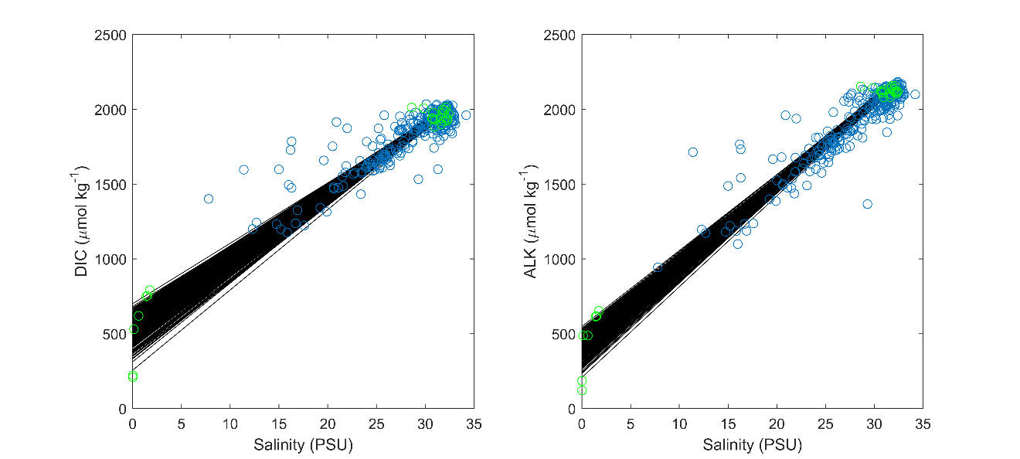

Figure S1. Results of bootstrapping analysis of freshwater and seawater endmembers. Black lines are individual bootstrapped mixing lines (n = 400), blue circles are the estuarine observations, and green circles are the observed fresh- and seawater endmembers.

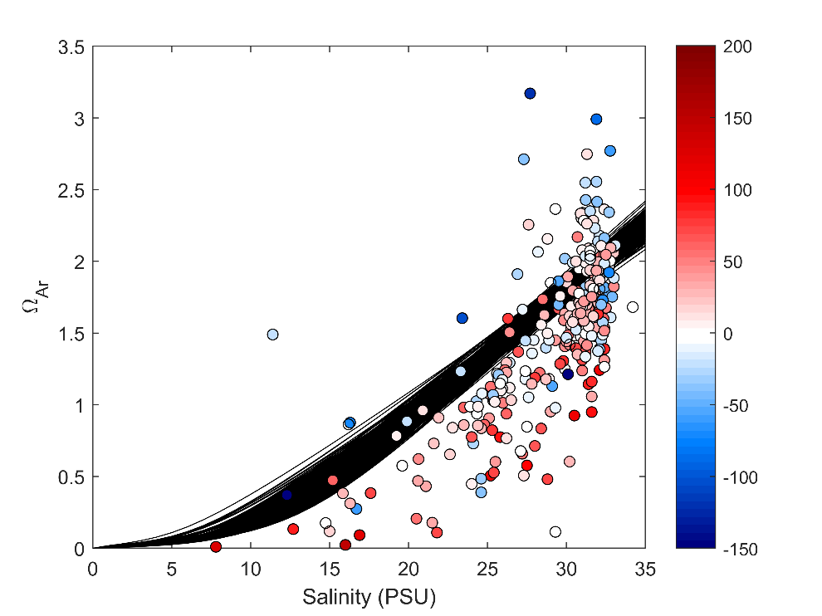

Figure S2. Results of bootstrapping analysis of freshwater and seawater endmembers. Black lines are bootstrapped mixing lines for aragonite saturation state (Ω_{Ar}, n = 400), calculated from DIC and ALK lines shown in Figure S1 and using the mean temperature from the seawater reference station (CBB1). Observations are shown as colored circles where the color is apparent oxygen utilization (µM).
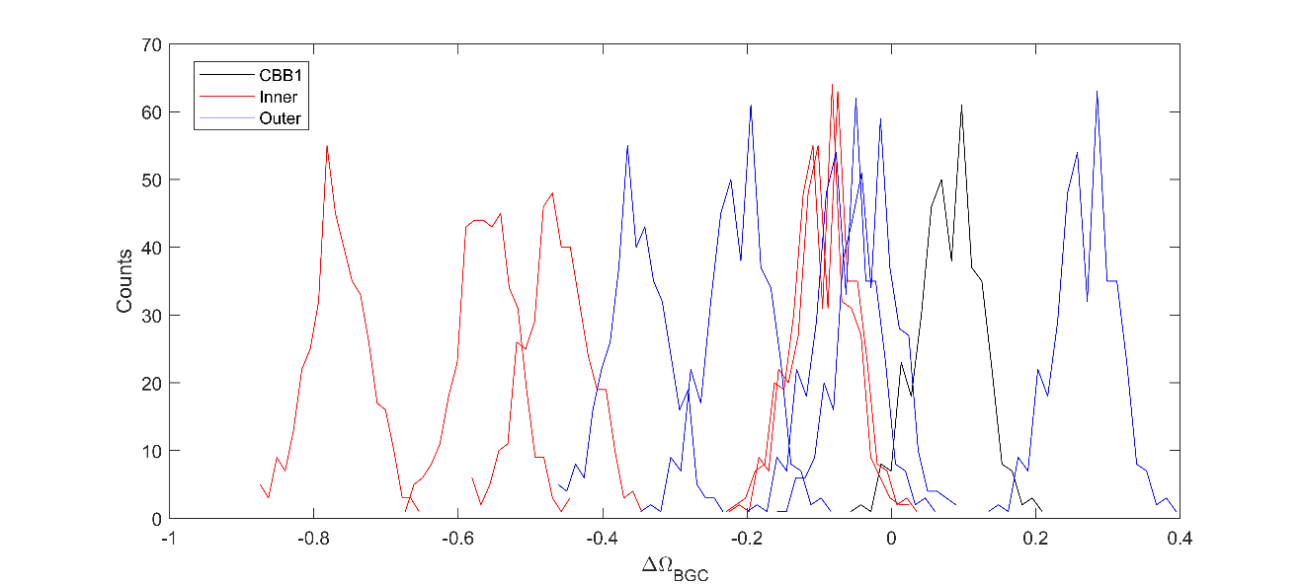

Figure S3. Histograms of the ∆Ω_{BGC} parameter calculated as a result of the bootstrapped freshwater and seawater endmembers (n = 400). Histograms are colored by inner harbors (red), outer harbors (blue) and the coastal reference station CBB1 (black).

Text S2. Estimates of the influence of anthropogenic carbon emissions on Buzzards Bay
To put our eutrophication results into context, we explored how anthropogenic carbon emissions have affected the carbonate system of Buzzards Bay. Our data were collected from 2015-2017, which for this period had a global average CO2 concentration of 402.6 ppm (NOAA ESRL). To estimate the influence of anthropogenic carbon emissions on our data, we calculated a new mixing curve as follows:

$${pCO}_{2-pre}=(\overline{{pCO}_{2-CBB1}}-402.6)+280$$

Where ${pCO}_{2-CBB1}$ is the pCO2 estimated at the coastal seawater endmember calculated from sample DIC, TA, T, and S and the overbar indicates averaging. We estimate that preindustrial average pCO2 was 280 ppm.

$${DIC}_{0-pre}=f({T_{0},S_{0},pCO}_{2-pre},{ALK}_{0})$$

Where f indicates the CO2SYS program, and ALK₀, T₀, and S₀ are the observed mean coastal seawater total alkalinity, temperature, and salinity, respectively. We then calculate a new mixing line for DIC (${DIC}_{pre})$using on the new seawater endmember (${DIC}_{0-pre}$) and assuming the observed freshwater endmember (Figure S4). Using our new mixing line, we estimate the anthropogenic impacts of carbon emissions on Ω for our observations as:

$${∆Ω}_{Pre}=f\left(T_{0}, S, {DIC}_{S}, {ALK}_{S}\right)-f\left(T_{0},S,{DIC}_{pre-S},{ALK}_{S}\right)$$

To estimate how future carbon emissions may influence the carbonate system of Buzzards Bay, we performed a similar analysis as described above, but rather than using the preindustrial value of 280 ppm, we estimated the future change in pCO2 in 2030 based on the most recent decadal increase as an addition of 23.9 ppm (NOAA ESRL) and:

$${∆Ω}_{Fut}=f\left(T_{0},S,{DIC}_{Fut-S},{ALK}_{S}\right)-f(T_{0}, S, {DIC}_{S}, {ALK}_{S})$$

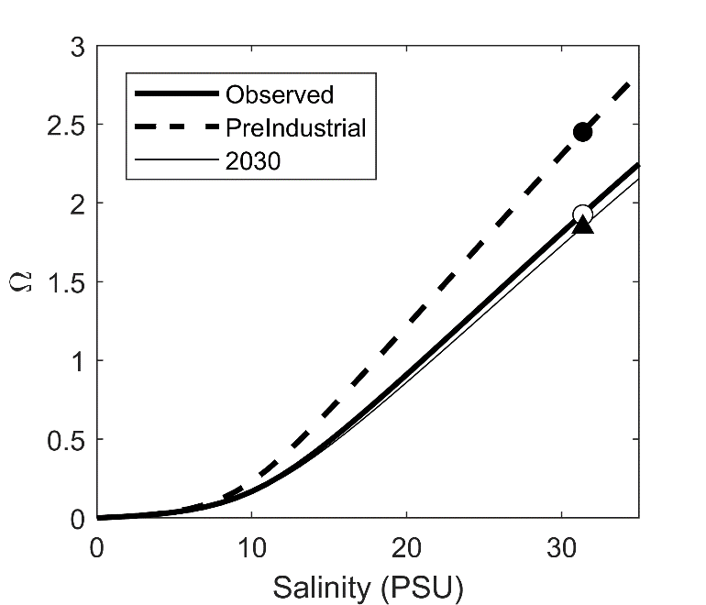

Figure S4. Mixing curves for Ω as observed, estimated for preindustrial conditions, and for 2030 under future atmospheric CO2. The points are the seawater endmembers.

Table S1. Estimated changes to aragonite saturation state (∆Ω) associated with water quality degradation relative to total maximum daily nitrogen loads (TMDLs), anthropogenic increases in atmospheric carbon dioxide (CO₂) from 280 ppm to present day conditions, and to conditions expected in 2030 based on continued atmospheric CO₂ rise using the past decade’s trend. Ratios are the ratio of ∆Ω_{TMDL} due to eutrophication divided by the changes associated with atmospheric increases. See supplement for more details.
 | Quissett | New Bedford | Westport | Wareham | West Falmouth
∆Ω _{TMDL} due to eutrophication | -0.03 | 0.15 | -0.17 | -0.24 | -0.58
∆Ω _{CO2} change from preindustrial to present | -0.53 | -0.52 | -0.49 | -0.42 | -0.42
Ratio | 0.06 | -0.28 | 0.35 | 0.58 | 1.38
Ω _{CO2} change from present to 2030 | -0.08 | -0.08 | -0.07 | -0.06 | -0.06
Ratio | 0.39 | -1.94 | 2.37 | 4.02 | 9.54

Text S3. Regional measurements of riverine DIC and ALK
Our measurements of the freshwater endmember for Buzzards Bay were compared to other regional publicly available measurements (Hartmann et al. 2019). Direct measurements riverine carbonate system variables were available from the Global Rivers Chemistry Database (GLORICH). There were 16 sampling stations located within a 100 km radius around Buzzards Bay which contained a total of 980 measurements of river chemistry, including ALK, pH, and temperature. Unfortunately, DIC was not measured at these stations, but DIC was estimated from ALK, pH (NBS), and temperature, assuming a salinity of zero using CO2SYS (K1 and K2 dissociation coefficients from Millero et al. 2010 and KSO4 dissociation coefficients from Dickson (1990) with total boron from Uppstrom 1979. The average ± standard deviation of DIC and ALK were 665 ± 279 and 473 ± 225 (µmol kg⁻¹).

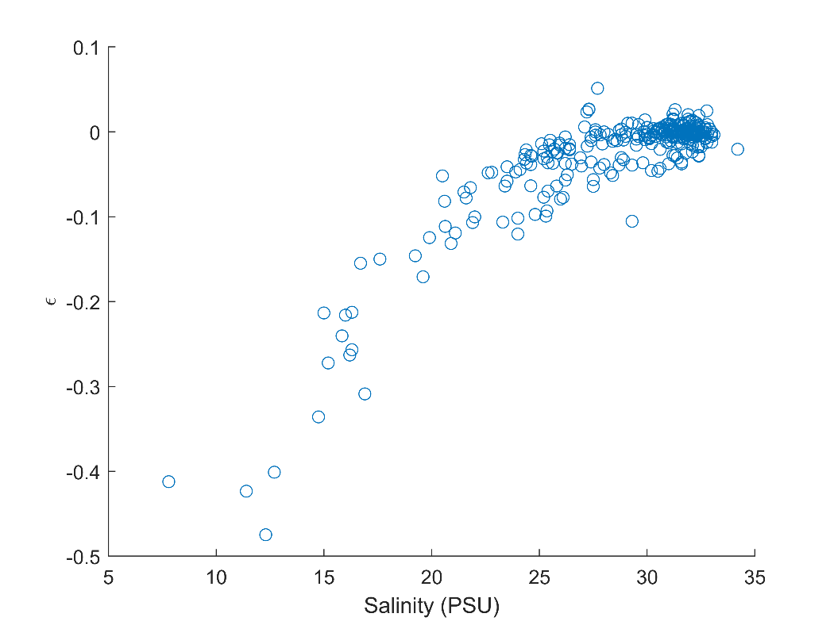

Figure S5. Estimated error term from the Ω decomposition.

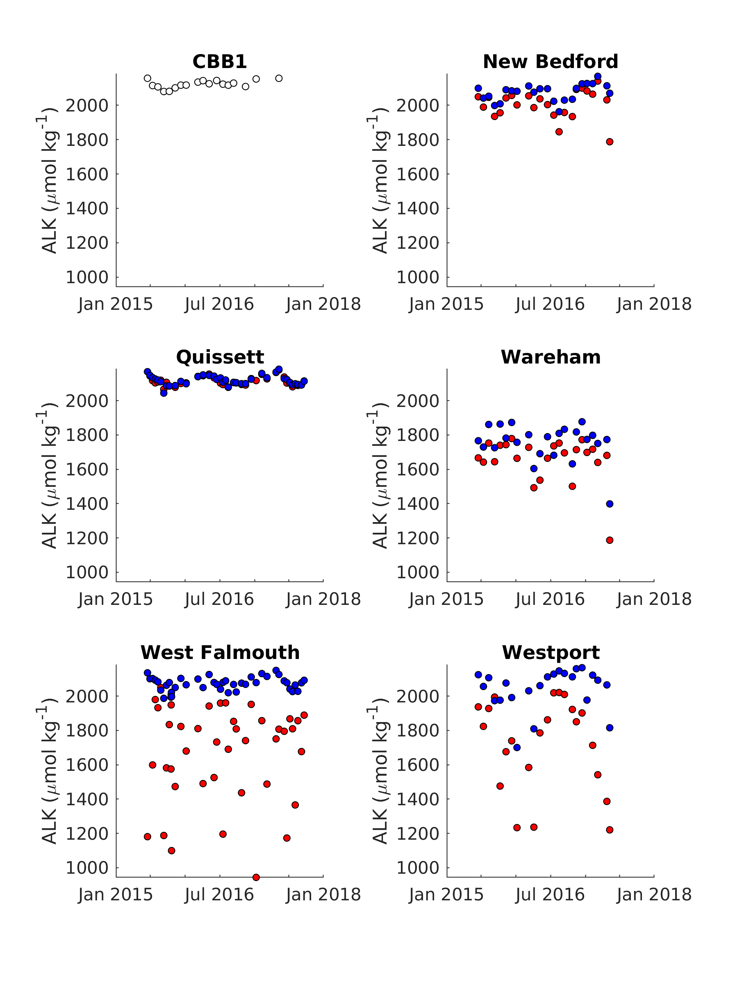

Figure S6. Time series of total alkalinity (ALK) from all embayments and the Buzzards Bay reference station (CBB1). Inner harbors are plotted in red, outer harbor stations are plotted in blue.

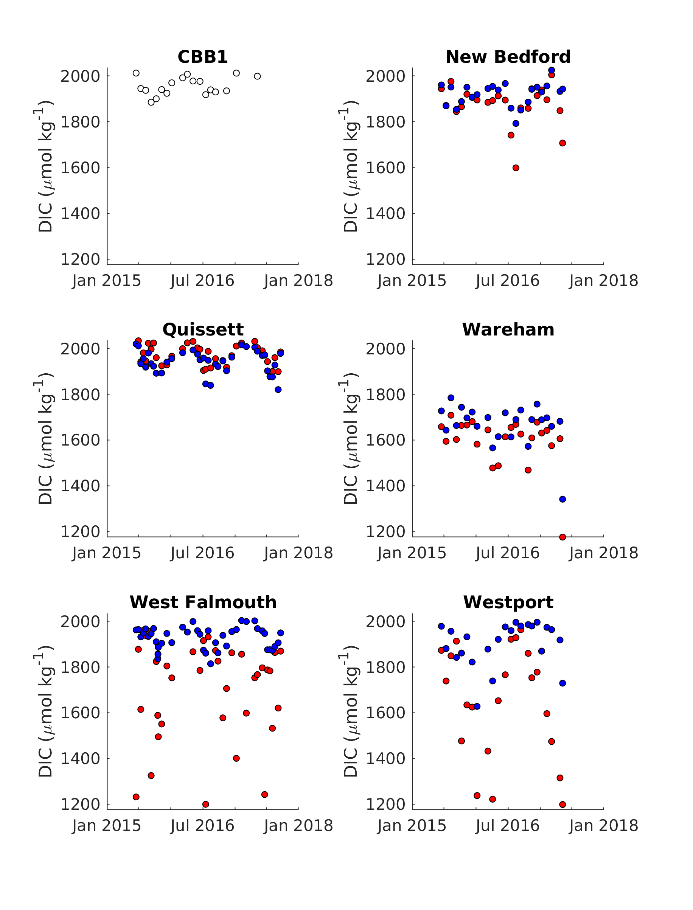

Figure S7. Time series of dissolved inorganic carbon (DIC) from all embayments and the Buzzards Bay reference station (CBB1). Inner harbors are plotted in red, outer harbor stations are plotted in blue.

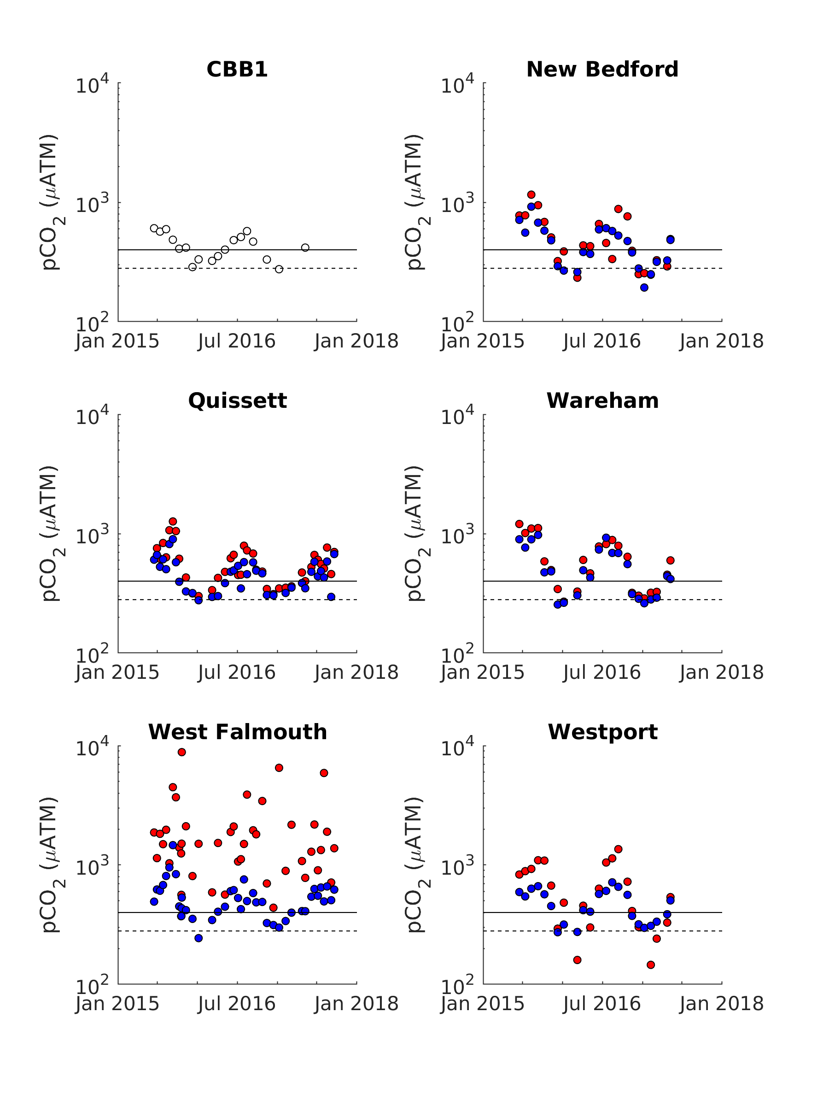

Figure S8. Time series of pCO2 from all embayments and the Buzzards Bay reference station (CBB1). Inner harbors are plotted in red, outer harbor stations are plotted in blue. The solid line is 400 µATM, and the dashed line is an estimate of the preindustrial value (280 µATM).

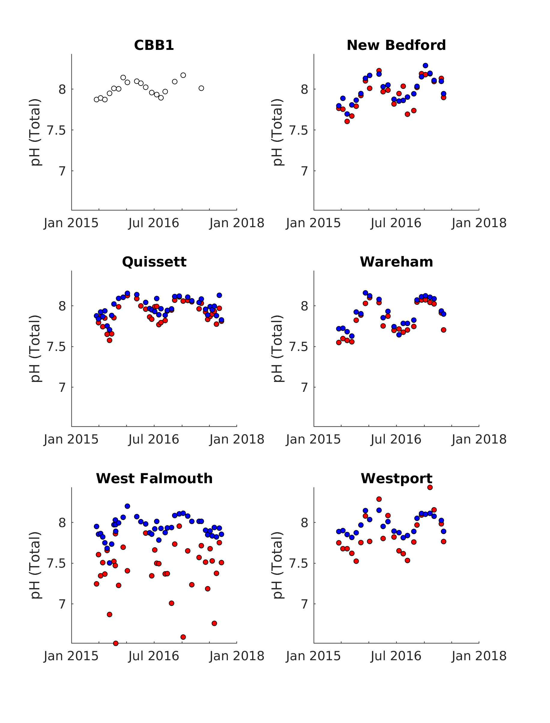

Figure S9. Time series of pH (total scale) from all embayments and the Buzzards Bay reference station (CBB1). Inner harbors are plotted in red, outer harbor stations are plotted in blue.

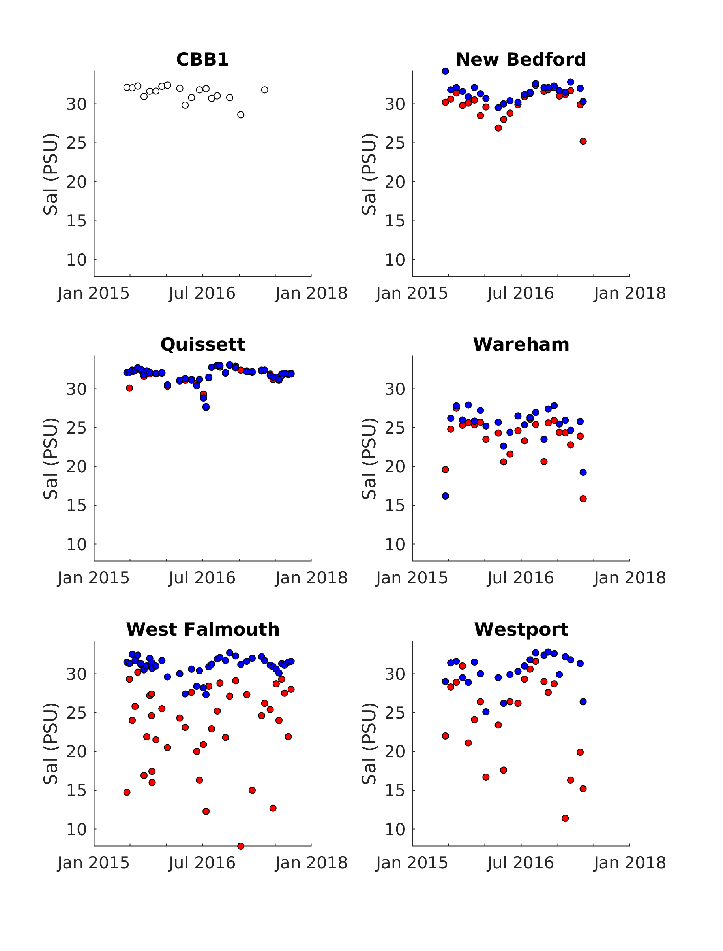

Figure S10. Time series of salinity (PSU) from all embayments and the Buzzards Bay reference station (CBB1). Inner harbors are plotted in red, outer harbor stations are plotted in blue.

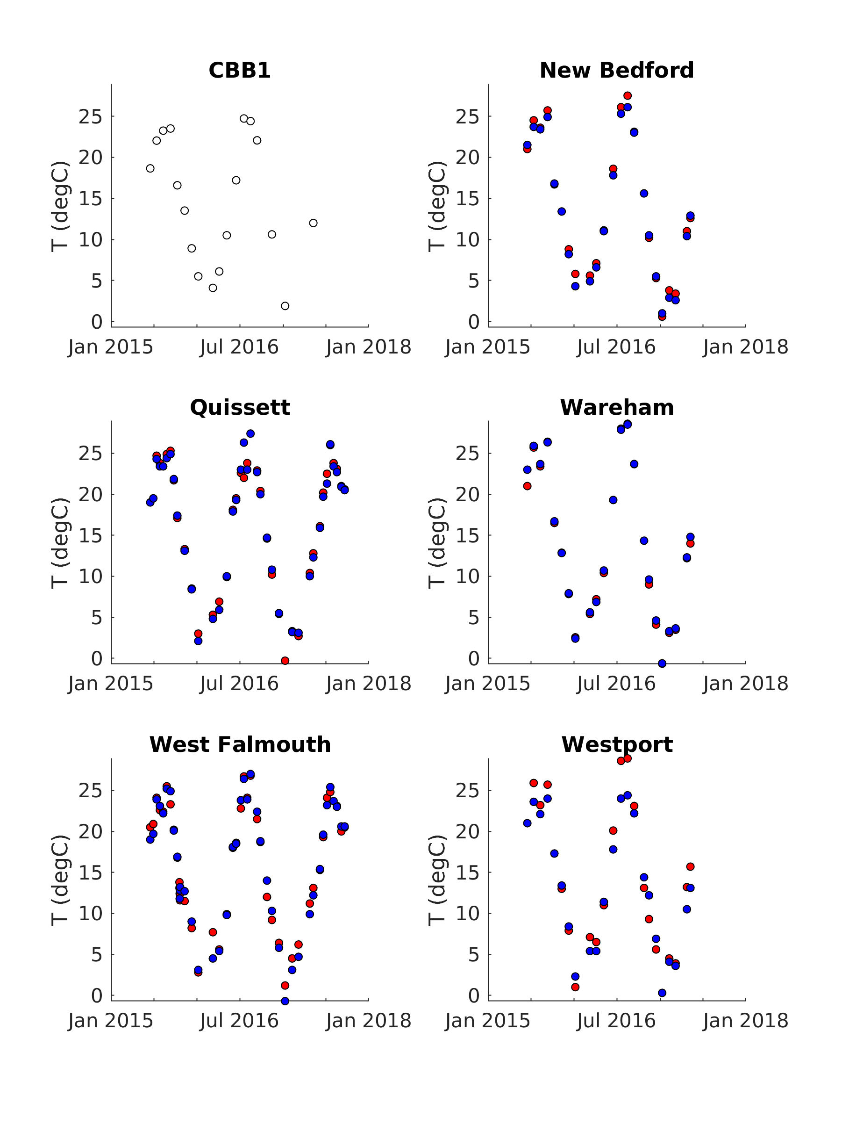

Figure S11. Time series of temperature (degrees celcius) from all embayments and the Buzzards Bay reference station (CBB1). Inner harbors are plotted in red, outer harbor stations are plotted in blue.

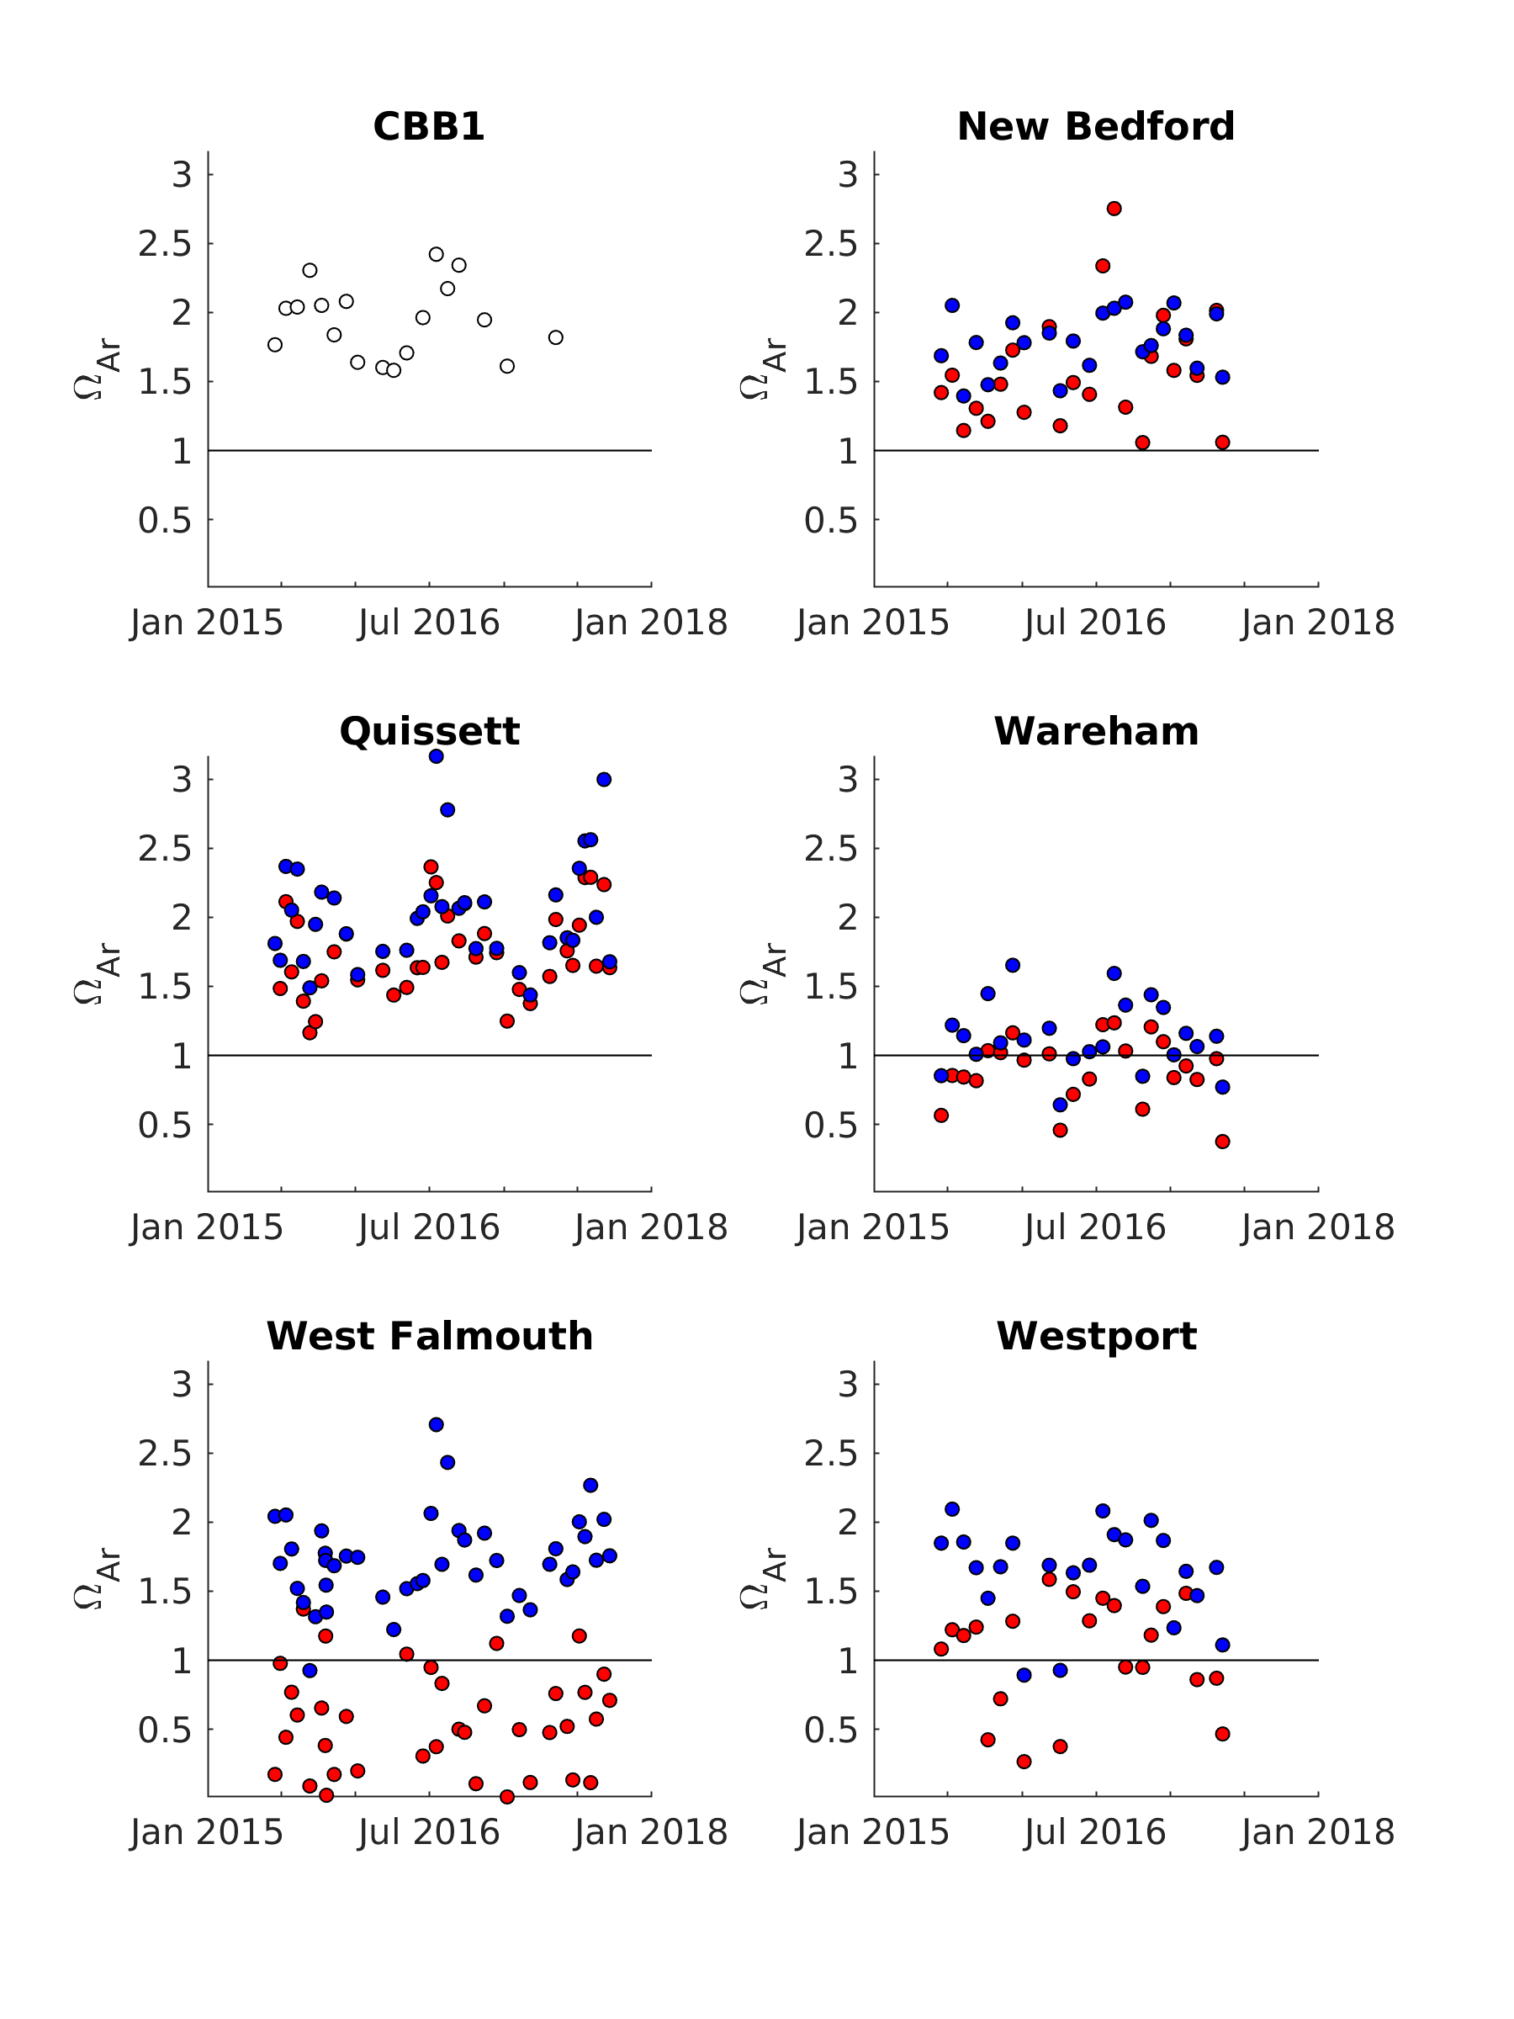

Figure S12. Time series of aragonite saturation state (Ω_{Ar}) from all embayments and the Buzzards Bay reference station (CBB1). Inner harbors are plotted in red, outer harbor stations are plotted in blue.

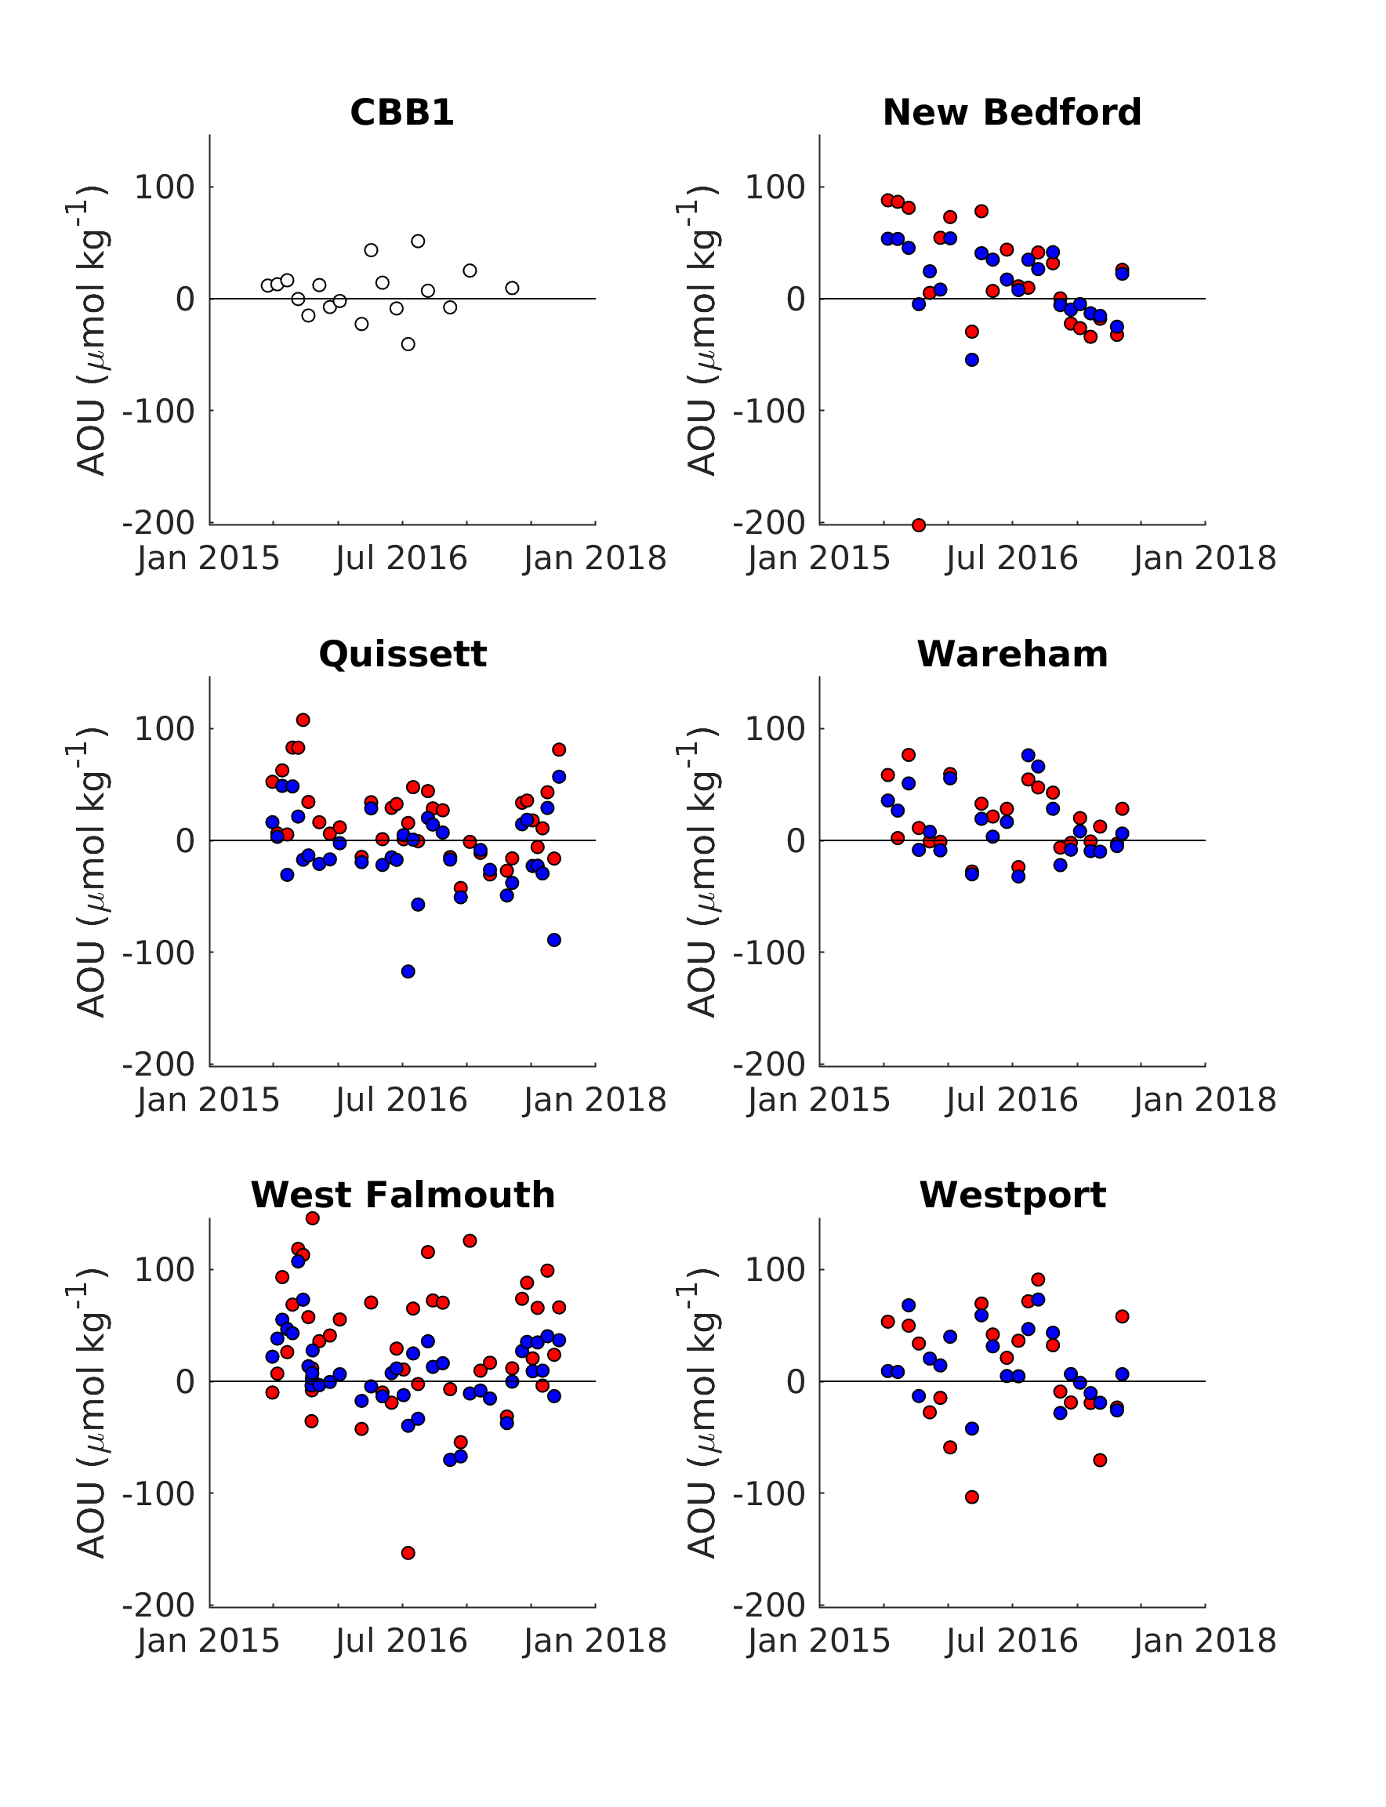

Figure S13. Time series of apparent oxygen utilization (AOU) from all embayments and the Buzzards Bay reference station (CBB1). Inner harbors are plotted in red, outer harbor stations are plotted in blue.

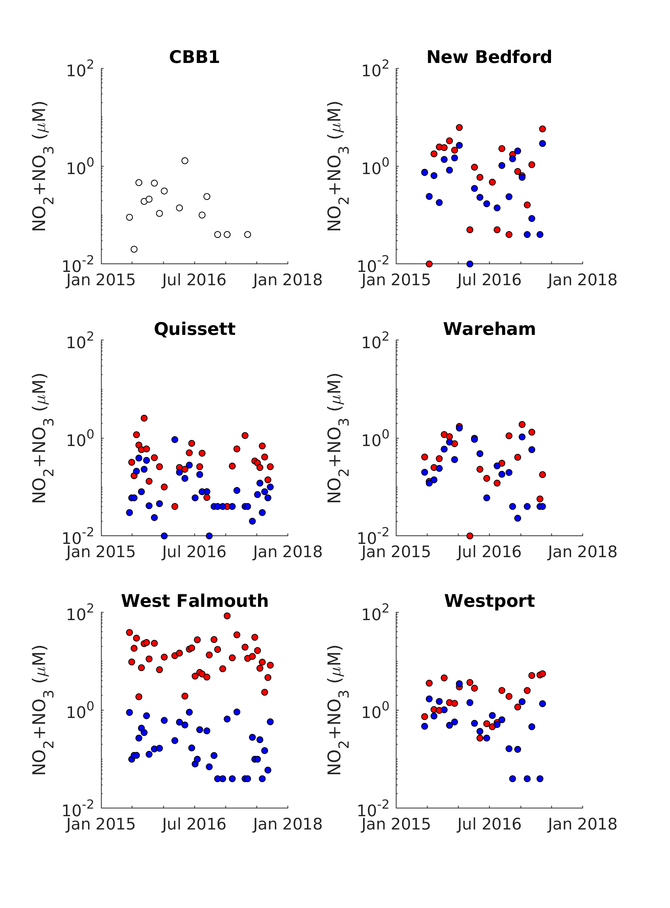

Figure S14. Time series of nitrite + nitrate (NO₂⁻ + NO₃⁻) from all embayments and the Buzzards Bay reference station (CBB1). Inner harbors are plotted in red, outer harbor stations are plotted in blue.

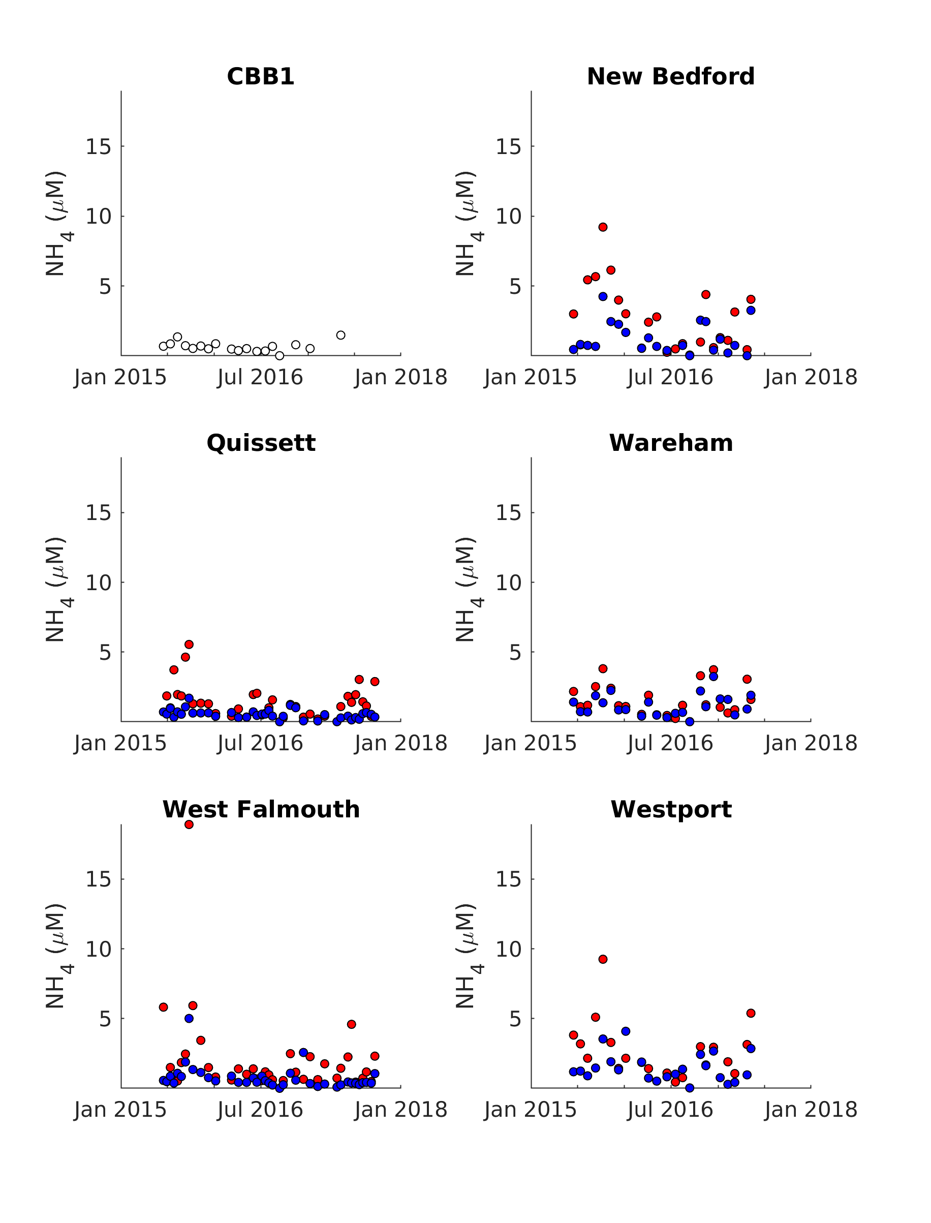

Figure S15. Time series of ammonium (NH₄⁺) from all embayments and the Buzzards Bay reference station (CBB1). Inner harbors are plotted in red, outer harbor stations are plotted in blue.

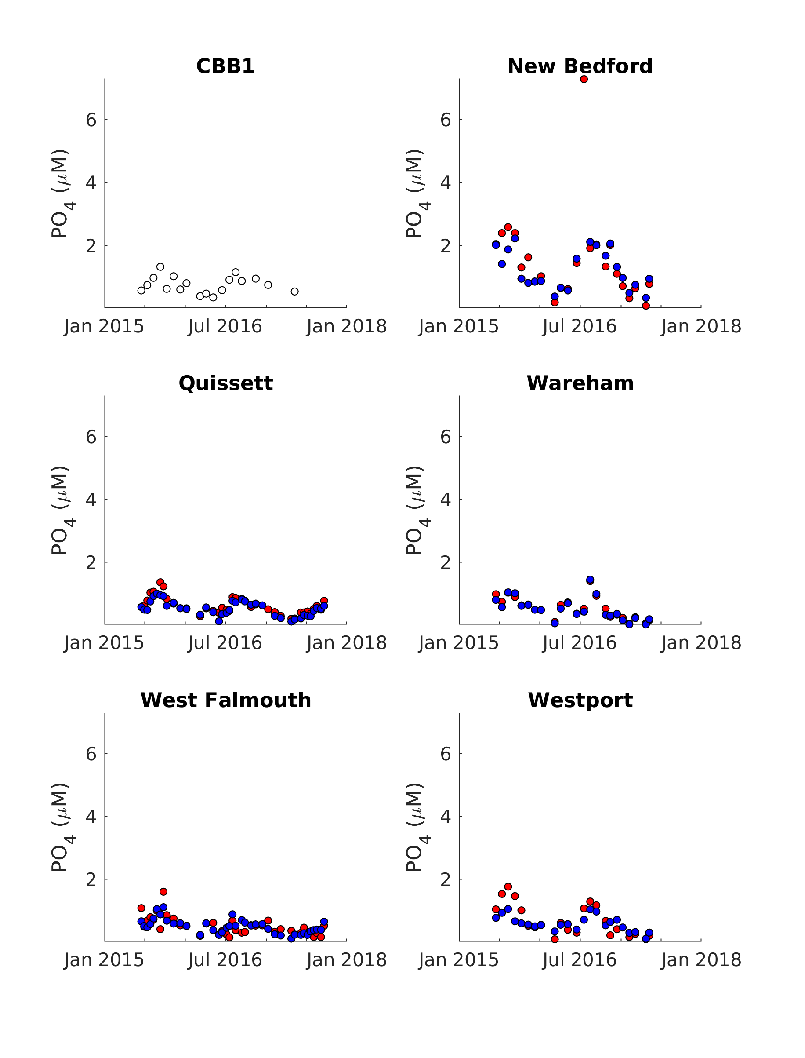

Figure S16. Time series of orthophosphate (PO₄⁻³) from all embayments and the Buzzards Bay reference station (CBB1). Inner harbors are plotted in red, outer harbor stations are plotted in blue.

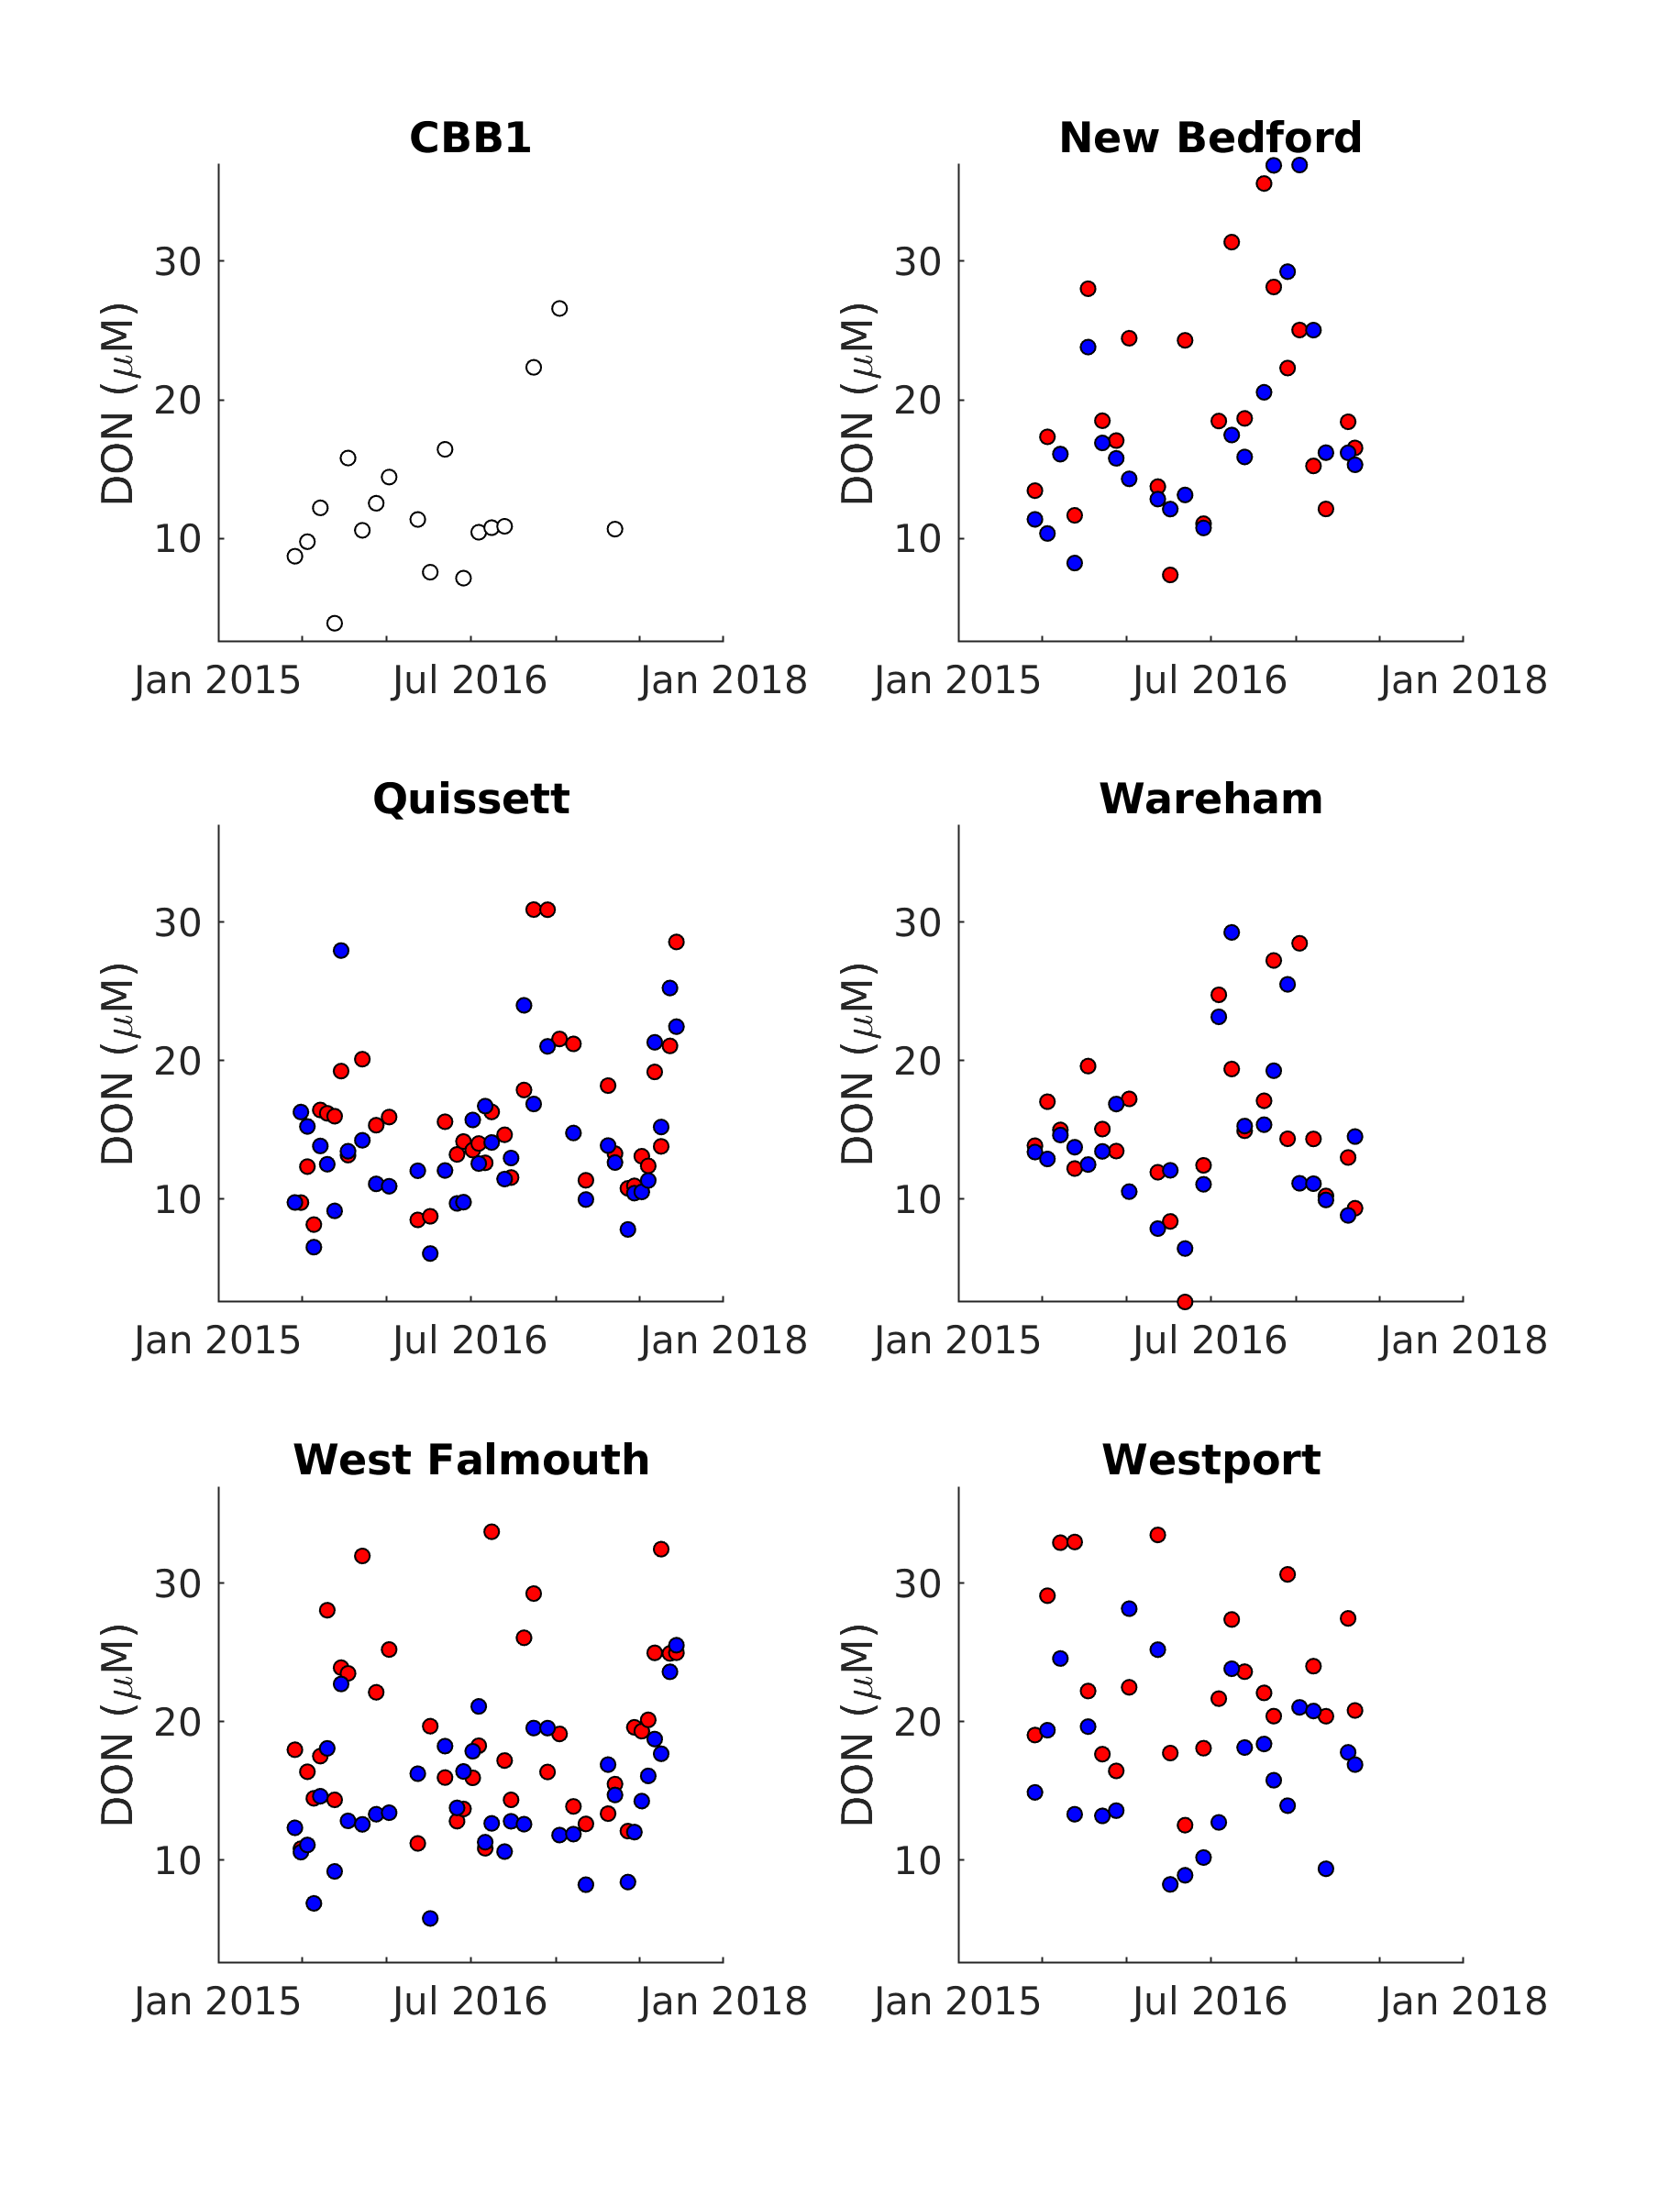

Figure S17. Time series of dissolved organic nitrogen (DON) from all embayments and the Buzzards Bay reference station (CBB1). Inner harbors are plotted in red, outer harbor stations are plotted in blue.

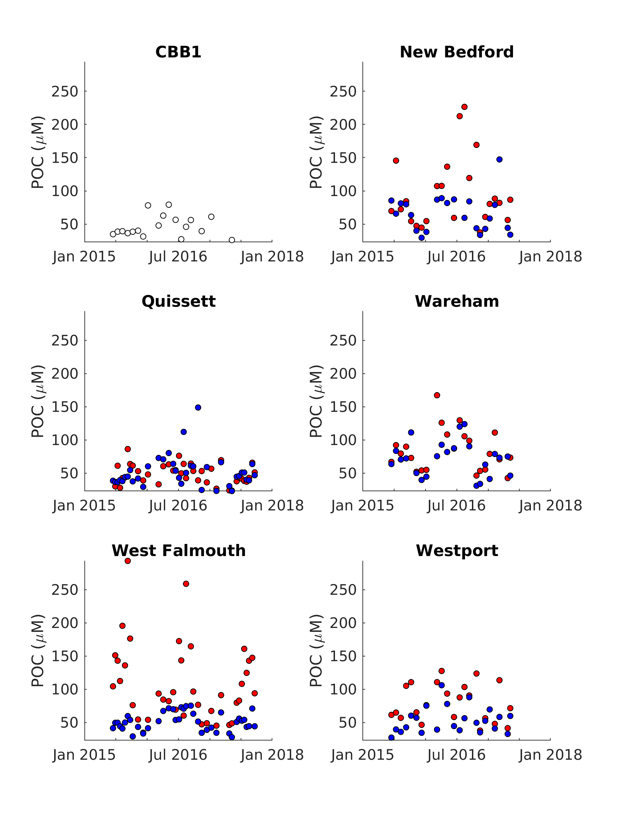

Figure S18. Time series of particulate organic carbon (POC) from all embayments and the Buzzards Bay reference station (CBB1). Inner harbors are plotted in red, outer harbor stations are plotted in blue.

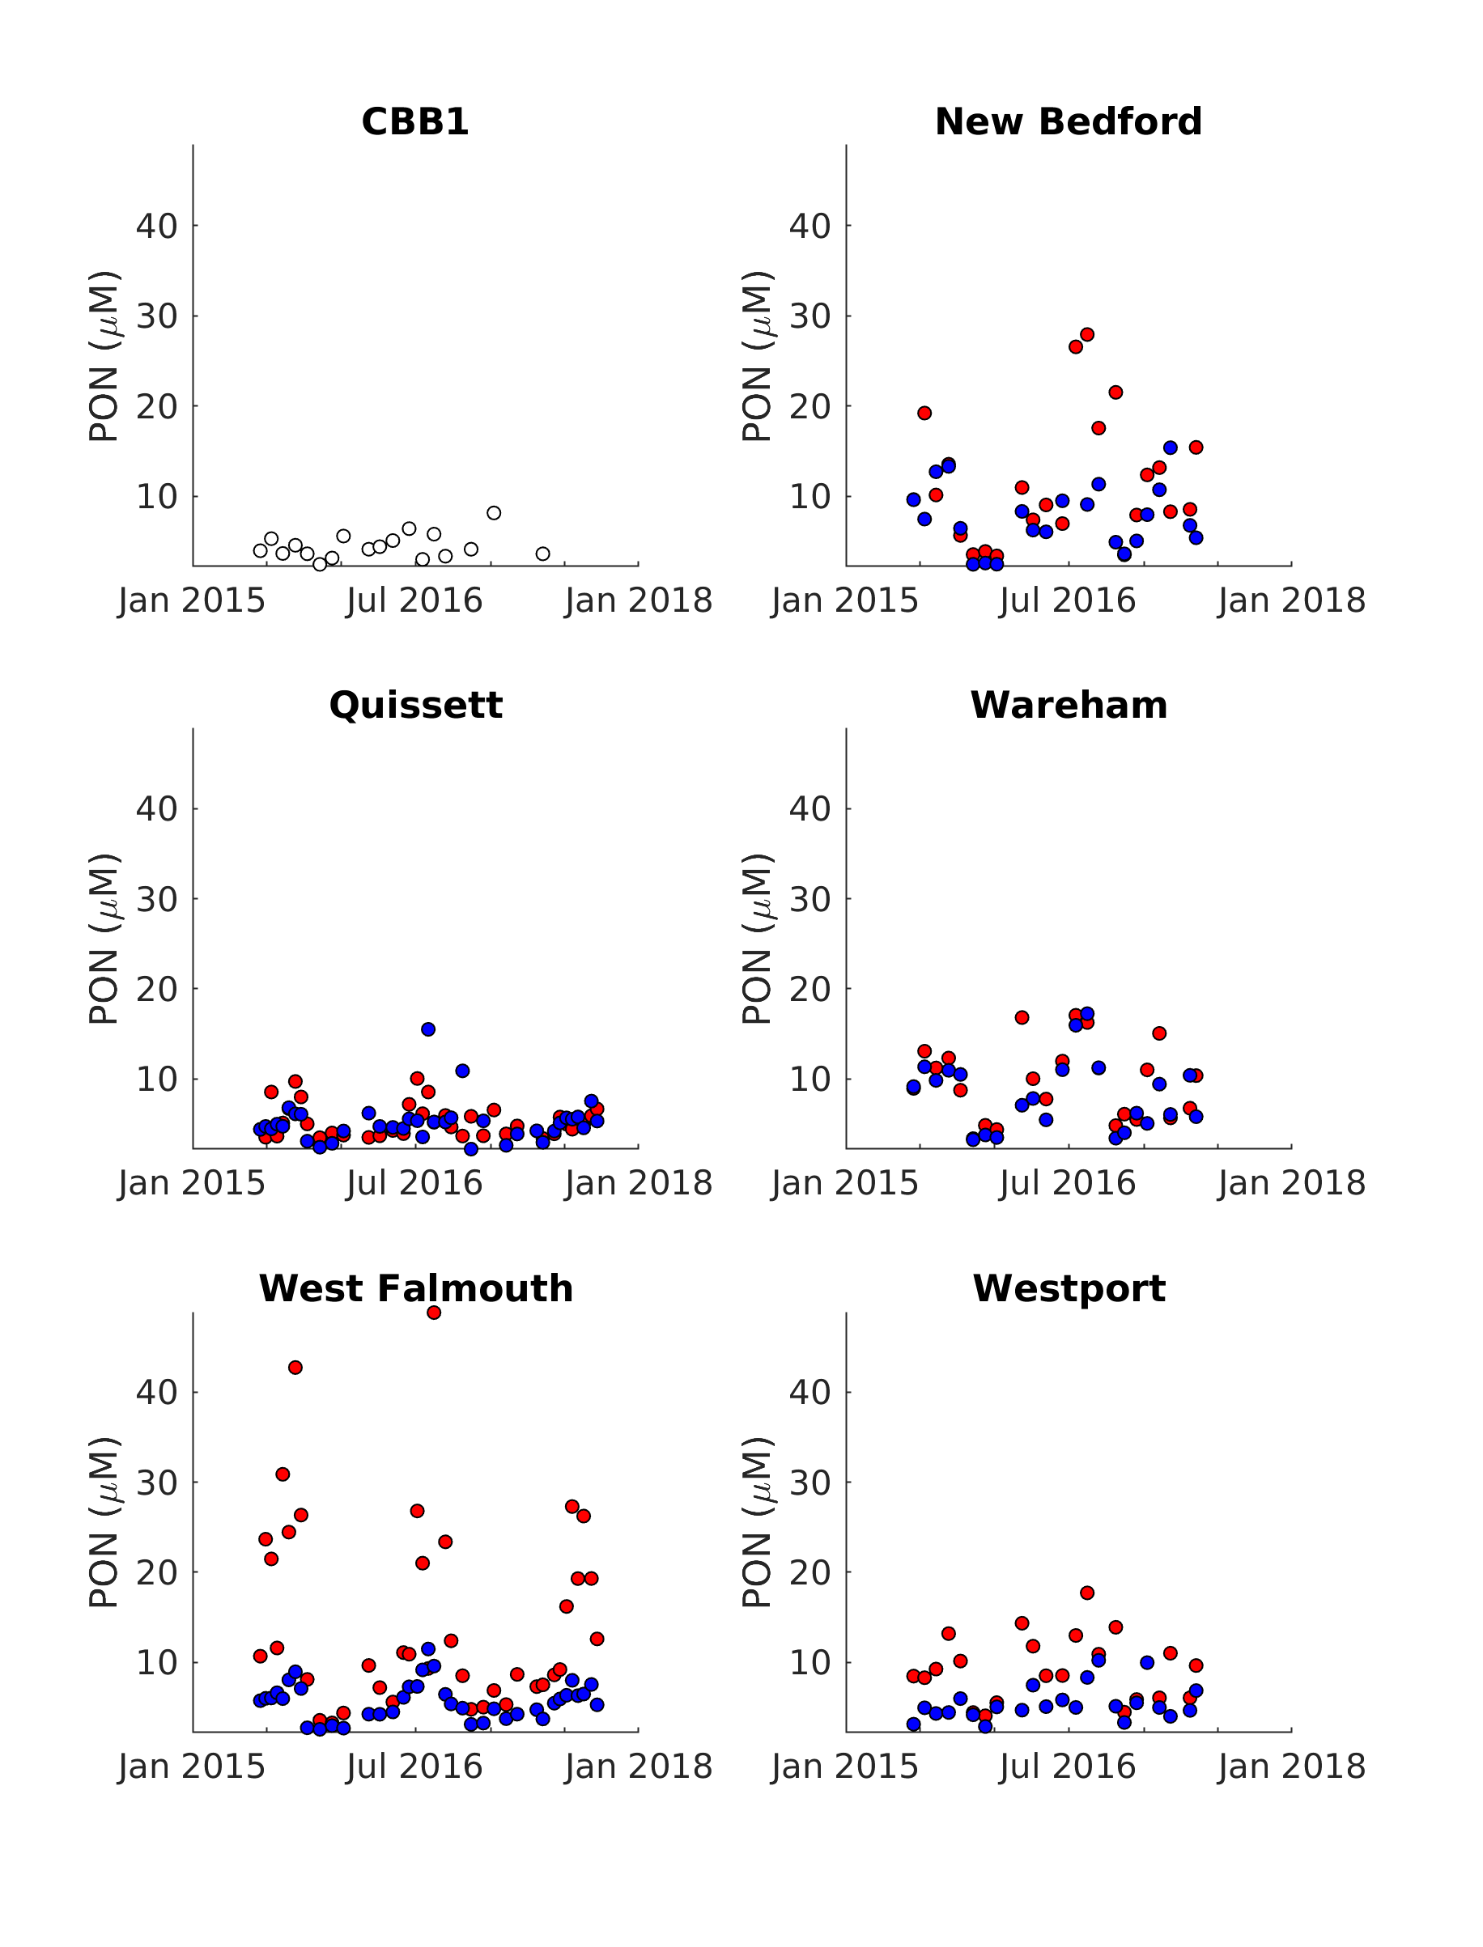

Figure S19. Time series of particulate organic nitrogen (PON) from all embayments and the Buzzards Bay reference station (CBB1). Inner harbors are plotted in red, outer harbor stations are plotted in blue.

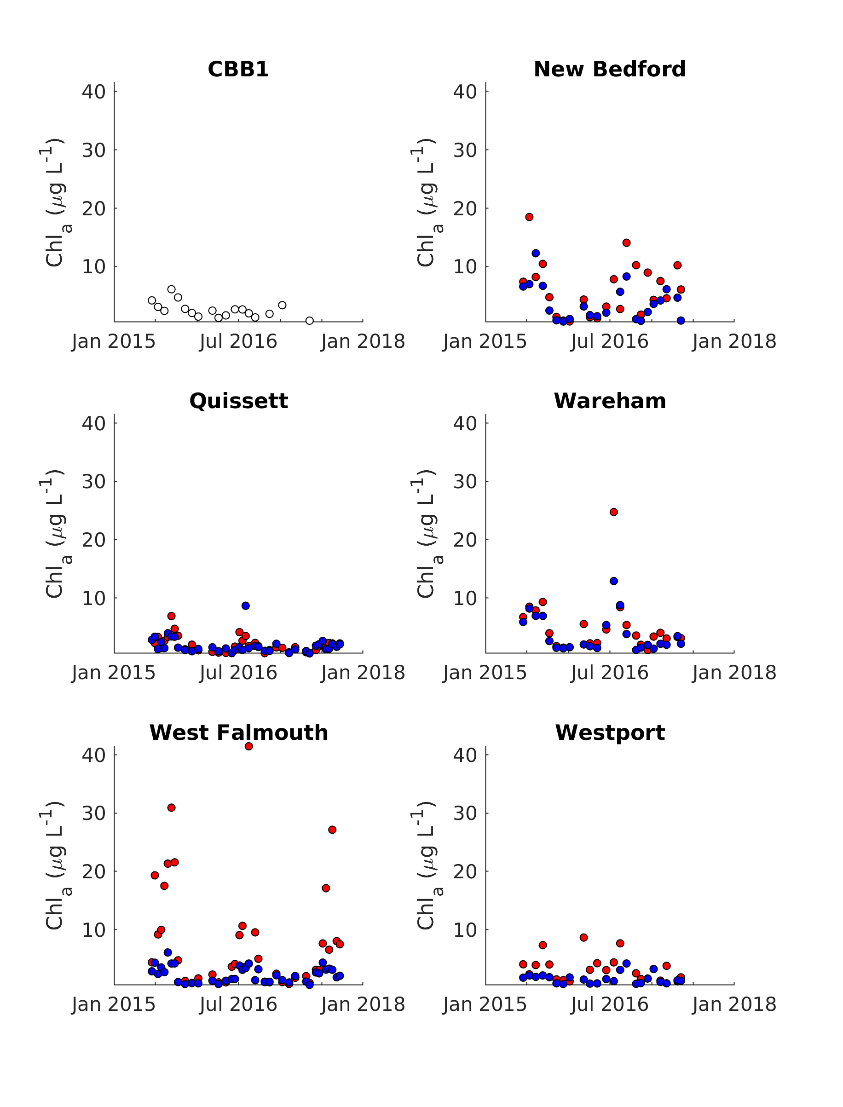

Figure S20. Time series of chlorophyll a (Chl_{a}) from all embayments and the Buzzards Bay reference station (CBB1). Inner harbors are plotted in red, outer harbor stations are plotted in blue.

