Geophysical Research Letters

Hydrologic properties of a highly permeable firn aquifer in the Wilkins Ice Shelf, Antarctica
Lynn Montgomery^{1*}, Clément Miège², Julie Miller^{3,4}, Theodore Scambos^{3,4}, Bruce Wallin⁵, Olivia Miller⁶, D. Kip Solomon⁷, Richard Forster⁸, Lora Koenig⁵
¹ Department of Atmospheric and Oceanic Sciences, University of Colorado Boulder, Boulder, CO, USA
² Department of Geography, Rutgers University, Piscataway, New Jersey, USA
³ Cooperative Institute for Research in Environmental Sciences, University of Colorado, Boulder, Colorado, USA
⁴ Earth Science and Observation Center, University of Colorado, Boulder, Colorado, USA
⁵ National Snow and Ice Data Center, Cooperative Institute for Research in Environmental Studies, Boulder, CO, USA
⁶ United States Geological Survey, Utah Water Science Center, Salt Lake City, UT, USA
⁷ Department of Geology and Geophysics, University of Utah, Salt Lake City, UT, USA
⁸ Geography Department, University of Utah, Salt Lake City, UT, USA
*Corresponding author: Lynn Montgomery (lynn.montgomery@colorado.edu)

Contents of this file

Text:
Text S1. Details of Borehole Dilution test
Text S2. GPR Methods
Text S3. SEEP2D Model Setup and Assumptions
Text S4. Definition of Specific Discharge and Linear Velocity
Text S5. Uncertainty of Density Measurements
Figures:
Figure S1. Airborne MCoRDS profile taken on November 16, 2014.
Figure S2. Firn density and stratigraphy for all three boreholes drilled at the field site.
Figure S3. Slug test set-up and water level change data.
Figure S4. Borehole dilution test set-up and homogenization of salt concentration.
Figure S5. 8-day continuous stationary GPS survey at the drill site.
Tables:
Table S1. Model output from regional climate models, RACMO2 and MAR, of snowfall and melt at the closest matched grid point to the field site.
Table S2. SEEP2D model input and output of variables in Darcy’s Law.
Introduction
The supplementary material here provides:
- Text supplementing geophysical and model methods and concepts.
- Figures supplementing geophysical methods and data.
- Tabular data summarizing model and field data.
Text S1. Details of Borehole Dilution test
We prepared a solution of 11500 uS/cm by adding 20 g of salt to 1 L of water (melted snow) targeting a resulting conductivity of 200 uS/cm once mixed in the water filled borehole (Figure S4a). Prior to injecting the solution, we ran an initial conductivity vertical profile to record the background specific conductivity with depth in the water-filled part of the borehole. We then placed a conductivity probe (HOBO Onset© U24-002-C) operating in its low range between 100 and 10000 uS/cm at the mid-point of the water-filled borehole and monitored the water conductivity for an hour as the water and salt were being mixed in the borehole (Figure S4). Any use of trade, firm, or product names is for descriptive purposes only and does not imply endorsement by the U.S. Government. For mixing the saline solution within the water-filled borehole, we lowered a small submersible pump (Proactive 12-V Tornado pump) and positioned it about one meter above the borehole base. The water pumped at the base of the borehole was released just above the water table via a 1.27-cm diameter plastic tubing to create a vertical water movement. We injected the saline solution from the surface using a 0.635-cm diameter plastic tube and flushed the solution using fresh water to make sure all saline water was injected. After injection, we turned the pump on and mixed the saline solution in the borehole for an hour until the column had a homogeneous conductivity of 200 uS/cm (Figure S4b).

Text S2. GPR Methods
The control unit, manufactured by Malå (a RAMAC system), is operated with a 250-MHz antenna. The antenna was towed on a sled behind the snowmobile (Figure S5). The average travel speed was 1.5 - 2.5 ms⁻¹ with a scanning rate of 1 second and a depth range set around 500 ns. This resulted in a stacked, or averaged, GPR trace being collected every 2 m on average. For simultaneous geolocation of the GPR traces, we used a dual-frequency Trimble© R7 GPS receiver in kinematic mode with a sampling interval of 1 seconds (~1.5-2.5 m). A GPS Zephyr GeodeticTM antenna was installed on a metal mast located at the back of the snowmobile, 1 m above the snow surface. For gaining positioning accuracy, we processed the GPS data using the precise point positioning (PPP) web-based processor hosted by the Canadian Spatial Reference Service (CSRS - https://webapp.geod.nrcan.gc.ca/geod/tools-outils/ppp.php). The travel time to depth conversion was done using a permittivity value of 2.32 which corresponds to an average density of 620 kg/m3 observed above the water table (upper 13.4 meters) using an empirical relationship from Kovacs et al., 1995. Using the nearest GPR trace to the three core sites, the depth of the high-reflective layer in the GPR profile was in good agreement ( +/- 20 cm) with the water table measured directly at the borehole site.

Text S3. SEEP2D Model Setup and Assumptions
We simulated flow along a 2D vertical cross section 3800 meters long with nodal spacing of approximately 6 meters horizontally and 4 meters vertically. The thickness (A) of the aquifer varied in space and was delineated by our GPR measurements of the water table, and observations of the firn-ice transition for core samples (Figure 3b). We derived specified recharge fluxes (Table S2) from melt estimates from MAR3.9 (7.5 km resolution) or RACMO2.3p2 (5.5km resolution) 2010-2017 averaged surface melt at our field site. No flow boundaries were used for the bottom and upstream side of the domain. Along the downstream boundary, where discharge occurs, we used a no flow boundary below sea level to approximate the presumed occurrence of a freshwater-salt water interface. A specified head (-0.28 meters ellipsoid height, Figure 3b) was used based on the water table height on the downstream boundary above sea level. Although aquifer properties may vary along the cross section, a heterogeneous simulation is not justified given the limited available field data.
Our simulations utilized the following assumptions:
1) the hydraulic conductivity is uniform throughout our study region
2) the bottom elevation of the aquifer is homogeneous,
3) any melt water that is not recharged to the aquifer is refrozen in the unsaturated zone overlying the aquifer. (i.e. we assume sublimation and evaporation of the melt water to be negligible).
4) The rift is partially filled with seawater (to the geoid height) and the density gradient between the freshwater of the aquifer and seawater in the rift causes a hydraulic barrier where no discharge can occur.
Assumption 1 is justified based on homogeneous hydraulic conductivity in a firn aquifer in Greenland (Miller et al., 2017).
Note: Assumption 4) is implemented in SEEP2D by only allowing for water to discharge above the geoid height (Figure 3b). In reality, there may be diffuse flow into seawater, however a more complex boundary is not currently warranted due to a lack of direct observations.
Text S4. Definition of Specific Discharge and Linear Velocity
The specific discharge, representing the flow of water per unit area of porous media (m³/m² s), is calculated at each depth using the specific conductivity measurements from the borehole dilution test (derived from Darcy’s Law)
$$q=\frac{πr}{2tα}ln⁡(\frac{C}{C_{0}})$$
where q is the specific discharge (length/time), r is the borehole radius (length), t is time, α is a formation factor accounting for the amplification of the velocity field by the borehole, commonly taken to be equal to 2 (Pitrak et al., 2007), and C/C₀ is the relative concentration at a given time.
Additionally, the linear velocity (V, the velocity through connected pores), is calculated by
$$V= \frac{q}{n}$$
using three porosity estimates from Koenig et al (2014), where q is the specific discharge and $n$ is the porosity (Cherry and Freeze, 1979).
Text S5. Uncertainty of Density Measurements
Average uncertainty of density measurements for all three cores was calculated using an error propagation formula for products and division based on Fornasini (2008) using an uncertainty of ± 0.002 m for length measurements, ± 0.003 g for weight measurements, ± 0.002 m for diameter measurements, and an error of ± 1% for intactness. There is additional uncertainty in the water-saturated aquifer layer (~13-29 m) from water drainage from cores on the way up the borehole or while taking the measurements of length, diameter, weight, and intactness, however we are unable to quantify the mass loss.

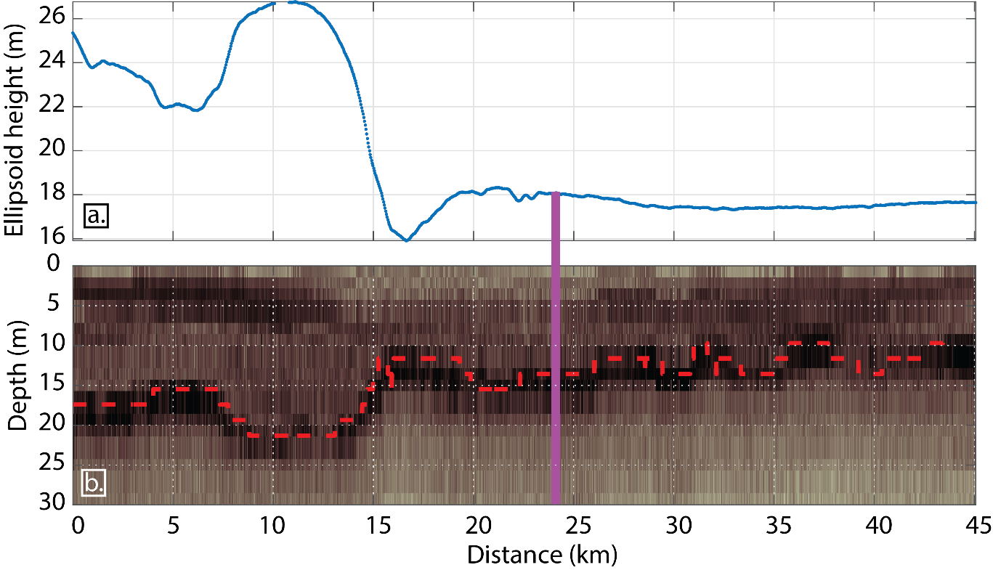
Figure S1. Inset a. shows the elevation profile (Ellipsoid height) for the OIB flight trajectory in the vicinity of our field site, using the Airborne Topographic Mapper data (Studinger, 2014). Inset b. represents the MCoRDS radar data collected simultaneously to the ATM data. We interpret the bright reflector, (dash red line) found between 10 and 25 meters, to be the water table. The purple vertical bar represents the closest location to our field site (1.8 km apart). The vertical precision of depth is limited to the vertical sample interval (also referred to as bin size) of ~1.9 m for a bandwith of 180-230 MHz, when converting from two-way travel time to depth using a permittivity value of 2.4 (corresponding to an average density of ~650 kg m⁻³). The MCoRDS and GPR trajectories intersect at two locations: 71.7543°W&70.8162°S and 71.7701°W&70.7944°S (see Figure 1b) with absolute depth-to-water differences of 0.6 and 1.2 meters, respectively.

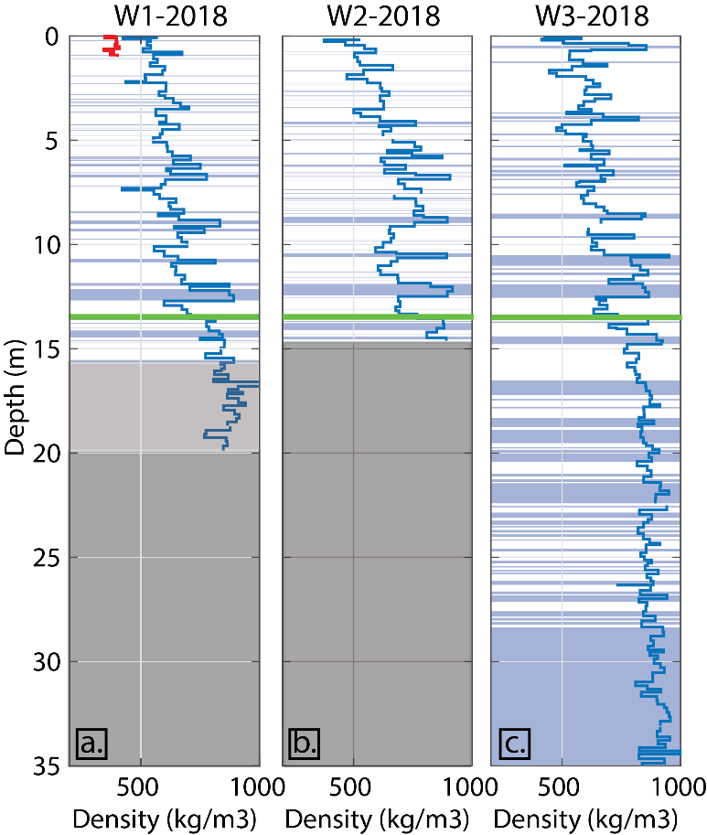
Figure S2. Density (blue line from coring, red line from pit) and stratigraphy (blue = ice lens, white = firn) for the three cores collected at our field site, the horizontal spacing between each core location is about 1 meter. The water table is represented by a green horizontal line. The light gray rectangle at W1 indicates that only the density was recorded. The dark gray rectangles at W1 and W2 indicate no measurements were taken.

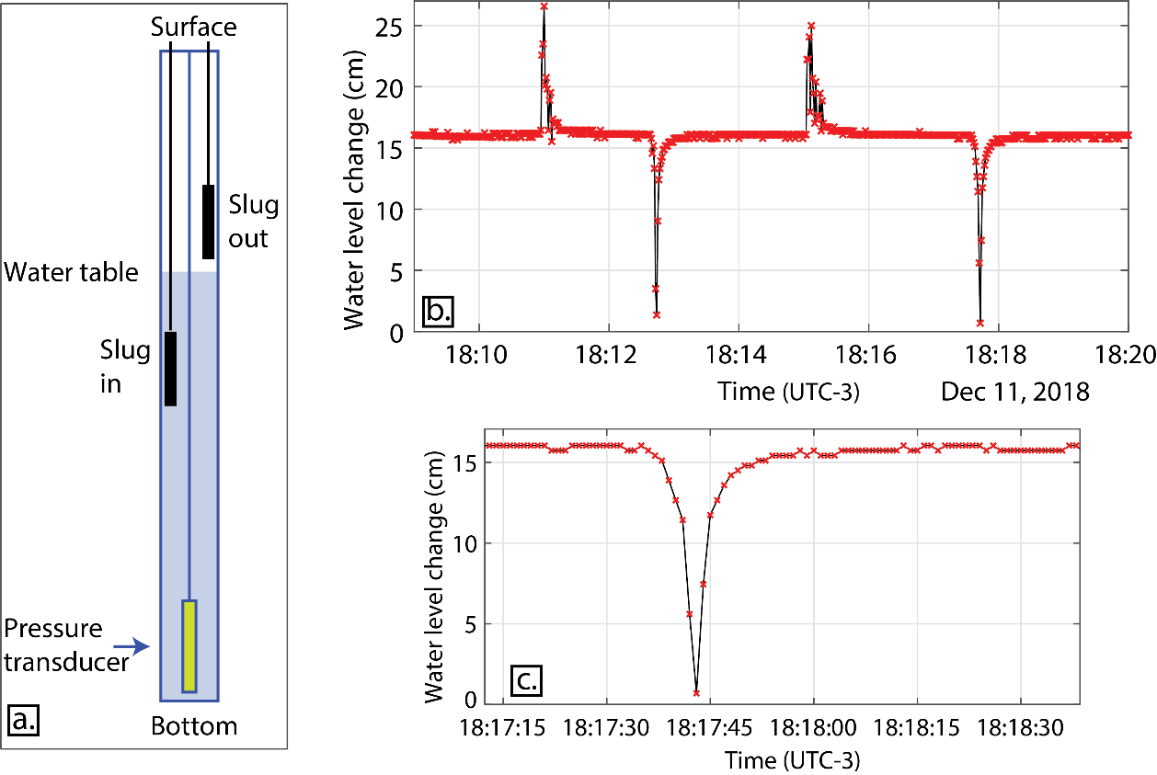
Figure S3. a) Slug test set-up (not at scale). b) Illustration of the water-level changes over time as the slug is inserted and removed from the borehole. c) Close up within the water-level time-series showing one the drawdown and recovery of the water table when removing the slug.

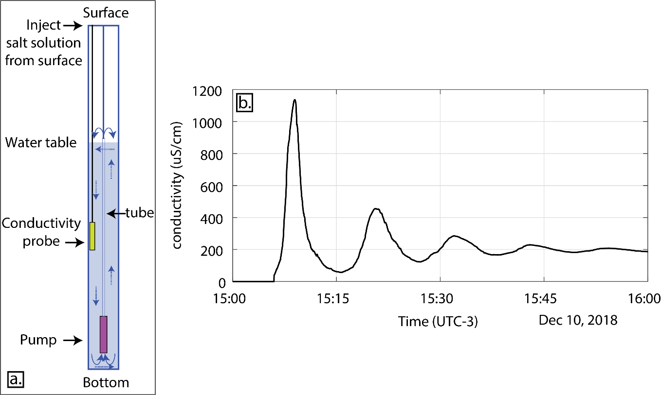
Figure S4. a) Dilution test setup (not at scale). b) Homogenization of salt concentration in the borehole water column after injection at the surface, using a pump placed at the bottom. This step happened prior to logging the evolution of the salt concentration of the water column.

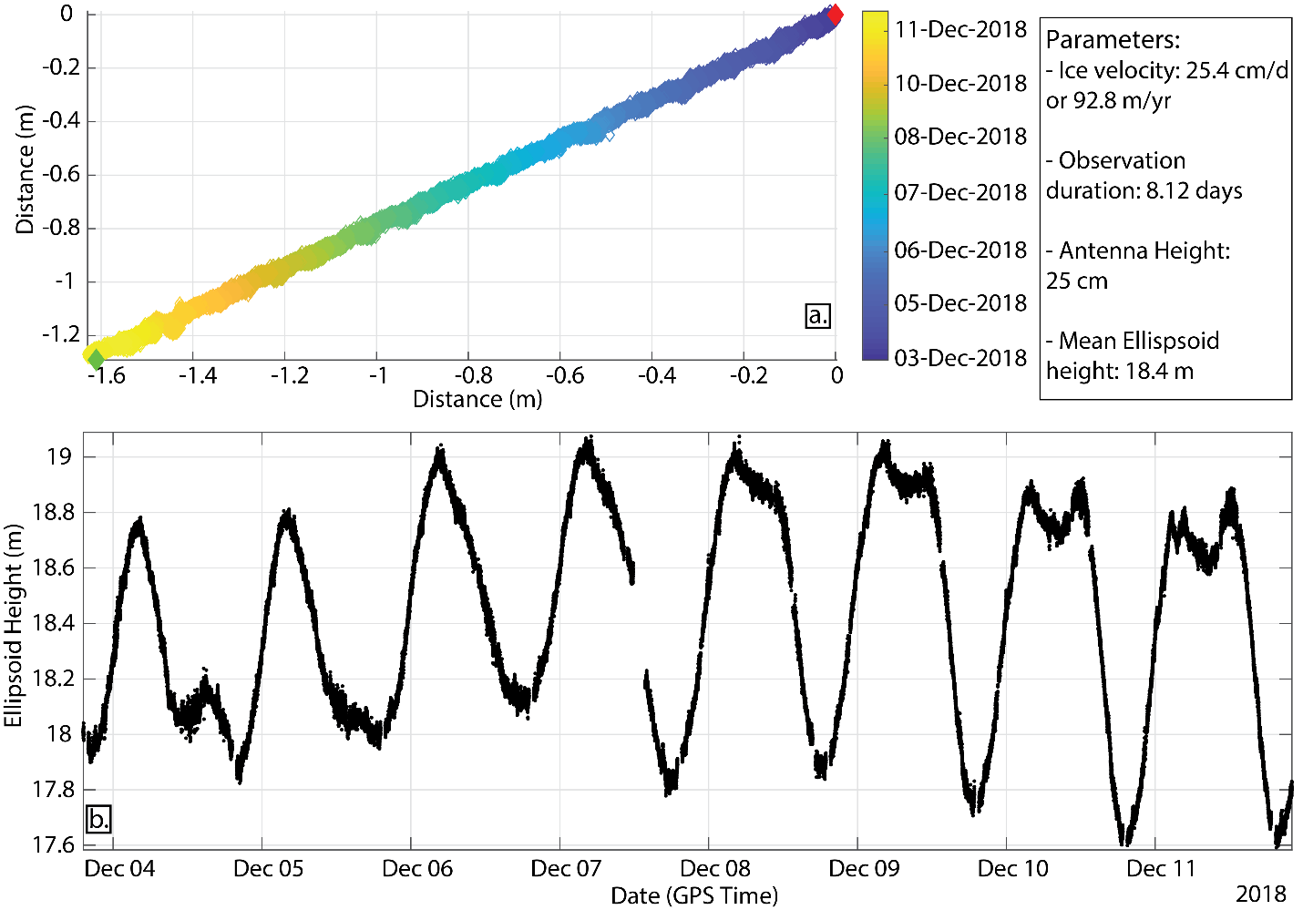
Figure S5. An 8-day continuous stationary GPS survey at the drill site to determine a short-term ice flow vector and the tidal range for part of the tidal cycle after processing the GPS data using with PPP online processor hosted by the Canadian Spatial Reference Service.

Table S1.
 | MAR SF | MAR ME | RACMO2 SF | RACMO2 ME
2010 | 559.74 | 424.35 | 563.79 | 230.49
2011 | 432.88 | 440.23 | 822.64 | 195.90
2012 | 503.48 | 228.02 | 590.23 | 222.07
2013 | 502.34 | 417.50 | 678.66 | 264.36
2014 | 597.04 | 215.68 | 755.65 | 105.64
2015 | 699.45 | 356.39 | 850.20 | 231.27
2016 | 912.56 | 495.76 | 1375.38 | 271.88
2017 | 529.57 | 836.10 | 716.75 | 396.34
Table S1. Values of snowfall (SF) and melt (ME) shown in Figure 1c in the manuscript from MAR and RACMO2 at the closest grid point to our field site at -70.80S, -71.71W.
Table S2.
 | Q | K | $$\frac{∂H}{∂x}$$ | Deviation from Observed Slope
Observed | ? | 1.38×10⁻⁴ | $$-\frac{5}{3800}$$ | -
High Recharge (MAR) | 425 | 1.38×10⁻⁴ | $$-\frac{46}{3800}$$ | 9x
High Recharge (RACMO2) | 250 | 1.38×10⁻⁴ | $$-\frac{26}{3800}$$ | 5x
Medium Recharge (RACMO2) | 125 | 1.38×10⁻⁴ | $$-\frac{13}{3800}$$ | 2x
Low Recharge (RACMO2) | 62.5 | 1.38×10⁻⁴ | $$-\frac{6}{3800}$$ | 1x
Low Recharge (MAR) | 42.5 | 1.38×10⁻⁴ | $$-\frac{5}{3800}$$ | 1x

Table S2. SEEP2D modelling of recharge scenarios using different amounts of recharge input/discharge output (Q, mmWE yr⁻¹) to determine if the steady state slope of the water table (∂H/∂x, m/m) outcome is plausible. Hydraulic conductivity (K) is in units of m s⁻¹). The final column shows the multiplicative factor by which the scenario deviates from the observed slope value.
References
Cherry, J., & Freeze, R. A. (1979). Groundwater. Englewood Cliffs, NJ: Prentice Hall.
Fornasini, P. (2008). The Uncertainty in Physical Measurements. New York, NY: Springer New York. https://doi.org/10.1007/978-0-387-78650-6
Koenig, L. S., Miège, C., Forster, R. R., & Brucker, L. (2014). Initial in situ measurements of perennial meltwater storage in the Greenland firn aquifer. Geophysical Research Letters, 41(1), 81–85. https://doi.org/10.1002/2013GL058083
Kovacs, A., Gow, A. J., & Morey, R. M. (1995). The in-situ dielectric constant of polar firn revisited. Cold Regions Science and Technology, 23(3), 245–256. https://doi.org/10.1016/0165-232X(94)00016-Q
Pitrak, M., Mares, S., & Kobr, M. (2007). A Simple Borehole Dilution Technique in Measuring Horizontal Ground Water Flow. Ground Water, 45(1), 89–92. https://doi.org/10.1111/j.1745-6584.2006.00258.x
Studinger, M. 2014, updated 2020. IceBridge ATM L2 Icessn Elevation, Slope, and Roughness, Version 2. [Subset Used: 2014]. Boulder, Colorado USA. NASA National Snow and Ice Data Center Distributed Active Archive Center. doi: https://doi.org/10.5067/CPRXXK3F39RV. [Date Accessed: 2018]. (n.d.).

