Table S1: Full uncorrelated model summary

Parametric coefficients:
Variable | Estimate | Standard Error | z value | p-value
Intercept | 188.00 | 36.76 | 5.12 | 3.14 x 10⁻⁷
Year | -0.096 | 0.02 | -5.28 | 1.33 x 10⁻⁷
Month | -0.014 | 0.02 | -0.80 | 0.42
Port: Ancon | 2.87 | 1.15 | 2.49 | 0.01
Port: Bayovar | -61.68 | 1.15 x 10⁷ | 0.00 | 1.0
Port: Chorillos | 0.63 | 1.25 | 0.51 | 0.61
Port: Constante | 4.14 | 1.68 | 2.47 | 0.01
Port: Las Delicias | 6.12 | 1.15 | 5.31 | 1.12 x 10⁻⁷
Port: Mancora | 5.15 | 1.28 | 4.04 | 5.32 x 10⁻⁵
Port: Paita | -60.53 | 2.12 x 10⁷ | 0.00 | 1.0
Port: Parachique | -62.91 | 3.88 x 10⁷ | 0.00 | 1.0
Port: Pisco | 5.56 | 1.01 | 5.48 | 4.33 x 10⁻⁸
Port: Salaverry | 4.23 | 1.02 | 4.16 | 3.17 x 10⁻⁵
Port: San Jose | 5.60 | 1.33 | 4.21 | 2.61 x 10⁻⁵
Port: Supe | 6.06 | 1.25 | 4.84 | 1.26 x 10⁻⁶
Port: Zorritos | 0.84 | 0.14 | 6.10 | 1.09 x 10⁻⁹

Smooth terms:
Variable | edf | Ref.df | Chi.sq | p-value
Mesh | 6.66 | 7.45 | 28.98 | 1.79 x 10⁻⁴
Distance to islands | 6.14 | 7.34 | 39.95 | 1.96 x 10⁻⁶
Log Chl-a | 8.65 | 8.96 | 53.29 | 1.79 x 10⁻⁸
SST | 3.84 | 4.83 | 117.28 | < 2 x 10⁻¹⁶
SST std dev | 2.61 | 3.33 | 11.49 | 0.01
SLA | 7.84 | 8.65 | 18.25 | 0.04
FSLE | 1.86 | 2.36 | 3.28 | 0.22
FSLE theta | 3.37 | 4.17 | 4.64 | 0.35

R² (adj)= 0.358, Deviance explained = 31.9%, UBRE = -0.028941, Scale est. = 1, n = 3212

Table S2: Model selection statistics

Model | N | % Dev expl | AIC | AUC | TSS
Full uncorrelated model | 3212 | 31.93 | 3119.04 | 0.83 | 0.49
Static | 3497 | 25.88 | 3611.80 | 0.82 | 0.48
Static + broad | 3212 | 30.89 | 3133.58 | 0.84 | 0.50
Static + meso | 3497 | 26.65 | 3595.54 | 0.82 | 0.48
Dynamic | 3544 | 10.48 | 4414.24 | 0.70 | 0.27
Static model includes year, month, port, targeting of sharks, mesh size (cm), and distance to islands (m).
Static + broad model includes year, month, port, targeting of sharks, mesh size (cm), distance to islands (m), SST, and log chl-a.
Static + meso model includes year, month, port, targeting of sharks, mesh size (cm), distance to islands (m), FSLE, and SLA.
Dynamic model includes SST, SST standard deviation, log chl-a, FSLE, FSLE theta, and SLA.

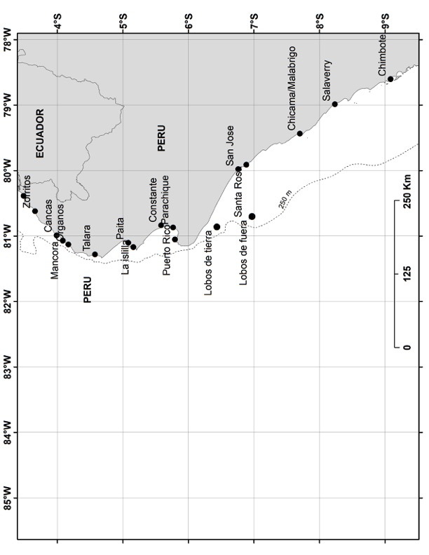

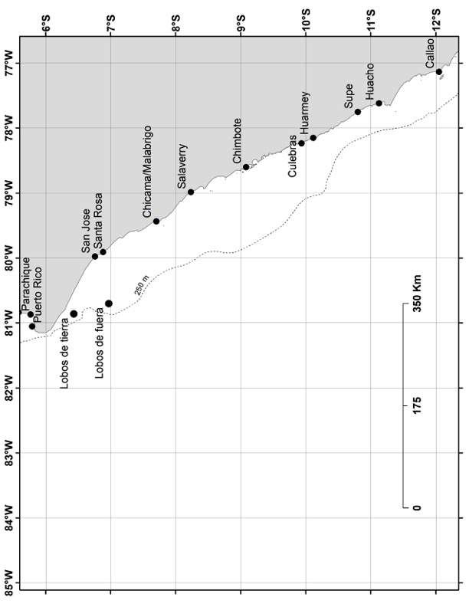

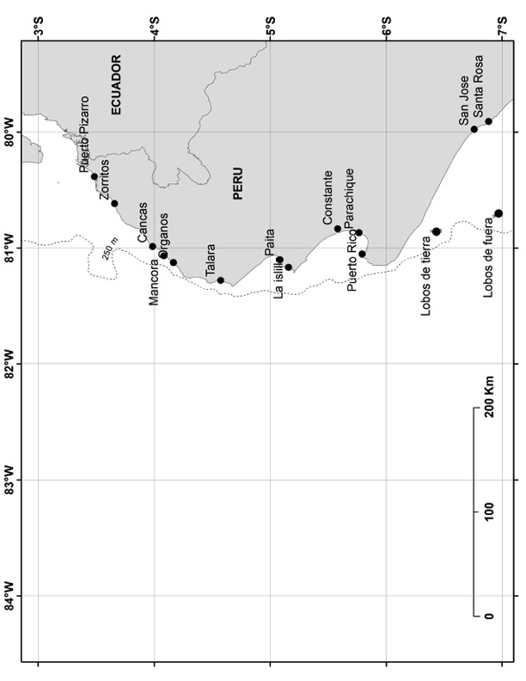
Figure S1: Example maps used in participatory mapping exercise.

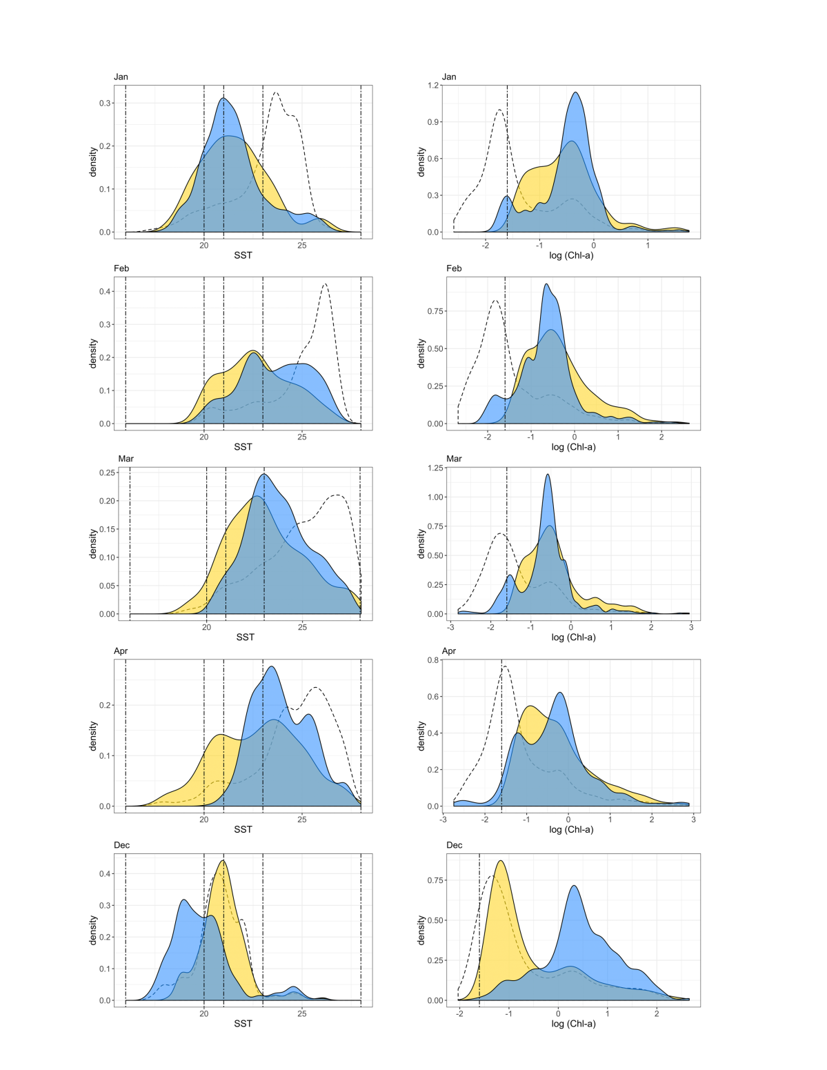
Figure S2: Density distributions of fisher-mapped variables (blue), biophysical model prediction values > 0.5 (yellow), and background environment (dotted line) for each month of the peak fishing season (December – April) 2012. For fisher-stated temperature (left), vertical dashed lines indicate quartiles used to categorize “optimal” habitat in Figure 2. For fisher-stated chlorophyll (right), vertical dashed line indicates the -1.6 cutoff representing green water.

