Geophysical Research Letters
Supporting Information for
Interannual Variability of Lower Equatorial Intermediate Current Response to ENSO in the Western Pacific
Qiang Ma^{1,2,3,4}, Jianing Wang^{1,2,3,4*}, Fan Wang^{1,2,3,4*}, Dongxiao Zhang^{5,6,} Zhixiang Zhang^{1,2,3,4}, Yilong Lyu^{1,2}.

¹ Key Laboratory of Ocean Circulation and Waves, Institute of Oceanology, Chinese Academy of Sciences, Qingdao, China
² Function Laboratory for Ocean Dynamics and Climate, Pilot National Laboratory for Marine Science and Technology Qingdao, Qingdao, China
³ Center for Ocean Mega-Science, Chinese Academy of Sciences, Qingdao, China
⁴ University of Chinese Academy of Sciences, Beijing, China
⁵Joint Institute for the Study of the Atmosphere and Ocean, University of Washington, Seattle, Washington, USA,
⁶ Pacific Marine and Environmental Laboratory, NOAA, Seattle, Washington, USA

Contents of this file

Figures S1 to S3

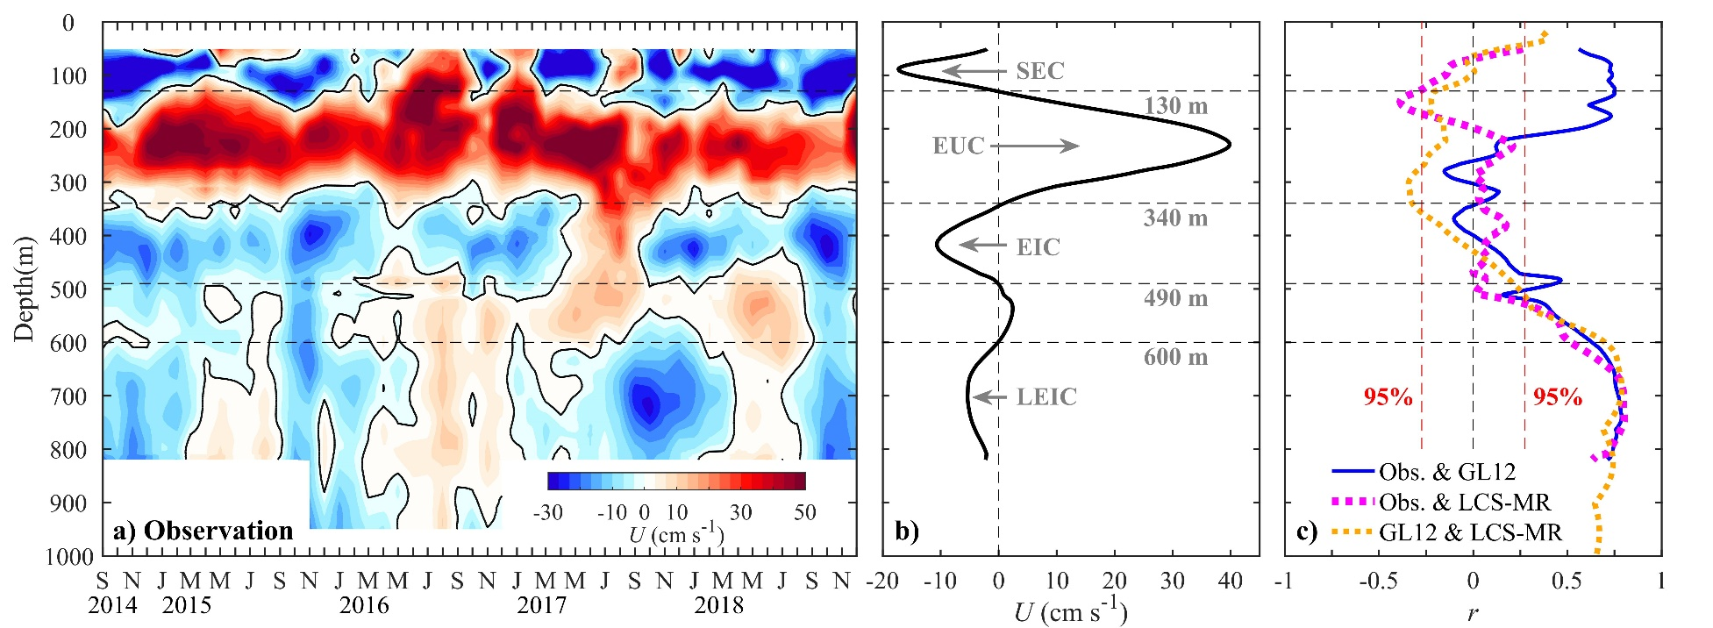

Figure S1. (a) Time-depth variations of observed monthly zonal current U during September 2014-December 2018 at 0º, 142ºE. (b) The vertical distributions of (b) observed time-averaged U and (c) zero-lag correlation coefficients r between observed and modeled zonal current anomaly U_{a}. The depth ranges of zonal currents are indicated in panel b. The red dashed lines in panel c denote coefficients that are significant at 0.05 level.
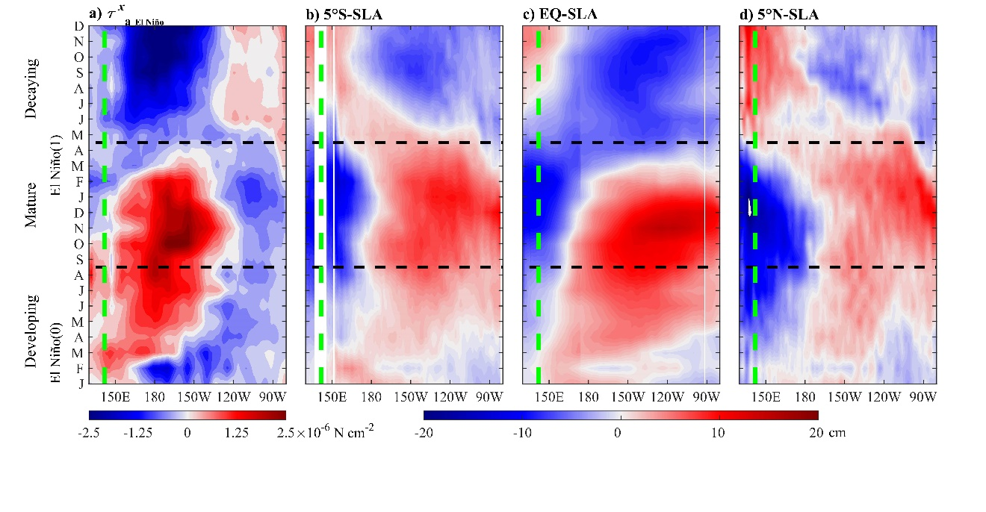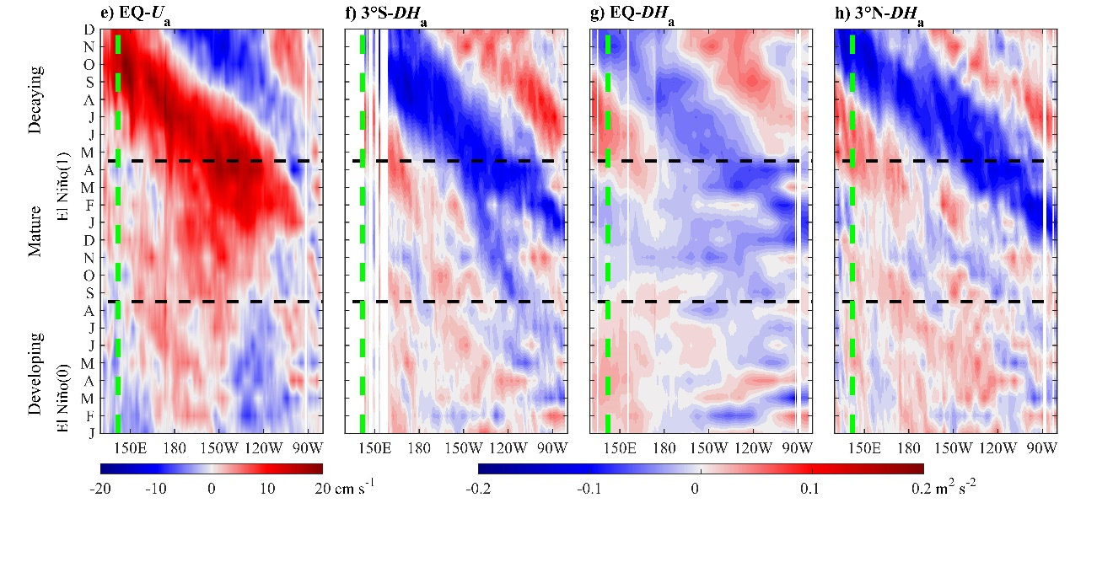

Figure S2. Longitude-time plots of composite (a) ERA-Interim zonal wind stress anomaly (τ^{x}_{a_El Niño}) averaged between 5°S-5°N, SLA along (b) 5°S, (c) the equator, and (d) 5°N, (e) U_{a} at the equator, and dynamic height anomaly DH_{a} along (f) 3°S, (g) the equator, and (h) 3°N averaged between 600-820 m in GL12. The black dashed lines in each panel are used to separate the developing [January(0)-August(0)], mature [September(0)-April(1)], and decaying [May(1)-December(1)] stages based on the τ^{x}_{a_El Niño} evolution. The green dashed line in each panel denotes the longitude of the mooring site.
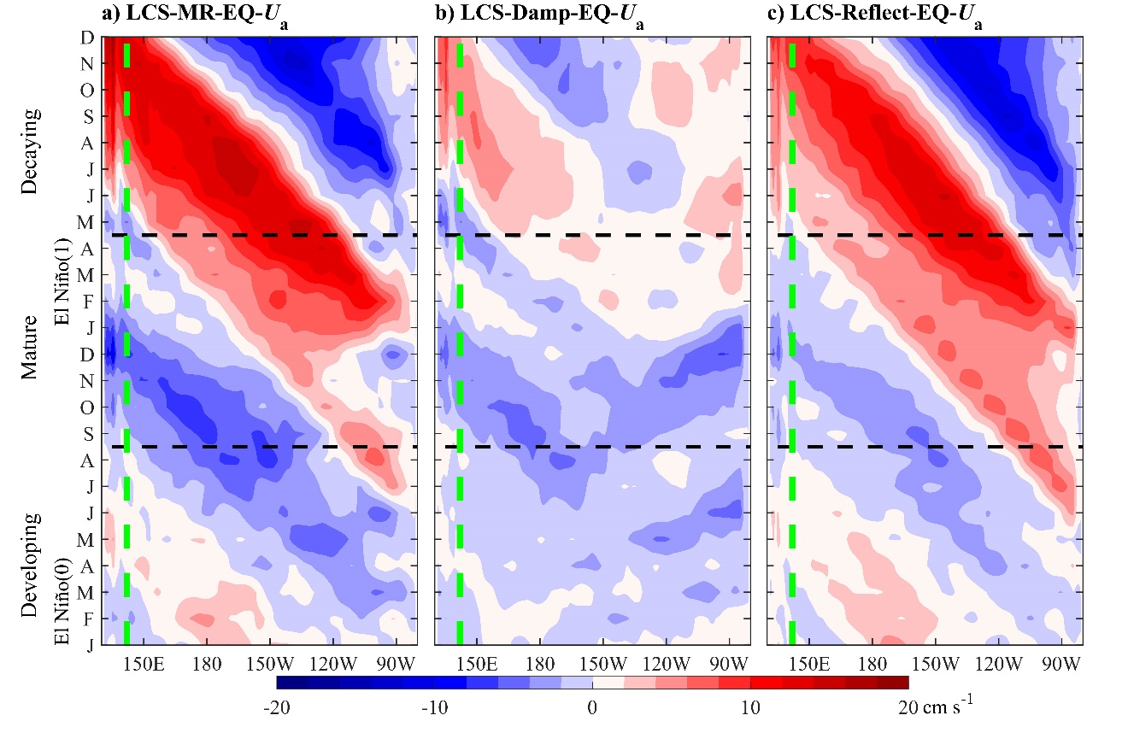

Figure S3. Longitude-time plots of composite U_{a} at the equator averaged between 600-820 m from (a) LCS-MR, (b) LCS-Damp, and (c) LCS-Reflect. The black dashed lines in each panel are used to separate the developing [January(0)-August(0)], mature [September(0)-April(1)], and decaying [May(1)-December(1)] stages based on the τ^{x}_{a_El Niño} evolution in Figure 3a. The green dashed line in each panel denotes the longitude of the mooring site.

