Supporting Information

“Estimating nest-level phenology and reproductive success of colonial seabirds using time-lapse cameras”

Jefferson T. Hinke, Andres Barbosa, Louise M. Emmerson, Tom Hart, Mariana A Juáres, Malgorzata Korczak-Abshire, Gennadi Milinevsky, Mercedes Santos, Philip N. Trathan, George M. Watters & Colin Southwell

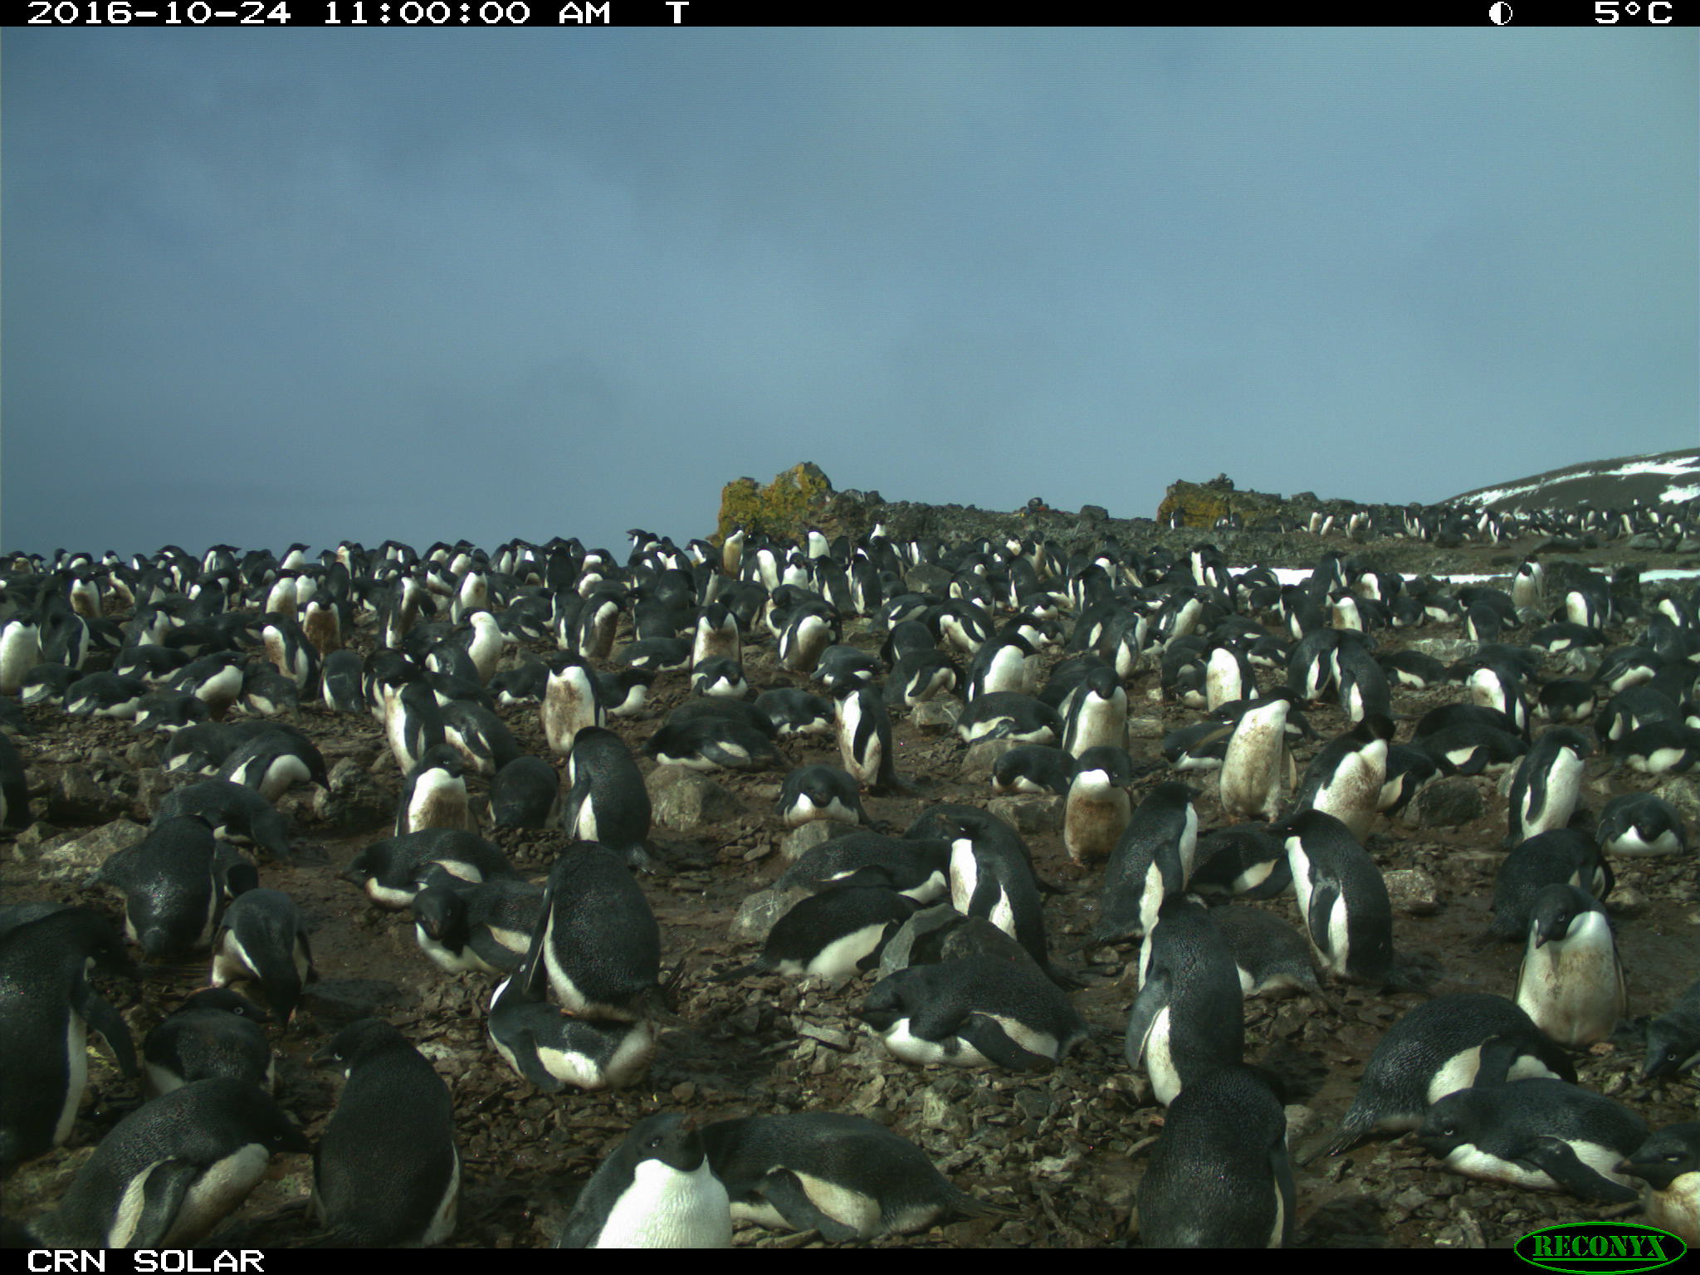
Fig. S1. Example photograph from the Castle Rocks North camera at the Copacabana colony during the egg laying period for Adélie penguins. Nests are attended by predominantly two adults and one nest shows clear evidence of copulation (red star).
Fig. S2. Example photograph from the Castle Rocks North camera at the Copacabana colony during the incubation period for Adélie penguins. Nests are attended by predominantly one adult and an egg is clearly visible in one nest (red star) as the parent turns it.
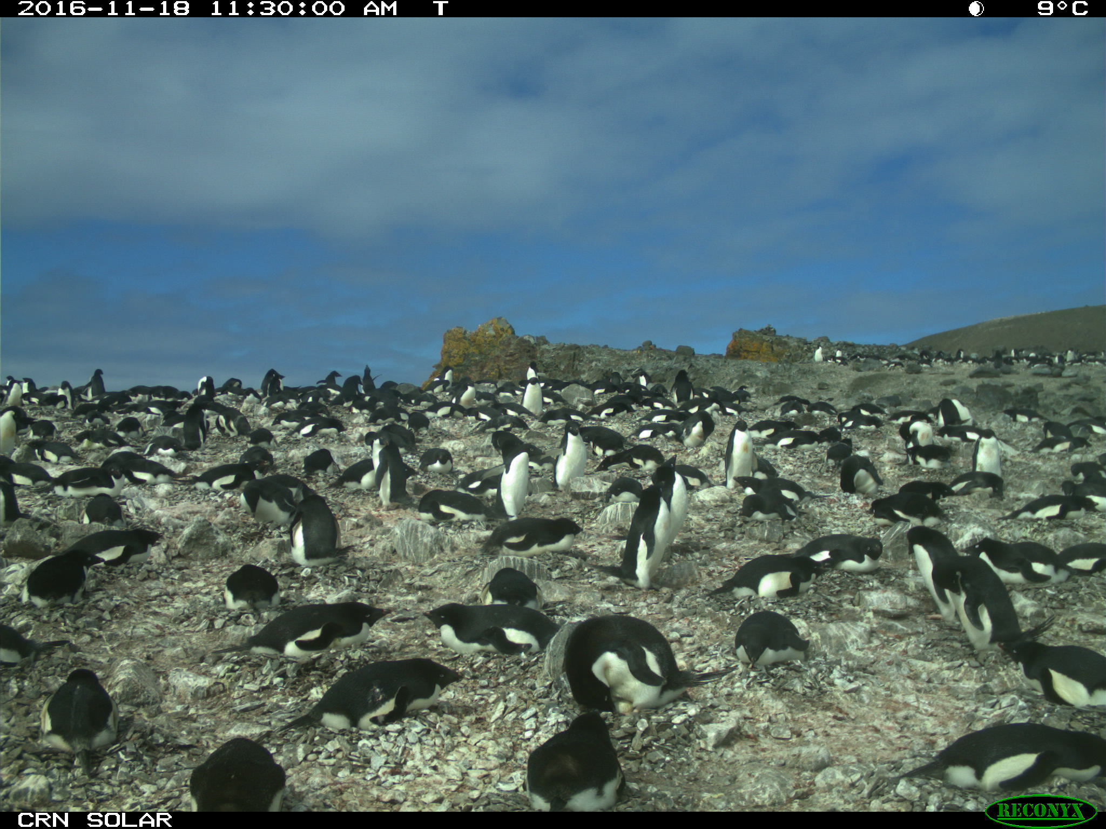
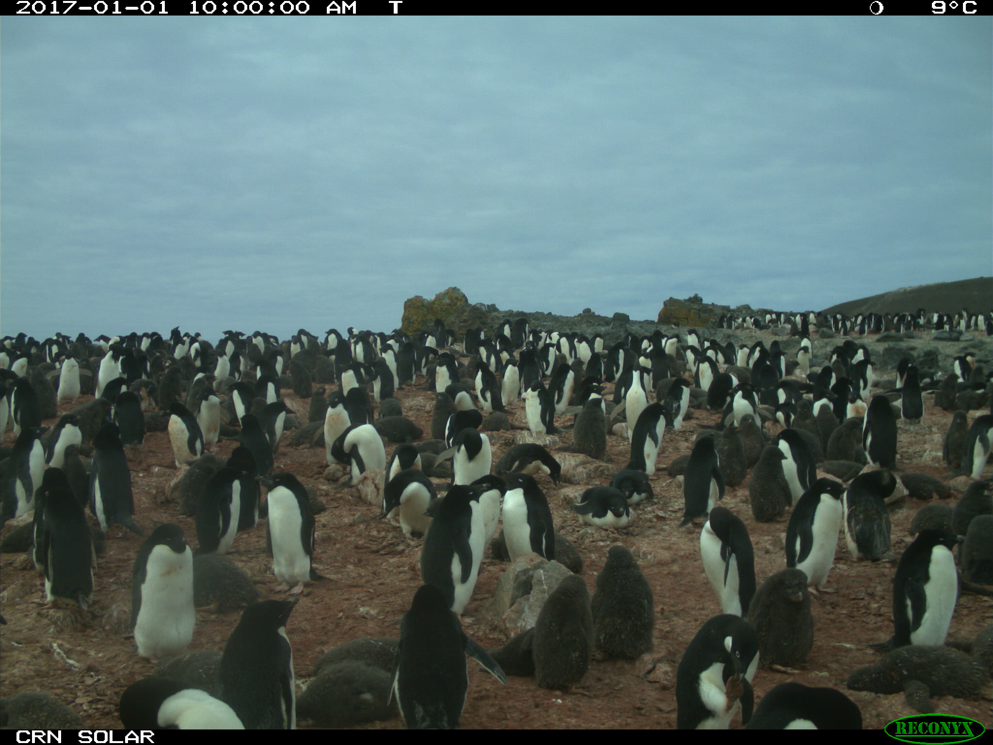
Fig. S3. Example photograph from the Castle Rocks North camera at the Copacabana colony during the crèche period for Adélie penguins. Nests structure is lost, most chicks are attended by an adult, but several nests are clearly unattended and a crèche of chicks are beginning to form (red star).
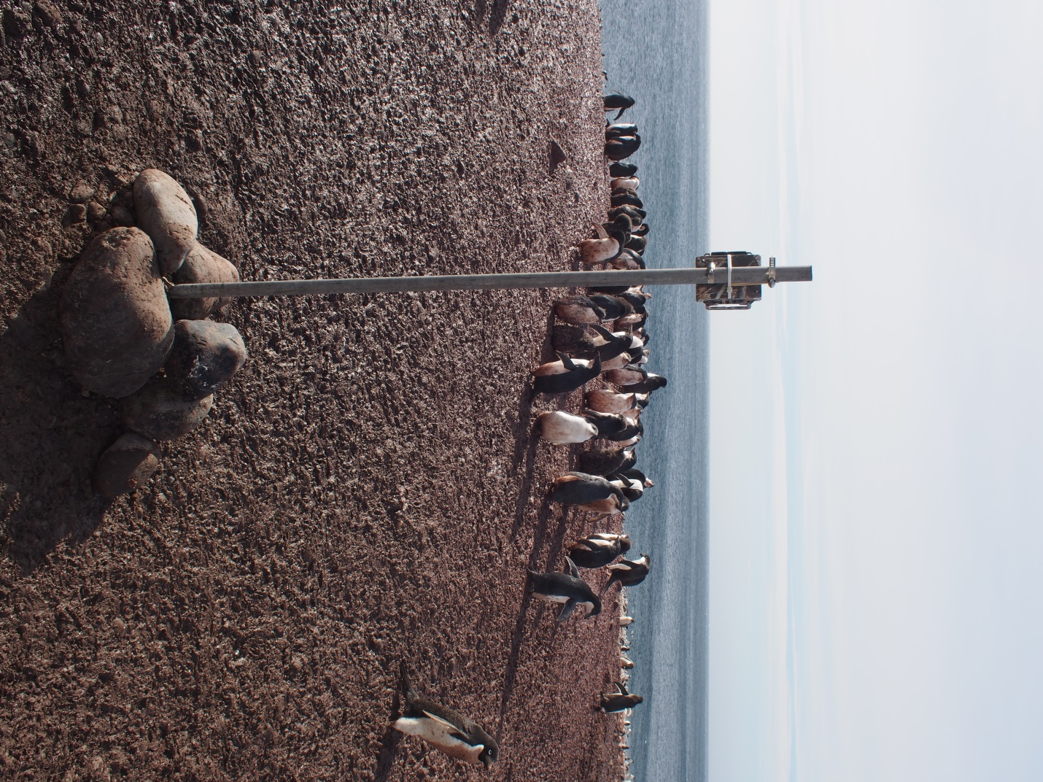
Fig. S4. Example time-lapse camera deployment. In this image crèche is well developed and Adélie penguin chicks have largely lost all fluffy down. Neither colony edge nor nest bowls are obvious at this stage. Photograph from Copacabana colony, King George Island. Photo credit: J Hinke, NOAA.
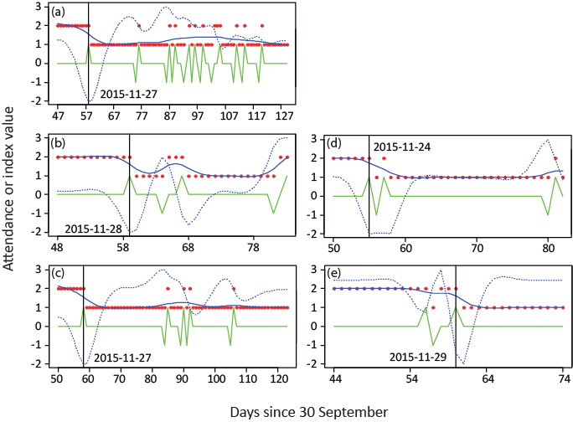
Fig. S5. Adult-attendance data (red dots) from chinstrap penguins at Cape Shirreff, Livingston Island, smoothing spline (solid blue line), derivative of smoother (dashed blue line; note that this is re-scaled for illustration purposes), differenced index of shift in nest attendance (green line), and estimated switch date (vertical black line) for 5 nests in the calibration study. The estimated switch date is printed on each panel. Differences in duration of each data series reflect nest success; adult attendance is not monitored beyond the fail date. The photographic record of adult attendance varies from abrupt (a-c) to gradual (d-e) shifts in attendance.
Appendix S1. Input data, R code for estimating nest-level phenology and reproductive success from daily observations of adult attendance and nest contents, and example output.

Input Data

Two data files containing daily nest attendance and the daily observations of nests contents are necessary to run the get_phenoloyg.r function in R (R Core Team 2016), detailed below. Using standard R functions, we briefly describe the necessary formats of those data.

The nest attendance, which we have imported to R with the name ‘attendance’ for use in the ‘get_phenology’ function, is stored as a data.frame. Missing and unknown data entries are entered as NA. The attendance data have the following structure:

> str(attendance)
'data.frame': 1165 obs. of 8 variables:
$ YEAR : chr "2016-17" "2016-17" "2016-17" "2016-17" ...
$ ROOKERY: chr "CS" "CS" "CS" "CS" ...
$ COLONY : int 3 3 3 3 3 3 3 3 3 3 ...
$ CAMERA : chr "3_1" "3_1" "3_1" "3_1" ...
$ SPP : int 3 3 3 3 3 3 3 3 3 3 ...
$ NEST : int 1 1 1 1 1 1 1 1 1 1 ...
$ DATE : POSIXct, format: "2016-11-15" "2016-11-16" "2016-11-17" ...
$ MAXN : int 2 2 2 2 2 2 2 2 2 1 ...

The data are stored as a simple data.frame with all fields populated. The first 10 rows are displayed below.

>head(attendance, n=10)

YEAR | ROOKERY | COLONY | CAMERA | SPP | NEST | DATE | MAXN
2016-17 | CS | 3 | 3_1 | 3 | 1 | 11/15/2016 | 2
2016-17 | CS | 3 | 3_1 | 3 | 1 | 11/16/2016 | 2
2016-17 | CS | 3 | 3_1 | 3 | 1 | 11/17/2016 | 2
2016-17 | CS | 3 | 3_1 | 3 | 1 | 11/18/2016 | 2
2016-17 | CS | 3 | 3_1 | 3 | 1 | 11/19/2016 | 2
2016-17 | CS | 3 | 3_1 | 3 | 1 | 11/20/2016 | 2
2016-17 | CS | 3 | 3_1 | 3 | 1 | 11/21/2016 | 2
2016-17 | CS | 3 | 3_1 | 3 | 1 | 11/22/2016 | 2
2016-17 | CS | 3 | 3_1 | 3 | 1 | 11/23/2016 | 2
2016-17 | CS | 3 | 3_1 | 3 | 1 | 11/24/2016 | 1

The second necessary data set is from the daily observations of nest contents, which we have named ‘repro’. This is also imported into R from a simple spreadsheet and has the following structure:

> str(repro)
'data.frame': 505 obs. of 13 variables:
$ YEAR : chr "2016-17" "2016-17" "2016-17" "2016-17" ...
$ ROOKERY : chr "CS" "CS" "CS" "CS" ...
$ SPP : int 3 3 3 3 3 3 3 3 3 3 ...
$ COLONY : int 3 3 3 3 3 3 3 3 3 3 ...
$ CAMERA : chr "3_1" "3_1" "3_1" "3_1" ...
$ NEST : int 1 1 1 1 1 1 1 1 1 1 ...
$ DATE : POSIXct, format: "2016-11-15" "2016-11-19" "2016-11-23" "2016-11-24" ...
$ COPULATION: int NA NA NA NA NA NA NA NA NA NA ...
$ LAY : int NA NA NA NA NA NA NA NA NA NA ...
$ MAXE : int 0 1 1 1 1 NA NA NA NA NA ...
$ HATCH : int NA NA NA NA NA NA NA NA NA NA ...
$ MAXC : int NA NA NA NA NA 1 1 1 1 1 ...
$ CRECHE : int NA NA NA NA NA NA NA NA NA NA ...

Here, fields with missing observations are filled with NA. The data are stored as a simple data.frame with all fields populated. The first 10 rows are displayed below. Several features are worth noting. The record for this nest begins on the date when an empty nest was confirmed. Observations of eggs (MAXE) are noted only on the dates when photographic evidence confirms presence of the egg, likewise for chicks. For example, the first egg was seen on 19 November. The first chick was not seen until 23 December and then not again until 27 Dec.

>head(repro, n=10)

YEAR | ROOKERY | SPP | COLONY | CAMERA | NEST | DATE | COPULATION | LAY | MAXE | HATCH | MAXC | CRECHE
2016-17 | CS | 3 | 3 | 3_1 | 1 | 11/15/2016 | NA | NA | 0 | NA | NA | NA
2016-17 | CS | 3 | 3 | 3_1 | 1 | 11/19/2016 | NA | NA | 1 | NA | NA | NA
2016-17 | CS | 3 | 3 | 3_1 | 1 | 11/23/2016 | NA | NA | 1 | NA | NA | NA
2016-17 | CS | 3 | 3 | 3_1 | 1 | 11/24/2016 | NA | NA | 1 | NA | NA | NA
2016-17 | CS | 3 | 3 | 3_1 | 1 | 11/28/2016 | NA | NA | 1 | NA | NA | NA
2016-17 | CS | 3 | 3 | 3_1 | 1 | 12/23/2016 | NA | NA | NA | NA | 1 | NA
2016-17 | CS | 3 | 3 | 3_1 | 1 | 12/27/2016 | NA | NA | NA | NA | 1 | NA
2016-17 | CS | 3 | 3 | 3_1 | 1 | 12/28/2016 | NA | NA | NA | NA | 1 | NA
2016-17 | CS | 3 | 3 | 3_1 | 1 | 12/29/2016 | NA | NA | NA | NA | 1 | NA
2016-17 | CS | 3 | 3 | 3_1 | 1 | 12/31/2016 | NA | NA | NA | NA | 1 | NA

Code to process attendance and nest content data

The code we developed to process nest attendance and nest content data is provided, with comments, below.

get_phenology.R

# process attendance data to determine date of clutch completion and age at crèche
get_phenology<-function(dat=attendance, rdat=repro, degf=10){
# attendance is a data frame of attendance data organized with headers to identify SPLIT_YEAR, ROOKERY, COLONY, CAMERA, SPP, NEST, DATE (m/d/y), and MAXN
# repro is a data frame of nest content observations organized with headers to identify SPLIT_YEAR, ROOKERY, SPP, COLONY, CAMERA, NEST,
#DATE, LAY, MAXE, HATCH, MAXC, and CRECHE
#
# require some packages
library(lubridate)
# specify a file name to write out data to the working direction
filename<-"test1.csv"
#
# index set up
#
n.years<-length(unique(dat$YEAR))
years<-unique(dat$YEAR)
#
# exclude dates of crèche (MAXN code = 4) or failure (MAXN code=5) for now
#
dat<-dat[dat$MAXN!=4,]
dat<-dat[dat$MAXN!=5,]
#
# omit NAs from Attendance data, if present
#
dat<-na.omit(dat)
#
# generate additional indices for nest-level analysis
#
n.cameras<-length(unique(dat$CAMERA))
cameras<-unique(dat$CAMERA)
#
# now run estimation for each nest in each camera
#
cid.list<-list()
repro.list<-list()
info<-list()
#
# specify correction factors - these are Egg lay interval and incubation interval data, in days, derived from the chronology data set available with the paper
# in the matrix, row 1 is for Adélie, row 2 is gentoo, and row 3 is chinstraps. Column 1 is the corrected Egg1-Egg2 interval, Column 2 is the Egg1 to Chick1 incubation interval
#
xfactors<-matrix(c(3.172885, 36.44776, 2.419168,37.4352, 2.400504, 36.68471), ncol=2, byrow=TRUE)
#
# loop over each camera
#
for(i in 1:n.cameras){
#
# create space for data for nest-level data within camera
#
cam.dat<-dat[dat$CAMERA==cameras[i],]
cam.rdat<-rdat[rdat$CAMERA==cameras[i],]
n.nests<-length(unique(cam.dat$NEST))
nests<-unique(cam.dat$NEST)
switch.out<-numeric(n.nests)
lay.dates<-numeric()
hatch.dates<-numeric()
eobs.dates<-numeric()
eobs1.dates<-numeric()
xfac.out<-data.frame(E1E2=NA, E1C1=NA)
repro.out<-matrix(0, nrow=n.nests, ncol=7)
#
# loop over each nest within camera
#
for(j in 1:n.nests){
nest.dat<-cam.dat[cam.dat$NEST==nests[j],]
nest.rdat<-cam.rdat[cam.rdat$NEST==nests[j],]
#
# pull out the species code for proper estimation of the correction factors
#
Spec<-unique(nest.dat$SPP)
xfac<-xfactors[Spec,]
xfac.out<-rbind(xfac.out,xfac)
#
# first compute CID and HATCH Dates
#
if(dim(nest.dat)[1]>4 & max(nest.dat$MAXN, na.rm=TRUE)==2){
# can only use a spline if you have more than 4 data points & you have some observations of 2 birds on the nest
tt.spline<-smooth.spline(nest.dat$DATE, nest.dat$MAXN, df=degf)
# derive the first derivative of the spline
pred.spline1<-predict(tt.spline, x=tt.spline$x, deriv=1)
# specify conditions on spline data for picking the switch date
#
# conditions set here are that the switch data should occur when nest goes from 2 to 1, so the only days with that transition are included
xx<-pred.spline1$x
yy<-pred.spline1$y
z<-c(nest.dat$MAXN[-1],1) # lags yy by one and finishes the observation with an arbitrary observation of 1 adult on the nest
zz<-nest.dat$MAXN-z
ttt<-data.frame(x=xx, y=yy, z=zz)
#
# bit to examine only initial 6 weeks of data, since the switch generally occurs within the first few weeks of observations
if(dim(ttt)[1]>42){
# for longer time series that are cut to 42 days
ttt<-ttt[1:42,] # CID should occur within first few weeks of attendance data collection
if(max(ttt$y==1)){
# no observations of 2 adults on the nest precludes estimation based on attendance.
switch.out[j]<-NA
switch<-NA
} else {
# where there are observations of 2 adults in the window
ttt<-ttt[ttt$z==1,] # force switch to occur when observation changes from 2 to 1
if(dim(ttt)[1]>0){
switch<-ttt$x[ttt$y==min(ttt$y)] # select minimum slope
#
# format switch value as date
switch<-as.POSIXct(as.Date(switch/(60*60*24), origin="1970-1-1"))
# ADD IN CHECK TO SEE IF EARLIEST EGG OBS OCCURS BEFORE THE ESTIMATED switch. IF SO, USE THAT AS THE ESTIMATED CID
# First, check if a LAY date is confirmed
lay.dat<-na.omit(nest.rdat$DATE[nest.rdat$LAY==1])
if(length(lay.dat)>0){
lay.date<-min(na.omit(lay.dat))
lay.dates[j]<-lay.date
} else {
lay.dates[j]<-NA
}
# Also check to see if hatch date is confirmed
hatch.dat<-na.omit(nest.rdat$DATE[nest.rdat$HATCH==1])
if(length(hatch.dat)>0){
hatch.date<-min(na.omit(hatch.dat))
hatch.dates[j]<-hatch.date
} else {
hatch.dates[j]<-NA
}
eobs.dat<-na.omit(nest.rdat$DATE[nest.rdat$MAXE>0])
if(length(eobs.dat>0)){
eobs.dates[j]<-min(eobs.dat)
eobs1.dates[j]<-min(eobs.dat)
} else {
# if no egg observations were made, add 10 days to the estimated CID(switch date)
# note that the above addition of 10 days is as a placeholder only to simplify later calculations
lay.dates[j]<-NA
hatch.dates[j]<-NA
eobs.dates[j]<-switch+10*60*60*24
eobs1.dates[j]<-NA
}
#
switch.out[j]<-switch
} else {
switch.out[j]<-NA
lay.dates[j]<-NA
hatch.dates[j]<-NA
eobs.dates[j]<-NA
eobs1.dates[j]<-NA
}
}
} else {
if(max(ttt$y==1)){
# no observations of 2 adults on the nest precludes estimation based on attendance.
switch.out[j]<-NA
lay.dates[j]<-NA
hatch.dates[j]<-NA
eobs.dates[j]<-NA
eobs1.dates[j]<-NA
switch<-NA
} else {
# for any record shorter than 42 days
ttt<-ttt[ttt$z==1,] # force switch to occur when observation goes from 2 to 1
switch<-ttt$x[ttt$y==min(ttt$y)] # select minimum slope
#
# format switch value as date
switch<-as.POSIXct(as.Date(switch/(60*60*24), origin="1970-1-1"))
#
switch.out[j]<-switch
#
# ADD IN CHECK TO SEE IF EARLIEST EGG OBS OCCURS BEFORE THE ESTIMATED CID. IF SO, USE THAT AS THE ESTIMATED CID
# First, check if a LAY date is confirmed
lay.dat<-na.omit(nest.rdat$DATE[nest.rdat$LAY==1])
if(length(lay.dat)>0){
lay.date<-min(na.omit(lay.dat))
lay.dates[j]<-lay.date
} else {
lay.dates[j]<-NA
}
# Also check to see if hatch date is confirmed
hatch.dat<-na.omit(nest.rdat$DATE[nest.rdat$HATCH==1])
if(length(hatch.dat)>0){
hatch.date<-min(na.omit(hatch.dat))
hatch.dates[j]<-hatch.date
} else {
hatch.dates[j]<-NA
}
eobs.dat<-na.omit(nest.rdat$DATE[nest.rdat$MAXE>0])
if(length(eobs.dat>0)){
eobs.dates[j]<-min(eobs.dat)
eobs1.dates[j]<-min(eobs.dat)
} else {
# if no egg observations were made, add 10 days to the estimated CID(switch date)
eobs.dates[j]<-switch+10*60*60*24
eobs1.dates[j]<-NA
}
}
}
} else {
# for any data set with too few points for estimating a spline
switch.out[j]<-NA
lay.dates[j]<-NA
hatch.dates[j]<-NA
eobs.dates[j]<-NA
eobs1.dates[j]<-NA
print(paste("Not enough data to estimate CID with spline for camera ", cameras[i], " nest ", nests[j], sep=""))
}
#
# now compute nest level success/failure
eggs<-na.omit(nest.rdat$MAXE)
if(length(eggs)>0){
max.egg<-max(eggs)
} else {
max.egg<-0
}
#
chicks<-na.omit(nest.rdat$MAXC)
if(length(chicks)>0){
max.chick<-max(chicks)
} else {
max.chick<-0
}
#
creche<-na.omit(nest.rdat$CRECHE)
if(length(creche)>0){
max.creche<-max(creche)
} else {
max.creche<-0
}
# now deal with dates for specific observations of ACTUAL LAY
obs.lay<-na.omit(data.frame(date=nest.rdat$DATE, lay=nest.rdat$LAY))
if(dim(obs.lay)[1]>0){
observed.lay<-min(obs.lay$date, na.rm=TRUE)
} else {
observed.lay<-NA
}
#
obs.hatch<-na.omit(data.frame(date=nest.rdat$DATE, hatch=nest.rdat$HATCH))
if(dim(obs.hatch)[1]>0){
observed.hatch<-min(obs.hatch$date, na.rm=TRUE)
} else {
observed.hatch<-NA
}
#
obs.creche<-na.omit(data.frame(date=nest.rdat$DATE, creche=nest.rdat$CRECHE))
if(dim(obs.creche)[1]>0){
observed.creche.date<-min(obs.creche$date, na.rm=TRUE)
} else {
observed.creche.date<-NA
}
spp<-nest.rdat$SPP[1]
#
repro.out[j,]<-c(spp, max.egg, max.chick, max.creche, observed.lay, observed.hatch, observed.creche.date)
}
#
# now apply corrections to the estimated clutch completion date to get estimated CID and HATCH dates based on repro data
xfac.out<-na.omit(xfac.out)
CID<-switch.out-(xfac.out[,1]*(60*60*24))
JCID<-as.POSIXct(as.Date(CID/(60*60*24), origin="1970-1-1"))
JCID<-lubridate::yday(JCID)
# ensure the JCID is continuous over the new year
# first get the last day of the year (assuming only data from one field season are used)
Ndays<-max(JCID)
JCID<-ifelse(JCID<100, JCID+Ndays, JCID)
ORIG.CID<-CID
# now replace estimated CID with observed CID if observation of egg was before estimated CID
j.eobs.dates<-as.POSIXct(as.Date(eobs.dates/(60*60*24), origin="1970-1-1"))
j.eobs.dates<-lubridate::yday(j.eobs.dates)
# ensure the j.eobs.dates is continuous over the new year
j.eobs.dates<-ifelse(j.eobs.dates<100, j.eobs.dates+Ndays, j.eobs.dates)
CIDcheck<-j.eobs.dates<JCID # if an egg observation date occurs before estimated CID, identify those records as TRUE
# note that, on average, the first observation of an egg in the nest occurs, on average, about 2 days after lay, based on our validation data
# this allows use of first egg observation as a proxy for clutch completion
CID<-ifelse(CIDcheck, eobs.dates-2*(60*60*24), CID)
type<-ifelse(CIDcheck, "Cor", "Est")
orig.switch<-ifelse(CIDcheck, switch.out, NA)
# now, if a lay date was confirmed in the photo repro, use the observed lay date rather than the estimated CID
lay.index<-!is.na(lay.dates>1)
CID<-ifelse(lay.index, lay.dates, CID)
type<-ifelse(lay.index, "Cor", type)
# also, correct switch date if CID was corrected
orig.switch<-ifelse(lay.index, switch.out, orig.switch)
switch.index<-type=="Est"
switch.new<-ifelse(switch.index, switch.out, CID+xfac.out[,1]*(60*60*24))
#
HATCH<-CID+(xfac.out[,2]*(60*60*24)) # based on mean time from E1 to C1
JHATCH<-as.POSIXct(as.Date(HATCH/(60*60*24), origin="1970-1-1"))
JHATCH<-lubridate::yday(JHATCH)
JHATCH<-ifelse(JHATCH<300, 366+JHATCH,JHATCH) # make sure January hatches are correctly coded
# Now correct hatch if observed hatch occurred prior to estimated hatch
j.hatch.dates<-as.POSIXct(as.Date(hatch.dates/(60*60*24), origin="1970-1-1"))
j.hatch.dates<-lubridate::yday(j.hatch.dates)
# ensure j.hatch.dates are continuous over the new year
j.hatch.dates<-ifelse(j.hatch.dates<100, j.hatch.dates+Ndays, j.hatch.dates)
hatch.index<-j.hatch.dates<JHATCH
hatch.index<-ifelse(is.na(hatch.index), FALSE, hatch.index) # make sure January hatches are correctly coded
HATCH<-ifelse(hatch.index, hatch.dates, HATCH)
type<-ifelse(hatch.index, "Cor", type)
ORIG.CID<-ifelse(type=="Est", NA, ORIG.CID)
out<-data.frame(Type=type, Orig_Switch=as.Date(orig.switch/(60*60*24), origin="1970-1-1"), Orig_CID=as.Date(ORIG.CID/(60*60*24), origin="1970-1-1"), Switch=as.Date(switch.new/(60*60*24), origin="1970-1-1"), CID=as.Date(CID/(60*60*24), origin="1970-1-1"),HATCH=as.Date(HATCH/(60*60*24), origin="1970-1-1"), EOBS=as.Date(eobs1.dates/(60*60*24),origin="1970-1-1"))
repro.df<-data.frame(repro.out)
cid.list[[i]]<-out
repro.list[[i]]<-repro.out
which.year<-unique(cam.dat$YEAR)
year<-rep(which.year, n.nests)
cam<-rep(cameras[i], n.nests)
hinfo<-data.frame(YEAR=year, CAMERA=cam, NEST=nests)
info[[i]]<-hinfo
}
names(info)<-cameras
names(cid.list)<-cameras
names(repro.list)<-cameras
#
# now append crèche date and reproductive success data
cid<-do.call("rbind", cid.list)
repro<-do.call("rbind", repro.list)
headers<-do.call("rbind", info)
#
out<-cbind(cid, repro)
names(out)<-c("TYPE", "ORIG_SWITCH", "ORIG_CID", "SWITCH","CID", "HATCH", "1stEOBS", "SPP", "EGGS","CHICKS","CRECHE","OBS.LAY.DATE", "OBS.HATCH.DATE", "CRECHE.DATE")
out<-cbind(headers, out)
# convert dates to Date objects
out$OBS.LAY.DATE<-as.Date(out$OBS.LAY.DATE/(60*60*24), origin="1970-1-1")
out$OBS.HATCH.DATE<-as.Date(out$OBS.HATCH.DATE/(60*60*24), origin="1970-1-1")
out$CRECHE.DATE<-as.Date(out$CRECHE.DATE/(60*60*24), origin="1970-1-1")
out$CRECHE.AGE<-out$CRECHE.DATE-out$HATCH
#
# now remove estimates of hatch and crèche dates for nest where no chicks were hatched and/or crèched
out$HATCH<-ifelse(out$CHICKS>0, out$HATCH, NA)
out$CRECHE.DATE<-ifelse(out$CRECHE>0, out$CRECHE.DATE, NA)
out$HATCH<-as.Date(out$HATCH, origin="1970-1-1")
out$CRECHE.DATE<-as.Date(out$CRECHE.DATE, origin="1970-1-1")
#print(filename)
write.csv(out, filename)
return(out)
# end of file
}

Output data

The output file is specified as a comma separated values (.csv) file and saved to the working directory of your R session upon successful completion of the analysis. Here, we illustrate the structure of this file (prior to saving to file) for phenology estimates from Cape Shirreff (cs.result).

> str(cs.result)
'data.frame': 18 obs. of 18 variables:
$ YEAR : Factor w/ 1 level "2016-17": 1 1 1 1 1 1 1 1 1 1 ...
$ CAMERA : Factor w/ 4 levels "3_1","3_2","23-1",..: 1 1 1 1 1 2 2 2 2 2 ...
$ NEST : int 1 2 3 4 5 1 2 3 4 5 ...
$ TYPE : Factor w/ 2 levels "Cor","Est": 1 2 2 2 2 1 2 1 2 1 ...
$ ORIG_SWITCH : Date, format: "2016-11-25" NA NA ...
$ ORIG_CID : Date, format: "2016-11-22" NA NA ...
$ SWITCH : Date, format: "2016-11-20" "2016-11-21" "2016-11-23" ...
$ CID : Date, format: "2016-11-17" "2016-11-18" "2016-11-20" ...
$ HATCH : Date, format: "2016-12-24" "2016-12-25" NA ...
$ 1stEOBS : Date, format: "2016-11-19" "2016-11-18" "2016-11-21" ...
$ SPP : num 3 3 3 3 3 3 3 3 3 3 ...
$ EGGS : num 1 2 2 1 1 1 2 2 1 2 ...
$ CHICKS : num 1 2 0 2 2 2 2 0 0 2 ...
$ CRECHE : num 1 2 0 2 2 2 2 0 0 2 ...
$ OBS.LAY.DATE : Date, format: NA NA NA ...
$ OBS.HATCH.DATE: Date, format: NA NA NA ...
$ CRECHE.DATE : Date, format: "2017-01-27" "2017-01-27" NA ...
$ CRECHE.AGE :Class 'difftime' atomic [1:18] 33.8 32.7 NA 22.7 27.7 ...
.. ..- attr(*, "units")= chr "days"

The estimated switch, lay, hatch and crèche dates are identified by the headers “SWITCH”, “CID”, “HATCH”, and “CRECHE.DATE”, respectively. If nest content observations force a correction of the estimated phenological dates, the header “TYPE” will be “Cor” or “Est”, if not corrected. The file also contains several data summaries that are pulled from the input files for each nest. These include the maximum number of eggs (EGGS), chicks (CHICKS), and number crèched (CRECHE), as well as any dates that were marked as observed true lay (OBS.LAY.DATE) and hatch dates (OBS.HATCH.DATE). Finally, CRECHE.AGE is a derived quantity to express the difference, in days, between hatch and crèche. Further information on the output file is available with the data made available with this paper.
References
R Core Team (2016). R: A language and environment for statistical computing. R Foundation for Statistical Computing, Vienna, Austria. https://www.R-project.org

