Supplemental Information

Table 1. Sample collection data, and stable isotope values for bulk tissues for Thunnus albacares (T.a.), Katsuwonus pelamis (K.p.), Thunnus obsesus (T.o.), Dosidicus gigas (D.g.), Sthenoteuthis oualaniensis (S.o.), Myctophum nitidulum (M.n.), Symbolophorus reversus (S.r.), Euphausia distinguenda (E.d.), and Euphausia tenera (E.t.). Mean values were calculated for replicate samples of the tunas and myctophids from a subset of stations that were analyzed for within location variability. NA = not applicable. See Methods for more details on within- location replicate samples.
Sample No. | Sample Date | Latitude | Longitude | Size (mm) | Replicate | δ¹⁵N (Mean)
Ta-1 | 6/1/2004 | 3.43ᵒN | 118.53ᵒW | 662 | 1 | 13.5
Ta-2 | 7/23/2004 | 1.87ᵒN | 139.82ᵒW | 580 | 1 | 14.6 (14.1)
Ta-3 | 7/23/2004 | 1.87ᵒN | 139.82ᵒW | 570 | 2 | 14.3 (14.1)
Ta-4 | 7/23/2004 | 1.87ᵒN | 139.82ᵒW | 570 | 3 | 13.4 (14.1)
Ta-5 | 6/25/2004 | 3.65ᵒN | 107.08ᵒW | 615 | 1 | 13.6
Ta-6 | 9/29/2004 | 4.55ᵒN | 111.97ᵒW | 630 | 1 | 13.8
Ta-7 | 9/17/2004 | 4.08ᵒN | 127.65ᵒW | 640 | 1 | 14.4
Ta-8 | 2/10/2005 | 8.90ᵒN | 99.67ᵒW | 640 | 1 | 12.5
Ta-9 | 2/27/2005 | 6.38ᵒN | 92.57ᵒW | 670 | 1 | 12.8 (13.5)
Ta-10 | 2/27/2005 | 6.38ᵒN | 92.57ᵒW | 530 | 2 | 13.8 (13.5)
Ta-11 | 2/27/2005 | 6.38ᵒN | 92.57ᵒW | 540 | 3 | 14.0 (13.5)
Ta-12 | 7/5/2005 | 1.05ᵒS | 126.10ᵒW | 619 | 1 | 8.1
Ta-13 | 6/23/2004 | 2.95ᵒS | 108.45ᵒW | 565 | 1 | 8.8
Ta-14 | 1/15/2005 | 4.18ᵒS | 111.35ᵒW | 553 | 1 | 8.7
Kp-1 | 7/23/2004 | 1.87ᵒN | 139.82ᵒW | 500 | 1 | 13.8 (11.8)
Kp-2 | 7/23/2004 | 1.87ᵒN | 139.82ᵒW | 490 | 2 | 10.8 (11.8)
Kp-3 | 7/23/2004 | 1.87ᵒN | 139.82ᵒW | 510 | 3 | 10.8 (11.8)
Kp-4 | 7/10/2004 | 6.02ᵒN | 99.12ᵒW | 432 | 1 | 12.9
Kp-5 | 8/6/2004 | 8.85ᵒN | 106.93ᵒW | 502 | 1 | 14.4
Kp-6 | 9/29/2004 | 4.55ᵒN | 111.97ᵒW | 500 | 1 | 11.6
Kp-7 | 9/14/2004 | 3.60ᵒN | 119.62ᵒW | 510 | 1 | 11
Kp-8 | 9/17/2004 | 4.08ᵒN | 127.65ᵒW | 490 | 1 | 10.6
Kp-9 | 1/13/2005 | 4.35ᵒN | 105.65ᵒW | 480 | 1 | 12.5
Kp-10 | 2/27/2005 | 6.38ᵒN | 92.57ᵒW | 480 | 2 | 13.0 (12.8)
Kp-11 | 2/27/2005 | 6.38ᵒN | 92.57ᵒW | 470 | 3 | 13.0 (12.8)
Kp-12 | 2/27/2005 | 6.38ᵒN | 92.57ᵒW | 470 | 1 | 12.5 (12.8)
Kp-13 | 7/5/2005 | 1.05ᵒS | 126.10ᵒW | 510 | 1 | 8.3
To-1 | 10/15/2003 | 4.70ᵒN | 103.63ᵒW | 423 | 1 | 13.7 (13.9)
To-2 | 10/15/2003 | 4.70ᵒN | 103.63ᵒW | 424 | 2 | 13.7 (13.9)
To-3 | 10/15/2003 | 4.70ᵒN | 103.63ᵒW | 438 | 3 | 14.2 (13.9)
To-4 | 3/17/2004 | 4.48ᵒN | 130.00ᵒW | 438 | 1 | 13.8
To-5 | 5/23/2004 | 5.27ᵒN | 125.52ᵒW | 506 | 1 | 13.3
To-6 | 7/23/2004 | 1.87ᵒN | 139.82ᵒW | 540 | 1 | 12.5 (12.8)
To-7 | 7/23/2004 | 1.87ᵒN | 139.82ᵒW | 520 | 2 | 12.9 (12.8)
To-8 | 7/23/2004 | 1.87ᵒN | 139.82ᵒW | 530 | 3 | 13.1 (12.8)
To-9 | 6/23/2004 | 2.95ᵒS | 108.45ᵒW | 517 | 1 | 10.9
To-10 | 6/27/2004 | 5.13ᵒN | 110.00ᵒW | 503 | 1 | 13.6
To-11 | 7/1/2004 | 1.55ᵒN | 113.42ᵒW | 466 | 1 | 12
To-12 | 9/14/2004 | 3.60ᵒN | 119.62ᵒW | 500 | 1 | 12.1
To-13 | 1/12/2005 | 6.78ᵒN | 105.23ᵒW | 500 | 1 | 13.4
To-14 | 1/15/2005 | 4.18ᵒS | 111.35ᵒW | 511 | 1 | 8.7
To-15 | 7/5/2005 | 1.05ᵒS | 126.10ᵒW | 452 | 1 | 12.6
Dg-1 | 10/17/2006 | 8.73ᵒN | 108.05ᵒW | 98 | 1 | 13.4
Dg-2 | 10/17/2006 | 8.73ᵒN | 108.05ᵒW | 148 | 1 | 14.7
Dg-3 | 10/12/2006 | 8.20ᵒN | 100.19ᵒW | 225 | 1 | 14.8
Dg-4 | 10/5/2006 | 9.03ᵒN | 93.06ᵒW | 197 | 1 | 13.3
Dg-5 | 10/5/2006 | 9.03ᵒN | 93.06ᵒW | 193 | 1 | 13.2
Dg-6 | 9/22/2006 | 6.23ᵒN | 90.91ᵒW | 167 | 1 | 12.6
Dg-7 | 9/21/2006 | 8.38ᵒN | 89.48ᵒW | 155 | 1 | 12.9
Dg-8 | 9/21/2006 | 8.38ᵒN | 89.48ᵒW | 159 | 1 | 12.5
So-1 | 8/27/2006 | 7.25ᵒN | 101.37ᵒW | 125 | 1 | 13.4
So-2 | 9/22/2006 | 6.23ᵒN | 90.91ᵒW | 113 | 1 | 11.7
So-3 | 9/20/2006 | 10.38ᵒN | 87.68ᵒW | 105 | 1 | 13.7
Mn-1 | 8/25/2006 | 5.65ᵒN | 108.00ᵒW | 53 | 1 | 12.1 (12.3)
Mn-2 | 8/25/2006 | 5.65ᵒN | 108.00ᵒW | 59 | 2 | 12.4 (12.3)
Mn-3 | 9/15/2006 | 0.23ᵒN | 119.92ᵒW | 57 | 1 | 7.6
Mn-4 | 8/29/2006 | 7.07ᵒN | 95.32ᵒW | 54 | 1 | 9.6
Mn-5 | 9/10/2006 | 4.48ᵒN | 134.73ᵒW | 50 | 1 | 12.2
Mn-6 | 9/12/2006 | 6.83ᵒN | 80.83ᵒW | 54 | 1 | 11.5
Mn-7 | 9/22/2006 | 6.23ᵒN | 90.90ᵒW | 44 | 1 | 12.1 (12.1)
Mn-8 | 9/22/2006 | 6.23ᵒN | 90.90ᵒW | 49 | 2 | 11.8 (12.1)
Mn-9 | 9/22/2006 | 6.23ᵒN | 90.90ᵒW | 43 | 3 | 12.4 (12.1)
Mn-10 | 10/28/2006 | 5.02ᵒN | 113.58ᵒW | 57 | 1 | 10.3
Mn-11 | 9/19/2006 | 1.90ᵒS | 107.58ᵒW | 58 | 1 | 5.8
Mn-12 | 8/12/2006 | 5.32ᵒN | 122.33ᵒW | 48 | 1 | 11.7
Mn-13 | 10/25/2006 | 2.3ᵒN | 105.25ᵒW | 39 | 1 | 11.4
Sr-10 | 8/24/2006 | 6.07ᵒN | 110.70ᵒW | 53 | 1 | 14.3 (13.9)
Sr-1 | 8/24/2006 | 6.07ᵒN | 110.70ᵒW | 56 | 2 | 13.4 (13.9)
Sr-2 | 9/19/2006 | 1.90ᵒS | 107.58ᵒW | 56 | 1 | 5.6
Sr-3 | 9/13/2006 | 1.83ᵒN | 125.47ᵒW | 65 | 1 | 10.8
Sr-4 | 10/7/2006 | 11.57ᵒN | 94.22ᵒW | 73 | 1 | 11.8
Sr-5 | 9/8/2006 | 6.30ᵒN | 140.72ᵒW | 63 | 1 | 15.8 (15.4)
Sr-12 | 9/8/2006 | 6.30ᵒN | 140.72ᵒW | 58 | 2 | 14.9 (15.4)
Sr-6 | 9/12/2006 | 6.83ᵒN | 80.83ᵒW | 55 | 1 | 12.2
Sr-7 | 9/23/2006 | 8.37ᵒN | 91.68ᵒW | 56 | 1 | 11.6
Sr-8 | 9/20/2006 | 10.38ᵒN | 87.68ᵒW | 55 | 1 | 11.7 (11.8)
Sr-9 | 9/20/2006 | 10.38ᵒN | 87.68ᵒW | 50 | 2 | 11.8 (11.8)
Sr-11 | 8/26/2006 | 6.48ᵒN | 104.38ᵒW | 53 | 1 | 12.1
Sr-13 | 10/24/2006 | 3.88ᵒN | 102.28ᵒW | 59 | 1 | 12.6
Ed-1 | 8/11/2006 | 3.25ᵒN | 120.03ᵒW | NA | 1 | 8.3
Ed-2 | 8/13/2006 | 7.37ᵒN | 124.68ᵒW | NA | 1 | 15
Ed-3 | 9/11/2006 | 3.49ᵒN | 131.27ᵒW | NA | 1 | 6.4
Ed-4 | 10/25/2006 | 2.30ᵒN | 105.26ᵒW | NA | 1 | 5
Ed-5 | 10/27/2006 | 3.36ᵒN | 110.85ᵒW | NA | 1 | 9
Ed-6 | 10/21/2006 | 9.62ᵒN | 96.48ᵒW | NA | 1 | 10.2
Ed-7 | 10/23/2006 | 5.39ᵒN | 99.53ᵒW | NA | 1 | 9.1
Et-1 | 8/11/2006 | 3.25ᵒN | 120.03ᵒW | NA | 1 | 5.9
Et-2 | 8/13/2006 | 7.37ᵒN | 124.68ᵒW | NA | 1 | 13.7
Et-3 | 9/11/2006 | 3.49ᵒN | 131.27ᵒW | NA | 1 | 4.8
Et-4 | 10/27/2006 | 3.36ᵒN | 110.85ᵒW | NA | 1 | 7.6
Et-5 | 10/21/2006 | 9.62ᵒN | 96.48ᵒW | NA | 1 | 9.3
Et-6 | 10/23/2006 | 5.39ᵒN | 99.53ᵒW | NA | 1 | 9.3

Table 2. Correlation coefficient matrix for oceanographic variables [Cell Diameter (CD), Chlorophyll a (Chla), Nitrate concentration (Nitrate), N*, Phosphate concentration (Phos), Sea-surface height (SSH), Sea-surface temperature (SST), Thermocline depth (TD)] at sampling locations used in this study. Phytoplankton cell diameter was calculated from Chl a and SST, and N* was calculated from nitrate and phosphate concentrations. See Materials and Methods for more details.
 | CD | Chla | Nitrate | N* | Phos | SSH | SST | TD
CD | - | 0.92 | -0.05 | 0.14 | -0.09 | -0.43 | -0.2 | -0.53
Chla | 0.92 | - | 0.3 | -0.16 | 0.27 | -0.51 | -0.2 | -0.49
Nitrate | -0.05 | 0.3 | - | -0.68 | 0.96 | -0.17 | -0.96 | 0.12
N* | 0.14 | -0.16 | -0.68 | - | -0.86 | 0.23 | 0.71 | -0.06
Phos | -0.09 | 0.27 | 0.96 | -0.86 | - | -0.21 | -0.94 | 0.11
SSH | -0.43 | -0.51 | -0.17 | 0.23 | -0.21 | - | 0.1 | 0.84
SST | 0.16 | -0.2 | -0.96 | 0.71 | -0.94 | 0.1 | - | -0.21
TD | -0.53 | -0.49 | 0.12 | -0.06 | 0.11 | 0.84 | -0.21 | -

- Regional oceanography and δ¹⁵N values
We utilized oceanographic data to evaluate relationships between nitrogen isotope values and regional oceanography. See material and methods for more information on data acquisition for nutrient concentrations, N*, and phytoplankton cell size estimates. Monthly mean Chl a data were obtained from monthly, Moderate Resolution Imaging Spectroradiometer (MODIS) Aqua satellite Ocean Color, and were available every 0.1 deg.² throughout our study area. Sea-surface temperature data were from the Advanced Very High Resolution Radiometer (AVHRR) Pathfinder v4.1 and Global Area Coverage (GAC) projects, and were also available every 0.1 deg.². To estimate thermocline depth, we utilized 2005 World Ocean Atlas data and computed the maximum temperature gradient (|ΔT/ Δz|), with ΔT > 2°C or Δz > 10 m, where T is temperature and z is depth and used the midpoint of corresponding interval as the thermocline depth, following the methods of Fiedler and Talley (2006). We used sea-surface height (SSH) data as a proxy for upwelling, which were from monthly, merged-mission data, available every 0.25 deg². across our study area through NOAA’s OceanWatch Program (http://oceanwatch.pifsc.noaa.gov/).
Phosphate and nitrate concentrations (see Materials and Methods section for details on data collection) showed similar spatial patterns, with lower values towards the northern end of our study area, and higher values south of the equator. The denitrification index, N* showed low values, which indicates loss of nitrate relative to phosphate due to denitrification. N* values ranged from -2 to 2 at the surface and -15 to 2 at a depth of 200 m, indicating denitrification. Below the photic zone N* patterns mirrored previously-described patterns of dissolved oxygen concentrations.
The SST data show the well-documented ETP warm pool in the northern portion of our study area, extending westward from the coast, and the cold tongue along the equator and southward. Mean annual (2005) values for surface Chl a concentration and median phytoplankton cell diameter enhanced productivity in regions of upwelling both north and south of the equator, and along the coast, while Chl a concentrations were fairly uniform (< 1 μg L⁻¹) throughout the remainder of our sample region (Fig 1a). Phytoplankton cell diameters computed from Chl a and SST values were overall small, ranging from 1-4 μm, with most values were < 2 um, and generally larger cell sizes in coastal areas.
The TD values indicated the relative deepening of the thermocline from east to west (~40 m to > 150 m) across the ETP (Fig 1b in SI). We found higher SSHs north and south of the equator, in relation to equatorial upwelling (Fig 1c). SSH was greater in the west portion of our study area, which is in agreement with previously documented oceanography in the ETP, where the westward flowing north and south equatorial currents create enhanced SSH in the western Pacific (Fiedler and Talley 2006, Pennington et al. 2006).
In preliminary analyses, we found no significant relationships between δ¹⁵N values and chlorophyll a concentration, sea-surface height, or thermocline depth were observed for any species. For most species, we did not find significant relationships between δ¹⁵N values and phytoplankton cell diameter, with the exception of Thunnus albacares (p = 0.001) and Katsuwonus pelamis (p = 0.008) δ¹⁵N values, which were positively related to phytoplankton cell diameter.

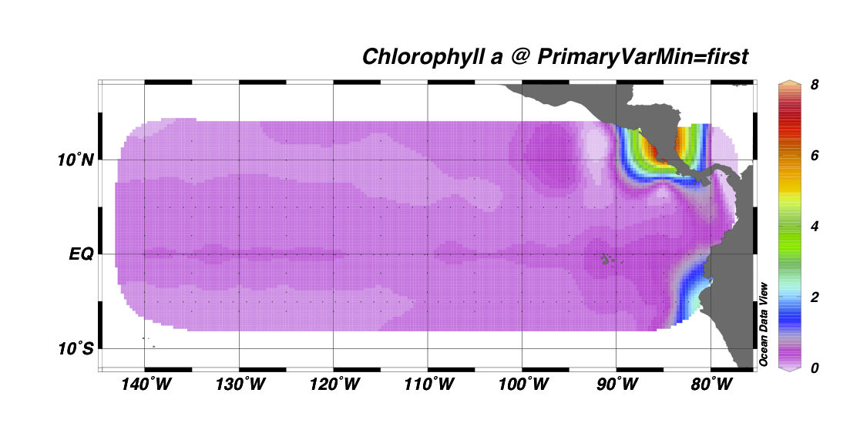
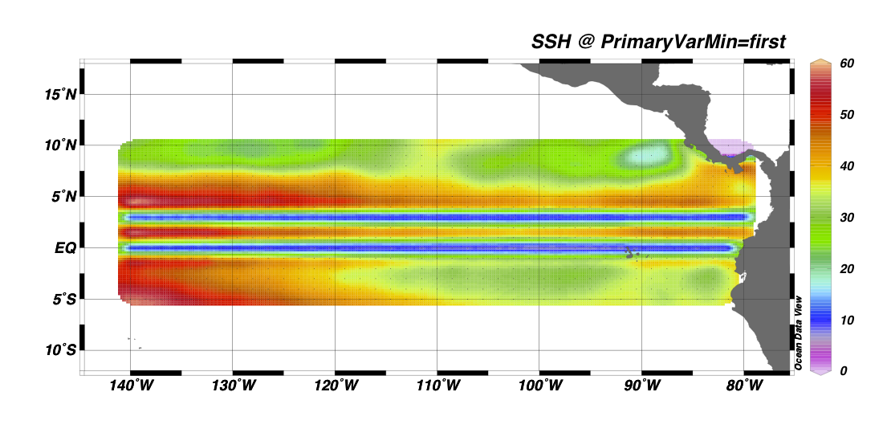
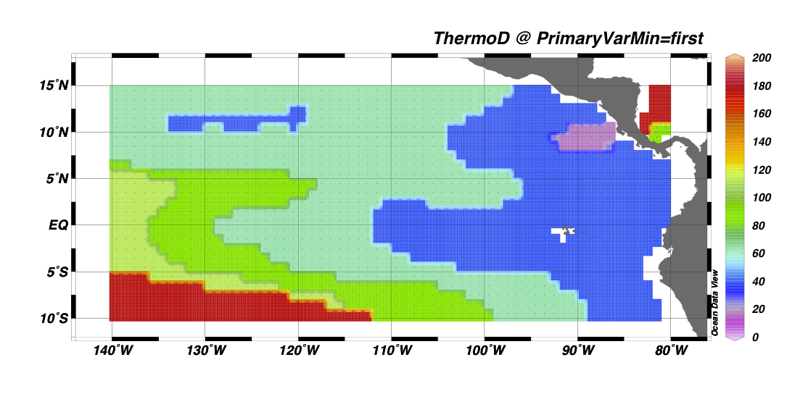
a
b
c

Fig. 1. Maps of a) chlorophyll a (mg/m³), b) estimated thermocline depth (m), and c) sea-surface height (cm) throughout our study area.

