
Water Resources Research
Supporting Information for

Quantifying the Spatial Variability of a Snowstorm Using Differential Airborne Lidar

W. Tyler Brandt^{1,2}, Kat J. Bormann³, Forest Cannon², Jeffrey S. Deems⁴, Thomas H. Painter⁵, Daniel Steinhoff², and Jeff Dozier¹

¹Bren School of Environmental Science & Management, University of California, Santa Barbara, California, USA.
²Center for Western Weather and Water Extremes, Scripps Institution of Oceanography, University of California, San Diego, La Jolla, California, USA.
³Jet Propulsion Laboratory, California Institute of Technology, Pasadena, California, USA.
⁴National Snow and Ice Data Center, Boulder, Colorado, USA.
⁵Joint Institute for Regional Earth System Science and Engineering, University of California, Los Angeles, California, USA.

Contents of this file

Text S1 to S2
Figures S1 to S11
Tables S1 to S5

Introduction
This supplement includes text describing additional research steps taken to investigate snow compaction. In addition, we present figures and tables cited in the main text.

Text S1.
The microphysics schemes in WRF govern precipitation phase, intensity, and distribution. The schemes range in complexity from those that only account for the mixing ratio of certain species of water (i.e. cloud, rain, snow, ice, graupel etc.) to schemes that also account for the number concentration of the particle species. Here, the WRF ensemble consists of individual members using one of the following schemes: (1) Morrison et al. (2009); (2) Thompson et al. (2008); (3) WSM6 (Hong & Lim, 2006) (4) WDM6 (Lim & Hong, 2010); (5) WSM7 (Bae et al., 2019); and (6) WDM7 (Bae et al., 2019).
For the majority of the WRF simulations, we use the YSU PBL scheme (Hong et al., 2006) to represent boundary layer processes and turbulent fluxes. In combination with the Thompson microphysics scheme, these modules are used to create operational forecasts at the Center for Western Weather and Water Extremes (CW3E: http://cw3e.ucsd.edu/). This explicit configuration is named “West-WRF” and has been validated over California for land-falling atmospheric rivers (Martin et al., 2018). However, since the boundary layer schemes also influence the mixing ratios within the microphysics schemes, which impacts the precipitation phase and distribution, we also experimented with two other PBL schemes: (1) MYNN2 (Nakanishi & Niino, 2006); and (2) MYJ (Janjić, 1994). For clarity, Table S5 summarizes the simulations used in this study.
Physics parameterization options shared across all simulations include: (1) the Rapid Radiative Transfer Model for GCMs (RRTMG: Iacono et al., 2008) for both shortwave and longwave spectral bands; (2) the revised MM5 surface layer scheme; (3) the Noah land surface model (Chen & Dudhia, 2001), which has four soil layers and a fractional (mosaic) land-cover distribution for each grid point; (4) the MODIS 30 arcsec 20-category land-use dataset; (5) a USGS 30 arcsec terrain height dataset; and (6) the scale-aware Grell-Freitas convective parameterization scheme (Grell & Freitas, 2014), which is only used for the 9-km domain.

Text S2.
The rate of snow compaction is nonlinear (Kojima, 1967). To investigate the compaction rate for this storm, we calculated the post-storm compaction rate at 48 snow study plots (which included the 12 snow study sites listed in Table 1) throughout the central and southern Sierra Nevada. We expanded our study area for this part of the investigation to enable a more robust examination of compaction versus a few potential physical drivers. These included: (1) elevation; (2) latitude, (3) distance to the Sierra Nevada Crest; (4) accumulated snow depth; (5) the accumulated SWE; and (6) mean temperature during the storm.
For each snow study site, we isolated the snow depths from the time of peak snow depth (Figure 2b, Point 3) to the snow depth at the time of the second ASO flight (Figure 2b Point 4). We then filled the data gaps in the snow depth record using a monotonically declining spline. Compaction rates were then calculated using linear and nonlinear methods.
The linear compaction rate involved solving for the slope of the line between the time of peak snow depth and the time of the second ASO flight. While compaction is nonlinear, we argue that using a simple linear approach is still applicable for short time periods (x < 48 hr). The R² was used as a goodness of fit measure.
For the nonlinear approach a lognormal distribution was fit to the distribution of the smoothed snow depths, and the measure of central tendency of the lognormal distribution $\left(μ\right)$, was then used to characterize the nonlinear rate of compaction. 𝜎, the measure of dispersion of the values, was used as a measure of fit.
The compaction rate, as determined by the linear slope, and by the value of $μ$, was then regressed against the aforementioned variables to identify the key drivers for the decline in depth. The scatter plots between accumulated snow depth and the linear slope as well as $μ$ produced the best correlation with an R² of 0.58 and a p value of 0.00. We note that the result is consistent with conceptual theory: the larger the accumulated snow depth, the greater the gravitational settlement. Nonetheless, we were surprised by the lack of correlation between compaction and the temperature-based metrics, but this may have been due to the relatively short temporal scale, as temperature-based compaction (i.e. snow metamorphism) might have needed longer time periods to become evident.
The median linear compaction rate between the point of peak snow depth and the second ASO flight is 121 mm d^{–1} (across all 48 snow stations). This compaction rate is consistent with values from McClung and Schaerer (2006), who state that settling rates can vary from 100 mm d^{–1} for newly fallen snow to 0.01 mm d^{–1} for dense snow. While wind speed also accelerates compaction, only 7 stations in the Sierra Nevada recorded SWE, snow depth, and wind speed simultaneously, so empirical results would be inappropriate.

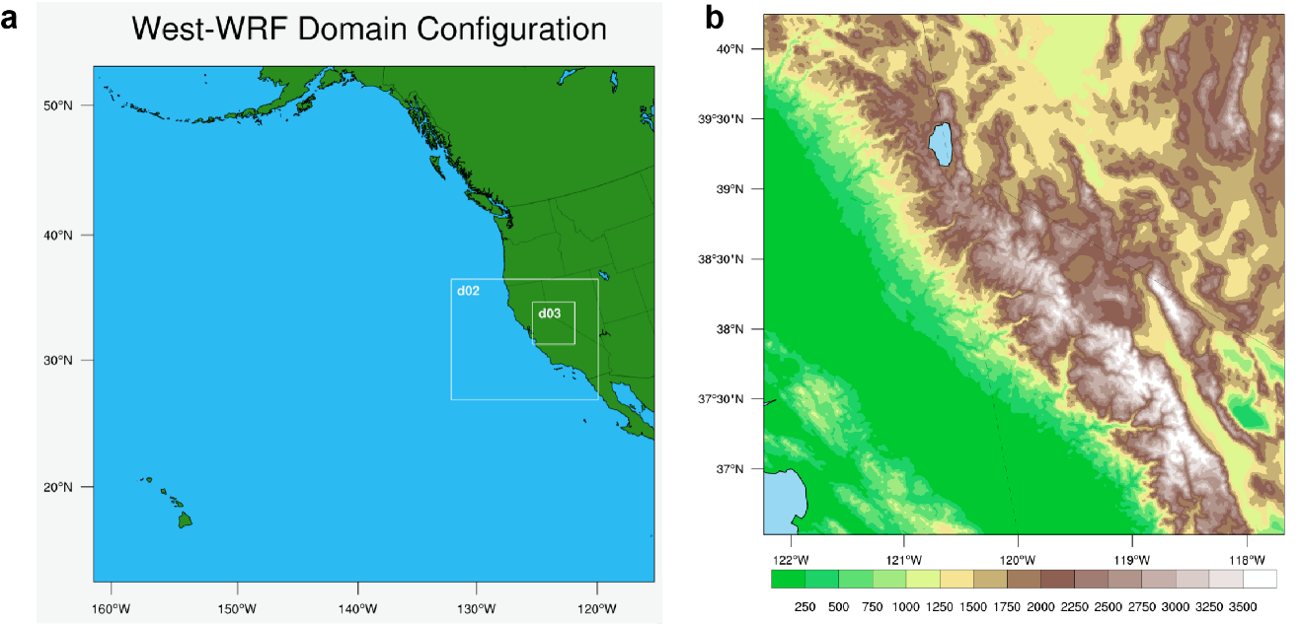

Figure S1. WRF nested domains (a), and WRF’s terrain representation within the smallest domain (d03), which is centered on the Tuolumne basin.

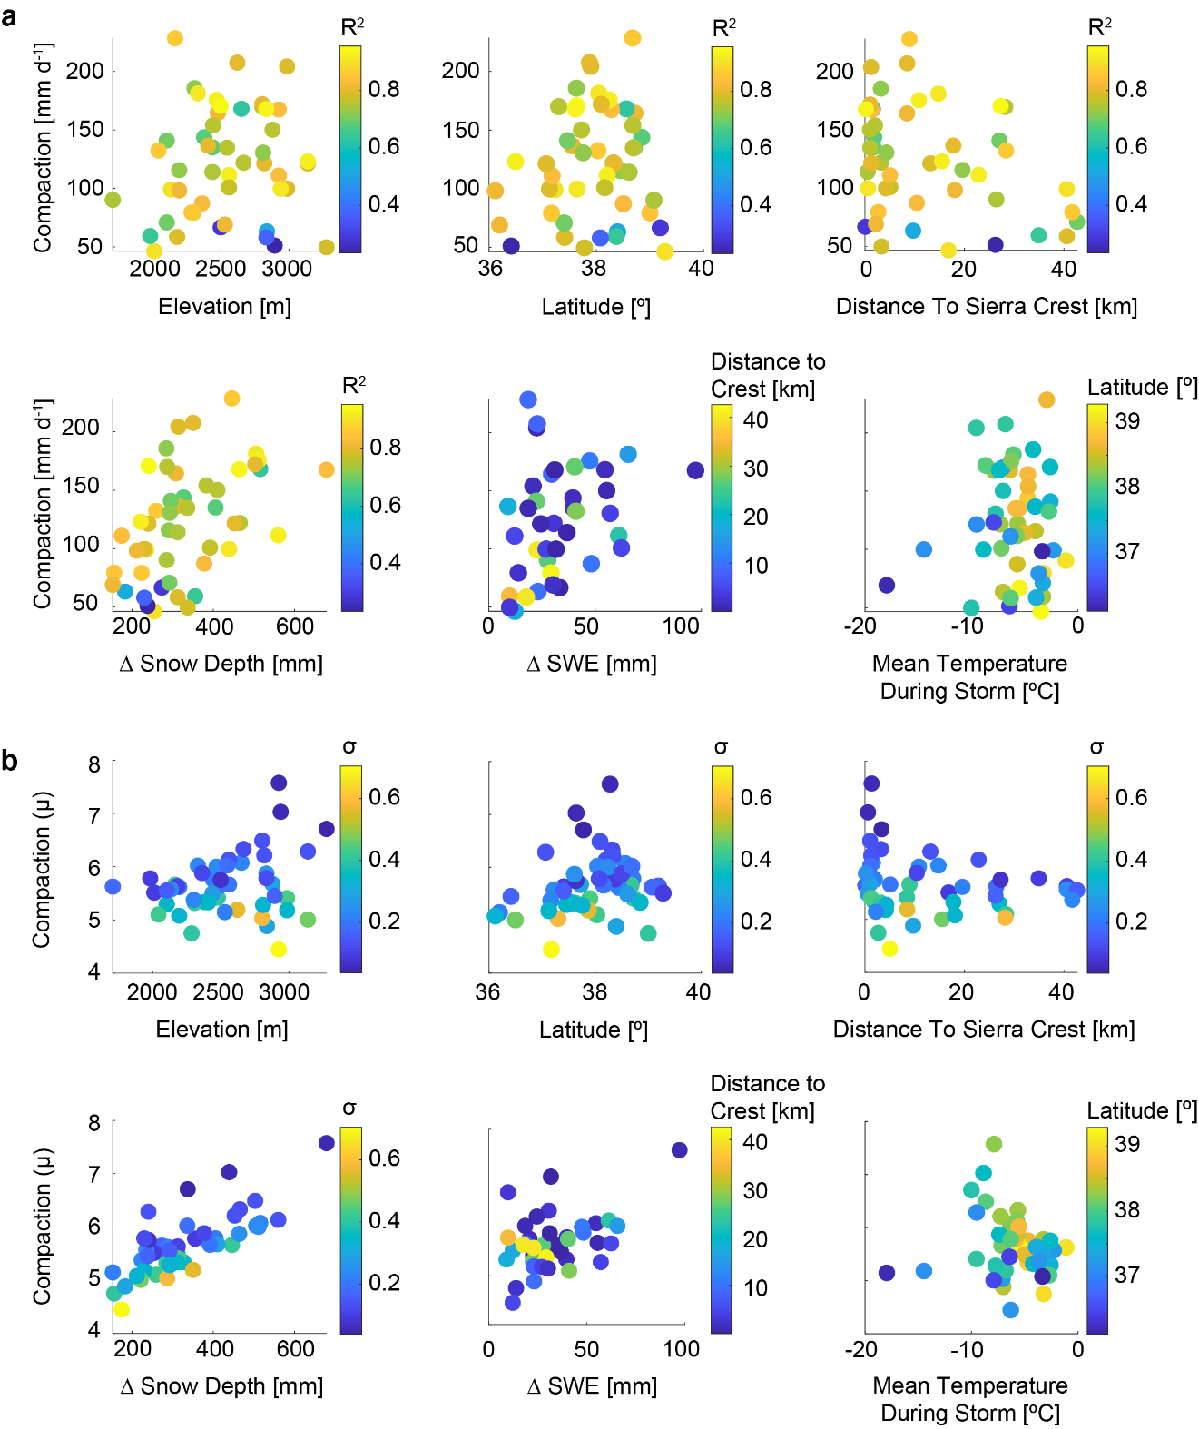

Figure S2. Compaction calculated using a linear approach (a) and nonlinear approach (b) plotted against elevation, latitude, the distance to the Sierra Nevada crest, the accumulated snow depth ($∆$ Snow Depth), the change ($∆$) in SWE, and mean temperature during the storm. Across both the linear and nonlinear compaction rates, the only consistent meaningful relationship was with the change in snow depth. This limited our options for spatially scaling a compaction rate across the Tuolumne.

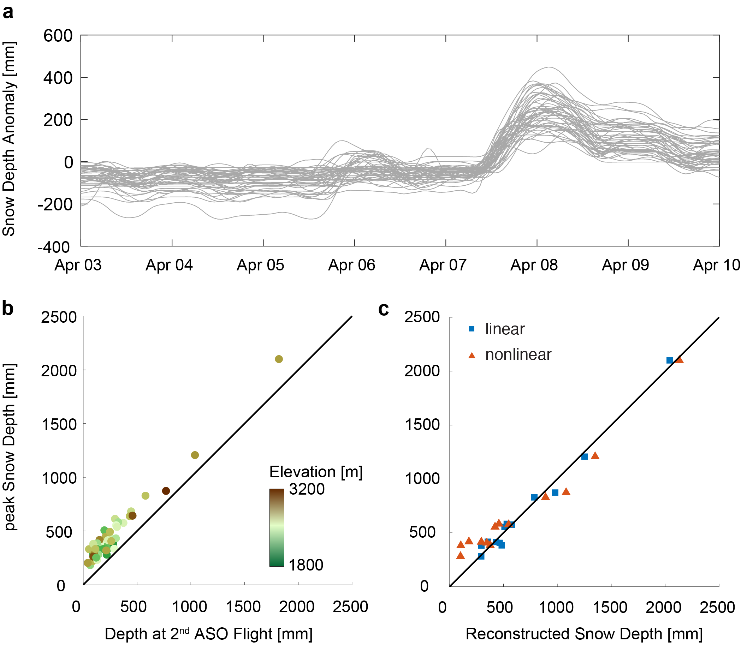

Figure S3. An assessment of compaction rates across 48 snow stations in the Sierra Nevada and ways to best reconstruct the peak snow depth (Point 3 Figure 2). (a) the snow depth anomaly during the ASO measurement period exhibiting the rapid rise of snow depths during the storm, and the rapid decline of snow depths post accumulation on the 8 April. (b) Depth at the time of the 2nd ASO flight (9 April 2015 12:00 PST), used as a predictor variable for the peak snow depth achieved during the storm (Point 3 in Figure 2). Across elevation the relationship is highly linear and indicative of a relatively constant compaction rate. (c) Reconstructed peak snow depth versus peak snow depth using a linear technique (b) versus a nonlinear technique that scaled the maximum and minimum linear compaction rate at all 48 snow stations across a snow depth from 0 – 500 mm using a quadratic and was added to the snow depth at the time of the second ASO flight. Percent errors for both methods can be found in Table S4. Nonetheless, the linear method provided the most accurate and precise reconstructed peak snow depth.

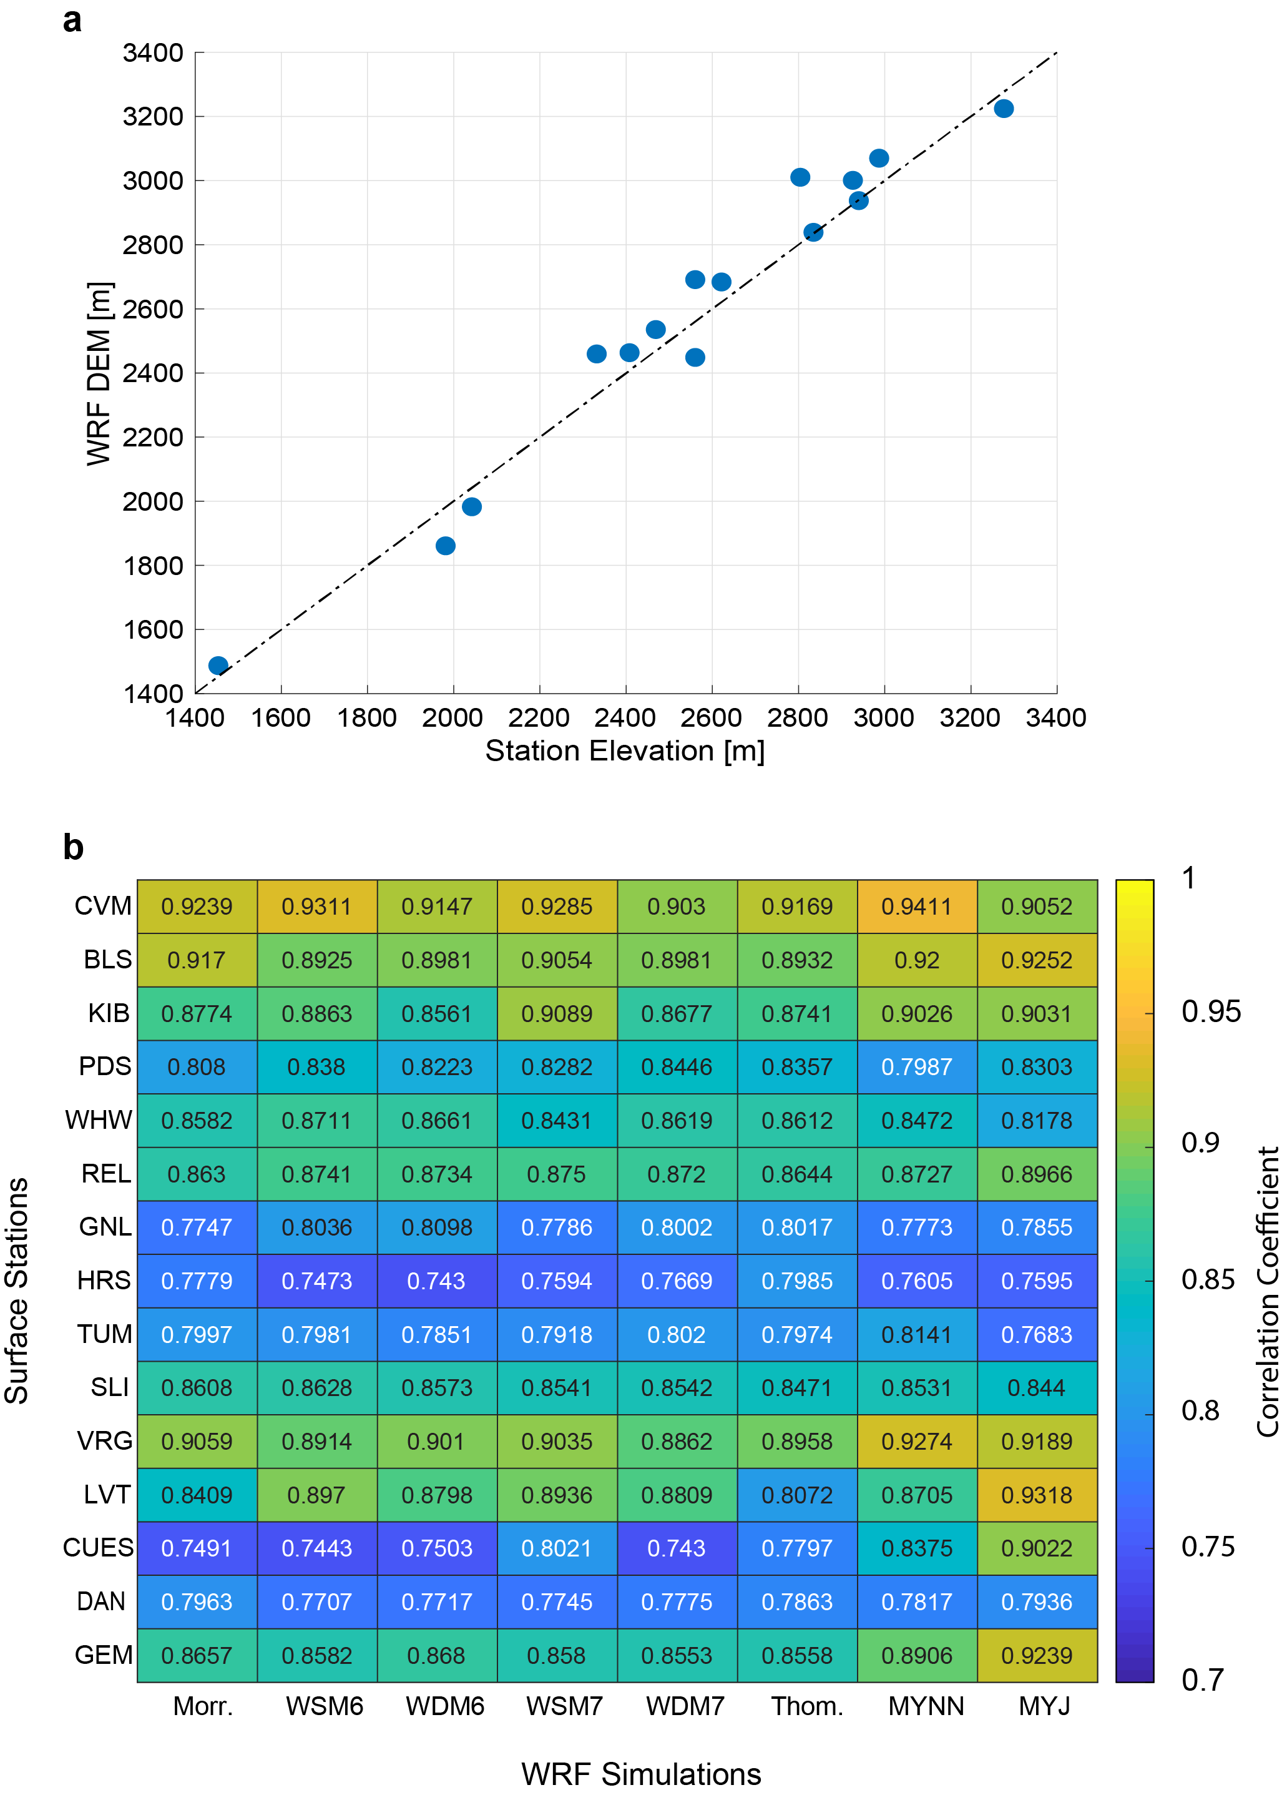

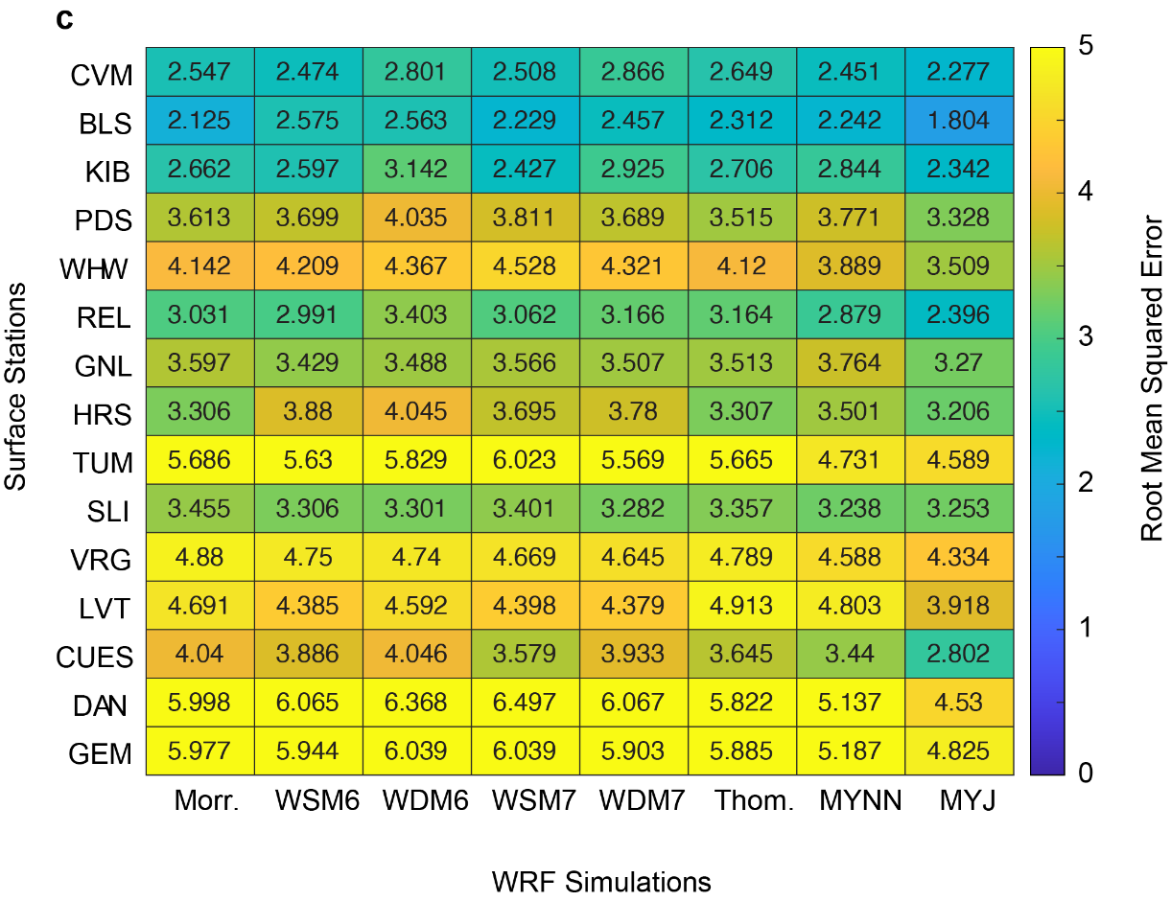

Figure S4. An investigation into WRF’s ability replicate surface temperature. (a) WRF DEM surface station elevation versus recorded surface station elevation. (b) A matrix of correlation coefficients and (c) root mean squared errors for surface station temperatures (low to high elevations) and WRF simulated temperature.

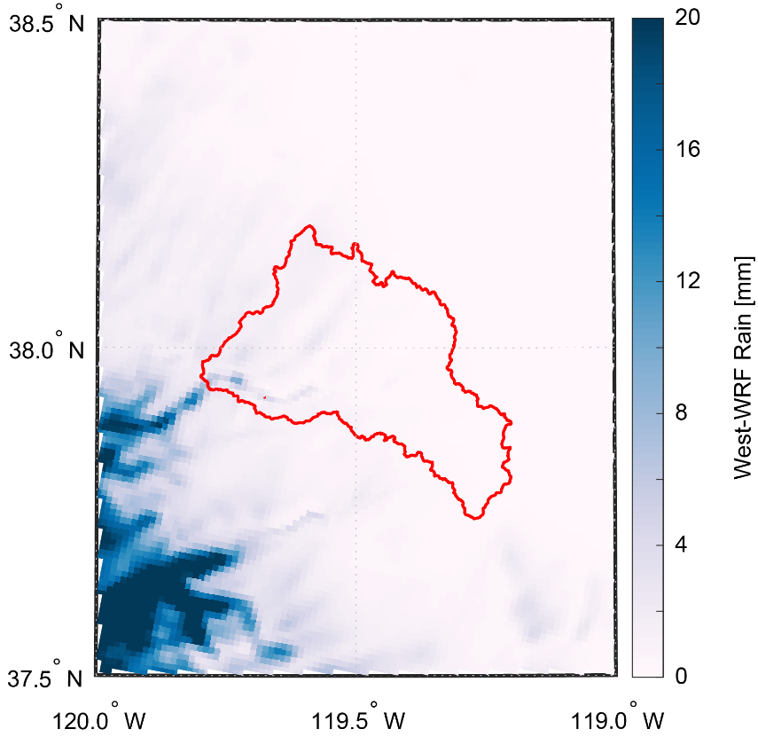

Figure S5. West-WRF modeled estimate of summed total rain (RAINNC minus SNOWNC) during the April 2015 storm.

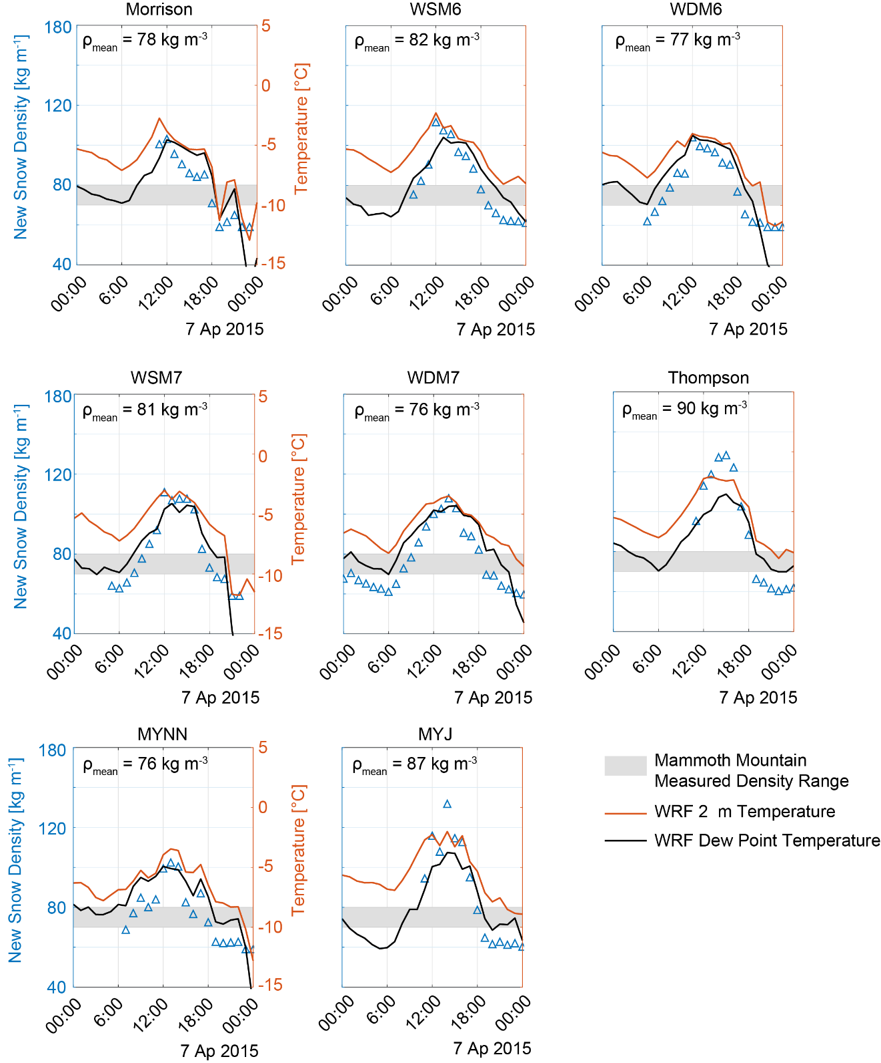

Figure S6. New snow density estimates from WRF using different configurations of microphysics and PBL schemes over Mammoth Mountain, CA during the 7 April 2015. The WRF 2 m temperature and dew point temperature have also been plotted on the secondary y-axis. Mammoth Mountain recorded two new snow densities of 70 kg m⁻³ and 80 kg m⁻³ during the April 2015 storm. This measured density range has been portrayed on each graph as the grey shaded region. In general, the ensemble of WRF simulations do a reasonable job replicating the measured new snow densities at Mammoth Mountain.

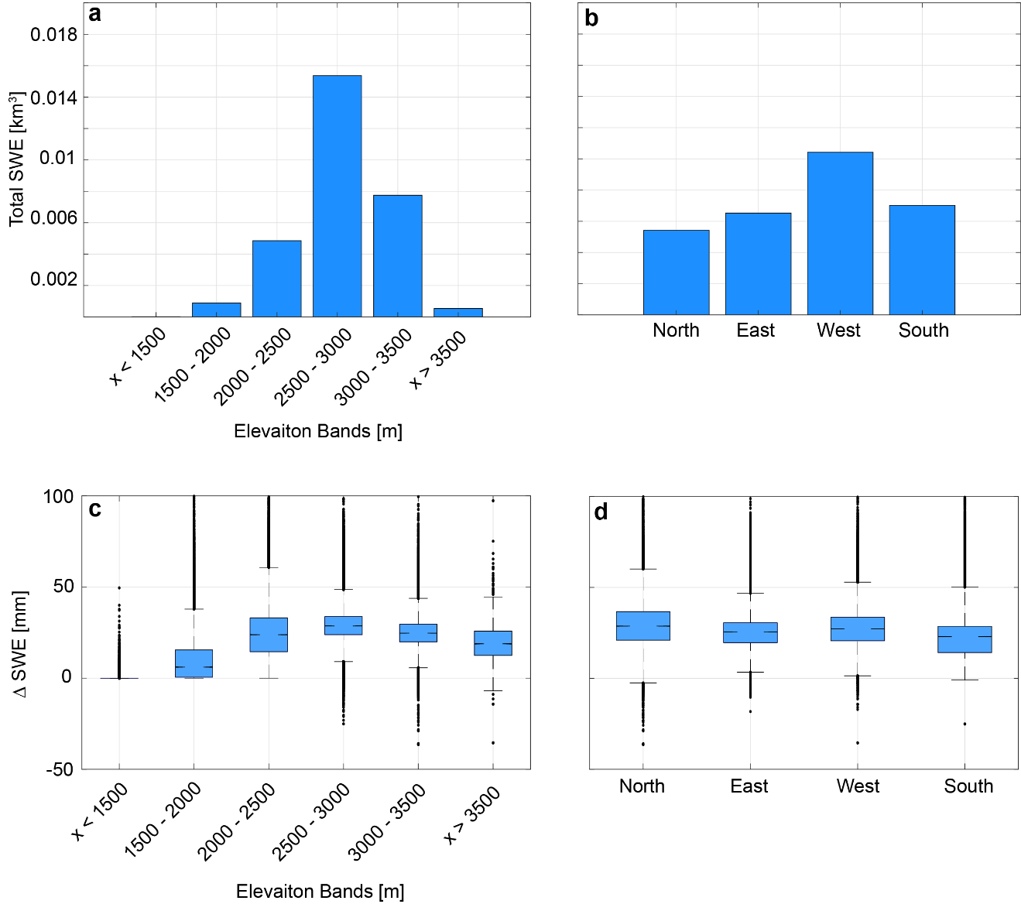

Figure S7. Distribution of the ASO derived $∆SWE$ across elevations and aspects within the basin as a summed total and a depth. (a) Summed $∆SWE$ binned by elevation. (b) $∆SWE$ binned and summed by aspect – north, east, west, and south. (c) Box plot of $∆SWE$ as a depth binned by elevation. (d) Box plot of $∆SWE$ binned by aspect.

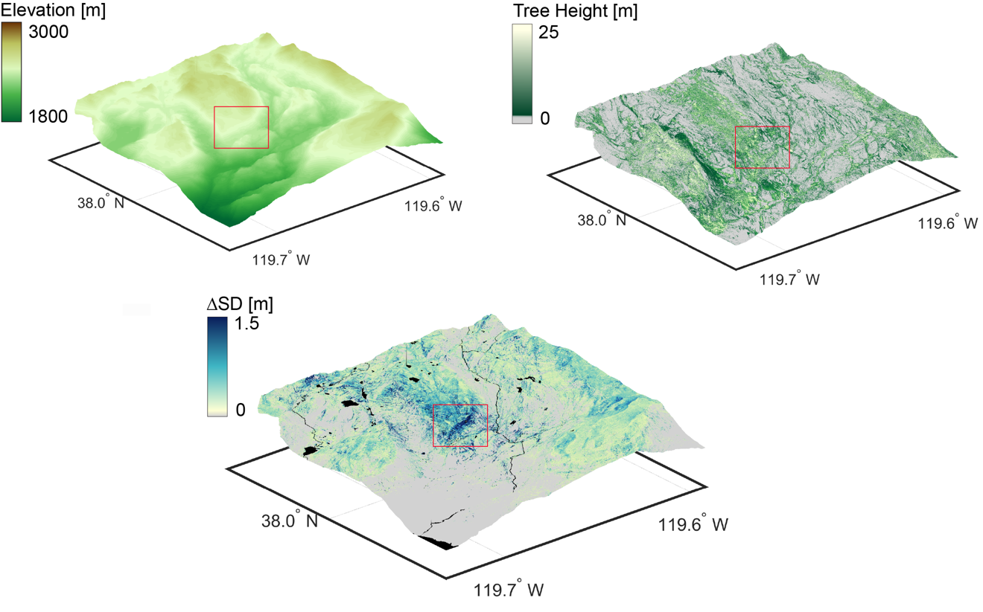

Figure S8. An examination of an anomaly in the 50 m ASO derived $∆SWE$ (Point 1 Figure 6a). Here we present a 3 m data from a DEM, 3 m ASO estimates of tree height, and 3 m ASO adjusted-$∆SD$. All datasets have been rendered in 3D. The red box highlights the adjusted-$∆SD$ anomaly which appears to be on the windward side of rapidly rising topography. Along this slope tree heights are relatively quite large and appear to bound the region of enhanced adjusted-$∆SD$. Given this it is likely that the anomaly is in fact a deep pocket of snow depth created by topography, trees and wind redistribution rather than an error in the lidar itself.

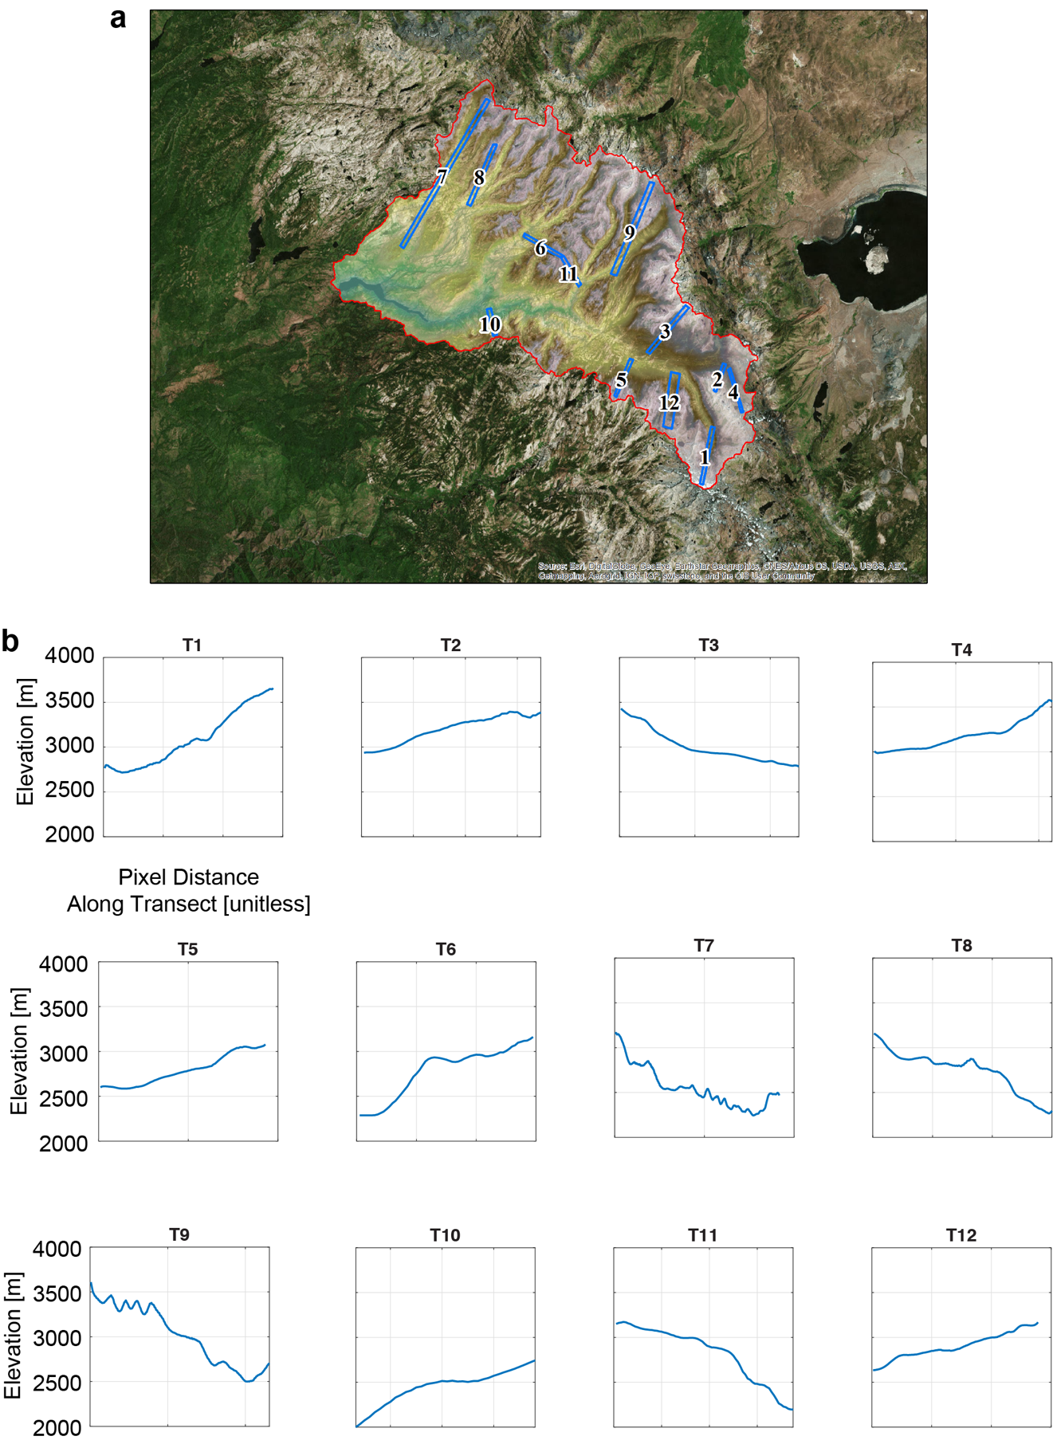

Figure S9. (a) transects used to identify how slope, tree height and land class influence the distribution of $∆SWE$. (b) the average elevation profile across each transect.

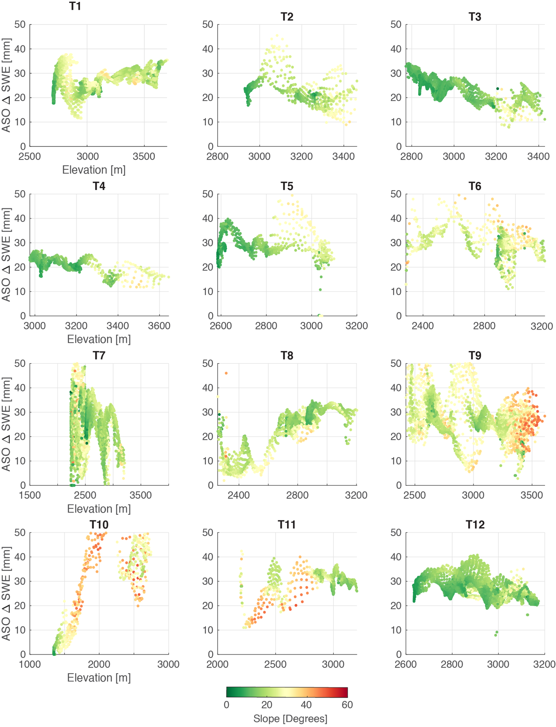

Figure S10. The $∆SWE$/elevation profile along each transect colored by slope. Importantly, the change in the $∆SWE$ along the elvation profile does not appear to always be associated with larges changes in slope.

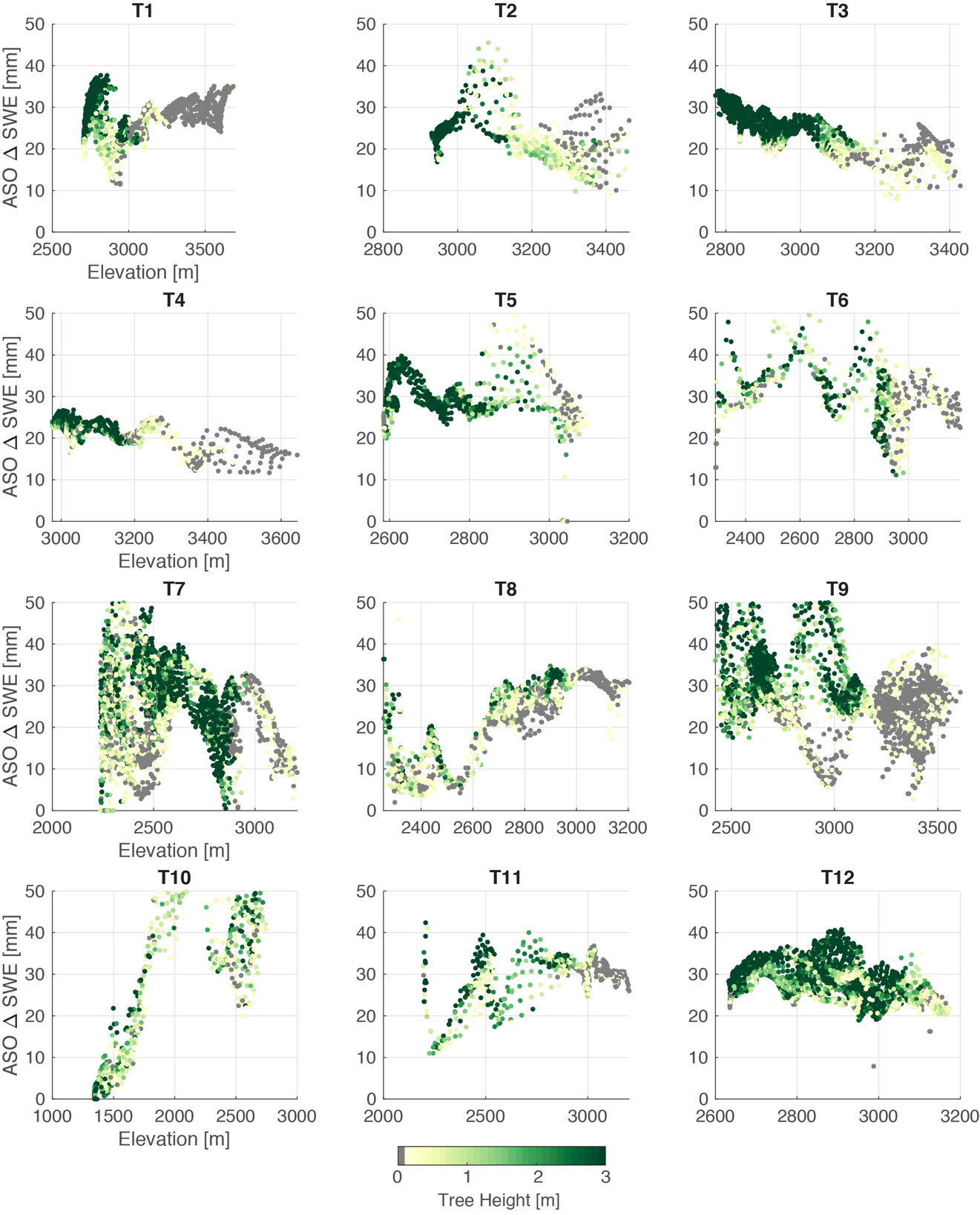

Figure S11. The $∆SWE$/elevation profile along each transect colored by tree height (as measured by ASO lidar). Importantly, the change in the $∆SWE$ along the elvation profile does not appear to driven by large changes in tree height.

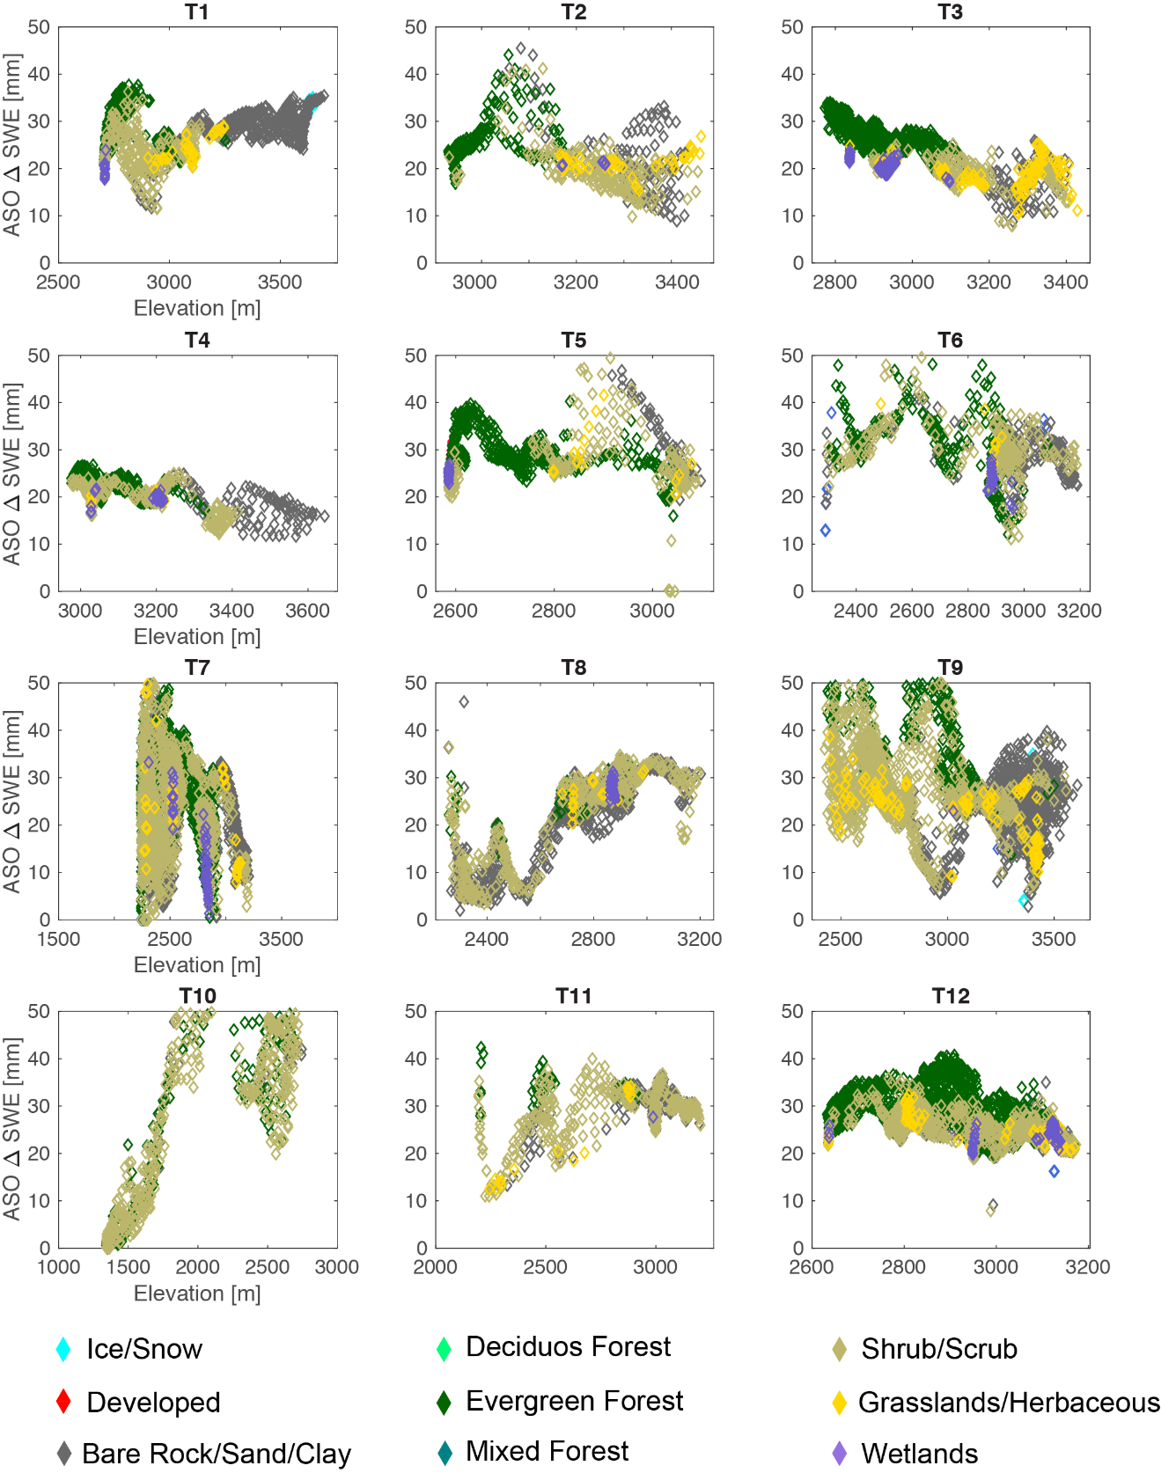

Figure S12. The $∆SWE$/elevation profile along each transect colored by land class. Again, the change in the $∆SWE$ along the elvation profile does not appear to always be associated with shifts in the land cover class.

Table S1. Wind stations in the San Joaquin hydrologic region and above 500 m elevation.

Table S2. Snow stations across the Sierra Nevada that possessed measurements of SWE, snow depth, and temperature during the April 2015 storm. Data were used in the compaction assessment.

Table S3. Compaction correction error analysis. Linear refers to using the linear relationship between the snow depth at the time of the second ASO flight plotted against the peak snow depth to help reconstruct the peak snow depth. Nonlinear refers to using a quadratic to scale compaction rates across snow depths varying from 0 to 500 mm and adding this to the snow depth at the time of the second ASO flight. The “linear” approach exhibited the least amount of error, and so was used to reconstruct peak snow depth.

Table S4. Surface temperature stations used to validate WRF’s 2m surface temperature for the new snow density estimate.

Table S5. A summary of the various microphysics and planetary boundary schemes used for each of the simulations referenced in this study. Q_{c} is the mixing ratio for clouds, Q_{r} is the mixing ratio for rain, Q_{i} is the mixing ratio for ice, Q_{s} is the mixing ratio for snow, Q_{g} is the mixing ratio for graupel, and Q_{h} is the mixing ratio for hail. N_{r} is the number concentration of rain nuclei, N_{i} is the number concentration of ice nuclei, N_{s} is the number concentration of snow nuclei, and N_{g} is the number concentration of graupel nuclei, N_{n} is the number concentration of cloud condensation nuclei.

References
Bae, S. Y., Hong, S.-Y., & Tao, W.-K. (2019). Development of a single-moment cloud microphysics scheme with prognostic hail for the Weather Research and Forecasting (WRF) model. Asia-Pacific Journal of Atmospheric Sciences, 55, 233-245. https://doi.org/10.1007/s13143-018-0066-3
Chen, F., & Dudhia, J. (2001). Coupling an advanced land surface–hydrology model with the Penn State–NCAR MM5 modeling system. Part I: Model implementation and sensitivity. Monthly Weather Review, 129, 569-585. https://doi.org/10.1175/1520-0493(2001)129<0569:Caalsh>2.0.Co;2
Grell, G. A., & Freitas, S. R. (2014). A scale and aerosol aware stochastic convective parameterization for weather and air quality modeling. Atmospheric Chemistry and Physics, 14, 5233-5250. https://doi.org/10.5194/acp-14-5233-2014
Hong, S.-Y., & Lim, J.-O. J. (2006). The WRF single-moment 6-class microphysics scheme (WSM6). Journal of the Korean Meterological Society, 42, 129-151.
Hong, S.-Y., Noh, Y., & Dudhia, J. (2006). A new vertical diffusion package with an explicit treatment of entrainment processes. Monthly Weather Review, 134, 2318-2341. https://doi.org/10.1175/mwr3199.1
Iacono, M. J., Delamere, J. S., Mlawer, E. J., Shephard, M. W., Clough, S. A., & Collins, W. D. (2008). Radiative forcing by long-lived greenhouse gases: Calculations with the AER radiative transfer models. Journal of Geophysical Research: Atmospheres, 113, D13103. https://doi.org/10.1029/2008jd009944
Janjić, Z. I. (1994). The step-mountain eta coordinate model: Further developments of the convection, viscous sublayer, and turbulence closure schemes. Monthly Weather Review, 122, 927-945. https://doi.org/10.1175/1520-0493(1994)122<0927:Tsmecm>2.0.Co;2
Kojima, K. (1967). Densification of seasonal snow cover. Presented at the Physics of Snow and Ice, International Conference on Low Temperature Science, Hokkaido University, Sapporo, Japan. http://hdl.handle.net/2115/20351
Lim, K.-S. S., & Hong, S.-Y. (2010). Development of an effective double-moment cloud microphysics scheme with prognostic cloud condensation nuclei (CCN) for weather and climate models. Monthly Weather Review, 138, 1587-1612. https://doi.org/10.1175/2009mwr2968.1
Martin, A., Ralph, F. M., Demirdjian, R., DeHaan, L., Weihs, R., Helly, J., Reynolds, D., & Iacobellis, S. (2018). Evaluation of atmospheric river predictions by the WRF model using aircraft and regional Mesonet observations of orographic precipitation and its forcing. Journal of Hydrometeorology, 19, 1097-1113. https://doi.org/10.1175/jhm-d-17-0098.1
McClung, D. M., & Schaerer, P. (2006). The Avalanche Handbook. Seattle, WA: Mountaineers Books.
Morrison, H., Thompson, G., & Tatarskii, V. (2009). Impact of cloud microphysics on the development of trailing stratiform precipitation in a simulated squall line: comparison of one- and two-moment schemes. Monthly Weather Review, 137, 991-1007. https://doi.org/10.1175/2008mwr2556.1
Nakanishi, M., & Niino, H. (2006). An improved Mellor–Yamada level-3 model: Its numerical stability and application to a regional prediction of advection fog. Boundary-Layer Meteorology, 119, 397-407. https://doi.org/10.1007/s10546-005-9030-8
Thompson, G., Field, P. R., Rasmussen, R. M., & Hall, W. D. (2008). Explicit forecasts of winter precipitation using an improved bulk microphysics scheme. Part II: Implementation of a new snow parameterization. Monthly Weather Review, 136, 5095-5115. https://doi.org/10.1175/2008mwr2387.1

