Supplementary data for Changes in the distribution of Al and particulate Fe along A16N in the eastern North Atlantic Ocean between 2003 and 2013: Implications for changes in dust deposition
Pamela M. Barrett^{a,b*}, Joseph A. Resing^{b}, Nathaniel J. Buck^{b}, William M. Landing^{c}, Peter L. Morton^{c}, Rachel U. Shelley^{c,1}
ªSchool of Oceanography, University of Washington, Seattle, WA, USA
^{b}Joint Institute for the Study of Atmosphere and Ocean, University of Washington PMEL/NOAA, Seattle, Washington, USA
^{c}Department of Earth, Ocean, and Atmospheric Science, Florida State University, Tallahassee, Florida, USA
¹Now at Laboratoire des Sciences de l'Environnement Marin, Institut Universitaire Européen de la Mer, Plouzané, France

Comparison of particulate P distributions along CLIVAR A16N
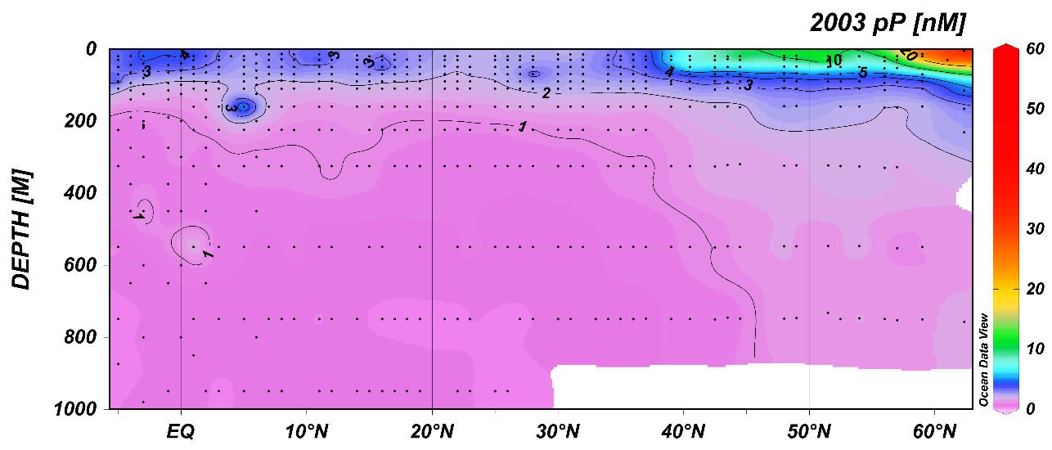
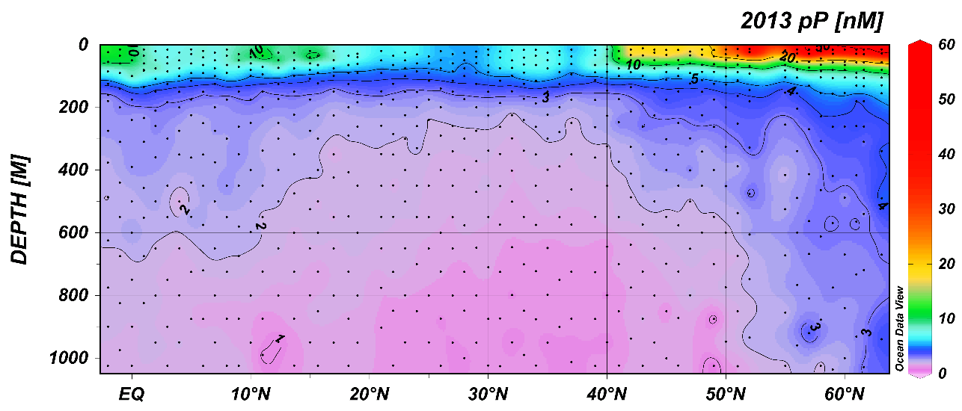
Fig. S1. Distributions of particulate P in nmol L⁻¹ along CLIVAR A16N in 2003 (top panel) and 2013 (bottom panel); black dots represent individual sample measurements. Note that color scale has been modified to more clearly show concentrations <10 n nmol L⁻¹.
Comparison of 2003 and 2013 CLIVAR A16N particulate Fe and particulate Al concentrations with results from the 2011 GEOTRACES North Atlantic Zonal Transect

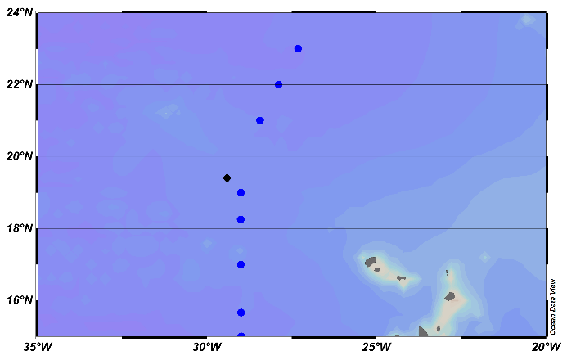

Fig. S2. Map showing the locations of 2013 CLIVAR A16N stations (blue circles) and 2011 GEOTRACES station 11-22 (black diamond). Average concentrations of particulate Al in nmol L⁻¹ at depth (200–1000 m) at stations 15–25°N along 2013 and 2003 CLIVAR A16N (circles) plotted with average pAl concentration at depth (200–1000 m) at 2011 GEOTRACES NAZT station 11-22 (diamond; Ohnemus and Lam, 2014). Data from Ohnemus and Lam is the sum of particulate Al concentrations from two filter size fractions (0.8–51 μm and >51 μm). CLIVAR A16N particulate Al concentrations are from 0.4 μm filter samples. Right panel is same but for particulate Fe.

Fig. S3. Depth profiles of particulate Al at GEOTRACES NAZT stations 10-12 (a; 17.4°N, 18.3°W), 10-11 (b; 17.4°N, 20.8°W), 10-10 (c; 17.4°N, 22.8°W), and 10-9 (d; 17.4°N, 24.5°W) as determined by in situ pumps with minimum 0.8 μm filter size (open symbols; Ohnemus and Lam, 2014) and discrete bottle sampling with 0.45 μm filter size (closed symbols; Twining et al., 2014). Station locations move progressively off-shore from the African margin (station 10-9) to open-ocean waters (station 10-12). In situ pump data is the sum of particulate Al concentrations from two size fractions (0.8–51 μm and >51 μm). Bottle data is either the sum of particulate Al concentrations from labile and refractory fractions, or from a total digest as described in Twining et al. (2014). Panel (c) of station 10-10 as shown in Fig. 3d of Twining et al. (2014).

Comparison of 2003 and 2013 CLIVAR A16N dissolved Al data with results from the 2011 GEOTRACES North Atlantic Zonal Transect

Fig. S4. Left panel: Concentration of dissolved Al in nmol L⁻¹ at 2003/2013 CLIVAR A16N station 94 (19.0°N, 29.0°W; Measures et al., 2008; this work) and 2011 GEOTRACES NAZT station 11-22 (19.4°N, 29.4°W; Measures et al., 2014). Right panel: Concentration of dissolved Al in nmol L⁻¹ at 2003/2013 CLIVAR A16N station 90 (21.0°N, 28.4°W; Measures et al., 2008; this work) and 2011 GEOTRACES NAZT station 11-22 (19.4°N, 29.4°W; Measures et al., 2014).

Fig. S5. Salinity profiles at 2011 GEOTRACES NAZT station 11-22 (19.4°N, 29.4°W) and at 2013 CLIVAR A16N stations between 18°N and 22°N. Legend colors same as in Fig. S4. Differences at mid-depths reflect a transition in water masses sampled from high-salinity North Atlantic Central Water to low-salinity Antarctic Intermediate Water with decreasing latitude.

References
Measures, C.I., Landing, W.M., Brown, M.T., Buck, C.S., 2008. High-resolution Al and Fe data from the Atlantic Ocean CLIVAR-CO2 Repeat Hydrography A16N transect: Extensive linkages between atmospheric dust and upper ocean geochemistry. Global Biogeochem. Cycles 22, GB1005, doi: 10.1029/2007GB003042.

Measures, C., Hatta, M., Fitzsimmons, J., Morton, P., 2014. Dissolved Al in the zonal N Atlantic section of the US GEOTRACES 2010/2011 cruises and the importance of Hydrothermal inputs. Deep-Sea
Res. II doi: 10.1016/j.dsr2.2014.07.006.

Ohnemus, D.C., Lam, P.J., 2014. Cycling of Lithogenic Marine Particles in the US GEOTRACES North Atlantic Transect. Deep-Sea Res. II, doi:10.1016/j.dsr2.2014.11.019.

Twining, B.S., Rauschenberg, S., Morton, P.L., Ohnemus, D.C., Lam, P.J., 2014. Comparison of particulate trace element concentrations in the North Atlantic Ocean as determined with discrete bottle sampling and in situ pumping. Deep-Sea Res. II, doi:10.1016/j.dsr2.2014.11.005.

