SUPPLEMENTARY MATERIAL: Additional Tables and Figures

Table S1. Akaike Information Criteron for small sample sizes (AICc) values, ΔAIC values, and AIC weights (AIC wt) for coast-wide dynamic factor analysis (DFA) models of Oregon Coast coho salmon. The best-fit model is highlighted in bold.

Pre-1990: | Observation error | AICc | ΔAIC | AIC wt
Trends = 1 | diagonal and equal | 1391.15 | 66.52 | 0.00
 | diagonal and unequal | 1411.74 | 87.11 | 0.00
 | equalvarcov | 1367.17 | 42.54 | 0.00
Trends = 2 | diagonal and equal | 1388.29 | 63.66 | 0.00
 | diagonal and unequal | 1356.09 | 31.46 | 0.00
 | equalvarcov | 1378.30 | 53.67 | 0.00
Trends = 3 | diagonal and equal | 1405.25 | 80.62 | 0.00
 | diagonal and unequal | 1324.63 | 0.00 | 1.00
 | equalvarcov | 1388.57 | 63.94 | 0.00
Post-1990: | Observation error | AICc | ΔAIC | AIC wt
Trends = 1 | diagonal and equal | 1337.75 | 36.81 | 0.00
 | diagonal and unequal | 1317.39 | 16.45 | 0.00
 | equalvarcov | 1300.94 | 0.00 | 0.94
Trends = 2 | diagonal and equal | 1315.23 | 14.29 | 0.00
 | diagonal and unequal | 1307.59 | 6.65 | 0.03
 | equalvarcov | 1308.41 | 7.47 | 0.02
Trends = 3 | diagonal and equal | 1335.47 | 34.53 | 0.00
 | diagonal and unequal | 1327.18 | 26.24 | 0.00
 | equalvarcov | 1323.67 | 22.73 | 0.00

Table S2. Observation error (R) for the best-fit, coast-wide dynamic factor analysis (DFA) model for pre-1990 Oregon Coast coho productivity. The Salmon, Floras, and Sixes populations were not included due to missing data.

Population | R
Necanicum | 0.55
Nehalem | 0.32
Tillamook | 0.72
Nestucca | 0.48
Salmon | -
Siletz | 0.31
Yaquina | 0.18
Beaver | 0.71
Alsea | 0.32
Siuslaw | 0.28
Siltcoos | 0.67
Tahkenitch | 0.85
Tenmile | 0.78
Lower Umpqua | 0.68
Middle Umpqua | 0.21
North Umpqua | 0.16
South Umpqua | 0.20
Coos | 0.68
Coquille | 0.82
Floras | -
Sixes | -

Table S3. Akaike Information Criteron for small sample sizes (AICc) values, ΔAIC values, and AIC weights (AIC wt) for regional dynamic factor analysis (DFA) models of Oregon Coast coho salmon. The best-fit model is highlighted in bold. A dash indicates that the model did not converge. NOR = North Coast, MID = Mid-Coast, LAK = Lakes, UMP = Umpqua River, and MSO = Mid-South Coast. For the Mid-Coast Post-1990 data, several best-fit models were identified, but the model with a “diagonal and unequal” error structure and two trends had the lowest root-mean-square error.

 |  |  | Pre-1990 |  |  |  | Post-1990
Pop | Trends | Observation error | AICc | ΔAICc | AIC wt |  | AICc | ΔAICc | AIC wt
NOR | Trends = 1 | diagonal and equal | 310.86 | 4.77 | 0.08 |  | 247.04 | 0.00 | 0.60
 |  | diagonal and unequal | 314.35 | 8.26 | 0.01 |  | 249.35 | 2.31 | 0.19
 |  | equalvarcov | 306.09 | 0.00 | 0.89 |  | 249.55 | 2.51 | 0.17
 | Trends = 2 | diagonal and equal | 317.64 | 11.55 | 0.00 |  | 253.58 | 6.54 | 0.02
 |  | diagonal and unequal | 325.79 | 19.70 | 0.00 |  | 257.41 | 10.37 | 0.00
 |  | equalvarcov | 314.13 | 8.04 | 0.02 |  | 256.12 | 9.08 | 0.01
MID | Trends = 1 | diagonal and equal | 376.69 | 67.76 | 0.00 |  | 411.55 | 10.40 | 0.00
 |  | diagonal and unequal | 331.11 | 22.19 | 0.00 |  | 405.27 | 4.12 | 0.06
 |  | equalvarcov | 358.34 | 49.41 | 0.00 |  | 402.91 | 1.76 | 0.19
 | Trends = 2 | diagonal and equal | 367.51 | 58.58 | 0.00 |  | 411.35 | 10.20 | 0.00
 |  | diagonal and unequal | 308.93 | 0.00 | 1.00 |  | 402.24 | 1.09 | 0.27
 |  | equalvarcov | 328.80 | 19.87 | 0.00 |  | 401.15 | 0.00 | 0.47
LAK | Trends = 1 | diagonal and equal | 235.34 | 6.16 | 0.04 |  | 217.32 | 13.48 | 0.00
 |  | diagonal and unequal | 239.94 | 10.76 | 0.00 |  | 221.92 | 18.08 | 0.00
 |  | equalvarcov | 229.18 | 0.00 | 0.96 |  | 203.84 | 0.00 | 1.00
 | Trends = 2 | diagonal and equal | - | - | - |  | - | - | -
 |  | diagonal and unequal | - | - | - |  | - | - | -
 |  | equalvarcov | - | - | - |  | - | - | -
UMP | Trends = 1 | diagonal and equal | 310.67 | 40.24 | 0.00 |  | 260.92 | 22.01 | 0.00
 |  | diagonal and unequal | 296.52 | 26.09 | 0.00 |  | 254.66 | 15.75 | 0.00
 |  | equalvarcov | 301.27 | 30.84 | 0.00 |  | 263.24 | 24.33 | 0.00
 | Trends = 2 | diagonal and equal | 305.52 | 35.09 | 0.00 |  | 245.49 | 6.58 | 0.04
 |  | diagonal and unequal | 270.66 | 0.00 | 1.00 |  | 238.91 | 0.00 | 0.95
 |  | equalvarcov | 297.08 | 26.65 | 0.00 |  | 247.92 | 9.01 | 0.01
MSO | Trends = 1 | diagonal and equal | 190.22 | 0.00 | 0.98 |  | 289.11 | 4.71 | 0.08
 |  | diagonal and unequal | 197.75 | 7.53 | 0.02 |  | 289.12 | 4.72 | 0.08
 |  | equalvarcov | - | - | - |  | 284.40 | 0.00 | 0.84
 | Trends = 2 | diagonal and equal | - | - | - |  | 299.81 | 15.41 | 0.00
 |  | diagonal and unequal | - | - | - |  | - | - | -
 |  | equalvarcov | - | - | - |  | - | - | -

Table S4. Akaike Information Criteron for small sample sizes (AICc) values, ΔAIC values, and AIC weights (AIC wt) for regional dynamic factor analysis (DFA) models with environmental covariates for Oregon Coast coho salmon. A dash indicates that the model did not converge. NOR = North Coast, MID = Mid-Coast, LAK = Lakes, UMP = Umpqua River, and MSO = Mid-South Coast. PDO = Pacific Decadal Oscillation, NPGO = North Pacific Gyre Oscillation.

 |  | Pre-1990 |  |  |  |  | Post-1990
Pop | Covariate | AICc | ΔAICc | AIC wt |  | Covariate | AICc | ΔAICc | AIC wt
NOR | No cov (H=1, evc) | 306.09 | 0.93 | 0.33 |  | No cov (H=1, de) | 247.04 | 0.00 | 0.94
 | PDO | 305.16 | 0.00 | 0.53 |  | PDO | 254.39 | 7.35 | 0.02
 | NPGO | 309.97 | 4.81 | 0.05 |  | NPGO | 255.55 | 8.51 | 0.01
 | PDO & NPGO | 308.94 | 3.78 | 0.08 |  | PDO & NPGO | 264.31 | 17.27 | 0.00
 | Temp | 313.26 | 8.10 | 0.01 |  | Temp | 256.28 | 9.24 | 0.01
 | Precip | 314.99 | 9.83 | 0.00 |  | Precip | 255.98 | 8.94 | 0.01
 | Temp & Precip | 318.22 | 13.06 | 0.00 |  | Temp & Precip | 262.89 | 15.85 | 0.00
MID | No cov (H=2, du) | 308.93 | 0.00 | 1.00 |  | No cov (H=2, du) | 402.24 | 0.00 | 0.94
 | PDO | 310.63 | 1.70 | 0.43 |  | PDO | 410.68 | 8.44 | 0.01
 | NPGO | 319.46 | 10.53 | 0.01 |  | NPGO | 408.55 | 6.31 | 0.04
 | PDO & NPGO | 322.65 | 13.72 | 0.00 |  | PDO & NPGO | 421.17 | 18.93 | 0.00
 | Temp | 317.67 | 8.74 | 0.01 |  | Temp | 416.75 | 14.51 | 0.00
 | Precip | 318.69 | 9.76 | 0.01 |  | Precip | 415.40 | 13.16 | 0.00
 | Temp & Precip | 320.70 | 11.77 | 0.00 |  | Temp & Precip | 427.22 | 24.98 | 0.00
LAK | No cov (H=1, evc) | 229.18 | 0.00 | 0.72 |  | No cov (H=1, evc) | 203.84 | 0.00 | 0.71
 | PDO | 231.91 | 2.73 | 0.18 |  | PDO | 207.65 | 3.81 | 0.11
 | NPGO | 235.05 | 5.87 | 0.04 |  | NPGO | 208.71 | 4.87 | 0.06
 | PDO & NPGO | 237.61 | 8.43 | 0.01 |  | PDO & NPGO | 208.89 | 5.05 | 0.06
 | Temp | 236.36 | 7.18 | 0.02 |  | Temp | 210.26 | 6.42 | 0.03
 | Precip | 235.98 | 6.80 | 0.02 |  | Precip | 209.95 | 6.11 | 0.03
 | Temp & Precip | 239.18 | 10.00 | 0.00 |  | Temp & Precip | 213.80 | 9.96 | 0.00
UMP | No cov (H=2, du) | 270.66 | 0.00 | 0.66 |  | No cov (H=2, du) | 238.91 | 0.00 | 0.58
 | PDO | 275.80 | 5.14 | 0.05 |  | PDO | 240.58 | 1.67 | 0.25
 | NPGO | 272.88 | 2.22 | 0.22 |  | NPGO | 244.97 | 6.06 | 0.03
 | PDO & NPGO | 278.13 | 7.47 | 0.02 |  | PDO & NPGO | 244.49 | 5.58 | 0.04
 | Temp | 279.92 | 9.26 | 0.01 |  | Temp | 248.93 | 10.02 | 0.00
 | Precip | 276.01 | 5.35 | 0.05 |  | Precip | 242.61 | 3.70 | 0.09
 | Temp & Precip | 284.09 | 13.43 | 0.00 |  | Temp & Precip | 247.72 | 8.81 | 0.01
MSO | No cov (H = 1, de) | 190.22 | 0.00 | 0.94 |  | No cov (H=1, evc) | 284.40 | 0.00 | 0.91
 | PDO | 196.91 | 6.69 | 0.03 |  | PDO | 290.54 | 6.14 | 0.04
 | NPGO | 199.73 | 9.51 | 0.01 |  | NPGO | 291.47 | 7.07 | 0.03
 | PDO & NPGO | 208.06 | 17.84 | 0.00 |  | PDO & NPGO | 299.60 | 15.20 | 0.00
 | Temp | 199.76 | 9.54 | 0.01 |  | Temp | 293.78 | 9.38 | 0.01
 | Precip | 199.54 | 9.32 | 0.01 |  | Precip | 293.75 | 9.35 | 0.01
 | Temp & Precip | 203.41 | 13.19 | 0.00 |  | Temp & Precip | 302.02 | 17.62 | 0.00

Table S5. Pearson’s correlation coefficient (r), R², and P-values describing the relationship between predicted productivity trends from the best-fit dynamic factor analysis (DFA) model for each region and environmental covariates for Oregon Coast coho salmon. A dash indicates that the DFA model did not converge. Covariates that were significantly correlated with productivity trends (P < 0.05) are highlighted in bold. NOR = North Coast, MID = Mid-Coast, LAK = Lakes, UMP = Umpqua River, and MSO = Mid-South Coast. PDO = Pacific Decadal Oscillation, NPGO = North Pacific Gyre Oscillation.
 |  | Pre-1990 |  |  |  |  |  |  | Post-1990
 |  | Trend 1 |  |  | Trend 2 |  |  |  |  | Trend 1 |  |  | Trend 2
 | Covariate | r | R² | P | r | R² | P |  |  | r | R² | P | r | R² | P
NOR | PDO | -0.33 | 0.08 | 0.060 |  |  |  |  |  | -0.36 | 0.10 | 0.061
 | NPGO | 0.07 | -0.03 | 0.702 |  |  |  |  |  | 0.53 | 0.26 | 0.004
 | PDO & NPGO |  | 0.06 | 0.160 |  |  |  |  |  |  | 0.23 | 0.017
 | Temp | 0.19 | 0.01 | 0.286 |  |  |  |  |  | -0.10 | -0.03 | 0.606
 | Precip | 0.25 | 0.03 | 0.165 |  |  |  |  |  | 0.33 | 0.08 | 0.088
 | Temp & Precip |  | 0.04 | 0.206 |  |  |  |  |  |  | 0.04 | 0.229
MID | PDO | -0.01 | -0.03 | 0.968 | -0.23 | 0.02 | 0.208 |  |  | -0.34 | 0.08 | 0.082 | -0.46 | 0.18 | 0.017
 | NPGO | 0.21 | 0.01 | 0.260 | 0.03 | -0.03 | 0.881 |  |  | 0.29 | 0.05 | 0.141 | 0.68 | 0.45 | 0.001
 | PDO & NPGO |  | -0.02 | 0.535 |  | -0.01 | 0.452 |  |  |  | 0.05 | 0.206 |  | 0.42 | 0.001
 | Temp | 0.01 | -0.03 | 0.951 | 0.37 | 0.11 | 0.036 |  |  | -0.22 | 0.01 | 0.280 | -0.02 | -0.04 | 0.905
 | Precip | 0.14 | -0.01 | 0.451 | 0.25 | 0.03 | 0.170 |  |  | -0.02 | -0.04 | 0.937 | 0.41 | 0.14 | 0.033
 | Temp & Precip |  | -0.05 | 0.752 |  | 0.11 | 0.070 |  |  |  | -0.03 | 0.565 |  | 0.10 | 0.106
LAK | PDO | -0.46 | 0.18 | 0.008 |  |  |  |  |  | -0.04 | -0.04 | 0.912
 | NPGO | -0.04 | -0.03 | 0.840 |  |  |  |  |  | 0.12 | -0.04 | 0.752
 | PDO & NPGO |  | 0.16 | 0.032 |  |  |  |  |  |  | -0.08 | 0.944
 | Temp | 0.15 | -0.01 | 0.398 |  |  |  |  |  | -0.94 | 0.24 | 0.006
 | Precip | 0.25 | 0.03 | 0.172 |  |  |  |  |  | 0.08 | -0.04 | 0.839
 | Temp & Precip |  | 0.03 | 0.263 |  |  |  |  |  |  | 0.21 | 0.024
UMP | PDO | -0.67 | 0.43 | 0.001 | 0.14 | -0.01 | 0.447 |  |  | -0.44 | 0.16 | 0.021 | 0.12 | -0.03 | 0.565
 | NPGO | -0.13 | -0.02 | 0.468 | 0.35 | 0.09 | 0.050 |  |  | 0.30 | 0.06 | 0.124 | -0.19 | -0.00 | 0.350
 | PDO & NPGO |  | 0.42 | 0.001 |  | 0.08 | 0.113 |  |  |  | 0.13 | 0.073 |  | -0.05 | 0.651
 | Temp | -0.18 | 0.00 | 0.324 | 0.05 | -0.03 | 0.792 |  |  | -0.20 | 0.00 | 0.321 | 0.32 | 0.07 | 0.102
 | Precip | 0.10 | -0.02 | 0.594 | 0.24 | 0.03 | 0.190 |  |  | 0.36 | 0.10 | 0.064 | 0.00 | -0.04 | 0.998
 | Temp & Precip |  | -0.03 | 0.580 |  | 0.00 | 0.377 |  |  |  | 0.10 | 0.109 |  | 0.03 | 0.270
MSO | PDO | -0.62 | 0.36 | 0.001 |  |  |  |  |  | -0.45 | 0.17 | 0.019
 | NPGO | 0.10 | -0.02 | 0.581 |  |  |  |  |  | 0.57 | 0.30 | 0.002
 | PDO & NPGO |  | 0.35 | 0.001 |  |  |  |  |  |  | 0.28 | 0.008
 | Temp | 0.12 | -0.02 | 0.531 |  |  |  |  |  | 0.03 | -0.04 | 0.878
 | Precip | 0.25 | 0.03 | 0.161 |  |  |  |  |  | 0.14 | -0.02 | 0.485
 | Temp & Precip |  | 0.01 | 0.331 |  |  |  |  |  |  | -0.06 | 0.743

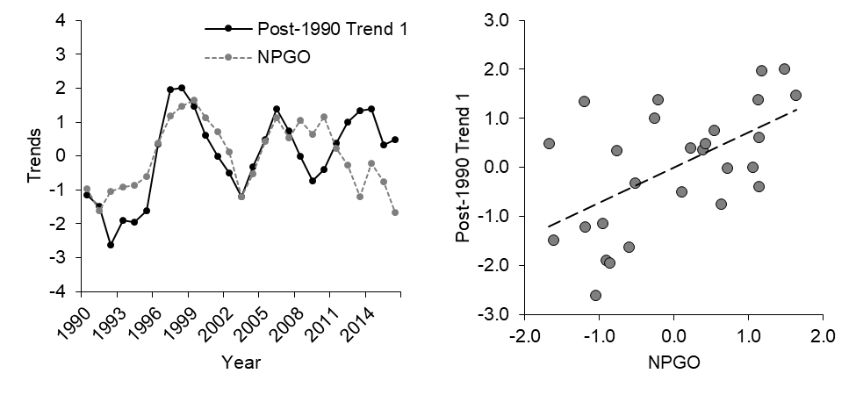
Figure S1. Coast-wide, post-1990 Trend 1 overlaid with NPGO (North Pacific Gyre Oscillation; left) and the correlation between Trend 1 and NPGO (right) for Oregon Coast coho salmon. Both data sets have been de-meaned and standardized.
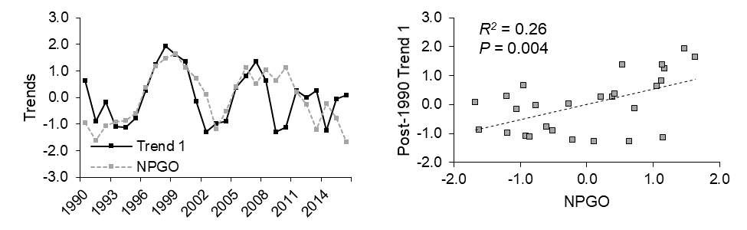
Figure S2. For the North Coast stratum, coho salmon productivity was positively correlated with NPGO (North Pacific Decadal Oscillation; bottom, square points) from 1990-on. Environmental covariates were z-transformed prior to analysis.
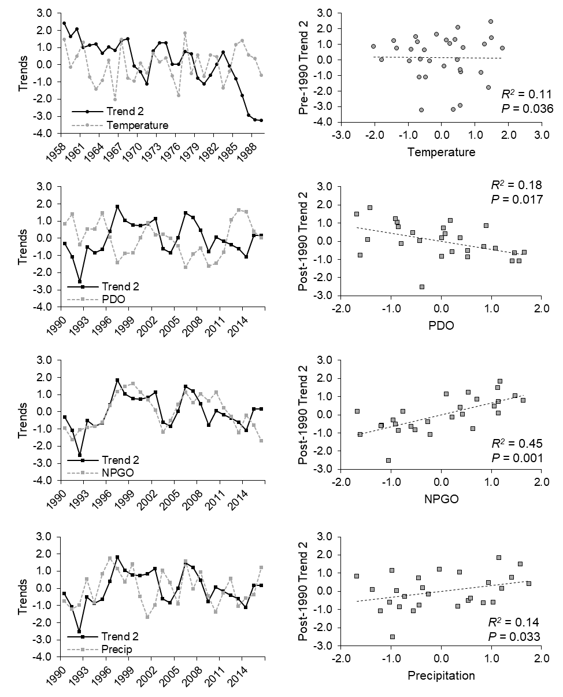
Figure S3. For the Mid-Coast stratum of coho salmon, pre-1990 productivity Trend 2 was correlated with summer air temperature (circular points), although the relationship was biologically unclear. Post-1990 productivity Trend 2 was negatively correlated with the Pacific Decadal Oscillation (PDO) and positively correlated with the North Pacific Gyre Oscillation (NPGO) and winter precipitation (square points). Environmental covariates were z-transformed prior to analysis.
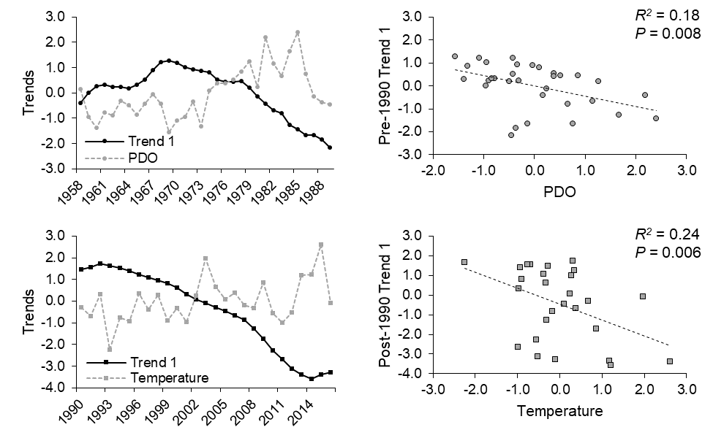
Figure S4. For the Lakes stratum, coho salmon productivity was negatively correlated with the Pacific Decadal Oscillation (PDO; top, circular points) prior to 1990, while from 1990-onward, productivity was negatively correlated with temperature (bottom, square points). Environmental covariates were z-transformed prior to analysis.
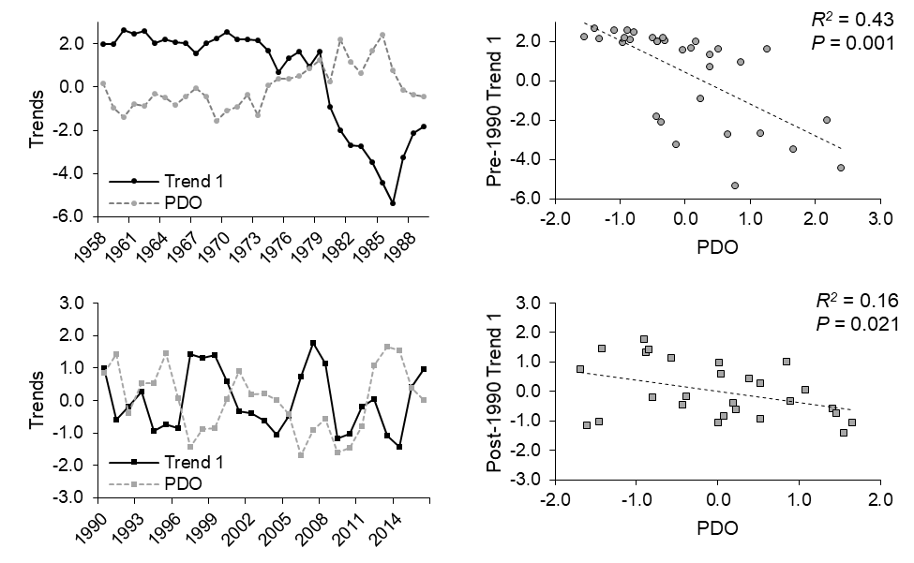
Figure S5. For coho salmon populations in the Umpqua River, both pre-1990 (top, circular points) and post-1990 (bottom, square points) Trend 1 were negatively correlated with the Pacific Decadal Oscillation (PDO). Environmental covariates were z-transformed prior to analysis.
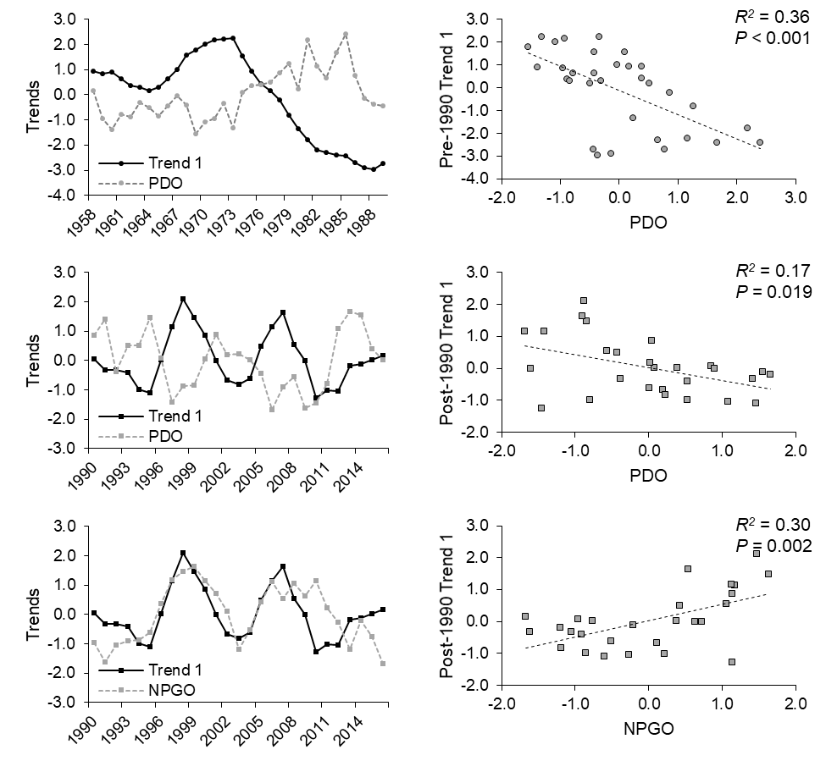
Figure S6. For the Mid-South Coast stratum of coho salmon, pre-1990 productivity was negatively correlated with the Pacific Decadal Oscillation (PDO; top, circle points), while post-1990 productivity was negatively correlated with PDO and positively correlated with the North Pacific Gyre Oscillation (NPGO; square points). Environmental covariates were z-transformed prior to analysis.
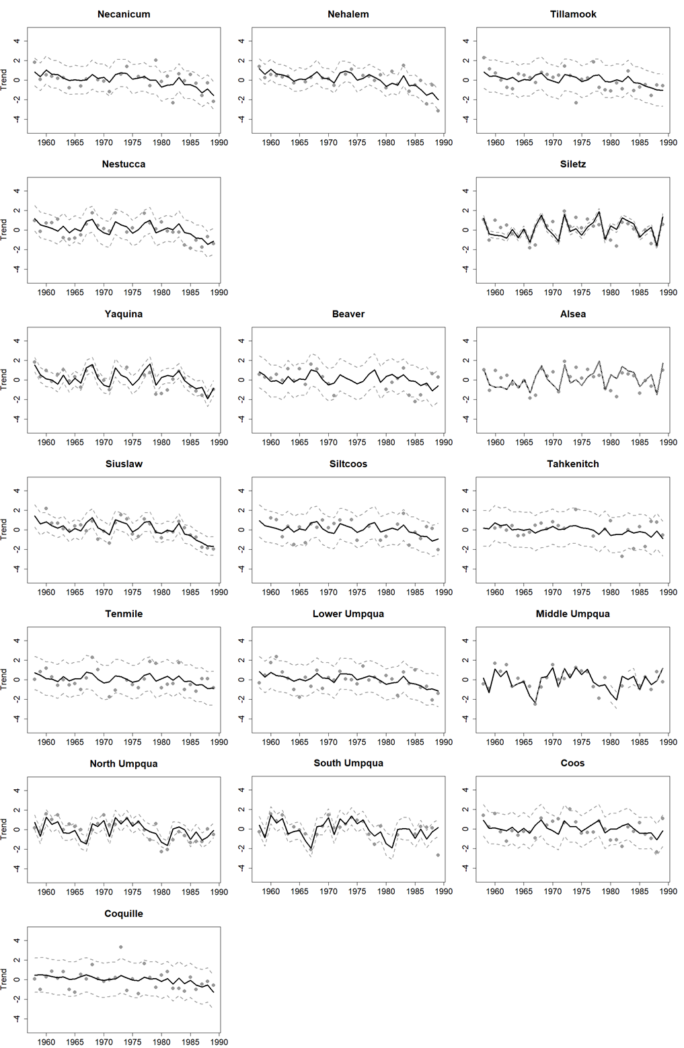
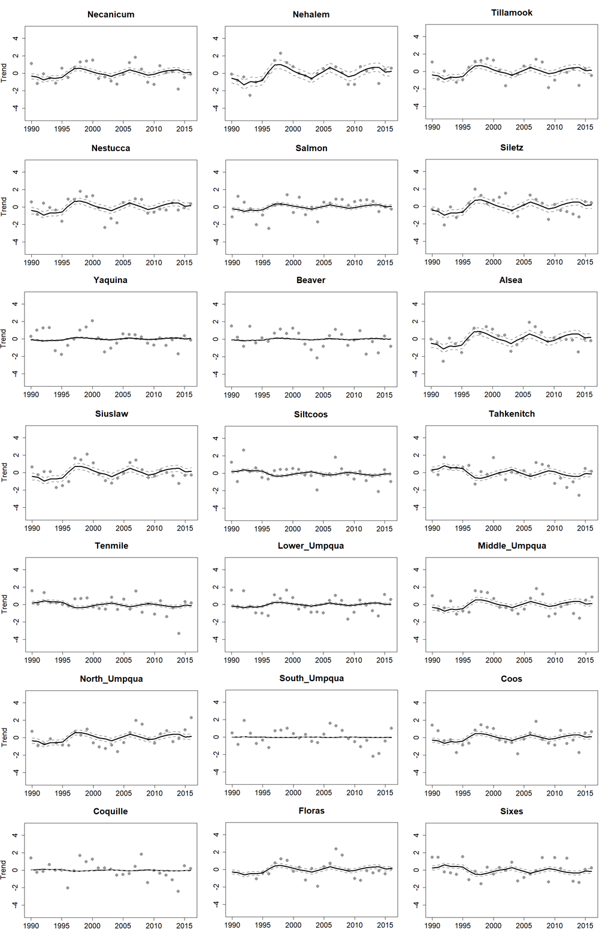
Figure S7. Standardized data (gray points) and predicted productivity trends for the pre-1990 (top) and post-1990 (bottom) coast-wide dynamic factor analyses (DFAs). Predictions are presented for each independent population of Oregon Coast coho salmon.

